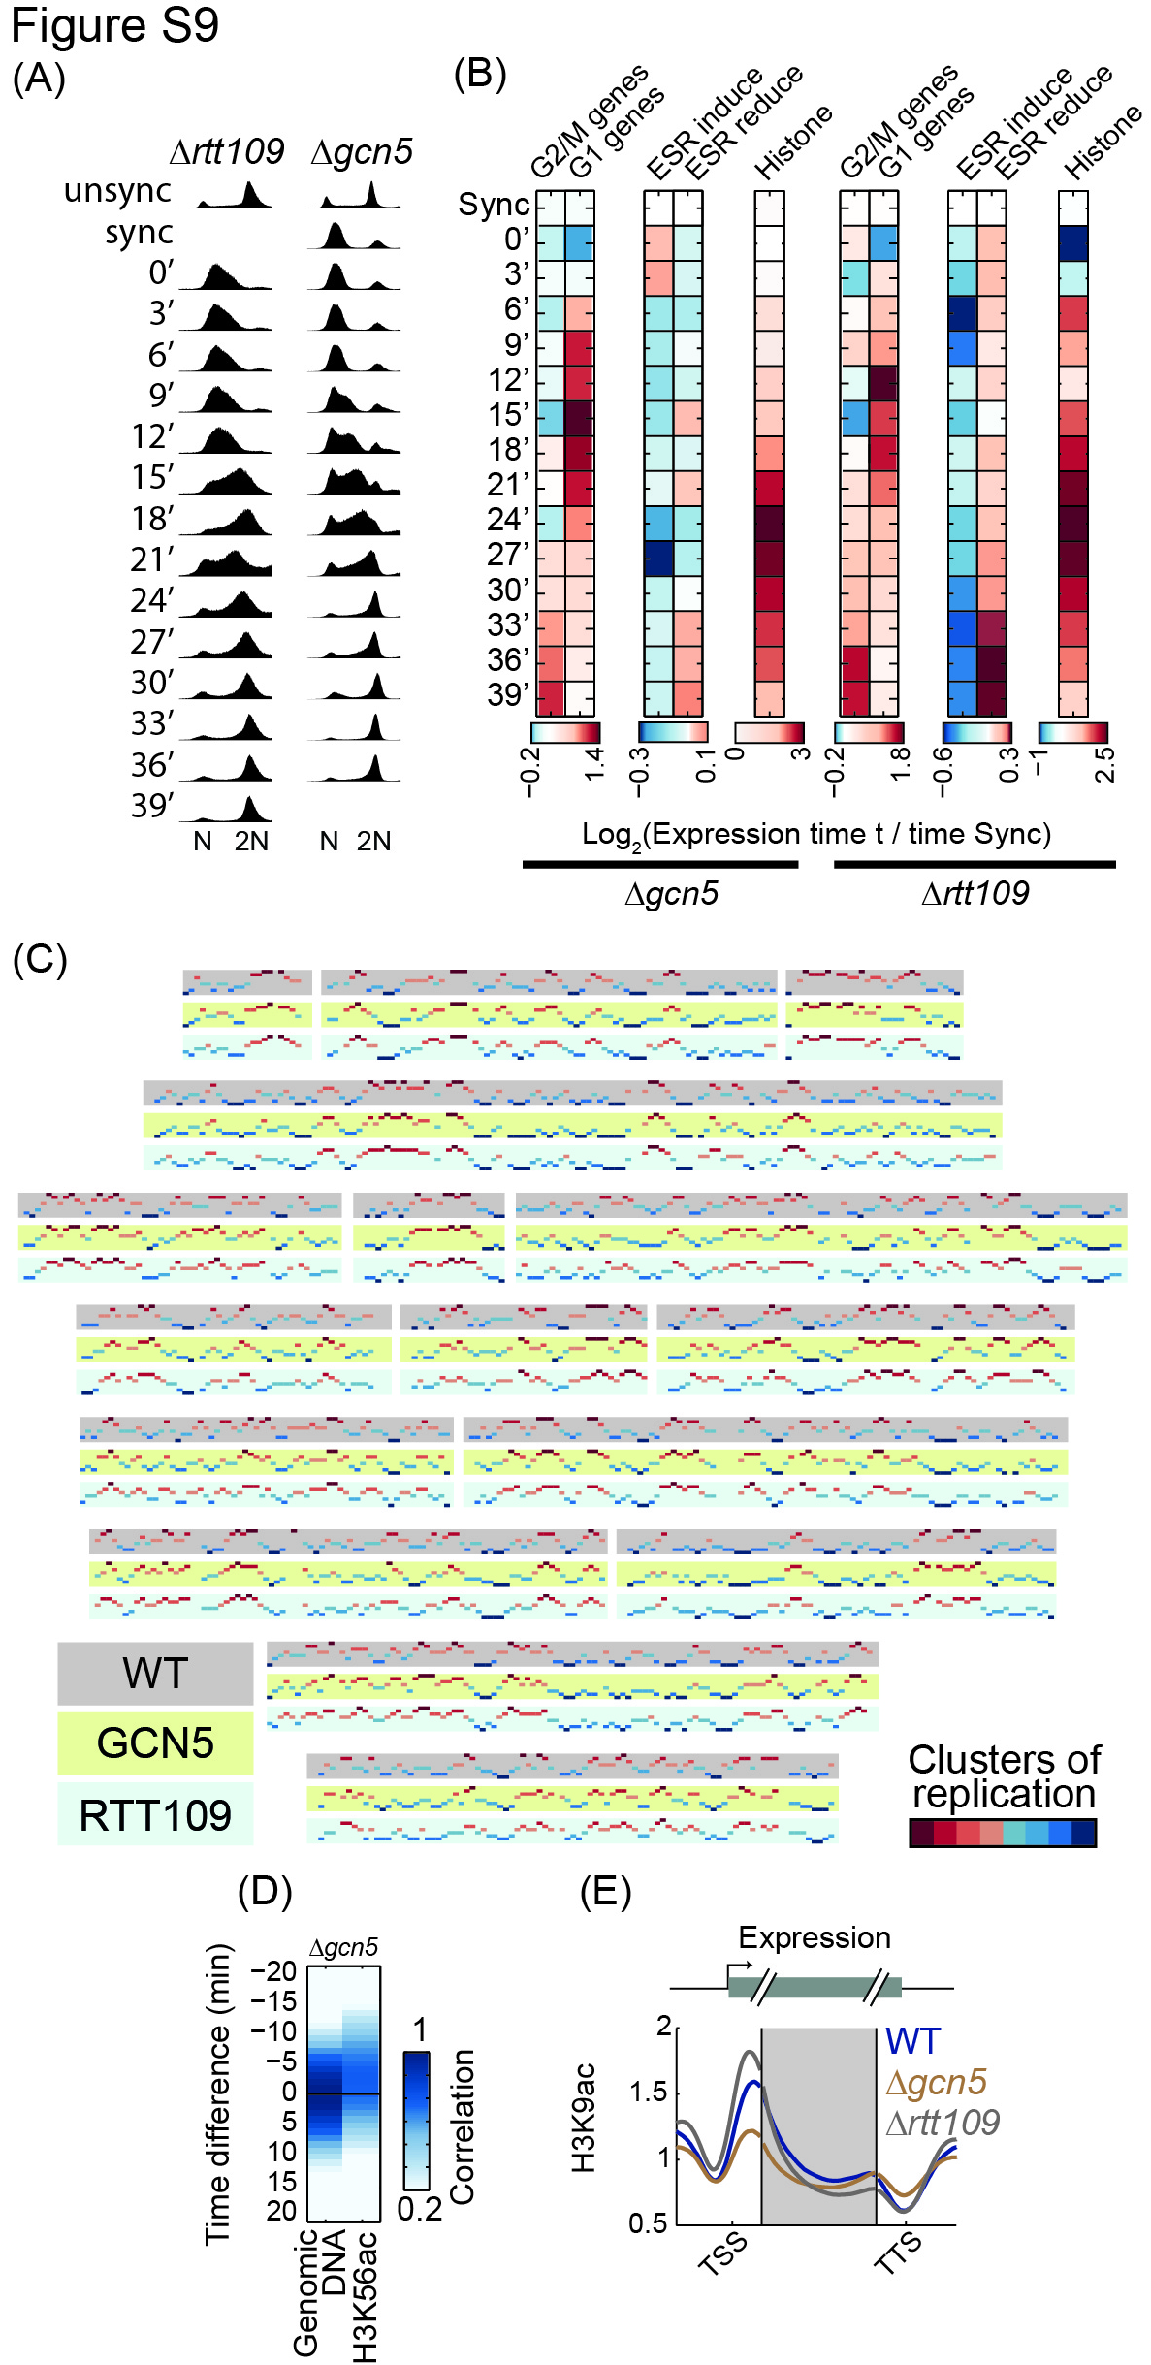
Figure S9: Cell-cycle and replication progression in strains deleted of acetyltransferases responsible of H3K9ac
- Synchronization in H3K9ac acetyltransferases deletions: DNA content along the synchronized cell cycle progression of Δgcn5 & Δrtt109 as measured by flow cytometry. Plotted as in Figure S1B, the synchronized time-point in Δrtt109 and 39 min in Δgcn5 are missing.
- Gene expression changes in H3K9ac acetyltransferases deletions: Expression changes in Δgcn5 and Δrtt109. Plotted as in Figure 1B.
- Whole genome replication profiles for Δgcn5 and Δrtt109 relative to WT: Genomic replication profiles, as in Figure S5C, are shown for the 3 strains (shaded boxes, WT - grey, Δgcn5 – yellow, Δrtt109 - blue) when synchronized using α-factor. Replication clusters were calculated independently for each strain.
- H3K56ac deposition in cells deleted of Gcn5: Same as Figure 5A for H3K56ac in Δgcn5. Short delay in H3K56ac is attributed to cross-reactivity with H3K9ac (Drogaris et al. 2012), addressed in Figure 4 and the main text.
- Metagene analysis of H3K9ac average pattern: Metagene analysis for Δgcn5 & Δrtt109 relative to WT in synchronized cells. Plotted as in Figure 5B for all genes.

