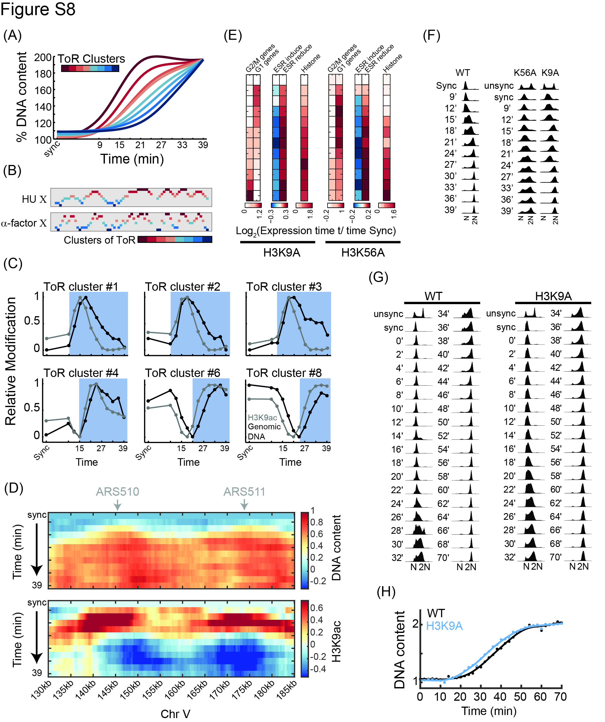
Figure S8: Acetylation of H3K9 precedes replication:
- Replication dynamics in cells released from α-factor synchronization: Time of replication clusters were generated for α-factor experiments (independent of assignment in HU experiments) and increase in DNA content is plotted as in Figure S5A.
- Replication programs deduced from DNA abundance: As in Figure 1F, for replication clusters on chromosome X, comparing the two differentially synchronized experiments. See Figure S9C for all other chromosomes.
- H3K9ac dynamics with respect to replication: As in Figure 4B, the average signals for genomic DNA (black) and H3K9ac (grey), for different replication clusters (ToR cluster 1-8, from early replicating to late replicating).
- As in Figure 4E, for the complete time course.
- Gene expression changes along the time course for H3 point mutations: Plotted as in Figure 1B for H3K9A and H3K56A mutants.
- DNA content along the synchronized cell cycle progression of WT, H3K9A, and H3K56A: DNA content measured by flow cytometry, as in Figure S1B.
- –(H) Replication progression in H3K9A mutant: Replication progression was measured using flow cytometry in H3K9A and its corresponding wild type in a 2-minute time resolution following α-factor synchronization (G) and the accumulating signal was quantified along time (H).

