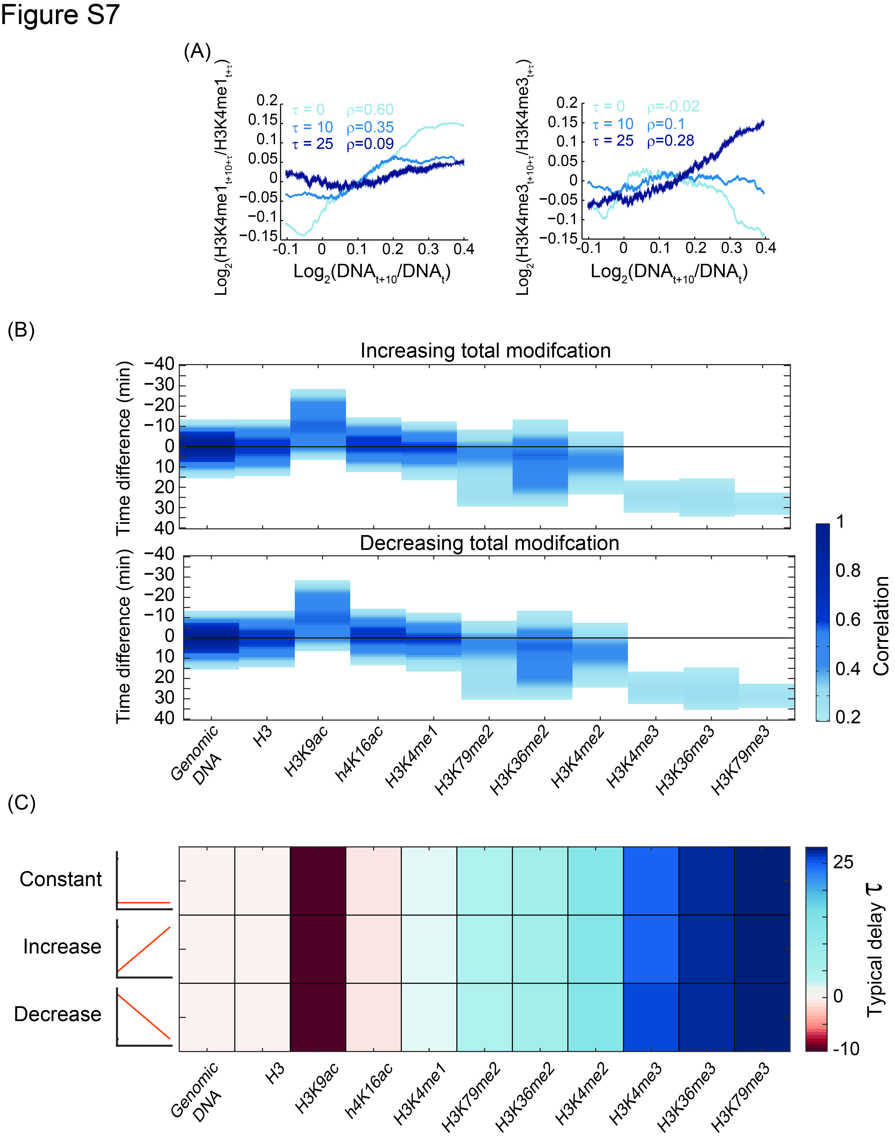
Figure S7: Cross-correlation of increase in histone modifications and DNA replication:
- Correlation of H3K4me1 (left) or H3K4me3 (right) corresponding to 3 specific delays presented in Figure 2B (denoted by ρ). Changes in the modification between time points relative to the changes in DNA content level in the indicated delay were smoothed using a running-average (windows of 1000).
- Cross-correlation of DNA and histone mark abundances for increasing/decreasing total signal: As an additional approach to examine the sensitivity of our analysis to changes in total enrichments (note S1), we assumed different temporal dynamics of the total modification levels, and simulated their possible effects on the parameters we measured. Correlations (>0.2) between changes in the indicated modification levels at time t, and changes in DNA content at time t-τ, as a function of the time delay τ, as in Figure 2B, when assuming linearly increasing (top) or linearly decreasing (bottom) total (sum of all modification in a specific time point) signal along the time course. Note that delay times are insensitive to monotonic changes in the total level of modification during S-phase.
- Typical time delay for increasing/decreasing total signal: Similar time delay τ is measured for constant, increasing or decreasing total signal shown in B, calculated as in Figure 2C.

