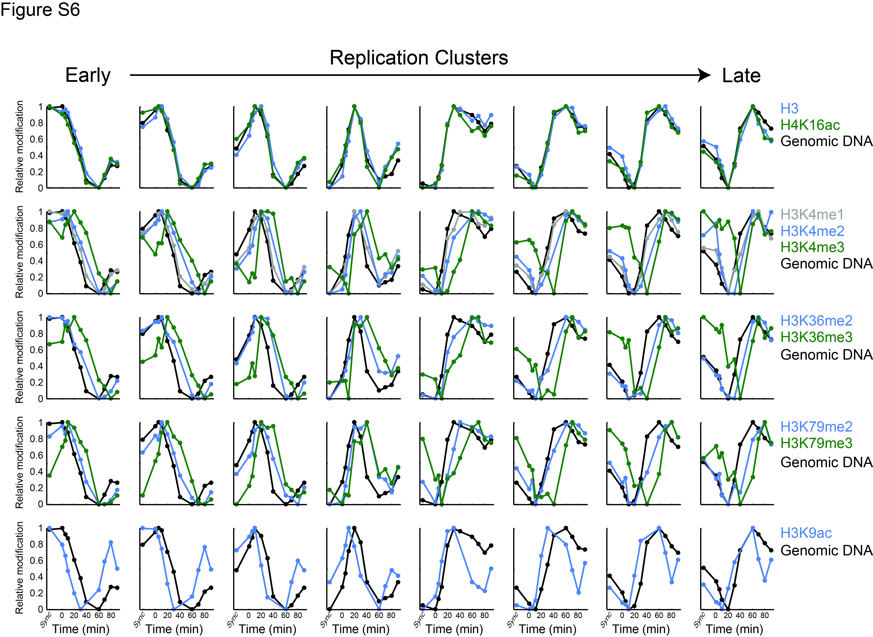
Figure S6: Delayed recovery of histone modification for regions with different time of replication:
As in Figure 2A, the temporal changes in genomic DNA (black) and the ten histone modifications were averaged over all regions assigned to each replication cluster, according to its time of replication (from left to right).

