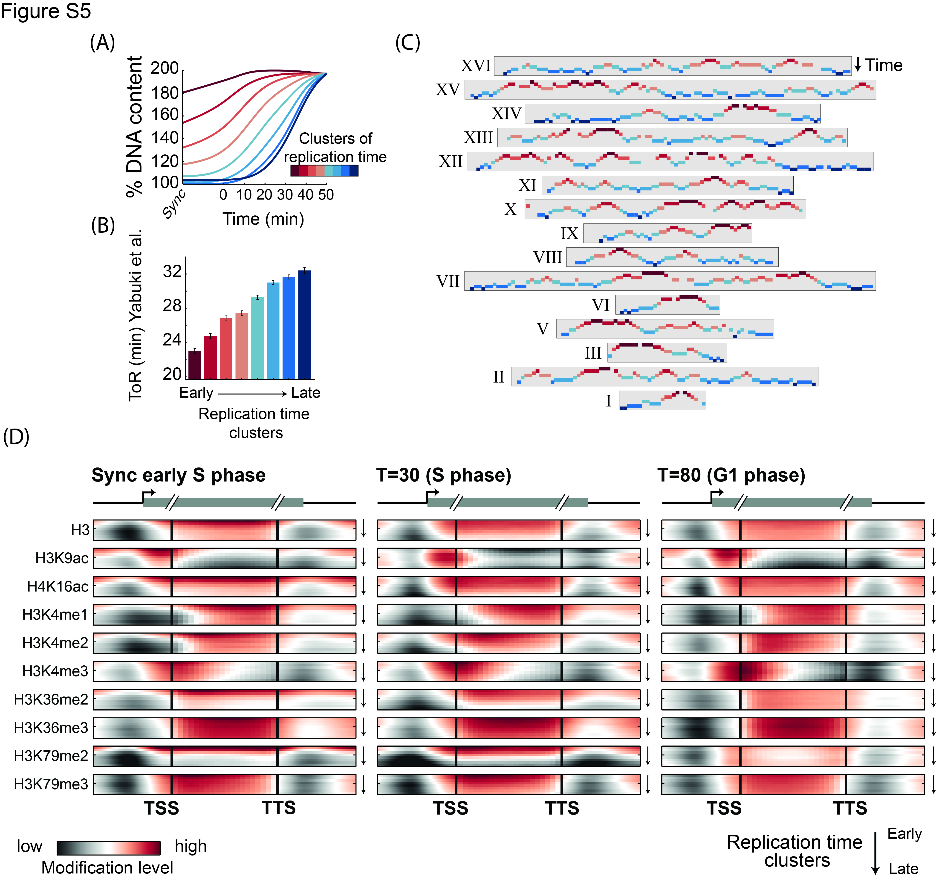
Figure S5: Defining replication timing, and its associated changes in histone modifications:
- Defining genomic clusters with different replication times: Genomic regions (10kb bins) were clustered into eight groups based on the temporal changes in their DNA content. The average increase in DNA content of each cluster was calculated. Clustering was performed using k-means (k=8) (Methods & note S1).
- Replication clusters capture previously defined replication timing: The average replication time, as defined by Yabuki et al. of the bins in each cluster defined in our study (Yabuki et al. 2002). Error bars represent standard error.
- Genomic replication profile: Cluster assignments of each genomic chromosome, as indicated. Clusters are color-coded as in (B) and positioned along the y-axis based on the average replication timing of the cluster. Notice that cluster assignment was independent of spatial order of bins on the chromosome, but still shows a continuous profile on all chromosomes.
- Metagene analysis for all measured modifications for 3 time-points in the cell cycle: Calculated and plotted for each modification, for genes positioned within each cluster, in 3 time points, as in Figure 1C. Y-axis depicts clusters ordered by time of replication. Many changes between different times of replication are seen in the two time points during S phase but not in G1.

