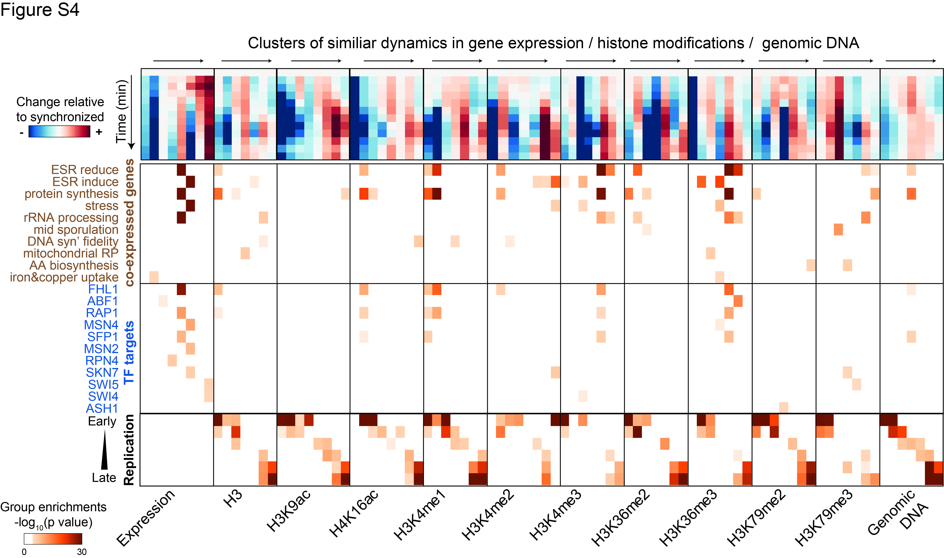
Figure S4: Comparing changes in gene expression and DNA replication to changes in histone modifications:
Genes were clustered according to their similar dynamics in gene expression, histone modifications, or genomic DNA (12 cluster assignments in total). The top panel depicts the temporal dynamics of each cluster (averaged over all genes in cluster) for the indicated feature. Enrichments of the indicated pre-specified gene classes within the cluster genes are shown beneath. Clusters were defined by k-means (k=8) and enrichment values were calculated using the hyper-geometric score. All groups showing at least one significant enrichment (p-value < 10e-5) are shown. Note, that a minority of the clusters were enriched with co-expressed gene groups, mostly with stress-induced and stress-repressed ones. This was observed primarily for mono- and tri-methylations, with tri-methylations changing in accordance with the changes in gene expression, while the mono-methylation pattern showed inverse temporal behavior (compare expression-based and modification-based enrichments). For the majority of modifications, including H3K9ac, H4K16ac and all dimethylations, co-modified groups showed little, if any, enrichment of co-expressed genes. Note that for all histone marks, the identified clusters well-described the temporal pattern of DNA replication.

