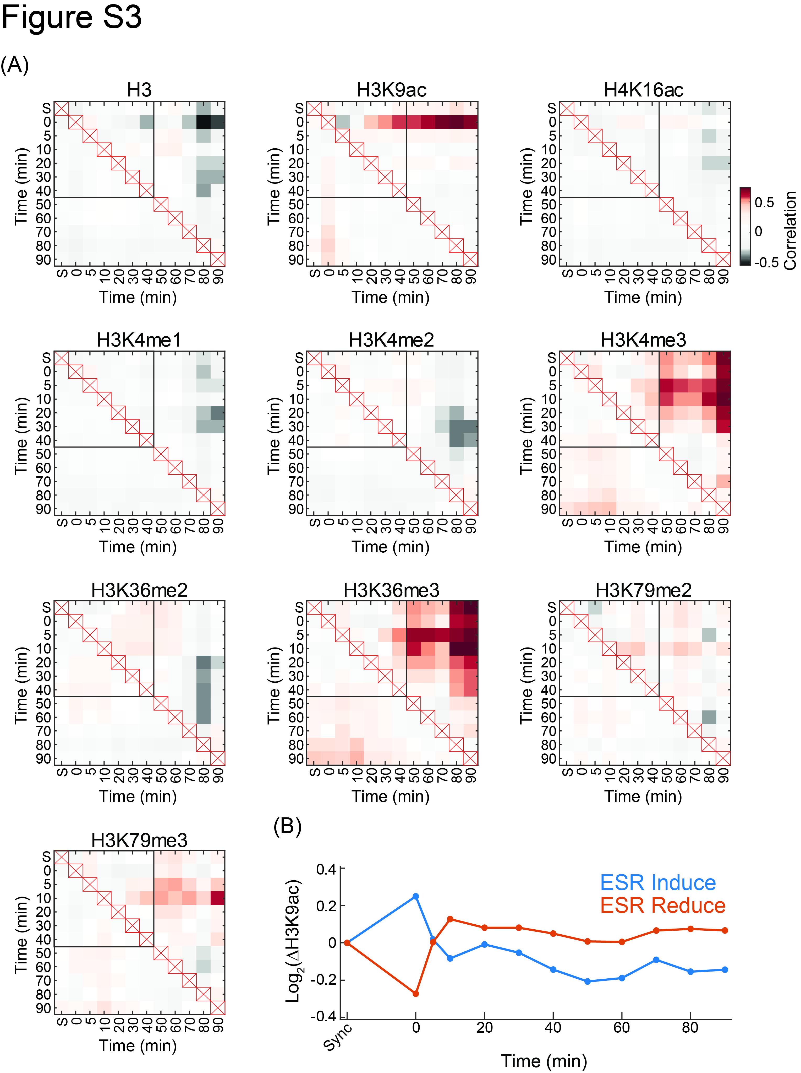
Figure S3: Correlation between changes in gene expression to changes in histone modifications:
- Correlations considering different time-shifts: For every two time points, correlation between the (log2) ratio of their gene expression and the (log2) ratio in the average histone modification signal over the gene was calculated. Correlations were calculated for all genes (under the diagonal) or ESR genes only (above the diagonal) (Gasch et al. 2000), separately. In cases of time points with two biological replicates for histone modifications, signal was averaged. Time points in which histone modification was missing, were estimated using cubic spline (p=0.1) on data from all other time points. Rectangle depicts the first 40 minutes, when replication occurs. “S” denotes the synchronized time point.
- Changes in H3K9 acetylation on ESR genes: Average signal of H3K9ac on ESR induce (blue) or reduce (red) genes along the time course relative to the synchronized time point. Notice that the correlation in H3K9ac shown in (A) is attributed to the spike in signal in the 0 minutes time point.

