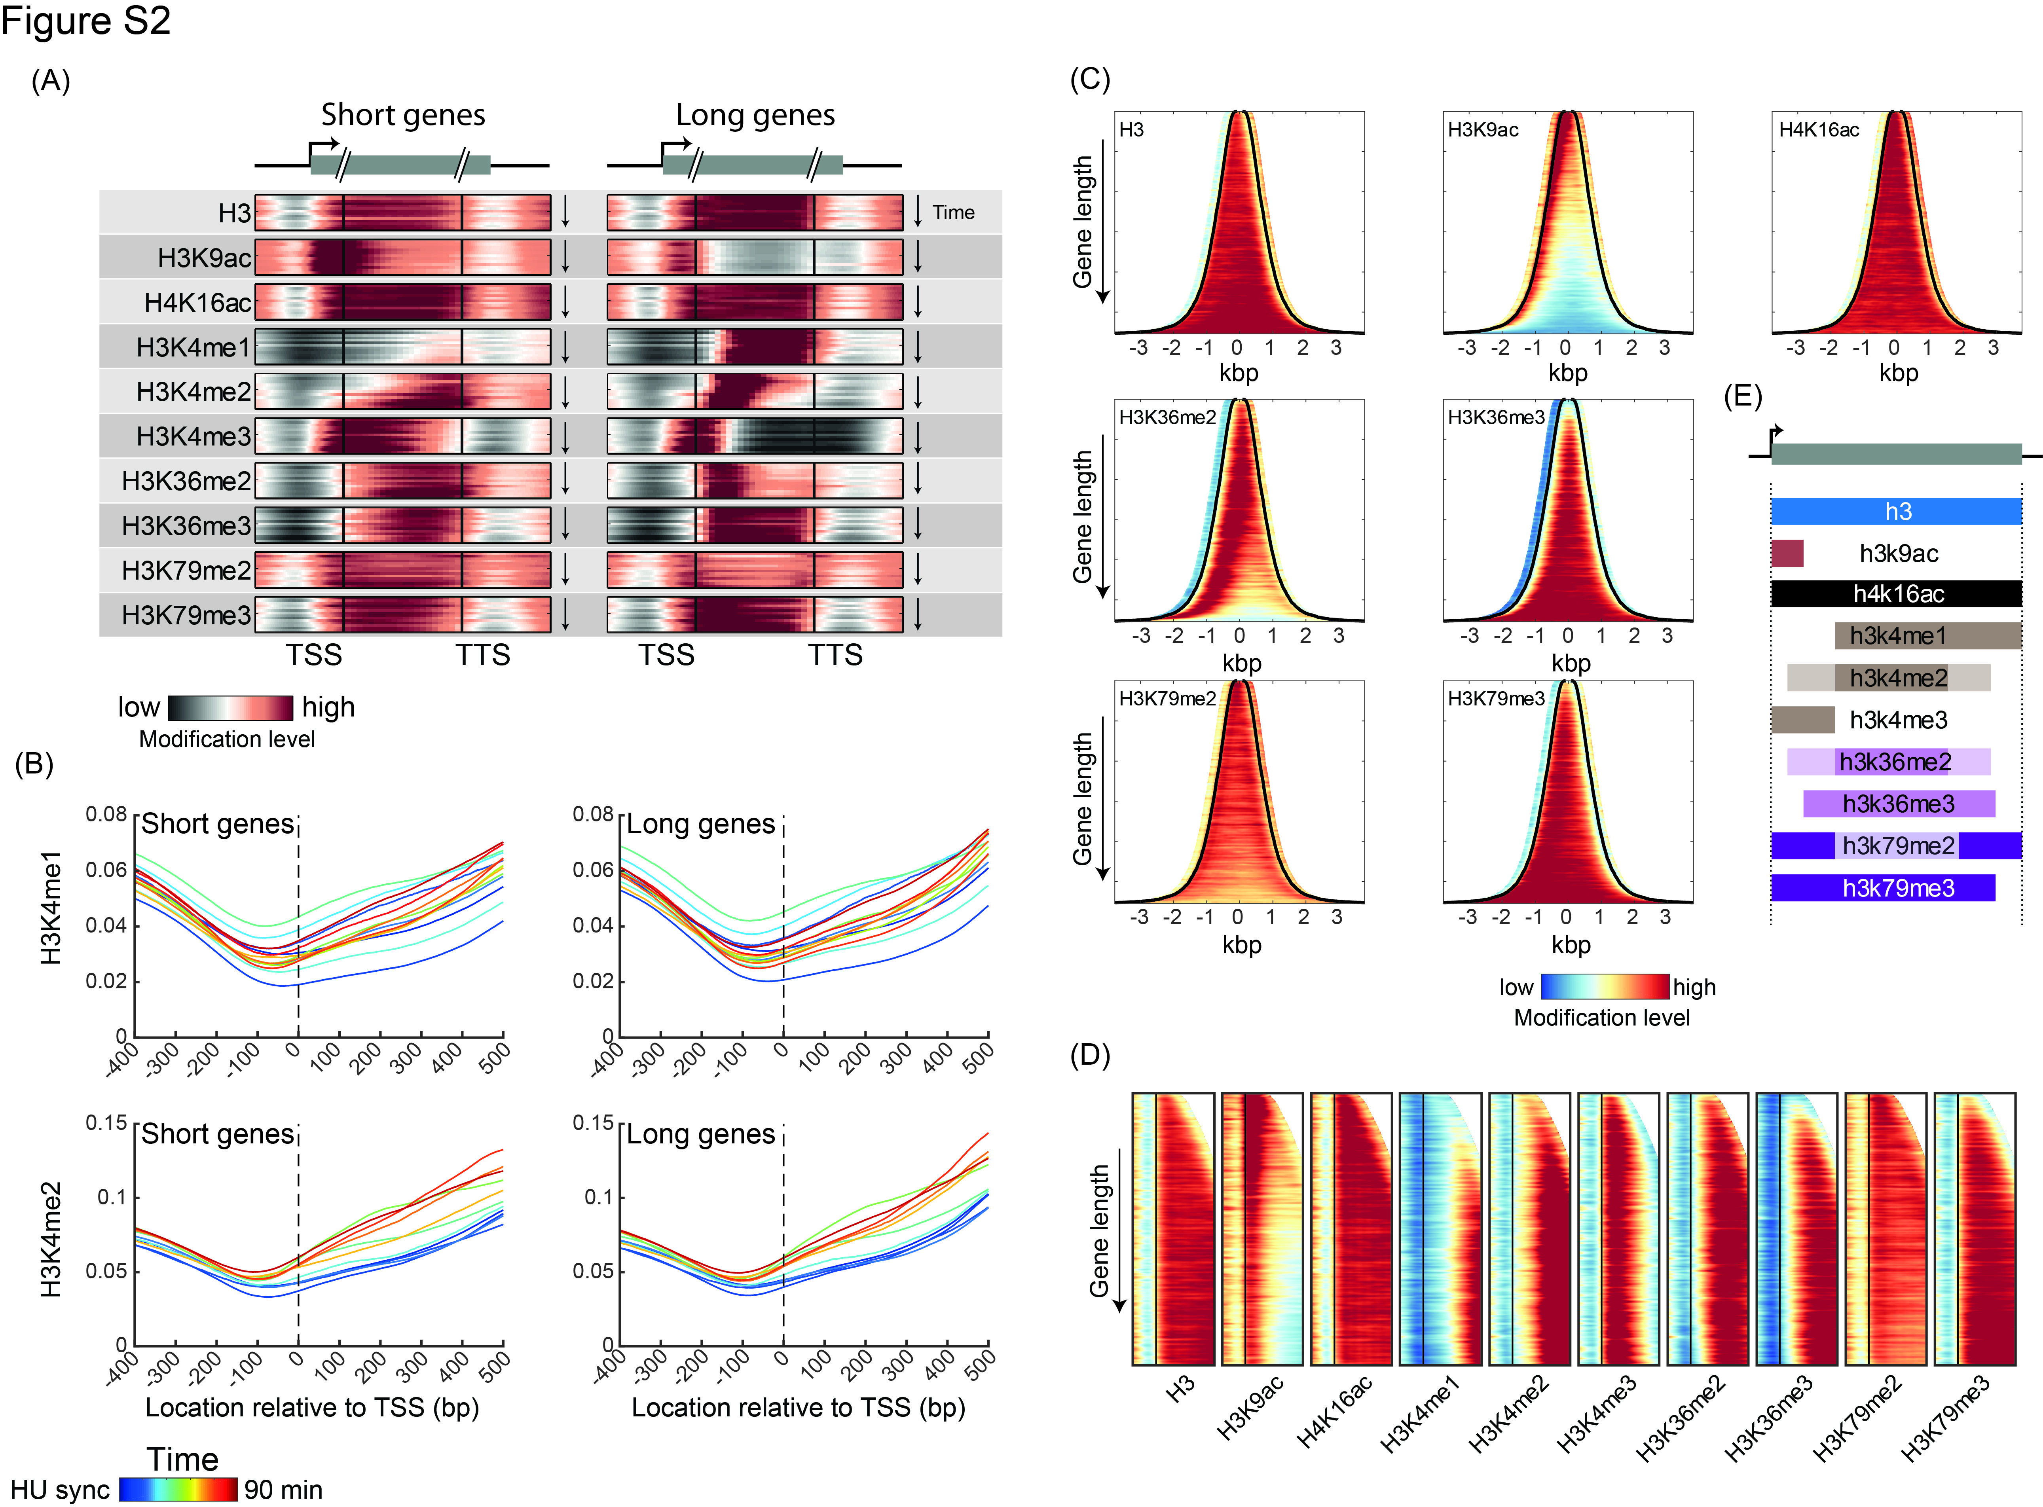
Figure S2: Gene length effect on patterns of histone modifications:
- Metagene analysis for short and long genes: As in Figure 1C, separated for 1000 shortest and 1000 longest genes, omitting from analysis genes <500bp or >3000bp.
- Changes in H3K4 methylation: Average signal of H3K4me1 or H3K4me2 on short (left) or long (right) genes, defined as in (A). Genes were aligned to the TSS and plotted for all time-points.
- Gene length-dependent effects on modification patterns: as in Figure 1D, for all other modifications, aligned by the center of the gene (set to 0) and averaged over all time-points in the time-course. Black left line represents TSS, black right line represents TTS.
- Same as in (C), aligning all genes to the 5’ end, according to the TSS, plotting data from TSS-400bp to TSS+1kb.
- Scheme of histone modifications patterns: Cartoon summarizing the general patterns of the tested histone modifications along genes, according to Figure 1D&S2C. For example, H3K9ac is found up to ~250bp after TSS of genes, while H3K4me1 is found from ~TSS+500bp to gene’s 3’.

