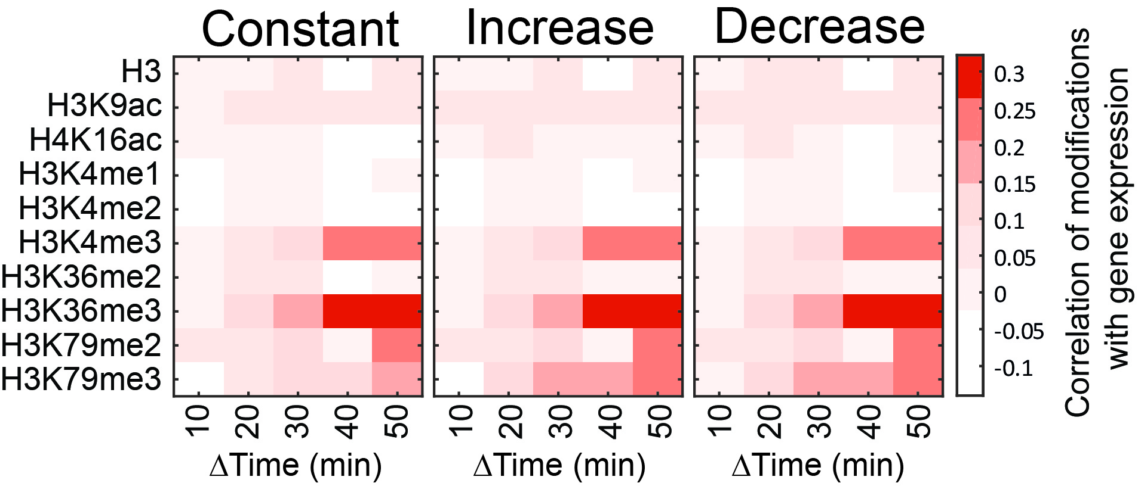
Figure S13: Correlating changes in gene expression to changes in histone modifications assuming different total modifications dynamics:
Correlating changes in gene expression to changes in histone modifications is not affected by increasing or decreasing total levels of histone modifications. Correlation was calculated as in Figure 1E assuming total levels of histone modifications were constant (left, exactly like 1E), linearly increasing (middle) or linearly decreasing (right).

