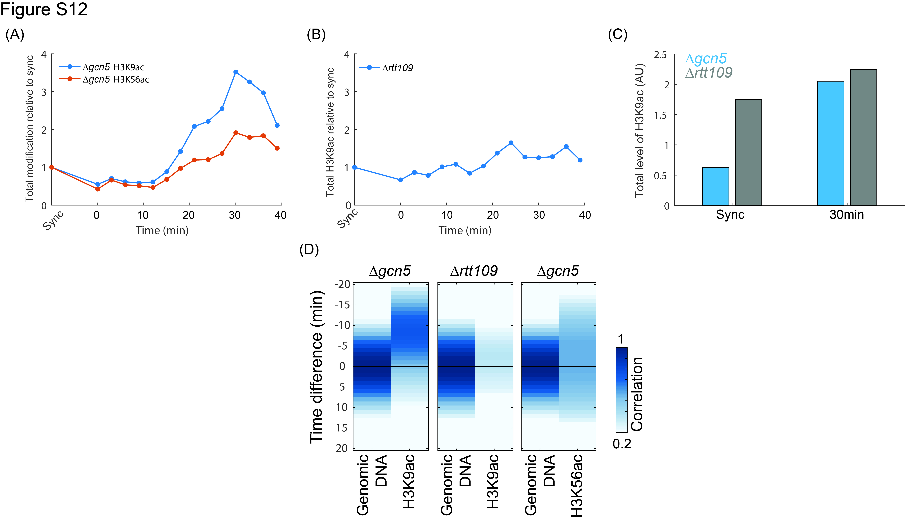
Figure S12: H3K9ac total levels during S-phase in Δrtt109 and Δgcn5, as measured by S. pombe spiking
To examine the sensitivity of our analysis to changes in total modification levels, we analyzed the modification levels in Δrtt109 & Δgcn5 α-factor time courses, in which S. pombe spiking was used (Note S2).
(A)-(B) Total amount of H3K9ac & H3K56ac relative to the synchronized time point, as calculated using S.pombe spiking (See Note S2). Calculated amounts are plotted for Δgcn5 (A) or Δrtt109 (B) released from G1 synchronization. While both total H3K9ac and H3K56ac increase upon entry into S-phase in Δgcn5, this increase is not seen in Δrtt109.
Total modification level (up to a constant factor) was calculated as follows:
Defining:
- $C, P$ – Amount of S. cerevisiae & S. pombe in the sample before the IP, respectively
- $M_{c}, M_{p}$ – Amount of DNA from S. cerevisiae & S. pombe in the sample after the IP.
- $I_{c},I_{p}$ - Amount of input sequences of S. cerevisiae & S. pombe.
- ${M'}_{c},{M'}_{p}$ - Amount of sequences of S. cerevisiae & S. pombe from ChIP-seq.
- $α_{c}, α_{p}$ – Level of modification in S. cerevisiae & S. pombe (“Enrichment”).
We want to get $\frac{α_{c}}{α_{p}}$ in terms of our observations: $I_{c},I_{p}, {M'}_{c},{M'}_{p}$. This will give us an estimation of the total modification in S. Cerevisiae as $α_{p}$ stays constant.
$M_{c}=Cα_{c}$ and $M_{p}=Pα_{p} .$Assuming sequencing conserves the amounts ratios, we get:
$$\frac{M_{c}^{'}}{M_{p}^{'}}=\frac{M_{c}}{M_{p}}=\left(\frac{C}{P}\right)\left(\frac{α_{c}}{α_{p}}\right)=\left(\frac{I_{c}}{I_{p}}\right)\left(\frac{α_{c}}{α_{p}}\right) => \frac{M_{c}^{'}}{M_{p}^{'}}=\frac{I_{c}{ α}_{c}}{I_{p }α_{p}} => \frac{α_{c}}{α_{p}}=\frac{M_{c}^{'}I_{p}}{M_{p}^{'}I_{c}}$$
(C) Rtt109 contributes to total level of H3K9ac mostly in S-phase. Levels of total H3K9ac are plotted for Δgcn5 & Δrtt109 in the synchronized time-point and in the middle of S-phase for comparison. Note that Gcn5 contributes the majority of H3K9ac when cells are not in S-phase, while during S-phase the contributions of Gcn5 and Rtt109 are similar.
(D) Calculating the delay of H3K9ac & H3K56ac relative to the DNA content as in Figure 5A & S9D, was repeated after taking into account the total levels of modifications calculated using the S. pombe spiking. Note that the predicted time-delay between H3K9ac appearance and DNA replication is insensitive to this normalization.

