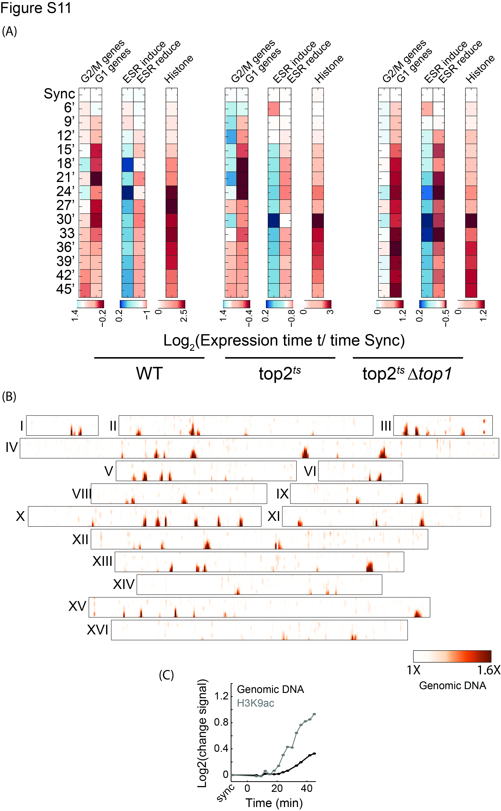
Figure S11: Topoisomerases depletion strengthens H3K9ac signal
- Gene expression changes: Expression changes in topoisomerases-depleted strains and W303 strain when synchronizing with α-factor as described. Plotted as in Figure 1B.
- Replication halts when depleting both yeast topoisomerases: DNA content as measured by DNA sequencing, in a strain depleted of both topoisomerases, for all chromosomes except VII (presented in Figure 6C).
- H3K9ac precedes replication: As in Figure 6G, for the second cluster of replication in top2^{ts}Δtop1.

