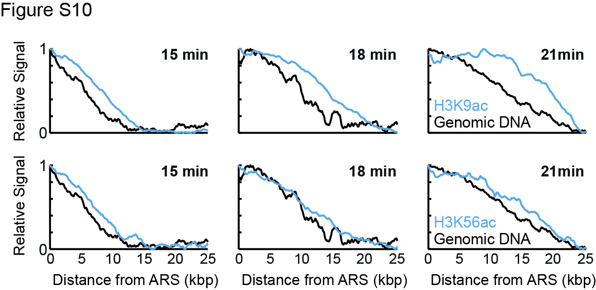
Figure S10: Spatial spreading of H3K56ac compared to replication in Δgcn5
Spatial progression of H3K9ac (top) or H3K56ac (bottom) relative to DNA is shown for Δgcn5, around early replicated origins, as in Figure 5E. Data for H3K9ac as in Figure 5E and shown here for comparison.

