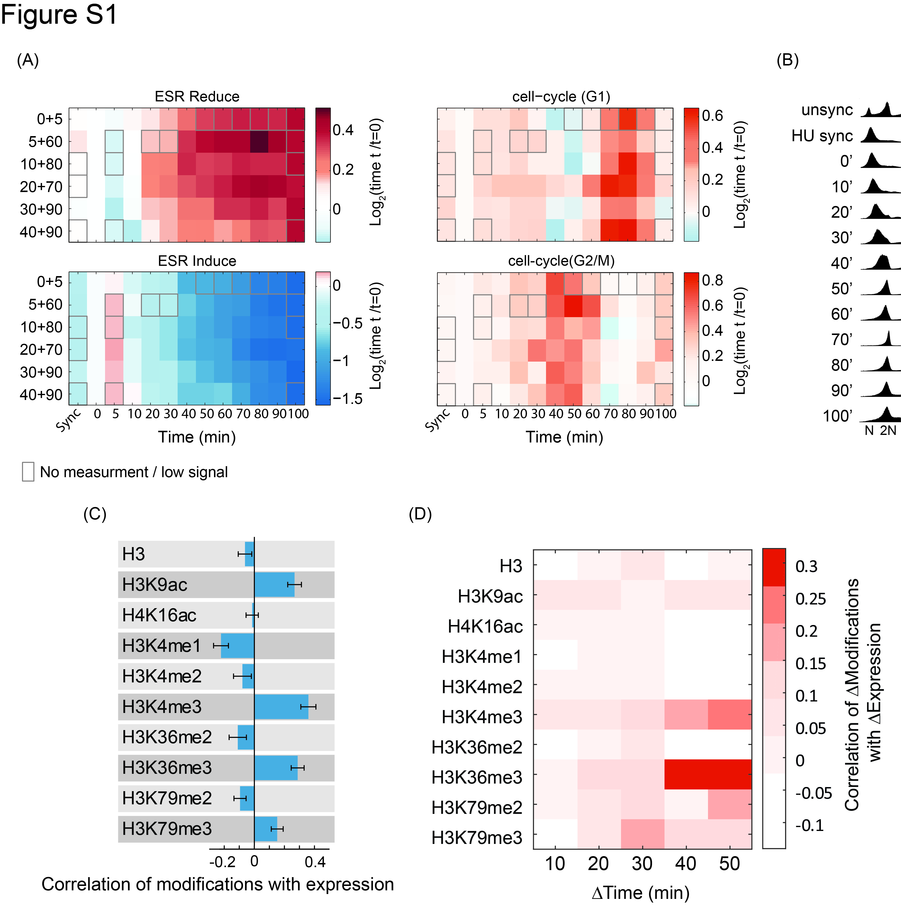
Figure S1: Expression dynamics along the yeast cell cycle:
- Gene expression changes along the time course for different biological replicates: (log2) changes in expression relative to the synchronized time point calculated for each biological replicate of the HU time-course (different rows). Changes were averaged over four gene groups separately: G1 genes, G2/M genes and ESR induce/reduce genes and plotted along the time-course (Gasch et al. 2000; Ihmels et al. 2002). Grey boxes indicate missing time points, for which the average of all other replicates is shown.
- Verifying synchronized cell-cycle progression using flow cytometry: Total DNA content of cells was measured using flow cytometry, at different time points. Shown are representative results from one experiment. We would like to note that despite the fact that cells in later times (70’-100’) show 2N DNA levels, they are not G2/M-arrested, as the clear down-regulation of G2/M genes and synchronized progression can be seen in the gene expression profiles in (A). We therefore attribute this effect to some technical issues with cell separation in the flow-cytometer following release from HU.
- Correlation between gene expression and histone modifications levels: Correlations between levels of gene expression and histone modifications were calculated for each time point and each modification. Correlation values are averaged over the time course, with error bars indicating the standard deviation.
- Correlation between changes in gene expression and changes in histone modifications: As in Figure 1E, but calculated by first measuring correlation at each pair of shifted time points, and then averaging them.

