SUPPLEMENTAL FIGURE LEGENDS
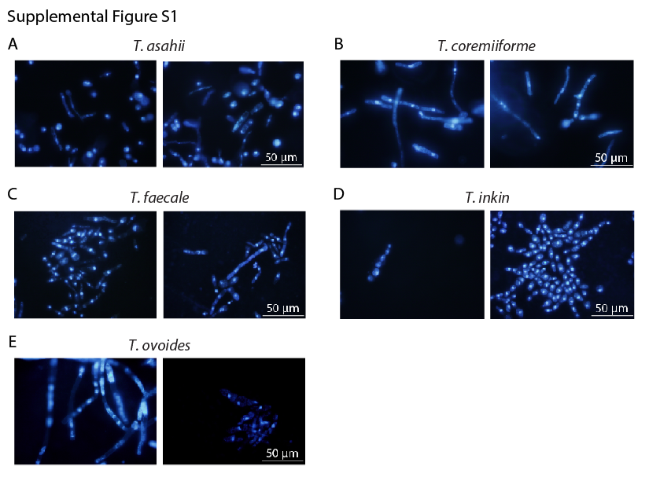
Supplemental Figure S1. Fluorescence microscopy of Trichosporon cultures. Trichosporon cultures were incubated in Sabouraud agar for four days prior to the experiment. Chromosomes were stained using 4',6-Diamidino-2-Phenylindole. (A) T. asahii. (B) T. coremiiforme. (C) T. faecale. (D) T. inkin. (E) T. ovoides.
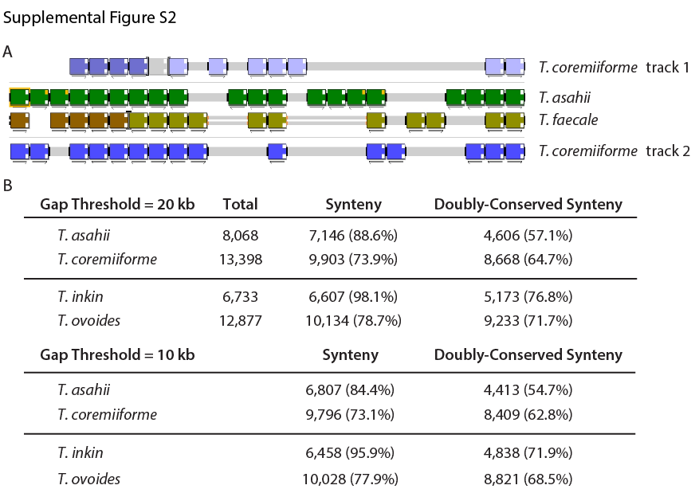
Supplemental Figure S2. Synteny structures identified by Gene Order Browser. (A) Example of synteny alignment performed in Gene Order Browser (Byrne and Wolfe 2005). Non-polyploid species (the two inner tracks) were used as the template for aligning homeologous genes (the two outer tracks). Each colored box represents a gene. Different colors represent distinct scaffolds or contigs within each genome. (B) Synteny mapping coverage at 20-kb and 10-kb gap thresholds (see Methods). The numbers of genes along with genome coverages are shown.
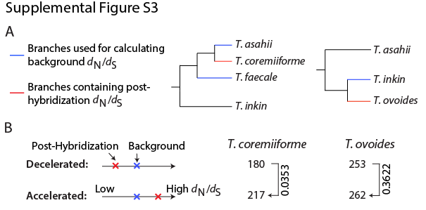
Supplemental Figure S3. Lack of significant changes in evolutionary rates of single-copy genes. Similar to Figure 3. (A) Diagram illustrating how background d_{N}/d_{S} are defined. Background d_{N}/d_{S} are calculated as the weighted average of d_{N}/d_{S} on the phylogenetic tree branches leading to non-polyploid species (blue branches, weighted by branch dS). d_{N}/d_{S} ratios are then calculated as the ratio of dN/dS of the branches leading to hybrid species (red branches) over the background d_{N}/d_{S}. (B) The number of single-copy genes that are evolutionarily accelerated or decelerated. The threshold is ±2-fold in d_{N}/d_{S} ratio. Arrows and labels indicate the directions of enrichment and the binomial test p-values (under the null hypothesis that a single-copy gene is equally likely to become evolutionarily accelerated or decelerated).
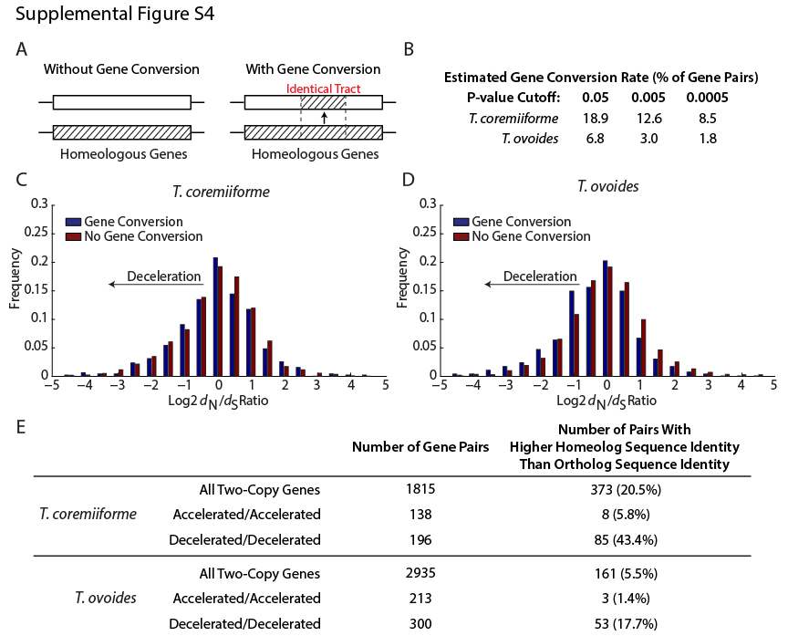
Supplemental Figure S4. Gene conversions associate with deceleration in evolutionary rates. (A) Diagram illustrating an identical sequence tract between ohnologs/paralogs that may have arisen via gene conversion. (B) Table summarizing the estimated gene conversion rates in post-hybridization genomes. P-values were obtained from GENECONV (Sawyer 1989). (C) Histogram comparing d_{N}/d_{S} ratios between homeologous gene pairs in T. coremiiforme with detected gene conversions and those without. d_{N}/d_{S} ratios of both genes in each homeologous pair are included. (D) Similar plot for T. ovoides genes. Here, the evolutionary rates of gene pairs with detected gene conversion are significantly decelerated (Mann-Whitney U test p-value = 3e-4). (E) Table showing the numbers of homeologous gene pairs where the level of sequence conservation between homeologs (homeolog sequence identity) is higher than that between orthologs (inter-species sequence identity). Decelerated/decelerated gene pairs are enriched for higher homeolog sequence conservation – also a possible consequence of gene conversions.
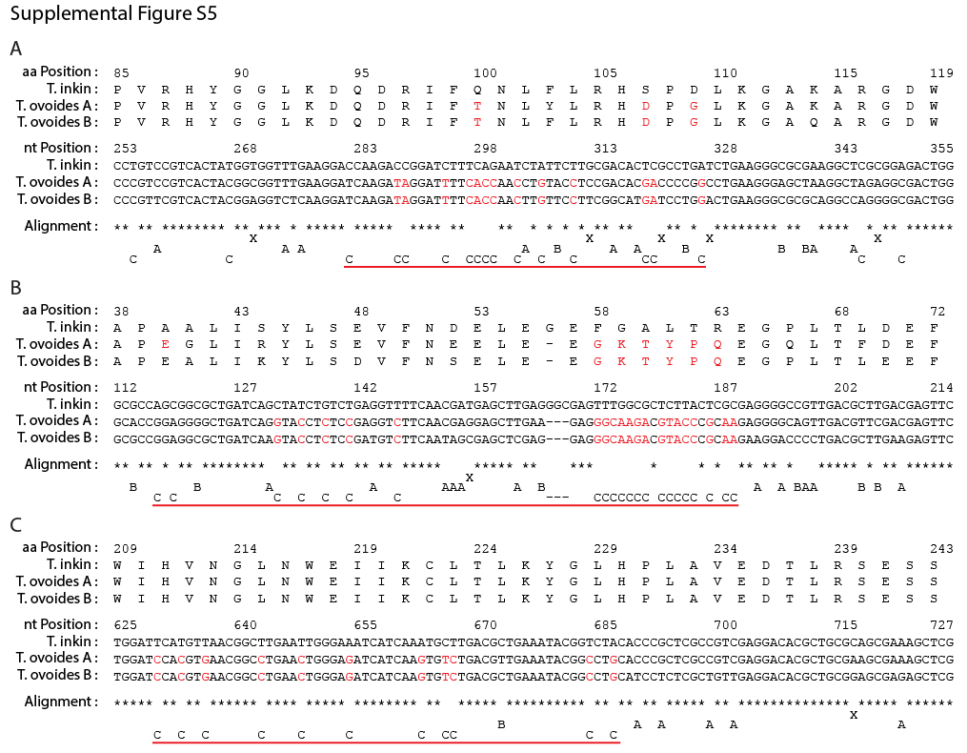
Supplemental Figure S5. Gene conversions in T. ovoides homogenize its homeologs. Examples of gene conversion events detected by GENECONV (Sawyer 1989). In each case, a 35-amino acid window surrounding gene conversion event was extracted from the full-length sequence amino acid alignment, which was also mapped to the corresponding nucleotide sequences to obtain nucleotide-level alignment (see Methods). Alignment symbols are defined as followed: “*” means that all three genes share the same nucleotide at that position, “X” means that three genes have different nucleotides at that position, “A” or “B” means that the nucleotide in only the homeolog from T. ovoides subgenome A or B is identical to T. inkin gene at that position, and “C” means that the nucleotides in T. ovoides homeologs are identical at that position but not identical to T. inkin. “–” represents alignment gaps. Red underlines indicate regions affected by gene conversions. Amino acids and nucleotides colored in red highlight the evidence and effect of gene conversions.

SUPPLEMENTAL REFERENCES
Byrne KP, Wolfe KH. 2005. The Yeast Gene Order Browser: combining curated homology and syntenic context reveals gene fate in polyploid species. Genome Res 15: 1456-1461.
Sawyer S. 1989. Statistical tests for detecting gene conversion. Mol Biol Evol 6: 526-538.
Yang RY, Li HT, Zhu H, Zhou GP, Wang M, Wang L. 2012. Draft genome sequence of CBS 2479, the standard type strain of Trichosporon asahii. Eukaryot Cell 11: 1415-1416.

