Supplemental information for

Genome-wide analysis of chromatin packing in Arabidopsis thaliana at single gene resolution

Chang Liu, Congmao Wang, George Wang, Claude Becker, Maricris Zaidem, and Detlef Weigel

Supplemental references
Sequeira-Mendes J, Araguez I, Peiro R, Mendez-Giraldez R, Zhang X, Jacobsen SE, Bastolla U, Gutierrez C. 2014. The Functional Topography of the Arabidopsis Genome Is Organized in a Reduced Number of Linear Motifs of Chromatin States. Plant Cell 26: 2351-2366.
Wang C, Liu C, Roqueiro D, Grimm D, Schwab R, Becker C, Lanz C, Weigel D. 2015. Genome-wide analysis of local chromatin packing in Arabidopsis thaliana. Genome Res 25: 246-256.

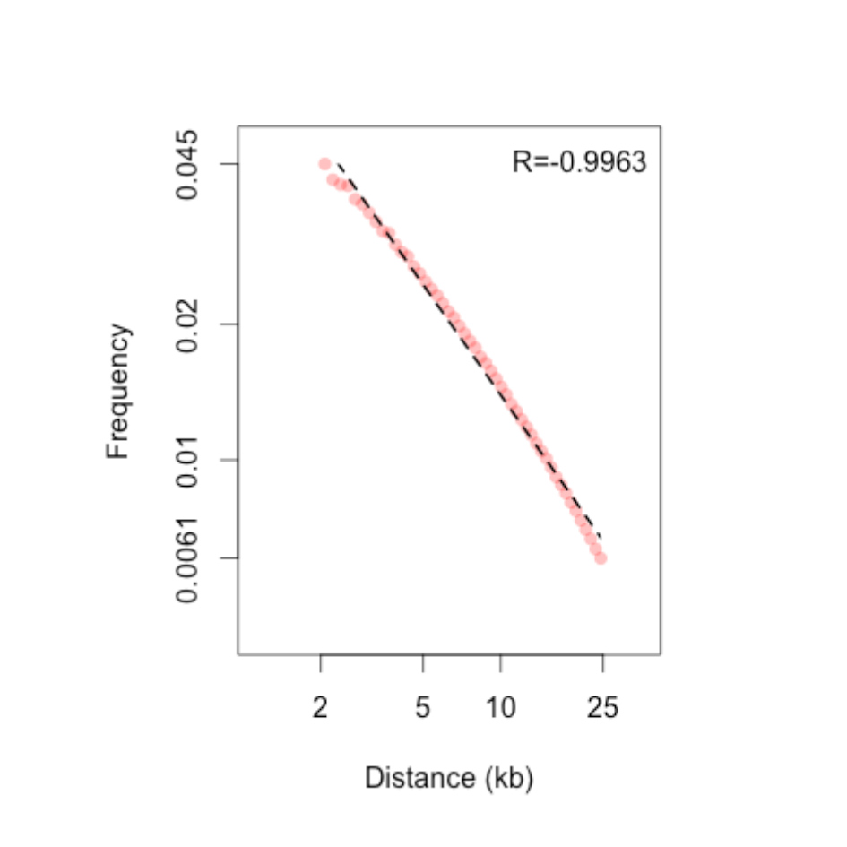
Figure S1. Contact frequency as a function of genomic distance.
The pink points indicate intervals of Hi-C reads showing the relative contact frequency of 2-25 kb apart, which is approximated by a power-law scaling (dotted line).

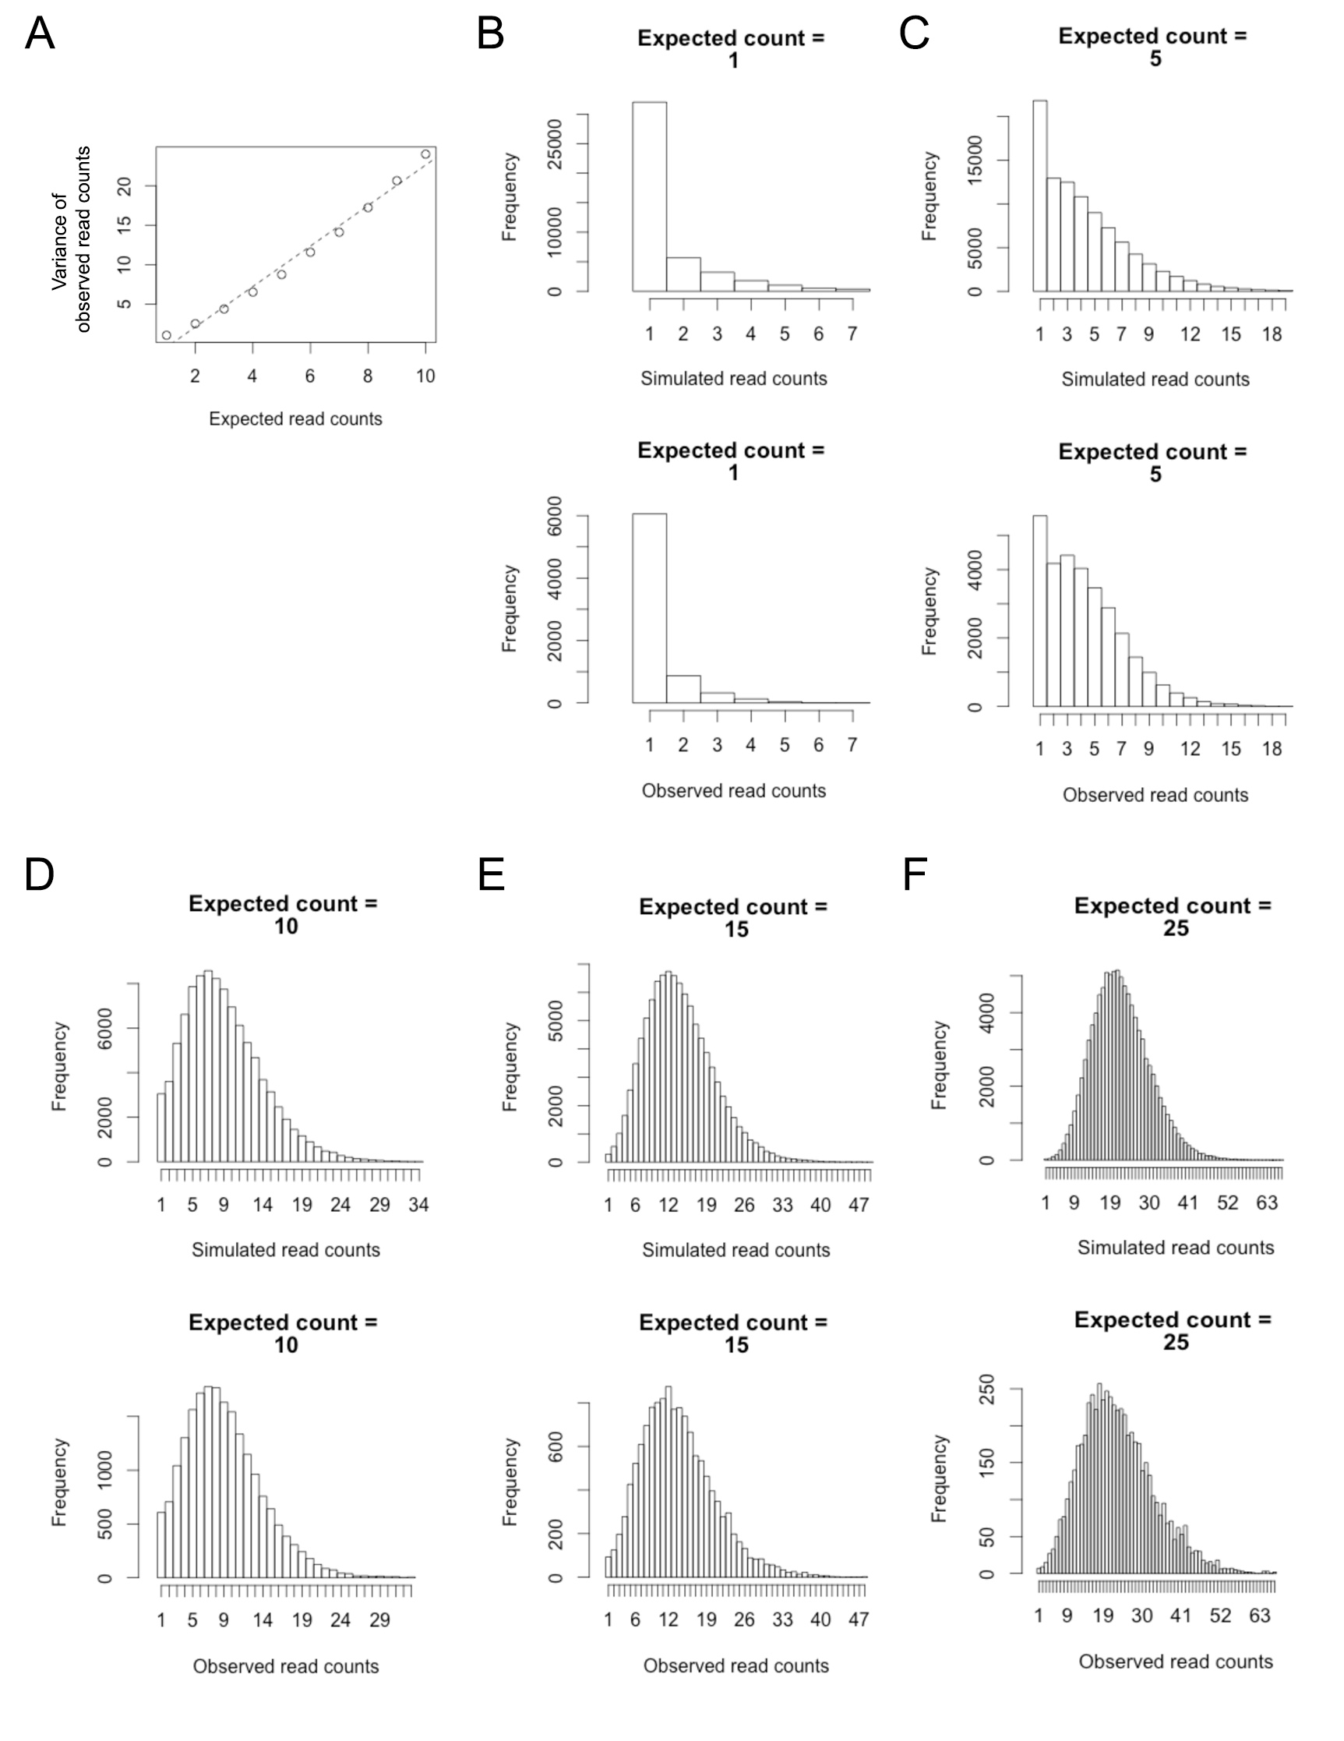
Figure S2. Fitting Hi-C reads counts with negative binomial distributions.
(A) The variance of observed counts is plotted against expected counts. The linear correlation suggests a negative binomial distribution. (B-F) For a list of expected counts, each comparison is made between the distributions of observed Hi-C reads and a pool of 100,000 simulations.

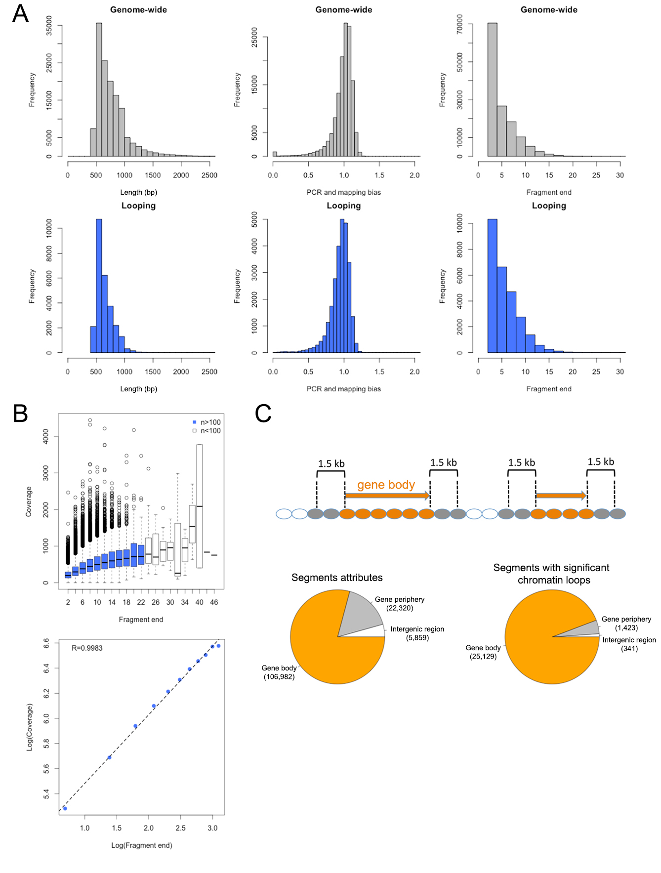Figure S3. Identification of chromatin loops as interacting segments.
(A) Distribution patterns of length (left), PCR and mapping bias (middle) and restriction enzyme cutting site number (right) in chromatin segments with significant looping events detected (B) Sequencing depth of a chromatin segment tends to be lower if it has less restriction enzyme cutting sites. Chromatin segments are grouped according to the number of fragment ends, and those groups having more than 100 segments are colored (upper panel), which show a log-linear relationship with the median of their sequencing depths (lower panel). (C) Attributes of chromatin segments with respect to the Arabidopsis genome annotation. The pie charts indicate that gene body segments are overrepresented among those forming significant chromatin loops.

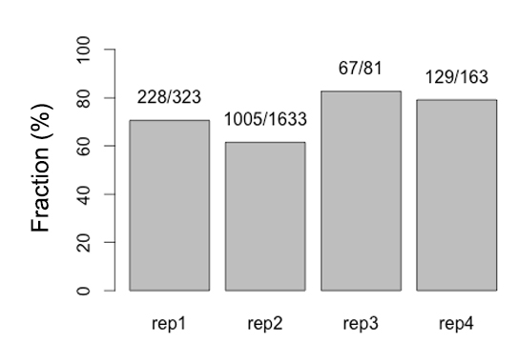
Figure S4. Reproducibility of Hi-C datasets.
Bar plot shows the fraction of significant chromatin loops identified in each replicate that can be reproduced from the pooled Hi-C reads of the other 3 replicates. Above each bar, the denominator indicates the number of significant chromatin loops identified from the corresponding replicate, and the numerator indicates how many overlap with significant loops identified from the combined pool of the other 3 replicates.

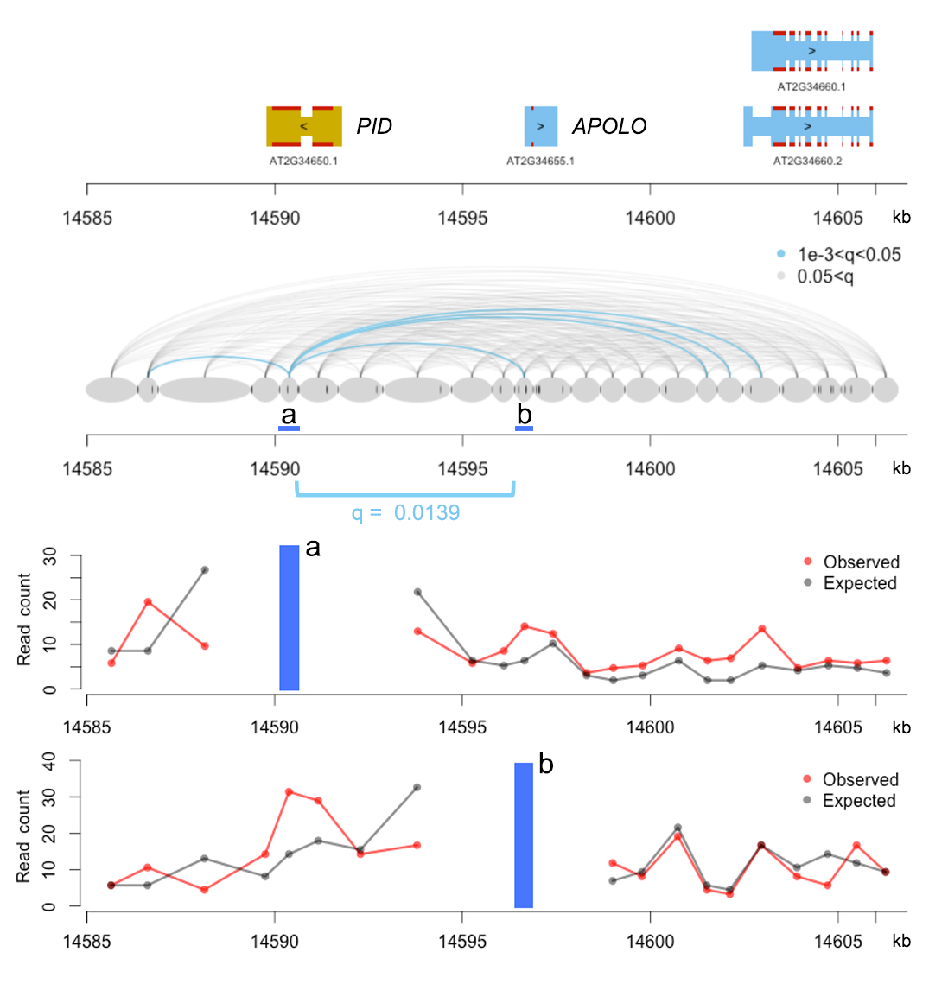
Figure S5. Chromatin loops at the PID and APOLO loci.
Details of the Hi-C reads from PID and APOLO are further shown by using them as anchor points.

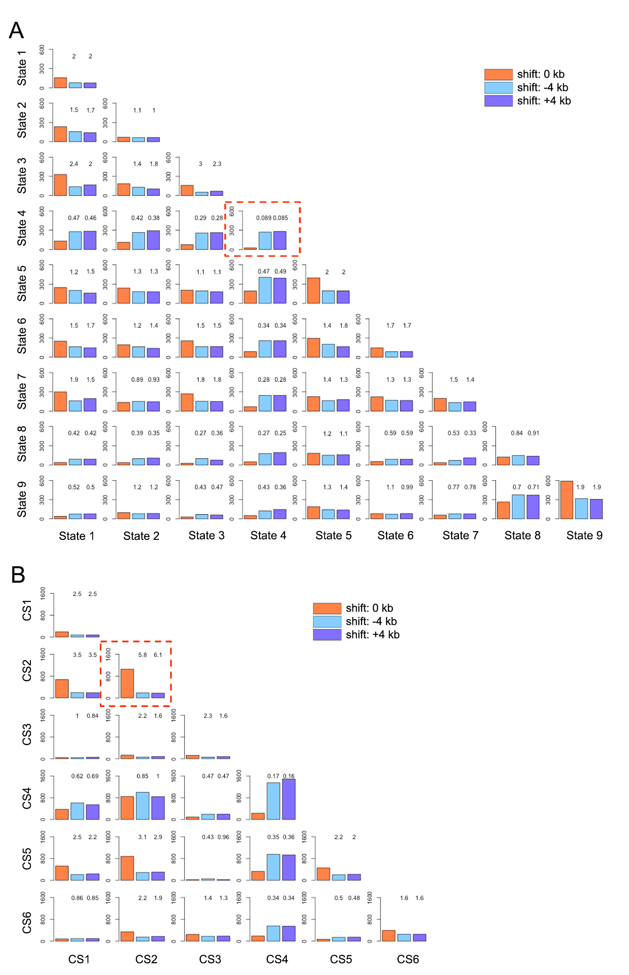Figure S6. Relationship between chromatin loop and epigenetic state.
The number of chromatin loops longer than 6 kb was calculated according to the chromatin states of the interacting partners. The annotations of chromatin states are according to (Sequeira-Mendes et al. 2014) (A) and (Wang et al. 2015) (B). For the control, the coordinates of chromatin states annotation are shifted 4 kb upstream or downstream, respectively. Numbers on top of control bars indicate fold change. In each panel, the highlighted combination, which shows the most contrast, is discussed in the main text.

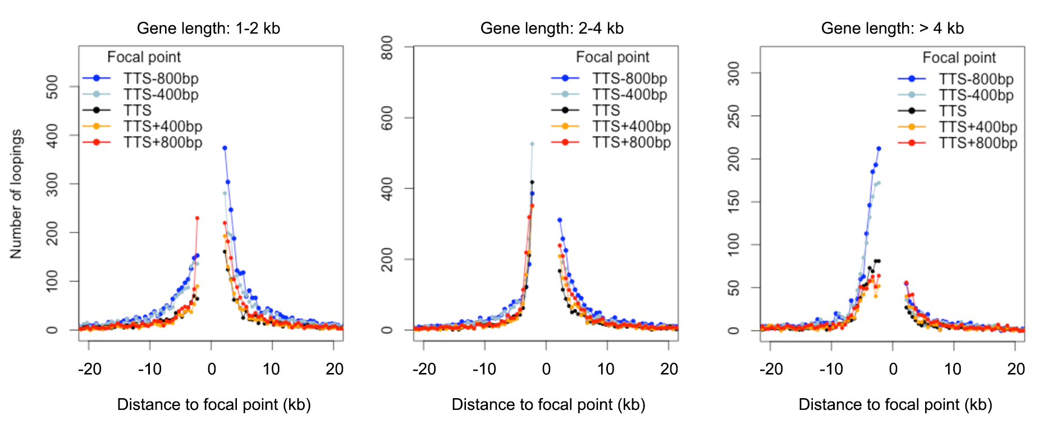Figure S7. Chromatin loops around TTSs.
Distribution of chromatin loop size and direction at various anchor points around TTSs, according to gene length.

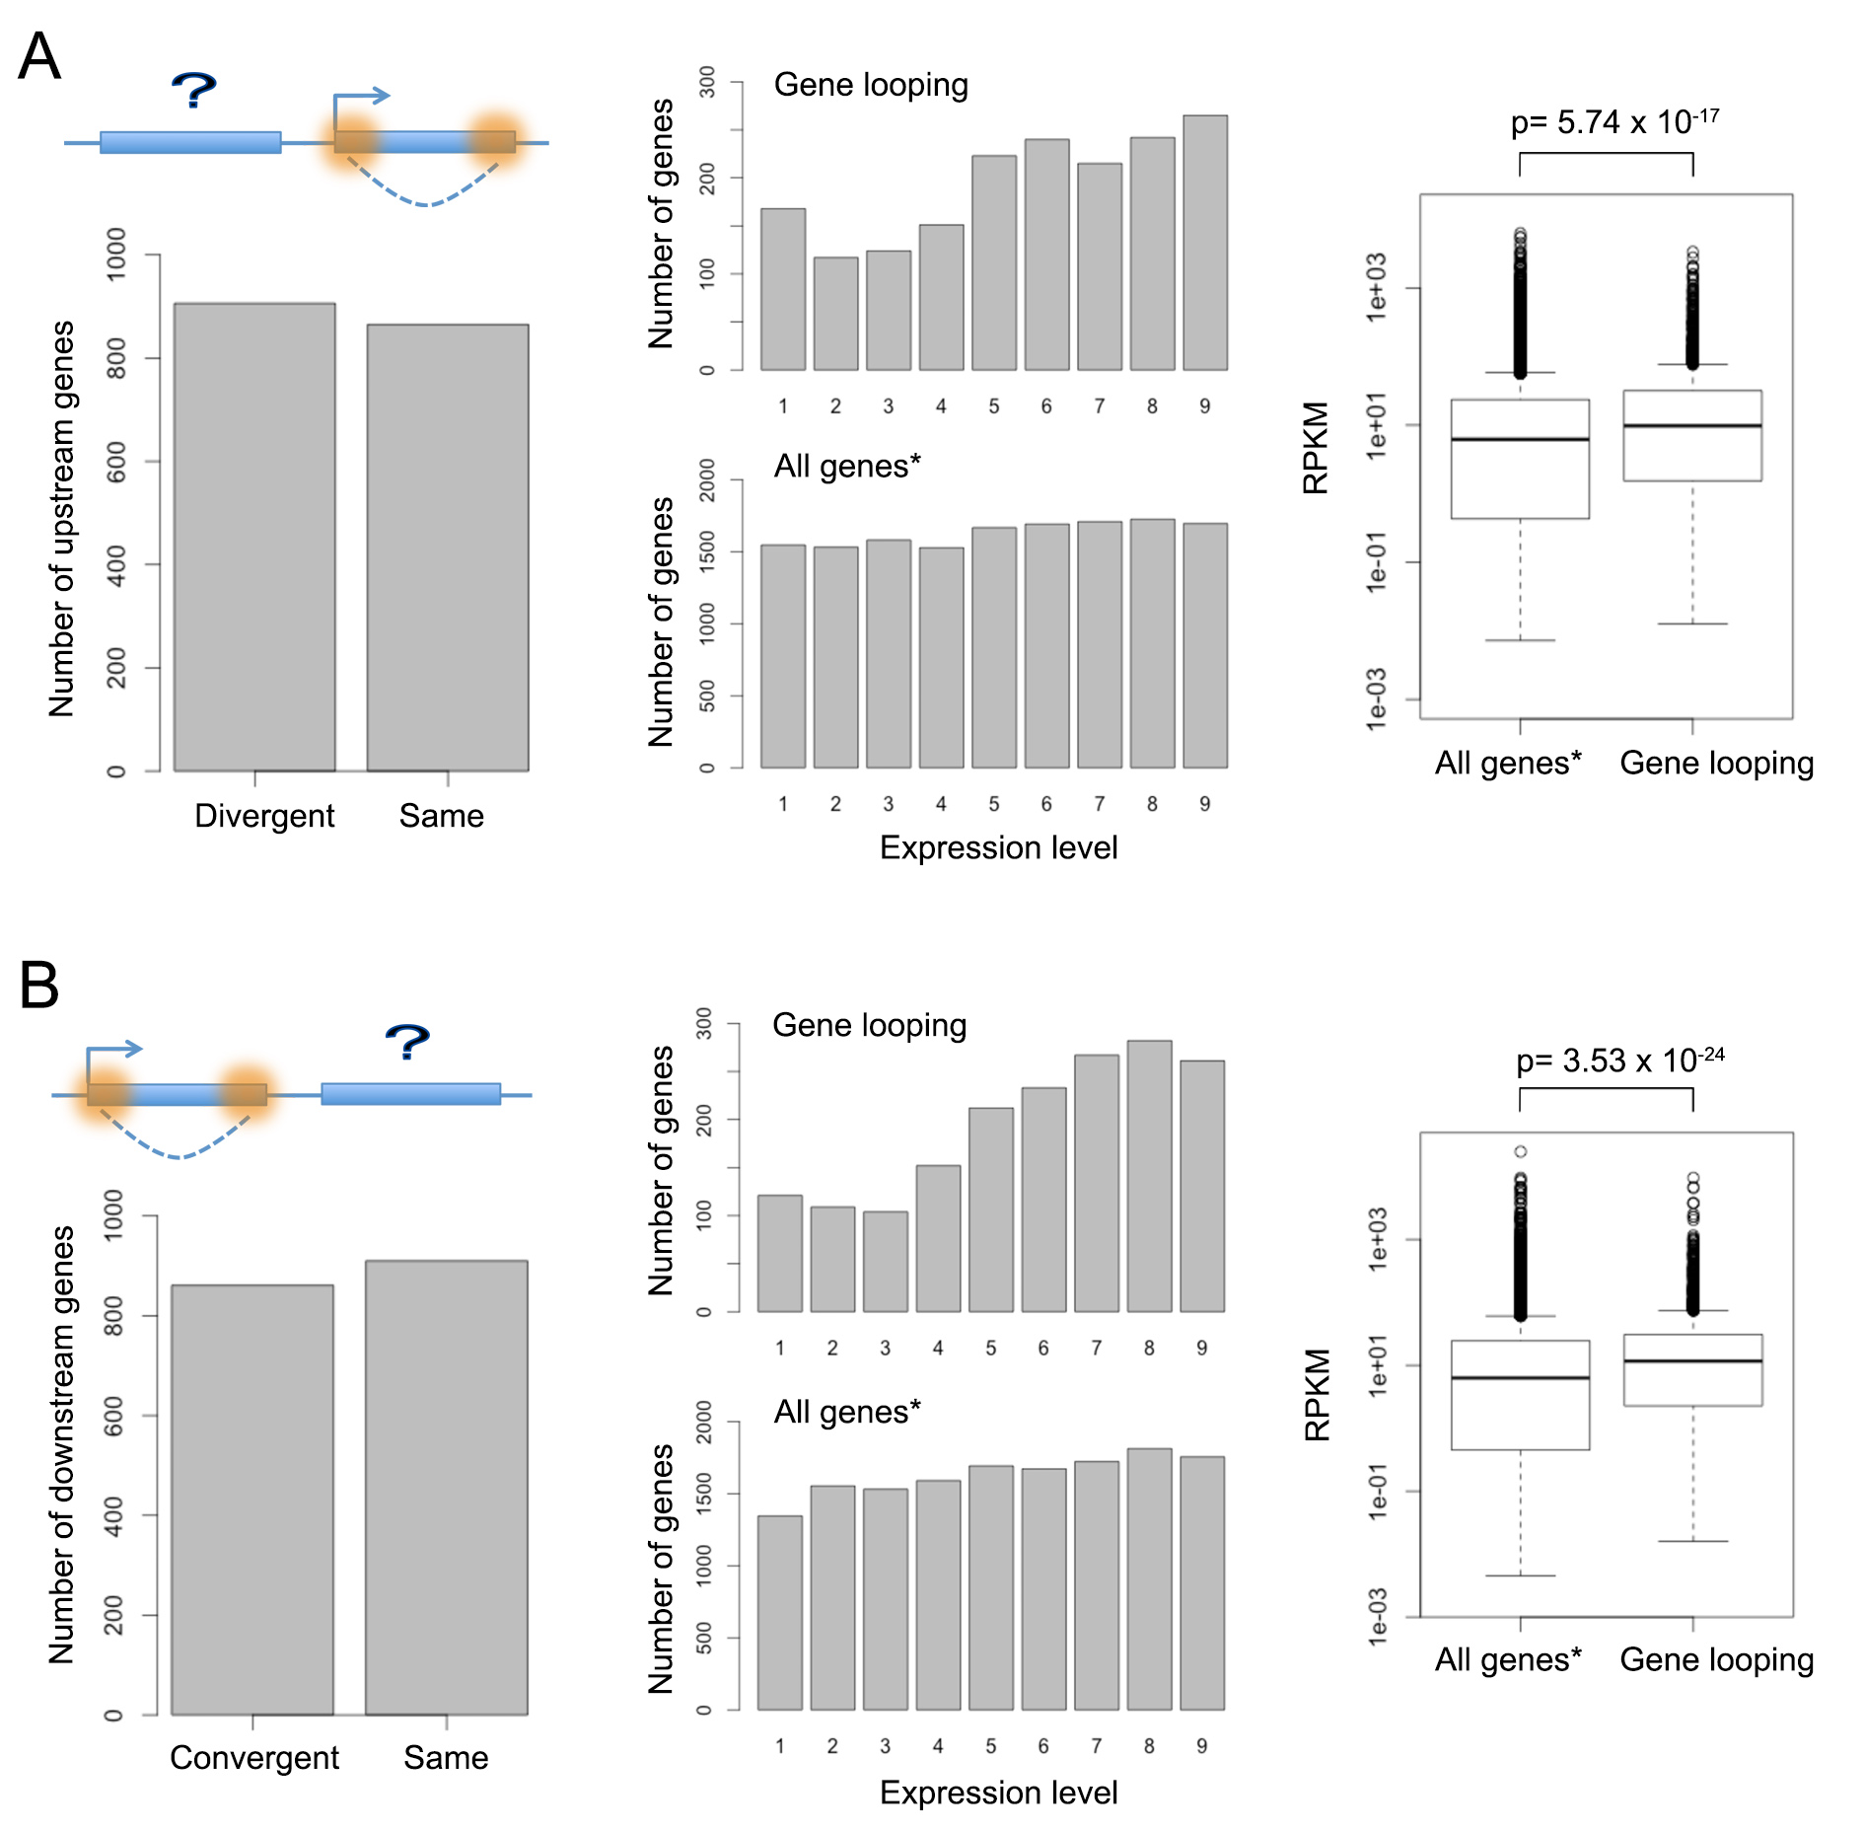
Figure S8. Analysis of genes located next to genes with self-loops.
Genes located next to self-looped genes (labeled with a question mark in the cartoon) are divided into two groups, depending on whether they are residing next to TSSs (A) or TTSs (B). For each group, the orientation (left panel) and transcriptional level (middle and right panels) are compared. The background transcription profile (“All genes*”), is estimated from genes located next to a total number of 14,672 genes that could be investigated with our algorithm (see details in Methods). The p-values indicate the results of Wilcoxon-Mann-Whitney tests.

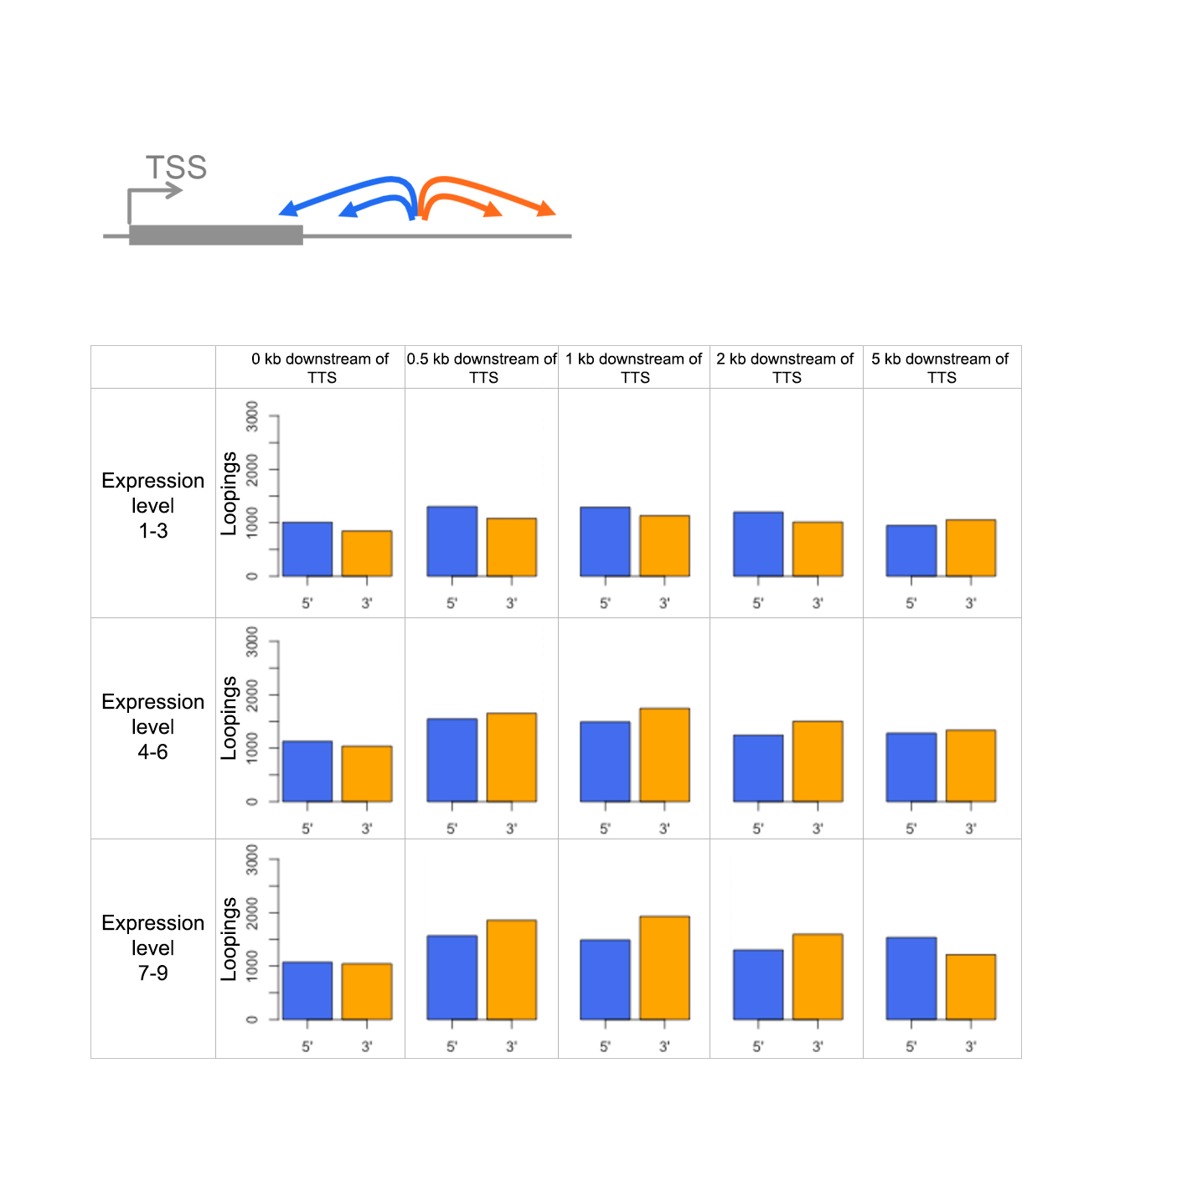Figure S9. Chromatin loops around TTSs.
Patterns of chromatin loops at regions downstream of genes. A focal point located downstream of a TTS can have interacting partners located at 3’ or 5’ regions with respect to the gene. Analysis of a serial of focal points (5 kb, 2 kb, 1 kb, 0.5 kb and 0 kb downstream of TTSs) on all genes in the genome is shown for different gene expression levels.

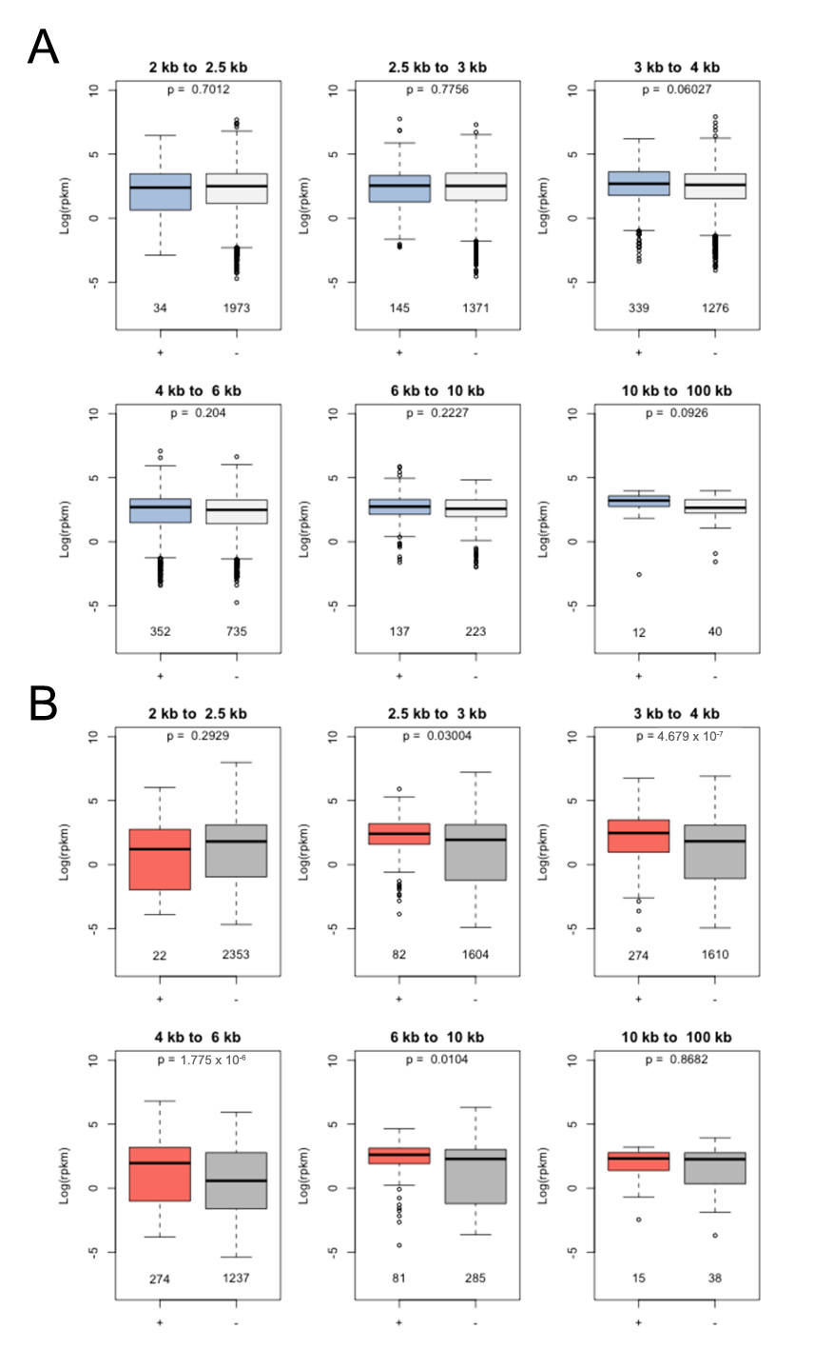
Figure S10. Correlation between gene loop and transcriptional activities.
Genes are divided into two groups, depending on whether there is at least one (A) or no (B) highly expressed gene (level 7-9) located within 5 kb of genes of interest. In each panel, genes are further grouped based on their lengths. The “+” and “-” signs indicate whether genes have a gene loop structure. The y-axis indicates gene expression measured as the natural base logarithm of RPKM (Reads Per Kilobase per Million reads) The p-values indicate the results of Wilcoxon-Mann-Whitney tests.

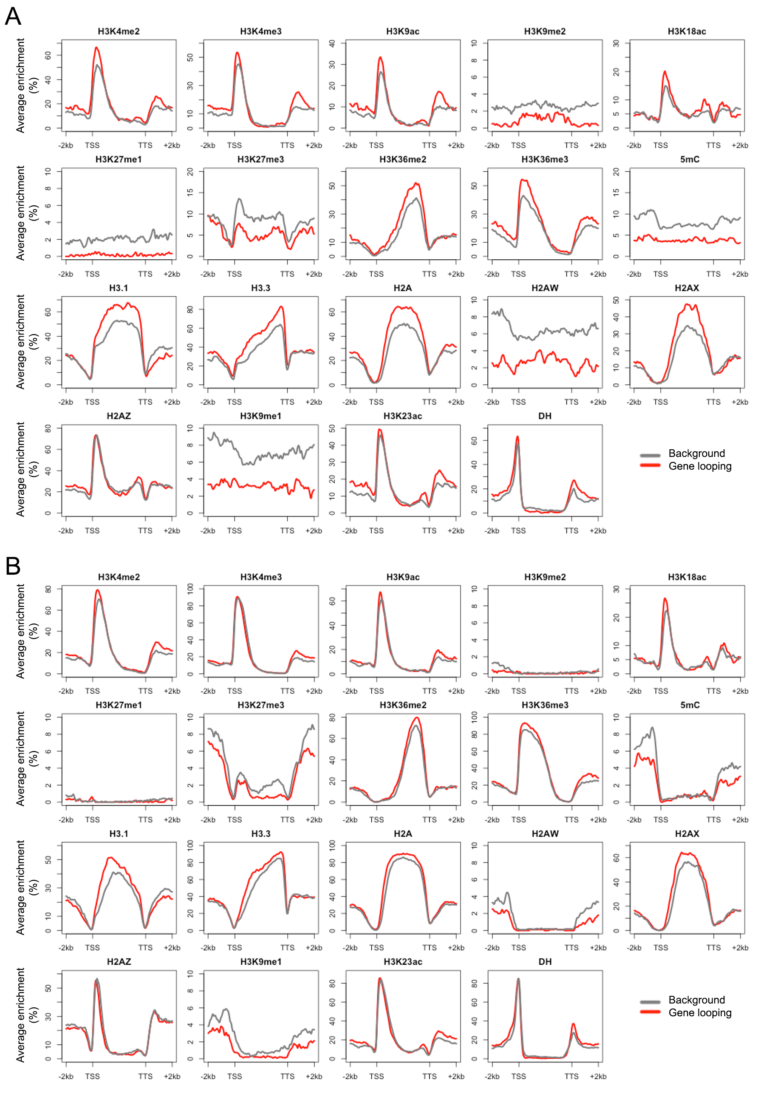Figure S11. Comparison of epigenetic marks around genes with gene loop structures.
Genes with intermediate (level 4-6) and high (level 7-9) expression levels are analyzed in (A) and (B), respectively. In each plot, genes are scaled to align their TSSs and TTSs. Average enrichment means the percentage of regions (calculated from 100 bp windows) enriched for the respective epigenetic mark.

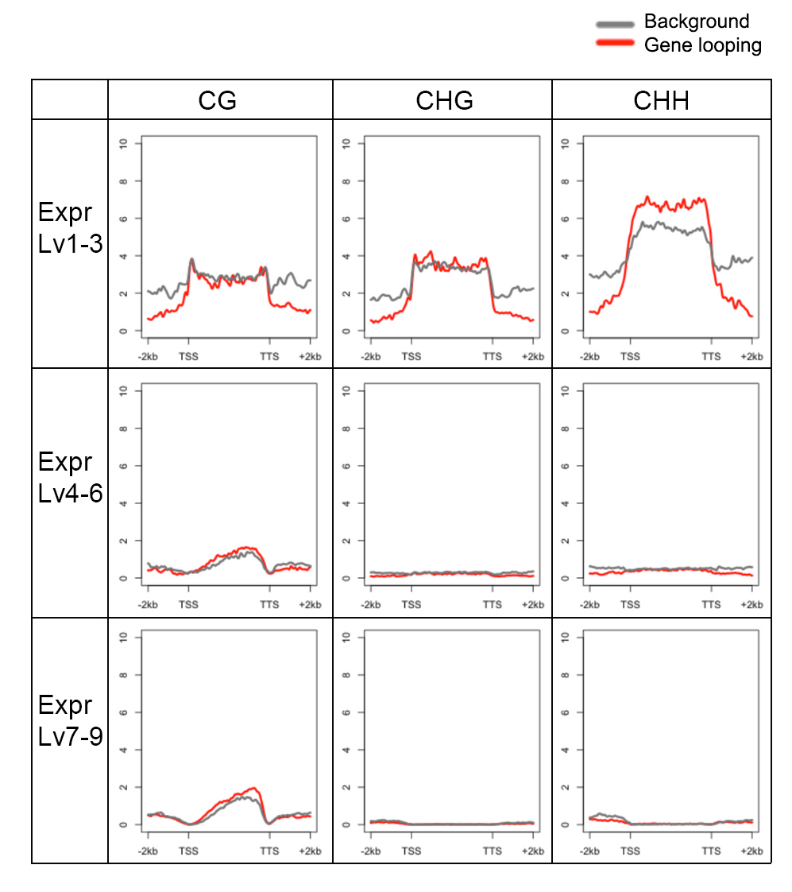
Figure S12. Comparison of different types of DNA methylation around genes with gene loop structures.
Each sequence context of DNA methylation is analyzed on genes grouped according to their expression levels. In each plot, genes are scaled to align their TSSs and TTSs; and the y-axis means the average number of methylated cytosines, calculated from 100 bp windows.

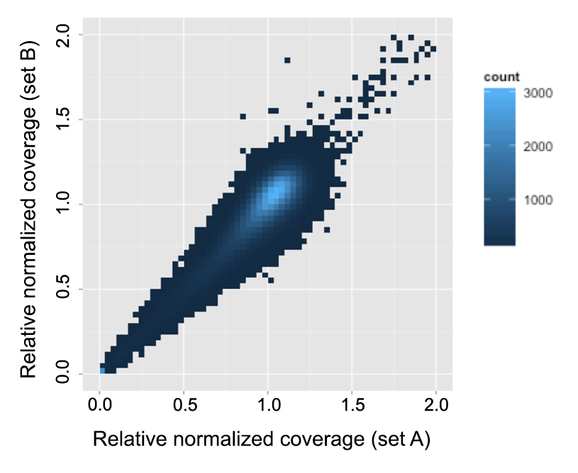
Figure S13. Analysis of PCR and mapping bias.
Ten individual genomic resequencing datasets of Arabidopsis thaliana Col-0 were divided into 2 sets as Set A (SRR1560644, SRR1560645, SRR1560647, SRR1560648, SRR1560652) and Set B (SRR1560654, SRR1560655, SRR1560657, SRR1560658, SRR1581142). Uniquely mapped reads were assigned to their corresponding chromatin segments, and the relative sequencing coverage of each chromatin segment was normalized according to its length, and plotted as a ratio compared to the average across the whole genome.

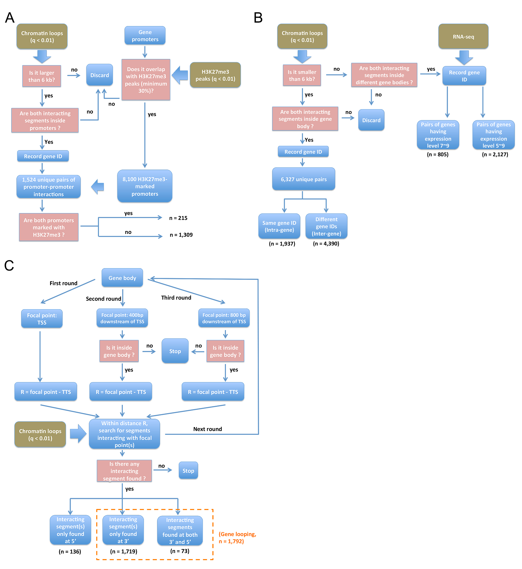
Figure S14. Analysis flowcharts.
The charts show the work flow for analyzing (A) promoter-promoter interactions (Fig. 3), (B) interactions between gene bodies (Fig. 4), and (C) gene loops (Fig. 5).

