Supplementary Material

Supplemental Methods
Genotype data and imputation.
Each individual in the DGN cohort was genotyped for 737,187 single nucleotide polymorphisms (SNPs) located on the autosomes and X Chromosome on the Illumina HumanOmni1-Quad BeadChip. Quality control was performed to identify samples with elevated heterozygosity, unexpected ancestry or pairwise IBD, and potential mislabeling, as described elsewhere (Battle et al. 2014). In order to increase the power of the association analyses, we imputed variants onto the genotyped variants. Prior to imputation, we pre-phased the genotypes using SHAPEIT v2.r644 (Delaneau et al. 2012) with default parameters for the autosomes and the '--chrX' flag for the X Chromosome. Next, we passed the haplotype estimates to IMPUTE2 (Howie et al. 2009) version 2.2.2 for imputation from the 1000 Genomes Phase I integrated haplotypes (Dec 2013 release) using the following parameters: '-Ne 20000 -filt_rules_l eur.maf<0.05 -call_thresh 0.9'. Due to the hemizygosity of males on the X Chromosome, the '-chrX' flag was used in IMPUTE2 to impute the non-pseudo autosomal regions (PAR) of the X Chromosome. Quality control after imputation included the exclusion of variants with genotype call rate of <90%, Hardy-Weinberg equilibrium P-value of < 1 × 10⁻⁶, minor allele frequency (MAF) of < 1%, or minimum reference and non-reference allele count (MAC) of 18. A total of 8,465,160 autosomal variants and 156,848 X-chromosome variants passed quality control criteria and were included in the association analyses. Of these, the autosomal variants included 7,714,879 (91.1%) SNPs and 750,281 (8.9%) short insertion-deletion polymorphisms (indels), and the X-chromosome variants included 140,611 (89.6%) SNPs and 16,237 (10.4%) indels.

Transcriptome data.
RNA-sequencing (RNA-seq) was previously performed for each individual in the DGN cohort, as described elsewhere (Battle et al. 2014). In brief, RNA was removed from whole blood, depleted of globin mRNA transcripts, and sequenced in an Illumina HiSeq 200, yielding an average of 70 million 51-bp single-ended reads per individual. Reads were aligned to the NCBI v37 H. sapiens reference genome using TopHat (Trapnell et al. 2009). Gene-level expression was quantified using HTSeq (Anders et al. 2015) and isoform-level expression was quantified using Cufflinks (Roberts et al. 2011). Only uniquely aligned reads were used for expression quantification. We consider a gene expressed if it has at least 10 reads in 100 individuals. For differential variance analyses, we required genes with at least ten reads in twenty-five individuals

Correction for known covariates in transcriptome data.
Several technical factors were corrected for both differential expression and variance analyses. These technical factors include sequencing depth, number of coding bases, number of UTR bases, number of PF aligned bases, number of BF bases, percent coding bases, percent mRNA bases, percent usable bases, percent UTR bases, individual specific exon coverage, median 5’ biases, median 5’ to 3’ biases, percent duplicated reads, median 3’ bias, median CV coverage, percent hemoglobin, individual specific GC coverage, percent of intergenic bases, percent of intronic bases, number of intronic bases, number of intergenic bases, time of day blood drawn, and inferred cell type frequencies for immune cells (monocytes, dendritic cells, activated dendritic cells, neutrophils, platelets, B cells, natural killer cells, activated natural killer cells, T helper cells, cytotoxic cells, and activated cytotoxic cells.

Correction for hidden covariates in transcriptome data.
We used the probabilistic estimation of expression residual (PEER) method (Stegle et al. 2012) to estimate and correct for hidden covariates in the RNA-seq data. To infer PEER factors, we supplied the one known covariate (sex) and inferred up to 40 hidden covariates. We calculated the expression residuals from the inferred PEER factors excluding the sex covariate in order to preserve the effect of sex on expression. For eQTL analysis, the PEER-corrected data was further log transformed to account for expression outliers. The number of PEER factors removed was tuned to maximize the number of cis-eQTLs in the expression data (Supplemental Fig. S13). We observed that the removal of these 25 factors from the expression data maximized discoveries.

eQTL effect size.
We calculated the eQTL effect sizes by estimating the slope coefficient ($β_{1}$) of the following linear regression model
$$y= μ+ β_{1} × genotype+error$$
where $y$ denotes the observed expression level of the gene, $μ$ the mean expression level across the population, $β_{1}$ the regression coefficient of genotype and error ~ N(0,$σ_{error}^{2}$). To calculate the effect size, we applied a subsampling approach to avoid biases from allele frequency. Specifically, we randomly subsampled 100 individuals with an equal distribution of males and females and matched the number of individuals with each allele analyzed. Then, we used the linear regression model to calculate the effect ($β_{1}$) of genotype on expression. To examine the relation of eQTL effect size and purifying selection ratios, we obtained the ratio of non-synonymous to synonymous substitutions (d_{N}/d_{S}) for human-rhesus gene alignments from Biomart Ensembl (Cunningham et al. 2015).

To compare the population differentiation of cis-eQTLs on the X Chromosome to the autosomes, we downloaded the VCFs from the 1000 Genomes Phase 3 (The 1000 Genomes Project Consortium 2015). We computed Weir and Cockerhams’s F_{ST} (Weir and Cockerham 1984) between the YRI and CEU populations using vcftools (The 1000 Genomes Project Analysis Group 2011). For the X Chromosome, we only used females for the F_{ST} calculation. Additionally, we filtered out the pseudo-autosomal regions (PAR) on the X Chromosome. We then compared the F_{ST} values for the top cis-eQTLs for each eGene (FDR < 5%) to matched controls. The control set for each eGene was defined as all tested variants within 5kb of the top cis-eQTL. A single variant was chosen randomly from this set, such that each top cis-eQTL had a single control variant for comparison. We compared the difference in F_{ST} values between the top cis-eQTLs and their matched controls on the X and the autosomes using a t-test.

Identification and extended analysis of sex-interacting eQTLs
In addition, we tested the genotype-sex interaction term only for genetic variants that were previously detected as cis-eQTLs in the joint sample (adjusted P-value < 0.2 after Bonferroni correcting for the number of variants tested per gene). With this approach, we improved our power (mean and median improvement of 2.8-fold), but the total number of genes with a sex-interacting eQTL discovered at FDR 5% remained unaffected. Therefore, downstream analyses of sex-interacting eQTLs used results from the original approach. To compare the distribution of associations on the autosomes and the X Chromosome, we randomly sampled 10,000 gene-variant tests from each distribution (e.g. autosomes and X Chromosome) a total of 10,000 times, and calculated the median and 95% confidence intervals for each distribution to create a quantile-quantile (Q-Q) plot (Fig. 3A). Furthermore, to ensure that the Bonferroni correction did not bias our comparison of X chromosome eQTLs to the autosomes given differences in sequence diversity and LD, we generated empirical P-values from 100K permutations for cis-eQTLs tested on the X chromosome and chromosome 19. The approximation to empirical P-values provided by the Bonferroni correction performed equally well for the X and chromosome 19 (Spearman rho 0.971, 0.884, respectively; P-values < 1e-15).

Gene ontology enrichment analysis
We used the database for annotation, visualization and integrated discovery (DAVID) (Dennis et al. 2003; Huang da et al. 2009) pathway enrichment online tool to obtain functional annotation for the significant genes in the differential expression variance (see Expression variance analysis) and sex-interacting eQTL (see Identification of sex-interacting eQTLs) analyses. Given that we were interested in the biological processes affecting expression variance and genotype-by-sex interactions, we restricted our gene ontology (GO) analysis to the category biological processes (GOTERM_BP_FA) in DAVID tools. For each GO term category, we used a conservative modified Fisher’s exact test (EASE score in DAVID tools) to test for enrichment against a background gene list and accounted for multiple testing using the Benjamini-Hochberg method (Benjamini and Hochberg 1995). The background gene list consisted of all genes expressed in whole blood (i.e. at least 10 reads in 100 individuals in the DGN cohort).

PBMC isolation.
Peripheral blood mononuclear cells (PBMCs) were isolated from the buffy coats by density gradient centrifugation on using the Ficoll-Paque PLUS (GE Healthcare, Uppsala, Sweden). Briefly, 4 ml of blood was diluted at a ratio of 1:1 (vol/vol) with phosphate-buffered saline (PBS) at room temperature. The 8-ml diluted blood sample was carefully layered onto 6 ml of Ficoll-Pague PLUS in 50-mL conical tubes and centrifuged at 400×g for 30 min at 18°C with the brake off. Next, the lymphocyte layer at the interphase was carefully removed and resuspended in three volumes (6 mL) of PBS, and centrifuged without the brake at 100×g for 10 min at 4°C. To remove platelets from the lymphocyte layer, the cells were resuspended in 6 mL of PBS and centrifuged using the previous settings. Following removal of the supernatant, we counted the cells with a hemocytometer. A subset of 50,000 cells was immediately used for ATAC-seq and the remaining cells were pelleted and stored at -20°C.

Open chromatin accessibility assay.
To profile for open chromatin regions, we used the Assay for Transposase Accessible Chromatin (ATAC-seq) protocol (Buenrostro et al. 2013). The ATAC-seq protocol was followed with zero modifications as previously described (Buenrostro et al. 2015). A total of twenty ATAC-seq libraries with unique single-index barcodes were created for multiplexed sequencing. Each sample was amplified in the range of five to eleven total PCR cycles, as determined by qPCR side reactions performed on each sample. The final amplified libraries were purified using Qiagen MinElute PCR Purification kit and eluted in 20μl elution buffer (10 mM Tris·Cl, pH 8). The fragment size distribution and quality of the libraries were evaluated on an Agilent Bioanalyzer 2000. Each library was quantified using the KAPA Library Quantification Kit (KAPA Biosystems) in triplicate at two dilutions, 1:10⁵ and 1:10⁶. Based on the individual library concentrations, the libraries were pooled at an equimolar concentration for 76-bp paired-end sequencing on an Illumina NextSeq 500 platform. We performed two sequencing runs on the pooled samples; each sequencing run yielded approximately 200 million paired-end reads (yielding >400 million paired-end reads in total).

Open chromatin accessibility data processing and peak calling.
We obtained approximately 200 million paired-end 76-bp reads per sequencing run (400 million paired-end reads in total) from pooled sequencing and de-multiplexed the reads as BCL files were converted to FASTQ files using the Illumina BCL2FASTQ Conversion Software (version 2.15.0). Reads were aligned to hg19 using Bowtie 2 (Langmead and Salzberg 2012). Reads were filtered by removing those with an alignment quality score less than 4 and reads mapping to chromosome Y, mitochondria, or unmapped contigs.

For comparison between samples, we obtained a consensus set of PBMC ATAC-seq regions by calling peaks on the pooled reads with MAC2 (Zhang et al. 2008) using the following parameters: “-g hs --q 0.01 --nomodel --nolambda --keep-dup all --call-summits.” The peaks were filtered using consensus excludable ENCODE blacklist to remove artificial signal in certain regions of the genome, such as centromeres, telomeres, and simple repeats (The ENCODE Project Consortium 2012). For quantification of peaks, peak bed files were converted to GFF3 format and the number of reads per peak per sample was quantified with HTSeq (Anders and Huber 2010) using the following parameters: “htseq-count -m intersection-strict --stranded=no’. We retained peaks that contain at least twenty total reads and read coverage across at least four individuals for downstream analysis.

Enrichment of sex-specific gene expression and sex-interacting eQTL in sex-specific ATAC-seq peaks
We tested if the sex-specific chromatin accessibility regions are more likely to be located upstream of genes exhibiting sex-specific expression. We restricted our analysis to chromatin accessibility regions located within 40kb upstream of genes that were previously tested for sex-specific expression (see Supplemental Methods). Then, we calculated the odds that varying groups of chromatin accessibility regions were located upstream of genes with sex-specific expression (FDR 5%). The varying groups of chromatin accessibility regions encompassed regions with increasing confidence of sex-specificity (top N%, ranked by P-value previously calculated in the differential open chromatin accessibility analysis). We generated a permuted background expectation plot by performing the same analysis with a permuted set of males and females for the sex-specific gene expression test (Supplemental Fig. S8A).

We also tested if the sex-specific chromatin accessibility regions are more likely to contain sex-interacting eQTLs genes. For each gene overlapping a chromatin accessibility region, we tested all variants within 1Mb of the gene for genotype-sex interactions. Then, we calculated the proportion of genes with a sex-interacting eQTL (nominal P-value < 0.1) in a sex-chromatin accessibility region for various FDR thresholds (FDR 100% [i.e. all peaks], 50%, 10%, and 5%). We generated a permuted background expectation plot by performing the same analysis with a permuted set of males and females for the genotype-sex interaction test (Supplemental Fig. S8B). In addition, we tested if sex-specific chromatin accessibility regions were enriched in sex-interacting eQTL variants. In this enrichment analysis, we tested the genotype-sex interaction term between the variant closest to the mid-point of each ATAC-seq region and the nearest five genes.

Supplemental Figures Legend

Figure S1. Effect of normalization on differential expression analysis
We compared the effect of different normalization methods on the differential expression analysis (Figure 1A) to determine if technical or environmental factors were influencing the analysis. We investigated the effect of three different normalization methods, including the effect or removing no covariates, removing the technical covariates, and removing the hidden PEER covariates. A. If we consider genes differentially expressed if they fall below the Benjamini-Hochberg adjusted p-value < 0.05 (FDR 5%), we observe that the X Chromosome has a greater proportion of DE genes than the autosomes for each normalization method. B. Similarly, if we consider genes differentially expressed if they fall below the more conservative Bonferroni adjusted p-value < 0.01, we also observe that the X Chromosome has a greater proportion of DE genes than autosomes.

Figure S2. Effect of normalization on differential expression variance analysis
We compared the effect of different normalization methods on the differential expression variance analysis (Figure 1A) to determine if technical or environmental factors were influencing the analysis. We investigated the effect of three different normalization methods, including the effect or removing no covariates, removing the technical covariates, and removing the hidden PEER covariates. A. If we consider genes to have differential variance if they fall below the Benjamini-Hochberg adjusted p-value < 0.05 (FDR 5%), we observe that the X Chromosome has a greater proportion of DV genes than the autosomes for each normalization method. B. Similarly, if we consider genes to have differential variance if they fall below the more conservative Bonferroni adjusted p-value < 0.01, we also observe that the X Chromosome has a greater proportion of DV genes than autosomes. C. We investigated the effect of two different normalization methods, i.e. effect of removing PEER covariates followed or not by quantile normalization, and two different variance tests, F-tests or Levene test. We consider genes to have differential variance if they fall below the Benjamini-Hochberg adjusted p-value < 0.05 (FDR 5%). We observe that the X Chromosome has a greater proportion of DV genes than the autosomes for each normalization method and testing strategy.

Figure S3. Replication of differential expression variance between the sexes
Comparison of genes with significant sex-specific expression variance (FDR 5%) on the autosomes and the X Chromosome in the DGN and ImmVar cohorts. To test for differences in expression variance, the number of males and females were matched and only genes with baseline expression in both males and females were tested (see Methods). Fisher’s exact test P-values above bars indicates significance of higher expression variance on X Chromosome relative to autosomes.

Figure S4. Proportion of variance explained by genotype on chr10
Proportion of variance explained (PVE) by genotype on chromosome 10 (chr10) in males and females. To test for the PVE, the number of males and females were matched (n = 274). We tested all genes on chr10 and genes with a cis-eQTL (Bonferroni adjusted P- value < 0.05). Unlike on the X Chromosome, there is no significant difference in the PVE for males and females for all genes (Wilcoxon-rank-sum P-value = 0.557) and all cis- eQTL genes (Wilcoxon-rank-sum P-value = 0.686).

Figure S5. Relationship of MAF and d_{N}/d_{S} with eQTLs
A. Histogram illustrating the distribution of minor allele frequencies (MAF) of eQTL variants. The data plotted is the MAF of the top variant (lowest P-value) for each gene tested. We observe that the MAF of X Chromosome eQTLs was significantly smaller than the mean MAF of autosomal eQTLs (0.189 versus 0.229; t-test P-value = 3.8 x 10⁻⁷). B. Histogram illustrating the distribution of mean expression levels of genes tested for eQTLs. We observe that the mean expression levels of X Chromosome eQTLs are slightly smaller than the mean expression levels of autosomal eQTLs (t-test P-value = 2.0 x 10-3). C. Comparison of F_{ST} estimates for the top cis-eQTLs (FDR 5%) and gene-matched controls on the autosomes and the X Chromosome. Control variants were chosen as variants tested as cis-eQTLs for the same gene as the top cis-eQTL. In addition, each control variant was required to be within 5kb of the top cis-eQTL. We found that the mean difference in F_{ST} statistics between cis-eQTLs and their matched controls on the X Chromosome was 0.0847 compared to 0.0287 for the autosomes (t-test P-value = 0.0433).
D. Relationship of eQTL effect size and strength of purifying selection. Boxplots for the effect size of eQTLs on the autosomes (n = 11967) and the X Chromosome (n = 303) at genes five d_{N}/d_{S} bins. eQTLs on the X Chromosome have lower effect sizes compared to eQTLs on the autosomes across different d_{N}/d_{S} bins (one-sided Wilcoxon-rank-sum test; **P-value < 5 × 10⁻⁴; * P-value < 5 × 10⁻²).

Figure S6. Conceptual illustration of sex-specific effects evaluated in this study
Example of a gene with sex-specific gene expression (left), a gene with sex-specific expression variance (middle), and a gene with a sex-interacting eQTL (right). In the example of sex-specific gene expression, this gene has higher expression in females compared to males. In the example of sex-specific variance, this gene has higher expression variability in females compared to males. In the example of a sex-interacting eQTL, females with different genotypes (AA, AT, and TT) show significant differences in expression, indicating that a genetic effect on expression is present within females but absent in males.

Figure S7. Comparison of methods for sex-interacting eQTL discovery
Quantile-quantile (QQ) plot describing the sex-interacting eQTL association P- values for SNPs tested within 1MB of genes on the X Chromosome (red) and the autosomes (purple) using two approaches. The naïve approach is indicated by open circles and the conditional approach (see Methods) is indicated by closed circles.

Figure S8. Sex-interacting allele-specific expression QTL (aseQTL) for NOD2
We used a binomial generalized linear mixed model (EAGLE method from Knowles et al., manuscript in preparation) to test for an association between allelic imbalance and sex. ). A. We observed a significant aseQTL with genotype-sex interactions for the regulatory variant at rs4785448 and NOD2 (P-value = 2.5 × 10⁻³). In this example, the allelic imbalance is measured as | a/n - 0.5 |, where a is the alterative allele read count and n is the reference allele count for heterozygotes at rs5743291. B. We also observe a marginally significant aseQTL with genotype-sex interactions for the regulatory variant at rs9846315 and DNAH1 (P-value = 1.0 × 10⁻¹). In this example, allelic imbalance was measure for heterozygotes at rs12163565.

Figure S9. Comparison of chromatin accessibility levels in males and females on
X.
The proportion of regions with higher chromatin accessibility in females for differential chromatin accessibility regions on X Chromosome compared to a matched set of random regions on the autosomes.

Figure S10. Integration of sex-specific genes and sex-interacting eQTLs genes with sex-specific chromatin accessibility for permuted genders
A. Odds ratio for sex-specific expression genes (FDR 5%) located upstream (40kb) of sex in differential chromatin accessibility regions (varying thresholds) using a permuted set of males and females (n=274) for sex-specific gene expression test. **P-value < 10⁻⁵, *P-value < 10⁻³, Fisher’s exact test. B. Proportion of sex-interacting eQTL genes (P-value < 0.05) in differential chromatin accessibility regions (varying thresholds) using a permuted set of males and females (n=274) for genotype-sex interaction tests.

Figure S11. Integration of sex-interacting eQTL variants in sex-specific chromatin accessibility regions
Proportion of sex-interacting eQTL genes (P-value < 0.05) in differential chromatin accessibility regions (varying thresholds).

Figure S12. Sex-specific effect sizes for GWAS variants with sex-biased eQTLs
Proportion of variants with higher eQTL effect size in females for GWAS variants of traits in the NHGRI-EBI catalog.

Figure S13. Removal of hidden covariates from expression data
The number eQTLs detected at FDR 5% as a function of the number of hidden covariates removed from the gene expression data. A matched number of males and females (n = 274) was used for eQTL detection. When 25 hidden covariates are removed, eQTL detection is optimized.

Figure S14. Percent GC Bias for Aligned ATAC-Seq reads
A. Barplot of the total number of reads per sample per sequencing run. We performed two sequencing runs on the pooled samples; each sequencing run yielded approximately 200 million paired-end reads (yielding >400 million paired-end reads in total). B. Boxplot comparing the read depth per sample between females and males. There is no significant difference in the mean read depth between females and males (28.9M versus 27.3M; t-test p-value = 0.41), and there is no significant difference in the variance of read depth between females and males (standard deviation of 4.5M versus 6.0M; F-test p-value = 0.49). C. Barplot illustrating read depth per sample, grouped by gender. D. Boxplot comparing the %GC bias per sample between females and males. There is no significant difference in the mean %GC between females and males (42.1% versus 41.9%; t-test p-value = 0.51), and there is no significant difference in the variance of %GC between females and males (standard deviation of 0.57% versus 0.74%; F-test p-value = 0.45). E. Barplot illustrating %GC bias per sample, grouped by gender.

Figure S15. Disease associated variants with sex-biased eQTLs
Proportion of independent (LD-pruned) variants with higher eQTL effect sizes in females for GWAS variants of traits in Immunobase at different p-value thresholds. Tested variants were included based on increasing stringency that they were an eQTL. Red indicates traits with effect sizes that are significantly different between sexes. ATD, autoimmune thyroid disease; CEL, celiac disease, JIA, juvenile idiopathic arthritis; MS, multiple sclerosis; PBC, primarily biliary cirrhosis, PSO, psoriasis, RA, rheumatoid arthritis; RND, random eQTL variants; SLE, systemic lupus erythematous; T1D, type 1 diabetes.

Supplementary Figures
Figure S1

Figure S2

Figure S3

Figure S4

Figure S5
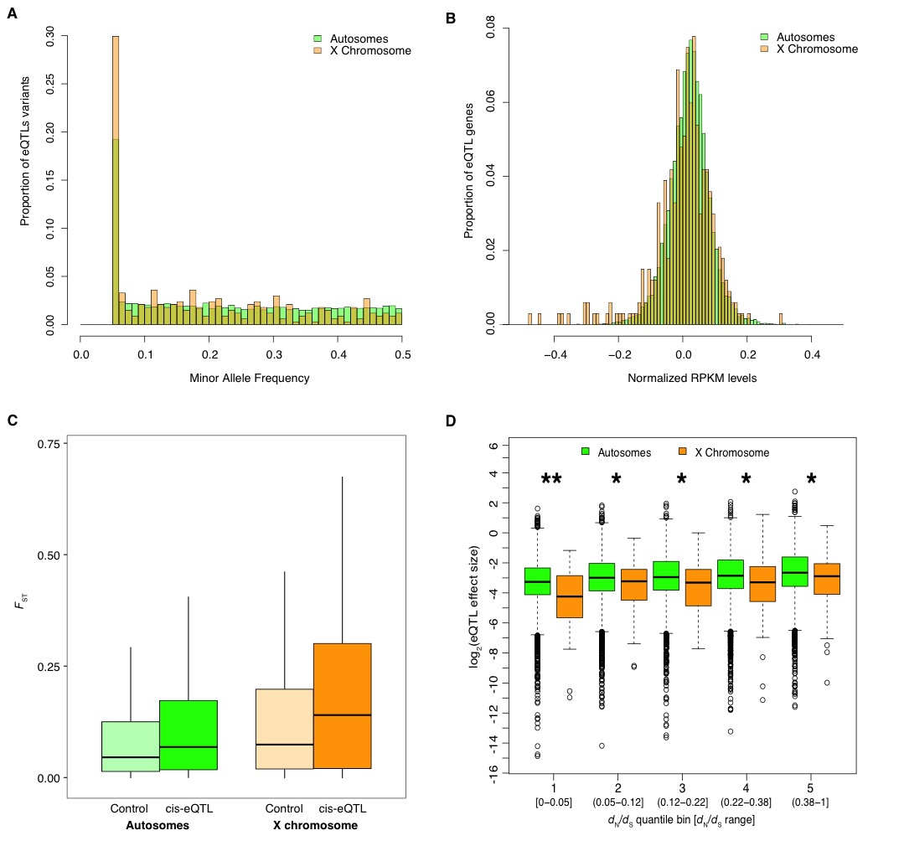

Figure S6

Figure S7

Figure S8
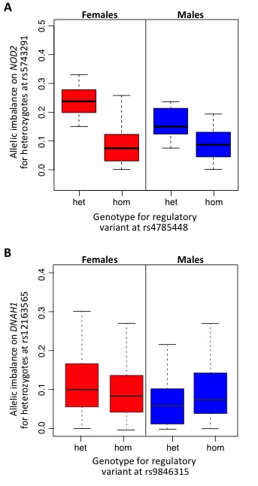

Figure S9

Figure S10

Figure S11

Figure S12

Figure S13

Figure S14

Figure S15

Supplementary Tables

Table S1. Functional enrichment of genes with sex-specific expression variance (FDR 5%)

Table S2. Replication of depletion of X Chromosome eQTLs in cohorts with different cell types

Table S3. Replication of sex-interacting eQTLs (FDR 5%) in additional cohorts

Table S4. Functional enrichment of top 100 sex-interacting eQTL genes

Supplemental References

Anders S, Huber W. 2010. Differential expression analysis for sequence count data. Genome Biol 11(10): R106.
Anders S, Pyl PT, Huber W. 2015. HTSeq--a Python framework to work with high-throughput sequencing data. Bioinformatics 31(2): 166-169.
Battle A, Mostafavi S, Zhu X, Potash JB, Weissman MM, McCormick C, Haudenschild CD, Beckman KB, Shi J, Mei R et al. 2014. Characterizing the genetic basis of transcriptome diversity through RNA-sequencing of 922 individuals. Genome Res 24(1): 14-24.
Benjamini Y, Hochberg Y. 1995. Controlling the False Discovery Rate - a Practical and Powerful Approach to Multiple Testing. J Roy Stat Soc B Met 57(1): 289-300.
Buenrostro JD, Giresi PG, Zaba LC, Chang HY, Greenleaf WJ. 2013. Transposition of native chromatin for fast and sensitive epigenomic profiling of open chromatin, DNA-binding proteins and nucleosome position. Nat Methods 10(12): 1213-1218.
Buenrostro JD, Wu B, Chang HY, Greenleaf WJ. 2015. ATAC-seq: A Method for Assaying Chromatin Accessibility Genome-Wide. Current protocols in molecular biology / edited by Frederick M Ausubel [et al] 109: 21 29 21-29.
Cunningham F, Amode MR, Barrell D, Beal K, Billis K, Brent S, Carvalho-Silva D, Clapham P, Coates G, Fitzgerald S et al. 2015. Ensembl 2015. Nucleic Acids Res 43(Database issue): D662-669.
Delaneau O, Marchini J, Zagury JF. 2012. A linear complexity phasing method for thousands of genomes. Nat Methods 9(2): 179-181.
Dennis G, Jr., Sherman BT, Hosack DA, Yang J, Gao W, Lane HC, Lempicki RA. 2003. DAVID: Database for Annotation, Visualization, and Integrated Discovery. Genome Biol 4(5): P3.
Howie BN, Donnelly P, Marchini J. 2009. A flexible and accurate genotype imputation method for the next generation of genome-wide association studies. PLoS Genet 5(6): e1000529.
Huang da W, Sherman BT, Lempicki RA. 2009. Systematic and integrative analysis of large gene lists using DAVID bioinformatics resources. Nature protocols 4(1): 44-57.
Langmead B, Salzberg SL. 2012. Fast gapped-read alignment with Bowtie 2. Nat Methods 9(4): 357-359.
Roberts A, Trapnell C, Donaghey J, Rinn JL, Pachter L. 2011. Improving RNA-Seq expression estimates by correcting for fragment bias. Genome Biol 12(3): R22.
Stegle O, Parts L, Piipari M, Winn J, Durbin R. 2012. Using probabilistic estimation of expression residuals (PEER) to obtain increased power and interpretability of gene expression analyses. Nature protocols 7(3): 500-507.
The 1000 Genomes Project Analysis Group. 2011. The variant call format and VCFtools. Bioinformatics 27(15): 2156-2158.
The 1000 Genomes Project Consortium. 2015. A global reference for human genetic variation. Nature 526(7571): 68-74.
The ENCODE Project Consortium. 2012. An integrated encyclopedia of DNA elements in the human genome. Nature 489(7414): 57-74.
Trapnell C, Pachter L, Salzberg SL. 2009. TopHat: discovering splice junctions with RNA-Seq. Bioinformatics (Oxford, England) 25(9): 1105-1111.
Weir BS, Cockerham CC. 1984. Estimating F-Statistics for the Analysis of Population Structure. Evolution 38(6): 1358-1370.
Zhang Y, Liu T, Meyer CA, Eeckhoute J, Johnson DS, Bernstein BE, Nusbaum C, Myers RM, Brown M, Li W et al. 2008. Model-based analysis of ChIP-Seq (MACS). Genome Biol 9(9): R137.

