Supplemental Material for

Chromosome-scale shotgun assembly using an in vitro method for long-range linkage

Nicholas H. Putnam^{*1}, Brendan L. O’Connell^{*1,2}, Jonathan C. Stites¹, Brandon J. Rice¹, Marco Blanchette¹, Robert Calef¹, Christopher J. Troll¹, Andrew Fields¹, Paul D. Hartley¹, Charles W. Sugnet¹, David Haussler^{2,3}, Daniel S. Rokhsar⁴, and Richard E. Green^{1,2}

¹Dovetail Genomics, LLC 2161 Delaware Ave., Suite A2, Santa Cruz CA 95060 ²Department of Biomolecular Engineering, University of California, Santa Cruz CA
³UC Santa Cruz Genomics Institute and Howard Hughes Medical Institute, University of California, Santa Cruz
⁴Department of Molecular and Cell Biology, University of California, Berkeley and Department of Energy Joint Genome Institute, Walnut Creek CA
*Equally contributing authors

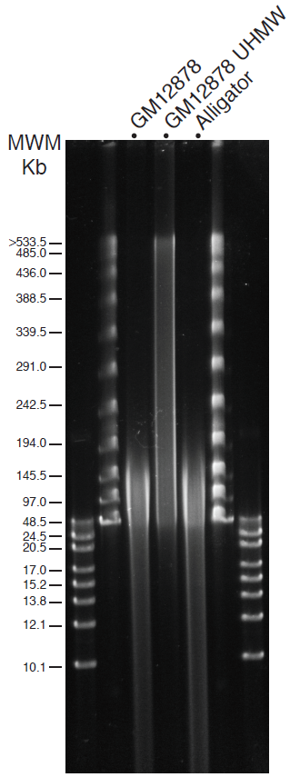

Figure S1: Pulsed field gel
200 ng of human gDNA, gDNA extracted from agarose-embedded cells following the Ultra High Molecular Weight DNA procedure and alligator gDNA were loaded next to 0.25 mm slice of agarose-embedded PFG l ladder and 0.1 μg GeneRuler HR (Thermo Scientific) on a 0.70% SeaKem Gold agarose (Lonza) in 0.5X KBB (Sage Science) and subjected to 16 hours electrophoresis using the 5-430Kb waveform type on a Pippin Pulse electrophoresis system (Sage Science).

Figure S2: Mnase digestion of in vitro chromatin assembly
Partial digestion of NA12878 in vitro assembled chromatin by micrococcal nuclease. The dark bands on the ladder correspond to 250bp and 500 bp. 250ng of chromatin was digested for two minutes and four minutes respectively.

Figure S3: Comparison of Chicago versus Hi-C read-pair distributions
A) A dotplot of TCC read pairs (Kalhor et al. 2012) mapped to a section of hg19 chr1. Read pairs with map quality scores less than 20, marked as PCR duplicates, or with separations of less than 2000 bases were excluded. 20,202 reads are shown. B) A dotplot of Chicago read pairs mapped to a section of hg19 chr1 using the same filters. 20,202 reads are shown.
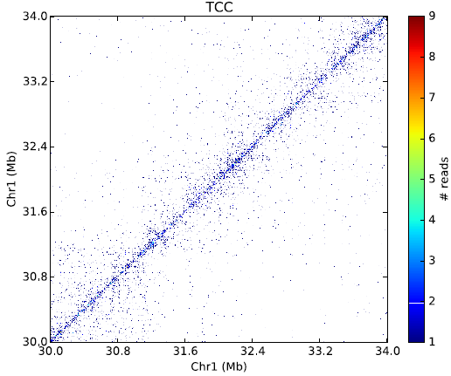

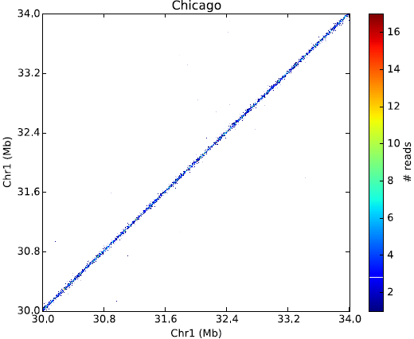
A

B

Figure S4: Expected read pair mapping distribution under inversion (homozygous)

Figure S5: Expected read pair mapping distribution under deletion (heterozygous)

Table S1: Long-range data used in human assemblies
Comparison of long-range data used to construct the human assemblies shown in Table 1 of the main text. “Physical coverage” refers to the total length spanned between read pairs, divided by the genome size, and corresponds to the mean number of read pairs mapped so as to span a randomly selection position in the genome. For Chicago libraries, the reported and estimated physical coverage is for pairs in the range 1 to 50 kbp.

Assembly | Library | Mean insert | Raw sequence coverage | Physical coverage
APLG | Shotgun | 155 bp | 51.9 X | NA
APLG | Mate-pair | 2,536 bp | 45.9 X | 249.4 X
APLG | Fosmic | 35,295 | 5.3 X | 49.5 X
Meraculous | Shotgun | 380 bp | 84 X | NA
Meraculous | Mate-pair | 2,536 | 45.9 X | 249.4 X
Meraculous | Fosmid | 35,295 | 5.3 X | 49.5X
Dovetail | Shotgun | 380 bp | 84 X | NA
Dovetail | Chicago L1 | NA (150 kb input) | 3.4 X | 11.5 X
Dovetail | Chicago L2 | NA (150 kb input) | 3.7 X | 13.0X
Dovetail | Chicago L3 | NA (~500 kb input; Figure S1) | 11.8 X | 17.0X

Misjoined scaffold alignments
The following pages show alignments to the GRCh38 reference sequence for each of the scaffolds containing one of the 68 global misjoins listed in Table 1 for HiRise assembly (MERAC PE + HiRise 1.0). Alignments were performed with the BLAST 2.2.26 megablast command with word size 100 and minimum percent identity 99 (Camacho et al. 2009).

References
Camacho C, Coulouris G, Avagyan V, Ma N, Papadopoulos J, Bealer K, Madden TL. 2009. BLAST+: architecture and applications. BMC Bioinformatics 10: 421.
Kalhor R, Tjong H, Jayathilaka N, Alber F, Chen L. 2012. Genome architectures revealed by tethered chromosome conformation capture and population-based modeling. Nat Biotechnol 30: 90-98.

