SUPPLEMENTAL INFORMATION
Exome sequencing and CRISPR/Cas genome editing identify mutations of ZAK as a cause of limb defects in humans and mice
Malte Spielmann^{1-3,15}, Naseebullah Kakar^{4-6,15}, Naeimeh Tayebi¹, Catherine Leettola⁷, Gudrun Nürnberg⁸, Nadine Sowada^{4,5}, Darío G Lupiáñez^{1,2,9}, Izabela Harabula¹, Ricarda Flöttmann², Denise Horn², Wing Lee Chan², Lars Wittler¹, Rüstem Yilmaz^{4,5}, Janine Altmüller⁸, Holger Thiele⁸, Hans van Bokhoven¹⁰, Charles E Schwartz¹¹, Peter Nürnberg^{8,12,13}, James U Bowie⁷, Jamil Ahmad⁶, Christian Kubisch¹⁴, Stefan Mundlos¹⁻³ & Guntram Borck⁴

¹Max-Planck-Institute for Molecular Genetics, Berlin, Germany
²Institute for Medical Genetics and Human Genetics, Charité Universitätsmedizin Berlin, Berlin, Germany
³Berlin-Brandenburg School for Regenerative Therapies (BSRT), Berlin, Germany
⁴Institute of Human Genetics, University of Ulm, Ulm, Germany
⁵International Graduate School in Molecular Medicine Ulm, University of Ulm, Ulm, Germany
⁶Department of Biotechnology and Informatics, BUITEMS, Quetta, Pakistan
⁷Department of Chemistry and Biochemistry, UCLA-DOE Institute of Genomics and Proteomics; University of California, Los Angeles, USA
⁸Cologne Center for Genomics, University of Cologne, Cologne, Germany
⁹Berlin-Brandenburg Center for Regenerative Therapies (BCRT), Berlin, Germany
¹⁰Department of Human Genetics, Radboud University Medical Center, Nijmegen, The Netherlands
¹¹J.C. Self Research Institute, Greenwood Genetic Center, Greenwood, USA
¹²Cologne Excellence Cluster on Cellular Stress Responses in Aging-Associated Diseases (CECAD), University of Cologne, Cologne, Germany
¹³Center for Molecular Medicine Cologne, University of Cologne, Cologne, Germany
¹⁴Institute of Human Genetics, University Medical Center Hamburg-Eppendorf, Hamburg, Germany

¹⁵These authors contributed equally to this work
Correspondence should be addressed to S.M. (stefan.mundlos@charite.de) or G.B. (guntram.borck@uni-ulm.de)
SUPPLEMENTAL INFORMATION
Suppl. Fig. 1
A) Pedigree of family 1 with haplotypes for markers in the chromosome 2q31 linkage region. The disease haplotype is shown in red. The linkage region (boxed) is flanked by recombinant SNP markers rs836624 and rs6433931. Genotypes for rare sequence variants identified by exome sequencing in the linkage region are also shown.
B) Sequence chromatograms of parts of ZAK exon 14 showing the c.1103T>G (p.Phe368Cys) mutation in family 1.

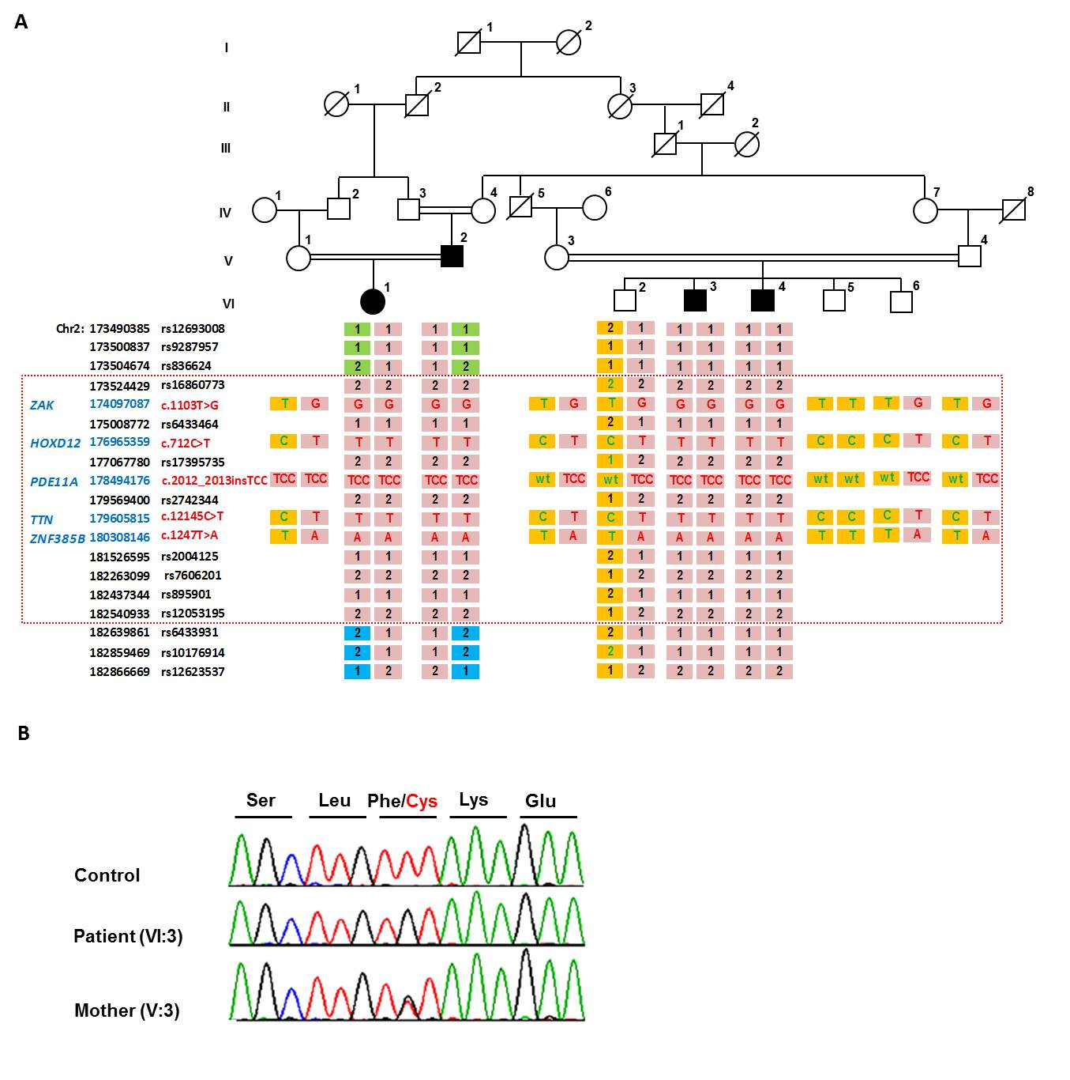
Suppl. Fig. 2: Audiograms of three affected individuals in family 1 showing moderate-to-severe bilateral sensorineural hearing impairment.

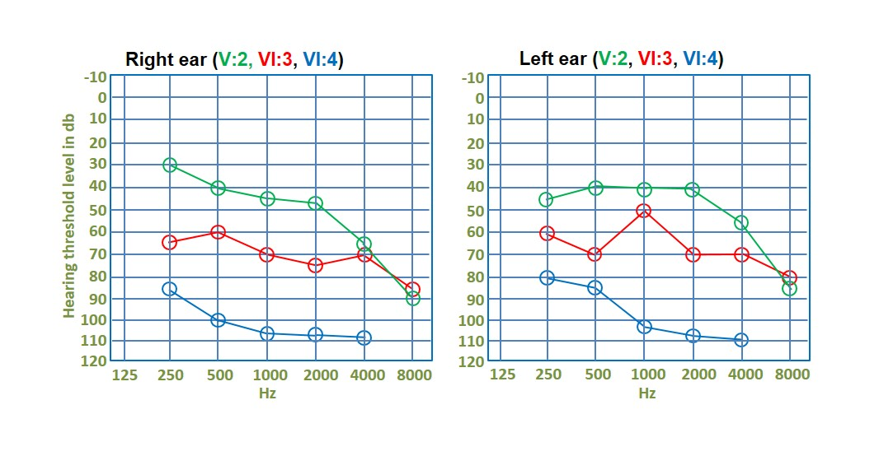
Suppl. Fig. 3: In situ hybridization using a probe for Znf385b on mouse embryos. Znf385b is mainly expressed in the central nervous system and the heart, with limited expression in the limbs. FL, forelimb; HL, hindlimb.

Suppl. Fig. 4: Homozygous intragenic deletion of ZAK
A) High resolution array CGH in an affected boy from Tunisia from family 2 revealed a homozygous intragenic deletion of ZAK
B) qPCR analysis showed that the deletion was heterozygous in his unaffected first cousin parents and homozygous in the affected boy.
C) Sanger sequencing of a junction fragment PCR confirmed a 14.7 kb deletion removing exons 12-16 of ZAK. An insertion of 31 bp occurred at the deletion site.

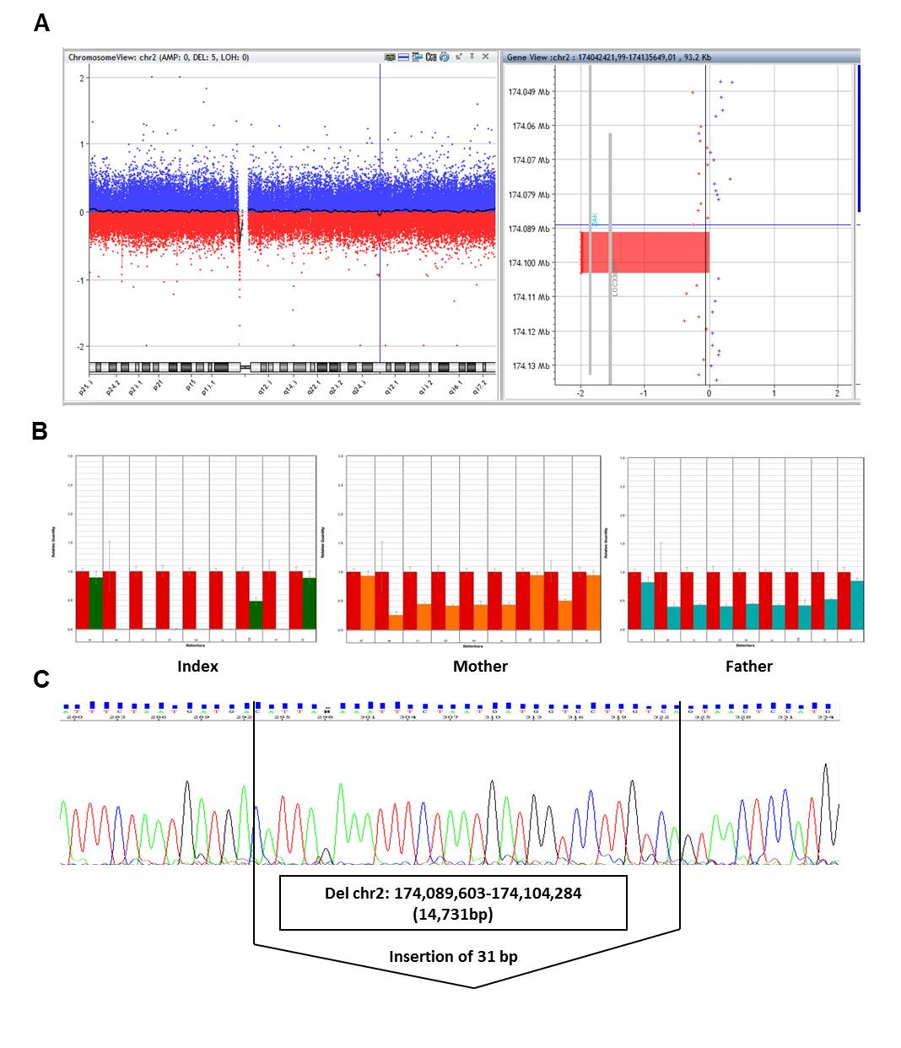

Suppl. Fig. 5: The CRISPR/Cas-mediated deletion in Zak exon 2 is embryonically lethal in mice.
A) Wild-type sequence and homozygous mutation in exon 2 of Zak in two independent clones. SgRNA sequence is marked in red.
B) The complete inactivation of Zak in mice resulted in fully penetrant lethality at E9.5 due to cardiac malformation. The homozygous mice showed severe cardiac edema and global growth retardation and were subsequently absorbed between E9.5 and E10.5.

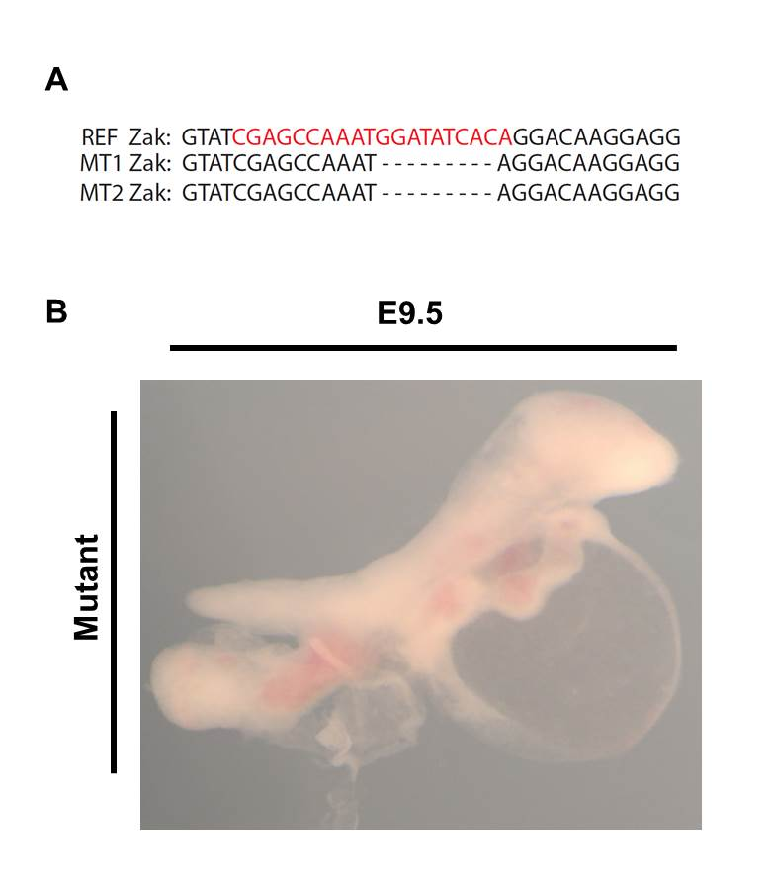

Suppl. Fig. 6: Off-target analysis
- The deletion was predicted to be in frame and Zak mRNA expression was normal in mutant limbs. Exon 14-15 and exon 15-16 showed a homozygous deletion.
- Based on the in silico predictions (crispr.mit.edu/) the most likely off-target mutations were analysed via Sanger sequencing. No predicted off-target mutation was found.

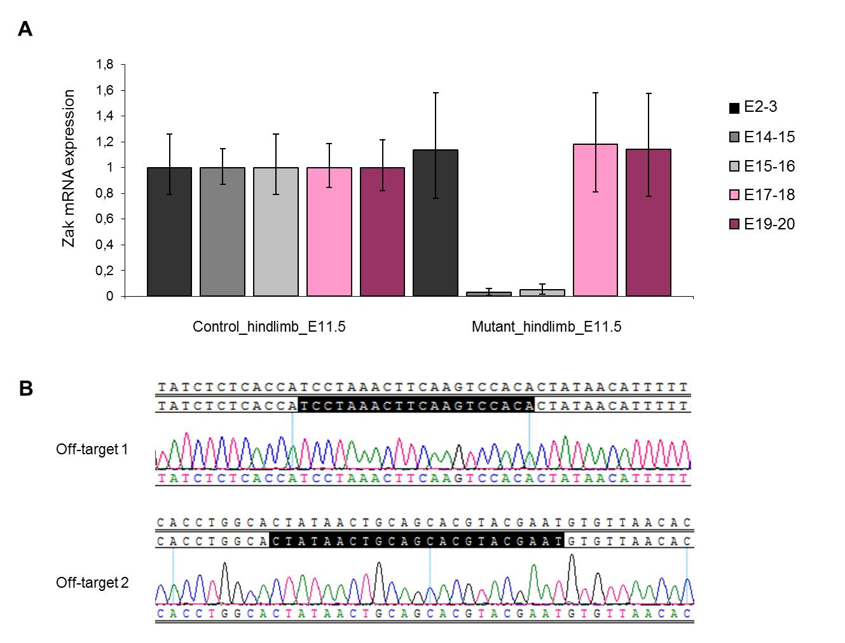

Suppl. Fig. 7: Two Zak^{-/-} mice showed a polydactyly of the feet representing a minimal variant of a distal duplication defect.

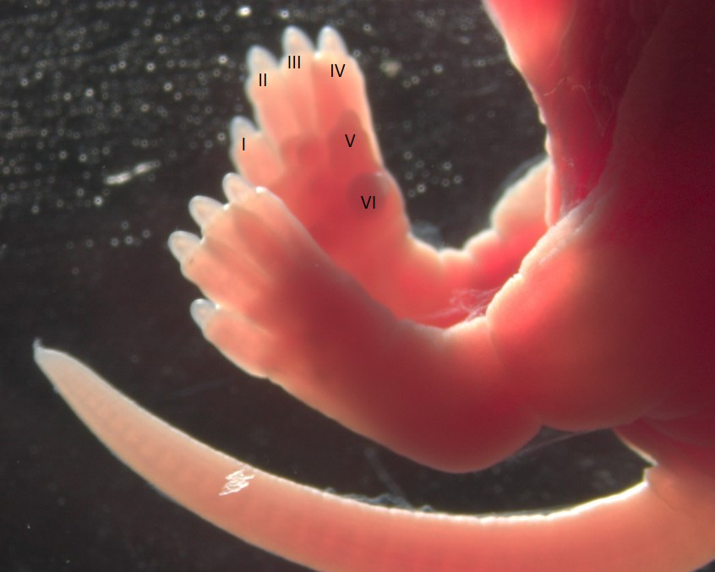

Suppl. Fig. 8: Whole mount in situ hybridizations at E11.5 in Zak^{-/-} mice with a deletion of exons 12-16
In situ hybridization in chimeric and homozygous embryos for Fgf8, Shh and Tp63 showed a normal staining pattern in WT and Zak mutant mice at E10.5.

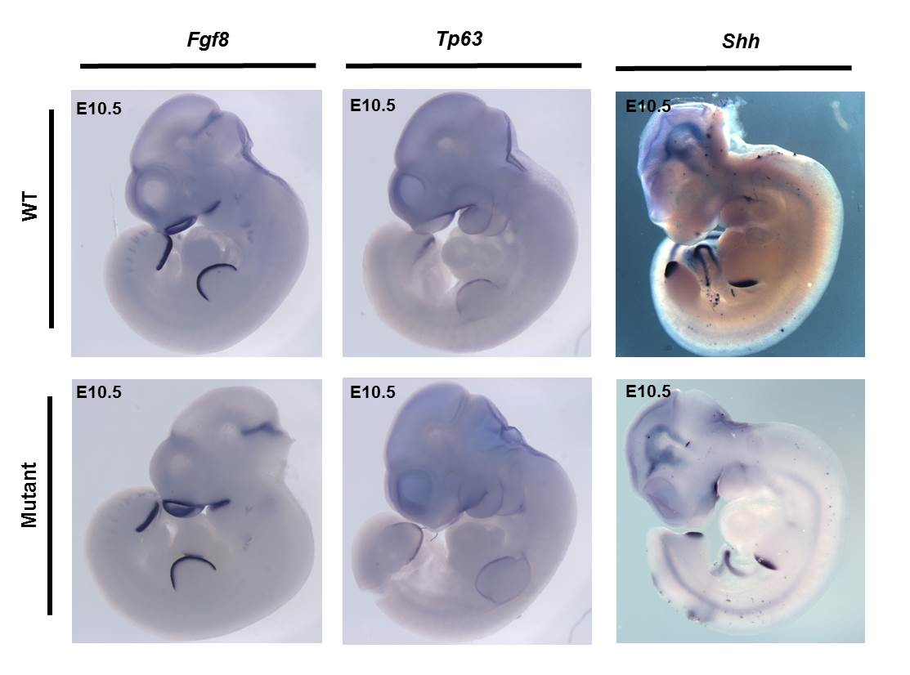

Suppl. Fig. 9: ZAK SAM domain circular dichroism
Thermal denaturation curves of wild-type ZAK-SAM and ZAK-SAM Phe368Cys monitored by circular dichroism signal at 222 nm. Wild-type ZAK-SAM exhibits cooperative unfolding while the Phe368Cys mutant exhibits non-cooperative unfolding and is highly unstructured.

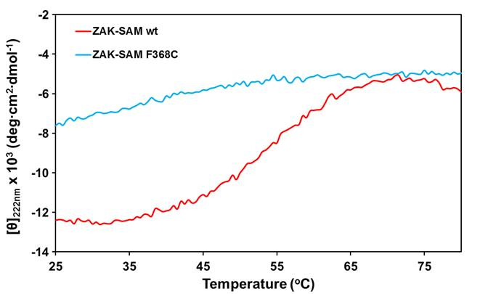

Suppl. Fig. 10: Homozygous deletion in mouse ESCs of exons 12 - 16 of Zak.
- Two sgRNAs located in the introns centromeric and telomeric to exons 12 and 16 of Zak were designed and cotransfected in mouse ESCs to induce double strand breaks at the desired positions. Two clones (out of 288) with a homozygous deletion of the 12 kb fragment were detected. Clone G12
- Homozygous deletion in mouse ESCs of exons 12 - 16 of Zak in clone B3
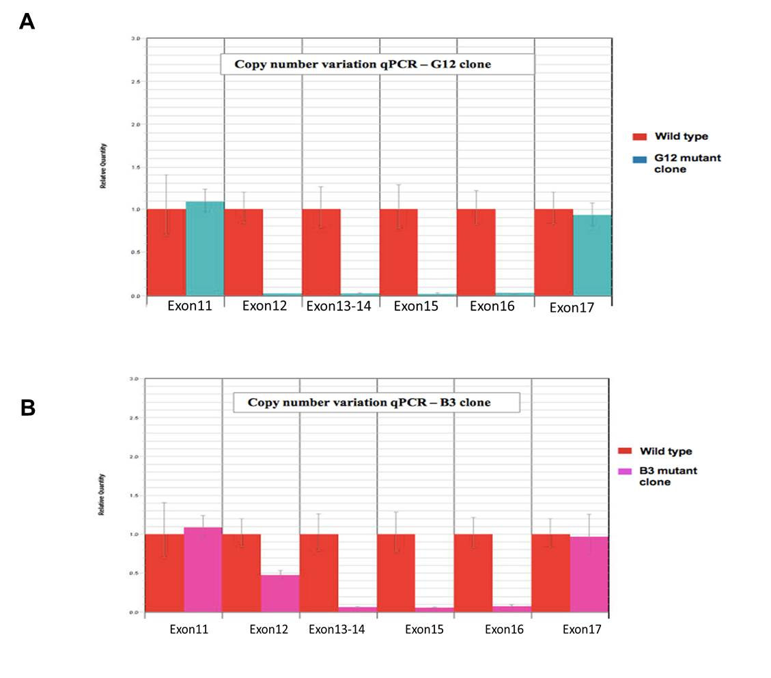

Suppl. Table 1: Rare sequence variants detected by exome sequencing in the linkage region on chromosome 2q31 in family 1.

ª Genomic positions are based on the GRCh37/hg19 human genome assembly.
^{b} The c.712C>T (p.Gln238*) variant in HOXD12 was interpreted as non-pathogenic because i) its allele frequency was too high in controls to explain a rare disease and ii) it leads to a predicted stop gain only in the minor transcript ENST00000404162, whereas it represents a synonymous change in the canonical transcript NM_021193.3.

aa, amino acid; Chr, chromosome; EVS, exome variant server; ExAC, exome aggregation consortium; nc, nucleotide; ND, not determined; PK, Pakistani.

Suppl. Table 2: primer sequences for Sanger sequencing of ZAK in Hg19
Primer sequences in hg19 | Primer sequences in hg19
Exon2: 159 bp | Exon12: 45 bp
F_CTGGAAGTTTCACAGGACTCG | F_ CAGCAGCTGAGAGCTGAAAG
F_ CCCTGTGACCCTCTAACTCG | R_ GACTTTCCTAAGGCCCAATC
Exon3: 88 bp | Exon13-14: 268 bp
F_ GAGTAGGAAGCCTGTTTTATTTGAC | F_ TGTGAAGACTGGCCACTGAC
R_ AACACACAATTCATAACTGAGCC | R_ caacagagcaagactctgcc
Exon4: 102 bp | Exon15: 63 bp
F_TGACATTAACTTTTAGAAACCACACC | F_ TTTGTTTGTACCCAATGATTTTAGTC
R_ATTTCAGGAGGGGAAAATGC | R_GCAGCAGGTGCATGTGTC
Exon5: 66 bp | Exon16: 93 bp
F_CATGTGAATTAGTTTCTGCTCTTG | F_ GGCATAATATGTCATTTCTGTTGG
R_aaggcttccatggtatcagc | R_ GACTGGATTACAGAGGCAGC
Exon6-7: 283 bp | Exon17: 123 bp
F_ CACCTTTCATAATCCCATATTGAAG | F_ AAGGCTGCACTAACTGGGG
R_TTAGGCATTCCACCAGCAG | R_ AAATGTGCCTTTCAACAGCC
Exon8: 87 bp | Exon18: 75 bp
F_ TTCTACAGTTGGGGTTGGTTG | F_aattgtgtatggcacaaccg
R_ ACTGCTAATCTTTCCATAAGCG | R_ATCTCCCAATAAATTATATGCTCTG
Exon9: 75 bp | Exon19: 151 bp
F_ CCTTCAGATACGGTGTTTGC | F_ CCTGGATGACTTTCTTTCCC
R_ GGAGCATCAATCCAGCTTTG | R_ctgatTGAGGTGGTATCCTCTG
Exon10: 107 bp | Exon20_1: 350 bp
F_ AAGAATAGAGCTCCCTAAACCTG | F_ CCCAAACAGCCCTGAATTATC
R_TTCATTGAGACGAGTGATGGTC | R_TGAAGGAGTGGAATGCTGAC
Exon11: 136 bp | Exon20_2: 350 bp
F_ AGCACCAGCATGTGTCTTTTAC | F_GGACAGTGGCTTTTCCAGTG
R_ GGGAAGAGGTGCCATGC | R_TTTCGTTAATTCAATCTGAAGGG

Suppl. Table 3: primer sequences and positions

