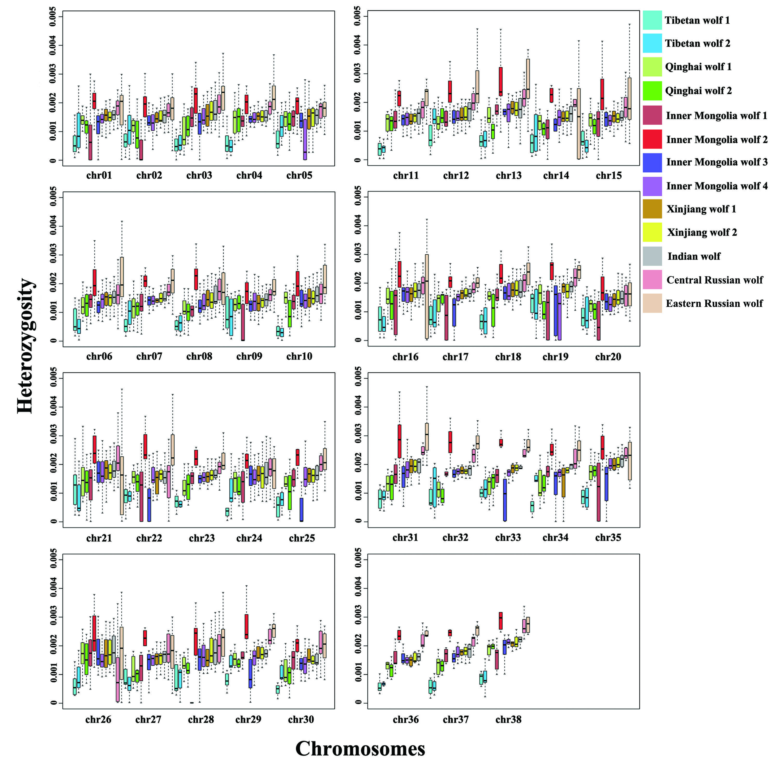

Figure S1. The box plot of heterozygosity from 5 mb non-overlapping windows across all the 38 autosomes. These are all the Asian wolves.

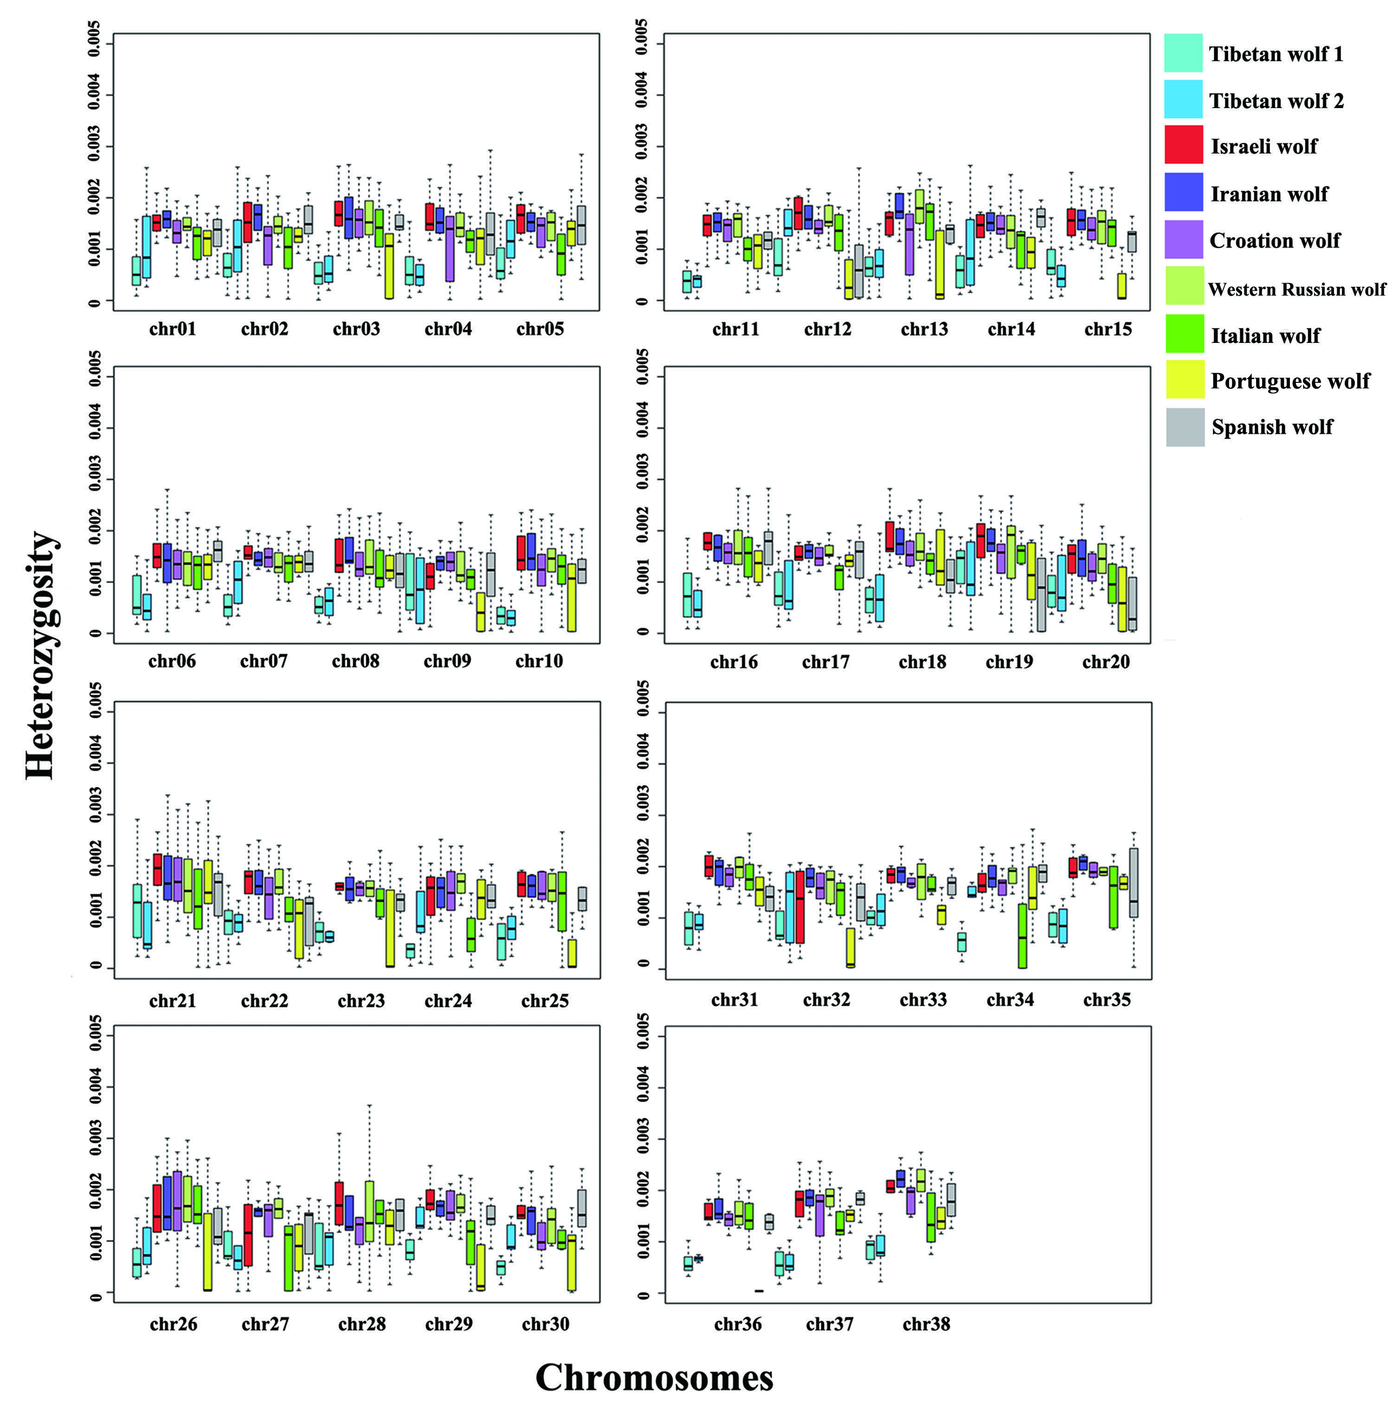
Figure S2. The box plot of heterozygosity from 5 mb non-overlapping windows across all the 38 autosomes. These are all the European and Middle East wolves, and two Tibetan wolves.

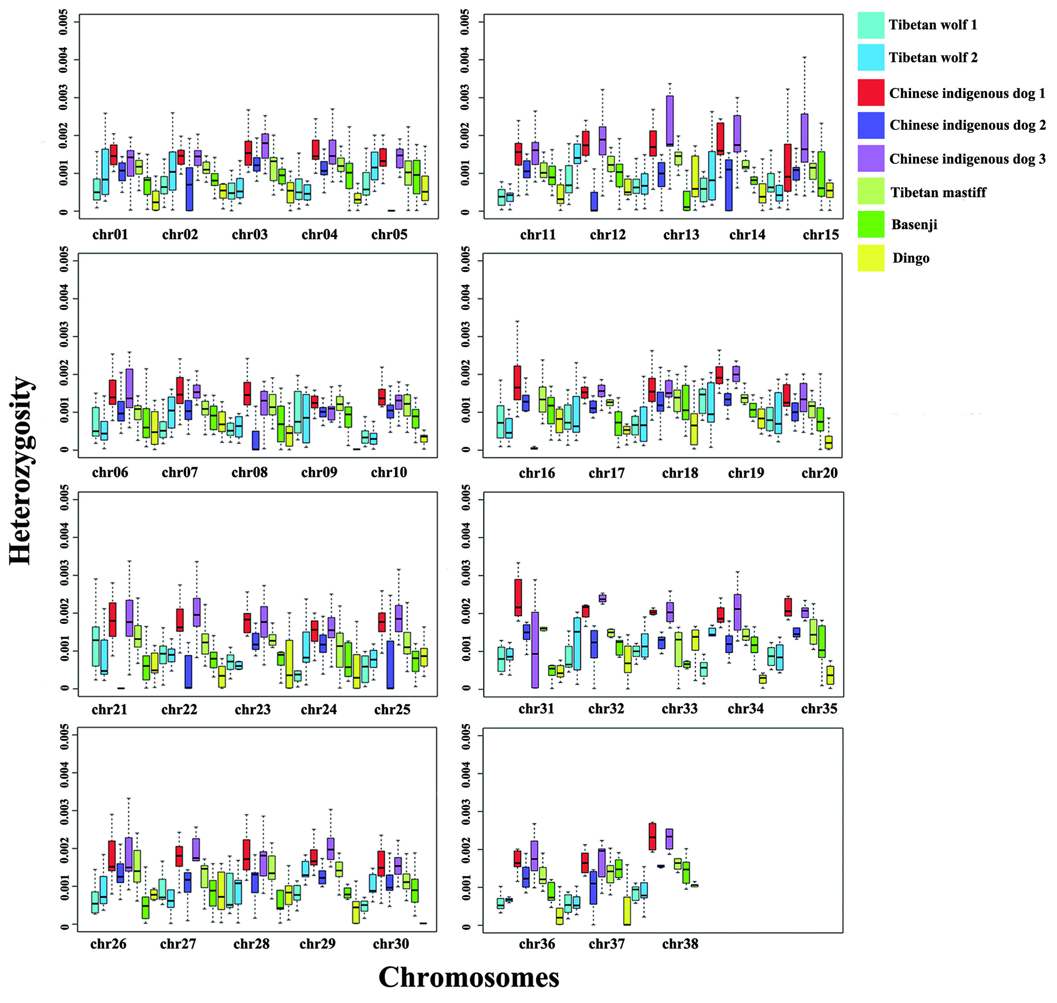
Figure S3. The box plot of heterozygosity from 5 mb non-overlapping windows across all the 38 autosomes. These are all the dogs and two Tibetan wolves.

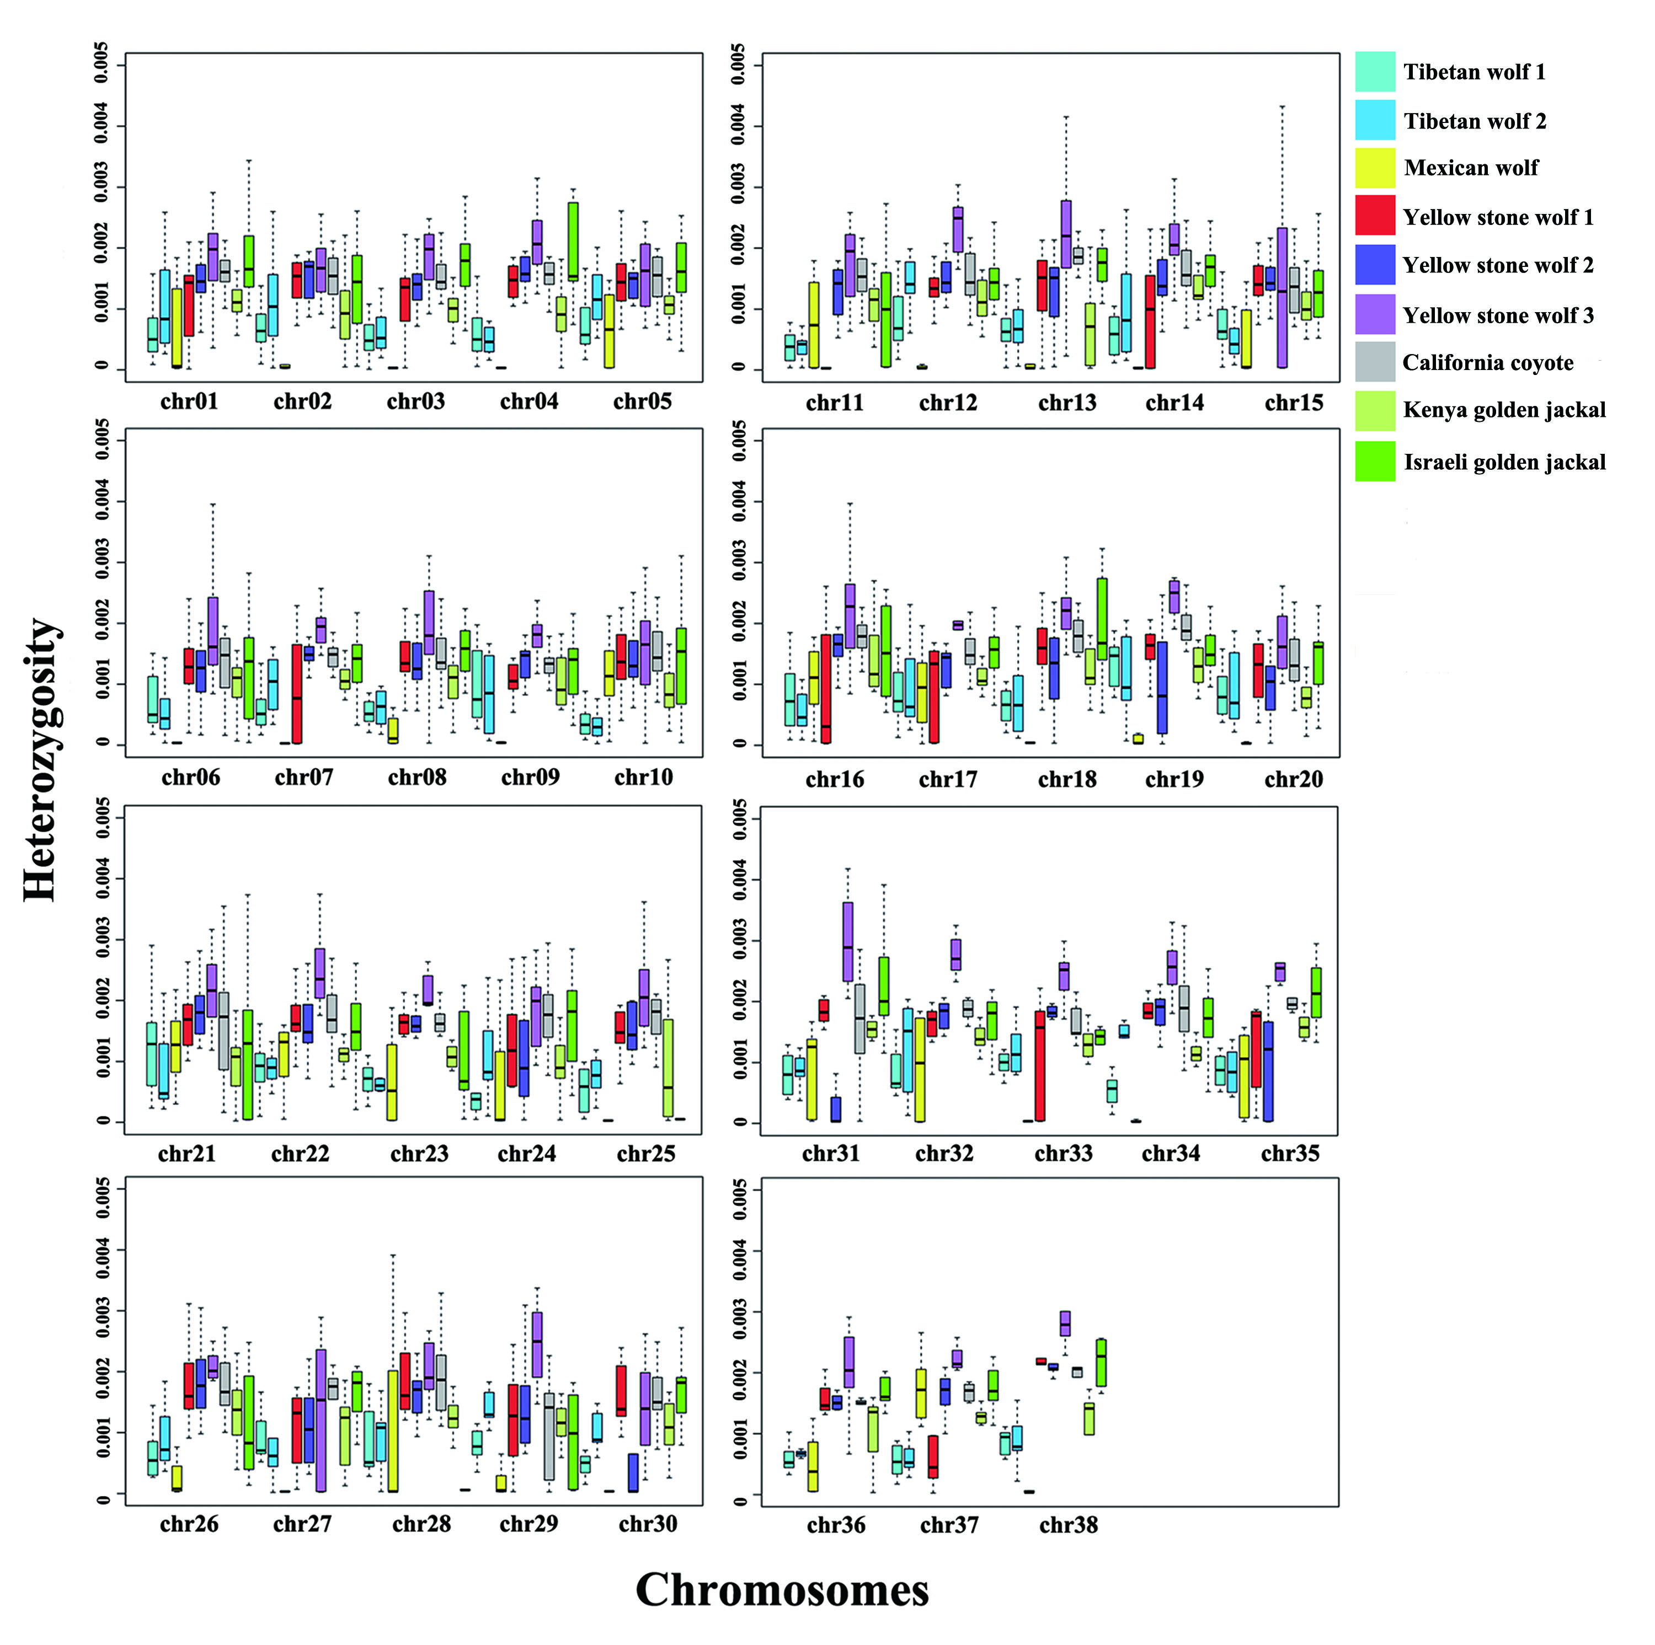

Figure S4. The box plot of heterozygosity from 5 mb non-overlapping windows across all the 38 autosomes. These are all the North American wolves, two Tibetan wolves and three outgroups.

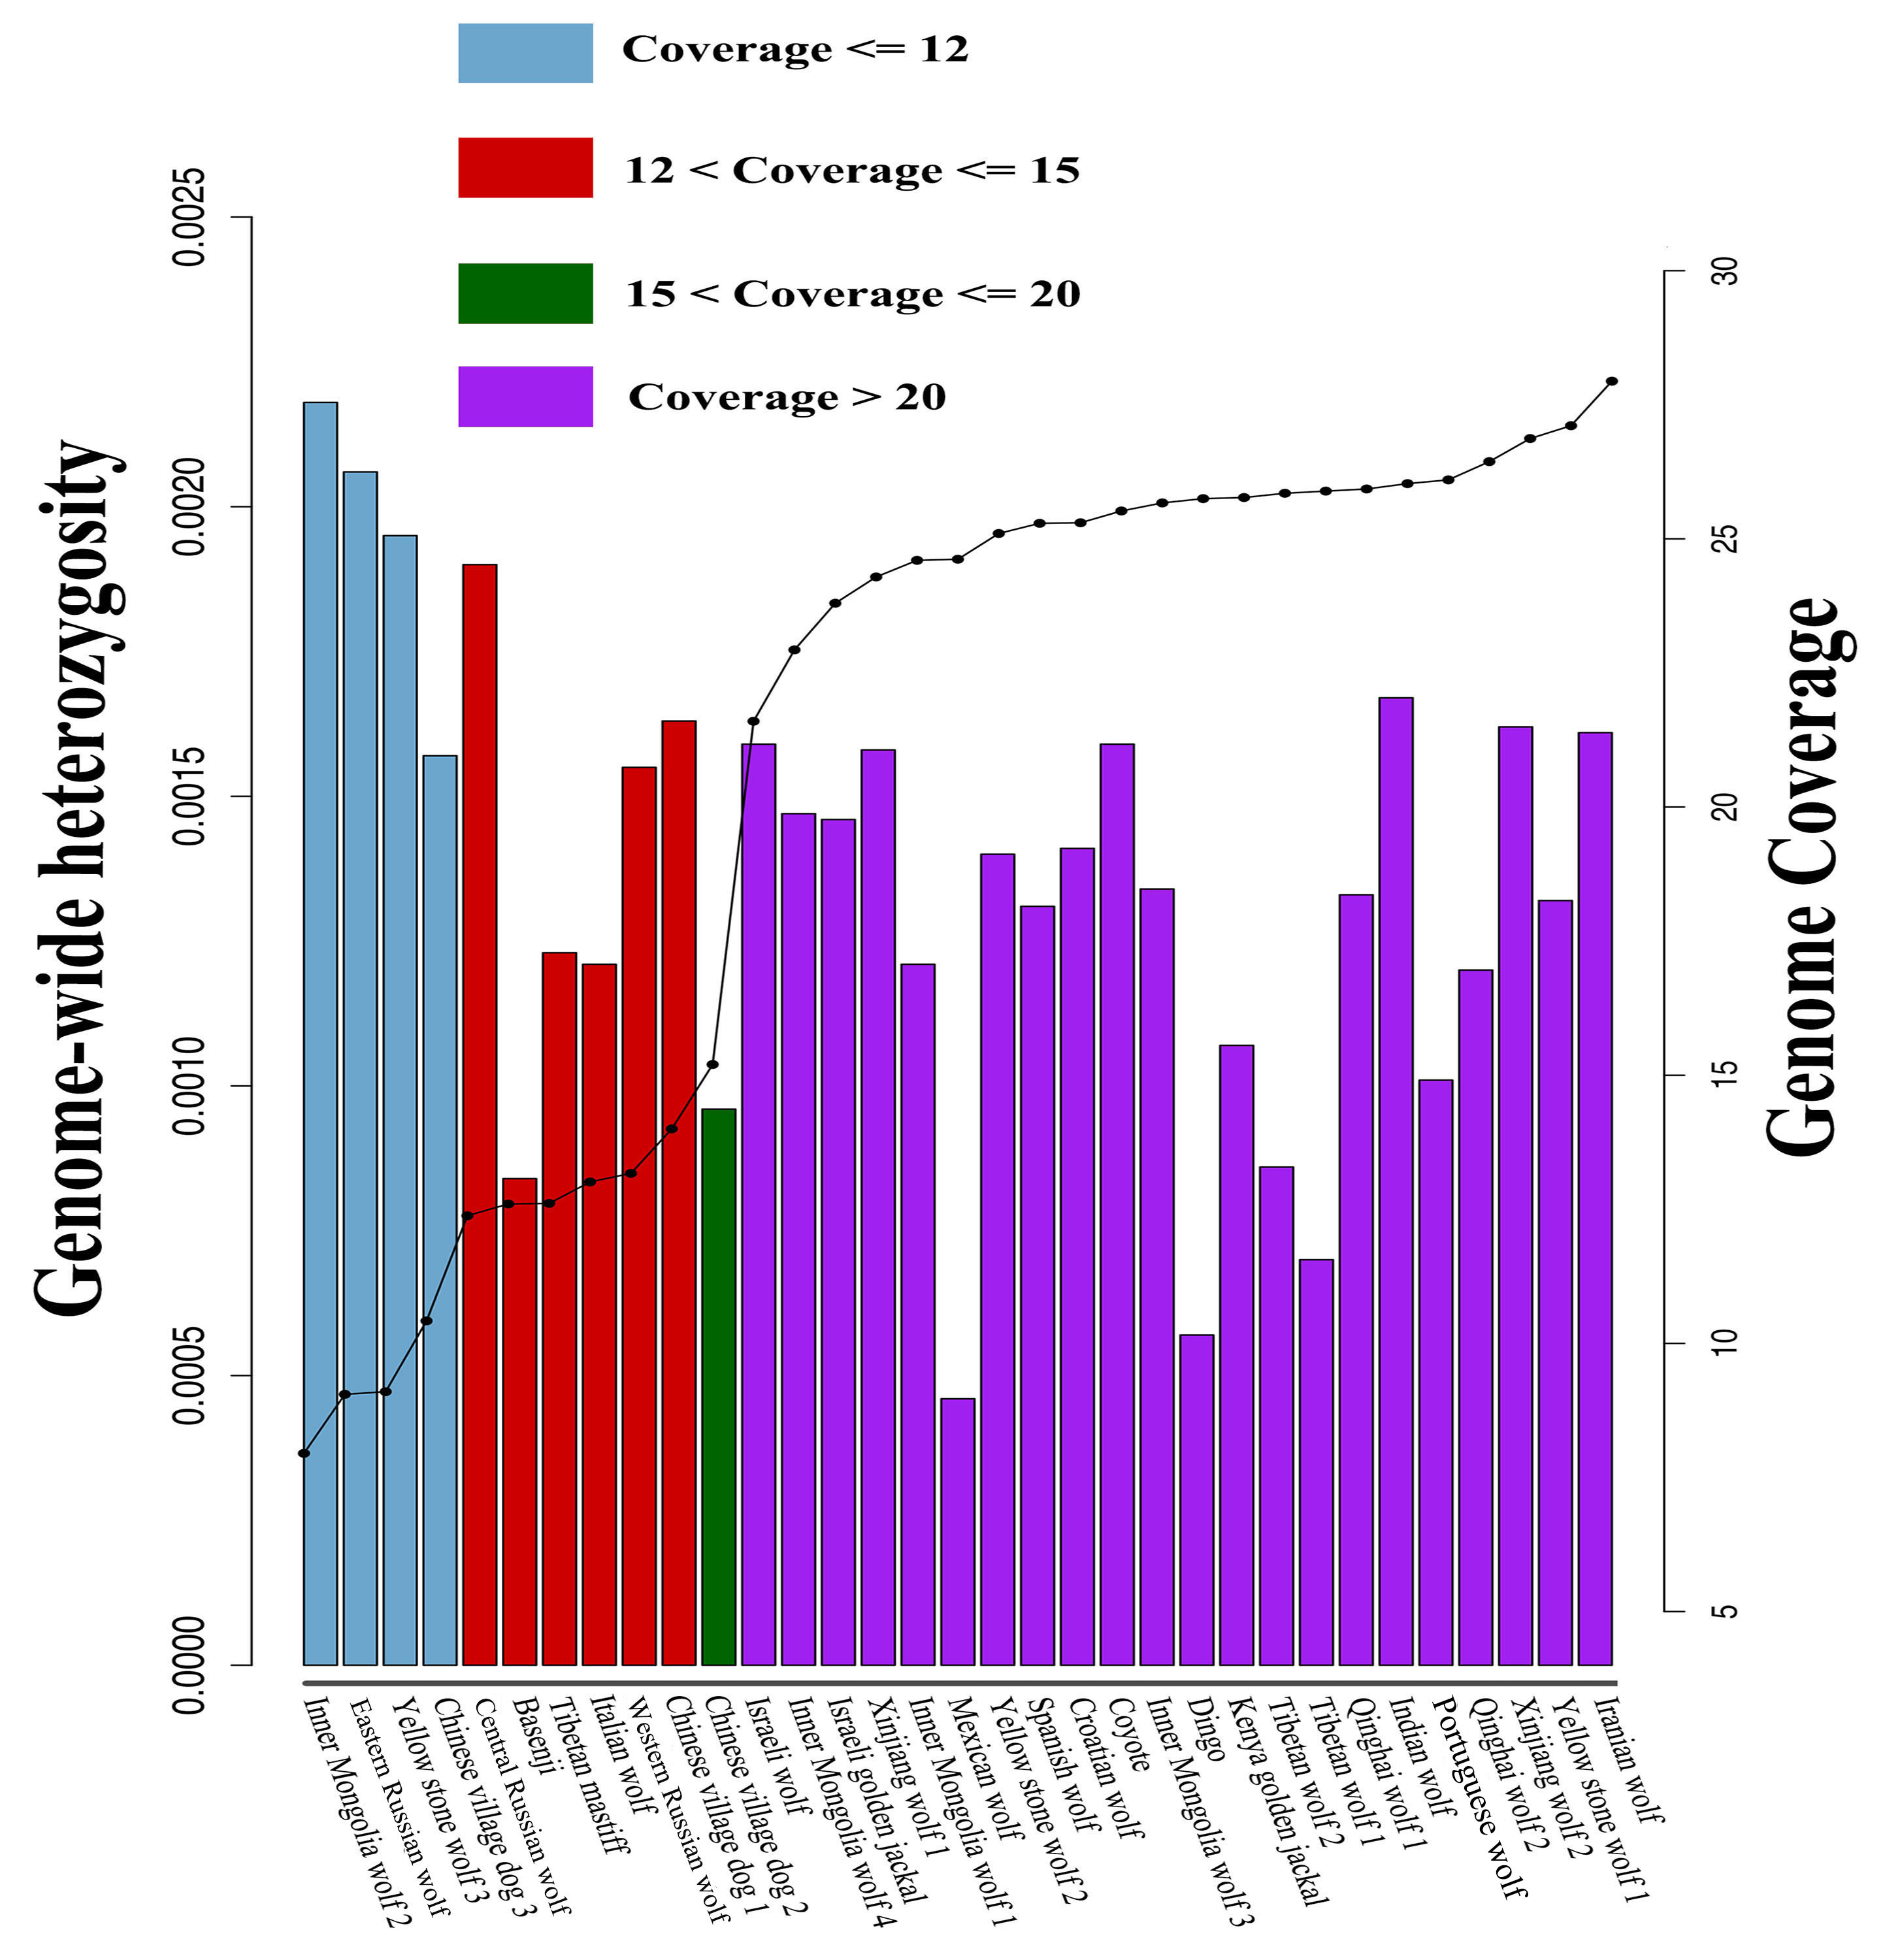

Figure S5. The genome wide heterozygosity and genome coverage. The bar is the genome wide heterozygosity in each sample, and the black plot is the genome coverage.

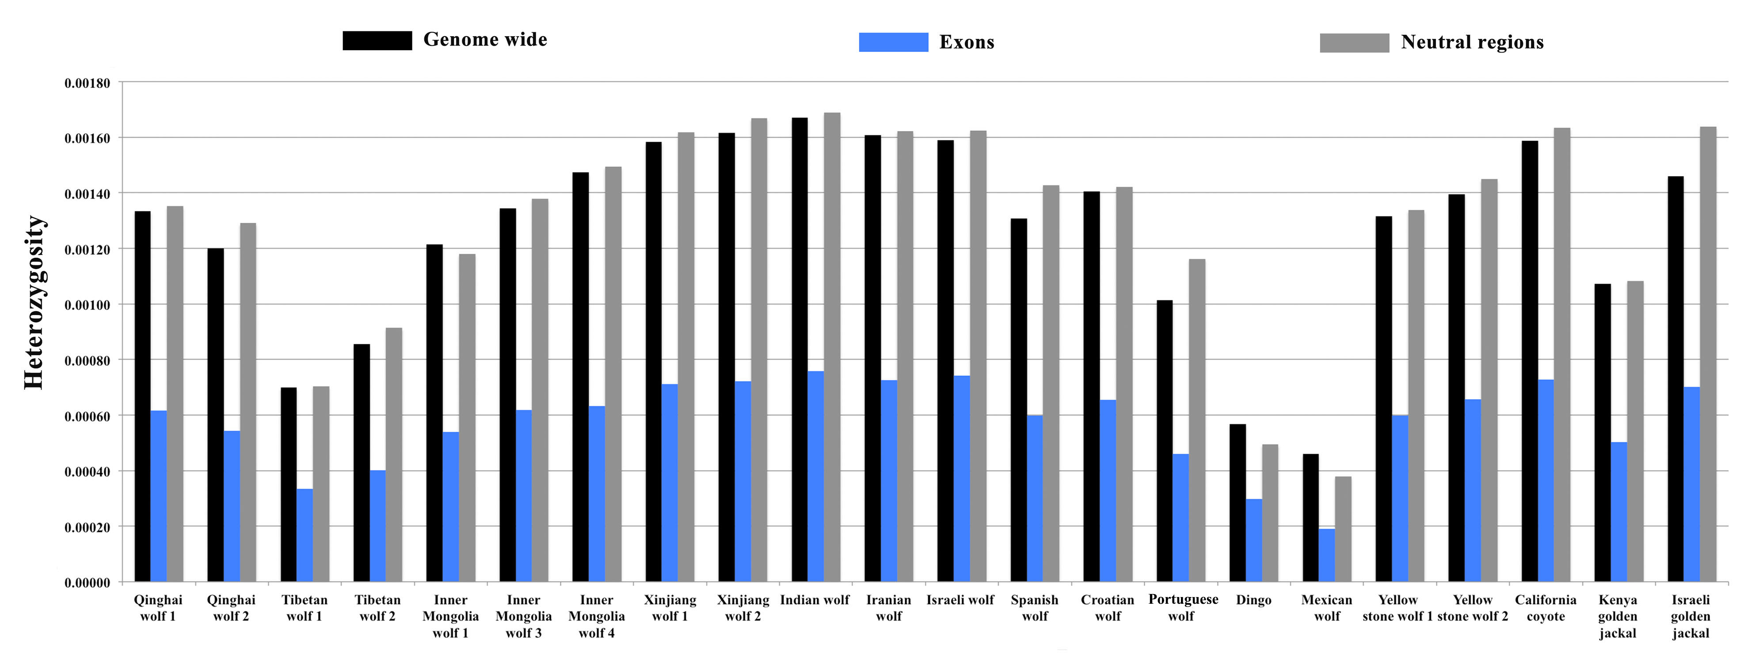
Figure S6. The heterozygosity of different genomic classes. The black bar is the genome wide heterozygosity, the blue bar is the heterozygosity of exons, and the grey bar is the heterozygosity of neutral regions. We only used samples with > 20-fold genome coverage.

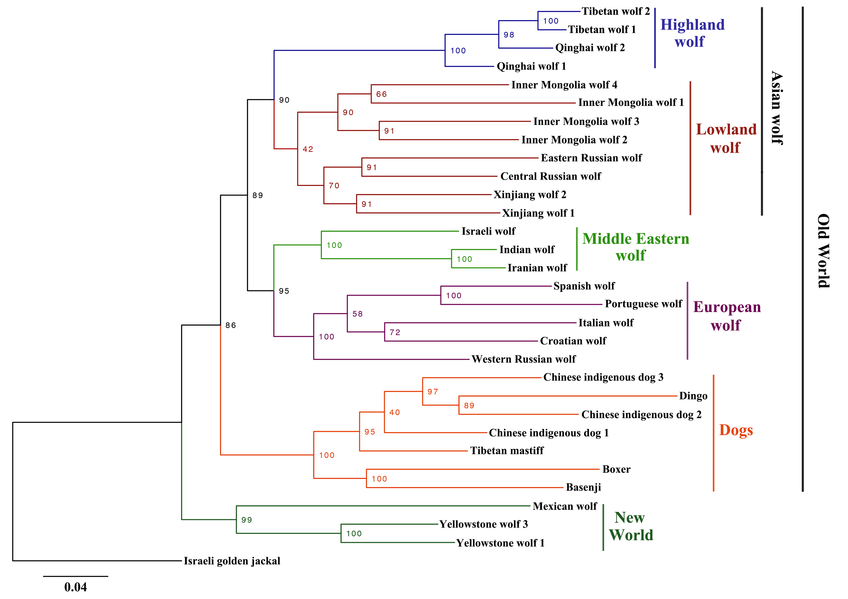
Figure S7. The maximum likelihood tree of 31 sequences. Numbers represent node supports inferred from 100 bootstrap repetitions. We excluded the Yellowstone wolf 2 because it is the offspring of Yellowstone wolf 1 (mother) and Yellowstone wolf 3 (father). The reference genome boxer was included. The Israeli golden jackal is the outgroup.

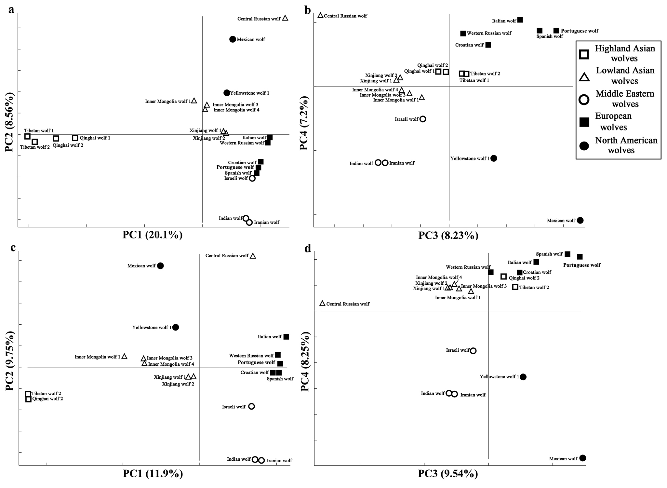

Figure S8. Principal component analyses of complete genome data for only wolves. Inner Mongolia wolf 2, Eastern Russian wolf, and Yellowstone wolf 3 were also removed due to their potential high genotype error (see Figure S5). We also excluded the Yellowstone wolf 2 as in Figure 3. (a) PC1 and PC2 of 20 wolves; (b) PC3 and PC4 of 20 wolves; (c) PC1 and PC2 of 18 wolves, excluding the Tibetan wolf 1 and Qinghai wolf 1; (d) PC3 and PC4 of 18 wolves, excluding the Tibetan wolf 1 and Qinghai wolf 1.

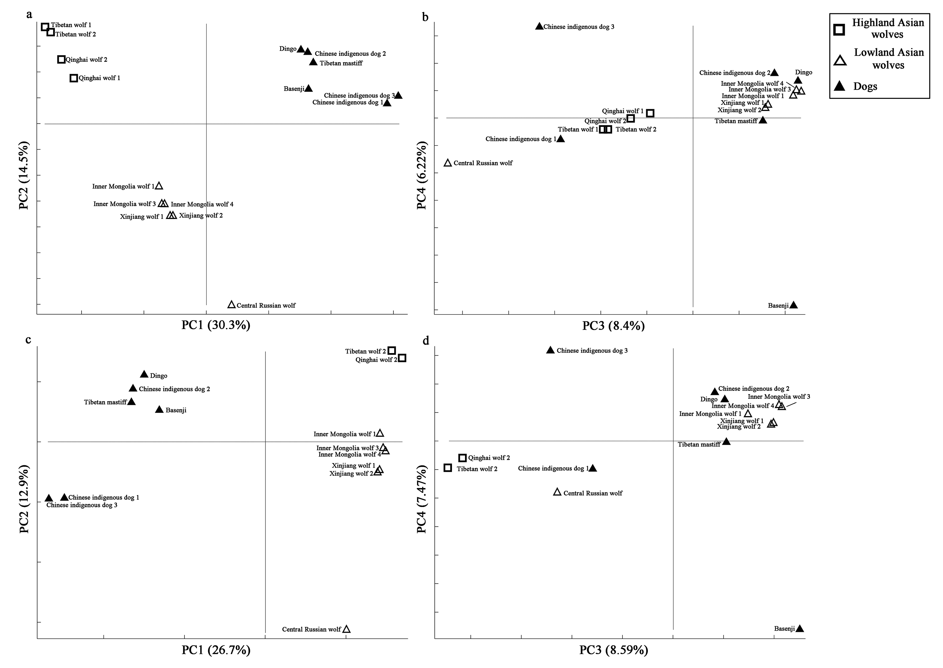

Figure S9. Principal component analysis (PCA) of complete genome data for Asian wolves and all the dogs. The results from PC1 to PC4 are shown. (a and b) Asian wolves and all dogs; (c and d) Asian wolves without Tibetan wolf 1 and Qinghai wolf 1 and all dogs

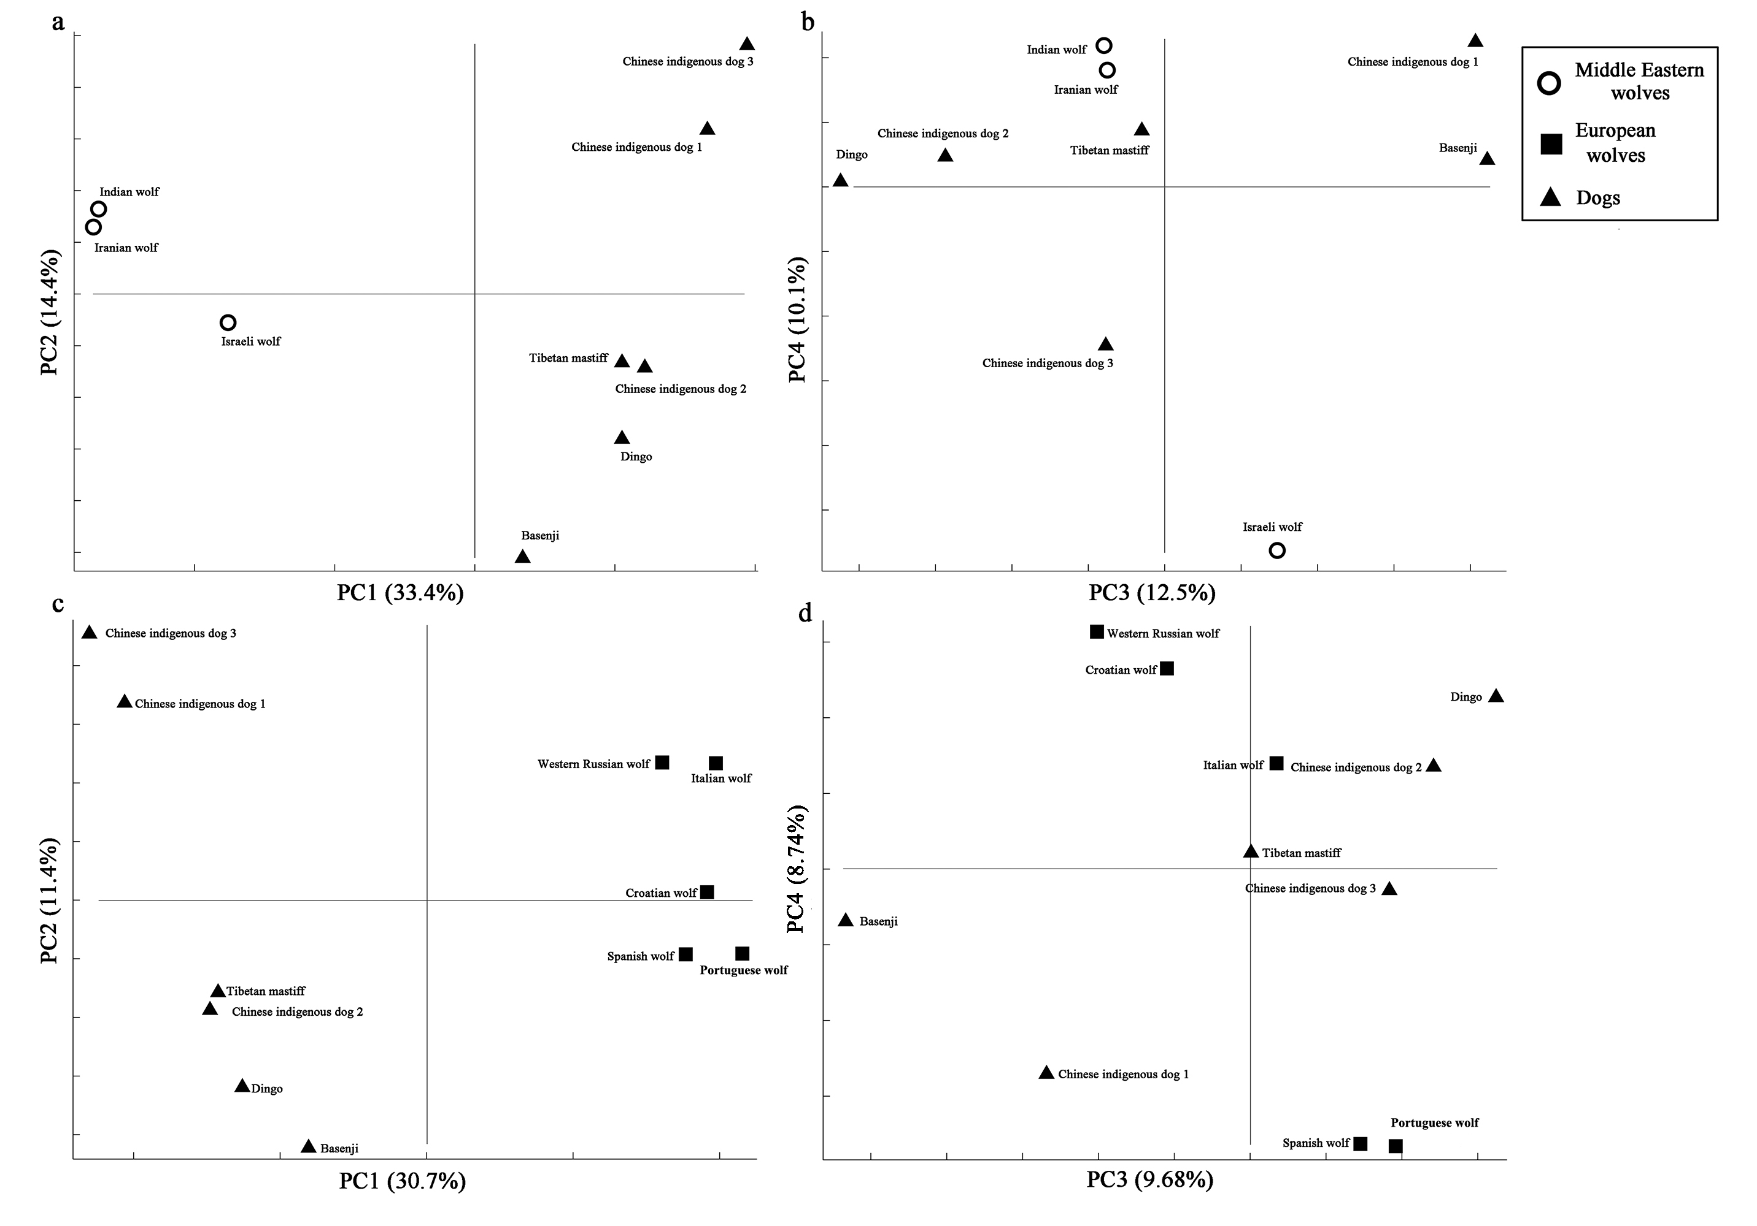
Figure S10. Principal component analysis (PCA) of complete genome data for Middle Eastern wolves, European wolves and all the dogs. The results from PC1 to PC4 are shown. (a and b) Middle Eastern wolves and all dogs. Indian wolf is grouped into Middle Eastern wolf here; (c and d) European wolves and all dogs.

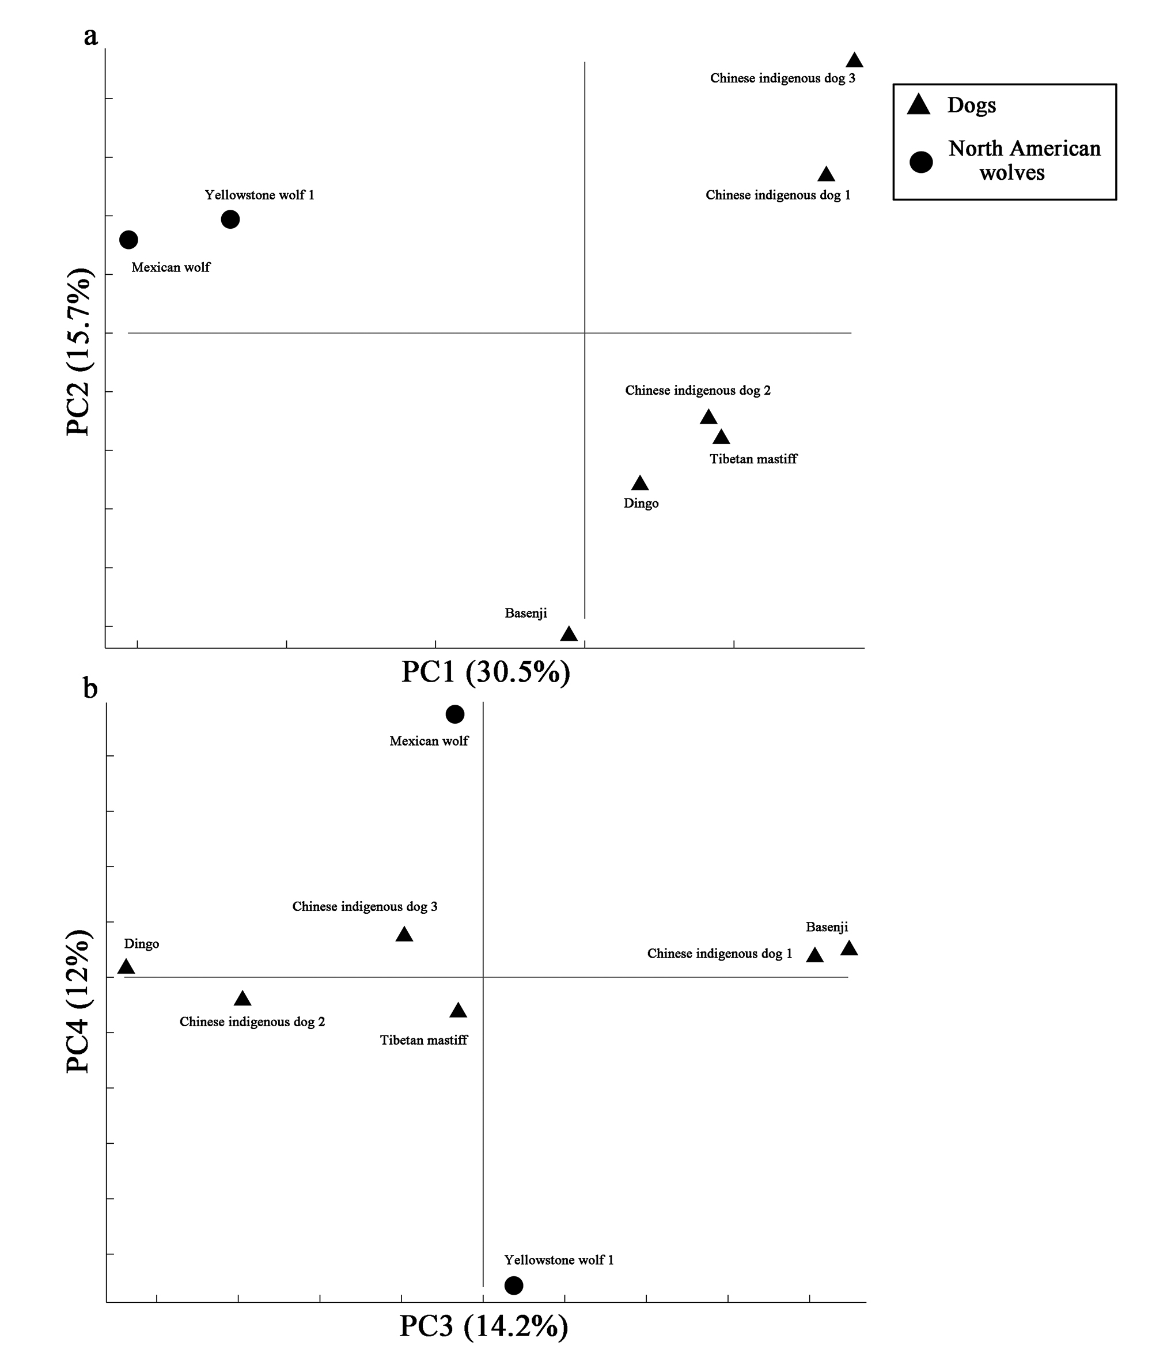
Figure S11. Principal component analysis (PCA) of complete genome data for Mexican wolf, Yellowstone wolf and all the dogs. The results from PC1 to PC4 are shown. Only one Yellowstone wolf (Yellowstone wolf 1) is used here.

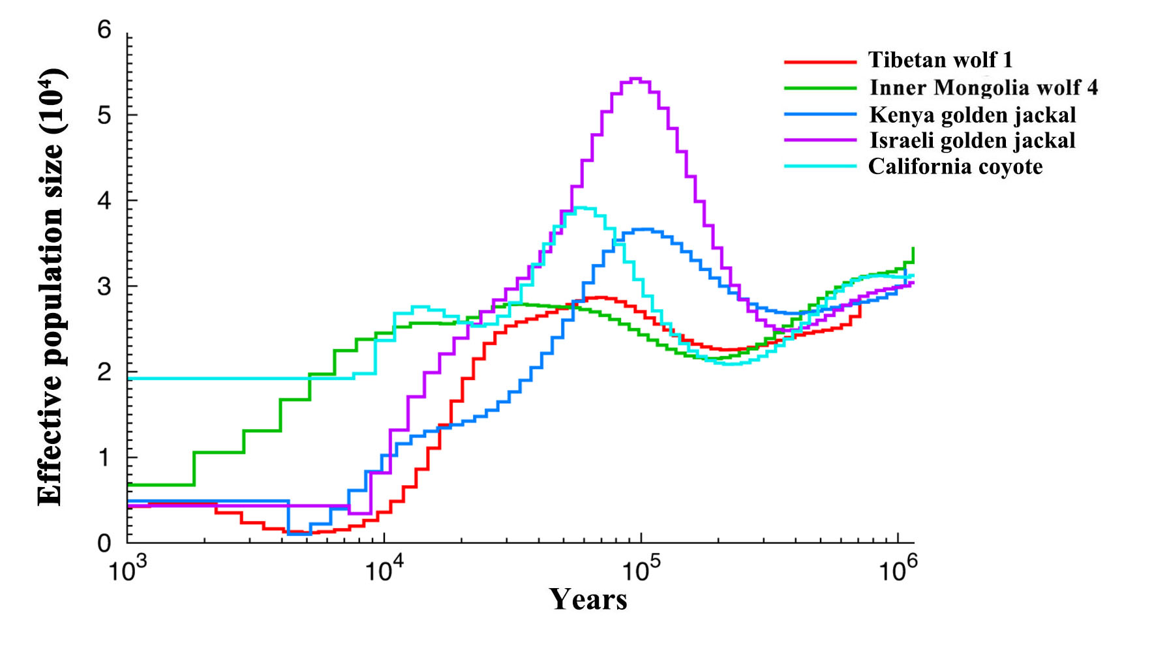

Figure S12. Demographic history of three outgroups in this study reconstructed from the their genomes analyzed with the genomic distribution of heterozygous sites using the pairwise sequential Markovian coalescent (PSMC). Followed Freedman et al. (2014) and Zhang et al. (2014), generation time = 3 and mutation rate = 1.0 × 10⁻⁸ per generation are applied. Tibetan wolf 1 and Inner Mongolia wolf 4 are exhibited here.

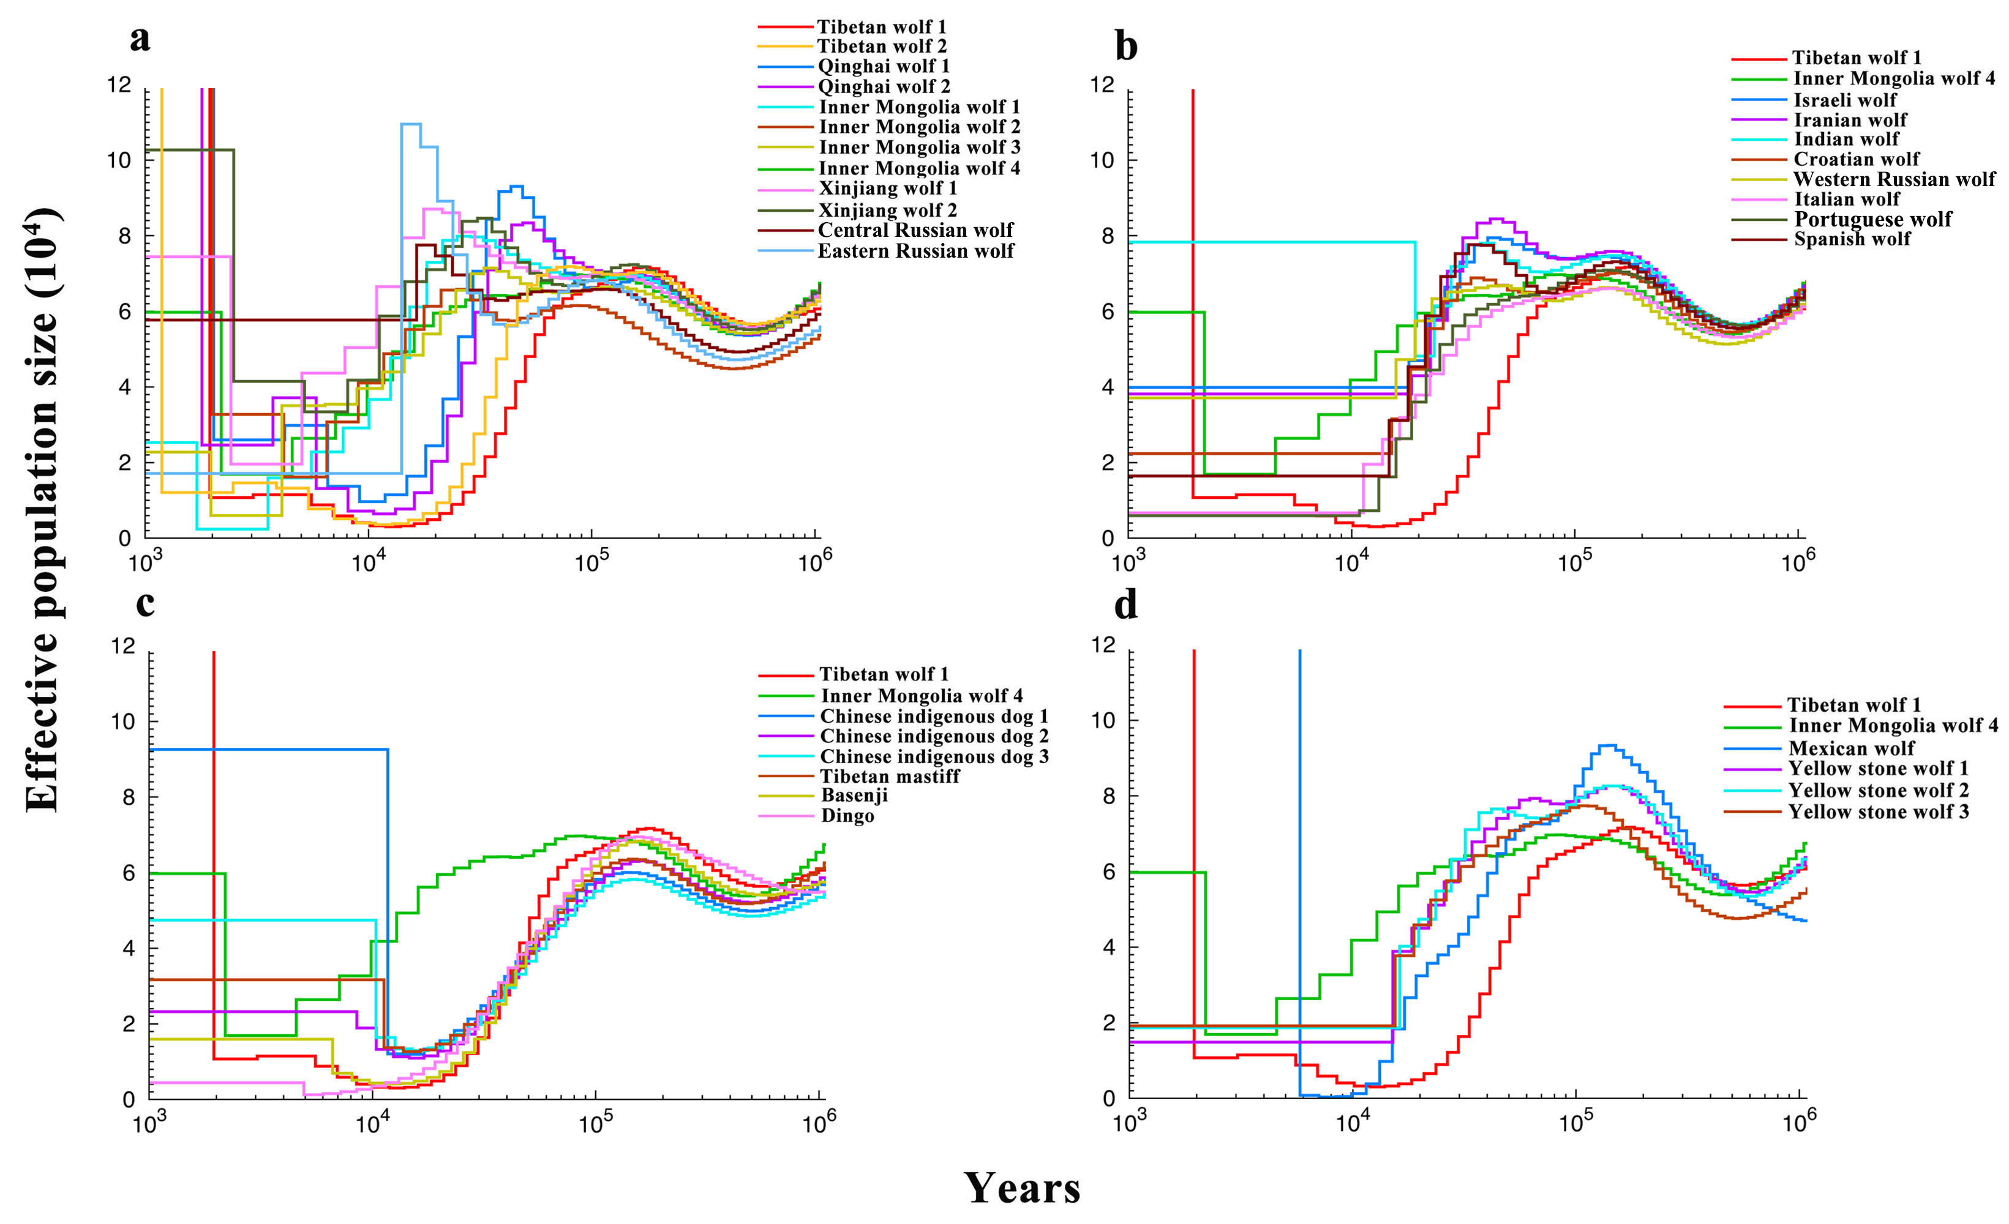

Figure S13. Demographic history of the candis in this study reconstructed from the their genomes analyzed with the genomic distribution of heterozygous sites using the pairwise sequential Markovian coalescent (PSMC). Followed Freedman et al. (2014) and Zhang et al. (2014), generation time = 3 is applied. Skoglund et al. (2015)’s reported a slower mutation rate (0.4 × 10⁻⁸ per generation), thus we applied this mutation rate here. Tibetan wolf 1 and Inner Mongolia wolf 4 are exhibited in all the plots. (a) all the Asian wolves; (b) all the European wolves and Middle Eastern wolves and Indian wolf; (c) dogs; (d) Mexican wolf and Yellowstone wolves.

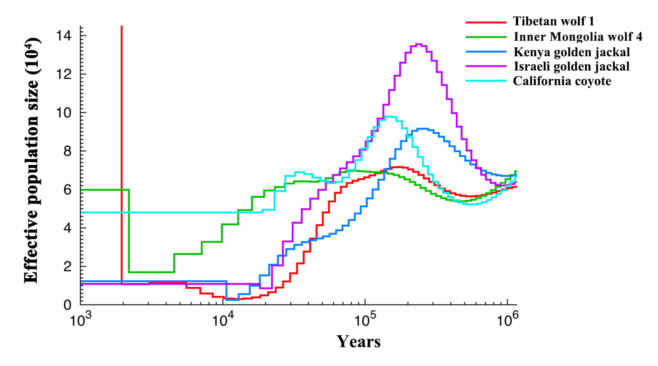

Figure S14. Demographic history of three outgroups in this study reconstructed from the their genomes analyzed with the genomic distribution of heterozygous sites using the pairwise sequential Markovian coalescent (PSMC). Followed Freedman et al. (2014) and Zhang et al. (2014), generation time = 3 is applied. Skoglund et al. (2015)’s reported a slower mutation rate (0.4 × 10⁻⁸ per generation), thus we applied this mutation rate here. Tibetan wolf 1 and Inner Mongolia wolf 4 are exhibited in all the plots.

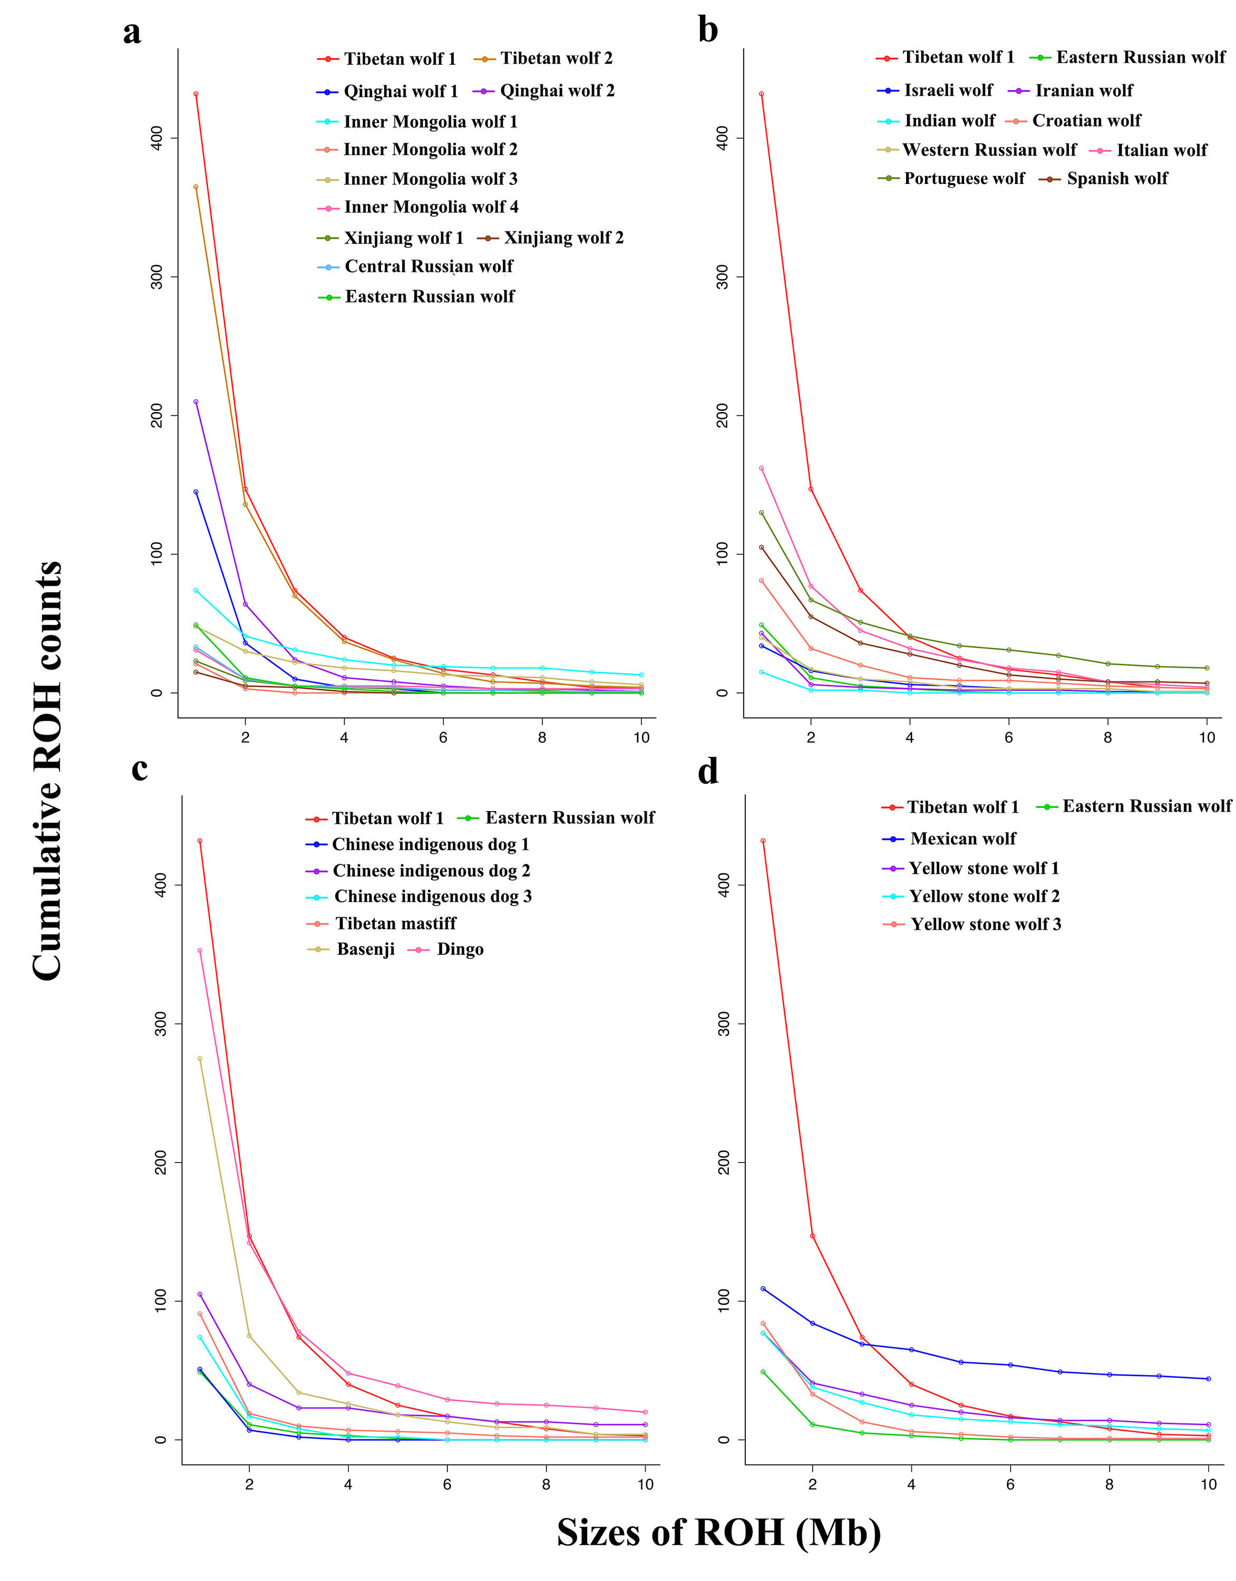
Figure S15. Autozygosity frequency distribution of runs of homozygosity (ROH). Tibetan wolf 1 and Russian wolf (east) are exhibited in all the plots. (a) Asian wolf; (b) European wolf and Middle Eastern wolf; (c) Dogs; (d) Mexican wolf and Yellowstone wolves.

