Supplementary figures and tables

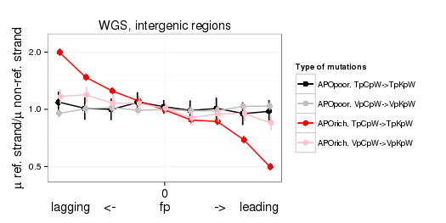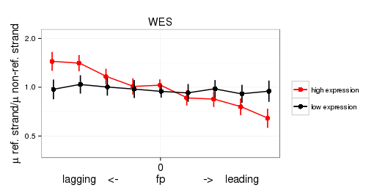
B
A

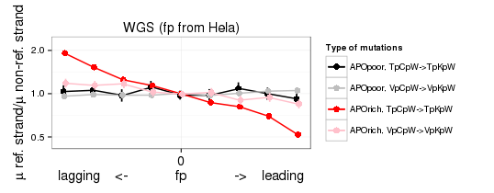
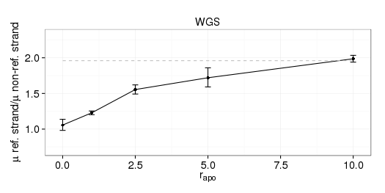
D
C
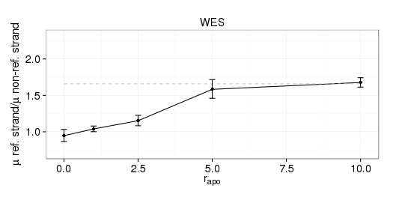
F

Supplementary figure 1. The ratio of the mutation rates on the reference and non-reference strands as a function of the propensity of the replication fork to replicate the reference strand as lagging or leading. Horizontal axis, genome split by fp values into 9 bins from low fp (bin 1) to high fp (bin 9) (A, B,C); or tumors grouped by r_{apo} into 5 bins (D, F). Vertical bars represent 95% confidence interval. WGS (B, C, D) and WES (A, F) datasets.

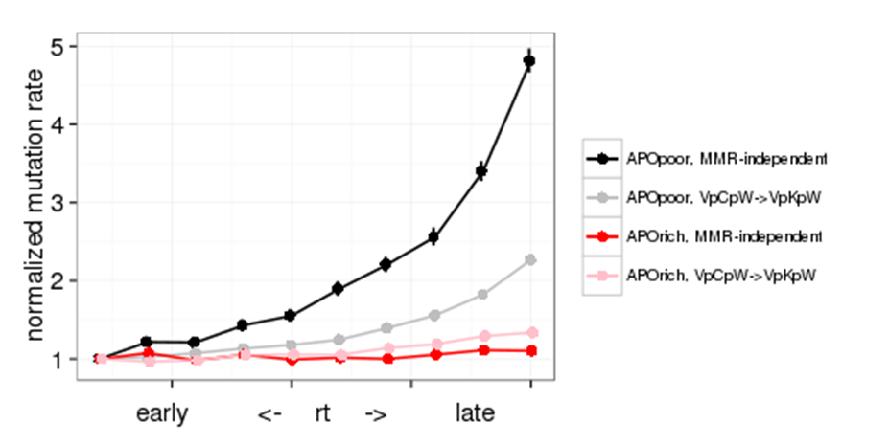
Supplementary figure 2. Mutation rates as a function of replication time (rt), relative to the mutation rate in the early rt bin. Horizontal axis: genome split into 10 bins of equal size from early to late rt. TpCpN→TpApN mutations are not associated with Mismatch Repair (MMR) deficiency(8). Vertical bars represent 95% confidence intervals.

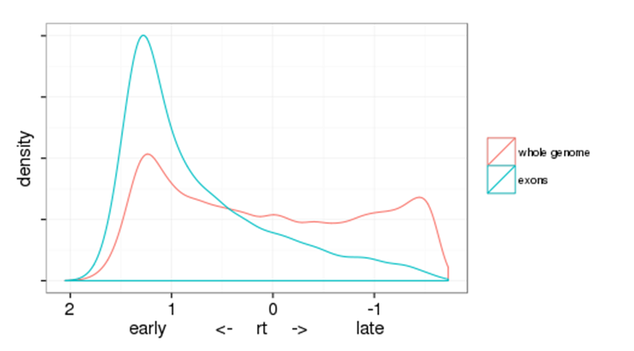

Supplementary figure 3. Distribution of genomic and exomic nucleotides across rt.

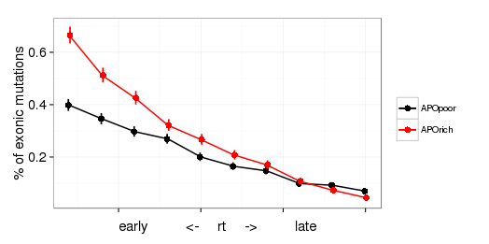
Supplementary figure 4. Mutations (CpG sitest excluded) in early vs. late replicating regions. Horizontal axis: genome split into 10 bins of equal size from early to late rt. Percentage of mutations in exons that fall into this bin (among all mutations in the genome) as a function of rt. In sum, 2.8% of mutations in APOrich tumors, and only 2.1% of mutations in APOpoor tumors, fall into exons. Vertical bars represent 95% confidence interval.

Supplementary Table 3. Replication timing is conservative among different tissues
Cell type | spearmans`s ρ
Nhek (keratinocytes) | 0.81
Helas3 (cervix carcinoma) | 0.72
Huvec (umbilical vein endothelial cell) | 0.75
K562 (chronic myelogenous leukemia) | 0.83
Gm12878 (lymphoblastoid cell) | 0.97

Supplementary Table 4. Signatures of APOBEC
 | Correlation with the canonical APOBEC3B signature |  |  | Average number of APOBEC3B-induced mutations per tumor | Fraction of APOBEC3B-induced mutations | APOBEC3B-induced mutation rate per 10⁶ sites | Normalized APOBEC3B-induced mutation rate | Lagging strand bias in bottom 10% fp bin
 | ρ | P-value | Fold enrichment
Canonical (TpCpW→TpKpW) | - | - | 20 | 6,060 | 0.95 | 50.90 | 1 | 1.97
Non-canonical 1 (TpCpS→TpKpS) | 0.94 | 3.9×10⁻⁶ | 3.12 | 489 | 0.68 | 9.51 | 0.19 | 1.90
Non-canonical 2 (TpCpN→TpApN) | 0.91 | 3.2×10⁻⁶ | 4.28 | 494 | 0.77 | 2.90 | 0.057 | 1.70

