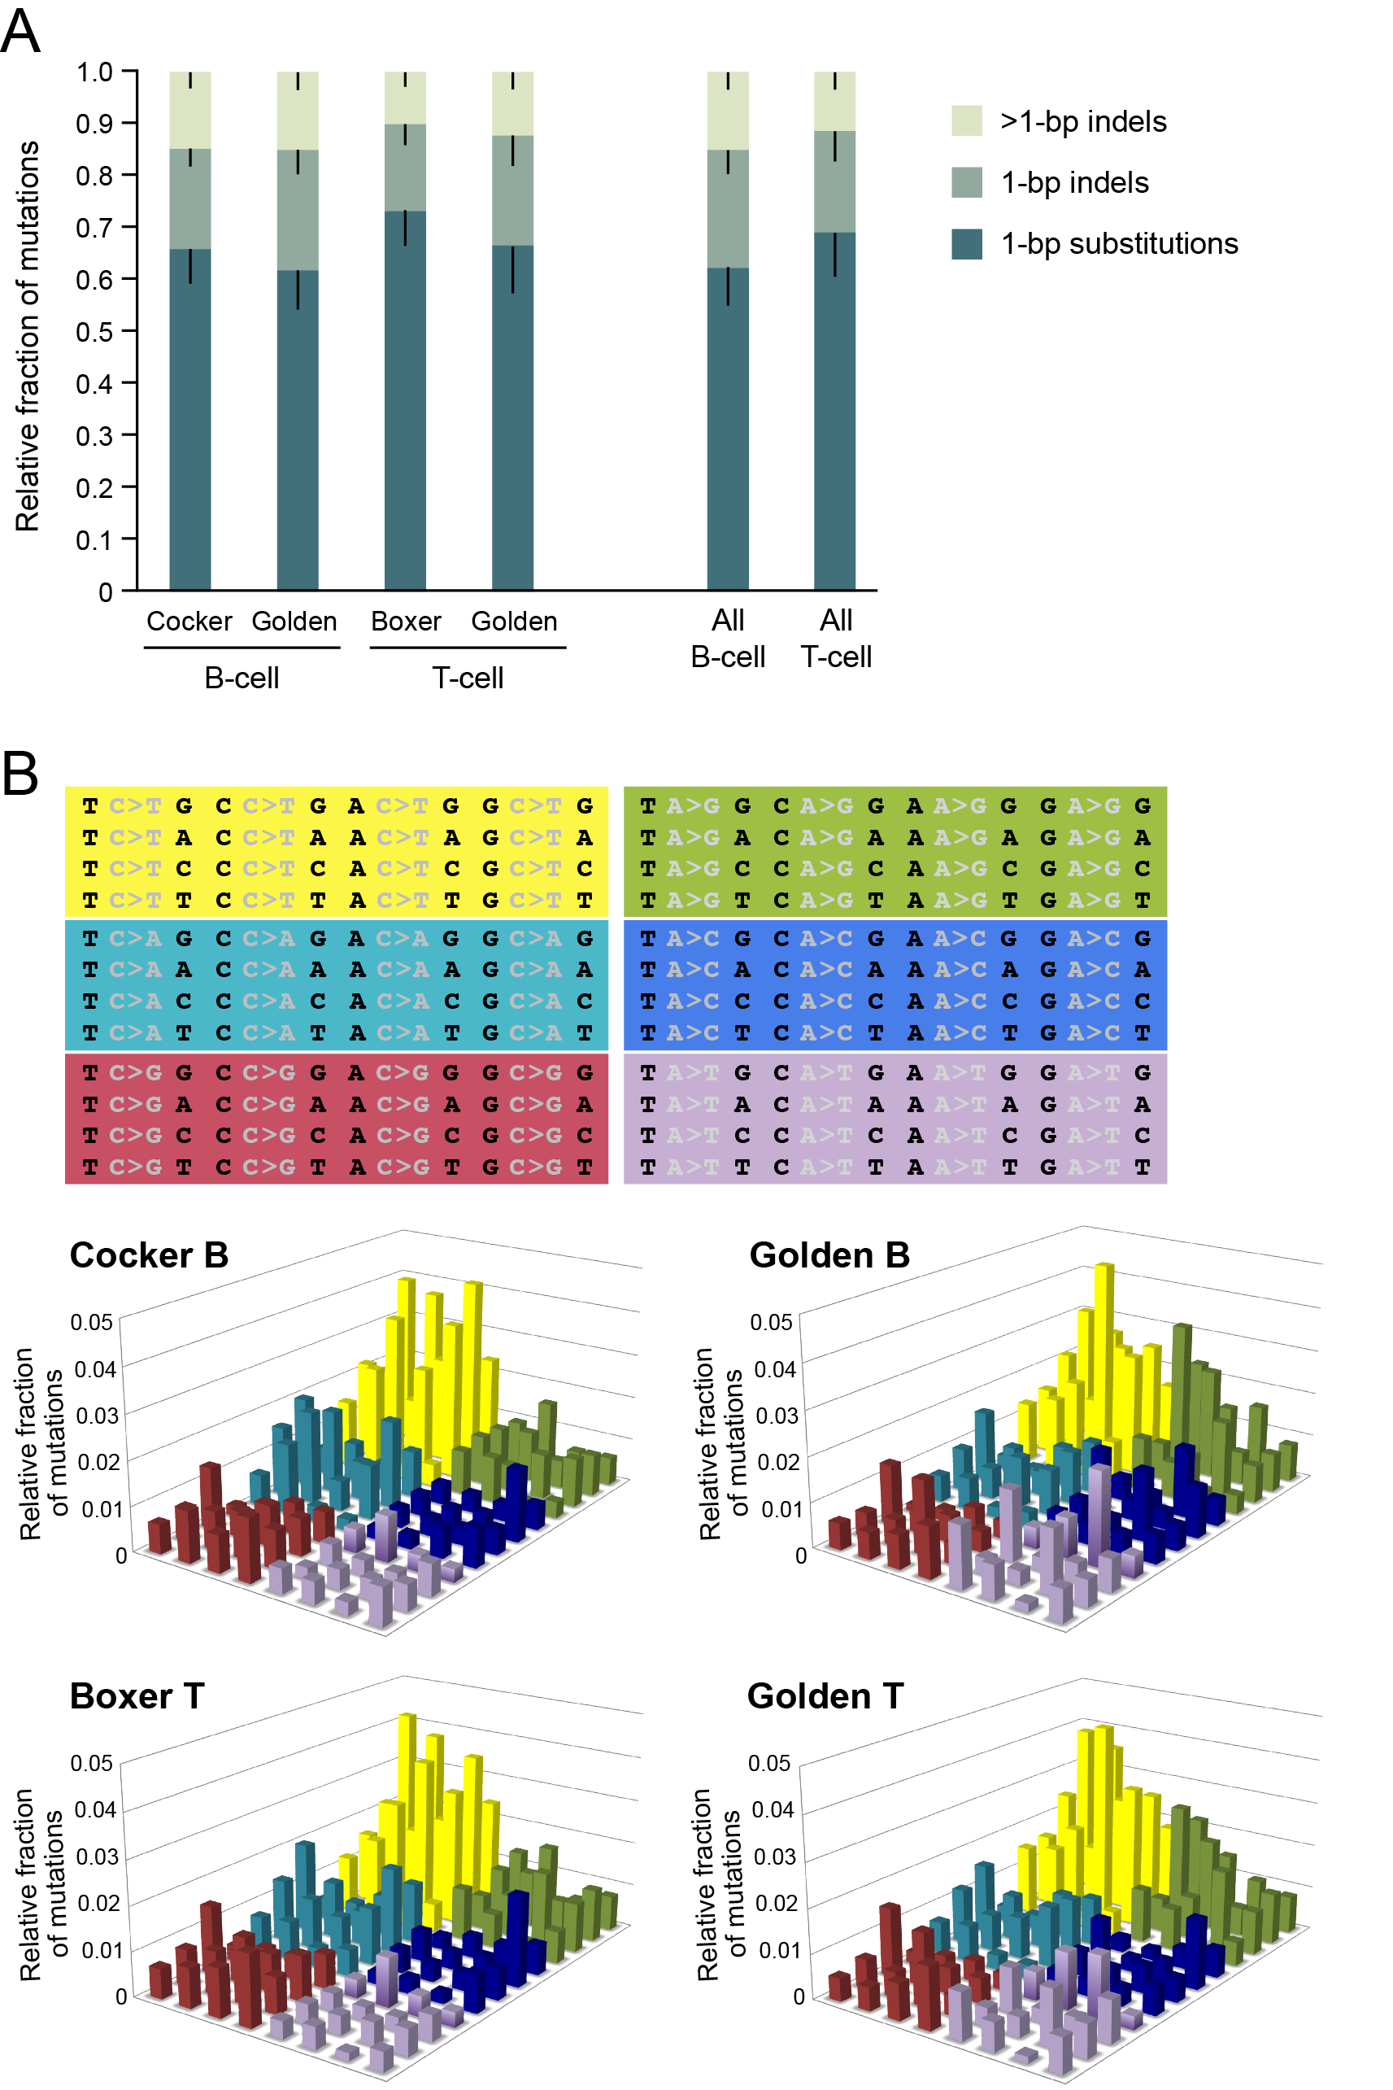

Supplementary Figure 1. General mutation load in B- and T-cell lymphoma. A, relative fraction of mutation type show overall similarities but with relatively more larger indels and less single basepair substitutions in B-cell lymphomas. B, single base-pair substitutions plotted to visualize the preceding and following base. The single base-pair substitution pattern is similar in all sample groups, with certain substitution patterns over- or underrepresented.
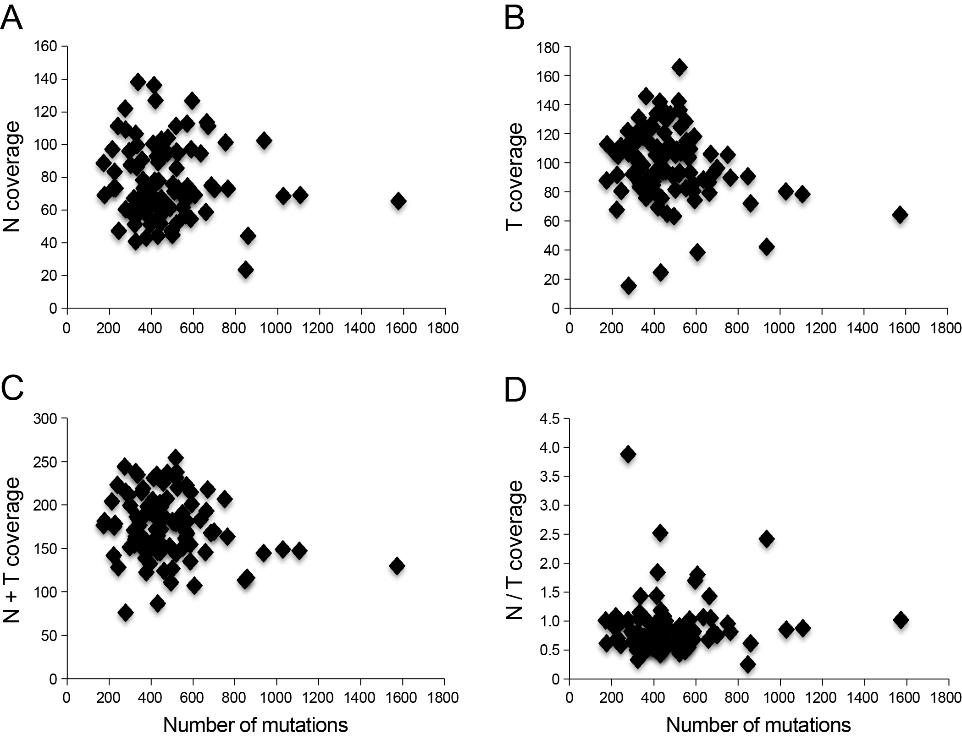

Supplementary Figure 2. Sequencing depth (y-axis) does not correlate with number of tumor-specific mutations (x-axis) when comparing mutations to A. Normal coverage, B. Tumor coverage, C. Tumor+Normal coverage, or D. Normal/Tumor coverage.

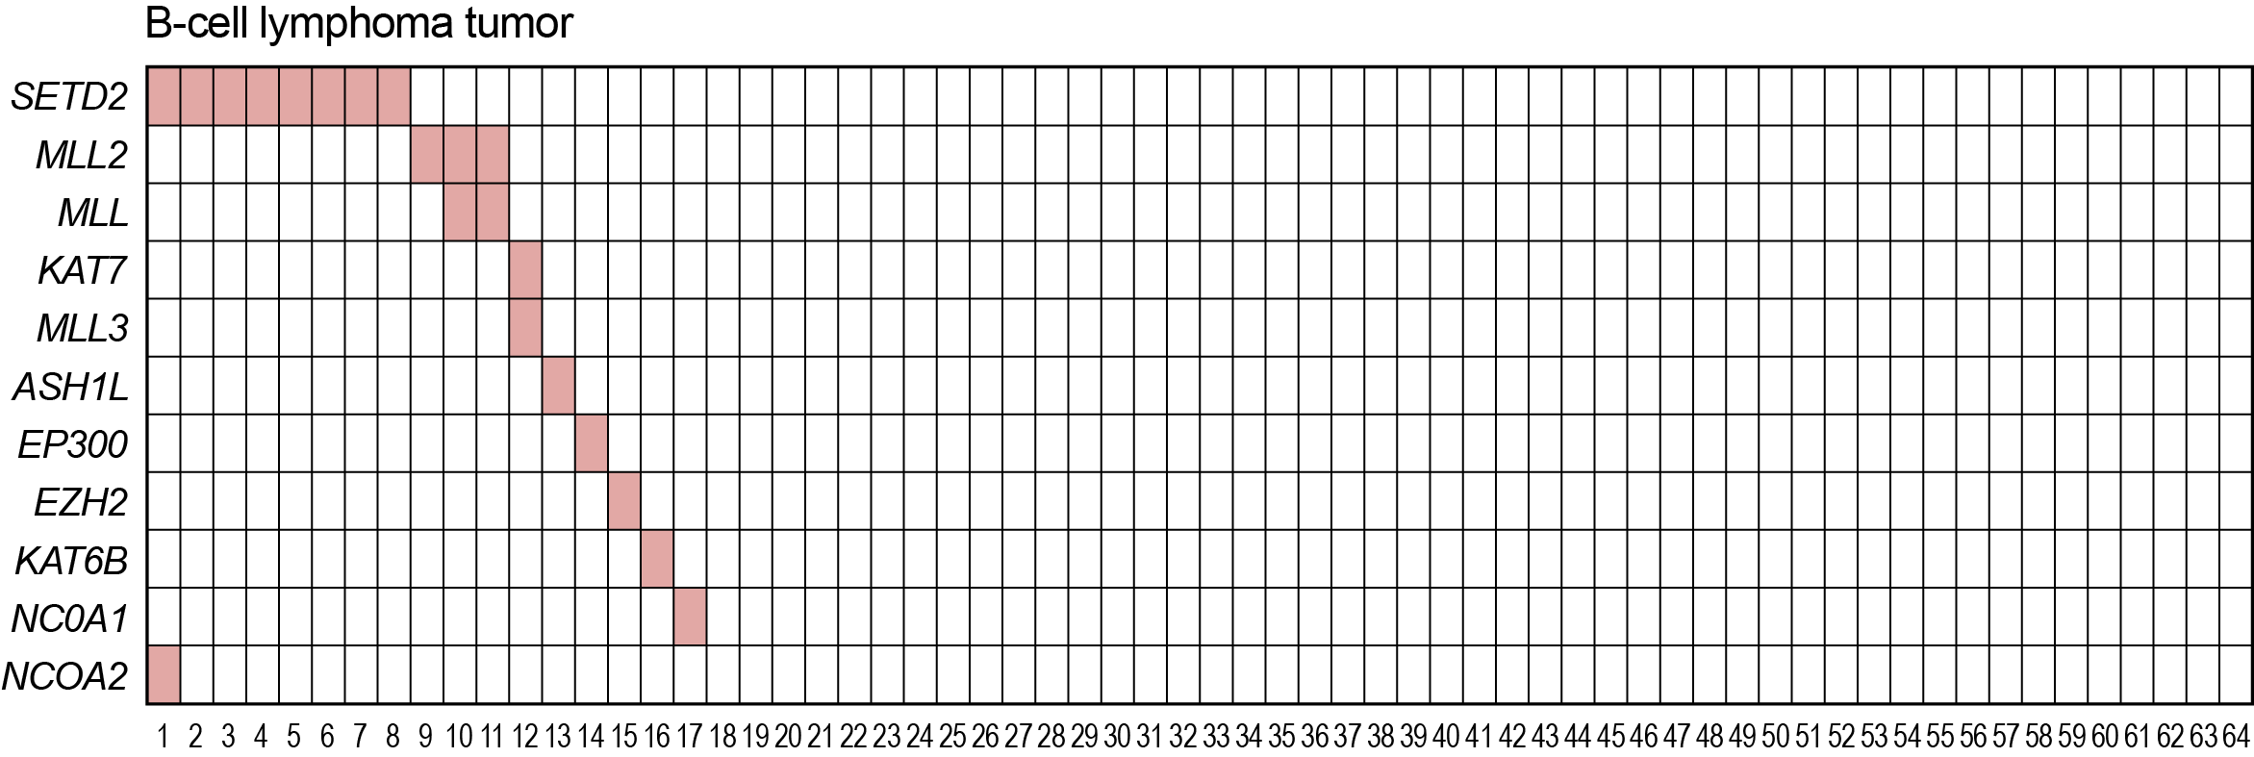

Supplementary Figure 3. Histone acetyltransferase and methyltransferase mutations in B-cell lymphoma tumors. 12.5% of all B-cell lymphomas studied have a mutation in SETD1. Red, mutation. White, no mutation.

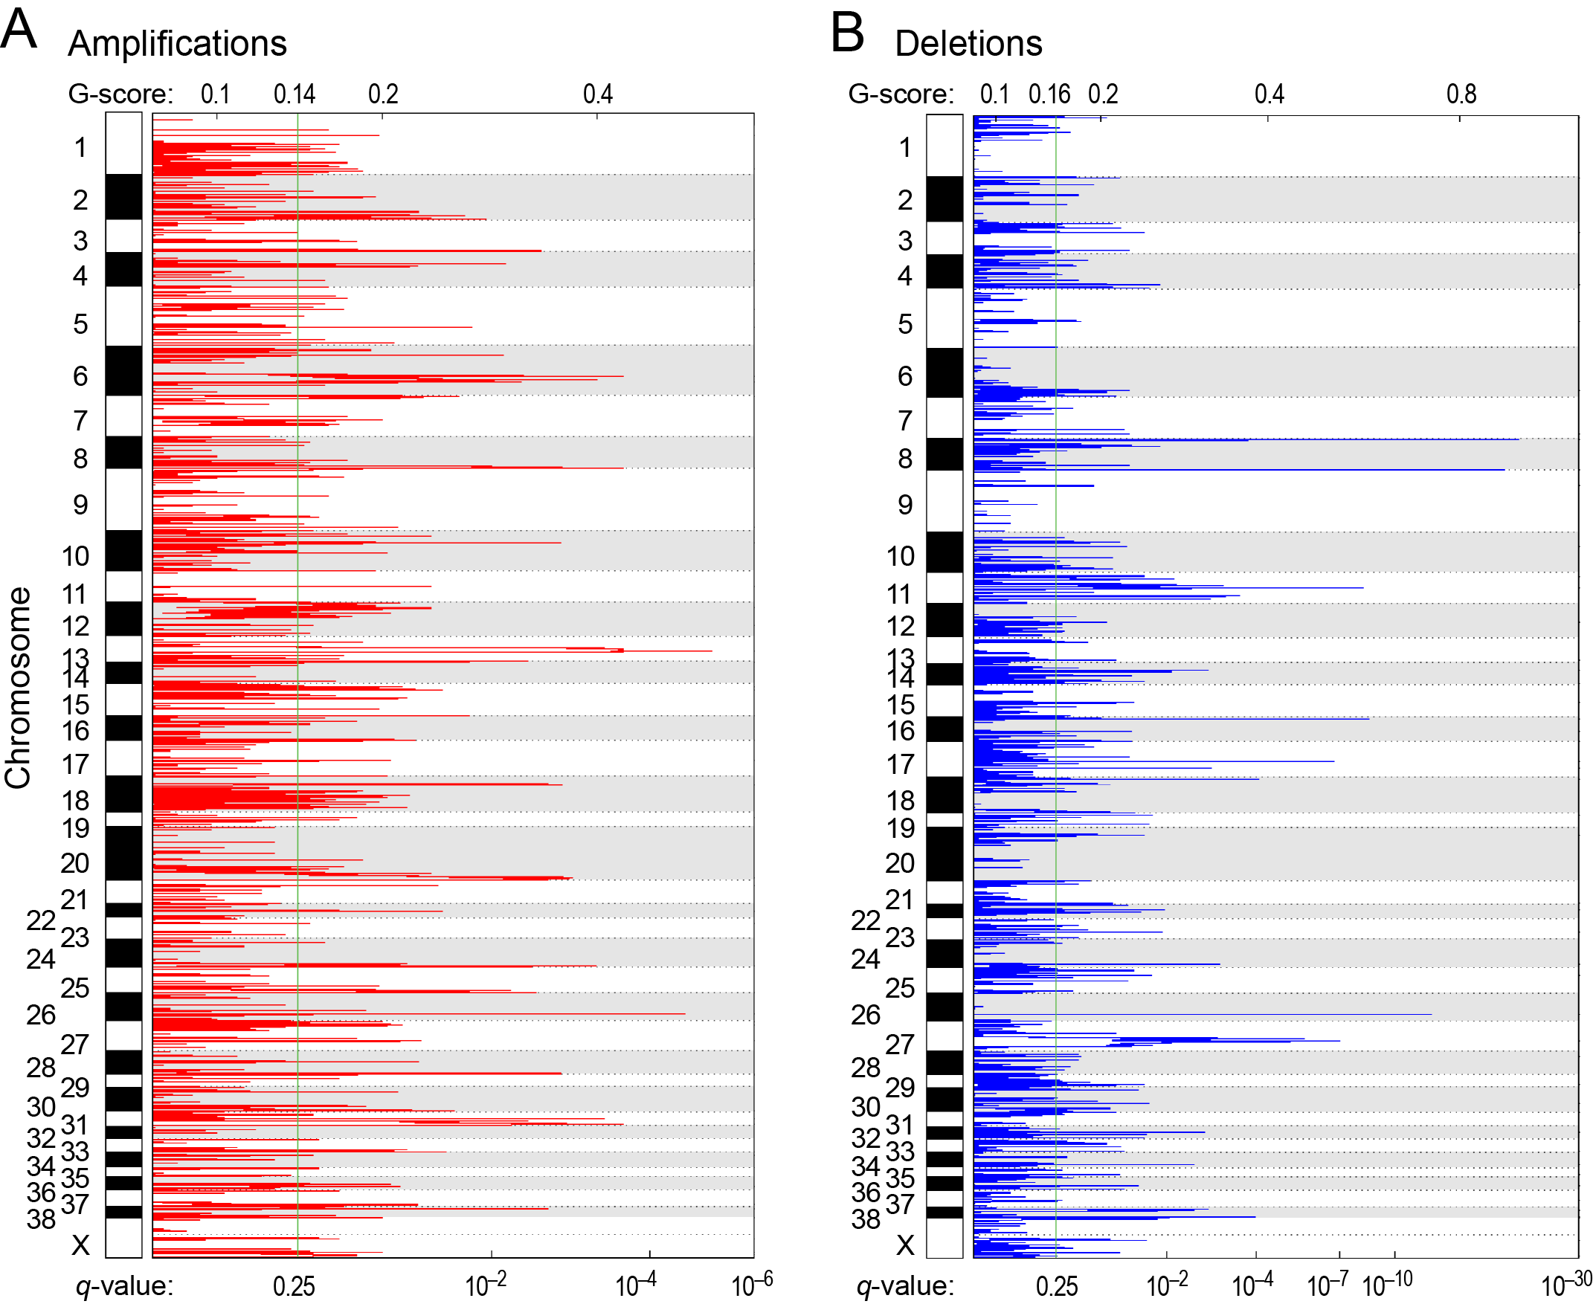
Supplementary Figure 4. Somatic copy number alterations estimated with GISTIC visualizing A. amplifications, and B. deletions.

