Supplemental figure legends
Figure S1. ZLD protein is not detected in stage 5 embryos depleted of maternal zld. A stage 5 yw control embryo and an embryo depleted of maternal zld (zld^{M-}) stained with anti-ZLD (green) and anti-tubulin antibodies (red) as a staining control.

Figure S2. FAIRE-seq data from 2-3 hour yw embryos are similar to previously published FAIRE-seq data from 2-4 hour OreR embryos. Scatter plot of the FAIRE signal from 2-3 hour yw embryos versus the FAIRE signal from 2-4 hour OreR embryos (McKay and Lieb 2013). Spearman’s rho = 0.75.

Figure S3. Levels of ZLD binding, as assayed by ChIP-seq signal, are correlated with a dependence on ZLD for chromatin accessibility. ZLD ChIP-seq peaks were binned into ten equally sized groups based on the peak height. For each decile, the fold change in FAIRE signal was calculated by dividing the average FAIRE z-score from the yw control embryos by the average FAIRE z-score in the zld^{M-} embryos. z-scores were used to allow quantitative comparisons between the two data sets. Similar results were obtained when the raw FAIRE signal was used.

Figure S4. FAIRE regions that depend on ZLD for accessibility (differential, ZLD-bound) are associated with genes that require ZLD for accessibility. Published microarray data (Liang et al., 2008) was used to determine ZLD-dependent gene expression.

Figure S5. Early RNA Polymerase II binding is associated with promoters that require ZLD for chromatin accessibility. Plot of average ChIP-signal for RNA Pol II at promoters at two different developmental time points spanning the MZT. Colors indicate the different FAIRE classes. Plots are centered on the FAIRE peak and oriented relative to the transcription start site of the nearest gene.

Figure S6. Histone modifications associated with regions of open chromatin. Distribution of ChIP-seq signals for histone marks indicated on the right surrounding individual classes of FAIRE peaks at specific nuclear cycles during the early stages of embryonic development. Colors indicate the different FAIRE classes. Plots are centered on the FAIRE peak and oriented relative to the transcription start site of the nearest gene.

Figure S7. ZLD binding, and not a dependence on ZLD for chromatin accessibility, correlates with the mean number of transcription factors bound to the regions, regardless of genomic location. Mean number of transcription factors (TFs) bound to each class of FAIRE peaks subdivided by genome annotation. Colors indicate the different FAIRE classes.

Supplemental Tables

Table S1. Motifs enriched in individual classes of FAIRE peaks with p-values and descriptions of the motif. Position weight matrices for ZLD and GAF binding generated by bacterial one-hybrid (Zhu et al. 2011), ChIP for ZLD (Harrison et al. 2011) or ORGANIC profiling for GAF (Kasinathan et al. 2014) are on the right.
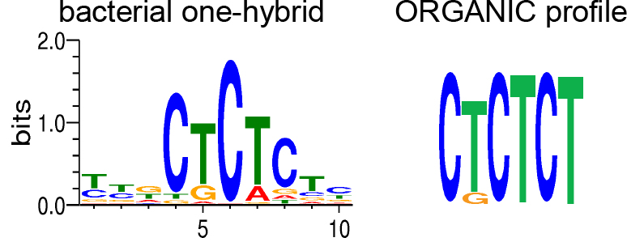
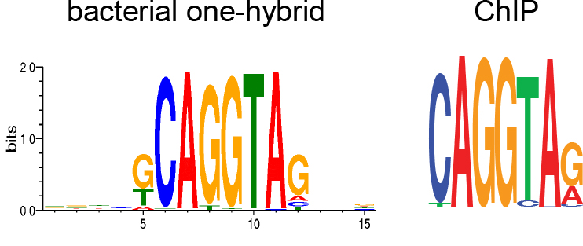

differential, ZLD-bound | Motif | p-value | Description
 | CAGGTA | 1 e-167 | ZLD binding
 | AGGTAG | 1 e-122 | ZLD binding
 | CCTGNC | 1 e-34 | ZLD binding
 | CCTGNA | 1 e-29 | ZLD binding
 | CCTNCC | 1 e-28 | ZLD binding
 | GNTACC | 1 e-25 | ZLD binding
 | GATCC | 1 e-23
differential, not ZLD-bound
 | CCCCANC | 1 e-9
 | GNGGAGC | 1 e-8
 | AGNGAG | 1 e-6
constitutive, ZLD-bound
 | CAGGTA | 1 e-96 | ZLD binding
 | AGGNAG | 1 e-82 | ZLD binding
 | CTCNCTC | 1 e-61 | GAGA  binding
 | CTCTNTC | 1 e-54 | GAGA  binding
 | CNCTCTC | 1 e-53 | GAGA  binding
 | AGNGAGA | 1 e-51 | GAGA  binding
 | GAGANA | 1 e-48 | GAGA  binding
constitutive, not ZLD-bound
 | TNTTAAA | 1 e-22 | AT-rich
 | TTTXAAA | 1 e-21 | AT-rich
 | ATTTAA | 1 e-18 | AT-rich
 | TNAATAA | 1 e-14 | AT-rich
 | TANTTTA | 1 e-12 | AT-rich
 | ANTATT | 1 e-10 | AT-rich
differential vs. constitutive
 | CAGGTA | 1 e-105 | ZLD binding
 | AGGTAG | 1 e-84 | ZLD binding
 | ACCTGC | 1 e-34 | ZLD binding
 | AGANCC | 1 e-24
 | CCTGNCC | 1 e-22
 | CCCAG | 1 e-20
constitutive vs. differential
 | TNTTAAA | 1 e-20 | AT-rich
 | ANAAAAA | 1 e-17 | AT-rich
 | AANTAAA | 1 e-17 | AT-rich
 | AAAAAT | 1 e-16 | AT-rich
 | TAAATA | 1 e-15 | AT-rich
 | AAAATA | 1 e-15 | AT-rich
 | TNTAAAA | 1 e-15 | AT-rich
 | TTNTAAA | 1 e-15 | AT-rich
 | ATTTAA | 1 e-13 | AT-rich

Supplemental References

Harrison MM, Li XY, Kaplan T, Botchan MR, Eisen MB. 2011. Zelda binding in the early Drosophila melanogaster embryo marks regions subsequently activated at the maternal-to-zygotic transition. PLoS Genet 7: e1002266.

Kasinathan S, Orsi GA, Zentner GE, Ahmad K, Henikoff S. 2014. High-resolution mapping of transcription factor binding sites on native chromatin. Nature methods 11: 203-209.

McKay DJ, Lieb JD. 2013. A common set of DNA regulatory elements shapes Drosophila appendages. Developmental cell 27: 306-318.

Zhu LJ, Christensen RG, Kazemian M, Hull CJ, Enuameh MS, Basciotta MD, Brasefield JA, Zhu C, Asriyan Y, Lapointe DS et al. 2011. FlyFactorSurvey: a database of Drosophila transcription factor binding specificities determined using the bacterial one-hybrid system. Nucleic Acids Res 39: D111-117.

