Oxford Nanopore Sequencing, Hybrid Error Correction and de novo Assembly of a Eukaryotic Genome

Supplemental Notes and Figures

Table of Contents
Supplemental Note 1. Flowcell performance 2
Supplemental Note 2. Nanopore sequencing production over time 5
Supplemental Note 3. Size selection and read lengths 6
Supplemental Note 4. Base-caller 5-mer performance 9
Supplemental Note 5. Raw read accuracy and coverage 12
Supplemental Note 6. Nanocorr performance of yeast genome 17
Supplemental Note 7. Nanocorr performance of E. coli K12 genome 19
Supplemental Note 8. Reference-Guided Assembly 21
Supplemental Note 9: Choice of Aligner 22
Supplemental Note 10: Flowcell Downsampling 25
Supplemental Note 11. Flow cell details 26
Supplemental References 31

Supplemental Note 1. Flowcell performance

We chose to sequence the yeast genome so that we could carefully measure the accuracy and other data characteristics of the device on a tractable and well-understood genome. Our flowcells have shown somewhat low reliability and throughput over the course of this project (Supplemental Figure 1A). However the average yield has generally improved over time though performance is still quite variable (Supplemental Figure 1B).This is due to a combination of improvements in chemistry, protocols, instrument software, and shipping conditions. Some runs have produced upwards of 450 Mb of sequencing data per flow cell over a 48 hour period. Seven of the highest yielding flow cells (flowcells generating more than 100Mb) produced over 82% of the data generated for the assembly of yeast W303.
The MinIon software can predict the number of functional pores before a run is started. In this study the number of predicted functional pores ranged from fewer than 100 to over 400. We found that if fewer than 350 functional pores were predicted, the resulting data amounts were severely limited and was a major source of variation in this study.

Figure S1A. Yield (Mb) and read distribution for each flowcell
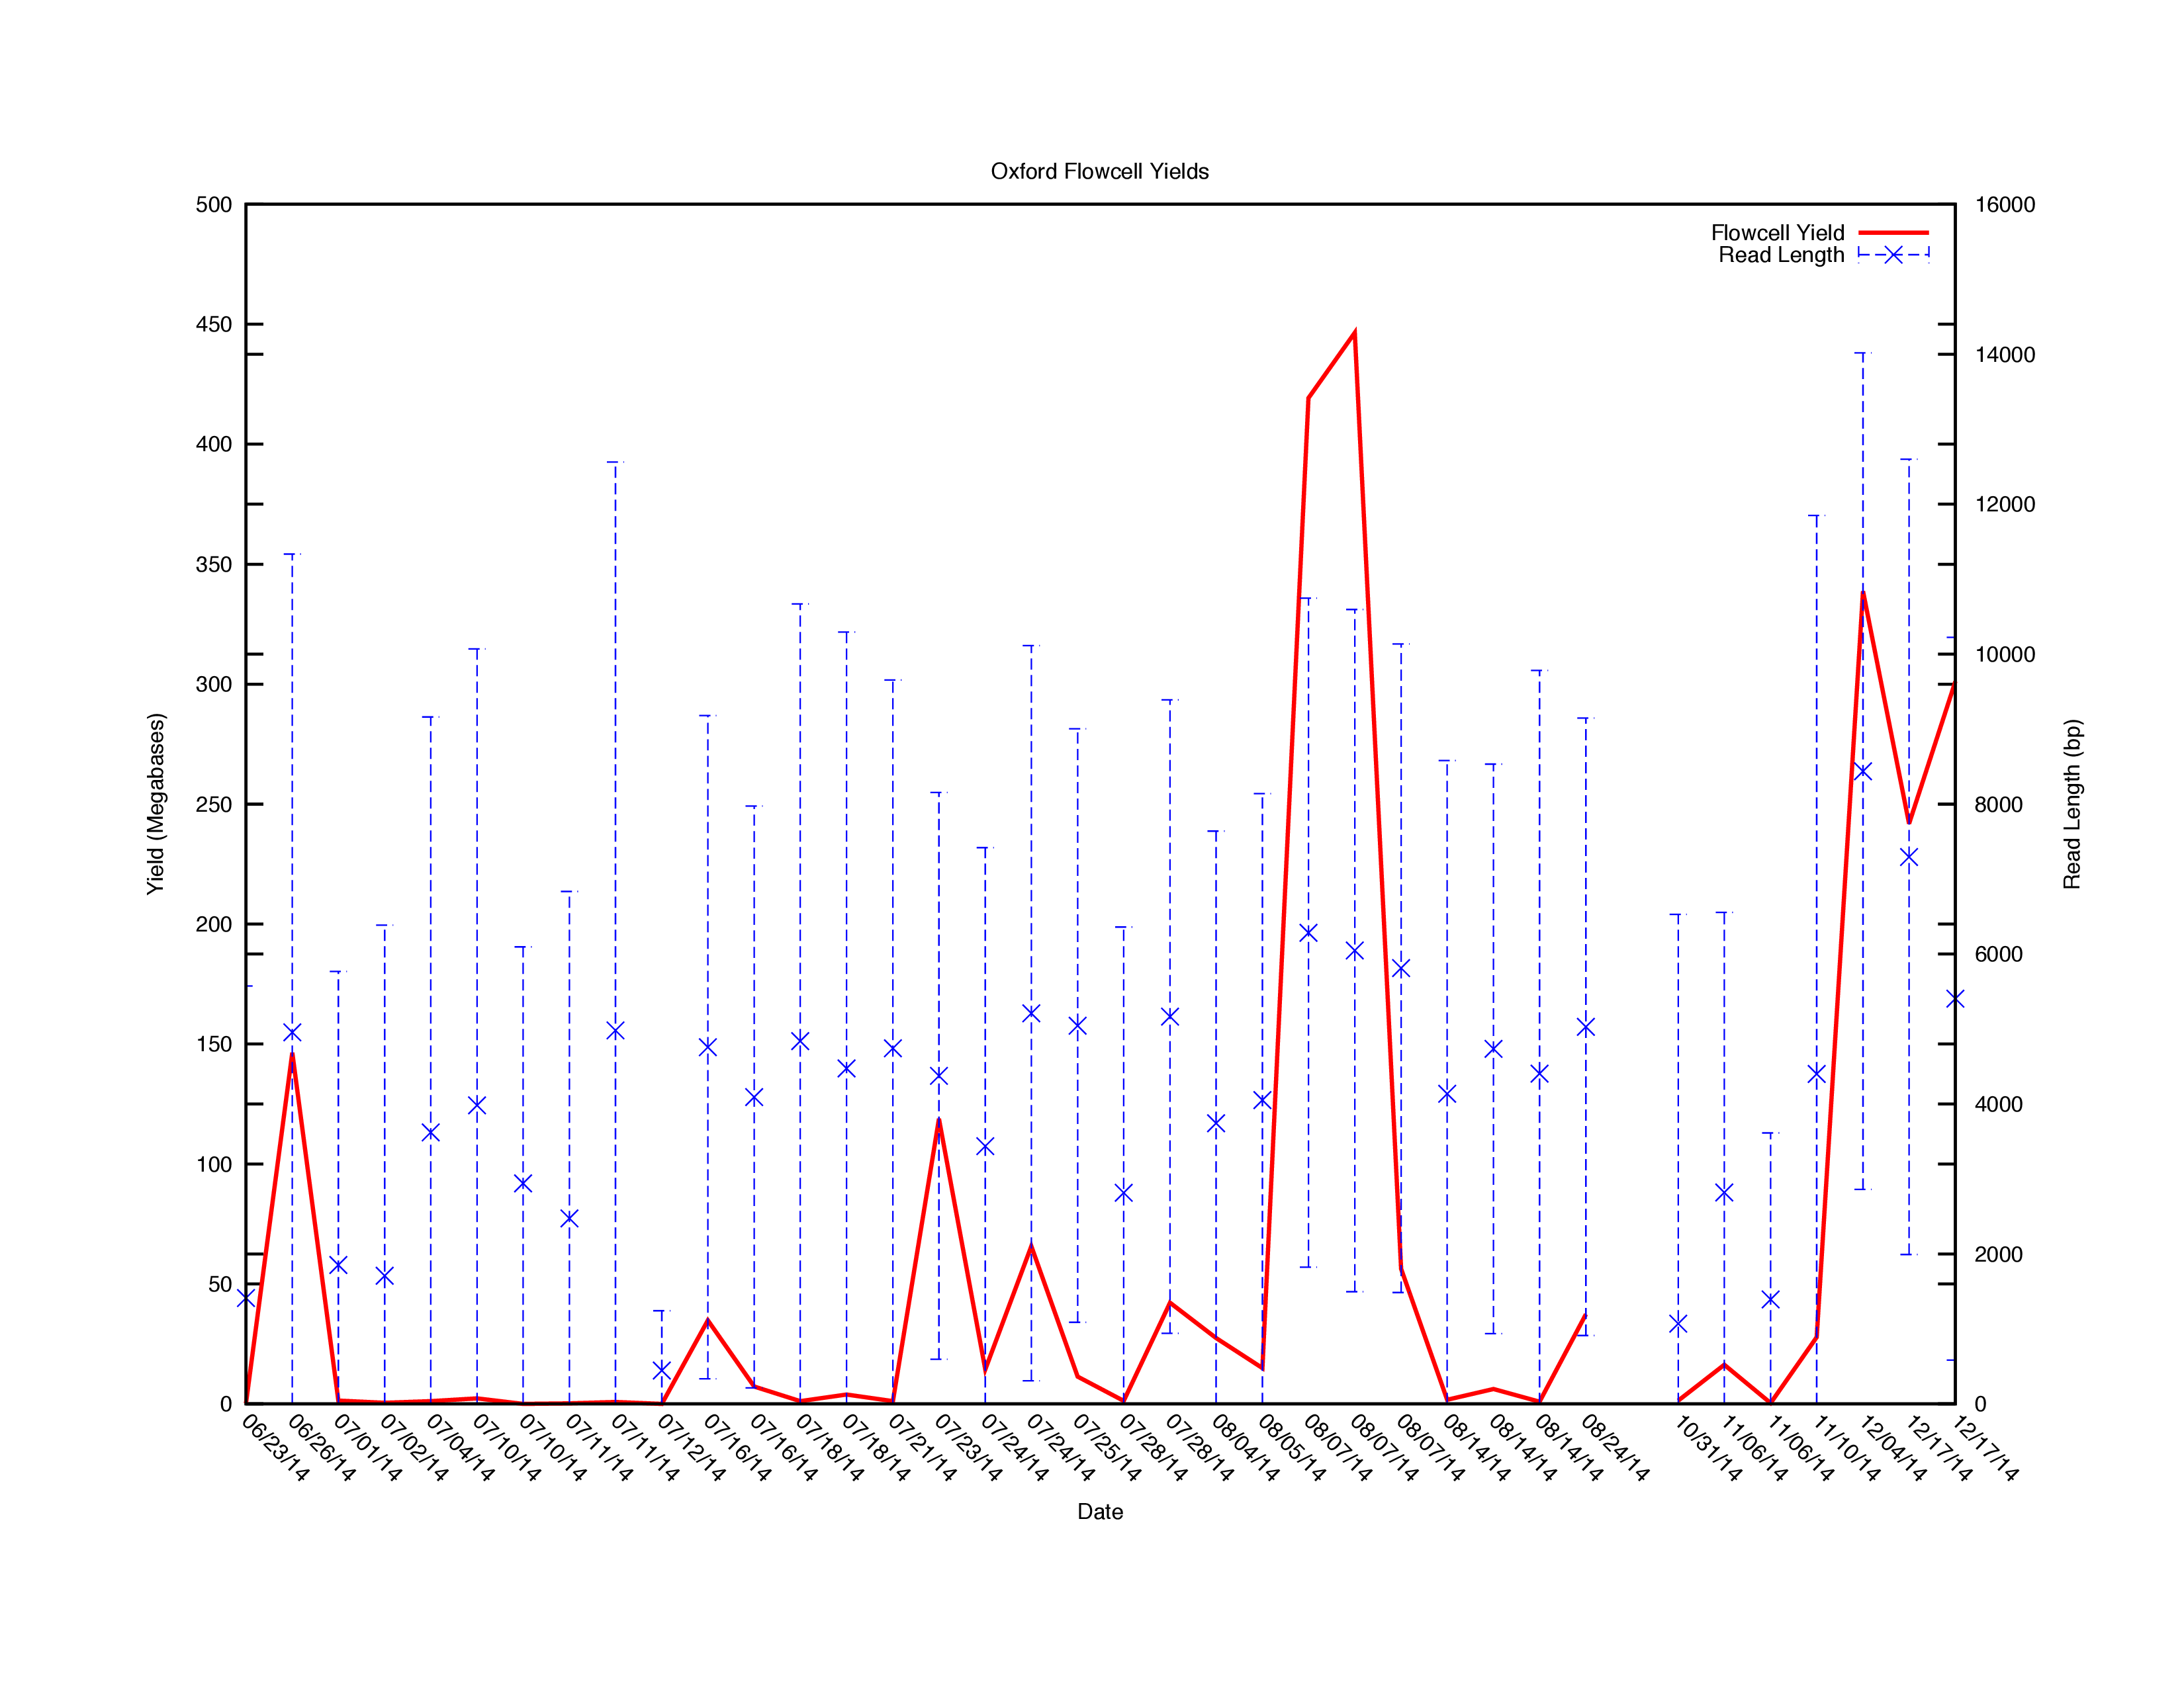
Figure S1A Flowcell yield and read lengths over time. Blue bars indicate the minimum, average and maximum length read from each flowcell. Read lengths have remained constant over the course of program. Flowcells used from 6/23/14 to 7/16/14 are R6 chemistry, from 7/18/14 to 8/24/14 are R7.0 chemistry, all remaining flowcells are R7.3

Figure S1B. Yield (Mb) for each flowcell iteration

Figure S1B. Average yield of each flowcell iteration for genomic preparations. R7.3 represents data from yeast and our own sequencing of E coli.

Supplemental Note 2. Nanopore sequencing production over time

To evaluate the productivity of each flowcell, we examined the cumulative base generation over time and found that sequencing throughput is nearly linear out to 48 hours. Although the instrument can be run indefinitely, the predefined protocol suggests ending the run at 48hrs after which sequence production begins to taper off.

Figure S2. Flowcell Yield (Mb) over time for a single run
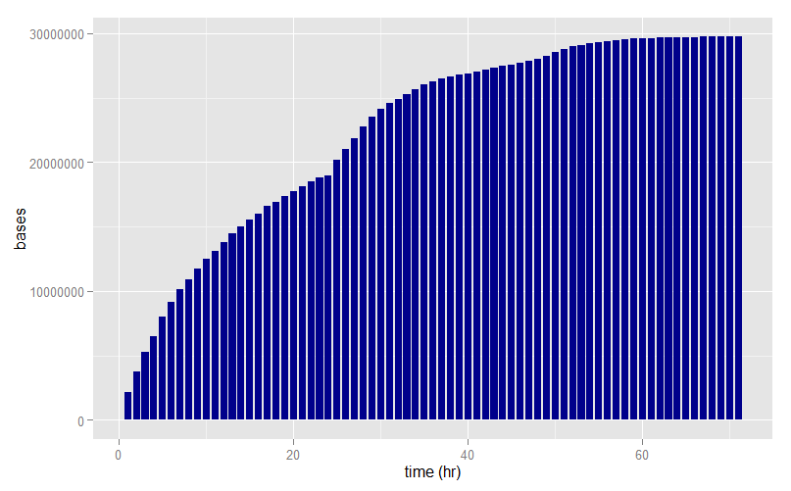

Figure S2. Yield over time bar chart. This plot displays the number of bases sequenced over each hour of a 72 hour run. The sharp increase in the flowcell yield observed at 24 hours is the point at which active pores are reselected and poor performing pores can be replaced with fresh pores.

Supplemental Note 3. Size selection and read lengths

The majority of the libraries used for this study were generated with a shearing parameter of 10kb, without significant size selection. The stochastic loading of DNA fragments into individual pores suggests that the length distribution of the resulting reads should mirror the length distribution of the fragments in the sample. Figure S3A shows a Bioanalyzer trace for a library sheared at 10kb. The peak at 17kb is the upper limit marker for the trace. The majority of fragments are between 5kb and more than 10kb. Figure S3B shows the fragment distribution of the same library post-sequencing. As is common with the bioanalyzer trace, the majority of fragments are between 5kb and more than 10kb indicating that many fragments are full length fragments. The 10 kb shearing parameter was compared to shearing at 20kb and omitting the shearing step (Figure S3C). As in the previous figures, the mean fragment length is less than the sheared target size and there are many fragments at 3.5kb, indicating an abundance of control DNA. As the input fragment size increases the sequenced fragment size increases as well. .
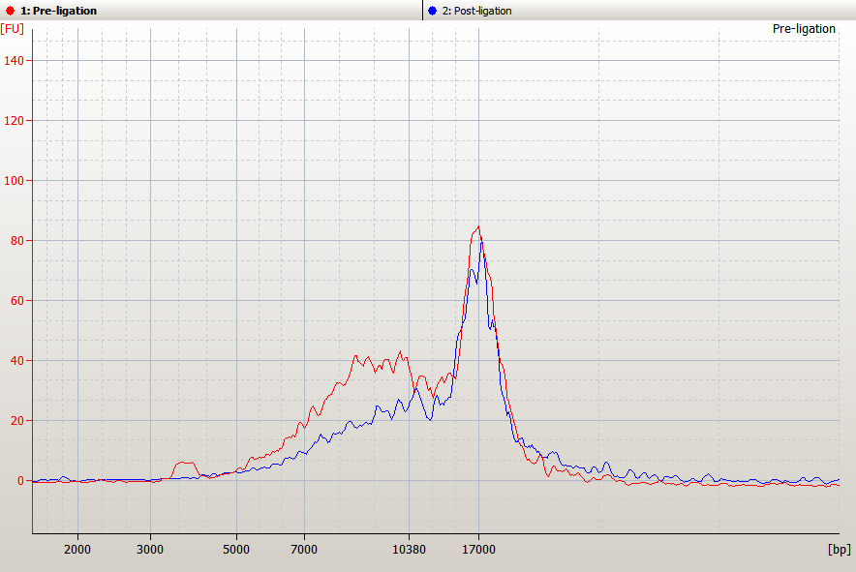
Figure S3A. Bioanalyzer trace for prepared library
Figure S3A. Bioanalyzer traces prepared from an Oxford library sheared at 10kb before and after adapter ligation. The large peak at 17kb is the upper marker.

Figure S3B. Run length distribution for a prepared library

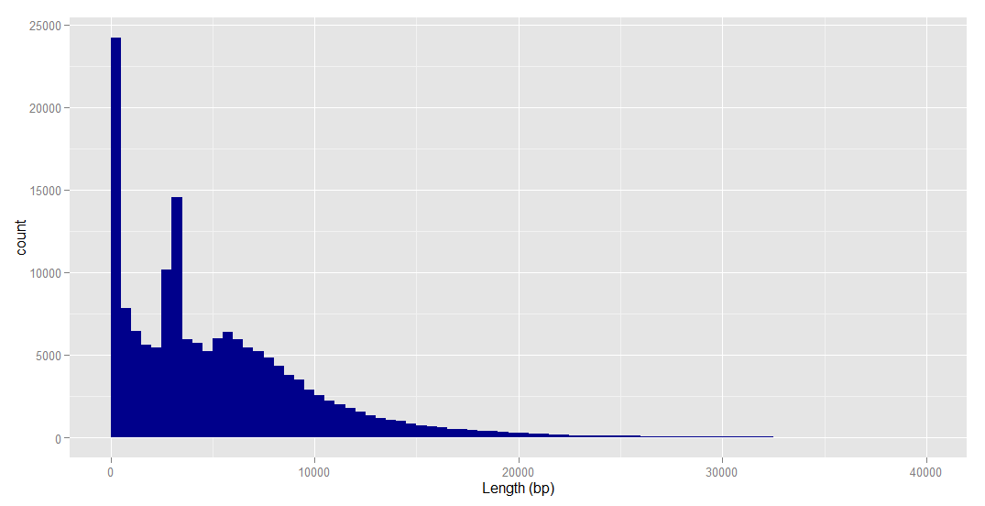
Figure S3B. Fragment lengths derived from sequencing. The large peak at 3500 is a control DNA spike in. For visualization purposes this figure has been truncated to 40000bp however there are a small number of reads that exceed that cutoff.

Figure S3C. Fragment distribution for libraries sheared to different sizes
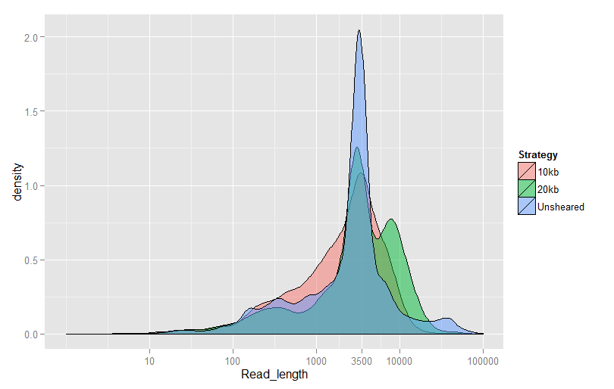
Figure S3C. Overlay of the fragment sizes at different shearing parameters. The large peak at 3500bp is a control DNA spike in. An increase in average fragment size is seen as shearing size is increased.

Supplemental Note 4. Base-caller 5-mer performance

To evaluate the general performance of the base caller, the expected abundance of each 5-mer was calculated from the reference genome and from of all of the reads generated by the flowcells. The abundance of each 5-mer derived from the nanopore data was compared to the abundance of each 5-mer derived from the reference. It was observed that the 5-mers with the least GC content were under represented in the nanopore generated data relative to the reference. 5-mers with the most GC content were over represented in the nanopore data relative to the reference. Overall, the most biased 5-mers were AAAAA and TTTTT with between a 3 and 4 fold lower abundance that would be expected (Figure S4A). There are many potential causes of this, including basecalling errors induced by homopolymers or sequencing bias for or against GC rich regions as has been previously reported in other sequencing technologies.¹¹
As the chemistry and basecalling parameters have improved, biases in the bascalling have also improved. As 5-mer GC content increases from 0 to 100%, the slope of a trend line through the fold change of a 5-mer relative to the reference can be used as an indicator of severity of bias. In a fully unbiased sample the slope would be 0 as the average fold difference from the reference would be 0 for all points regardless of GC content (Figure S4A). When the slope of the trend line is examined for each flowcell version and read type (R6.0-R7.3 and 1D vs 2D) it is seen that the slope is getting closer to 0; from 3.20 for R6.0-1D to 1.52 for R7.3-2D (Figure S4B).

Figure S4A. Distribution of fold change from expected for 5-mers with different GC content

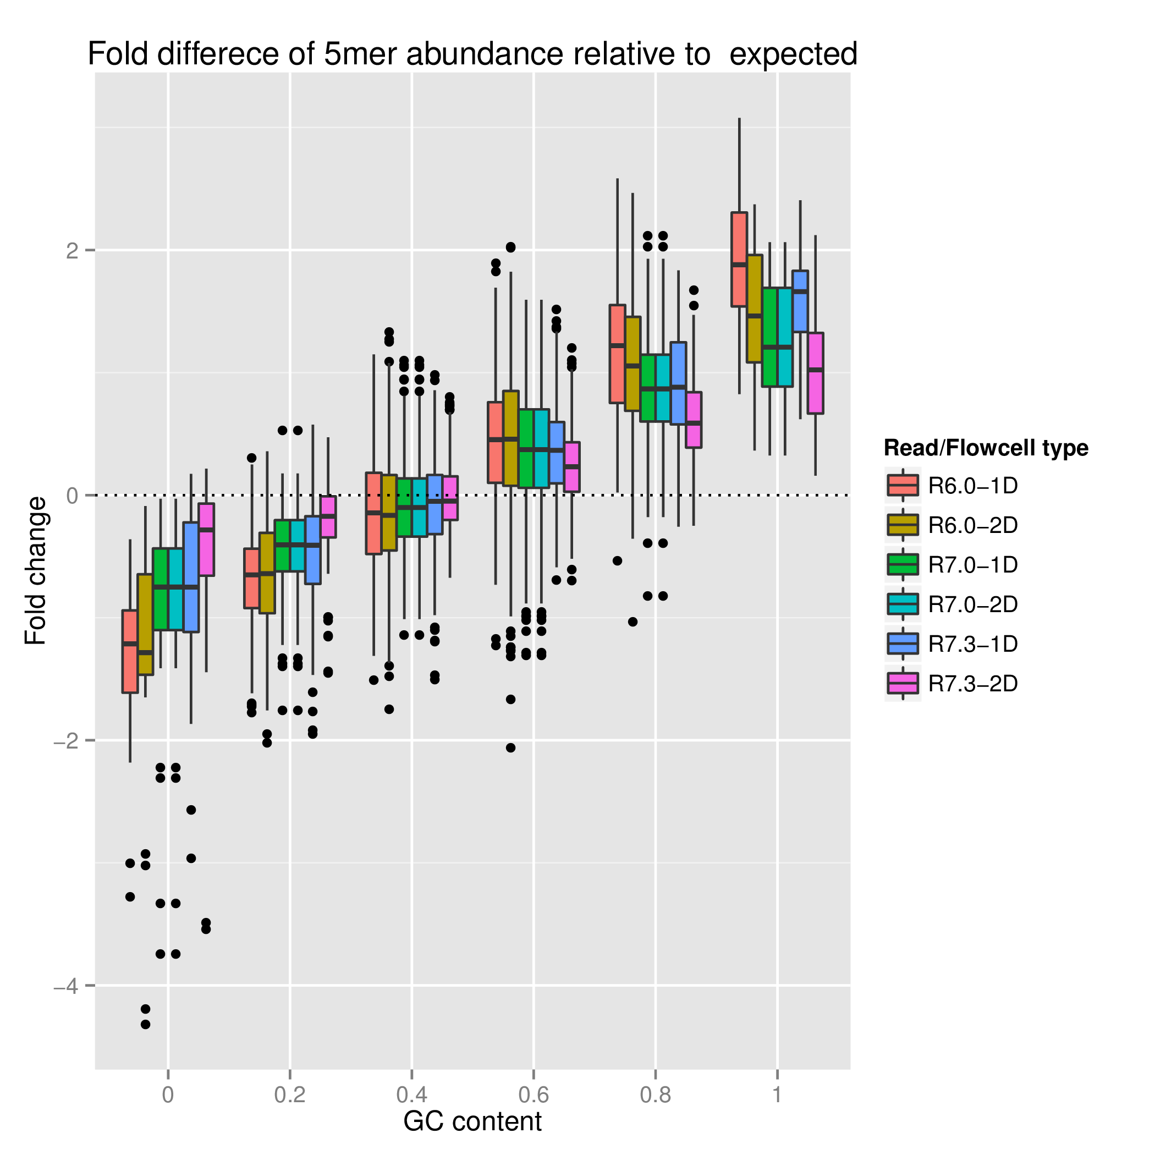

Figure S4A. Distribution of the fold change relative to reference for each possible 5-mer at a given GC content.

Figure S4B. Slope of fold change from expected for 5-mers from 0-100% GC content

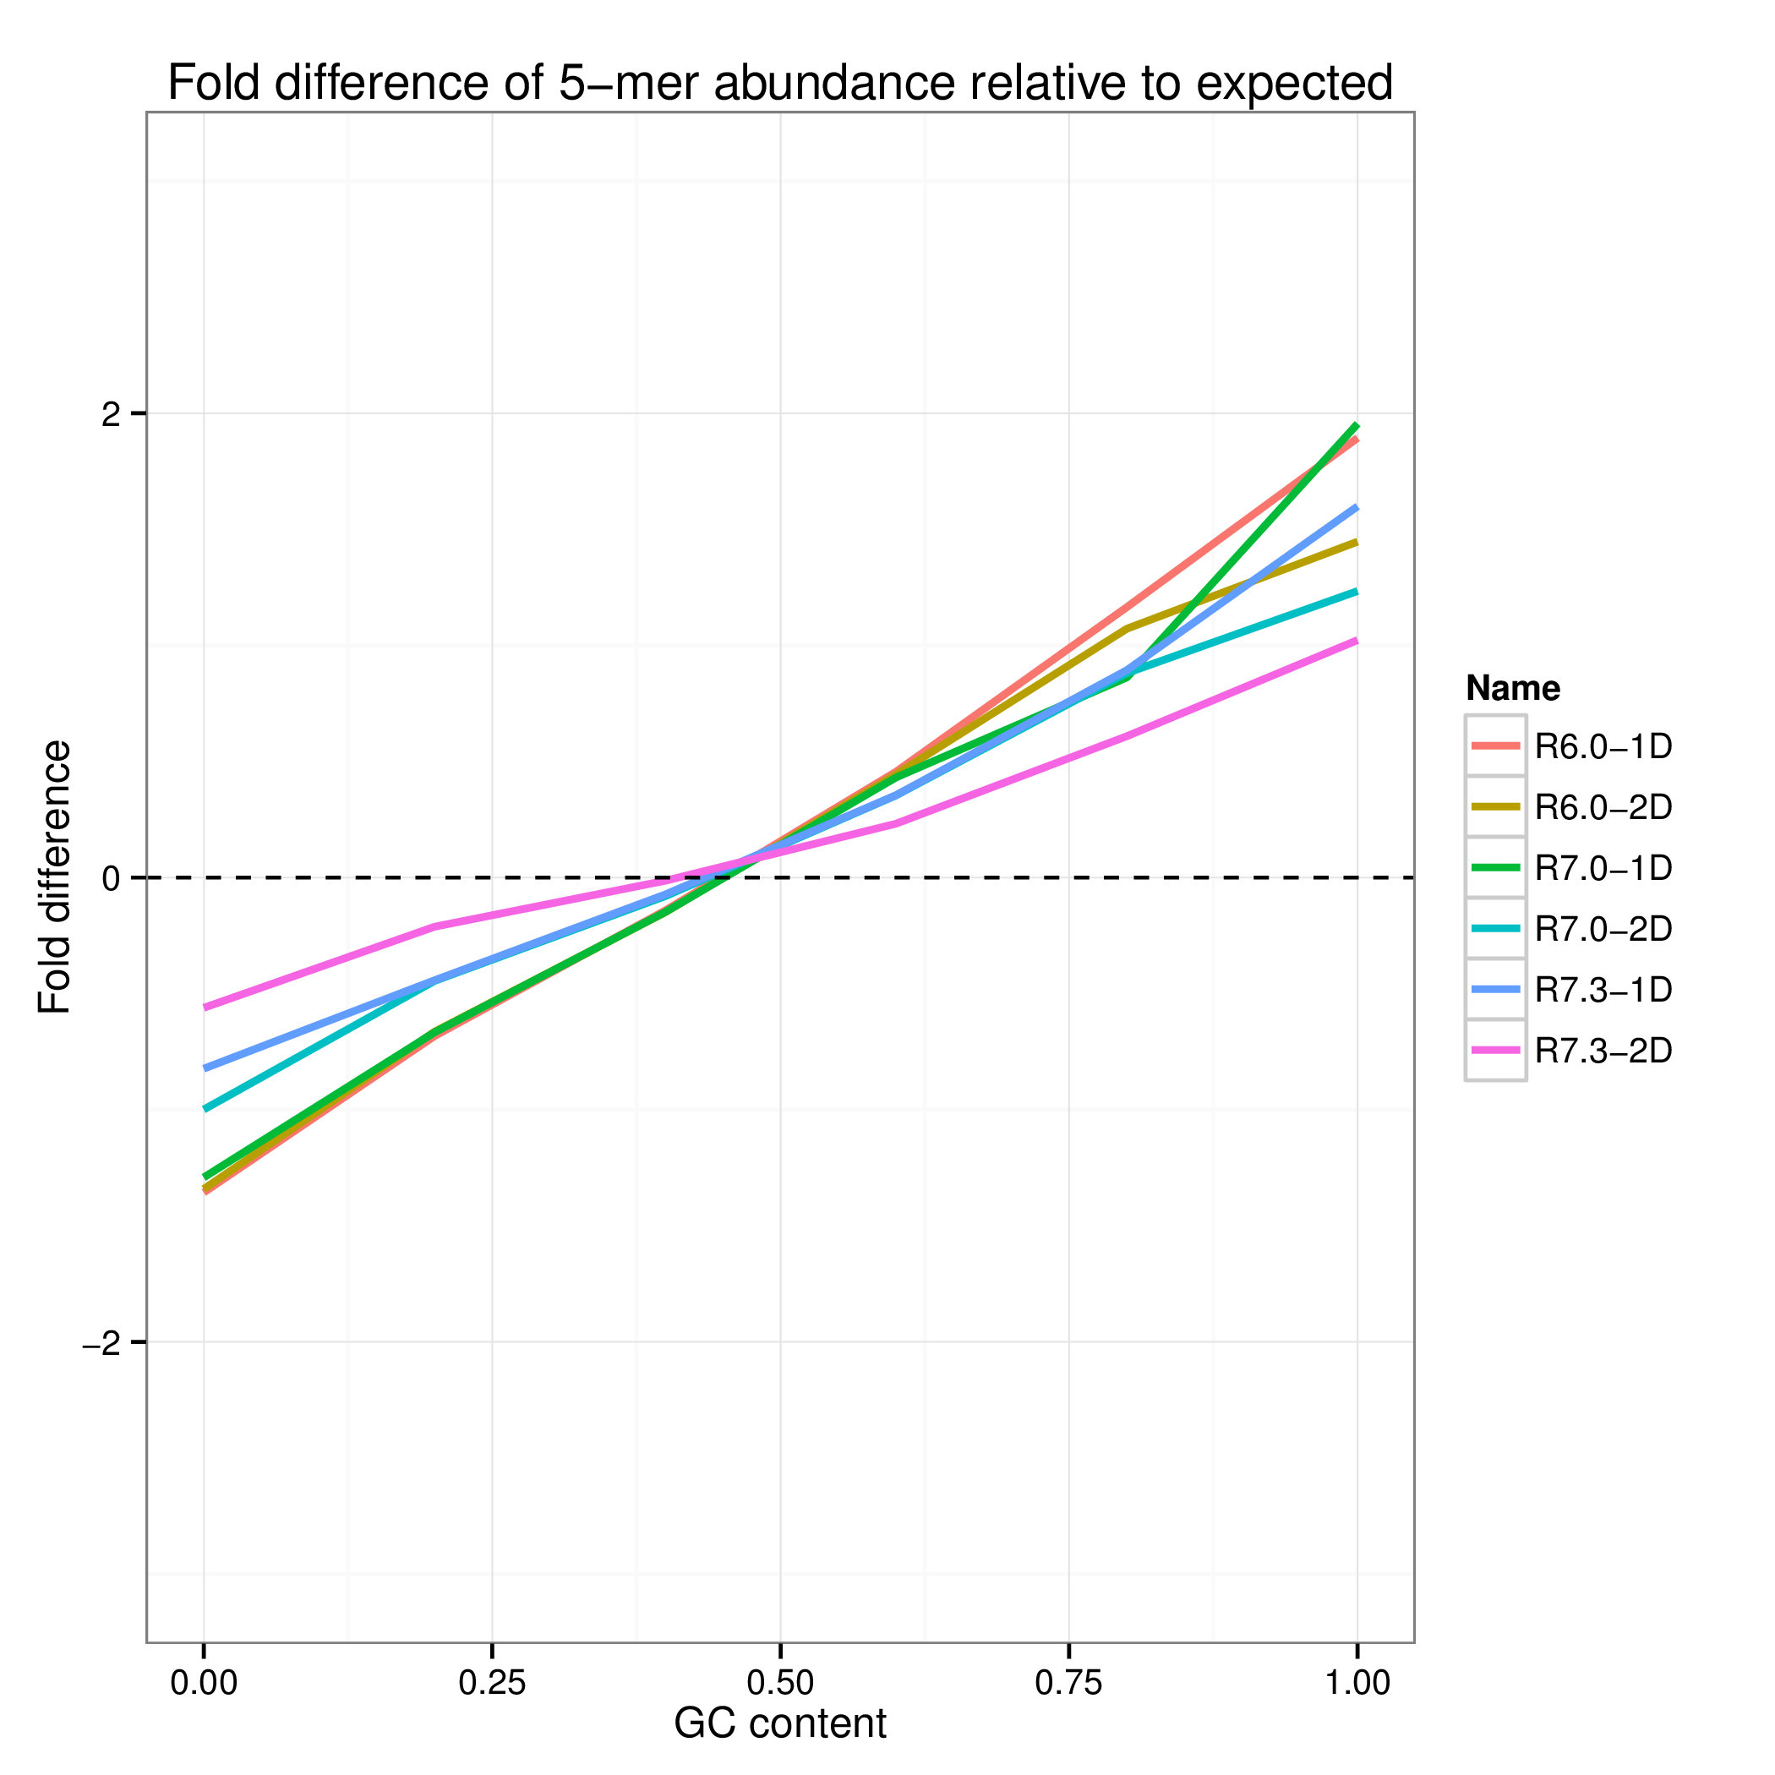
Figure S4B. Trend lines derived from fold change values for each 5-mer for a given GC content. Dashed horizontal line represents perfectly uniform sequencing.

Supplemental Note 5. Raw read accuracy and coverage

Due to the nature of the library preparation, three “types” for reads can be generated. A template and a complement reads read are generated from a single pass along a library molecule. These are termed 1D and they are not built from a consensus. The two-direction read are generated from the consensus between a template and a complement read and are termed 2D. The following figures detail various error and quality metrics collected. Such as the average percent ID was for each of the read “types” (Figure S5A), the error rate across a read (Figure S5B), distribution of aligned reads across the genome (Figure S5C), distribution of reads across various GC content levels (Figure S5D).

Figure S5A. Distribution of percent Identity of each of the three read “types”

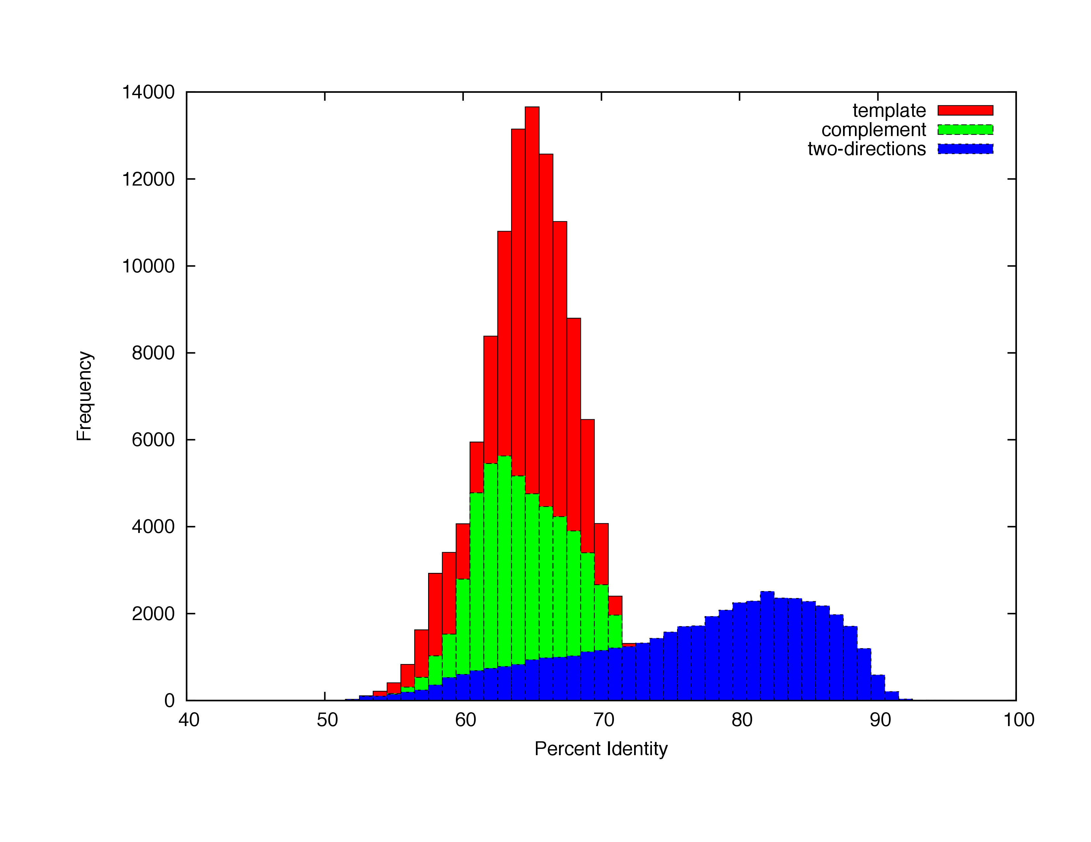

Figure S5A. Histogram of 1D (template and complement) and 2D read accuracy as determined by aligning the reads to the reference genome using BLASTN. The 1D reads average 63% accuracy, while the 2D reads average 72% accuracy. We speculate the bimodal distribution in the accuracy of the 2D is explained by a failure in 2D basecalling for some of 2D reads so that it reverts to 1D accuracy.

Figure S5B. Per-position error rates

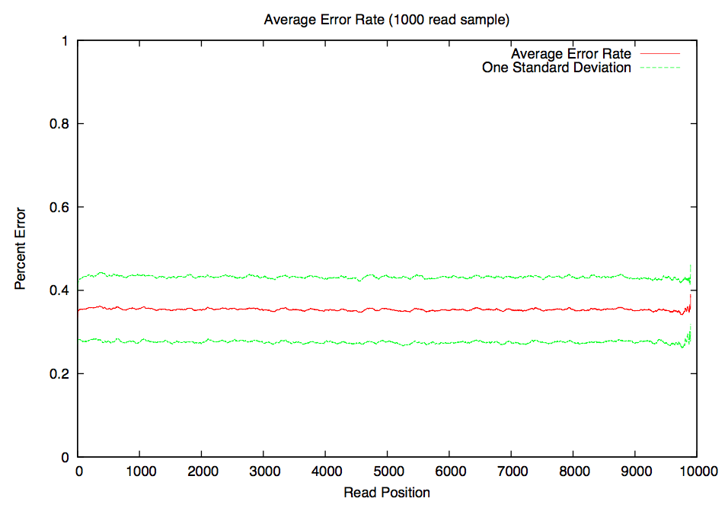

Figure S5B. Average error rate over the length of the read (red). Green lines indicate one standard deviation. 1000 reads with lengths between 9kb and 10kb were sampled and error rate was calculated for 100bp sliding windows using BLASTN alignments to the S288C reference genome

Figure S5C. Distribution of alignment coverage across genome

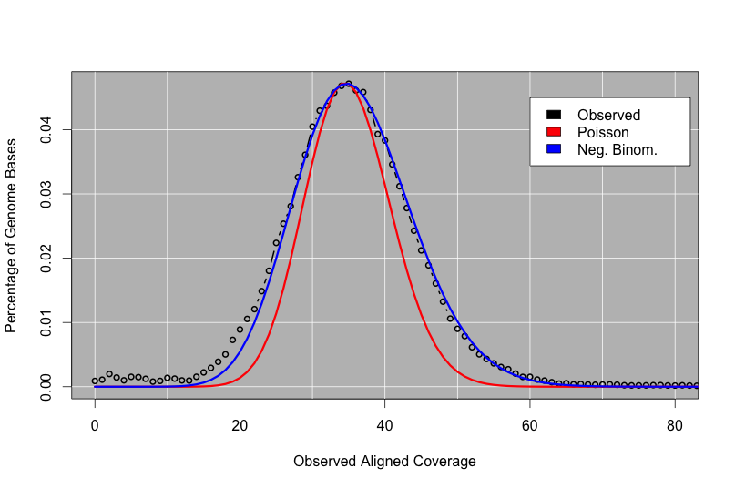

Figure S5C. Distribution of alignment coverage across the S288C reference genome. The observed coverage (black circles) approximates the expected Poisson distribution (red), although it is better represented as a negative binomial distribution with a larger standard deviation.

Figure S5D. Distribution of coverage across different levels of GC content.

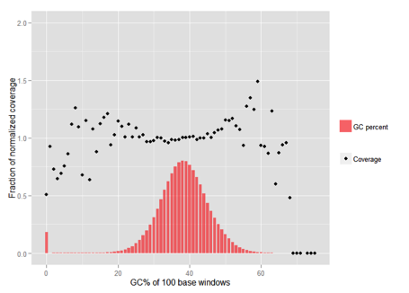
Figure S5D. Plot of coverage relative to the GC content of the W303 genome. Coverage (black dots) is mostly uniform at average GC content (30-50% GC) while high and low GC content shows a more variable coverage profile.

Supplemental Note 6. Nanocorr performance of yeast genome

The raw and error corrected reads, along with the final assemblies and parameters used for the error correction and assembly can be found on the nanocorr website:
http://schatzlab.cshl.edu/data/nanocorr/

Figure S6A. Distribution of percent identities for corrected and uncorrected yeast reads
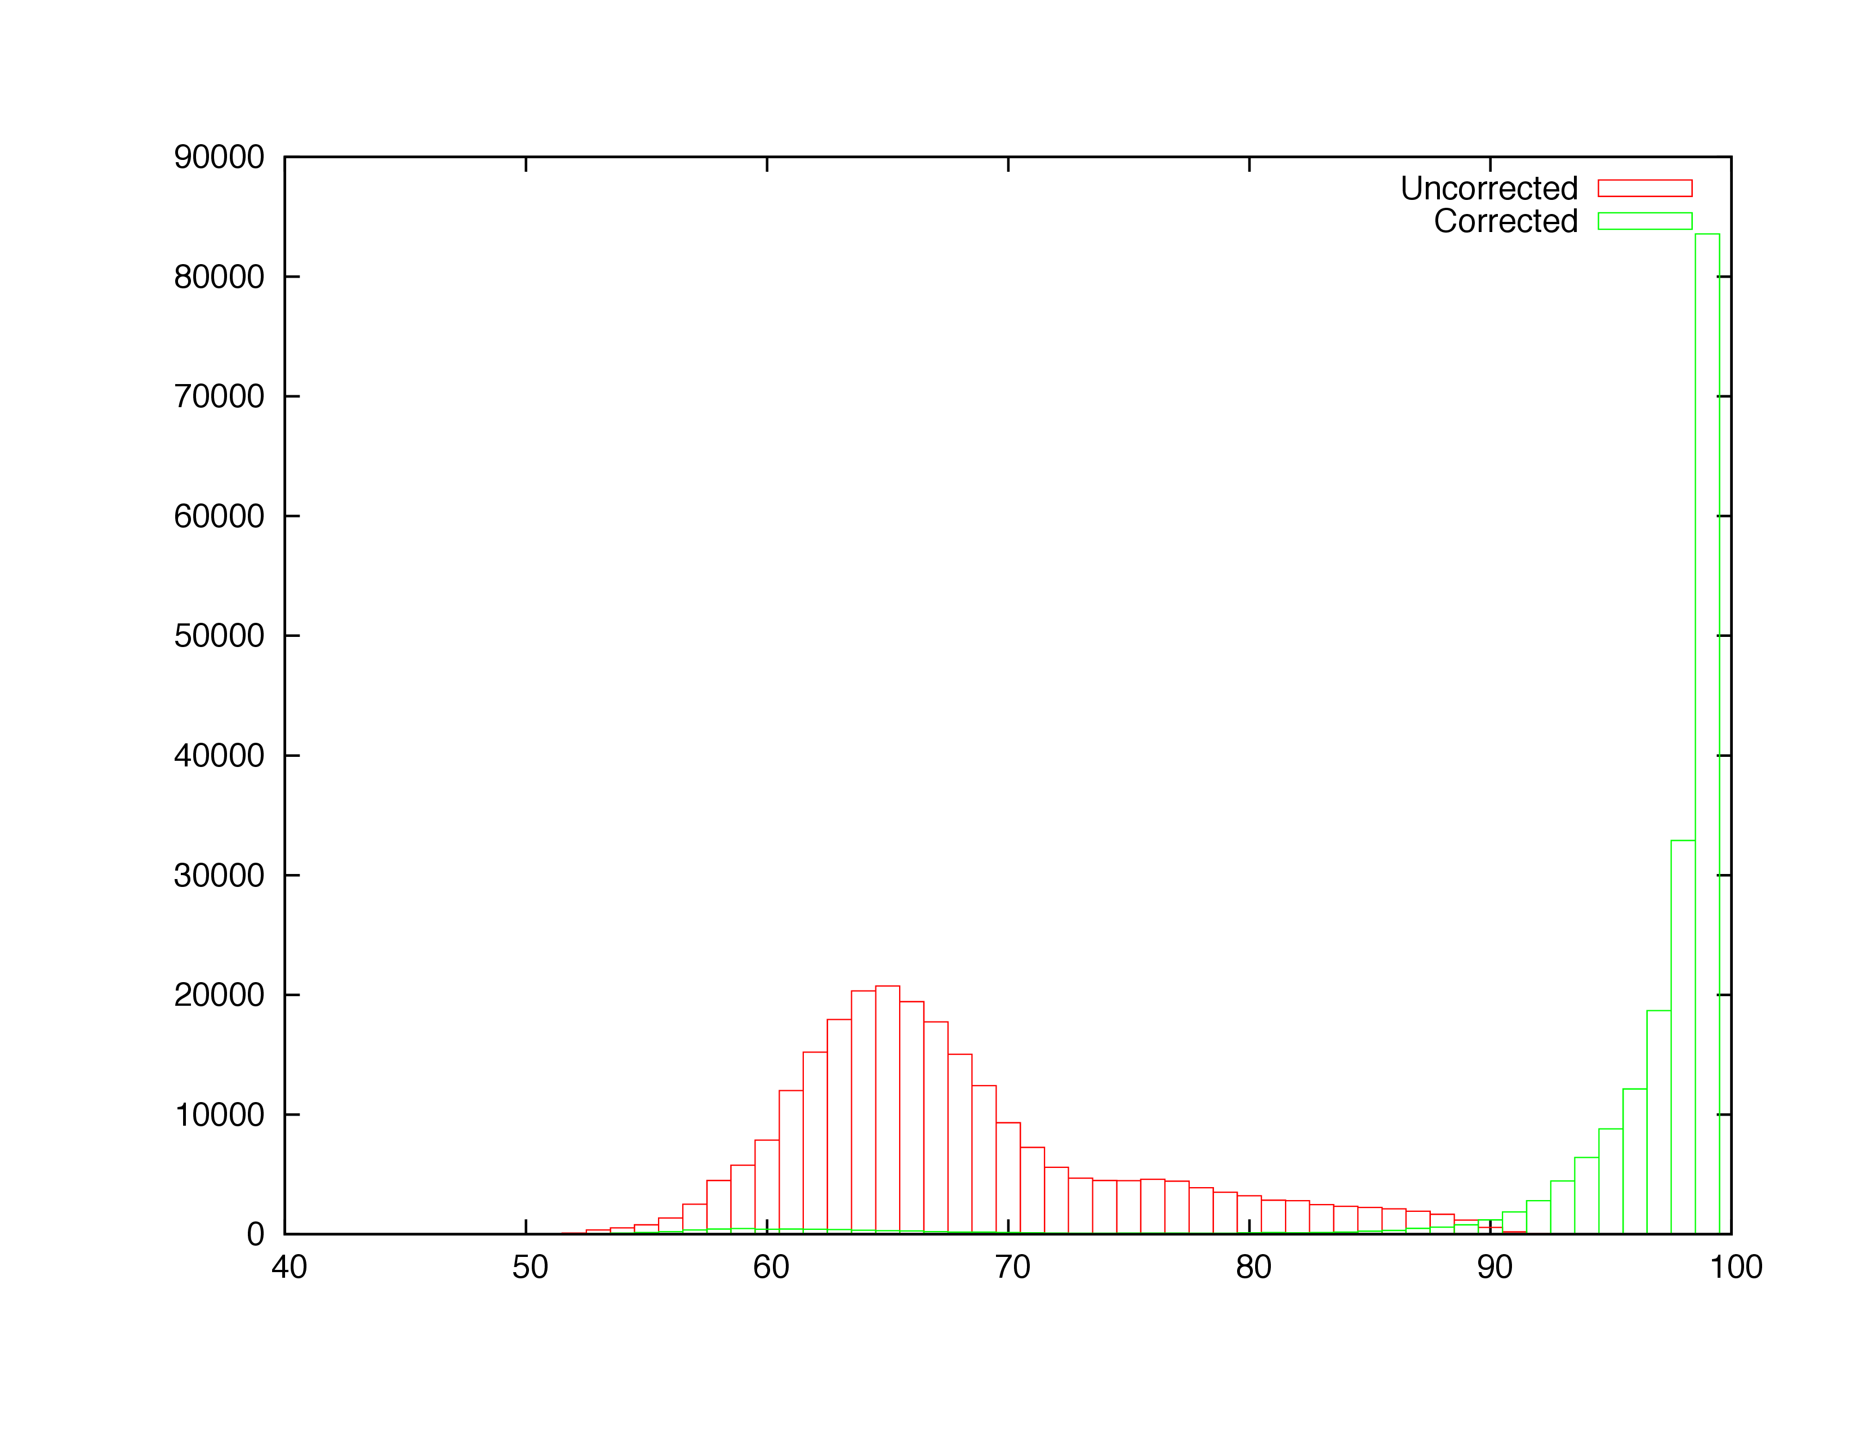
Figure S6A. Histogram of the percent identity of reads before and after error correction with Nanocorr in yeast. After correction, the long read accuracy improves to over 97%.
Figure S6B. Dotplot of yeast Nanocorr assembly

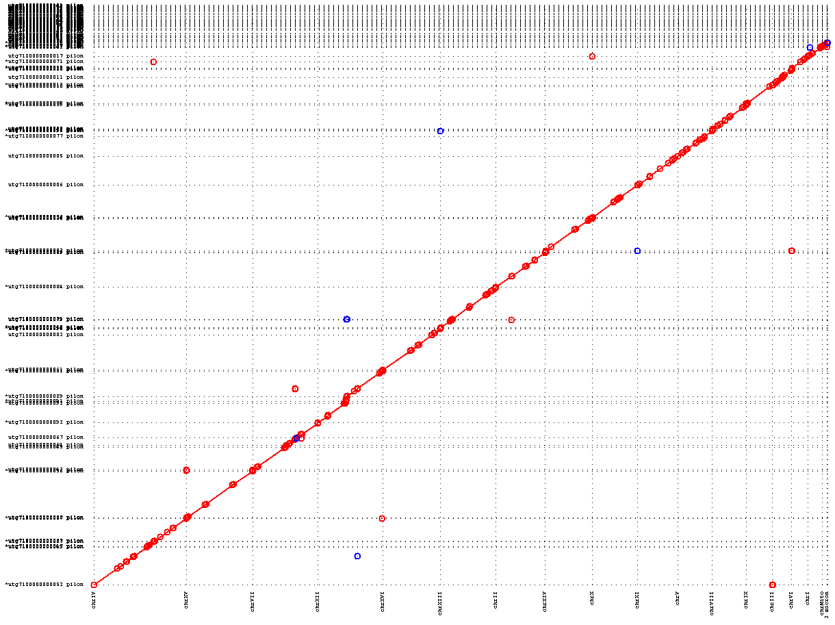
Figure S6B. Dot plot of Nanocorr-corrected Oxford Nanopore assembly (y-axis) of yeast versus the reference genome (x-axis).

Supplemental Note 7. Nanocorr performance of E. coli K12 genome

The raw and error corrected reads, along with the final assemblies and parameters used for the error correction and assembly can be found on the nanocorr website:
http://schatzlab.cshl.edu/data/nanocorr/

Figure S7A. Distribution of percent identities for corrected and uncorrected yeast reads

Figure S7A. Histogram of the percent identity of reads before and after error correction with Nanocorr in E. coli K12. After error correction, the long read accuracy improves to over 98%.
Figure S7B. Dotplot of E. coli Nanocorr assembly
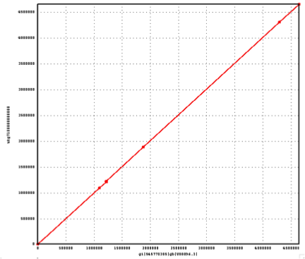
Figure S7B. Dot plot of Nanocorr-corrected Oxford Nanopore assembly (y-axis) of E. coli K12 versus the reference genome (x-axis). The nanocorr corrected assembly consisted of a single near perfect contig shown here as a single line along the diagonal, using dots to highlight the position of a few residual differences to the reference.

Supplemental Note 8. Reference-Guided Assembly

In order to assess the efficiency of the error correction routine we built an assembly based on “perfect reads” from the reference genome. The “perfect reads” were derived from the alignments of the Nanopore reads to the S288C reference sequence using both BLAST or LAST with these parameters:
BLAST:
-reward 5 -penalty -4 -gapopen 8 -gapextend 6 -task blastn -dust no -evalue 1e-5

LAST:
-s 2 -T 0 -Q 0 -a 1

The longest alignment for each read was chosen and the sequence corresponding to the reference coordinates in the alignment was extracted from the genome as new read sequences. These “perfect reads” were then assembled using the Celera assembler using the same parameters as the Nanocorr corrected reads. The “perfect reads” created using either the BLASTN or LAST alignments gave an assembly with a contig N50 of 811kb. Based on this evidence we can conclude that the choice of aligner has only a marginal affect on some downstream processes such as genome assembly.

Supplemental Note 9: Choice of Aligner

When we began our experiments there was much debate within the community on the best aligner to use for working with Oxford Nanopore reads. In these early stages we tried several aligners but settled on BLASTN with the alignment parameters detailed in the methods section of the main text. The community is undecided which aligner is “best” because “best” is application dependent as there are various, sometimes conflicting metrics, by which to test alignment results. Since our initial experiments, the LAST aligner has risen to become very popular in the community.
In an attempt to compare BLAST and LAST, we took a sample of 142,576 reads (7 flowcells) of R7.3 data. Alignments were made to the S288C reference yeast genome using with BLAST parameters: “-dust no -task blastn -reward 5 -penalty -4 -gapopen 8 -gapextend 6 -evalue 1e-5” and LAST parameters: “-s 2 -T 0 -Q 0 -a 1”. Where multiple alignments for each read existed, only the longest was kept to make the analysis comparable.
BLAST aligned 89,996 (63%) reads while LAST aligned 86,908 (60%) (Supplementary Table 1). For the majority of the reads, BLAST and LAST would align the read to equivalent positions in the genome, such that the coordinates overlapped by at least 50% of their span. In the remaining ~10% of the cases, the reads either aligned to different repeat instances or the alignment length produced by one aligner was less than 50% the length of the other.
The LAST alignments had a slightly higher per base identity, but was within 1 percentage point either when the coordinates agreed or not (Supplementary Table 2, Supplementary Figure S8A, S8B). BLAST tends to produce longer alignments when the alignments are matched by position, which may be more suitable for our downstream applications of error correction and assembly (Supplemental Figure S8C). When the alignments are not matched by position, LAST produces slightly longer alignments (Supplemental Figure S8D). We investigated the most extreme examples of LAST producing longer alignments of a read than BLAST and in each case found BLAST would report 2 or more short alignments, each <50% the length of LAST, at an equivalent position as the one long LAST alignment. The reverse is also true: the most extreme cases of the BLAST alignments being longer than the LAST alignments are also explained by short LAST alignments being contained by substantially longer BLAST alignments.
Overall, BLAST and LAST give very comparable results. Notably, the choice of aligner seems to have only a minimal effect on downstream results as can be seen in reference guided assembly experiment described in Supplementary Note 8.

Supplemental Table 1. Number of Reads Aligned per Aligner
LAST & BLAST Align to Same Location | 70890 (49.72 %)
LAST & BLAST Align to Different Locations | 13278 (9.31 %)
Only Aligned by BLAST | 5828 (4.08 %)
Only Aligned by LAST | 2740 (1.92 %)

Supplemental Table 2. Error Profile by Aligner
 | Matches (%) | Mismatches (%) | Insertions (%) | Deletions (%)
Blast | 69.83 | 16.27 | 2.86 | 11.04
Last | 70.61 | 13.85 | 3.70 | 11.85
Blast* | 66.44 | 18.58 | 3.09 | 11.89
Last* | 66.22 | 15.70 | 4.07 | 13.99
* Alignments where Blast and Last did not agree on the position of the read.

Figure S8 Comparison of lengths and PIDs of reads aligned by BLAST and LAST
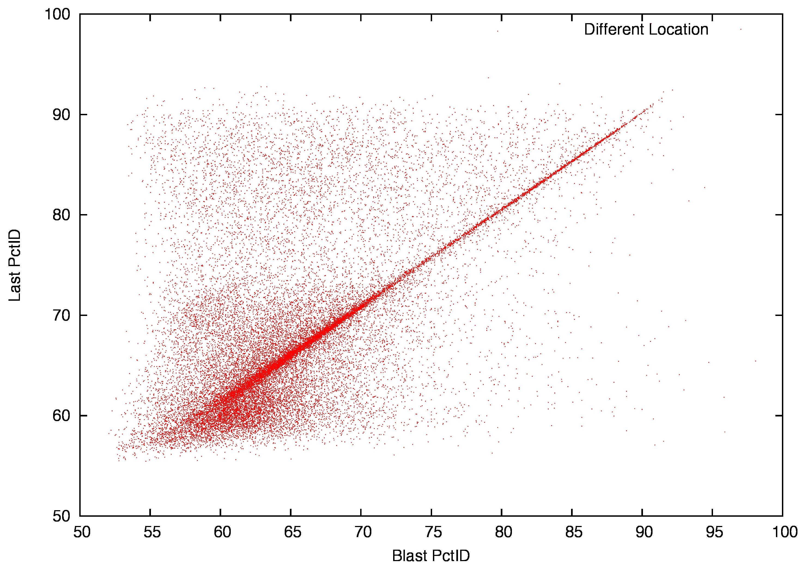
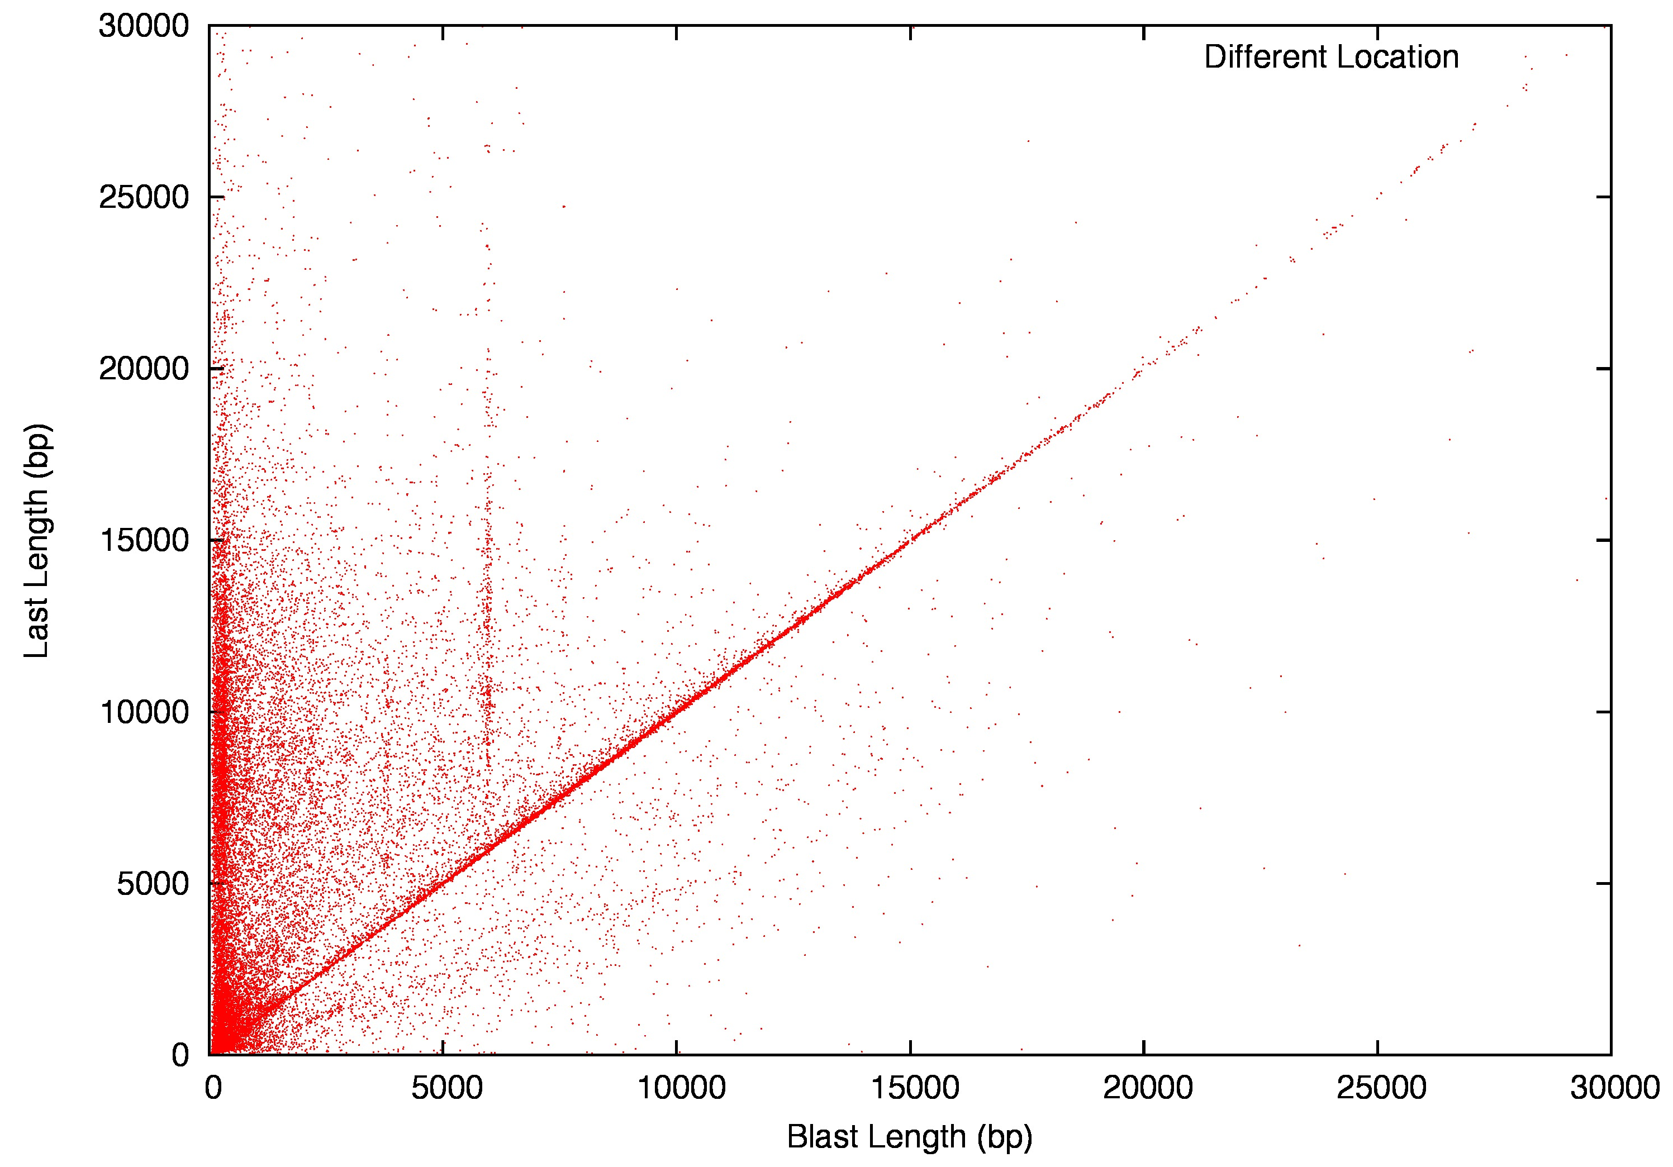
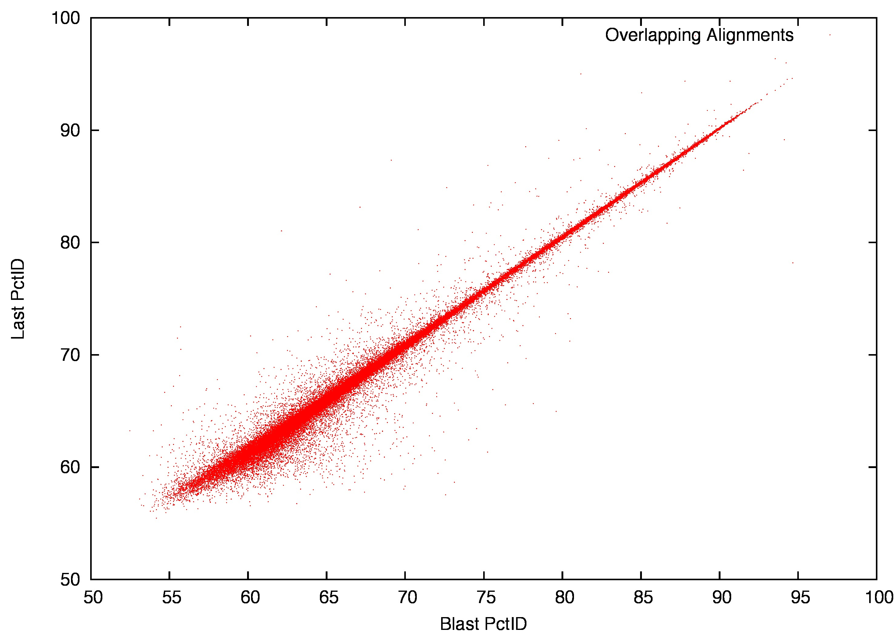

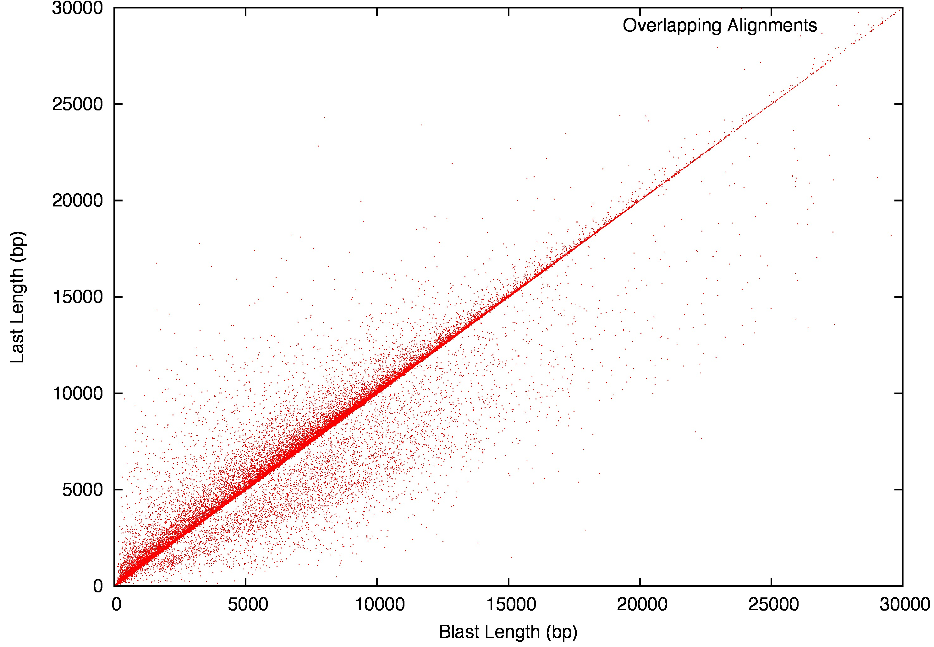

Figure S8. Comparison of BLAST and LAST alignment lengths and PIDs. A/Top-left) Comparison of PIDs from LAST and BLAST where the alignments were matched for position; B/Top-right) Comparison of PIDs from LAST and BLAST where the alignments were at different locations; C/Bottom-left) Comparison of LAST and BLAST lengths where the alignments were matched for position; D/Bottom-right) Comparison of the LAST and BLAST lengths when the alignments were at different locations.

Supplemental Note 10: Flowcell Downsampling

The flowcell performance can be sporadic, but when a flowcell performs well it can produce a lot of data as seen in Supplementary Figure 1. To evaluate the best-case scenario, we sorted flowcells by yield and performed a number of assemblies each time adding one additional flowcell. This allowed us to see how increased coverage affected assembly performance as well as gauge the minimum number of flowcells to assemble the yeast genome. As can be seen from Supplementary Figure S8, just three flowcells are needed to achieve the best assembly. After this point, additional coverage actually decreases assembly performance; a well-known characteristic of Overlap Layout Consensus assemblers such as Celera.

Figure S9. Assembly Performance versus Coverage
Figure S9. Flowcells were sorted by yield and progressively added to the assembly. As can be seen, with just three flowcells, the best assembly can be achieved as measured by the N50 metric. As additional flow cells are added, performance becomes stochastic, a well-known characteristic of overlap layout consensus assemblers like Celera.

Supplemental Note 11. Flow cell details

Date notes the data a flow cell was run as noted in Figure 1 of the main document.
06/23/14 – R6.0 Performed using ONT supplied ligase, overnight motor incubation, 1 ug DNA starting material
06/26/14 – R6.0 Overnight motor incubation, 1 ug DNA starting material
07/01/14- R6.0 Flowcell had been previously used for Lambda burn-in and washed per Oxford protocol, 1 ug DNA starting material, overnight motor incubation
07/02/14 R6.0 Flowcell had been previously used on 06/23/14 for W303 DNA and washed per Oxford , 1 ug DNA starting material protocol, overnight motor incubation
07/04/14 R6.0 Flowcell had been previously used on 06/26/14 for W303 DNA and washed per Oxford protocol, 1 ug DNA starting material, overnight motor incubation
07/10/14-1 R6.0 Ampure bead concentration was 0.4X for all wash steps, DNA was sheared following Covaris instructions 1kb 1ug DN input, overnight motor incubation
07/10/14-2 R6.0 DNA was sheared following Covaris instructions 10kb, 2ug DNA input, overnight motor incubation
07/11/14-1 R6.0 DNA was sheared following Covaris instructions 10kb, 2ug DNA input, overnight motor incubation
07/11/14-2 R6.0 Ampure bead concentration was 0.4X for all wash steps, DNA was sheared following Covaris instructions 10kb, 2ug DNA input, overnight motor incubation
07/12/14 R6.0 Ampure bead concentration was 0.4X for all wash steps, DNA was sheared following Covaris instructions 10kb, 2ug DNA input, overnight motor incubation
07/16/14-1 R6.0 DNA was sheared following Covaris instructions 10kb, 1ug DNA input , overnight motor incubation
07/16/14-2 R6.0 DNA was sheared following Covaris instructions 10kb, 1ug DNA input, overnight motor incubation
07/18/14-1 R7.0 DNA was sheared following Covaris instructions 10kb, 1ug DNA input, overnight motor incubation
07/18/14-2 R7.0 DNA was sheared following Covaris instructions 10kb, 1ug DNA input, overnight motor incubation
07/21/14 R7.0 Flowcell was washed following Oxford protocol prior to DNA loading, DNA was sheared following Covaris instructions 10kb, 1ug DNA input, overnight motor incubation
07/23/14 R7.0 DNA was sheared following Covaris instructions 10kb, 1ug DNA input, 30min motor incubation
07/24/14-2 R7.0 DNA was sheared following Covaris instructions 10kb, 1ug DNA input, 30min motor incubation
7/24/14 R7.0 DNA was sheared following Covaris instructions 10kb, 1ug DNA input, overnight motor incubation
07/25/14 R7.0 DNA was sized selected post shearing with blue pippin (Sage) at >10kb, DNA was sheared following Covaris instructions 10kb, 1ug DNA input, 30min motor incubation
07/28/14-1 R7. Flowcell was washed following Oxford protocol prior to DNA loading, DNA was sheared following Covaris instructions 10kb, 1ug DNA input, 30min motor incubation
07/28/14-2 R7. 0Flow cell QCd at 0 available pores and appeared to have a crack, DNA was sheared following Covaris instructions 10kb, 1ug DNA input, 30min motor incubation
08/04/14 R7.0 DNA was sheared following Covaris instructions 10kb, 1ug DNA input, 30min motor incubation
08/05/14 R7.0 DNA was sheared following Covaris instructions 10kb, 1ug DNA input, 30min motor incubation
08/07/14-1 R7.0 DNA was sheared following Covaris instructions 10kb, 2ug DNA input then split into two equal aliquots prior to ligation, adapter mix allowed to incubate for 5 minutes with ligase prior to adding HP adapter, 30min motor incubation, 240ng DNA estimated added to flow cell
08/07/14-2 R7.0 DNA was sheared following Covaris instructions 10kb, 2ug DNA input then split into two equal aliquots prior to ligation, adapter mix allowed to incubate for 5 minutes with ligase prior to adding HP adapter, 30min motor incubation, 240ng DNA estimated added to flow cell
08/07/14-3 R7.0 DNA was sheared following Covaris instructions 10kb, 2ug DNA input then split into two equal aliquots prior to ligation, adapter mix allowed to incubate for 5 minutes with ligase prior to adding HP adapter, 30min motor incubation, 240ng DNA estimated added to flow cell
8/10/14 R7.0 Left over sample from 8/7/14 had been prepared upto ligation ligation reaction ws carried out 8/10/14 Adapter mix allowed to incubate for 5 minutes with ligase prior to adding HP adapter, 30min motor incubation, 240ng DNA estimated added to flow cell
08/14/14-1 R7.0 DNA was sheared following Covaris instructions 10kb, 2ug DNA input then split into two equal aliquots prior to ligation, adapter mix allowed to incubate for 5 minutes with ligase prior to adding HP adapter, 30min motor incubation, 5ng DNA estimated added to flow cell
08/14/14-2 R7.0 DNA was sheared following Covaris instructions 10kb, 2ug DNA input then split into two equal aliquots prior to ligation, adapter mix allowed to incubate for 5 minutes with ligase prior to adding HP adapter, 30min motor incubation, 50ng DNA estimated added to flow cell
08/14/14-3 R7.0 DNA was sheared following Covaris instructions 10kb, 2ug DNA input then split into two equal aliquots prior to ligation, adapter mix allowed to incubate for 5 minutes with ligase prior to adding HP adapter, 30min motor incubation, 5ng DNA estimated added to flow cell
08/14/14-3 R7.0 DNA was sheared following Covaris instructions 10kb, 2ug DNA input then split into two equal aliquots prior to ligation, adapter mix allowed to incubate for 5 minutes with ligase prior to adding HP adapter, 30min motor incubation, 5ng DNA estimated added to flow cell
08/24/14 R7.0 DNA was sheared following Covaris instructions 10kb, 2ug DNA input then split into two equal aliquots prior to ligation, adapter mix allowed to incubate for 5 minutes with ligase prior to adding HP adapter, 30min motor incubation, 50ng DNA estimated added to flow cell
8/28/14-1 R7.0 DNA was sheared following Covaris instructions 10kb, 2ug DNA input then split into two equal aliquots prior to ligation, adapter mix allowed to incubate for 5 minutes with ligase prior to adding HP adapter, 30min motor incubation, 5ng DNA estimated added to flow cell
8/28/14-2 R7.0 DNA was sheared following Covaris instructions 10kb, 2ug DNA input then split into two equal aliquots prior to ligation, adapter mix allowed to incubate for 5 minutes with ligase prior to adding HP adapter, 30min motor incubation, 240ng DNA estimated added to flow cell
8/29/14-1 R7.0 DNA was not sheared. 2ug DNA input then split into two equal aliquots prior to ligation, adapter mix allowed to incubate for 5 minutes with ligase prior to adding HP adapter, 30min motor incubation, 150ng DNA estimated added to flow cell
8/2914-2 R7.0 DNA was sheared following Covaris instructions 20kb, 2ug DNA input then split into two equal aliquots prior to ligation, adapter mix allowed to incubate for 5 minutes with ligase prior to adding HP adapter, 30min motor incubation, 150ng DNA estimated added to flow cell
9/10/14 R7.0 DNA was sheared following Covaris instructions 10kb, 2ug DNA input then split into two equal aliquots prior to ligation, adapter mix allowed to incubate for 5 minutes with ligase prior to adding HP adapter, 30min motor incubation, 50ng DNA estimated added to flow cell
9/11/14-1 R7.0 DNA was sheared following Covaris instructions 10kb, 2ug DNA input then split into two equal aliquots prior to ligation, adapter mix allowed to incubate for 5 minutes with ligase prior to adding HP adapter, 30min motor incubation, 50ng DNA estimated added to flow cell
9/11/14-2 R7.0 DNA was sheared following Covaris instructions 10kb, 2ug DNA input then split into two equal aliquots prior to ligation, adapter mix allowed to incubate for 5 minutes with ligase prior to adding HP adapter, 30min motor incubation, 250ng DNA estimated added to flow cell
9/15/14-1 R7.0 DNA was sheared following Covaris instructions 10kb, 2ug DNA input then split into two equal aliquots prior to ligation, adapter mix allowed to incubate for 5 minutes with ligase prior to adding HP adapter, 30min motor incubation, 250ng DNA estimated added to flow cell
9/15/14-2 R7.0 DNA was sheared following Covaris instructions 10kb, 2ug DNA input then split into two equal aliquots prior to ligation, adapter mix allowed to incubate for 5 minutes with ligase prior to adding HP adapter, 30min motor incubation, 250ng DNA estimated added to flow cell
10/31/14 R7.3 DNA was sheared following Covaris instructions 10kb, 2ug DNA input then split into two equal aliquots prior to ligation, adapter mix and hairpin adapter added at same time, wash buffer beads spiked with BSA. No his beads used 100ng DNA estimated added to flow cell
11/06/14-1 R7.3 DNA was sheared following Covaris instructions 10kb, 2ug DNA input then split into two equal aliquots prior to ligation, adapter mix and hairpin adapter added at same time, wash buffer beads spiked with BSA. No his beads used 125ng DNA estimated added to flow cell
11/6/14-2 R7.3 DNA was sheared following Covaris instructions 10kb, 2ug DNA input then split into two equal aliquots prior to ligation, adapter mix and hairpin adapter added at same time, wash buffer beads spiked with BSA. No his beads used 125ng DNA estimated added to flow cell
11/10/14 R7.3 DNA was sheared following Covaris instructions 10kb, 2ug DNA input then split into two equal aliquots prior to ligation, adapter mix and hairpin adapter added at same time, 72ng DNA estimated added to flow cell
12/4/14 R7.3 DNA was sheared following Covaris instructions 10kb, 2ug DNA input then split into two equal aliquots prior to ligation, adapter mix and hairpin adapter added at same time, 250ng DNA estimated added to flow cell
12/17/14 R7.3 DNA was sheared following Covaris instructions 10kb, 2ug DNA input then split into two equal aliquots prior to ligation, adapter mix and hairpin adapter added at same time, 126ng DNA estimated added to flow cell
12/14/14 R7.3 DNA was sheared following Covaris instructions 10kb, 2ug DNA input then split into two equal aliquots prior to ligation, adapter mix and hairpin adapter added at same time, 126ng DNA estimated added to flow cell. Voltage was manually manipulated during course of run

Supplemental References

- Ross, M.G., et al. Characterizing and measuring bias in sequence data. Genome Biol.(2013), 14, R51.

