Supplement
MAP Inference
We infer the correct alignments of ambiguous reads by identifying a MAP assignment to the MRF described. We developed an inference algorithm based on simulated annealing to approximate the MAP solution. In order to propose reasonable moves in the state space, we leverage the fact that the sampled long fragments in each well generate reads that often map to nearby locations.
Our inference procedure is shown in Algorithm 1. We start with an initial mapping of the reads to one of their top scoring candidate alignments, denoted as topAS. We iteratively update the graph assignment and score each assignment using $P$, the global probabilistic function defined in Equation 1 until convergence. Given the current graph assignment, we examine a single candidate cloud $c^{S}$ and create a set of proposal moves to the next graph assignment based on this cloud’s active reads. For each target cloud $c^{T}$ (in which at least one active read has a candidate alignment), we propose to move the maximal set of active reads that can map to that target. Note, evaluating the graph score for each move only requires re-evaluation of the source and target cloud potentials. We choose the move with the maximal field score or keep the current assignment according to the acceptance probability function and temperature. The temperature function that we use cools down exponentially with respect to the number of iterations $n$.
After the inference procedure has converged, multi-mapped reads are given updated quality scores based on the resulting cloud formation as described in Methods.

Algorithm 1 MAP Inference Procedure
1: procedure SUBMOVE(cS,cT,r)
2: r′←r
3: for i ∈ {i | ri = (cS,•)}∩IcT do ◃ intersection of source cloud active read set with target cloud index set
4: ri′ ← (cT ,arg maxk P(r−i,Ri = (cT ,k))) ◃ assign Ri to the best alignment within target cloud
5: end for
6: return r′
7: end procedure

8: procedure MAPINFERENCE
9: r ← TOPAS(R); p ← P(r)
10: rmax ←r; pmax ← p
11: n←0
12: repeat
13: cS ← n mod |C |
14: cT ← argmaxC P(SUBMOVE(cS,C,r))
15: r′ ← SUBMOVE(cS,cT ,r)
16: p′ ← P(r′)
17: T ←TEMPERATURE(n/nmax)
18: if exp(-(p - p′)/T) > UNIFORM(0,1) then
19: r ← r′; p ← p′
20: end if
21: if p > pmax then
22: rmax ←r; pmax ← p
23: end if
24: n←n+1
25: until convergence or n > nmax
26: return rmax
27: end procedure

RFA Variant Discovery
In order to call variants using our RFA alignments, we first applied a GATK pipeline on all RFA aligned wells simultaneously to discover a candidate set of germline variants using an approach similar to those used for standard short read sequencing (DePristo et al., 2011). Using the output BED file of each well, which includes the positions of the converged clouds as well as computed queries, we determined a cutoff for the lowest 2% quality clouds, using the $P\left(R_{c}\right)$ query discussed in Methods. This helped us to identify low quality long fragments likely originating from novel or very distant sequence from the reference. In order to call a variant with the RFA alignments, we required at least three non-low quality clouds to project the alternate allele predicted from GATK. This strategy is stringent and could be loosened with the implementation of a variant calling strategy that leveraged all the long read information effectively.
Validation
For validating SNV calls for NA12878 with the assembled synthetic long reads from deep Illumina TruSeq synthetic long-read sequencing, we required at least 12 assembled synthetic long reads to overlap the projected site with a single optimal mapping; this was required in order to limit the number of sites that would be incorrectly penalized due to not sampling the alternate allele. In order to count our predicted variant as validated, we required at least two of the 12 assembled long reads to display the predicted alternate allele. Our analysis was not sensitive to the chosen threshold of 12. Although this allowed us to validate 33,984 variants, an additional 1,318 variants met our coverage requirement for validation, but we could not confidently project a true or false negative. Some of these calls had either a single synthetic long read supporting the alternate allele or multiple completely ambiguous alignments supporting it. An additional 13,797 SNVs were covered by less than 12 assembled long reads, with 8,283 validating.
The set of PacBio assembled BACs targeting high identity duplications in 15q13.3 (Antonacci et al., 2014), which we used for validation, contained sequences from both paternal and maternal alleles. We were able to successfully align the maternal BACs to their known origin in the reference. However, the high identity repeats together with the fact that the paternal allele displays a large inversion resulted in poor alignment of the paternal BACs. All of our analysis is with respect to the alignments of the maternal BACs for which we were able to produce useable alignments.
For validating SNV calls for our cancer sample, we selected a random subset that was amenable to target-specific PCR amplification followed by sequencing. We targeted regions such that at least one of the primers contained unique sequence (up to one mismatch) in order to minimize background capture of other homologous regions. Each primer was restricted to be between 20bp and 25bp and the total amplicon was restricted to being no larger than 500bp. The targeted SNV was required to be within 50 bases of the sequence start site in order to be visible in a high quality position in the resulting sequenced reads. These restrictions to allow for targeted amplification biased our results towards validation of variants in which there was at least one 20-25bp sequence unique up to one mismatch and within 500bp of the SNV to be validated. However, validation on NA12878 with orthogonal long read sequencing methods confirmed that our high accuracy is true and is not an artifact of the primer design method used. Amplification was done in a multiplex fashion followed by a single lane of Illumina HiSeq2000 sequencing. As some of our targets may have more than two copies (due to copy number variation in our sample), we chose a cutoff alternate allele frequency (AAF) of 0.1. Our analysis was not very sensitive to this cutoff, and only 3% of the targeted sites showed AAF less than 0.02 corresponding to definite true negatives. Out of the 346 submitted, 323 had an AAF of at least 0.1 and were considered validated. Only 10 of the remaining displayed an AAF of less than 0.02.
The validation rates obtained represent a lower bound on our variant discovery accuracy. We found that the distribution of TruSeq long fragments over each allele did not follow a binomial distribution; rather, we observed cases where 12 or more long fragments were sampled from one allele, and only a single long fragment was sampled from the other. If no assembled long reads were sampled from the allele our approach predicted, then our validation strategy would unfairly penalize these as not validated. In the PCR results of the invasive breast carcinoma sample, one alternative explanation for unvalidated variants is that some of them lie in high copy number variation regions, in which only copies not containing the variant were amplified by PCR
TruSeq Read Cloud Sample Properties
Supplementary Figure 2 shows the properties of our read clouds from our 8 lanes of TruSeq read cloud sequencing of our IDC sample (Manuscript in preparation). Read cloud sizes are separated into classes determined by the presence of the end-markers ligated to the original long fragments. Zero implies no end-markers were present, one implies at least one was present, and two implies both were present.

Supplementary Figures
Supplementary Figure 1: Wells are first aligned using a standard short read aligner, and for each uniquely mappable cloud, a stencil of the relative positions of the short reads from the start of the cloud is saved. To simulate a read cloud, a position in the genone is chosen at random and a random stencil from the bank is used as a “cookie cutter” to cut out simulated short reads. This process is repeated until the simulated well has the desired coverage of the read cloud process.
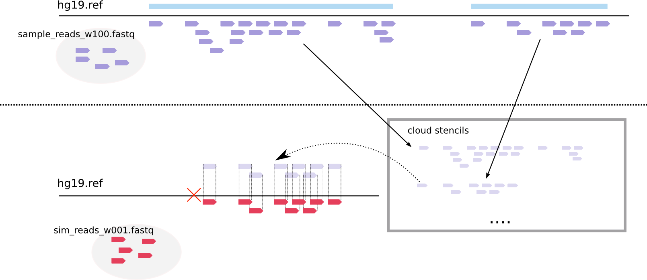

Supplementary Figure 2: Properties of Read clouds from 8 lanes of TruSeq read cloud sequencing of our IDC sample

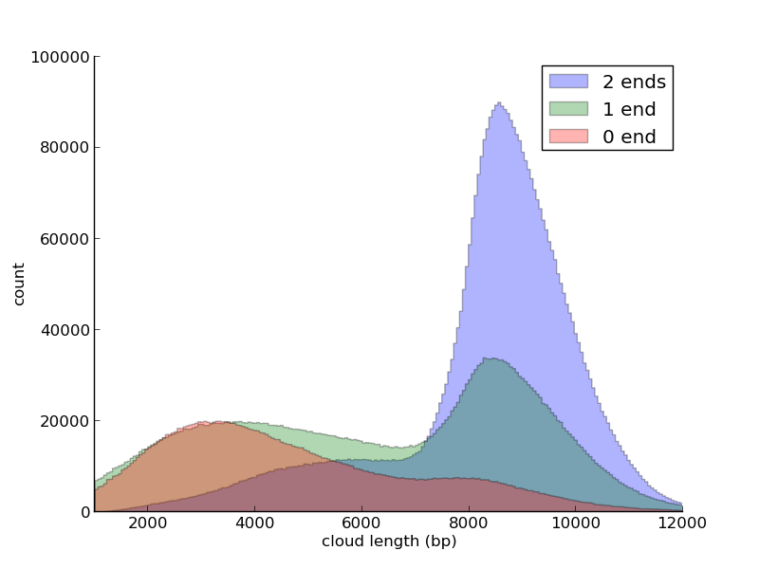
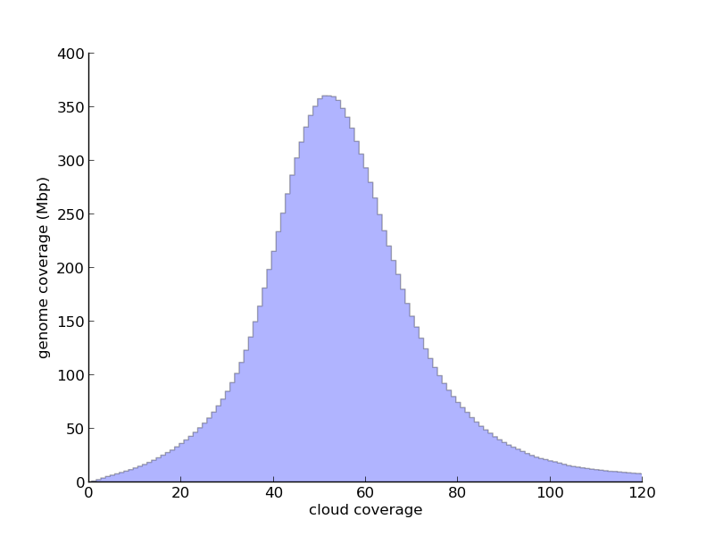
(a) Read cloud sizes (b) Read Cloud Genome Coverage
References
Antonacci, F., Dennis, M. Y., Huddleston, J., Sudmant, P. H., Steinberg, K. M., Rosenfeld, J. A., Miroballo, M., Graves, T. A., Vives, L., Malig, M., et al. (2014). Palindromic golga8 core duplicons promote chromosome 15q13.3 microdeletion and evolutionary instability. Nat Genet 46:1293–302.
DePristo, M. A., Banks, E., Poplin, R., Garimella, K. V., Maguire, J. R., Hartl, C., Philip- pakis, A. A., del Angel, G., Rivas, M. A., Hanna, M., et al. (2011). A framework for variation discovery and genotyping using next-generation dna sequencing data. Nat Genet 43:491–8.

