Supplementary Data

S1: Illumina vs Complete Genomics
 |  | Variants CG | Variants Illumina | Overlap | % CG variants in Illumina | % Illumina variants in CG | % concordance of unique SNVs
HCC1187 | SNVs | 2,807,012 | 3,138,276 | 2,741,583 | 97.7% | 87.4% | 85.6%
HCC1187 | Indels | 564,317 | 620,848 | 364,614 | 64.6% | 58.7% | 55.6%
HCC2218 | SNVs | 3,288,466 | 3,688,521 | 3,221,286 | 98.0% | 87.3% | 85.8%
HCC2218 | Indels | 591,081 | 696,777 | 397,570 | 67.3% | 57.1% | 55.3%
S1.1: Comparisons of indels and SNVs between Illumina and Complete Genomics

 |  | Variants CG | Variants Illumina | Overlap | % CG variants in Illumina
HCC1187 | SNVs | 2,892,114 | 3,138,276 | 2,741,583 | 94.8%
HCC1187 | Indels | 521,766 | 620,848 | 364,614 | 69.9%
HCC2218 | SNVs | 3,381,792 | 3,688,521 | 3,221,286 | 95.3%
HCC2218 | Indels | 544,418 | 696,777 | 397,570 | 73.0%
S1.2: Comparison of indels and SNVs between Illumina and Complete Genomics, corrected for block substitutions.

 | SVs (Ill-CG) | Overlap with other platform (Ill-CG)
HCC1187 | 1465-1593 | 648-672 (44%-42%)
HCC2218 | 1472-1571 | 644-668 (43%-42%)
S1.3: Number of SVs detected in each platform and the number of SVs that overlap with the other platform. Illumina: Tumour SVs with QUAL>=200. CG: highConfidenceJunctions file. The number of overlapping junctions can differ due to the fact that in some cases CG describes an event as several junctions, while Illumina describes the same event as a single breakpoint. Our algorithm checked only if an event occurred within 500 base pairs of either side of the junction in the other platform’s file to count it as a match.

S2 Associated N vs Virtual Normal
 |  | Germline variants  (=also present in Associated Normal) | Variants also removed by VN
Illumina | HCC1187 | 3,557,818 | 3,480,757 (97.83 %)
Illumina | HCC2218 | 4,129,154 | 4,047,269 (98.02 %)
CG | HCC1187 | 3,067,857 | 3,050,883 (99.45 %)
CG | HCC2218 | 3,558,675 | 3,533,914 (99.30 %)
CG | G110 | 3,812,604 | 3,733,202 (97.92 %)
CG | G316 | 3,808,914 | 3,726,702 (97.84 %)
S2.1: Number of germline variants (those present in associated normal) also corrected for by the virtual normal approach.
 |  | Total corrected | overlap | MN only | VN only
Illumina | HCC1187 | 3,648,428 | 3,328,847 (91.3%) | 228,971 (6.3%) | 90,609 (2.5%)
Illumina | HCC2218 | 4,239,960 | 3,887,262 (91.7%) | 241,893 (5.7%) | 110,805 (2.6%)
CG | HCC1187 | 3,302,300 | 3,042,265 (92.1%) | 25,693 (0.8%) | 234,442 (7.1%)
CG | HCC2218 | 3,798,818 | 3,522,497 (92.7%) | 36,179 (1.0%) | 240,142 (6.3%)
CG | G110 | 3,936,864 | 3,733,202 (94.8%) | 79,402 (2.0%) | 124,260 (3.2%)
CG | G316 | 3,937,098 | 3,726,702 (94.7%) | 82,212 (2.1%) | 128,184 (3.3%)
S2.2: Comparison between associated normal correction and virtual normal correction. Total corrected indicates the number of variants corrected for when using a combination of the two approaches.

SNVs |  | True somatic  (DB+N+VN) | DB only | MN | VN+DB  (all-highConf)
Illumina | HCC1187 | 11,409 | 36,521 | 15,499 | 31,470-13,553
Illumina | HCC2218 | 20,560 | 55,952 | 27,823 | 49,190-23,079
CG | HCC1187 | 11,343 | 47,740 | 15,419 | 30,058-14,248
CG | HCC2218 | 19,255 | 65,213 | 22,432 | 47,331-24,713
S2.3: Number of somatic (tumour-specific) SNV variants identified by each method. True somatic indicates the number of somatic variants after full correction (associated normal, virtual normal, and database). Percentages indicate the false positive fraction.

Indels |  | True somatic  (DB+N+VN) | DB only | MN +DB | VN+DB  (all-highConf)
Illumina | HCC1187 | 786 | 51,020 | 985 | 38,746-1,580
Illumina | HCC2218 | 459 | 57,319 | 601 | 42,554-1,897
CG | HCC1187 | 1,202 | 65,140 | 2,820 | 10,290-1,347
CG | HCC2218 | 622 | 62,218 | 1,366 | 9,097-1,557
S2.4: Number of somatic (tumour-specific) indel variants identified by each method. True somatic indicates the number of somatic variants after full correction (associated normal, virtual normal, and database). Percentages indicate the false positive fraction.

S3 Quality of variants
Ti-Tv ratio
Ti/Tv ratio | HCC1187 |  | HCC2218
 | CG | Illumina | CG | Illumina
ALL variants | 2.11 | 2.00 | 2.11 | 2.00
Somatic MN | 1.60 | 1.24 | 1.48 | 1.24
Somatic DB | 1.54 | 1.06 | 1.40 | 1.11
Somatic DB+MN | 1.42 | 0.82 | 1.22 | 0.84
Somatic DB+VN | 1.37 | 1.00 | 1.22 | 1.05
Somatic DB+MN+VN | 1.20 | 0.77 | 1.00 | 0.86
Table S3.1. Ti/Tv ratios of SNVs for different filter combinations. The full set of variants has Ti/Tv ratio >= 2, indicating high-quality calls. The Ti/Tv ratio drops as more filtering is performed, which is consistent with observations in literature (Liu et al. 2002). MN=Matched normal, DB=database filter, VN=Virtual Normal

Mutational spectrum
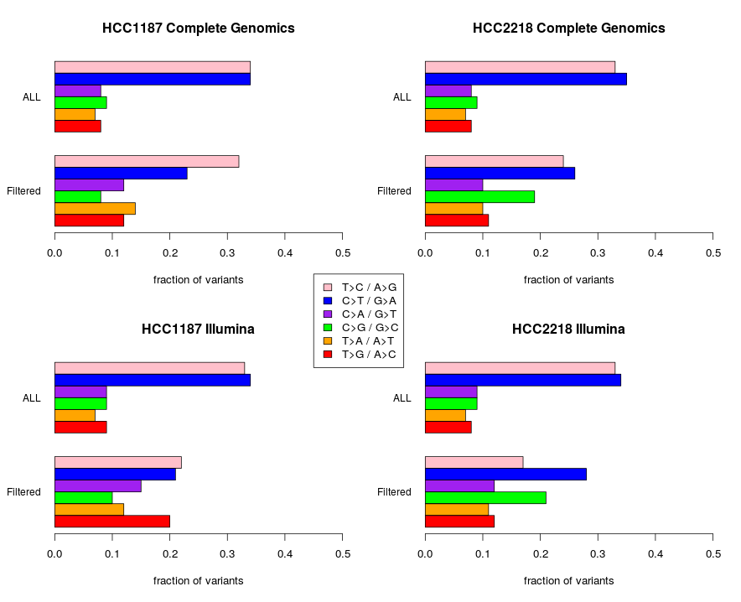
Figure S3.1: Mutational spectra for the samples from Illumina (bottom) and Complete Genomics (top).
S4: Algorithmic vs position-based comparison
S4.1 : Variants missed due to use of a position-based algorithm which did not take into account surrounding reference bases and nearby variants.
Illumina HCC1187
Example 1)
Location: chr11:31447885-31447896
reference: ~AATGTCTTGGA~
COSMIC: ~AATGTCTTGGA~ del:TCTTG
Illumina: ~AATGTCTTGGA~ del:TGTCT
Type: Canonicalisation
In both cases the resulting sequence is ~AATGGA~ but both the positions of the variant and the deleted bases differ.
Example 2)
Location: chr12:123214717-123214725
reference: ~AATTGAA~
COSMIC: ~AATTTGAA~ ins:T
Illumina: ~AATTTGAA~ ins:T
Type: Canonicalisation
In both cases the resulting sequence is ~AATTTGAA~ but Illumina described the variant as an insertion before the first T in the reference sequence snippet, while the COSMIC variant was described as an insertion after the second T.
Example 3)
Location: chr18:33740942-33740950
reference: ~ GACTCTGC~
COSMIC: ~ GACTCTGC~ del: CT
Illumina: ~ GACTCTGC~ del: CT
Type: Canonicalisation
deletion of CT occurs in both cases, but where Illumina described the variant using the leftmost possible canonicalisation, COSMIC variant was described as the right-most canonicalisation.
Example 4)
Location: chr18:33740942-33740950
reference: ~ GTTTCGCAGCTTATCAGGGTGCGTGTTCACGAA~
COSMIC: ~ GTTTCGCAGCTTATCAGGGTGCGTGTTCACGAA ~
del: GCAGCTTATCAGGGTGCGTGTTCAC
Illumina: ~ GTTTCGCAGCTTATCAGGGTGCGTGTTCACGAA ~
del: CGCAGCTTATCAGGGTGCGTGTTCA
Type: Canonicalisation
deletion of two (slightly) different sequences lead to the same resulting sequence.

Illumina HCC2218
Example 1)
Location: chrX:15301650-15301665
reference: ~ GAGTGGCTCTGGCAG~
COSMIC: ~ GAGTGGCTCTGGCAG~ del: GCCAGA, rev. compl.: TCTGGC
Illumina: ~ GAGTGGCTCTGGCAG~ del: TGGTCT
Type: Canonicalisation
This equivalence was missed because the deletion of two different pieces of sequence lead to the same resulting sequence. A further confounding factor was the fact that the deleted sequence in COSMIC was described on the reverse strand, necessitating both the translation to its reverse complement, and knowledge of the reference sequence in the area, in order to determine that these two variants are in fact equivalent.

Complete Genomics HCC1187
Example 1)
Location: chr3:167750545-167750553
reference: ~ TCTGCCTC~
COSMIC: ~ TCTAGCTC~ snp: G>A, snp: C>G (after taking reverse complement)
CG: ~ TCTAGCTC~ sub: GC>AG
Type: multi-variants (block substitution)
What is described as two consecutive SNVs in COSMIC is described as a 2-bp substitution by CG.
Example 2) See example 2 of Illumina Sample.
Example 3) See example 3 of Illumina Sample.
Example 4)
Location: chr19:19243495-19243500
reference: ~GGTCTCCAG~
COSMIC: ~GGTCAACAG~ snp: T>A, snp: C>A (after taking reverse complement)
CG: ~GGTCAACAG~ sub: TC>AA
Type: multi-variant (block substitution)
What is described as two consecutive SNVs in COSMIC is described as a 2-bp substitution by CG.
Example 5)
Location: chr21:46321581-46321612
reference: ~ TTTCGCAGCTTATCAGGGTGCGTGTTCACGA ~
COSMIC: ~ TTTCGCAGCTTATCAGGGTGCGTGTTCACGA ~
del: GCAGCTTATCAGGGTGCGTGTTCAC
Complete: ~ TTTCGCAGCTTATCAGGGTGCGTGTTCACGA ~
del: CGCAGCTTATCAGGGTGCGTGTTCA
Type: Canonicalisation
Two different variants resulting in identical observed sequences. In one case the C nucleotide is deleted at the beginning of the variant, in the other at the end. This is also a canonicalisation issue, but here both the position and the ref/alt fields differ between two variants.

Complete Genomics HCC2218
This sample contained 2 block substitution variants which would not have been detected using a purely position-based method, as well as the variant described under example 1 of the Illumina HCC2218 sample.

S4.2: Structural Variants
The annotation differences of SVs are even greater than for small variants and pose an even bigger challenge to comparison. The Illumina data file describes SVs by a single position, and a deleted or inserted sequence. Complete genomics also tries to determine the origin of a inserted sequence, and therefore also has a second position associated with each SV. This difference leads to vastly differing descriptions of often complex structural rearrangements. Examples of a few of the most frequently observed types of differing descriptions for the same event between Illumina and Complete Genomics are described below.
- Because CG determines the origin of inserted sequences, an insertion event described in one line in Illumina VCF file, is described as two events in the CG junctions file (Figure 10).
- Single insertions in the Illumina file are sometimes found to be a chain of insertions from various parts of the genome by CG, possibly combined with novel sequence insertions, leading to a situation similar to the previous one, but one event as described by Illumina is described as 3 or more CG junctions.
- Strandedness can also complicate matters. We found several examples of SVs, where the position determined by Illumina fell within only a few base pairs of the left side position in CG, but the assembled sequences appeared very different, but this was only due to the fact that CG uses a stranded description, and when taking the reverse complement, the sequences were revealed to be identical.
Comparing SVs across platforms is a non-trivial problem with a large number of confounding factors. Public variants databases often contain variants from many different sources, so in order to optimally utilise these resources, algorithms must be developed capable of reconciling the differences in descriptions of variants. In order to adequately compare such vastly different descriptions of the same events, a reconstruction of the genome within an area may be necessary, followed by a comparison of the resulting sequences.

S5 HCC1187, HCC2218 hg18 analysis
Structural variations:
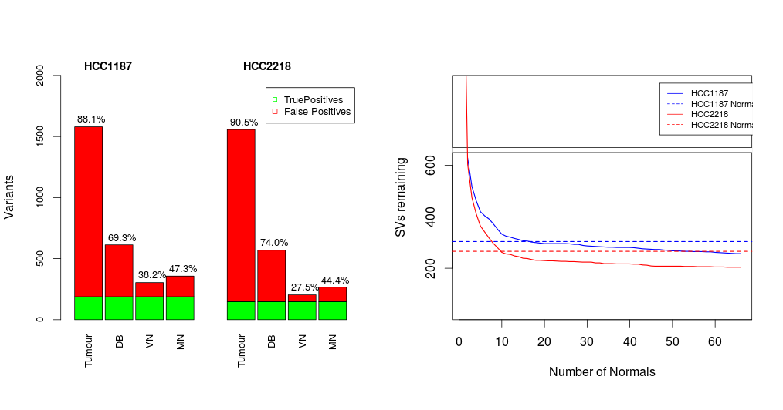
Figure S5.1: Structural variant results for hg18-mapped version of the two samples (HCC1187, HCC2218). Left: number of false-positive SVs identified by each correction method; matched normal (MN), virtual normal (VN), and database filter (DB). Golden set (variants remaining after application of all three filters) indicated in green. Right: number of corrected variants after each additional VN sample. Dashed lines indicate number of variants remaining after correction with the MN.

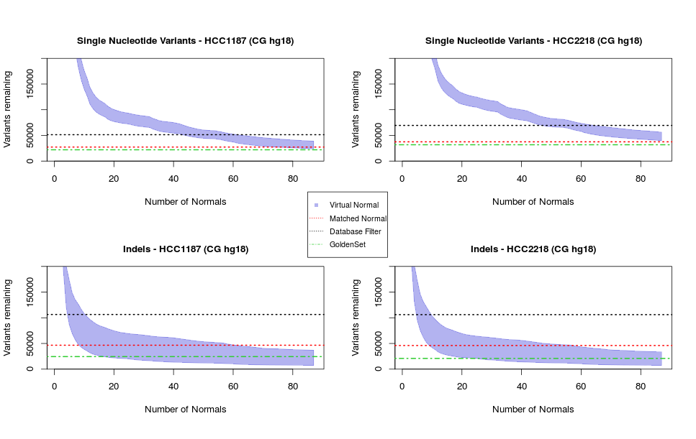
Small variants:
Figure S5.2: Number of variants removed after filtering with each additional virtual normal sample. Black dashed line indicates the number of variants labelled as somatic when using only a database filter. The red line signifies the number of variants after correction with matched normal and the database, and the green dashed line indicate the number of true somatic variants; those remaining after application of all correction methods

S6: Influence of Ethnicity
Structural Variations
For this analysis we used the 54 public virtual normal samples; individuals from 5 different populations across the world. For each population and each subpopulation we calculated the average number of variants filtered out by each of the virtual normal samples belonging to each of the different populations (Table S6.1). Our four tumour samples (HCC1187,HCC2218,G110 and G316) are all from individuals of European descent.
Population | HCC1187 | HCC2218 | G110 | G316
SAN | 934 ± 9 (59.2%) | 947 ± 10 (60.7%) | 1294 ± 9 (63.1%) | 1275 ± 10 (63.3%)
EUR | 925 ± 24 (58.6%) | 945 ± 22 (60.6%) | 1278 ± 28 (62.3%) | 1255 ± 27 (62.3%)
ASN | 900 ± 12 (57.0%) | 906 ± 18 (58.1%) | 1247 ± 23 (60.8%) | 1223 ± 23 (60.8%)
AMR | 883 ± 24 (56.0%) | 897 ± 26 (57.5%) | 1232 ± 34 (60.1%) | 1202 ± 32 (59.7%)
AFR | 849 ± 35 (53.8%) | 856 ± 29 (54.9%) | 1189 ± 35 (58.0%) | 1161 ± 37 (57.7%)
Table S6.1: Average number ± standard deviation (percentage) of tumour variants removed per virtual normal sample belonging to the different super populations. AFR =African, AMR=Ad Mixed American, ASN=East Asian, EUR=European, SAN=South Asian.
We observe that the European and South Asian populations share the most variants with our (European) tumour samples, while the African population has the fewest variants in common with each of the four tumour samples (Figure S6.3). The difference is approximately 100 SVs per sample.
Small Variations
We again group the virtual normal samples by population and determine the average number of variants removed from our tumour samples.
Population | HCC1187 | HCC2218 | G110 | G316
EUR | 2,182,620 (60.5%) | 2,455,999 (55.6%) | 2,515,691 (59.2%) | 2,507,752 (58.9%)
SAN | 2,164,683 (60.0%) | 2,441,100 (55.3%) | 2,496,848 (58.7%) | 2,482,520 (58.3%)
AMR | 2,110,599 (58.5%) | 2,380,546 (53.9%) | 2,430,353 (57.2%) | 2,419,265 (56.8%)
ASN | 2,080,060 (57.6%) | 2,343,996 (53.1%) | 2,392,479 (56.3%) | 2,382,441 (55.9%)
AFR | 1,960,860 (54.3%) | 2,222,154 (50.3%) | 2,261,259 (53.2%) | 2,252,804 (52.9%)
Table S6.2: Average number and percentage of small variants removed per VN genome grouped by population.
We observe that the samples from the European population share the most variants with our (European) tumour samples, and the samples from the African population, on average, have the fewest variants in common with our samples. The difference is approximately 200,000 variants genome-wide.

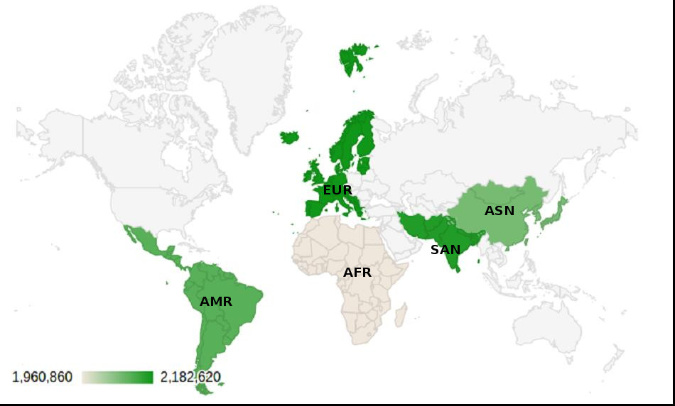
Figure S6.3: Similarity in terms of small variants of five different populations, American (AMR), African (AFR), European (EUR), Asian (ASN) and South Asian (SAN).

S7: Prostate Cancer Samples
Since both HCC1187 and HCC2218 samples are cell lines and to demonstrate that our method also works for patient data, we additionally analysed two prostate cancer patient samples, G110 and G316. These were sequenced by Complete Genomics and use genome build hg18. WGS variation data from these samples are available at The European Nucleotide Archive (ENA) (http://www.ebi.ac.uk/ena), accession number PRJEB9673. Because the virtual normal samples were sequenced on hg19, we had to use a smaller virtual normal set here, consisting of 85 genomes; 54 public genomes from Complete Genomics, and 31 in-house genomes, also sequenced by CG (Figure S7.1-S7.3). However, we observe that for these samples, we need fewer virtual normal samples to correct the same amount of common small variants as the database filter than we did for the hg19 samples. One of the explanations for this is that there are far more hg19 variants in the public databases than hg18 variants, and thus the golden set is also larger for hg18 than hg19 samples (fewer common variants are corrected for in the hg18 golden sets). Similarly, there will be less correction in the golden set because we used a smaller virtual normal set than we did for hg19. We also analysed the hg18-mapped versions of the breast cancer cell line samples (HCC1187 and HCC2218), and indeed see that the DB corrected set and the golden set contain more variants.

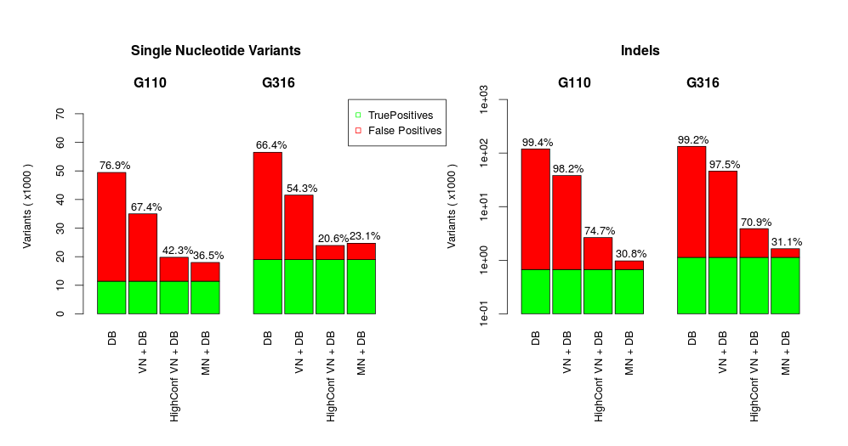
Figure S7.1: Number of false positives (FP) somatic SNVs (left) and Indels (right) identified per filtering method for Complete Genomics prostate cancer samples. True Positives (green) are those variants remaining after application of all filters. DB denotes an aggressive database filter. VN+DB denotes the aggressive database filter plus the virtual normal filter. HighConf VN+DB denotes the list of highest-confidence somatic variants as determined by the VN method. MN+DB is the database filter in combination with a correction with the matched normal sample.
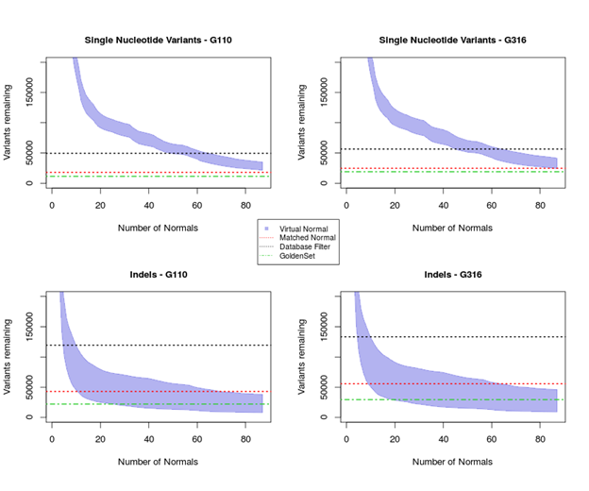
Figure S7.2: Number of variants removed after filtering with each additional virtual normal sample. Black dashed line indicates the number of variants labelled as somatic when using only a database filter. The red line signifies the number of variants after correction with matched normal and the database, and the green dashed line indicate the number of true somatic variants; those remaining after application of all correction methods
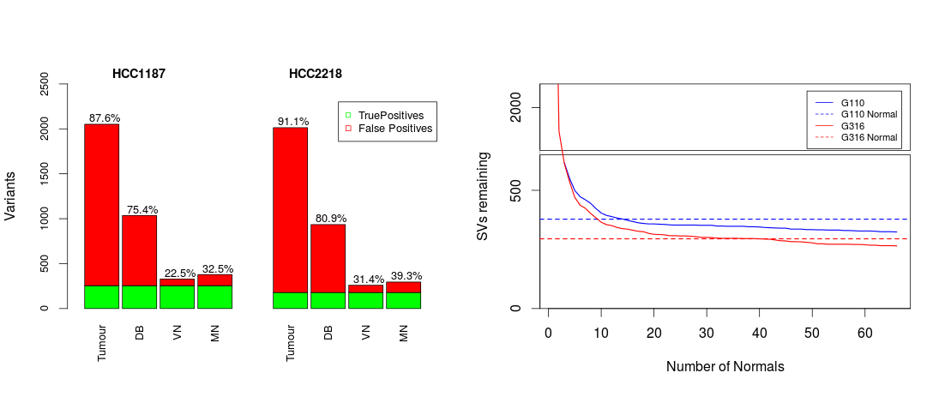
Figure S7.3: Structural variant results for prostate cancer samples. Left: number of false-positive SVs identified by each correction method; matched normal (MN), virtual normal (VN), and database filter (DB). Golden set indicated in green. Right: number of corrected variants after each additional VN sample. Dashed lines indicate number of variants remaining after correction with the MN.

S8: Performance Small Variant Analysis by type
S8.1 Complete Genomics
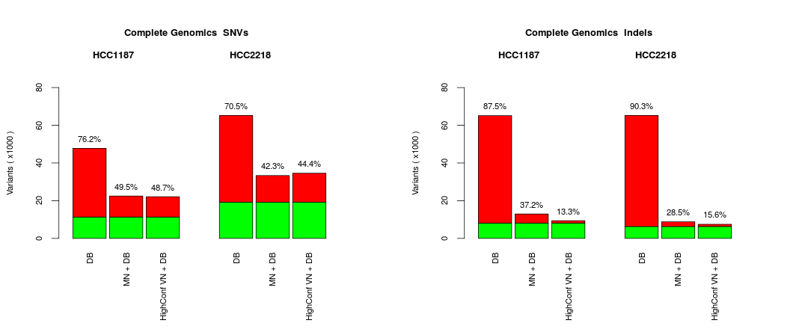
Figure S8.1.1: Number of false positives (FP) somatic SNVs (left) and Indels (right) identified per filtering method for Complete Genomics. True Positives (green) are those variants remaining after application of all filters. DB denotes an aggressive database filter. VN+DB denotes the aggressive database filter plus the virtual normal filter. HighConf VN+DB denotes the list of highest-confidence somatic variants as determined by the VN method. MN+DB is the database filter in combination with a correction with the matched normal sample.
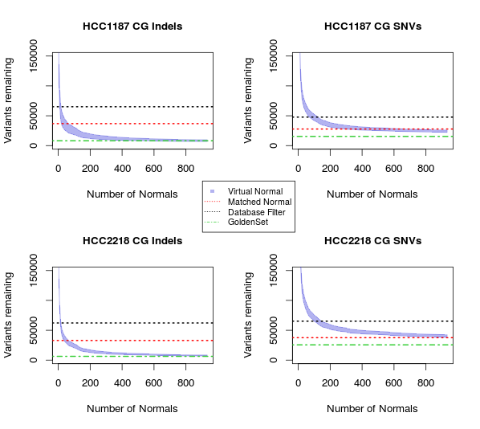

Figure S8.1.2: Number of small variants (Left: Indels, Right: SNVs) removed after filtering with each additional virtual normal sample. Black dashed line indicates the number of variants labelled as somatic when using only a database filter. The red line signifies the number of variants after correction with matched normal and the database, and the green dashed line indicate the number of true somatic variants; those remaining after application of all correction methods

S8.2 Illumina

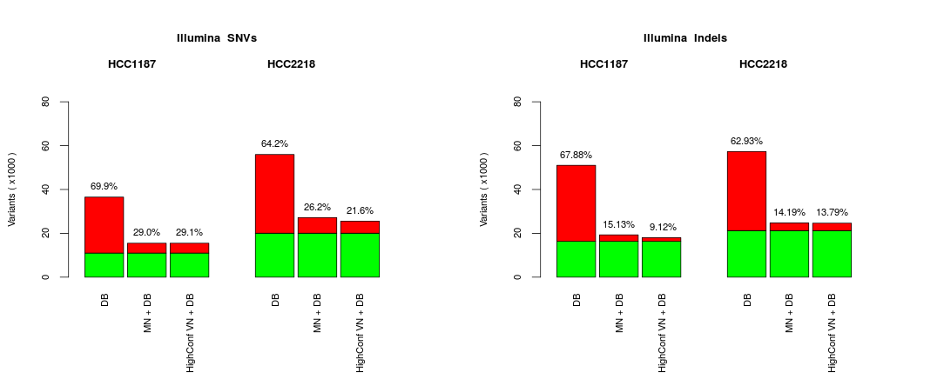

Figure S8.2.1: Number of false positives (FP) somatic SNVs (left) and Indels (right) identified per filtering method for Complete Genomics. True Positives (green) are those variants remaining after application of all filters. DB denotes an aggressive database filter. VN+DB denotes the aggressive database filter plus the virtual normal filter. HighConf VN+DB denotes the list of highest-confidence somatic variants as determined by the VN method. MN+DB is the database filter in combination with a correction with the matched normal sample.

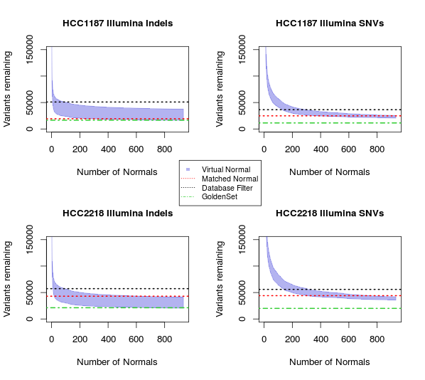

Figure S8.2.2: Number of small variants (Left: Indels, Right: SNVs) removed after filtering with each additional virtual normal sample. Black dashed line indicates the number of variants labelled as somatic when using only a database filter. The red line signifies the number of variants after correction with matched normal and the database, and the green dashed line indicate the number of true somatic variants; those remaining after application of all correction methods.

