Supplementary Tables

Suppl Table 1. Sequencing statistics.
Sample |  | Sequenced reads (x10⁶) | (%) |  | Filtered (x10⁶) ª | (%) |  | Perfect match (x10⁶) | (%) |  | 1 mismatch (x10⁶) | (%) |  | ≥ 2 mismatches (x10⁶) | (%)
Livp S |  | 4.32 | 100 |  | 2.95 | 68.4 |  | 2.04 | 47.3 |  | 0.53 | 12.3 |  | 0.38 | 8.8
Bora S |  | 4.01 | 100 |  | 2.67 | 66.6 |  | 1.64 | 40.8 |  | 0.58 | 14.6 |  | 0.45 | 11.2
Delta R- |  | 4.05 | 100 |  | 2.69 | 66.5 |  | 1.64 | 40.6 |  | 0.59 | 14.6 |  | 0.46 | 11.3
Delta R+ |  | 4.26 | 100 |  | 2.87 | 67.2 |  | 1.77 | 41.5 |  | 0.62 | 14.5 |  | 0.48 | 11.2
Patg S |  | 4.51 | 100 |  | 3.08 | 68.3 |  | 2.20 | 48.8 |  | 0.51 | 11.4 |  | 0.36 | 8.0
Phet R- |  | 4.46 | 100 |  | 3.10 | 69.5 |  | 2.25 | 50.4 |  | 0.51 | 11.3 |  | 0.35 | 7.8
Phet R+ |  | 4.48 | 100 |  | 3.14 | 70.1 |  | 2.27 | 50.7 |  | 0.51 | 11.5 |  | 0.35 | 7.9
Nakh R- |  | 4.59 | 100 |  | 3.18 | 69.5 |  | 2.28 | 49.8 |  | 0.54 | 11.7 |  | 0.37 | 8.0
Nakh R+ |  | 3.37 | 100 |  | 2.36 | 70.0 |  | 1.69 | 50.1 |  | 0.40 | 11.9 |  | 0.27 | 8.0
NwOr S |  | 4.18 | 100 |  | 2.88 | 69.0 |  | 2.00 | 47.8 |  | 0.52 | 12.4 |  | 0.37 | 8.7
Cayn R- |  | 3.88 | 100 |  | 2.64 | 67.9 |  | 1.78 | 45.8 |  | 0.50 | 12.9 |  | 0.36 | 9.3
Cayn R+ |  | 4.10 | 100 |  | 2.82 | 69.0 |  | 1.90 | 46.4 |  | 0.53 | 13.0 |  | 0.39 | 9.5
StGe R- |  | 6.39 | 100 |  | 4.29 | 67.2 |  | 2.91 | 45.5 |  | 0.80 | 12.5 |  | 0.58 | 9.1
StGe R+ |  | 4.37 | 100 |  | 2.98 | 68.2 |  | 2.02 | 46.2 |  | 0.55 | 12.7 |  | 0.41 | 9.3
Mean |  | 4.35 | 100 |  | 2.98 | 68.4 |  | 2.03 | 46.6 |  | 0.55 | 12.7 |  | 0.40 | 9.2
ª: Reads passing all filtering steps (read pairing, sequence quality and mapping quality)

Supplementary Table 2. Gene amplifications linked to deltamethrin resistance.
See separate file

Supplementary Table 3. Associations between gene amplifications and kdr mutations
Supercontig 1.1188
Population / kdr mutations |  | AAEL014614 (CYP9J?) |  |  | AAEL014615 (CYP9J23) |  |  | AAEL014617 (CYP9J28)
Population / kdr mutations |  | r | P value |  | r | P value |  | r | P value
Nakh_V1016G |  | 0.13 | 0.672 |  | 0.31 | 0.298 |  | 0.61 | 0.025
Phet_V1016G |  | -0.55 | 0.201 |  | -0.75 | 0.051 |  | -0.30 | 0.520
Cayn_V1016I |  | 0.36 | 0.099 |  | -0.28 | 0.204 |  | -0.22 | 0.317
StGe_V1016I |  | 0.45 | 0.064 |  | -0.17 | 0.499 |  | -0.08 | 0.756
Nakh_F1534C |  | -0.07 | 0.818 |  | -0.24 | 0.437 |  | -0.58 | 0.036
Phet_F1534C |  | 0.55 | 0.201 |  | 0.75 | 0.051 |  | 0.30 | 0.520
Cayn_F1534C |  | 0.34 | 0.120 |  | -0.13 | 0.572 |  | -0.02 | 0.941
StGe_F1534C |  | 0.47 | 0.059 |  | -0.18 | 0.486 |  | -0.04 | 0.890
Supercontig 1.1327
Population / kdr mutations |  | AAEL014892 (CYP6BZ?) |  |  | AAEL014893 (CYP6BB2) |  |  | AAEL014890 (CYP6CC1)
Population / kdr mutations |  | r | P value |  | r | P value |  | r | P value
Nakh_V1016G |  | 0.15 | 0.635 |  | -0.25 | 0.417 |  | -0.25 | 0.409
Phet_V1016G |  | -0.45 | 0.317 |  | -0.07 | 0.888 |  | -0.03 | 0.942
Cayn_V1016I |  | -0.09 | 0.689 |  | -0.14 | 0.541 |  | 0.06 | 0.800
StGe_V1016I |  | -0.14 | 0.570 |  | -0.27 | 0.285 |  | -0.23 | 0.365
Nakh_F1534C |  | -0.07 | 0.817 |  | 0.28 | 0.363 |  | 0.26 | 0.393
Phet_F1534C |  | 0.45 | 0.317 |  | 0.07 | 0.888 |  | 0.03 | 0.942
Cayn_F1534C |  | -0.21 | 0.347 |  | -0.26 | 0.240 |  | 0.08 | 0.725
StGe_F1534C |  | -0.09 | 0.721 |  | -0.21 | 0.410 |  | -0.19 | 0.456
Supercontig 1.142
Population / kdr mutations |  | AAEL005112 (CCEAE3A) |  |  | AAEL005101 (CCEAE4A) |  |  | AAEL005122 (CCEAE6A)
Population / kdr mutations |  | r | P value |  | r | P value |  | r | P value
Nakh_V1016G |  | 0.08 | 0.796 |  | 0.10 | 0.757 |  | 0.10 | 0.743
Phet_V1016G |  | 0.39 | 0.390 |  | 0.31 | 0.495 |  | 0.33 | 0.464
Cayn_V1016I |  | 0.12 | 0.602 |  | 0.29 | 0.183 |  | 0.12 | 0.607
StGe_V1016I |  | -0.06 | 0.811 |  | -0.05 | 0.846 |  | 0.10 | 0.700
Nakh_F1534C |  | -0.07 | 0.809 |  | -0.07 | 0.809 |  | -0.11 | 0.730
Phet_F1534C |  | -0.39 | 0.390 |  | -0.31 | 0.495 |  | -0.33 | 0.464
Cayn_F1534C |  | 0.09 | 0.702 |  | 0.10 | 0.659 |  | -0.04 | 0.858
StGe_F1534C |  | -0.03 | 0.907 |  | -0.03 | 0.911 |  | 0.12 | 0.660
For each population, the amplification level of each gene was correlated with kdr mutation genotype (homozygote wildtype: 0, heterozygote 0.5, homozygote resistant: 1) across all individuals. Correlation coefficient and their associated P value are shown. Values in bold were considered significant (P < 0.05).
Supplementary Table 4. Polymorphism variations dataset.
See separate file

Supplementary Table 5. Description and location of all captured genes.
See separate file

Supplementary Table 6. Primers used for qPCR.
Accession number | Gene name ª | forward primer (5'-3') | reverse primer (5'-3') | Product lenght (bp)
AAEL014614 | CYP9J? | GGAAGCGTTGAGCATGTGTG | AACTGTGAAACCGTGGGGTC | 121
AAEL014615 | CYP9J23 | AGAATCCACGAAGCGATGAG | CTATCCAGGGCGGCAATG | 122
AAEL014617 | CYP9J28 | CTATTTCGGAGTCCTAGTGGCC | CTTTGACTCCTCGGTACTTGTCG | 197
AAEL014891 | CYP6P? | TTCACCTTCAGCGAAGACCC | GATTAGGTGCGGCGTCCTTA | 152
AAEL014893 | CYP6BB2 | AGTTCAAGGGCCGAGGATTG | CGGATCCACGAAAATTCCGC | 143
AAEL014890 | CYP6CC1 | CGAACGTTGCGTTCTTGGTT | CCGGGCCTTCAAATCTCTGT | 185
AAEL005112 | CCEAE3A | TCTAAGAAACCCGAATATGACG | TTGAGGAGGCACGAACAG | 130
AAEL005101 | CCEAE4A | GTAAATGCCGGAGAAACGGC | ACCATTTTTCGCCATTGGGC | 89
AAEL005122 | CCEAE6A | TGGCTCCAGTCGAGGTAGAA | AAGTTGGTCCACATGCGACA | 76
AAEL005950 | AAEL005950 | TCCGGTTCCGTCTGGTATCT | GTGTGTGTAACGGCTCCAGA | 186
AAEL007808 | CYP4D39 | AGTCCTGGAAGTTCTGCACG | AAGGCGACTTTCCGACGAAT | 132
AAEL000987 | RPL8 | CTGAAGGGAACCGTCAAGCAA | TCGGCGGCAATGAACAACT | 119
AAEL009496 | RPS7 | GTTGGAGATGAACTCGGACCTG | GCCTTCTTGCTGTTGAACTCG | 87
ª: P450 names ending with interrogation marks are not official. Their CYP subfamily is proposed according to best protein homology in mosquitoes.

Supplementary Figures

Supplementary Figure 1. Sequencing coverage across captured regions.
Box plots show the coverage distribution for all captured regions across all samples. Mean coverage is shown as a solid line within box. Interquartiles are shown as whiskers and outliers as dots.
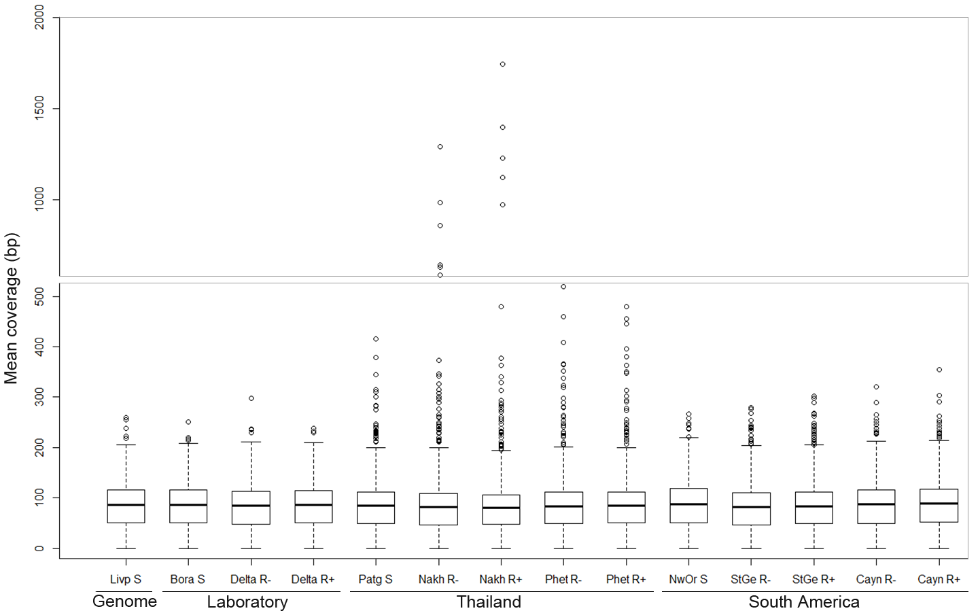
Supplementary Figure 2. Cross-comparison of CNV data obtained by DNA-seq and qPCR.
Each dot represents the CNV of one gene in one resistant population/phenotype versus all susceptible strains. For qPCR, the mean CNV across all individuals was used. Pearson’s correlation coefficient is shown.
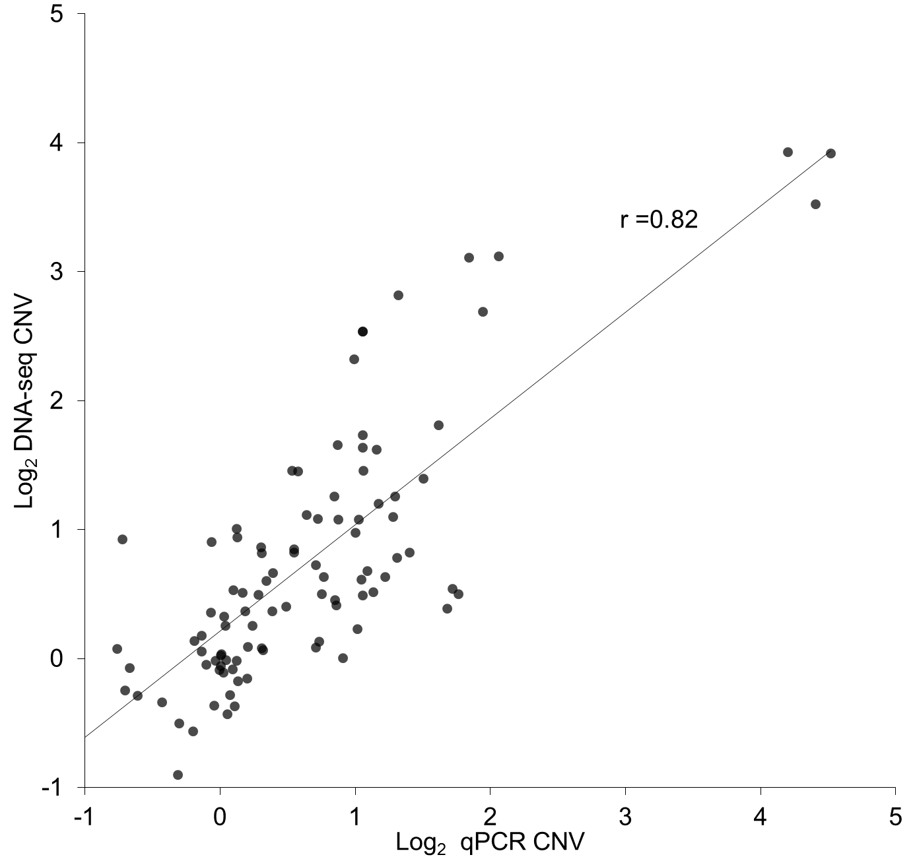

Supplementary Figure 3. Gene amplification levels on individual mosquitoes.
Nine candidate genes from three distinct supercontigs were targeted for validation. CNV were analyzed by qPCR on gDNA extracted from 12 individual mosquitoes per population/phenotype. For each gene, relative genomic DNA quantity is shown for each mosquito across all populations. Quantitative PCR data were normalized according to two genes displaying no amplification across all individuals and conditions and are presented as gDNA quantity relative to one individual of the susceptible Livp population. White, grey and black circles represent S, R- and R+ individuals respectively. Horizontal marks show the mean gDNA quantity of each population. Horizontal dotted grey lines show the upper 90% quantile of individuals from all susceptible populations.

Supplementary Figure 4. Gene amplifications frequencies across populations.
Nine candidate genes from three distinct supercontigs were analyzed. For each gene, individuals showing a CN higher than the 0.9 quantile of CNs observed among individuals from all susceptible populations were considered affected by gene amplification.

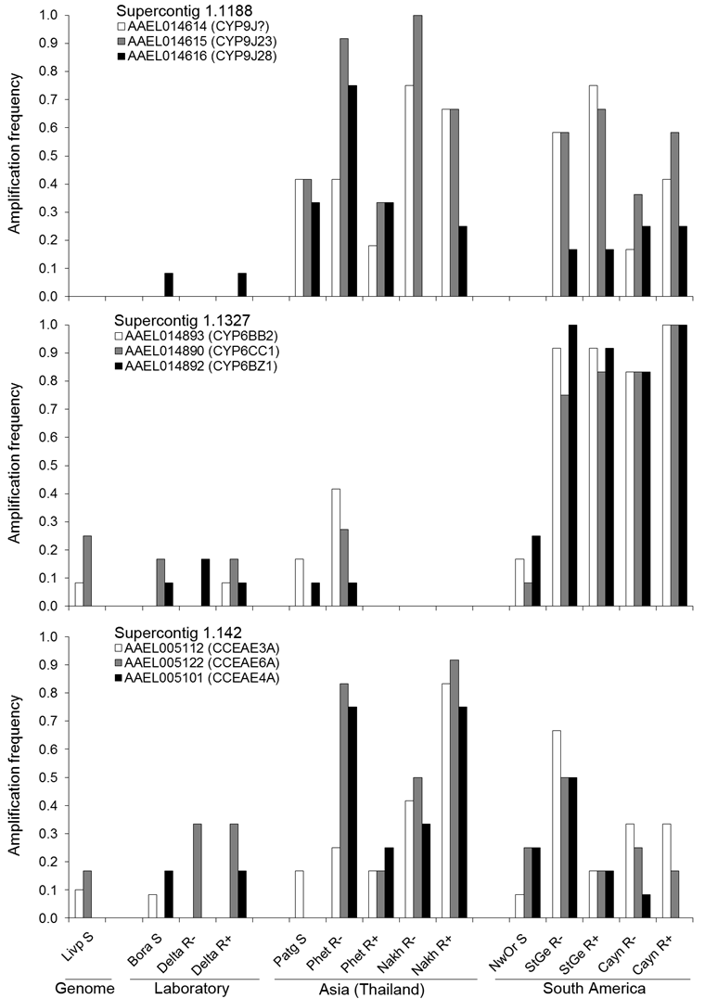

Supplementary Figure 5. Comparison of CNV profiles across populations and individuals.
Individual CNV data obtained by qPCR are presented for nine genes located in three different supercontigs. Only individuals from which reliable qPCR signal were obtained for all genes are shown. Normalized gDNA quantities < 1 are masked for clarity. Individuals are sorted by geographic regions, populations and phenotypes (R- or R+).
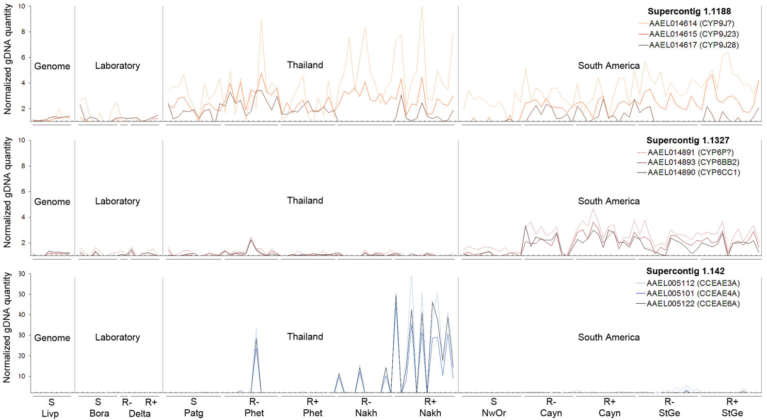

Supplementary Figure 6. Impact of gene amplifications on transcription levels.
Nine genes were studied across 3 different supercontigs. Gene amplifications levels were extracted from sequencing data. Transcription levels were estimated by RT-qPCR on 3 independent biological replicates. Both gene amplification and transcription levels are expressed as fold change versus the mean of all susceptible populations (R/meanS). Correlation coefficients and their respective P values are shown for each gene (* P<0.05; ** P<0.01; *** P<0.001).
Supplementary Figure 7. Population structure deduced from PCA analysis.
A total of 30400 polymorphic substitutions were used for PCA analysis. PCA was computed from the allele frequencies of all polymorphic substitutions across populations. The first two axes representing almost 60% of variability are represented. The three geographical groups are colored.
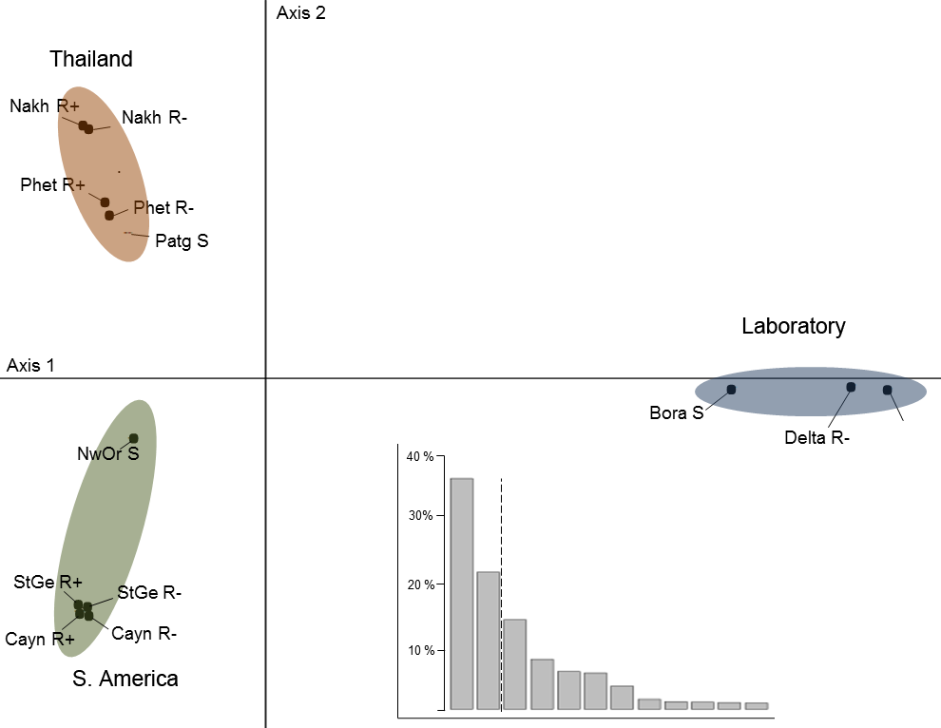

Supplementary Figure 8. Comparison of kdr frequencies between DNA-seq and qPCR.
For DNA-seq, kdr frequencies were estimated from pools of 130 individual based on the number of reads supporting each allele at each locus. For allele-specific qPCR, kdr frequencies were deduced from the genotype of 12 mosquitoes per population/phenotype.

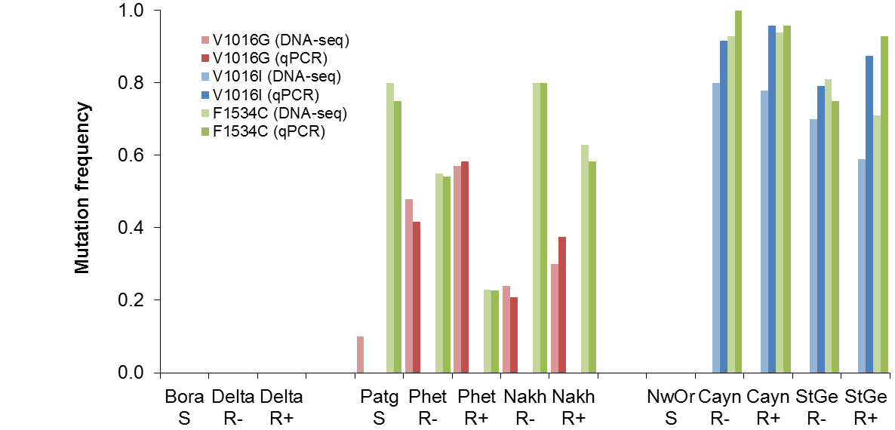

Supplementary Figure 9. Comparison of Bayesian and frequency filtering approaches.
The numbers of polymorphism variations associated with deltamethrin resistance identified by each approach are shown for each geographical group. The frequency-based filtering approach includes all variation types (SNPs, MNPs and InDels) while the Bayesian approach only included substitutions. Loci identified by frequency-based filtering are shown as normal typing while those identified by the Bayesian approach are shown within brackets. Non-synonymous variations are shown in bold.
