Supplemental Figures
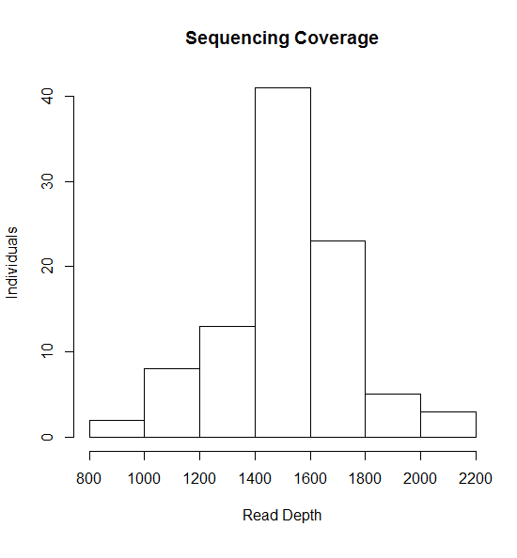
Supplemental Figure 1: Distribution of TruSeq Custom Amplicon sequencing coverage for 95 individuals. For each individual, the read depth was determined by calculating the median coverage per amplicon for that specific individual. The median read depth for an individual in the cohort is 1500x.
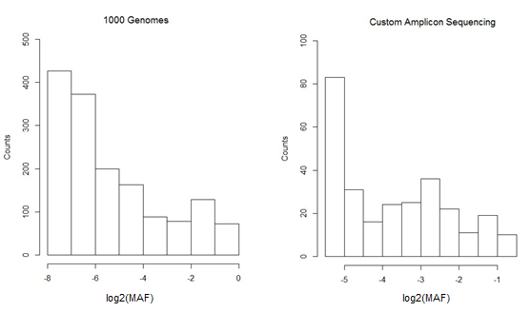
Supplemental Figure 2: Distribution of allele frequencies in the 1000 Genomes Project and our TruSeq Custom Amplicon Sequencing for 95 individuals. The high coverage permitted confidently calling a higher number of private variants per individual.

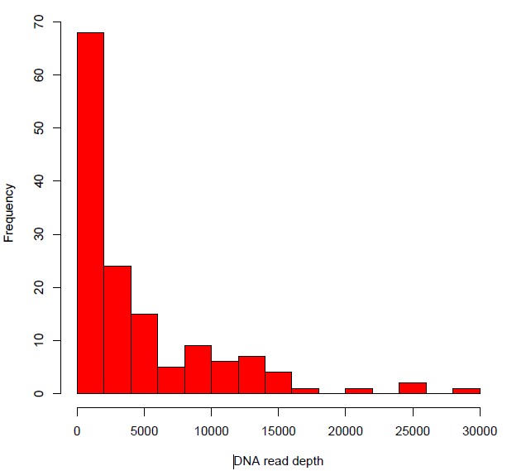
Supplemental Figure 3: Distribution of median coverage per amplicon of STARR-seq DNA plasmid input library sequencing. The Y-axis represents the number of amplicons and the X-axis represents the median depth per fragment. The median number of times an amplicon was sequenced was 2200 times.

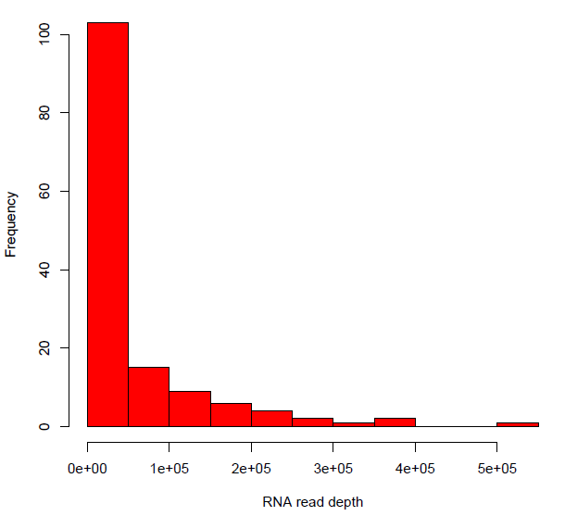
Supplemental Figure 4: Distribution of median coverage per amplicon of the RNA-seq output library sequencing. The Y-axis represents the number of amplicons and the X-axis represents the median depth per fragment. The median number of times an amplicon was sequenced was 13,000 times.

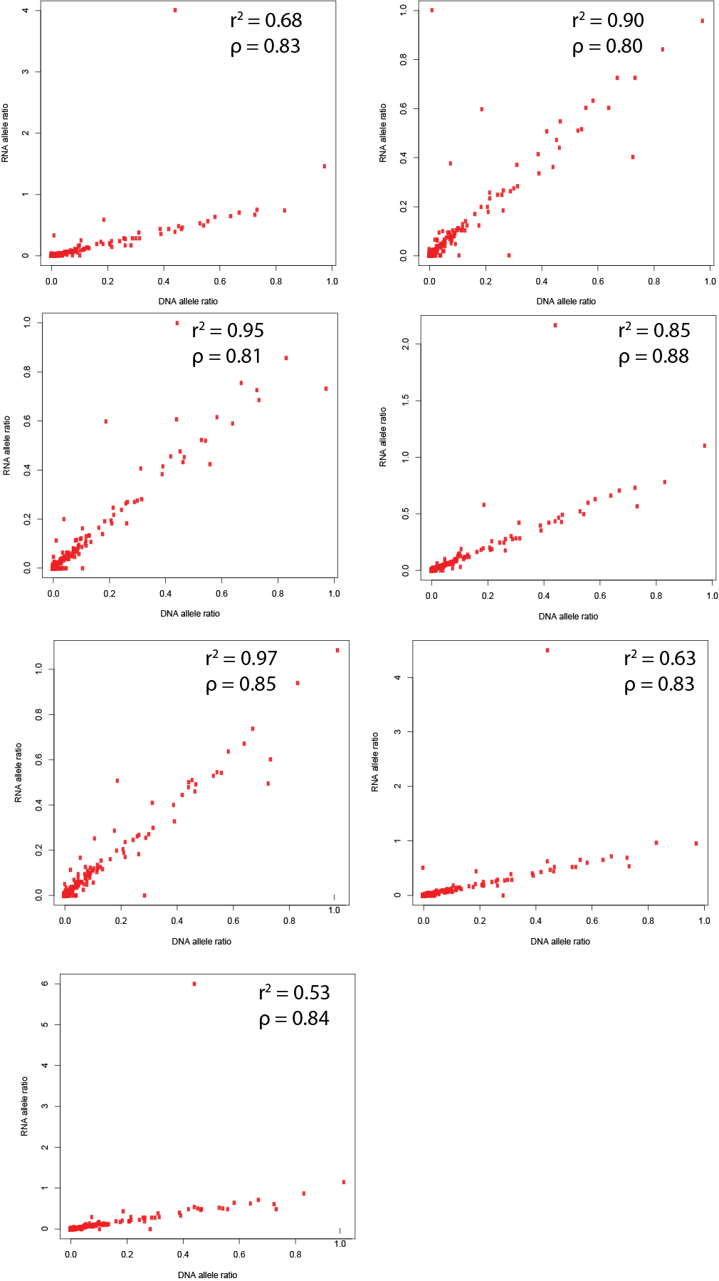

Supplemental Figure 5: Allele ratio in the DNA plasmid library (X-axis) versus allele ratio in RNA-seq output libraries (Y-axis) for each replicate. Allele ratio is defined as (number of reads containing Allele₀) / (number of reads containing Allele₁). Allele₀ is the reference allele and Allele₁ is the alternate allele defined by the VCF file. Generally, the alternative allele has lower frequency, although this is not always the case.

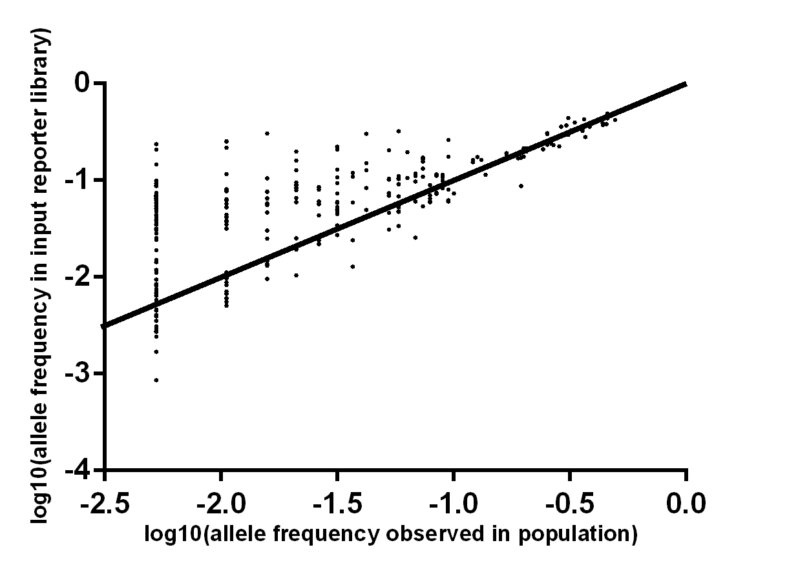
Supplemental Figure 6: Plotted is a comparison of the allele frequency of each SNP in the cohort DNA determined by variant calling to the allele frequency of each SNP in the resulting reporter library. Allele frequencies of the cohort DNA used are shown on the X-axis; and the allele frequency in the resulting reporter library are on the Y-axis.

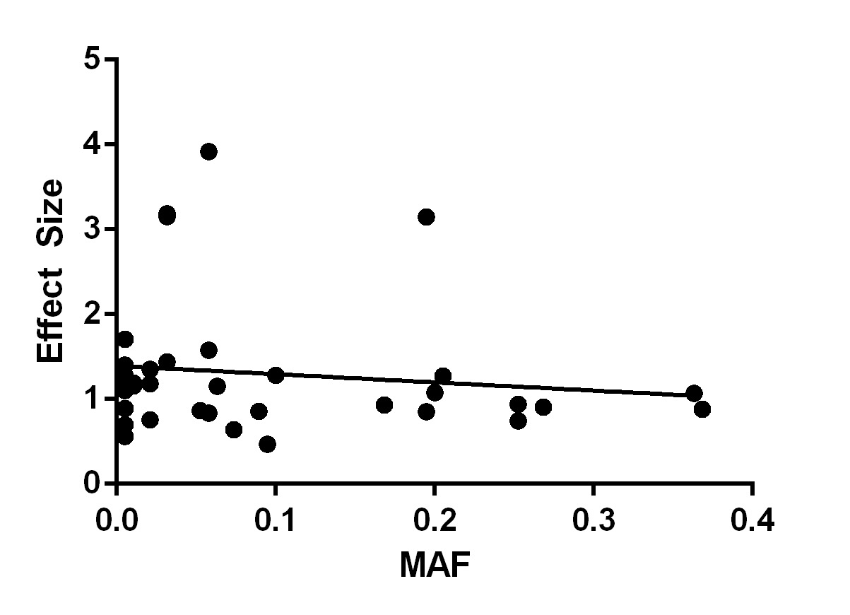
Supplemental Figure 7: Correlation between minor allele frequency (MAF: X-axis) and variant effect size (Y-axis) for functional variants identified in our population STARR-seq assay (Spearman ρ = -0.18, p = 0.28).
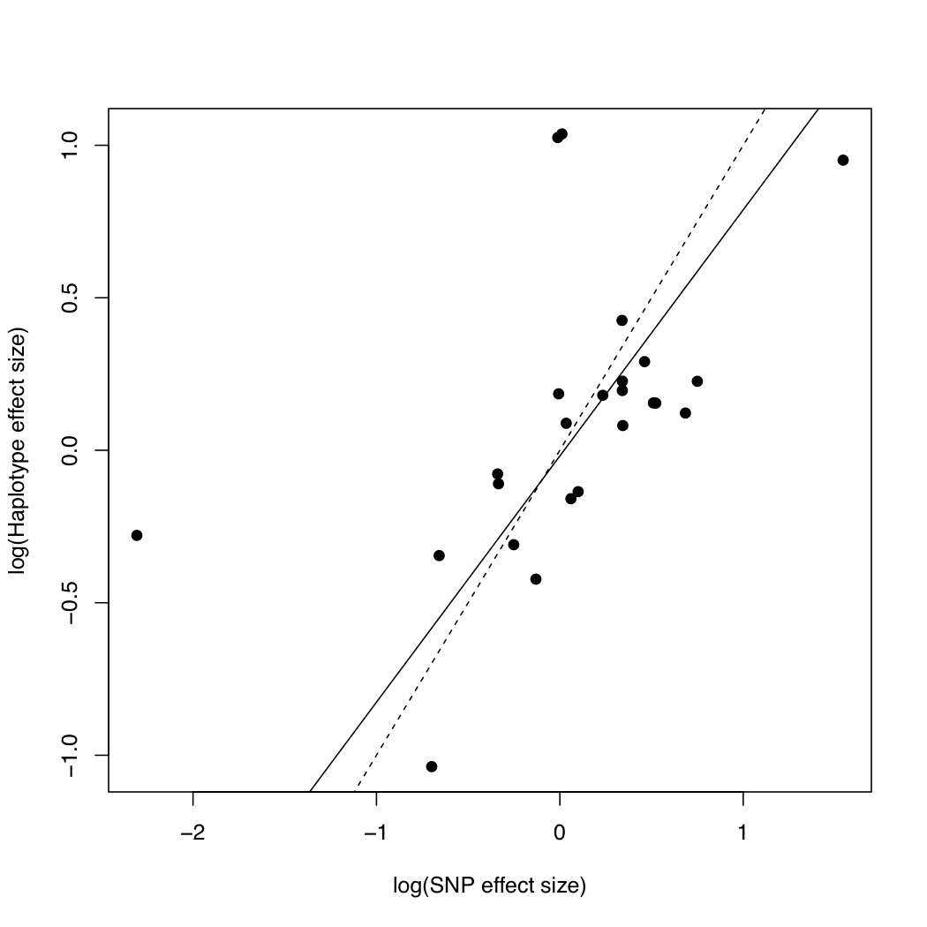
Supplemental Figure 8: Correlation between SNP effect sizes (X-axis: log of product of effect sizes of SNPs on haplotype) and log of observed haplotype effects (Y-axis) for putative regulatory haplotypes containing more than one SNP (r = 0.54, p = 0.007). Observed haplotype effect sizes were computed as normalized ratios for each haplotype versus all pooled haplotypes at a locus: (RNA_{haplotype}/DNA_{haplotype})/(RNA_{pooled}/DNA_{pooled}). Solid line: regression line (slope=0.8, intercept=-0.019); dotted line: 1:1 diagonal.
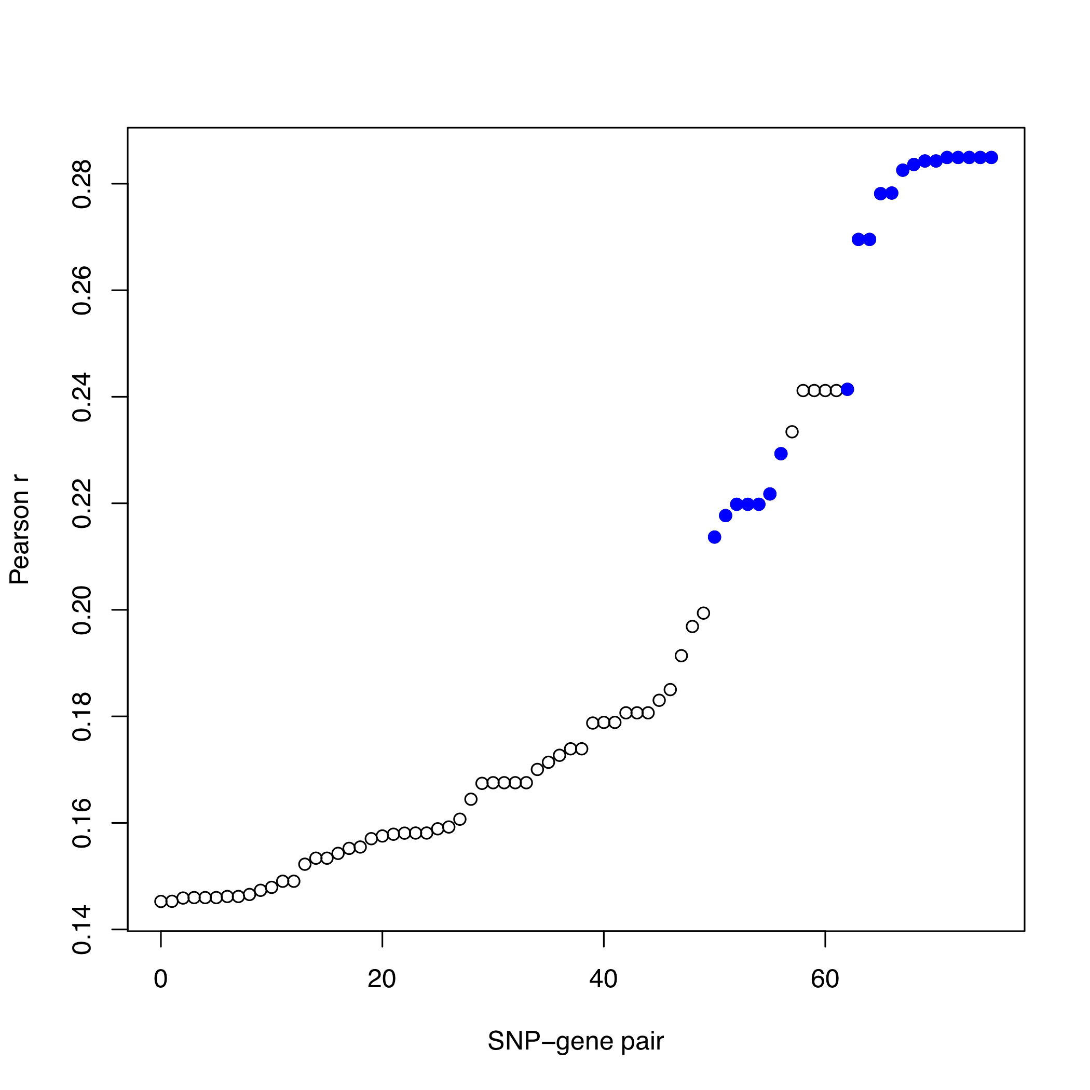
Supplemental Figure 9: Pearson correlation coefficients for five genes (LINC00881:ENSG00000241135.1, LINC00880:ENSG00000243629.1, CCNL1:ENSG00000163660.7, TIPARP:ENSG00000163659.8, LEKR1:ENSG00000197980.6) and 67 proximal SNPs. Blue points correspond to eQTLs for LINC00881 as defined by the GEUVADIS consortium and shown in Fig. 2C.

Supplemental Tables

Supplemental Table 1: Transition:Transversion ratios in 1000 Genomes and Custom Amplicon Sequencing
 | 1000 genomes | Custom Amplicon Sequencing
Exons | 2.71 | 2.83
DHS Peaks | 2.36 | 2.31
DHS Peak middle | 2.65 | 2.63
DHS Peak edges | 2.25 | 2.18
Non DHS Intergenic | 1.61 | 1.97
Overall | 2.02 | 2.17

Supplemental Table 2: Proportion of assayed variation in Population STARR-seq
 | Number of Fragments Sequenced | Number of Variants Called
Custom Amplicon Assay | 174 | 321
Population STARR-seq | 173 | 283
Percent | 99.42528736 | 88.16199377

Supplemental Table 3: STARR-seq Primers
TS2SSF: | TAGAGCATGCACCGGACACTCTTTCCCTACACGACGCTCTTCCGATCT
TS2SSpatientR: | GGCCGAATTCGTCGATCGCGAGTTAATGCAACGATCGTCGAAATTCGC
PPRead2 | TCGCGAGTTAATGCAACGATCGTCGAAATTCGC
PPBCread | GCGAATTTCGACGATCGTTGCATTAACTCGCGA
PPBC1 | CAAGCAGAAGACGGCATACGAGATCGTGATTCGCGAGTTAATGCAACGATCGTCGAAATTCG*C
PPBC2 | CAAGCAGAAGACGGCATACGAGATACATCGTCGCGAGTTAATGCAACGATCGTCGAAATTCG*C
PPBC3 | CAAGCAGAAGACGGCATACGAGATGCCTAATCGCGAGTTAATGCAACGATCGTCGAAATTCG*C
PPBC4 | CAAGCAGAAGACGGCATACGAGATTGGTCATCGCGAGTTAATGCAACGATCGTCGAAATTCG*C
PPBC5 | CAAGCAGAAGACGGCATACGAGATCACTGTTCGCGAGTTAATGCAACGATCGTCGAAATTCG*C
PPBC6 | CAAGCAGAAGACGGCATACGAGATATTGGCTCGCGAGTTAATGCAACGATCGTCGAAATTCG*C
PPBC7 | CAAGCAGAAGACGGCATACGAGATGATCTGTCGCGAGTTAATGCAACGATCGTCGAAATTCG*C
PPBC8 | CAAGCAGAAGACGGCATACGAGATTCAAGTTCGCGAGTTAATGCAACGATCGTCGAAATTCG*C
PPBC9 | CAAGCAGAAGACGGCATACGAGATCTGATCTCGCGAGTTAATGCAACGATCGTCGAAATTCG*C
 | *= phosphorothioate bond.

Supplemental Table 4: Luciferase Validation Primers
chr3 156800768 F | CTGGCCTAACTGGCCGGTACCCCAGCCTGTGTGGATGTTGC
chr3 156806431 F | CTGGCCTAACTGGCCGGTACCGGGGAAGATCAGGGGATGAA
chr3 156812738 F | CTGGCCTAACTGGCCGGTACCAGTTCGTTTTCCGGGGGTGA
chr3 156852592 F | CTGGCCTAACTGGCCGGTACCTGACAGCCCCCTCTAGTGCAG
chr3 156878129 F | CTGGCCTAACTGGCCGGTACCCGGCAGCAGTAGCTGTCGAA
chr3 156898104 F | CTGGCCTAACTGGCCGGTACCTTCTGTAGATGATTGAAATATTTTGGA
chr3 156800768 R | TACCCTAGGGAGATCTCCCTTGTCCCCAGGAAGCTC
chr3 156806431 R | TACCCTAGGGAGATCTCTCTTCCCGCTCGCAGCA
chr3 156812738 R | TACCCTAGGGAGATCTTGAGGGAGCTGTCTTCAGTTCAGA
chr3 156852592 R | TACCCTAGGGAGATCTGCATCAGTTGAGCTGAGGGACA
chr3 156878129 R | TACCCTAGGGAGATCTCCGCCACTTCCCTTGGTACA
chr3 156898104 R | TACCCTAGGGAGATCTCTTCATGGAGAGGTGGAGGA

Supplemental Data
Supplemental Data 1: Amplicon Probe Coordinates
Supplemental Data 2: DHS coordinates
Supplemental Data 3: Phased VCF file for 95 individuals
Supplemental Data 4: Variant effect sizes determined using population STARR-seq
Supplemental Data 5: Enhancer Activity Scores for Significant Functional Variants
Supplemental Data 6: Enhancer Activity Scores for Non-significant Variants
Supplemental Data 7: Haplotype Sequences
Supplemental Data 8: Haplotype Effects

