Supplemental Material

Frequent somatic transfer of mitochondrial DNA into the nuclear genome of human cancer cells

Young Seok Ju, Jose M. C. Tubio, William Mifsud, Beiyuan Fu, Helen R. Davies, Manasa Ramakrishna, Yilong Li, Lucy Yates, Gunes Gundem, Patrick S. Tarpey, Sam Behjati, Elli Papaemmanuil, Sancha Martin, Anthony Fullam, Moritz Gerstung, ICGC Prostate Cancer Working Group, ICGC Bone Cancer Working Group, ICGC Breast Cancer Working Group, Jyoti Nangalia, Anthony R. Green, Carlos Caldas, Åke Borg, Andrew Tutt, Ming Ta Michael Lee, Laura J. van't Veer, Benita K. T. Tan, Sam Aparicio, Paul N. Span, John W.M. Martens, Stian Knappskog, Anne Vincent-Salomon, Anne-Lise Børresen-Dale, Jórunn Erla Eyfjörd, Adrienne M Flanagan, Christopher Foster, David E. Neal, Colin Cooper, Rosalind Eeles, Sunil R. Lakhani, Christine Desmedt, Gilles Thomas, Andrea L. Richardson, Colin A. Purdie, Alastair M. Thompson, Ultan McDermott, Fengtang Yang, Serena Nik-Zainal, Peter J. Campbell and Michael R. Stratton

Contents
- Supplemental Text
- Novel germline mitochondrial sequence in the nuclear genome ----------------- 3
- Frequent nuclear transfer of mtDNA in human cancer cells -------------------------- 3

- Supplemental Tables
- Supp.Table.1: Sample and sequencing information ----------------------------------- 5
- Supp.Table.3: Novel germline mtDNA sequences in the nucleus (Numts) -------- 5
- Supp.Table.3: Primer sequences ----------------------------------------------------- 6
- Association between mtDNA integration and transposable elements ---------------- 7

- Ethical approval and the lists of ICGC working group participants
1. Ethical Approval ----------------------------------------------------------------------- 8
2. ICGC Prostate cancer working group ----------------------------------------------------- 9
2. ICGC Breast cancer working group ----------------------------------------------------- 10
Supplemental Text
Novel germline mitochondrial sequence in the nuclear genome
In addition to the somatic transfers, we found 55 previously unreported mtDNA nuclear integrations that were shared between cancer and normal tissues from the same individual. 63.6% (n=35) of these integrations were found in only one individual and the population allele frequency for 98.2% of them (n=54) was 0.5% or less. Most are therefore likely to have taken place in the germline during recent human evolution (Supplemental Table 3). Almost all were simple insertions into the nuclear genome. However, one, which is shared by four samples, was combined with a tandem duplication of 22.3kb of nuclear DNA (Supplemental Fig. 9). The results indicate that nuclear transfer of mtDNA is ongoing in the human germline and, in some instances, is closely associated with intranuclear structural changes, similar to the observations reported here in somatic cells.

Frequent nuclear transfer of mtDNA in human cancer cells
We observe a much higher rate of mitochondrial DNA fusion to the nuclear genome in human somatic cells than in the human germline. With about 1000 cell divisions from the fertilized egg to the progenitor cell of the dominant cancer cell clone, the rate of somatic nuclear mtDNA fusion appears to be 2 x 10⁻⁵ event per cell per cell generation (pcpg), which is at least several hundreds times higher than the rate observed in the human germline (5 x 10⁻⁸ pcpg) across the evolution (Hazkani-Covo et al. 2010) (Methods).

Assuming that the intrinsic rates of double strand break generation and of ligation to a break in a different chromosome are similar for mitochondrial and nuclear DNA, our findings indicate that physical escape of mtDNA to make contact with nuclear DNA is frequent in some human somatic cells. Under conservative assumptions i) that >10% of mtDNA which escapes is integrated with nuclear DNA, and ii) that the rate of escape is constant during these cell divisions, the results suggest more than one mtDNA escape to the nucleus in 5,000 cell generations (2×10⁻⁴ pcpg). If the escape is a cancer cell specific phenomenon, its rate must be substantially higher. Our estimated escape frequency in human cells appears to be comparable to the rate observed in Saccharomyces cerevisiae (Thorsness et al. 1990)(2×10⁻⁵ pcpg) and to the rate of nuclear migration of chloroplast DNA in tobacco plants (~10⁻⁴ pcpg; Huang et al. 2003).

Supplemental Tables
Supp. Table 1. Sample and sequencing information of 559 primary and 28 cell-line tumor-normal pairs.
Ju_TableS1_SamplesInfo_withAccession.xlsx
Depicted below is a thumbnail of the file.
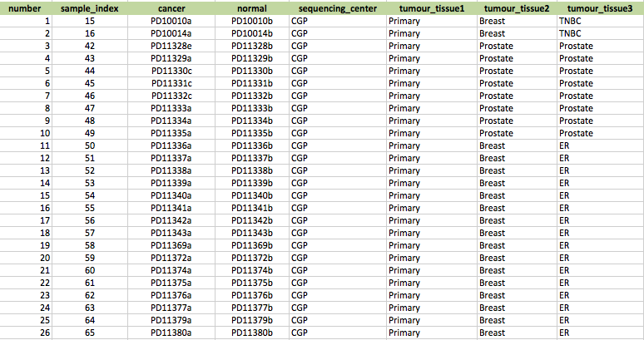

Supp. Table 2. List of novel germline mtDNA sequences in human nuclear genome.
Ju_TableS2_Inherited_mtDNA.xlsx
Depicted below is a thumbnail of the file.
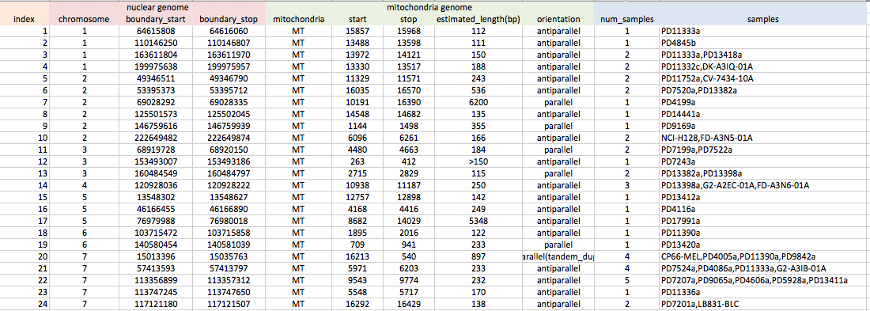

Supp. Table 3. Primer sequences for PCR validations.
Ju_TableS3_PrimerSequences.xlsx
Depicted below is a thumbnail of the file.
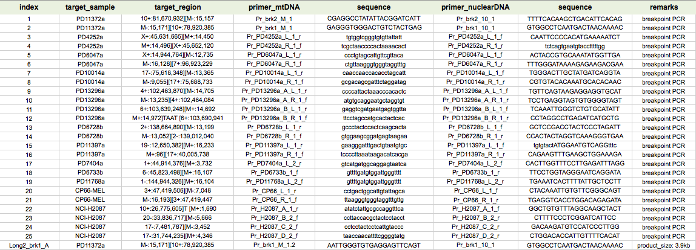

Supp. Table 4. Association between mtDNA integration and transposable elements.
Ju_TableS4_mtDNAinsertions_and_transposableelements.xlsx
Depicted below is a thumbnail of the file.

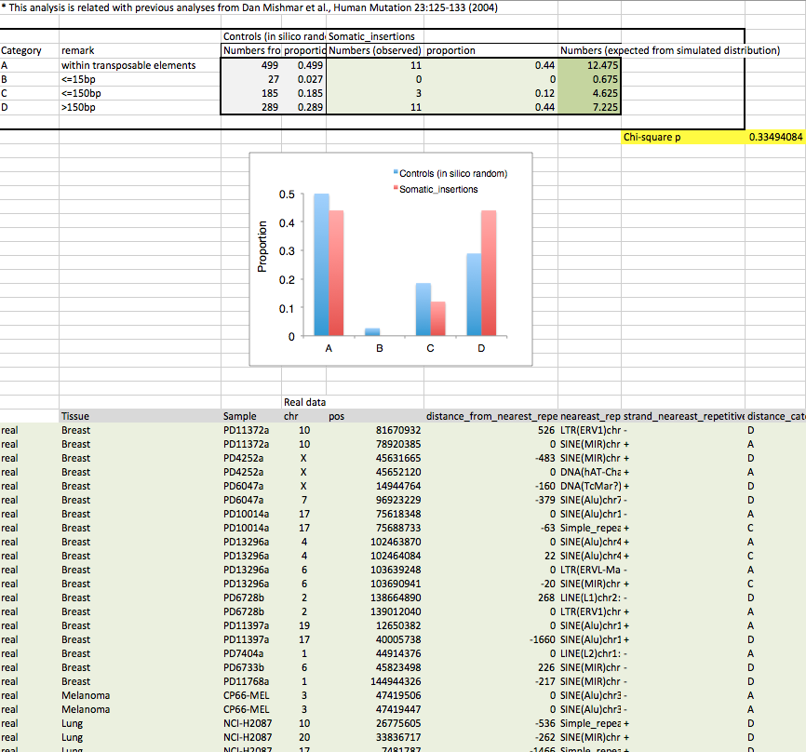
Ethical approval references

Genome Analysis of myeloid and lymphoid malignancies (10/H0306/40)
Genomic Analysis of Mesothelioma (11/EE/0444)
Myeloid and lymphoid cancer genome analysis (07/S1402/90)
The Treatment of Down Syndrome Children with Acute Myeloid Leukemia and Myelodysplastic Syndrome(AAML0431)
CLL (chronic lymphocytic leukaemia) genome analysis (07/Q0104/3)
Cancer Genome Project - Global approaches to characterising the molecular basis of paediatric ependymoma
(05/MRE04/70)
PREDICT-Cohort (09/H0801/96)
ICGC Prostate (Evaluation of biomarkers in urological diseases) (LREC 03/018)
ICGC Prostate (779) (Prostate Complex CRUK Sample Cohort) (MREC/01/4/061)
ICGC Prostate (Tissue collection at radical prostatectomy) (CRE-2011.373)
Somatic molecular genetics of human cancers, melanoma and myeloma (Dana Farber Cancer Institute)(08/H0308/303)
Breast Cancer Genome Analysis for the International Cancer Genome Consortium Working Group (09/H0306/36)
Genome analysis of tumours of the bone (09/H0308/165)

Participants in ICGC prostate cancer working group
Colin Cooper^{1,2,16}, Rosalind Eeles^{1,3,16}, David Wedge⁴, Peter Van Loo^{4,5}, Gunes Gundem⁴, Ludmil Alexandrov⁴, Barbara Kremeyer⁴, Adam Butler⁴, Andrew Lynch⁶, Sandra Edwards¹, Niedzica Camacho¹, Charlie Massie⁷, ZSofia Kote-Jarai¹, Nening Dennis³, Sue Merson¹, Jorge Zamora⁴, Jonathan Kay⁷, Cathy Corbishley⁸, Sarah Thomas³, Serena Nik-Zainai⁴, Sarah O’Meara⁴, Lucy Matthews¹, Jeremy Clark², Rachel Hurst², Richard Mithen⁹, Susanna Cooke⁴, Keiran Raine⁴, David Jones⁴, Andrew Menzies⁴, Lucy Stebbings⁴, Jon Hinton⁴, Jon Teague⁴, Stuart McLaren⁴, Laura Mudie⁴, Claire Hardy⁴, Elizabeth Anderson⁴, Olivia Joseph⁴, Victoria Goody⁴, Ben Robinson⁴, Mark Maddison⁴, Stephen Gamble⁴, Christopher Greenman¹⁰, Dan Berney¹¹, Steven Hazell³, Naomi Livni³, Cyril Fisher³, Christopher Ogden³, Pardeep Kumar³, Alan Thompson³, Christopher Woodhouse³, David Nicol³, Erik Mayer³, Tim Dudderidge³, Nimish Shah⁷, Vincent Gnanapragasam⁷, Peter Campbell⁴, Andrew Futreal^{4,16}, Douglas Easton^{12,16}, Anne Y Warren¹³, Christopher Foster^{14,16}, Michael Stratton^{4,16}, Hayley Whitaker⁷, Ultan McDermott^{4,16}, Daniel Brewer^{1,2}, David Neal^{7,15,16}.

Affiliations
¹Division of Genetics and Epidemiology, The Institute Of Cancer Research, Sutton, UK
²Department of Biological Sciences and School of Medicine, University of East Anglia, Norwich, UK
³Royal Marsden NHS Foundation Trust, London and Sutton, UK
⁴Cancer Genome Project, Wellcome Trust Sanger Institute, Hinxton, UK
⁵Human Genome Laboratory, Department of Human Genetics, VIB and KU Leuven, Leuven, Belgium
⁶Statistics and Computational Biology Laboratory, Cancer Research UK Cambridge Research Institute, Cambridge, UK
⁷Urological Research Laboratory, Cancer Research UK Cambridge Research Institute, Cambridge, UK
⁸Department of Histopathology, St Georges Hospital, London, UK
⁹Institute of Food Research, Norwich Research Park, Norwich, UK
¹⁰School of Computing Sciences, University of East Anglia, Norwich, UK
¹¹Department of Molecular Oncology, Barts Cancer Centre, Barts and the London School of Medicine and Dentistry, London, UK
¹²Centre for Cancer Genetic Epidemiology, Department of Oncology, University of Cambridge, Cambridge, UK
¹³Department of Histopathology, Cambridge University Hospitals NHS Foundation Trust, Cambridge, UK
¹⁴Bostwick Laboratories, London, UK
¹⁵Department of Surgical Oncology, University of Cambridge, Addenbrooke's Hospital, Cambridge, UK
¹⁶Senior Principal Investigators of the Cancer Research UK funded ICGC Prostate Cancer Project

Participants in ICGC breast cancer working group

Elena Provenzano¹, Marc van de Vijver², Andrea L Richardson^{3,4}, Colin Purdie⁵, Sarah Pinder⁶, Gaetan MacGrogan⁷, Anne Vincent-Salomon^{8,9}, Denis Larsimont¹⁰, Dorthe Grabau¹¹, Torill Sauer¹², Øystein Garred¹², Anna Ehinger¹³, Gert G Van den Eynden¹⁴, C.H.M. van Deurzen¹⁵, Roberto Salgado²⁹, Jane E Brock⁴, Sunil R Lakhani^{16,17,18}, Dilip D Giri¹⁹, Laurent Arnould²⁰, Jocelyne Jacquemier²¹, Isabelle Treilleux²², Carlos Caldas^{1,23}, Suet-Feung Chin²³, Aquila Fatima³, Alastair M Thompson²⁴, Alasdair Stenhouse²⁴, John Foekens²⁵, John Martens²⁵, Anieta Sieuwerts²⁵, Arjen Brinkman²⁶, Henk Stunnenberg²⁶, Paul N. Span²⁷, Fred Sweep²⁸, Christine Desmedt²⁹, Christos Sotiriou²⁹, Gilles Thomas³⁰, Annegein Broeks³¹, Anita Langerod³², Samuel Aparicio³³, Peter Simpson¹⁸, Laura van 't Veer^{34,35}, Jórunn Erla Eyfjörd³⁶, Holmfridur Hilmarsdottir³⁶, Jon G Jonasson^{37,38}, Anne-Lise Børresen-Dale^{32,39}, Ming Ta Michael Lee⁴⁰, Bernice Huimin Wong⁴¹, Benita Kiat Tee Tan⁴², Gerrit K.J. Hooijer², Andrew Tutt⁴³

Affiliations
¹Cambridge Breast Unit, Addenbrooke’s Hospital, Cambridge University Hospital NHS Foundation Trust and NIHR Cambridge Biomedical Research Centre, Cambridge CB2 2QQ, UK
²Department of Pathology, Academic Medical Center, Meibergdreef 9, 1105 AZ Amsterdam, The Netherlands
³Department of Cancer Biology, Dana-Farber Cancer Institute, 450 Brookline Ave., Boston, Massachusetts 02215, USA
⁴Department of Pathology, Brigham and Women's Hospital, Harvard Medical School, 75 Francis St., Boston, Massachusetts 02115, USA.
⁵East of Scotland Breast Service, Ninewells Hospital, Dundee, United Kingdom
⁶Department of Research Oncology, Guy’s Hospital, King’s Health Partners AHSC, King’s College London School of Medicine, London SE1 9RT, UK
⁷Institut Bergonié, 229 cours de l’Argone, 33076, Bordeaux, France
⁸Institut Curie, Department of Tumor Biology, 26 rue d’Ulm, 75248 Paris cédex 05, France.
⁹Institut Curie, INSERM Unit 830, 26 rue d’Ulm, 75248 Paris cédex 05, France
¹⁰Department of Pathology, Jules Bordet Institute, Brussels 1000, Belgium
¹¹Department of Pathology, Skåne University Hospital, Lund University, SE-221 85 Lund, Sweden
¹²Department of Pathology, Oslo University Hospital Ulleval and University of Oslo, Faculty of Medicine and Institute of Clinical Medicine, Oslo, Norway.
¹³Department of Gynecology & Obstetrics, Department of Clinical Sciences, Lund University, Skåne University Hospital Lund, SE-221 85 Lund, Sweden
¹⁴Translational Cancer Research Unit, GZA Hospitals St.-Augustinus, Antwerp, Belgium.
¹⁵Department of Pathology, Erasmus Medical Center, Rotterdam, the Netherlands.
¹⁶The University of Queensland, School of Medicine, Herston, Brisbane, QLD 4006, Australia
¹⁷Pathology Queensland: The Royal Brisbane & Women’s Hospital, Brisbane, QLD 4029, Australia
¹⁸The University of Queensland, UQ Centre for Clinical Research, Herston, Brisbane, QLD 4029, Australia
¹⁹Department of Pathology, Memorial Sloan-Kettering Cancer Center, New York, NY, USA
²⁰Centre Georges-François Leclerc, 1 rue du Professeur Marion, 21079, Dijon, France
²¹Institut Paoli Calmettes, biopathology department, 232 Bd Ste Marguerite, 13009, Marseille, France
²²Centre Léon Bérard, Lyon, France; Université Claude Bernard Lyon1 - Université de Lyon, Lyon, France.
²³Department of Oncology, University of Cambridge and Cancer Research UK Cambridge Research Institute, Li Ka Shin Centre, Cambridge CB2 0RE
²⁴Department of Surgical Oncology, University of Texas MD Anderson Cancer Center, Houston, Texas, USA.
²⁵Erasmus MC Cancer Institute, Erasmus University Medical Center, Rotterdam, The Netherlands.
²⁶Radboud University, Department of Molecular Biology, Faculty of Science, Nijmegen Centre for Molecular Life Sciences, 6500 HB Nijmegen, The Netherlands.
²⁷Department of Radiation Oncology, Radboud University Medical Centre, Nijmegen, The Netherlands
²⁸Department of Laboratory Medicine, Radboud University Medical Centre, Nijmegen, The Netherlands
²⁹Breast Cancer Translational Research Laboratory, Institut Jules Bordet, Université Libre de Bruxelles, Brussels, Belgium
³⁰Universite Lyon1, INCa-Synergie, Centre Leon Berard, 28 rue Laennec Lyon Cedex 08 France
³¹Department Experimental Therapy, The Netherlands Cancer Institute, Plesmanlaan 121, 1066 CX Amsterdam, The Netherlands
³²Department of Genetics, Institute for Cancer Research, The Norwegian Radium Hospital, Oslo University Hospital, O310 Oslo, Norway
³³Department of Molecular Oncology, BC Cancer Agency, 675 W10th Avenue, Vancouver V5Z 1L3
³⁴The Netherlands Cancer Institute, Division of Molecular Carcinogenesis, Amsterdam, The Netherlands.
³⁵Department of Surgery, University of California, San Francisco, San Francisco, California, United States of America.
³⁶Cancer Research Laboratory, Faculty of Medicine, University of Iceland, Reykjavik, Iceland
³⁷Department of Pathology, University Hospital, Reykjavik, Iceland
³⁸Icelandic Cancer Registry, Icelandic Cancer Society, Skogarhlid 8, P.O.Box 5420, 125, Reykjavik, Iceland
³⁹ The K.G. Jebsen Center for Breast Cancer Research, Institute for Clinical Medicine, Faculty of Medicine, University of Oslo, Norway
⁴⁰Laboratory for International Alliance on Genomic Research, RIKEN Center for Integrative Medical Sciences, Yokohama, Japan
⁴¹NCCS-VARI Translational Research Laboratory, National Cancer Centre Singapore, 11 Hospital Drive, 169610, Singapore
⁴²Department of General Surgery, Singapore General Hospital, Singapore
⁴³ Breakthrough Breast Cancer Research Unit, Research Oncology, King’s College London, Guy’s Hospital, London SE1 9RT, UK.

