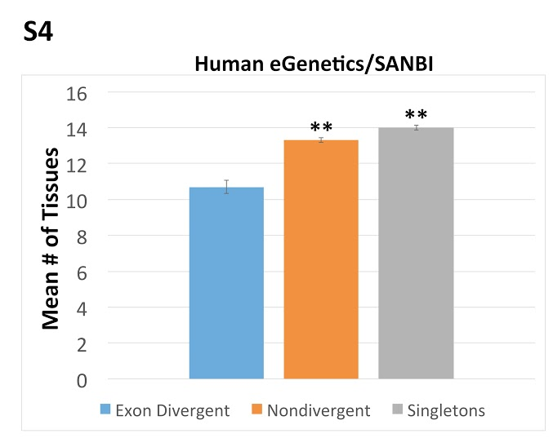

Supplemetal figure 4. Exon divergent paralogs are expressed in fewer tissue types. For an independent estimate of the number tissues in which each gene is expressed we queried the egenetics/SANBI gene expression database. Exon divergent paralogs (blue) are expressed in significantly fewer tissue types than both nondivergent paralogs (orange) and singletons (grey). Student’s t-test was used to calculate significance levels. The asterisks indicate the significance of the difference as compared to exon divergent paralogs, **p < .01 *p< .05.

