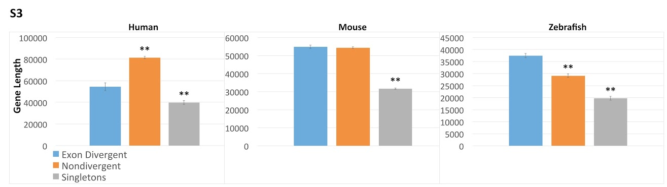

Supplemental figure 3. Gene length. Histograms comparing mean gene length of exon divergent (blue), nondivergent paralogs (orange) and singletons (grey). Student’s t-test was used to calculate significance levels. The asterisks indicate the significance of the difference as compared to exon divergent paralogs, **p < .01 *p< .05.

