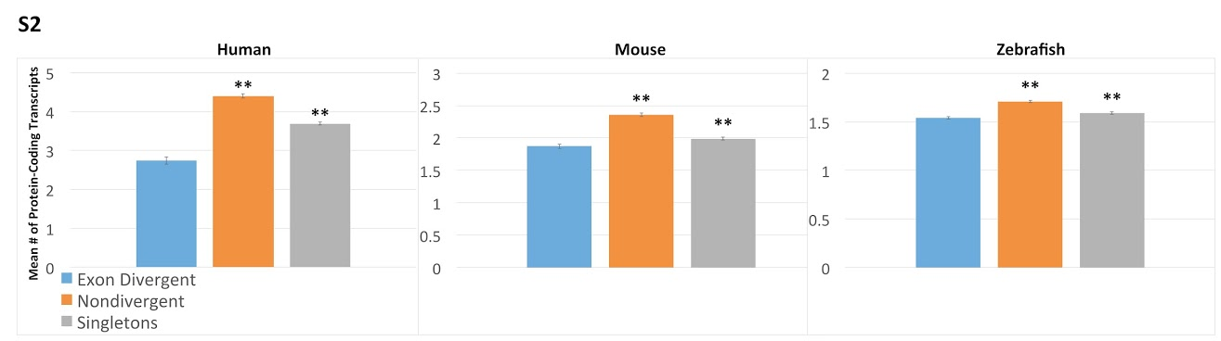
Supplemental figure 2. Levels of alternative splicing when only transcripts that code for a protein product are considered. Histograms comparing the number of protein coding transcripts between exon divergent (blue), nondivergent paralogs (orange) and singletons (grey). In each species the nondivergent paralogs have significantly fewer transcripts per gene using this measure. Student’s t-test was used to calculate significance levels. The asterisks indicate the significance of the difference as compared to exon divergent paralogs, **p < .01 *p< .05.

