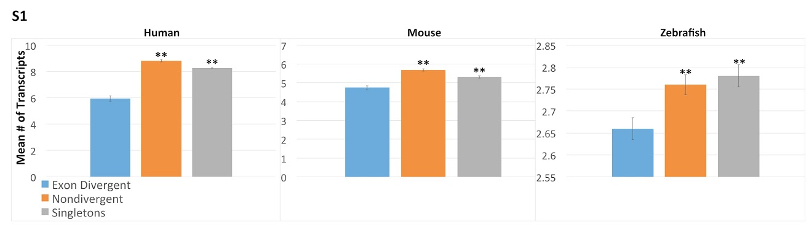
Supplemental figure 1. The mean number of transcripts, excluding genes with one transcript. Histograms comparing the number of transcripts between exon divergent (blue), nondivergent paralogs (orange) and singletons (grey), omitting those genes with a single transcript. In each species the nondivergent paralogs have significantly fewer transcripts per gene using this measure. Student’s t-test was used to calculate the significance of the differences in mean number of transcripts. The asterisks indicate the significance of the difference as compared to exon divergent paralogs, **p < .01 *p< .05.

