SUPPLEMENTARY FILE 1
Germline and Somatic Imprinting in the Non-Human Primate Uncovers Primate-Specific Acquisition
Clara Y. Cheong¹, Keefe Chng^{1,} •, Shilen Ng^{1,•}, Siew Boom Chew^{1, •}, Louiza Chan¹, Anne C Ferguson-Smith^{1,2}
¹Growth, Development and Metabolism Program, Singapore Institute for Clinical Sciences, Agency for Science, Technology and Research (A-STAR), 30 Medical Drive, Singapore 117609
² Department of Genetics, University of Cambridge, Downing Street, Cambridge CB2 3EH, UK
• Present affiliations; KC: Crown Bioscience Inc., 3375 Scott Blvd., Suite 108, Santa Clara, CA 95054 ; SN: Health Sciences Authority, 3 Biopolis Drive, Synapse, Singapore 138623; SBC: Syngenta APAC Pte Ltd, 50 Science Park Road, #06-01, The Kendall, Singapore 117406
Supplementary Table 1: Allelic Expression by NHP Tissue and Gene
Supplementary Figure 2: Pyrosequencing and Capillary Sequencing Data
Supplementary Figure 3: Imprinted Gene Cluster Maps and Putative Cynomolgus DMRs
Supplementary Figure 4: Novel Variant of CDKN1C in Cynomolgus Macaque
Supplementary Figure 5: Additional Bisulfite Diagrams of Macaque Samples
Supplementary Table 6: Known Parental Origin of Germline Methylation
Supplementary Table 7: Primers for Bisulfite DNA Amplification & Sequencing
Supplementary Table 8: Primers for Pyrosequencing of Bisulfite-converted DNA
Supplementary Table 9: Primers for Genotyping and RT-PCR
Supplementary Table 10: List of Identified Cynomolgus SNPs

Cheong_Supplementary Table 1
Locus | Gene | Known Allelic Exp in Human | Allelic Expression
Locus | Gene | Known Allelic Exp in Human | Placenta |  | Umbilical Cord |  | Muscle |  | Liver |  | Kidney |  | Pancreas |  | Testes |  | Cerebellum |  | Blood
Locus | Gene | Known Allelic Exp in Human | B | M | B | M | B | M | B | M | B | M | B | M | B | M | B | M | B | M
PLAGL1 | PLAGL1 | P | 0 | 5 | 0 | 7♦ | 0 | 5 | 0 | 4♦ | 0 | 3 | 0 | 3 | no SNP |  | 0 | 2 | - | -
IGF2R | IGF2R | M/= | 0 | 3♦ | 0 | 3♦ | 0 | 5♦ | 0 | 6♦ | 0 | 5♦ | 0 | 4♦ | 1 | 0 | - | - | 4 | 0
IGF2R | Putative AIRN | P | no SNP |  | no SNP |  | 0 | 7 | 1 | 5 | 0 | 6 | - | - | - | - | - | - | - | -
IGF2R | SLC22A1 | = | 0 | 3 | 0 | 3 | 3 | 0 | 5 | 0 | 4 | 1 | - | - | - | - | - | - | - | -
IGF2R | SLC22A2 | M | 2 | 0 | 2 | 0 | 4 | 0 | 4 | 0 | 3 | 0 | 2 | 0 | 1 | 0 | - | - | - | -
IGF2R | SLC22A3 | M | 3 | 1 | 5 | 0 | 1 | 1 | 1 | 1 | 1 | 0 | 1 | 0 | 1 | 0 | - | - | - | -
INPP5F | INPP5F transcript var. 1 | = | 6 | 0 | 4 | 0 | 1 | 0 | - | - | - | - | - | - | - | - | - | - | - | -
INPP5F | INPP5F transcript var. 2 | P | 1 | 2♦ | 0 | 4 | 0 | 2 | 0 | 1 | 0 | 1 | - | - | - | - | - | - | - | -
IGF2 | IGF2 | P | 0 | 2 | 0 | 2 | 1 | 1 | 3 | 0 | 1 | 2♦ | 0 | 2 | 0 | 1 | - | - | - | -
IGF2 | H19 | M | 0 | 3 | 0 | 3 | 0 | 2 | 0 | 3 | 0 | 2 | 0 | 2 | 0 | 1 | 0 | 1 | - | -
IGF2 | INS | P | 0 | 2 | 0 | 2 | no SNP |  | no SNP |  | no SNP |  | no SNP |  | no SNP |  | no SNP |  | no SNP
KCNQ1 | KCNQ1 | M | 1 | 4♦ | 2 | 2♦ | 3 | 0 | 6 | 0 | 5 | 0 | 3 | 0 | 1 | 0 | - | - | 2 | 0
KCNQ1 | CDKN1C | M | no SNP |  | no SNP |  | 0 | 4 | 0 | 4 | 0 | 4 | - | - | - | - | no SNP |  | - | -
KCNQ1 | SLC22A18 | M | 0 | 5 | 0 | 4 | 5 | 0 | 5 | 0 | 4 | 0 | - | - | - | - | 1 | 0 | - | -
DLK1 | DLK1 | P | 0 | 2 | no SNP |  | 0 | 4 | 0 | 4♦ | 0 | 4♦ | 0 | 4 | 0 | 1 | no SNP |  | 0 | 3
DLK1 | MEG3 | M | 0 | 5 | 0 | 5 | no SNP |  | no SNP |  | no SNP |  | no SNP |  | no SNP |  | no SNP |  | no SNP
DLK1 | DIO3 | P | 2 | 1 | 3 | 0 | 0 | 4♦ | 0 | 3♦ | 3 | 1 | 0 | 3♦ | - | - | no SNP |  | 4 | 0
SNRPN | MKRN3 | P | 4 | 0 | 0 | 4 | 0 | 5 | - | - | - | - | - | - | 1 | 0 | 0 | 3 | - | -
SNRPN | MAGEL2 | P | 4 | 2 | 0 | 6 | 0 | 3 | - | - | - | - | - | - | - | - | 0 | 2 | - | -
SNRPN | NDN | P | 4 | 1 | 0 | 6 | 0 | 4 | - | - | - | - | - | - | 0 | 2 | 0 | 2 | - | -
SNRPN | SNRPN | P | 0 | 6 | 0 | 6 | 0 | 6 | - | - | - | - | - | - | 0 | 3 | 0 | 4 | - | -
SNRPN | UBE3A | M | 3 | 0 | 3 | 0 | 6 | 0 | - | - | - | - | - | - | 2 | 0 | 1 | 1 | - | -
SNRPN | ATP10A | M | 2 | 3 | 5 | 0 | 7 | 0 | - | - | - | - | - | - | 2 | 0 | 4 | 0 | - | -
PEG3 | PEG3 | P | 0 | 3 | 0 | 3 | - | - | 0 | 2 | 0 | 3 | 0 | 3 | 0 | 2♦ | no SNP |  | - | -
PEG3 | ZIM2 | P | 3 | 2 | 0 | 4 | - | - | - | - | 0 | 4 | 0 | 4 | 2 | 0 | no SNP |  | - | -
PEG3 | USP29 | P | 0 | 2 | - | - | - | - | - | - | 0 | 2 | - | - | 2 | 0 | 0 | 1 | - | -
PEG3 | ZIM3 | M | 0 | 2 | 0 | 1 | - | - | - | - | - | - | 0 | 1 | 1 | 0 | - | - | - | -
PEG3 | ZNF264 | P | 0 | 5 | 0 | 3 | - | - | - | - | 5 | 0 | 5 | 0 | 2 | 0 | - | - | - | -
L3MBTL1 | L3MBTL1 | P | 0 | 3♦ | 1 | 1 | 4 | 0 | 0 | 6 | 0 | 6 | 3 | 3 | 2 | 0 | no SNP |  | 1 | 3
L3MBTL1 | SGK2 | P | 1 | 2 | 3 | 1 | 5 | 0 | 6 | 0 | 6 | 0 | 2 | 0 | 3 | 0 | no SNP |  | 2 | 2
L3MBTL1 | GDAP1L1 | P | no SNP |  | no SNP |  | 3 | 0 | 4 | 0 | 3 | 0 | 2 | 0 | 1 | 0 | 1 | 0 | - | -
NAP1L5 | NAP1L5 | P | 0 | 3♦ | 3 | 0 | 2 | 0 | 1 | 1♦ | 1 | 0 | 1 | 0 | 1 | 0 | - | - | - | -
COMMD1 | COMMD1 | U | 2 | 0 | 3 | 0 | 2 | 0 | 3 | 0 | 3 | 0 | - | - | 2 | 0 | no SNP |  | - | -

Supplementary Table 1: Allelic Expression by NHP Tissue and Gene
In tissue-specific data columns, the number of informative macaque samples with mono (M) or biallelic (B) expression of imprinted genes are shown.
No SNP: no informative samples; “♦” indicates that some or all samples showed incomplete imprinted expression, with the minor allele expressed at levels up to 30% of the primary expressed allele, as determined by sequencing chromatogram peak heights and pyrosequencing. In the column, ‘Known allelic expression in human’ - P: Paternal, M: Maternal, U: Unknown, =: Biallelic expression. IGF2R is polymorphically imprinted in the human population, hence shown as “M/=”.

Cheong_Supplementary Figure 2

Panel A: IGF2R
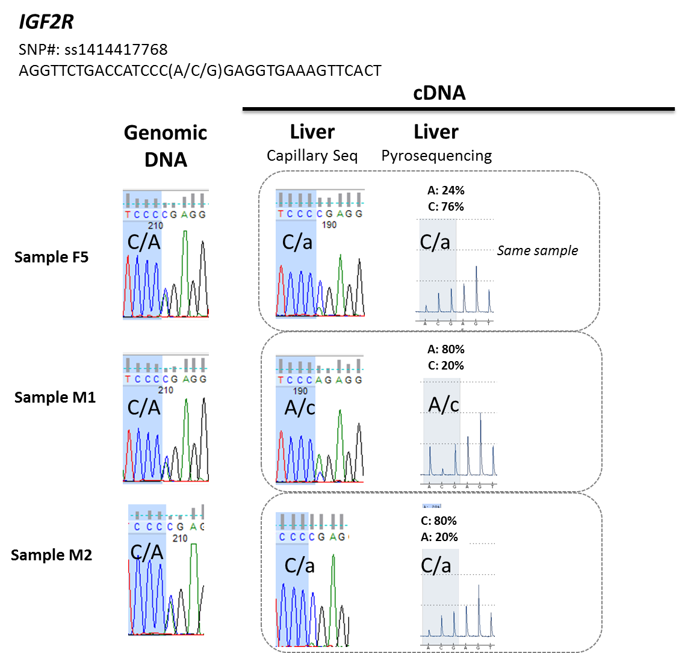

Panel B: KCNQ1
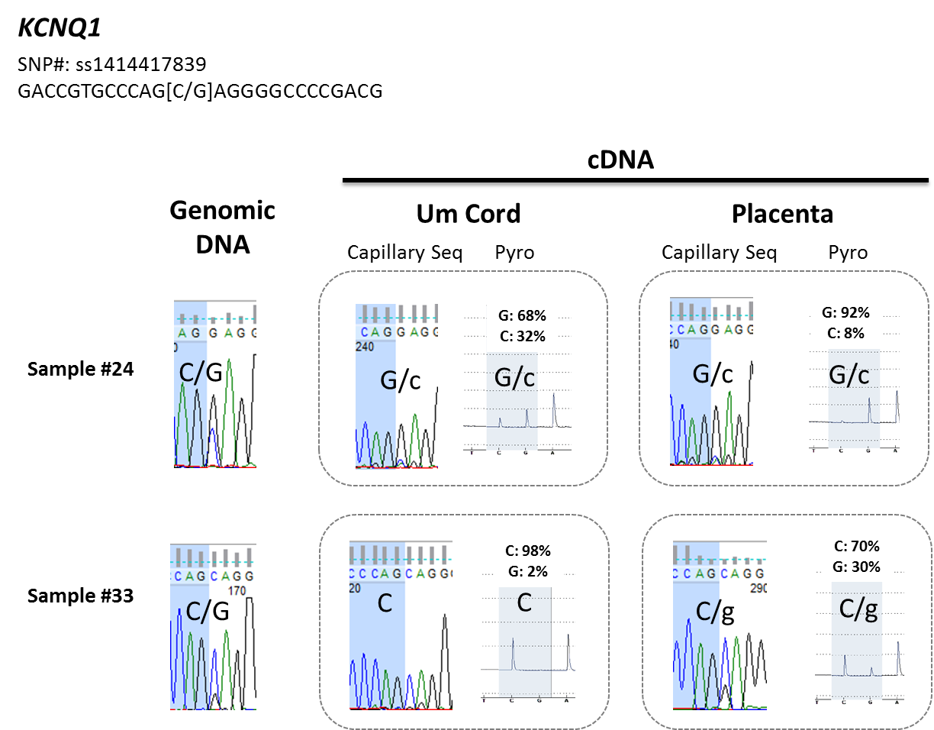

Panel C: PEG3
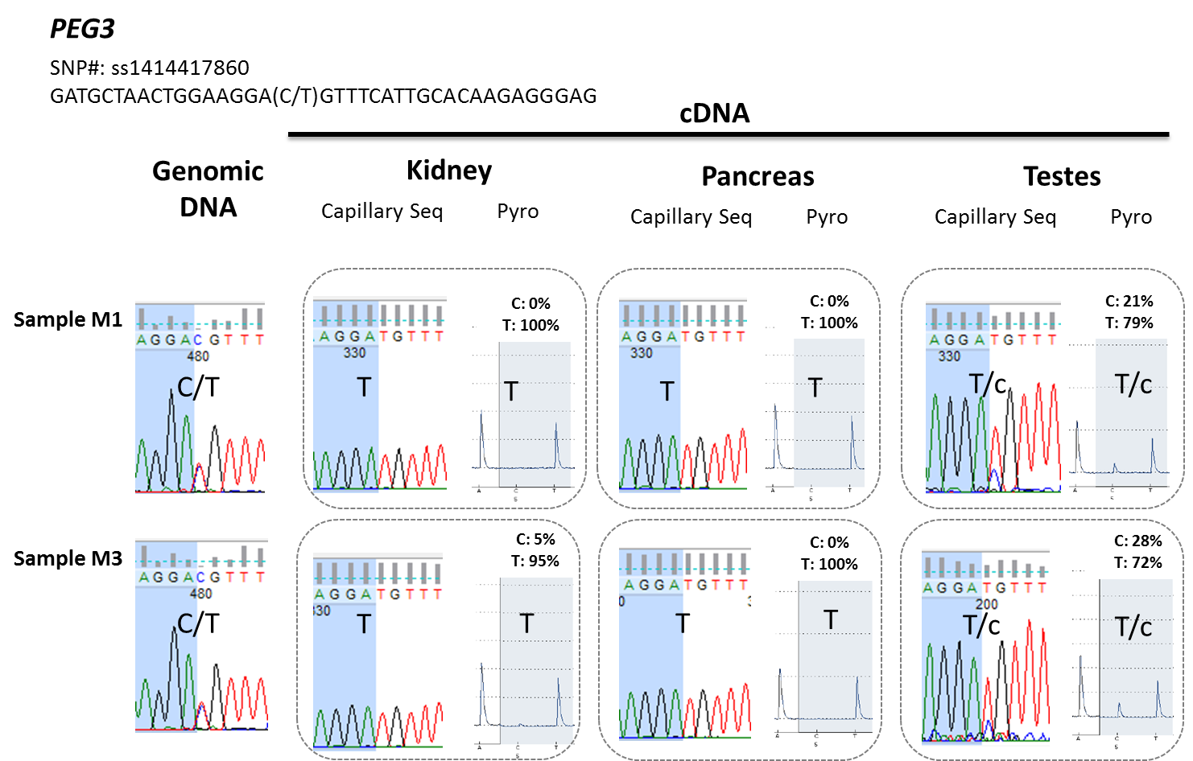

Panel D: Allelic Expression Is Determined by Pyrosequencing across Tissues and Individuals
Gene | Tissue/ID | F4 |  | F5 |  | F6 |  | M1 |  | M2 |  | M3 |  | M4
 |  | %Me | Call | %Me | Call | %Me | Call | %Me | Call | %Me | Call | %Me | Call | %Me | Call
PLAGL1 | Liver |  |  |  |  | A 0: G 100 | G |  |  | A 77: G 23 | A/g
PLAGL1 | Kidney | A 100 : G 0 | A |  |  | A 4: G 96 | G |  |  | A 100: T 0 | A
PLAGL1 | Pancreas | A 100 : G 0 | A |  |  | A 0: G 100 | G |  |  | A 100: T 0 | A
IGF2 | Liver |  |  |  |  |  |  | A 48: T 52 | T/A | A 48: T 52 | T/A
IGF2 | Kidney |  |  |  |  |  |  | A 13:T 87 | T/a | A 12: T 88 | T/a
IGF2 | Pancreas |  |  |  |  |  |  | A 0: T 100 | T | A 0: T 100 | T
IGF2 | Testes |  |  |  |  |  |  | A 3: T 97 | T
H19 | Liver |  |  | T 4: C 96 | C | T 100: C 0 | T | T 1: C 99 | C |  |  |  |  | T 2: C 98 | C
H19 | Kidney |  |  | T 0 : C 100 | C | T 100: C 0 | T | T 0 : C 100 | C | T 8: C 92 | C/t
H19 | Pancreas |  |  | T 7: C 93 | C/t | T 100: C 0 | T
H19 | Testes |  |  |  |  |  |  | T 7: C 93 | C/t
DLK1 | Liver | C 11: T 89 | T/c | C 86: T 14 | C/t |  |  |  |  |  |  | C 10: T 90 | T/c | C 79: T 21 | C/t
DLK1 | Kidney | C 0: T 100 | T | C 83: T 17 | C/t |  |  |  |  |  |  | C 0: T 100 | T | C 79: T 21 | C/t
DLK1 | Pancreas | C 0: T 100 | T | C 100: T 0 | C |  |  |  |  |  |  | C 4: T 96 | T
DLK1 | Testes |  |  |  |  |  |  |  |  |  |  | C 45: T55 | T/C
PEG3 | Liver |  |  |  |  | C 100: T 0 | C | C 0 : T 100 | T |  |  | C 0 : T 100 | T
PEG3 | Kidney |  |  |  |  | C 100: T 0 | C | C 0 : T 100 | T |  |  | C 5 : T 95 | T
PEG3 | Pancreas |  |  |  |  | C 100: T0 | C | C 0 : T 100 | T |  |  | C 0 : T 100 | T
PEG3 | Testes |  |  |  |  |  |  | C 21: T 79 | T/c |  |  | C 28: T 72 | T/c
IGF2R | Liver |  |  | A 24: C 76 | C/a | A 80: C 20 | A/c | A 80: C 20 | A/c | A 20: C 80 | C/a
IGF2R | Kidney |  |  | A 16: C 84 | C/a | A 83: C 17 | A/c | A 86: C 14 | A/c | A 23: C 76 | C/a
IGF2R | Pancreas |  |  | A 20: C 80 | C/a | A 81: C 19 | A/c | A 84: C 16 | A/c | A 25: C 75 | C/a
IGF2R | Testes |  |  |  |  |  |  | A 53: C 47 | A/C
KCNQ1 | Liver |  |  | C 58: G 42 | C/G |  |  |  |  | C 50: G 50 | C/G
KCNQ1 | Kidney |  |  | C 55: G 45 | C/G | C 56: G 44 | C/G |  |  | C 53: G 47 | C/G
KCNQ1 | Pancreas |  |  | C 53: G 47 | C/G |  |  | C 53: G 47 | C/G | C 55: G 45 | C/G
KCNQ1 | Testes |  |  |  |  |  |  | C 56: G 44 | C/G

Supplementary Figure 2: Pyrosequencing and Capillary Sequencing
To confirm that allelic calls made by capillary sequencing were accurate, we also performed quantitative pyrosequencing across 7 genes in multiple tissues and informative individuals. Data generated from both technology platforms were concordant, and examples for 3 genes are shown in panels A, B & C. In these panels, the allelic calls made by capillary and pyrosequencing are shown as follows: Biallelic (both capitals), Preferential Imprinted Expression (capital for major allele, lower case for minor allele) and Monoallelic (single capital letter). Panel D presents a table view of the pyrosequencing data generated across the imprinted genes tested, percentage expression values are shown for each allele analyzed. Preferential monoallelic expression is noted where the minor allele is expressed at levels between 5 – 30% by pyrosequencing. The samples presented are a subset of subjects analyzed by capillary sequencing.
Cheong_Supplementary Figure 3
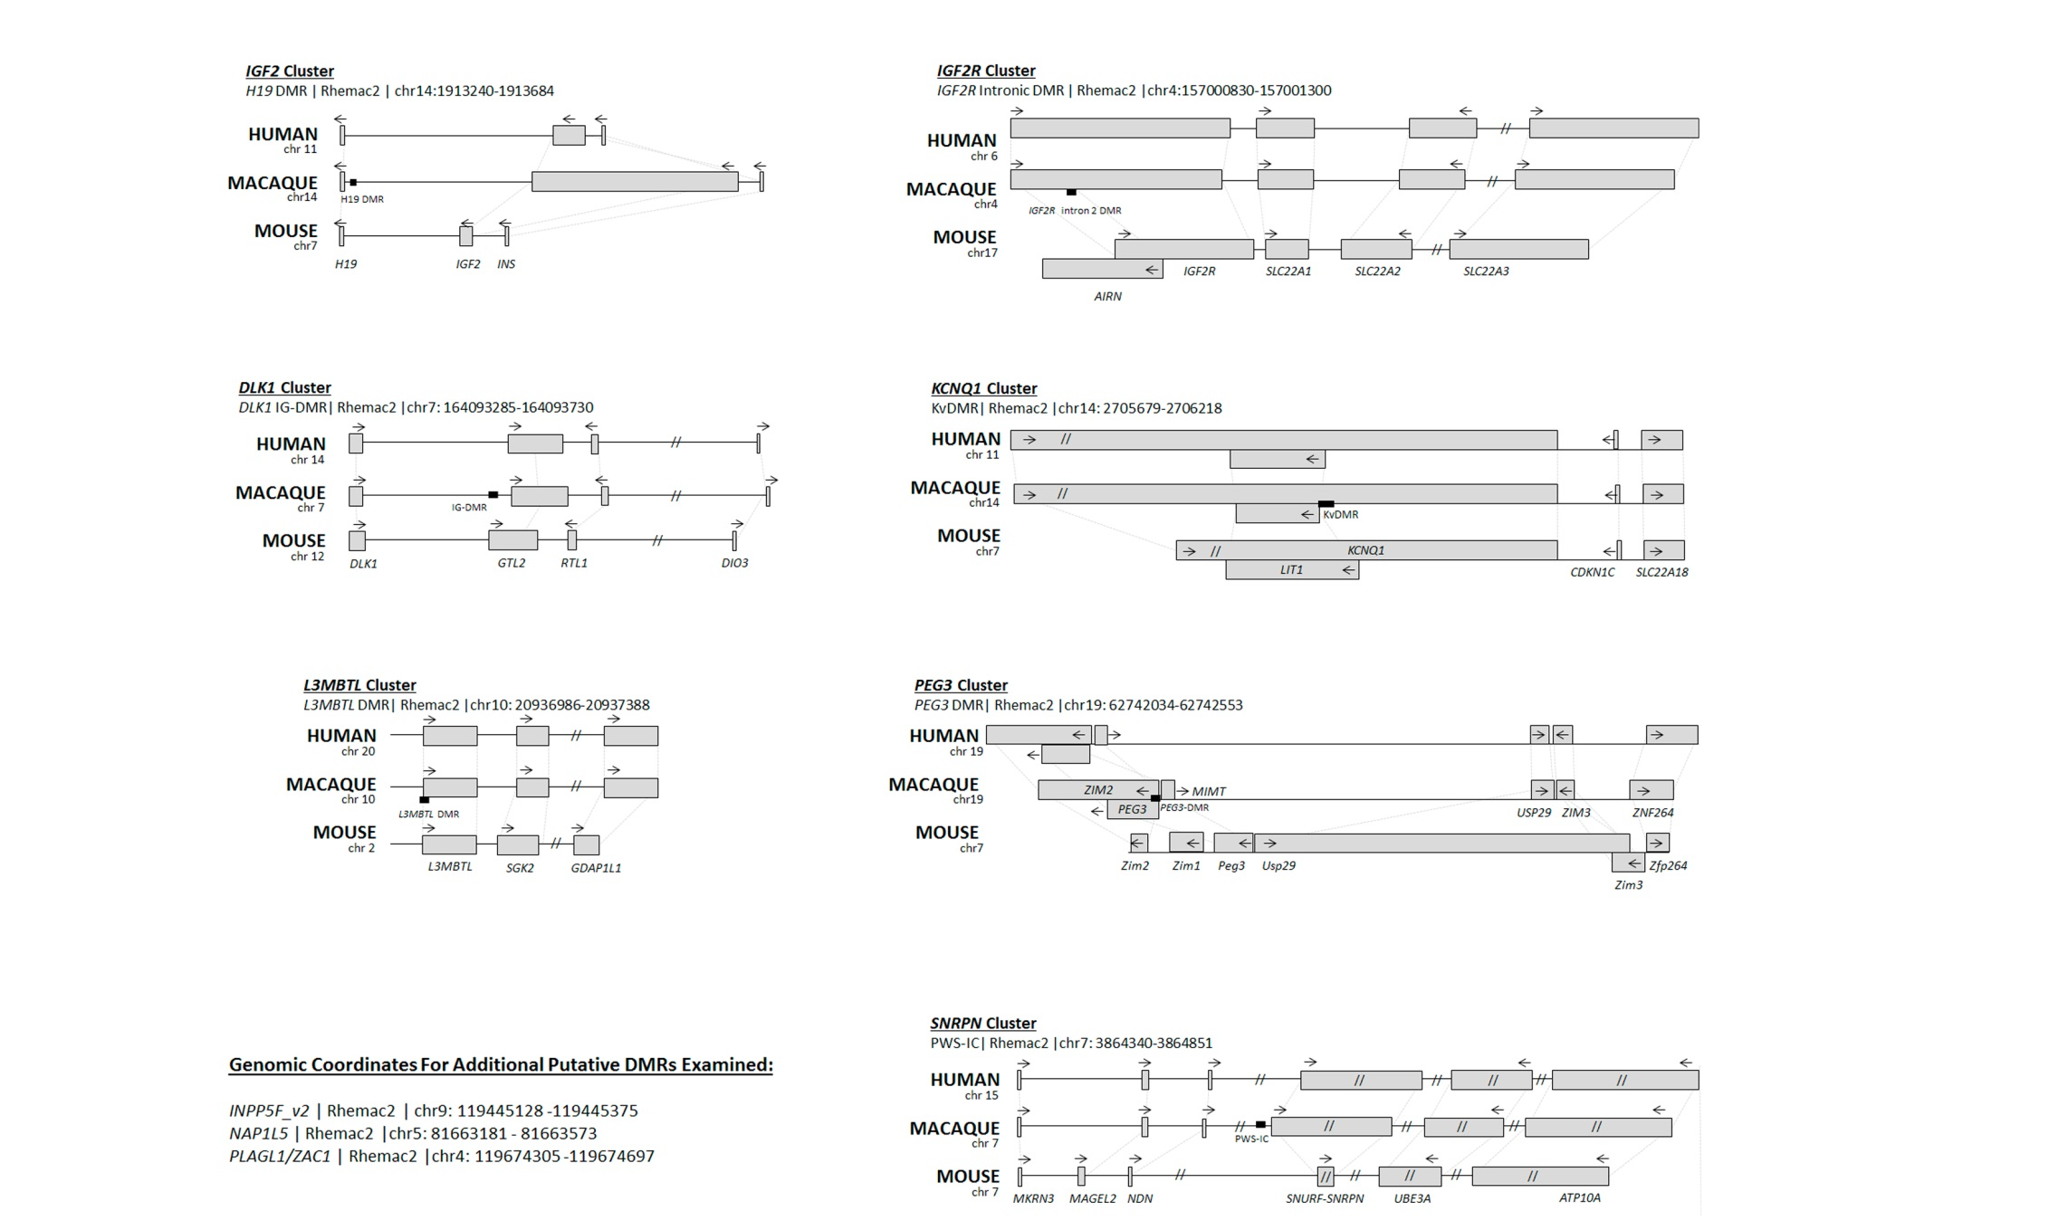

Supplementary Figure 3: Imprinted Gene Cluster Maps and Putative Cynomolgus DMRs
Maps show the conservation in relative gene position and orientation between Human, Macaque and Mouse genomes at the imprinted gene clusters examined. Gene distances are approximately to scale, unless otherwise indicated with a “//”. Genomic coordinates for putative Macaque DMRs examined are indicated. PLAGL1, NAP1L5 and INPP5F were examined as single genes, so no cluster map is shown for these loci.

Cheong_Supplementary Figure 4
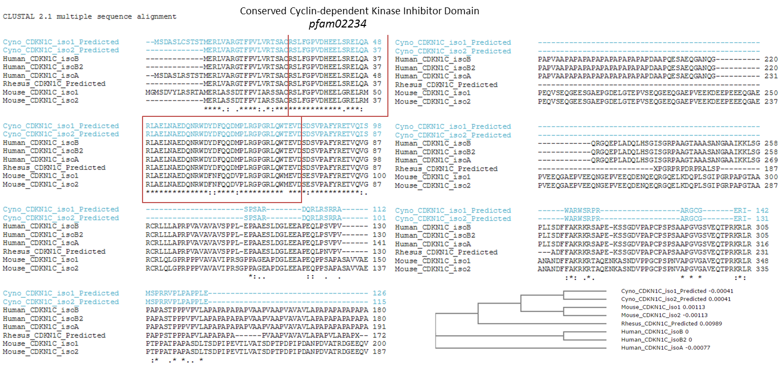

Supplementary Figure 4. Novel Variant of CDKN1C in Cynomolgus Macaque
The cyclin-dependent kinase inhibitor domain is conserved in CDKN1C proteins across primates and rodents (boxed in red). Downstream of this, there is increasing divergence between CDKN1C protein sequences from multiple species, as also shown by the phylogenetic tree (lower right).

Cheong_Supplementary Figure 5
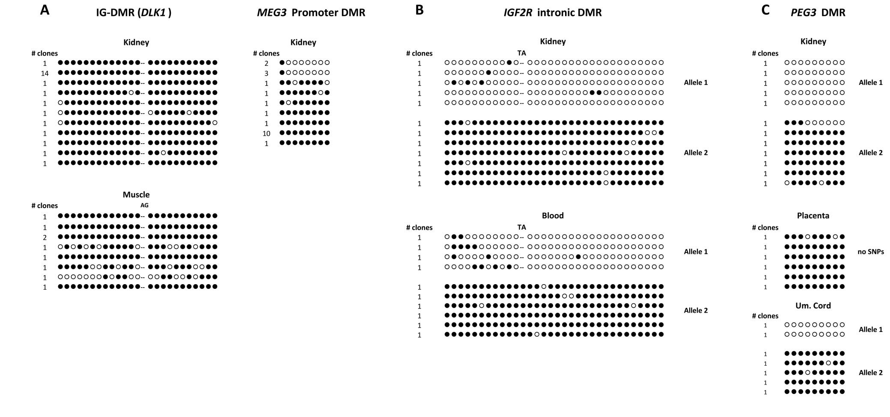

Supplementary Figure 5. Additional Bisulfite Diagrams of Macaque Samples
DNA methylation in additional tissues/samples for DMR regions shown in Main Figures 1 & 2 – (A) DLK1 IG-DMR and MEG3, where hypermethylation is evident in adult somatic tissues. (B) IGF2R DMR, additional somatic tissues (kidney & blood) also showed distinct allele-specific methylation. (C) At the PEG3 DMR, placenta-specific hypermethylation is seen. This was not observed in somatic tissues or umbilical cord (here, and in main figures)
Cheong_Supplementary Table 6
 | Human Germline Methylation |  | Primate Germline Methylation |  | Mouse Germline Methylation
 | Oocyte | Sperm | Oocyte | Sperm | Oocyte | Sperm
DLK1 | Unmethylated | Methylated | no data | no data | Unmethylated | Methylated
 | (Geuns et al. 2007a) | (Geuns et al. 2007a) |  |  | (Hiura et al. 2007) | (Hiura et al. 2007)
H19 | Unmethylated | Methylated | no data | Methylated | Unmethylated | Methylated
 | (Borghol et al. 2006) | (Kerjean et al. 2000) |  | (Mitalipov et al. 2007) | (Tremblay et al. 1995) | (Tremblay et al. 1995)
IGF2R | no data | no data | no data | no data | Methylated | Unmethylated
 |  |  |  |  | (Lucifero et al. 2002) | (Lucifero et al. 2002)
INPP5F  transcript variant 2 | no data | no data | no data | no data | Methylated | Unmethylated
 |  |  |  |  | (Wood et al. 2007) | (Wood et al. 2007)
KCNQ1 | Methylated | Unmethylated | no data | no data | Methylated | Unmethylated
 | (Geuns et al. 2007b) | (Geuns et al. 2007b) |  |  | (Engemann et al. 2000) | (Engemann et al. 2000)
L3MBTL1 | no data | no data | Methylated | Unmethylated | not imprinted | not imprinted
 |  |  | (Aziz et al. 2013) | (Aziz et al. 2013)
PEG3 | no data | no data | no data | no data | Methylated | Unmethylated
 |  |  |  |  | (Lucifero et al. 2002) | (Lucifero et al. 2002)
SNRPN | Methylated | Unmethylated | no data | Unmethylated | Methylated | Unmethylated
 | (Geuns et al. 2003) | (El-Maarri et al. 2001; Geuns et al. 2003) |  | (Mitalipov et al. 2007) | (Lucifero et al. 2002) | (Lucifero et al. 2002)
 | Unmethylated | (El-Maarri et al. 2001; Geuns et al. 2003) |  | (Mitalipov et al. 2007)
 | (El-Maarri et al. 2001) | (El-Maarri et al. 2001; Geuns et al. 2003) |  | (Mitalipov et al. 2007)
PLAGL1 | no data | no data | no data | no data | Methylated | Unmethylated
 |  |  |  |  | (Smith et al. 2002) | (Lucifero et al. 2002)

Supplementary Table 6: Known Parental Origin of Germline Methylation
Summary of published gamete methylation data for human, primate and mouse at established imprinted loci. Reference details are available at the end of this document.
Cheong_Supplementary Table 7

Supplementary Table 7: Primers for Bisulfite DNA Amplification & Sequencing
Gene | Direction | Sequence | Tissues
H19 DMR | F | ATTTATGTTTTGGGATGGATGT
 | R | ATCCTTCCCACAAAATCTCTAA
 | F | AGAATTTTGGGGTATTTGGTTTG | Oocytes only
 | R | CCATATATATTTCTAAAAACTTCCCCTTC | Oocytes only
DLK1 | F | GTTAAGAGTTTGTGGATTTGTGAGAAATG
 | R | CTAAAAATCACCAAAACCCATAAAATCAC
GTL2 | F | TTGTGTTCGAATTTATTTTGTTTG
 | R | CCCAAATTCTATAACAAATTACTCTAAC
snoDMR | F | TTTTTTTTTGGAGGGAGAAGG
 | R | TCTCTCATTCCCCACTTTAAAAAA
KCNQ1 DMR | F | GATTGGGTAGTAGTAGGGGAAGG
 | R | CTCACACCCAACCAATACCTC
SNRPN | F | TTTGGTTAGTGGTGTGTGTAAA
 | R | CTTTAAAACCCAAATACCCAA
 | F | GAGGGTATTGGGATTTTTGTATTG | Oocytes only
 | R | CAAACTATCTCTTAAAAAAAACCACC | Oocytes only
NAP1L5 | F | TTAGGGTAGTAATAGGAGGAATTTGGTG
 | R | TAAAACTCCTCAACCATCTAACCAAC
L3MBTL1 | F | YGAYGTTTTTATAGTTTTTAGGGTTT
 | R | ACTTTCCCYGAAAACCAATC
PLAGL1 | F | GTTGGTATAGGAGGTAAGTTAGTTTGG
 | R | CCCAAACACCTACCCTAC
 | F | TATTTGTAAAGTATTTAGGATAGTGTTTGG | Oocytes only
 | R | CCAAAATAAACTACCTAAACCTAATCACAC | Oocytes only
IGF2R intronic DMR | F | TGTGGTTTTAAAGAGGTTTTGT
 | R | CTCCTAACAACTTCAAAAAACAA
PEG3 | F | TTATTTTTGATGGGGGTAGTTG
 | R | CCCAAACACAAAATAAAACCAC
 | F | GTTTAGGTGTGGGGTTGTTTATAGG | Oocytes only
 | R | CAAATCTCCTAACTCCCCCAAATAC | Oocytes only
INPP5F transcript variant 1 | F | GGAGGTTATTAGTGGTTATAGTAAGAAGG
 | R | TTAACTTAAAAAAACTCCATACCAACCC
INPP5F transcript variant 2 | F | GGAAGTTAGATGTGTTTTTTGGG
 | R | AAAAAATCTTAAAAATCATAACCACAAC

Cheong_Supplementary Table 8

Supplementary Table 8: Primers for Pyrosequencing of Bisulfite-converted DNA
Gene | Primer Dir | Sequence
DLK1 | Forward | CTGTGCTAACAACGGGACCTG
 | Reverse | AGGGGCACAGGAGCATTCATA
 | Seq | CCTGCGTGAGCCTGG
H19 | Forward | AATCGAACACGCTGCACTTTACA
 | Reverse | TTCTGGAGCCGATTCCTGAGT
 | Seq | AGCCGATTCCTGAGT
IGF2 | Forward | GCAAGCGCCCTGTGAGTG
 | Reverse | GGGGTGCCTCGAAGTGTTT
 | Seq | CCCAAAGAGCCAAAT
IGF2R | Forward | CATGGGGATGACCAGGACAG
 | Reverse | ACCAGCCCTGCCCTATCGT
 | Seq | AGGTTCTGACCATCCC
KCNQ1 | Forward | AACGCCCTGCCCACCTAC
 | Reverse | CCTTGGCCTCCCCTCTGA
 | Seq | GCTGACCGTGCCCAG
PEG3 | Forward | AGTCAAGCGACCAGTCACAGA
 | Reverse | ATTCCCTTCATAAACCCTCTGC
 | Seq | GTCAGATGCTAACTGGAA
PLAGL1 | Forward | ATACCTGCCTCTCTGGACCTGTC
 | Reverse | GTGCCAGCTGAGAACACATGA
 | Seq | ATCTCTGCCCCACAG
Cheong_Supplementary Table 9

Supplementary Table 9: Primers for Genotyping and RT-PCR
Gene | Genotyping | RT-PCR | Direction | Sequence
IGF2 | * | * | F | GAAGCCAGCTTGAGACCATC
 | * | * | R | ACGAATGGGCAGGTAATTTG
H19 | * | * | F | ATGGTGCTACCCAGCTCAAG
 | * |  | R | ATGGAATGCTTGAAGGTTGC
 |  | * | R | CACCCAGCCCAGATGAAG
INS | * | * | F | GGAGCGAGGCTTCTTCTACA
 | * | * | R | TGGTTCAAGGGCTTTATTCG
DLK1 | * |  | F | GTGGGAGAAGACAGGCTTTG
 | * |  | R | ACAGGAGACTGGGAGGAGGT
 |  | * | F | CGACGGCTGGGATGGGAAACT
 |  | * | R | GCAGAAATTGCCTGAGAAGCCAG
MEG3 (also known as GTL2) | * |  | F | ACTCCAGCTGCCTGTTTCC
 | * |  | R | GTGCCTCCTCCCCAGATTA
 |  | * | F | ATGCCTCTCCCTTCCCAGAG
 |  | * | R | GCCCGTGCTTTAGAACCGTATC
DIO3 | * | * | F | CCCAGGACTTTGCCTCTACA
 | * | * | R | ACACTCACCAAATGGCCTTC
COMMD1 (also known as MURR1) | * |  | F | TTTGGGACCCTGGGTATTTT
 | * |  | R | TGAGAACCTCTGCACTGGAA
 |  | * | F | GCCTGAGCTGGAGAGTTGAT
 |  | * | R | GGAAGATTGAATGCGAGGAT
IGF2R | * |  | F | GAGCAGAATGGGGTCTCTGA
 | * |  | R | CACGTGTGTGCCCTTAAGAA
 |  | * | F | TGCTGCAGGAGAAGTTCCAACG
 |  | * | R | CCCATCACGAAAACTCTTCCCT
AIRN |  | * | F | TCAGGAAGTAGGACAGGAAGG
 |  | * | R | TTACACACTCACCAGGCCTAC
SLC22A1 | * |  |  | TGCAACAGTTTCATCATCAACA
 | * |  |  | TTGGCATTGTGTTTGTTTTAGG
 |  | * | F | CGGGAGTGACGCTACTTCTT
 |  | * | R | TGGGGGTAGGCAAGTATGAG
 |  | * | F | GAACCTCGGAGTGATGGTGT
SLC22A2 | * |  | F | TTGGTGCTTGACTTGACCTG
 | * |  | R | GAACAAATGTCCCACCCATC
 | * |  | F | TGGCATTCACGAAGACAAGA
 | * |  | R | CACATTCATGCTTACCCAGTCT
 |  | * | F | GACATTGGTGGCATCATCAC
 |  | * | R | CCCATGGTACCCCTGTGT
SLC22A3 | * |  |  | TGGGTTTTCATGAGAAGTTGTG
 | * |  |  | CTCTTCCCCAAGACAACTCG
 |  | * | F | CTCTTGATCTTACTAACCATTGAG
 |  | * | R | CTCTTCCCCAAGACAACTCG
INPP5F transcript variant 1 | * |  | F | GGATTCCATGGGGGATTAAC
 | * |  | R | GCCGAGAAGGTGTCTGTTCT
 |  | * | F | CCTCACGAAGACATCATTGG
 |  | * | R | GACAAAAACTGTGGGCCTGT
INPP5F transcript variant 2 | * |  | F | TTGTGCCTTCCCTAATGAGC
 | * |  | R | GCTATTCCCAGGACCCTCTC
 |  | * | F | GGCTCAAGCAACAATTTTCA
 |  | * | R | TGTATGTTGCCAGCAGAAGG
KCNQ1 | * |  | F | CCTGGCCCTCTCTGAAGGAGGC
 | * |  | R | TGTTTGGCTGGCTGCTGGGA
 | * |  | F | TGACGCAGCTGGACCAGAGGC
 | * | * | R | TACCCACCGACCAGGAAGAGGT
 |  | * | F | AAGAGCAAGGATCGTGGCAGC
 |  | * | R | CCACAGGCCCTCCAAATGGG
CDKN1C | * |  | F | GCGGTGTTGTTGAAACTGAA
 | * |  | R | CTGTCCACTTCGGTCCACTG
 | * |  | F | ATTTCTTCGCCAAGCGCAAGA
 | * | * | R | CCCAGAGTCCGCGATGGAAATA
 |  | * | F | CTCCTTTCCCCTTCTTCTCG
 |  | * | F | GTGCCAGCCAGGTCTGAT
 |  | * | R | CCTGCTGGAAGTCGTAATCC
SLC22A18 | * |  | F | GGATGGGTCAGGAGAGATGA
 | * |  | R | CACTGAAGGACACAGGCAGA
 |  | * | F | AGGTGGCCTCCAACTTCC
 |  | * | R | GGACCAGAAGGACAAGGACA
 |  | * | R | TGGAGGGATTTAGTAGGAGTTTATTG
L3MBTL1 | * |  | F | CCCAGTACACCTGGGTGGCTAGACA
 | * |  | R | GCTCAGTGTGGCTCTGCTAGATGCT
 |  | * | F | CAGTCGCCAAGTGGACCATC
 |  | * | R | GGTAAAGTGATTGGATCTACATGTTCCTCC
 |  | * | F | GCACCAGTCCCTCTTCATGT
 |  | * | R | TTGTGTTCCCACCATATCAGTC
SGK2 | * |  | F | TAGGAAGCATGGGGCACTCACAG
 | * | * | R | CAAAATCCAAACACCAGGAGGCC
 |  | * | F | CTCCACCCTTCAACCCAAA
 |  | * | R | GGGCAGAAATACAGCCTCTG
GDAP1L1 | * |  | F | GGCAGAAATGCGAGCTGTGG
 | * |  | R | CCCCATTCAGAGGTACCGGTTAG
 | * |  | F | ATGAGTCCCAGGATGTTTCATCC
 | * | * | R | TGGCGTGGATGCAGAGACTTC
 |  | * | F | GAGAAGAGGAAGCTGGAGAACGAG
 |  | * | F | AACCGGTACCTCTGAATGGG
NAP1L5 | * | * | F | TCCGCAAGATCTCTCTGGAC
 | * | * | R | TCCTCCTCGTCATCCTCGTA
PEG3 | * |  | F | GGGATGAGTCTTGGTCCTCA
 | * | * | R | TCAAAACGTTTCCCTCCAAC
 |  | * | F | CACAATCCAGGACAACATGG
ZIM2 | * |  | F | GCACTAACTCCAGGGCAAAG
 | * |  | R | TCAACAGTGATTGGACACAACA
 |  | * | F | TATCTCACGCCTGGAAGCGG
 |  | * | R | GACTGAAGACTTTGCCACAGTC
 |  | * | F | ATCACGTGCAGTGGAGACAG
 |  | * | R | CGACTGAAGACTTTGCCACA
USP29 | * |  | F | CAGATTTGGAGCCAGAGGAC
 | * |  | R | TGAGAGTCAAGAGGCACCTG
 |  | * | F | CTGCCTGCAGTGTGACCAT
 |  | * | R | CCATTTTTGGCATCGAGAGTC
ZIM3 | * |  | F | TGAAGCCAGAATGATCACCA
 | * |  | R | GGTTTCTCTCCCGTGTGTGT
 |  | * | F | ACGTGATCTTGAGGTTGGAGC
 |  | * | R | CTTCCACAGCAACGACATTCAA
ZNF264 | * | * | F | ATGGACCAGGAAGGAAGACC
 | * |  | R | CCCTTTTGTGTGCTGGATTT
 |  | * | R | CTGGTGCCACATGAGGTATG
 |  | * | R | ACAACATAGTGCCGGAGAAA
RASGRF1 | * |  | F | ACTTCCCTGGCTCTTTCTCC
 | * |  | R | GAGCTTTGTCAGGGGTTCAG
 |  | * | F | CAAGCTGCTGAAGCACTACG
 |  | * | R | CTCTGGTGATGTTGCCCTTT
MKRN3 | * |  | F | AACTGCCCATTTGGAGACAC
 | * |  | R | CAGATGAGCAGCTGCAAGAC
 |  | * | F | GCTATTGCCTGTTTTCCCTGT
 |  | * | R | TTCTCCTTTCACTCTGCCACA
MAGEL2 | * |  | F | CCCAAAACCACGCTTACATT
 | * | * | R | TTCACAAAGCCAGCACAAAG
 |  | * | F | TGAGGATGAACCTGACAGCA
NDN | * | * | F | ATGTGGTACGTGCTGGTCAA
 | * | * | R | CCTGGTGAGGATCAGAAAGC
SNRPN | * |  |  | GGTAGATTGCAGTGCAGCTTT
 | * |  |  | AACCCCCATTTACCCAAATC
 |  | * | F | GCTCCGTCTACTCTTTGAAGC
 |  | * | R | GTTGCTCTGCCAACAGGTG
UBE3A | * |  | F | TTGCAACAGGGTAAACATGC
 | * |  | R | TGGCATCATCATCGTTCACT
 | * |  | F | AAAAATCAATGTTGCATGCCTA
 | * |  | R | TGTTTGTCGTACTTCGGTCAG
 |  | * | F | CCCCAACAACTCCTGCTCT
 |  | * | R | TCCAGATATTCAGGACTGTGGA
 |  | * | F | CGCATGTACAGTGAACGAAGA
 |  | * | R | CCATGGGAAAATGTACATCCA
ATP10A | * |  | F | AGCTTCCAGAGACCCTCACA
 | * |  | R | CCACAGCAATACCTAACCTTTTG
 |  | * | F | ATGACACCTGTCGCTGCAC
 |  | * | R | ACCTTGGACTCCTCAGGACA
PLAGL1 | * |  | F | CAATACCTGCCTCTCTGGACCTG
 | * |  | R | GGCACAATACATGCAGTTCGAGA
 | * |  | R | GCAGCTCCTTGGGCAGGTTTAT
 |  | * | F | GCAGCCTGACTGTGGCAAAGC
 |  | * | R | GATGGAAATGAGGCAGGATGGC

Cheong_Supplementary Table 10

Supplementary Table 10: List of Identified Cynomolgus SNPs
Reference: Macaca_fascicularis_5.0 (accession GCF_000364345.1)
Available through Database of Single Nucleotide Polymorphisms (dbSNP). Bethesda (MD): National Center for Biotechnology Information, National Library of Medicine.
Chr | Position | Ref Allele | Alt Allele | Gene | Ref Seq | ssID
4 | 10790382 | G | A | AIRN | NC_022275.1 | ss1414417769
4 | 10790432 | C | A | AIRN | NC_022275.1 | ss1414417770
4 | 10790468 | C | T | AIRN | NC_022275.1 | ss1414417771
4 | 10790661 | A | T | AIRN | NC_022275.1 | ss1414417772
4 | 10790670 | A | G | AIRN | NC_022275.1 | ss1414417773
4 | 10693272 | G | A | IGF2R | NC_022275.1 | ss1414417764
4 | 10693328 | G | C | IGF2R | NC_022275.1 | ss1414417765
4 | 10693411 | G | A | IGF2R | NC_022275.1 | ss1414417766
4 | 10693539 | G | A | IGF2R | NC_022275.1 | ss1414417767
4 | 10693567 | A | G | IGF2R | NC_022275.1 | ss1414417768
4 | 48472026 | T | C | PLAGL1 | NC_022275.1 | ss1414417874
4 | 48472205 | A | C | PLAGL1 | NC_022275.1 | ss1414417875
4 | 48472206 | G | A | PLAGL1 | NC_022275.1 | ss1414417876
4 | 48472207 | C | A | PLAGL1 | NC_022275.1 | ss1414417877
4 | 48472212 | C | T | PLAGL1 | NC_022275.1 | ss1536213772
4 | 48472638 | G | C | PLAGL1 | NC_022275.1 | ss1414417878
4 | 10636594 | C | A | SLC22A1 | NC_022275.1 | ss1414417759
4 | 10636597 | T | C | SLC22A1 | NC_022275.1 | ss1414417760
4 | 10636616 | T | C | SLC22A1 | NC_022275.1 | ss1414417761
4 | 10636707 | T | C | SLC22A1 | NC_022275.1 | ss1414417762
4 | 10640420 | G | A | SLC22A1 | NC_022275.1 | ss1414417763
4 | 10581675 | A | T | SLC22A2 | NC_022275.1 | ss1414417757
4 | 10581700 | G | A | SLC22A2 | NC_022275.1 | ss1414417758
4 | 10354358 | C | T | SLC22A3 | NC_022275.1 | ss1414417755
4 | 10369845 | C | T | SLC22A3 | NC_022275.1 | ss1414417756
5 | 87839324 | T | A | NAP1L5 | NC_022276.1 | ss1414417774
5 | 87839372 | C | T | NAP1L5 | NC_022276.1 | ss1414417775
5 | 87839408 | C | T | NAP1L5 | NC_022276.1 | ss1414417776
5 | 87839627 | C | T | NAP1L5 | NC_022276.1 | ss1414417777
7 | 3658170 | T | C | ATP10A | NC_022278.1 | ss1414417793
7 | 3658171 | T | C | ATP10A | NC_022278.1 | ss1414417794
7 | 3658205 | A | G | ATP10A | NC_022278.1 | ss1414417795
7 | 166786348 | G | C | DIO3 | NC_022284.1 | ss1414417798
7 | 166786627 | G | A | DIO3 | NC_022284.1 | ss1414417799
7 | 166786641 | A | G | DIO3 | NC_022284.1 | ss1414417800
7 | 166786710 | A | C | DIO3 | NC_022284.1 | ss1414417801
7 | 166786786 | G | A | DIO3 | NC_022284.1 | ss1414417802
7 | 165945992 | C | T | DLK1 | NC_022284.1 | ss1414417796
7 | 166028190 | C | A | DLK1 CG6 | NC_022284.1 | ss1414417879
7 | 1950762 | G | A | MAGEL2 | NC_022278.1 | ss1414417780
7 | 1950801 | G | T | MAGEL2 | NC_022278.1 | ss1414417781
7 | 1950829 | A | C | MAGEL2 | NC_022278.1 | ss1414417782
7 | 166078426 | C | T | MEG3 | NC_022284.1 | ss1414417797
7 | 1871919 | T | C | MKRN3 | NC_022278.1 | ss1414417778
7 | 1872057 | C | T | MKRN3 | NC_022278.1 | ss1414417779
7 | 1992100 | C | T | NDN | NC_022278.1 | ss1414417783
7 | 1992475 | G | A | NDN | NC_022278.1 | ss1414417784
7 | 1992559 | G | A | NDN | NC_022278.1 | ss1414417785
7 | 1992574 | G | C | NDN | NC_022278.1 | ss1414417786
7 | 2956185 | T | C | SNRPN | NC_022278.1 | ss1414417787
7 | 2956265 | G | A | SNRPN | NC_022278.1 | ss1414417788
7 | 2957175 | A | C | SNRPN | NC_022278.1 | ss1414417789
7 | 2957248 | G | A | SNRPN | NC_022278.1 | ss1414417790
7 | 3373292 | A | G | UBE3A | NC_022278.1 | ss1414417791
7 | 3373403 | G | C | UBE3A | NC_022278.1 | ss1414417792
9 | 119124377 | C | T | INPP5F | NC_022280.1 | ss1414417805
9 | 119124674 | G | A | INPP5F | NC_022280.1 | ss1414417807
9 | 119124728 | T | C | INPP5F | NC_022280.1 | ss1414417809
9 | 119124944 | A | C | INPP5F | NC_022280.1 | ss1414417811
9 | 119119772 | A | G | INPP5F-v2 | NC_022280.1 | ss1414417803
9 | 119119790 | C | T | INPP5F-v2 | NC_022280.1 | ss1414417804
9 | 119124599 | G | A | INPP5F-v2 | NC_022280.1 | ss1414417806
9 | 119124674 | G | A | INPP5F-v2 | NC_022280.1 | ss1414417807
9 | 119124728 | T | C | INPP5F-v2 | NC_022280.1 | ss1414417809
10 | 75987131 | T | C | GDAP1L1 | NC_022281.1 | ss1414417827
10 | 75987192 | C | T | GDAP1L1 | NC_022281.1 | ss1414417828
10 | 75987409 | G | T | GDAP1L1 | NC_022281.1 | ss1414417829
10 | 75227729 | G | A | L3MBTL1 | NC_022281.1 | ss1414417812
10 | 75227742 | C | T | L3MBTL1 | NC_022281.1 | ss1414417813
10 | 75227850 | G | A | L3MBTL1 | NC_022281.1 | ss1414417814
10 | 75227989 | G | C | L3MBTL1 | NC_022281.1 | ss1414417815
10 | 75228152 | C | T | L3MBTL1 | NC_022281.1 | ss1414417816
10 | 75228455 | C | A | L3MBTL1 | NC_022281.1 | ss1414417817
10 | 75228514 | A | G | L3MBTL1 | NC_022281.1 | ss1414417818
10 | 75228522 | T | C | L3MBTL1 | NC_022281.1 | ss1414417819
10 | 75271725 | C | T | SGK2 | NC_022281.1 | ss1414417820
10 | 75271925 | A | T | SGK2 | NC_022281.1 | ss1414417821
10 | 75271927 | G | A | SGK2 | NC_022281.1 | ss1414417822
10 | 75271947 | C | T | SGK2 | NC_022281.1 | ss1414417823
10 | 75272039 | G | A | SGK2 | NC_022281.1 | ss1414417824
10 | 75272073 | G | A | SGK2 | NC_022281.1 | ss1414417825
10 | 75272085 | T | A | SGK2 | NC_022281.1 | ss1414417826
13 | 47924764 | G | A | COMMD1 | NC_022284.1 | ss1414417830
13 | 47924765 | C | T | COMMD1 | NC_022284.1 | ss1414417831
13 | 47924814 | C | T | COMMD1 | NC_022284.1 | ss1414417832
14 | 2847097 | C | G | CDKN1C | NC_022285.1 | ss1414417844
14 | 2847308 | A | C | CDKN1C | NC_022285.1 | ss1414417845
14 | 2847352 | A | C | CDKN1C | NC_022285.1 | ss1414417846
14 | 1965708 | G | A | H19 | NC_022285.1 | ss1414417833
14 | 1966174 | A | G | H19 | NC_022285.1 | ss1414417834
14 | 1972491 | C | T | H19 DMR | NC_022285.1 | ss1414417880
14 | 1972492 | G | A | H19 DMR | NC_022285.1 | ss1414417881
14 | 1972926 | C | G | H19 DMR | NC_022285.1 | ss1414417882
14 | 2089839 | G | C | IGF2 | NC_022285.1 | ss1414417835
14 | 2111382 | C | T | INS | NC_022285.1 | ss1414417836
14 | 2111387 | C | T | INS | NC_022285.1 | ss1414417837
14 | 2808350 | G | A | KCNQ1 | NC_022285.1 | ss1414417838
14 | 2808454 | G | C | KCNQ1 | NC_022285.1 | ss1414417839
14 | 2808540 | T | C | KCNQ1 | NC_022285.1 | ss1414417840
14 | 2808560 | C | T | KCNQ1 | NC_022285.1 | ss1414417841
14 | 2808587 | G | A | KCNQ1 | NC_022285.1 | ss1414417842
14 | 2808596 | G | A | KCNQ1 | NC_022285.1 | ss1414417843
14 | 2888638 | A | G | SLC22A18 | NC_022285.1 | ss1414417847
14 | 2888699 | A | G | SLC22A18 | NC_022285.1 | ss1414417848
14 | 2888770 | G | A | SLC22A18 | NC_022285.1 | ss1414417849
19 | 57532401 | C | T | PEG3 | NC_022290.1 | ss1414417853
19 | 57532464 | C | T | PEG3 | NC_022290.1 | ss1414417854
19 | 57532530 | C | A | PEG3 | NC_022290.1 | ss1414417855
19 | 57532533 | T | C | PEG3 | NC_022290.1 | ss1414417856
19 | 57532629 | A | G | PEG3 | NC_022290.1 | ss1414417857
19 | 57532650 | C | T | PEG3 | NC_022290.1 | ss1414417858
19 | 57532692 | T | C | PEG3 | NC_022290.1 | ss1414417859
19 | 57532791 | G | A | PEG3 | NC_022290.1 | ss1414417860
19 | 57805125 | G | C | USP29 | NC_022290.1 | ss1414417861
19 | 57805202 | G | C | USP29 | NC_022290.1 | ss1414417862
19 | 57805218 | A | G | USP29 | NC_022290.1 | ss1414417863
19 | 57805273 | G | A | USP29 | NC_022290.1 | ss1414417864
19 | 57805487 | C | T | USP29 | NC_022290.1 | ss1414417865
19 | 57482406 | A | G | ZIM2 | NC_022290.1 | ss1414417850
19 | 57482689 | G | T | ZIM2 | NC_022290.1 | ss1414417851
19 | 57482881 | G | A | ZIM2 | NC_022290.1 | ss1414417852
19 | 57811184 | A | G | ZIM3 | NC_022290.1 | ss1414417866
19 | 57811206 | C | T | ZIM3 | NC_022290.1 | ss1414417867
19 | 57811463 | A | G | ZIM3 | NC_022290.1 | ss1414417868
19 | 57811504 | G | A | ZIM3 | NC_022290.1 | ss1414417869
19 | 57873671 | G | A | ZNF264 | NC_022290.1 | ss1414417870
19 | 57873684 | C | A | ZNF264 | NC_022290.1 | ss1414417871
19 | 57874183 | A | G | ZNF264 | NC_022290.1 | ss1414417872
19 | 57874189 | G | A | ZNF264 | NC_022290.1 | ss1414417873

REFERENCES

Aziz A, Baxter EJ, Edwards C, Cheong CY, Ito M, Bench A, Kelley R, Silber Y, Beer PA, Chng K et al. 2013. Cooperativity of imprinted genes inactivated by acquired chromosome 20q deletions. The Journal of clinical investigation 123(5): 2169-2182.
Borghol N, Lornage J, Blachere T, Sophie Garret A, Lefevre A. 2006. Epigenetic status of the H19 locus in human oocytes following in vitro maturation. Genomics 87(3): 417-426.
El-Maarri O, Buiting K, Peery EG, Kroisel PM, Balaban B, Wagner K, Urman B, Heyd J, Lich C, Brannan CI et al. 2001. Maternal methylation imprints on human chromosome 15 are established during or after fertilization. Nat Genet 27(3): 341-344.
Engemann S, Strodicke M, Paulsen M, Franck O, Reinhardt R, Lane N, Reik W, Walter J. 2000. Sequence and functional comparison in the Beckwith-Wiedemann region: implications for a novel imprinting centre and extended imprinting. Hum Mol Genet 9(18): 2691-2706.
Geuns E, De Rycke M, Van Steirteghem A, Liebaers I. 2003. Methylation imprints of the imprint control region of the SNRPN-gene in human gametes and preimplantation embryos. Hum Mol Genet 12(22): 2873-2879.
Geuns E, De Temmerman N, Hilven P, Van Steirteghem A, Liebaers I, De Rycke M. 2007a. Methylation analysis of the intergenic differentially methylated region of DLK1-GTL2 in human. Eur J Hum Genet 15(3): 352-361.
Geuns E, Hilven P, Van Steirteghem A, Liebaers I, De Rycke M. 2007b. Methylation analysis of KvDMR1 in human oocytes. J Med Genet 44(2): 144-147.
Hiura H, Komiyama J, Shirai M, Obata Y, Ogawa H, Kono T. 2007. DNA methylation imprints on the IG-DMR of the Dlk1-Gtl2 domain in mouse male germline. FEBS Lett 581(7): 1255-1260.
Kerjean A, Dupont JM, Vasseur C, Le Tessier D, Cuisset L, Paldi A, Jouannet P, Jeanpierre M. 2000. Establishment of the paternal methylation imprint of the human H19 and MEST/PEG1 genes during spermatogenesis. Hum Mol Genet 9(14): 2183-2187.
Lucifero D, Mertineit C, Clarke HJ, Bestor TH, Trasler JM. 2002. Methylation dynamics of imprinted genes in mouse germ cells. Genomics 79(4): 530-538.
Mitalipov S, Clepper L, Sritanaudomchai H, Fujimoto A, Wolf D. 2007. Methylation status of imprinting centers for H19/IGF2 and SNURF/SNRPN in primate embryonic stem cells. Stem Cells 25(3): 581-588.
Smith RJ, Arnaud P, Konfortova G, Dean WL, Beechey CV, Kelsey G. 2002. The mouse Zac1 locus: basis for imprinting and comparison with human ZAC. Gene 292(1-2): 101-112.
Tremblay KD, Saam JR, Ingram RS, Tilghman SM, Bartolomei MS. 1995. A paternal-specific methylation imprint marks the alleles of the mouse H19 gene. Nat Genet 9(4): 407-413.
Wood AJ, Bourc'his D, Bestor TH, Oakey RJ. 2007. Allele-specific demethylation at an imprinted mammalian promoter. Nucleic Acids Res 35(20): 7031-7039.

