SUPPLEMENTAL INFORMATION
Effect of mini-chromosome maintenance protein 2 deficiency on the locations of DNA replication origins
Dimiter Kunnev¹, Amy Freeland¹, Maochun Qin², Robert W. Leach², Jianmin Wang², Rajani Shenoy¹ and Steven C. Pruitt¹
Departments of Molecular and Cellular Biology¹and Biostatistics and Bioinformatics²,
Roswell Park Cancer Institute, Elm and Carlton Streets, Buffalo, NY 14263, USA
Supplemental Figures
Figure S1. FACS profiles of wt (A) and MCM2 deficient (B) cells following BrdU labeling. The box in each figure indicates s-phase cells where the value above the box is the proportion of cells in s-phase. (C) confirms that the growth rate of wt and MCM2 deficient cells is similar over a 72 hr period. (D) and (E) show FACS profiles of BrdU labeled MEFs from a strain of mice, R26-M2rtTA;TRE-Tight-Cdkn1b bigenic mice (Pruitt et al., 2013), in which Cdkn1b (p27^{kip1}) is induced by doxycycline (DOX) treatment where (D) is no DOX and (E) is 24 hours of DOX treatment. (F) shows two locations in the Hoxb4 region (Hoxb4_96179.3 and Hoxb4_96182.8) where PCR was used to measure the enrichment of SNS by NSCR in samples prior WGA in comparison to NSCR-SNS sequence data from whole genome amplified DNA for wt and MCM2 deficient MEFs (upper portion where the locations of the amplicons used in designing PCR primers are marked by arrows). The lower portions shows PCR products where in each case the wash (W) and RNase I release (R) fractions for both wt (WT) and MCM2 deficient (Def) MEFs is shown. (G) and (H) show additional locations in the genome, near to the Ras1gap2 and Wnt3 genes respectively, assayed for the effect of WGA as described for (F). (I) – (K) are PCR assays of NSCR enriched SNSs from MEFs carrying the DOX inducible Cdkn1b transgene without WGA for the Hoxb4_96179.3, Ras1gap2 and Wnt3 locations where wash (W) and RNase I release (R) fractions for both untreated (No DOX) and treated (+DOX) MEFs are shown.
Figure S2. Proportion of NSCR-SNS peaks tightly associated with G-quadruplex and TG dinucleotide repeat motifs. The chart summarizes the proportion of G-quadruples or TGn≥4 motifs within 250 bp 5’ of all NSCS-SNS peaks for wt and deficient samples and for exp. 1 and exp. 2 as indicated.
Figure S3. Sequence motifs enriched near to NSCR-SNS peaks “unique” to MCM2 wt cells in exp. 1. (A) shows motifs that were identified based on over representation within 2kbp of NSCR-SNS peaks that are “unique” to wt MEFs relative to MCM2 deficient MEFs in exp. 1. In each case the motif sequence (motif), the chromosome on which the motif was initially identified (Chr), the number of times the motif occurs in all wt (wt) or MCM2 deficient (def) unique peaks, the P-value, E-value, degree of enrichment normalized over all chromosomes (wt/def norm.), the average of the stiffness values for the motif (Motif Avg. Stiffness), and the average of the consensus DNA bendability values for the motif (Motif Avg. Consensus Bendabiliy) are given. Motifs that exhibit consensus DNA bendability higher than the average of all sequences within 2 kbp of total wt peaks are highlighted in blue. (B)-(J) show the distributions of several motifs where (B)-(D) are for AACSCCCA, (E)-(G) are for CYCAGCC, and (H)-(J) are for CWGCCS. For each motif the distribution in peaks from wt (red) and deficient (blue) samples are shown where (B), (E), and (F) plot unique peaks from exp. 1 (the data sets on which the motifs were identified, (C), (F), and (I) plot all (95% cutoff) peaks from exp. 1 and (D), (G), and (J) plot all (95% cutoff) peaks from exp. 2. Positions of maxima (green highlight) obtained from the peak distributions are indicated in (A).
Figure S4. Sequence motifs enriched near to NSCR-SNS peaks “unique” to MCM2 deficient cells in exp. 1. (A) shows motifs that were identified based on over representation within 2 kbp of NSCR-SNS peaks that are unique to MCM2 deficient MEFs relative to wt MEFs in exp. 1. In each case the motif sequence (motif), the chromosome on which the motif was initially identified (Chr), the number of times the motif occurs in all MCM2 deficient (def) or wt (wt) unique peaks, the P-value, E-value, degree of enrichment normalized over all chromosomes (def /wt norm.), the average of the stiffness values for the motif (Motif Avg. Stiffness), and the average of the consensus DNA bendability values for the motif (Motif Avg. Consensus Bendabiliy) are given. Motifs that exhibit consensus DNA bendability higher than (blue) and lower than (orange) the average of all sequences within 2 kbp of total wt peaks are highlighted. (Asterisks indicate motifs that are related to TG dinucleotide repeats and described previously.) (B)-(J) show the distributions of several motifs where (B)-(D) are for CATAWW, (E)-(G) are for ATAWTW, and (H)-(J) are for AWATTW. For each motif the distribution in peaks from wt (red) and deficient (blue) samples are shown where (B), (E), and (F) plot unique peaks from exp. 1 (the data sets on which the motifs were identified, (C), (F), and (I) plot all (95% cutoff) peaks from exp. 1 and (D), (G), and (J) plot all (95% cutoff) peaks from exp. 2. Positions of maxima (green highlight) and minima (red highlight) obtained from the peak distributions are indicated in (A).
Figure S5. Sequence motifs enriched near to NSCR-SNS peaks “unique” to wt or MCM2 deficient cells in exp. 2. Charts of some of the motifs found as described in Figures S3 and S4 above using data from exp. 2.
Figure S6. Sequence motifs enriched near to NSCR-SNS peaks “unique” to wt or MCM2 deficient cells and common to exp. 1 and 2. NSCR-SNS peaks that are common to exps. 1 and 2 using the largest 5% of peaks from each experiment were identified and compared between wt and deficient to define wt or MCM2 deficient “unique” peaks common to both experiments. (A) shows motifs associated with the wt “unique” peaks and (B) shows motifs associated with the MCM2 deficient “unique” peaks in order of relative enrichment in total common peaks. Consensus bendability and stiffness values for each motif are shown where, in the case of consensus bendability, blue highlighting indicates values that are above average and orange highlighting indicates values that are below average. Panel (C) is a plot of the bendability and stiffness values for each motif for both wt enriched (red) and MCM2 deficient enriched (blue).
Figure S7. Distribution of sequence motifs enriched in wt and MCM2 deficient NSCR-SNSs. (A)-(F) show the distribution of several sequence motifs identified on the basis of enrichment in wt unique (A)-(C) or MCM2 deficient unique (D)-(F) as described in Figures S3 and S4. (G) shows the regional distribution of several sequence motifs where track (1) shows the wt minus MCM2 deficient NSCR-SNS wiggle file (exp. 1) for an approximately 4 Mb region on Chr 10. Tracts 2 and 3 show examples of the distribution of motifs enriched in wt “unique” NSCR-SNS peaks and tracks 4 and 5 show examples of the distribution of motifs enriched in MCM2 deficient “unique” NSCR-SNS peaks. Tracks 6-8 show CpG islands, gene density and replication timing, respectively.
Figure S8. MCM2 Chromatin Immuno-Precipitation (ChIP). Panel A shows NSCR-SNSs from wt (exp1) and MCM2 deficient (exp 1) cells for 4 locations on Chr 10 near to the Mbd3/Tcf3 locus and one location on Chr 19 near to the Pten gene which correspond to the positions indicated in the graph in B, below. Wiggle files are displayed using the UCSC Genome Browser where the vertical viewing range setting is the same between the wt and Mcm2 deficient data for each position. The positions of amplicons used to assess enrichment by ChIP at these locations are also indicated. Panel B shows results from ChIP analysis for MCM2 binding where the ratio of signal from rtPCR assays for wt/MCM2 deficient cells for each of the amplions indicated in panel A is graphed.
Figure S9. Bootstrap analysis of the relationship between the effect of MCM2 deficiency on nascent strand density in MEFs and locations of CNVs in tumors. Panels (A) and (B) show the distributions of the weighted means of NSCR wt-MCM2 def values plotted for randomly assigned groups of deletion intervals that were of the same size as those found experimentally in Fig. 5 and from the same chromosomes from which the actual deletions were found. Similar analyses were done for data from exp. 1 (A) and exp. 2 (B). The weighted means for experimentally observed deletions is 0.47 for exp. 1 and 0.77 in exp.2 and p < 0.001 in each case.
Figure S10. Gene alterations and expression level changes in replication licensing factors (RLFs) in human breast invasive carcinomas. (A), sequence, aCGH and expression data showing amplications, homozygous deletion, copy number gains, heterozygous losses and mutations as indicated in the key from 463 completed breast invasive carcinomas (Cancer Genome Atlas Network, 2012) were analyzed using cBioPortal. (A) Genomic alterations, as indicated by the key, in RLFs (MCM2-7, CDC6, CDT1 and ORC1-6), proliferation markers (PCNA and MKI67), and control genes (LALBA and LYZ) where results for each gene are aligned vertically for a given tumor sample. (B) shows MCM2-7 RNA expression levels in human breast invasive carcinomas. The distribution of MCM2-7 transcript levels is shown for tumors that have a heterozygous loss, are diploid, have a copy number gain or exhibit amplification for the same MCM2-7 gene (as indicated in the figure). Note that the transcript levels for two MCM4 cases and one MCM6 case in which aCGH data is interpreted as homozygous loss exhibit transcript levels that are within the range heterozygous loss suggesting that the aCGH data is in error in these cases.
Figure S11. Characteristics of non-synonymous mutations in MCM2-7 in several cancer types. The percent of mutations that have a medium or high likelihood of affecting function and the percent that are located within a conserved MCM domain are shown.
Figure S12. Loss of function alterations in RLF genes for 9 human cancer types. Each panel shows the distribution of heterozygous losses and mutations in RLF genes (MCM2-7, CDC6, CDT1, and ORC1-6) and PCNA, LALBA and LYZ for all tumors within each TCGA cancer type data set indicated in the panel.
Figure S13. Loss of function alterations in RLF genes for 6 additional human cancer types Panels show data as described in Figure S12 for 6 additional cancer types as indicated in the figure.

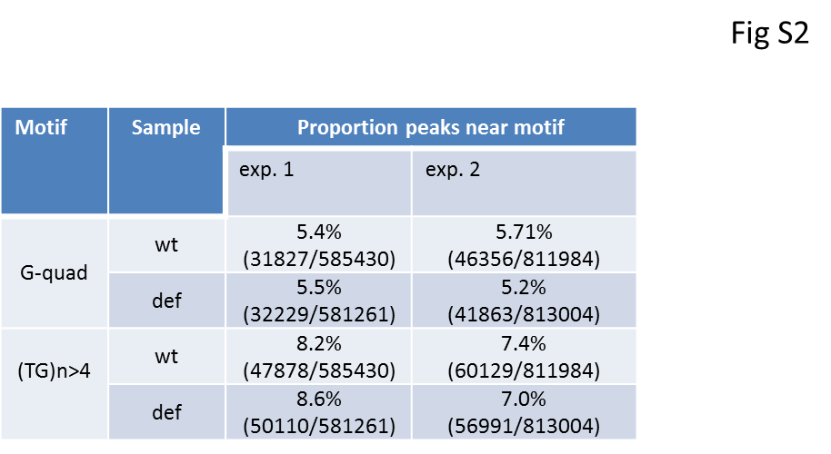
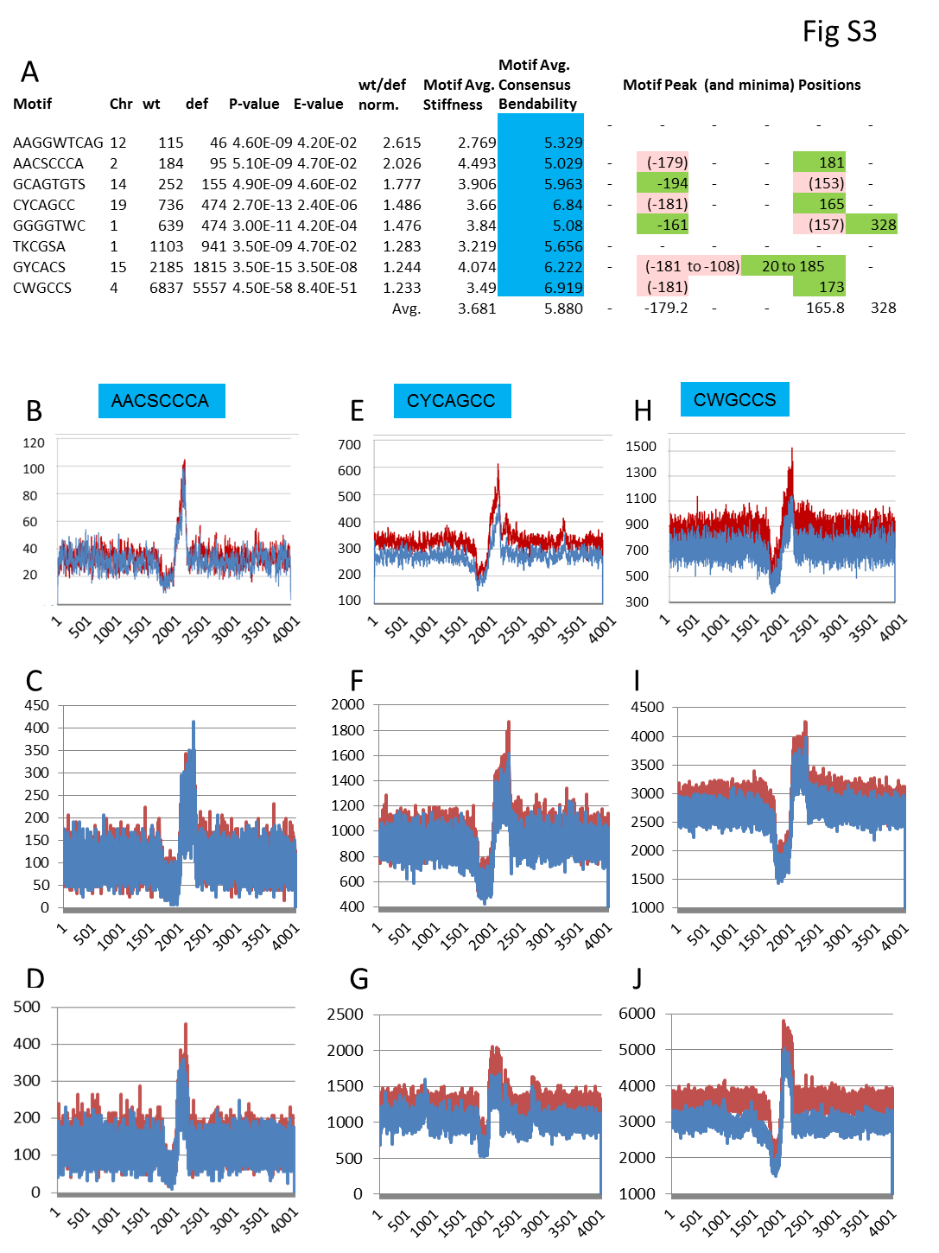
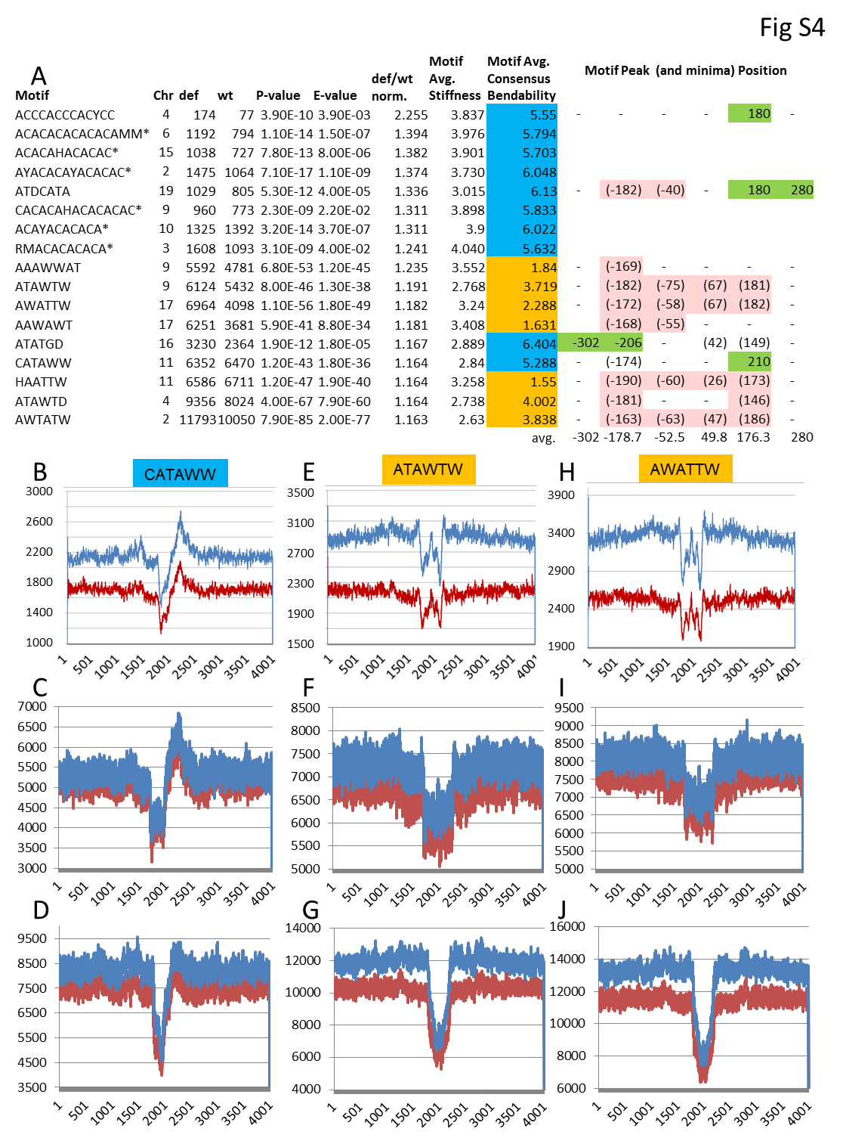
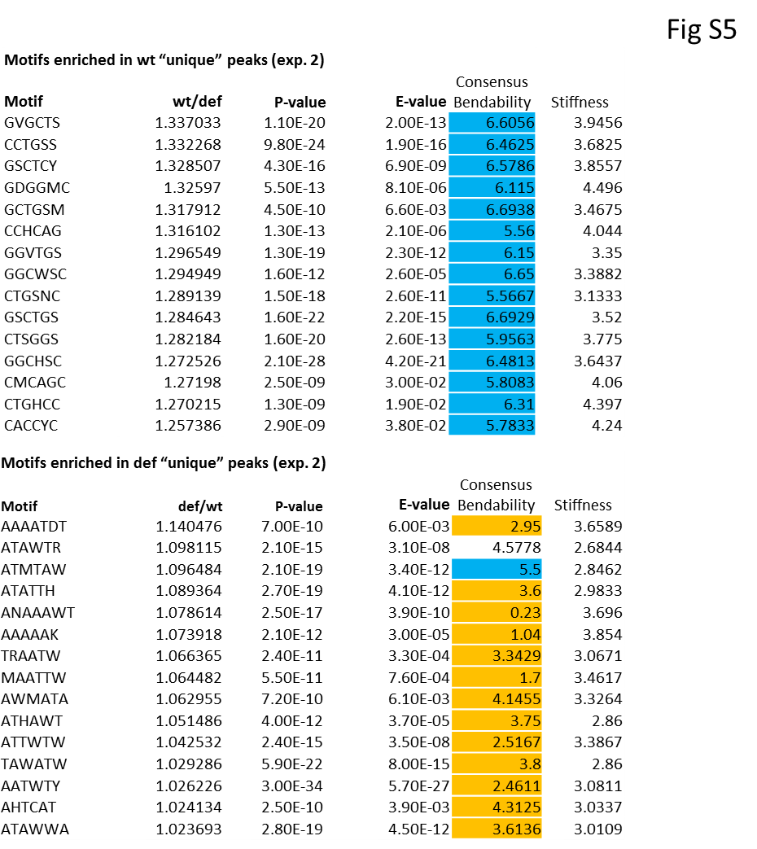
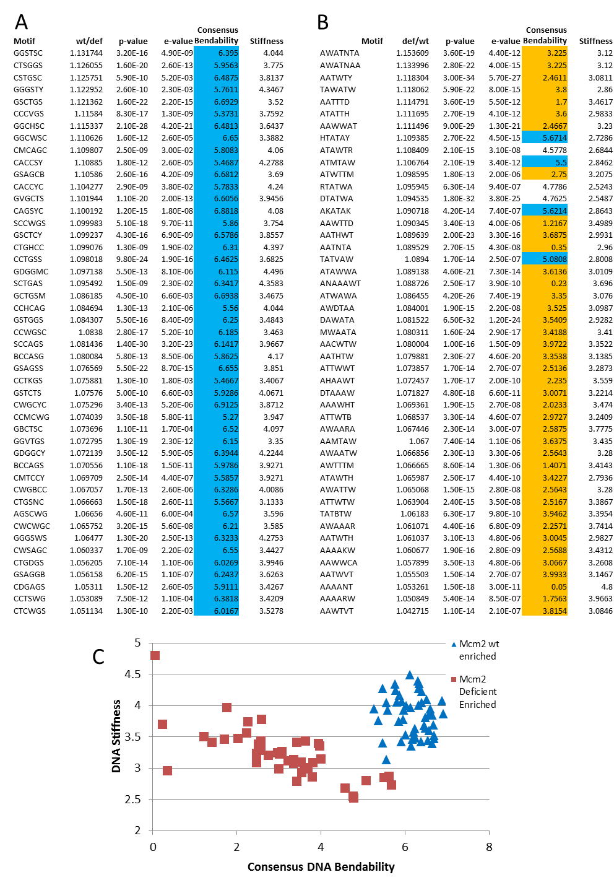
Fig S6
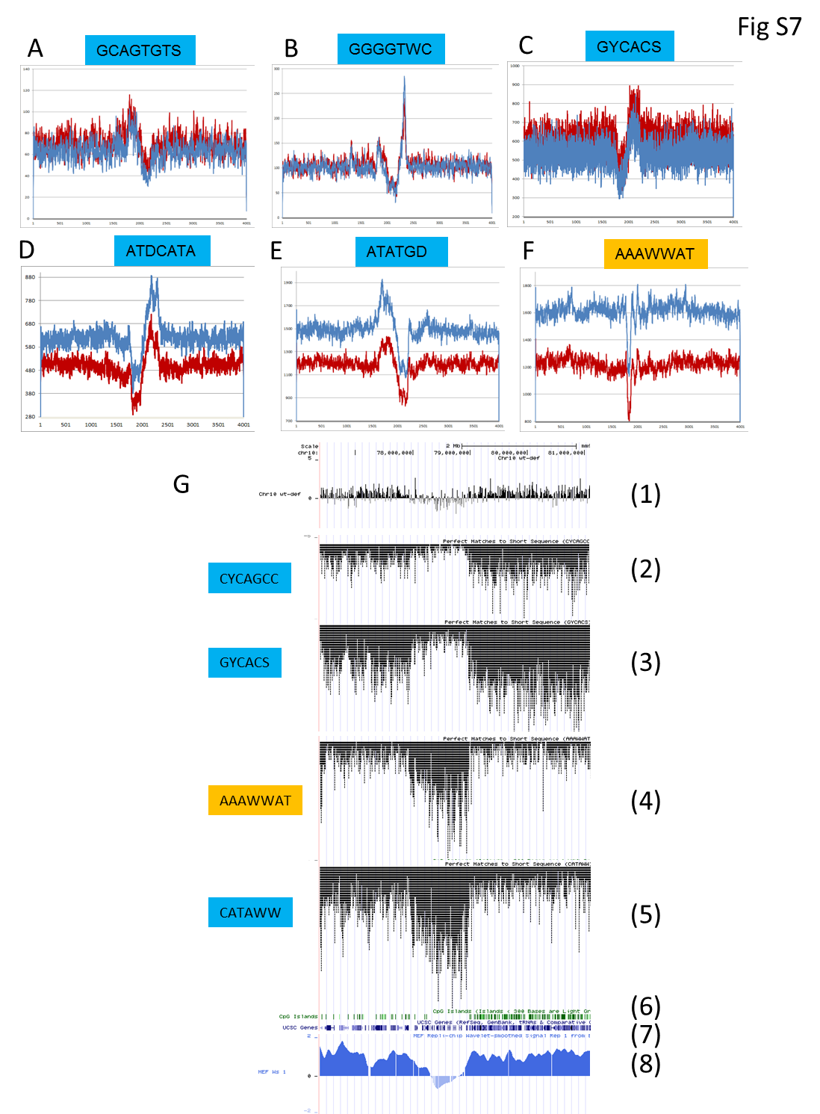
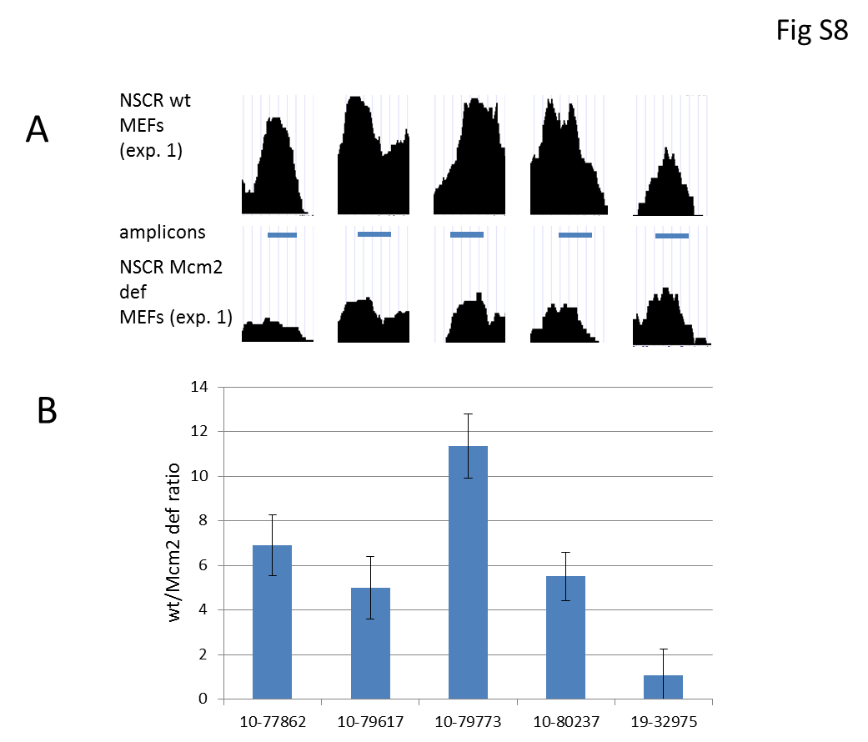
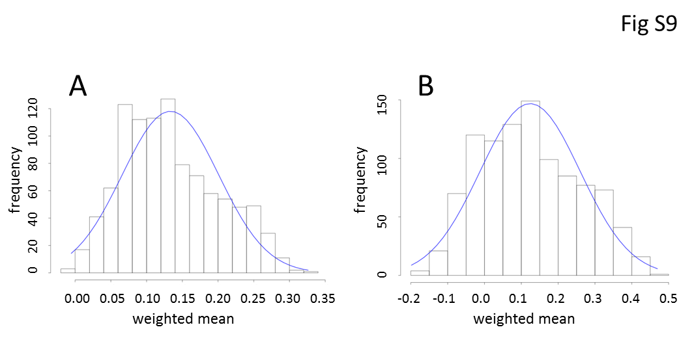
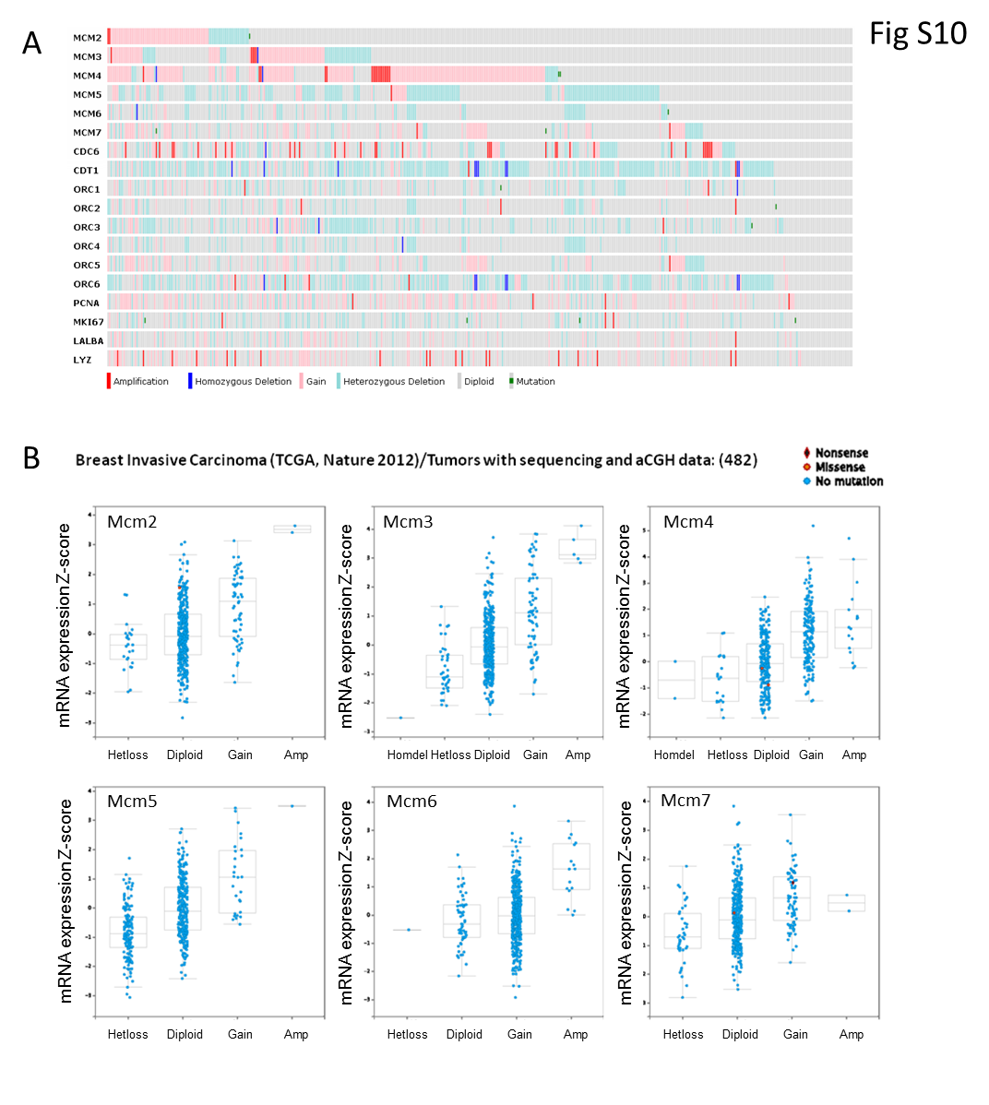

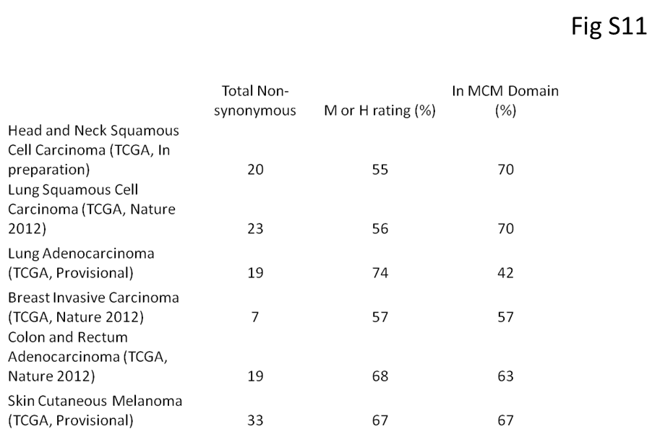

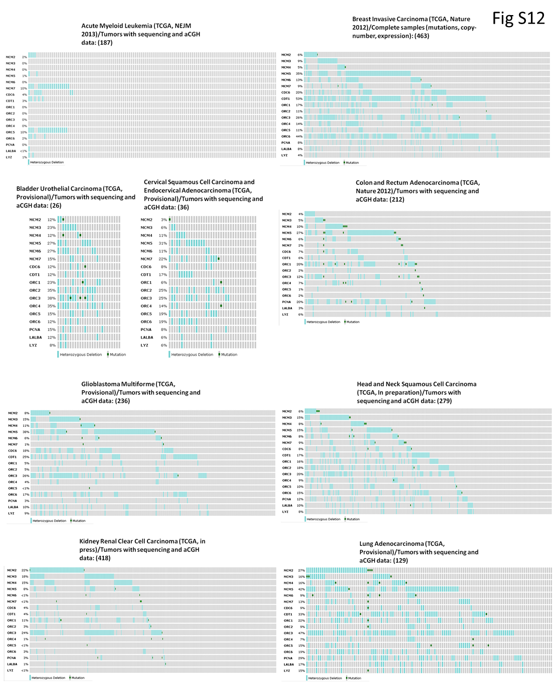
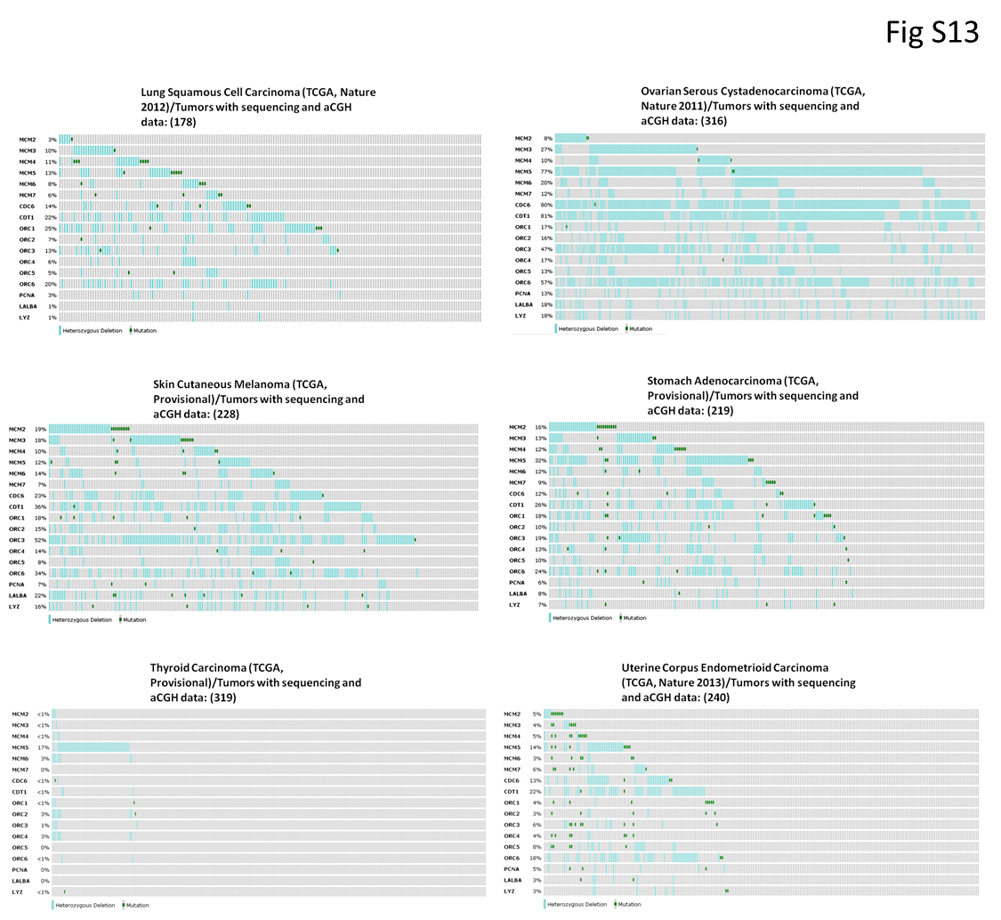
Supplemental Methods
Preparation of chimeric RNA:DNA artificial nascent strands and DNA fragment control
The template for preparation of RNA:DNA chimeric molecules was a 435 bp PCR product from mouse BAC RP-144G23 resulting from amplification with primers F-Mbd3-Ori-79863 CAGCTCCTCGGCTTAAAATG and R-Mbd3-79863 GTCCTCGCAGTAACGCAATAG (synthesized by IDT). Chimeric RNA:DNA artificial nascent strands were generated by PCR using synthetic RNA-DNA chimeric primers (synthesized by IDT) containing a 12 ribonucleotide leader and 20 deoxyribonucleotides where the forward primer, F-Mbd3-79863 -12RNA-20DNA, was rArUrCrArGrArUrCrArCrUrUCAGCTCCTCGGCTTAAAATG and the reverse primer, R-Mbd3-79863 -12RNA-20DNA, was rGrGrUrGrCrArUrUrUrCrUrGTCCTCGCAGTAACGCAATAG. PCR using these primers resulted in a 459 bp band was purified from and agarose gel under RNase Free conditions. For detection of chimeric RNA:DNA following NSCR, primers F-Mbd3-Ori-79863 5’CAGCTCCTCGGCTTAAAATG3’ and R-Mbd3-Ori-79863 5’ACACTGTGCTTCCGGAGTCT3’ were used and resulted in a 203bp amplicon.
DNA fragments was PCR amplified using template λ-DNA (Invitrogen Cat# 15612-013) and primers set forward: F-LambdaDNA829 AAGGTTTACGCCCGTTTTCT and reverse R-LambdaDNA829 GTTACGCCACCAGTCATCCT. Product size is 829bp. To detect this sequence we used other primers forward: F-detect Lam829 AACGTCCGATATCACGAAGG and reverse: R-detect Lam829 AGATATTCACGCAGGGGAAA . Product size is 235bp
Nascent Strand Capture and Release
All steps in the procedure were performed using RNase and DNase free conditions. The method contains 6 major steps as follows. I. Genomic DNA was isolated by addition of 5 ml lysis buffer (1% SDS; 40mM EDTA; 500mM NaCl; 10mM Tris HCl pH 8.0; 0.5mg/ml proteinase K) per 15 cm dish containing ~2.5 x 10⁷ cells, incubation at 37°C for 18 hr and extraction with phenol/chloroform. II. DNA was separated from RNA using TRIzol Reagent (Invitrogen Cat# 15596-018) following the provided procedure except the final steps of DNA dissolving. Instead, the purified DNA was extensively washed and dissolving in TE buffer (Cellgro Cat# 46-009-CM). III. DNA was size fractionated using sucrose gradient sedimentation as described (Grégoire et al., 2006) except that 16 ml gradients were used and fractions with DNA size between 400 and 2000 bp were pooled and precipitated by ethanol precipitation. IV. Size fractionated DNA was 5’-biotinylated by T4 polynucleotide kinase mediated thiophosphate addition followed by reaction with biotin maleimide (Vector Laboratories, # SP-1501) using a commercially available kit (Vector Laboratories, # MB-9001) and following the protocol provided. V. Biotinylated DNAs were captured on streptavidin magnetic beads (New England BioLabs Cat#S1420S) and washed using a protocol modified from D. Wilson (http://molbio.mgh.harvard.edu/szostakweb/protocols/biotin-avidin/index.html). The buffers required in this step are: Buffer A, high salt, (1M NaCl; 20mM Tris pH 7.5; 5mM EDTA; 0.1% Igepal CA-630 (Sigma I8896-50ML)); Buffer B, low salt, (TE buffer with 0.1% Igepal CA-630); Buffer C, UREA buffer, (4M Urea; 10mM Tris pH 7.5; 1mM EDTA; 0.1% Igepal CA-630), 20X SSC Buffer (Cellgro Cat# 46-020-CM); TE buffer pH 7.5; and RNase I Buffer, RNB, (10mM Tris pH 7.5; 100mM NaCl; 5mM EDTA). Binding was performed by incubation of biotinylated DNA with streptavidin beads for one hour at room temperature in Buffer A. Unbound material was recovered and collected as a flow through (Fraction F). Following binding, streptavidin beads were washed (1 ml each) 1 time with each with Buffers A and B at room temperature (RT), 1 time with Buffers C at 70°C for 5’, 2 times with 20X SSC at 70°C for 10’, 1 time with TE and RNB at RT. Streptavidin beads were then incubated with 200 µl RNB for 15min at room temperature, RNB was recovered, and collected as a wash control (Fraction W). VI. Nascent DNA strands were released by addition of 200 µl of RNB containing 0.02U/µl RNase I (Fermentas; Catalog # EN0601) and incubating for 15 min at RT. Supernatant was collected as the release fraction (Fraction R). Residual bound material was released by washing the streptavidin beads with 1ml TE, incubation with 100 µl 0.4 N NaOH at RT for 5 min followed by addition of 100 µl 0.4 N HCl and recovering the supernatant as the column fraction (Fraction C).
Genomic PCR primers
Primers used in Figure S1 panels F-K are: F-Hoxb4_96179.3 GAGTCCAGCCGTTCCTCTG R-Hoxb4_96179.3 AGATGGGGAGGGGTAGGAG; F-Hoxb4_96182.8 TGGAAGGACAATGTTGCAGA R-Hoxb_496182.8 AAACCACGATGTGATGGTCA; F-Rap1gap2_74307.5 TGGGACGAGGAAAGCTCTAA, R-Rap1gap2_74307.5 CTTAAGTGCTGGGGAAGTGG; F-Wnt3_103634.5 CCCAAACTGTGGAGAACTGG, R-Wnt3_103634.5 TCAGGAACATCTACCTCCCCT.
BioInformatics
Peak determination. NSCR-NGS data was aligned to the mouse genome (mm9) and wiggle files were extracted (GenomeQuest). Wiggle files were either displayed directly in the UCSC Genome Browser or used for peak determination. For peak determination, the coverage distribution over the whole genome was treated as background null distribution. A candidate peak was called if the max coverage exceeds a cutoff value determined by percentile of the null distribution in a window size greater than a cutoff value of 400bp as the technique captures a segment around this size. After a peak candidate region was determined, the coverage in the region was smoothed using spline curve and exact peak positions were determined using the smoothed coverage such that the highest peak in a region was selected followed by any peak that was 200bp away from existing peak with enough peak height drop. Peak summit locations were used to determine the minimum inter-peak distance (101bp) among each peak file individually. Half of that distance (50bp) was used to associate peaks between the wild-type female and Mcm2-deficient male peak files, obtaining files of peaks common between the two samples, peaks unique to the wt, and peaks unique to the Mcm2-deficient sample.
Sample comparisons. A histogram of the inter-peak distances of the peaks common to both samples was created at single-base resolution for up to 50 bases using a perl script. Each peak was then annotated with genes containing the closest transcription start site and CpG islands containing the closest center-point. A histogram of distances of each peak to the closest CpG island-center using a 10bp sliding window was then generated separately for peaks common between the Mcm2-deficient and wt, peaks unique to the wt, peaks unique to the Mcm2-deficient sample, all wt peaks, and all Mcm2-deficient peaks. A histogram comparing wt peak heights and Mcm2-deficient peak heights was generated using a 100bp sliding window for peaks common between the two samples, as well as for all peaks. The height data was then subjected to a KS test using R (R Development Core Team, 2011).
The wiggle data of the autosomes was normalized by library size and adjusted for gender. The normalized autosomal wiggle data was then subtracted, coordinate-by-coordinate to generate wt minus deficient difference files.
Preparation of bedGraph file lambda-Exonuclease prepared Nascent Strand DNA data (Cayrou et al, 2011). GSM718744, a microarray data file on Nimblegen platform GPL13476, obtained from the NCBI Gene Expression Omnibus (GEO) (http://www.ncbi.nlm.nih.gov/geo) under accession no. GSE29183 was used to generate a bedGraph file on the mm8 mouse genome build which was translated to mm9.
Motif search and Bendability/stiffness calculation
The sequences within 260 bases around the each peak detected as previous described are extracted from reference mouse genome sequences (mm9) and are stored in a FASTA file. DREME (Bailey, 2011), a program to detect significant enriched motifs in a set of sequences against a set of background sequences, is run on both control and Mcm2 deficient peak sequences using each other as back ground to search motifs that are enriched in either control or Mcm2 deficient peaks. The motif sizes are set to be between 5 and 15 bases.
The average bendability for 2000 bases around each peak was calculated at each position based on the method published at http://hydra.icgeb.trieste.it/dna/bend_it.html.
Chromatin Immunoprecipitation (ChIP) and rtPCR assays
ChIP was performed using an EpiQuik chromatin immunoprecipitation kit (cat # P-2002-3) per the manufacturer’s instructions. Briefly, 5x10⁶ wt or Mcm2 deficient passage 4, 129Sv MEFs were harvested and washed with PBS. Cells were cross-linked with 1% formaldehyde (methanol free) in 9ml of media for 10 min at room temperature with rotation followed by quenching with 1ml 1.25M glycine. Cells were centrifuged for 5 min and washed with ice cold PBS. The cell pellet was re-suspended in 1ml of pre-lysis buffer and incubated on ice for 10 minutes followed by centrifugation at 5000 rpm for 10 minutes. The nuclear pellet was re suspended in 500 µl of lysis buffer containing protease inhibitor cocktail. Chromatin was sheared at 4˚C using a 60 Sonic Dismembrator (Fisher Scientific) on continuous mode at maximum output power. The sheared chromatin (fragment size range 500 to 1500 bp) was centrifuged at 14,000 rpm for 10 minutes to pellet the cell debris and the supernatant was diluted 1:1 in ChIP dilution buffer. For the IP step, the 96 well plate from the kit was incubated at RT for 90 minutes with 4ug of anti-Mcm2 goat IGG polyclonal (Santa Cruz, sc9839) diluted in 100ul antibody buffer per well. Following incubation the antibody solution was removed, wells were washed with antibody buffer, 100 µl of the diluted chromatin supernatant was transferred to each antibody coated well and incubated at RT for 90 minutes on a shaker. Supernatant was removed and wells were washed with the wash buffer and 1X TE buffer (pH 8.0). Cross links were reversed by proteinase K treatment for 90 minutes in a 65˚C water bath. DNA was purified and eluted in 20 µl of the elution buffer. Recovered DNAs were assayed by rtPCR using BioRad IQ SYBR Green Supermix (cat. no. 170-8882) and a CFX96 Real-Time System C1000 Thermal Cycler (Bio-Rad). Primers used in the assay were: F-Chr10-77862 GCAACAGGTGAGTTGCAGAA, R-Chr10-77862 ATTGTGCAGTGATGCATGGT; F-Midn-79617.6 TCTGCCTATGCCCATACCTC, R-Midn-79617.6 ACACCTGCGCACACTGATAA; F-Apc2-79773.6 GCAGGGGTGAACCTGATTTA, R-Apc2-79773.6 GCTCACCATCCACATCACAC; F-Dot1l-80237.4 AGTGCTACGGCTTTGATGCT, R-Dot1l-80237.4 AGCAGAGAAGCAGGCTGAAG; F-Chr19-Ori-32975 GCCCAGAGAACAGAAAGCAC, R-Chr19-Ori-32975 GCACTCCCACCAGTTTCCTA.
References
Bailey, T.L. (2011). DREME: Motif discovery in transcription factor ChIP-seq data. Bioinformatics 27(12), 1653-1659.
R Development Core Team (2011). R: A language and environment for statistical computing. R Foundation for Statistical Computing, Vienna, Austria. ISBN 3-900051-07-0, URL

