Supplementary Methods
Gene List
The total list of 313 genes surveyed is presented here: 0610010K14Rik, 1110008P14Rik, 1700012A03Rik, 1700029I15Rik, 1700034O15Rik, 1810026J23Rik, 2010107G12Rik, 2310009B15Rik, 2310039H08Rik, 2410016O06Rik, 2610002J02Rik, 2700081O15Rik, 2700097O09Rik, 3110062M04Rik, A130010J15Rik, A230050P20Rik, A830005F24Rik, Aard, Abt1, Acot1, Adam26a, Adamts15, Adck3, Adig, Agps, Ahrr, Alox5, Amer2, Ampd1, Amz1, Anp32e, Aox1, Apof, Arap1, Arhgap18, Arhgap19, Arhgap25, Arl10, Atat1, Atf5, Atg9b, Atp1b4, Atp6v1b1, Bgn, Bpifa2, C130073F10Rik, C4bp, Cadm2, Calcb, Car2, Caskin2, Ccdc115, Ccdc116, Ccdc141, Ccdc163, Ccl22, Ccl9, Cd200r3, Cd200r4, Cd248, Cd6, Cdkn2a, Cfap52, Cfb, Ciart, Cldn16, Cnnm4, Cnot6, Coa7, Col6a2, Cope, Cox4i1, Crybb3, Csl, Cul5, D130043K22Rik, D17Wsu92e, Dgat2l6, Dgkq, Dip2a, Dram1, Dstn, Dusp21, Dusp3, Efhd2, Enho, Ephx4, Erg, Esco1, Eva1b, Evi5, Fadd, Fam122a, Fam210b, Farp2, Fastk, Fbxo44, Ffar4, Fgfbp3, Fopnl, Fryl, Fus, G6b, Gas2l1, Gdap1, Gh, Gkn2, Glrx5, Gng13, Gnpda2, Golga7, Gpc2, Gpr119, Gpr158, Gpr182, Gpr20, Gpr35, Gpr50, Gpr88, Gpsm3, Grid2ip, Gtf2a1, Hacl1, Hmg20b, Hmgn2, Hoga1, Hrasls, Htra4, Ido2, Ifi202b, Ifi35, Ift27, Igfbpl1, Igsf11, Ikbkap, Il18bp, Il33, Il6ra, Inf2, Iqub, Jazf1, Kcnab3, Kcnk15, Kcnk18, Kctd15, Kif12, Klf14, Klhl8, Klk7, Kmo, Krt16, Krt2, Krtap17-1, Lancl2, Leprel2, Lpar5, Lpin3, Lrrc72, Lrrk1, Lst1, Lypla2, Lyplal1, Maob, Mcoln2, Med28, Med29, Megf10, Mettl20, Mob3a, Mplkip, Msantd1, Mtnr1b, Mturn, Myo18a, Negr1, Ninj1, Nme8, Nppb, Nsg1, Nuak1, Nudt19, Nutf2, Oas1g, Osbpl7, Oxgr1, Oxld1, P2ry13, P4hb, Panx1, Parp11, Pcdh18, Pck2, Pcnt, Pcsk1n, Pepd, Pex26, Pfkfb4, Plekha8, Plekhg4, Pllp, Podnl1, Podxl2, Ppapdc2, Ppp6r3, Pprc1, Pramel6, Pramel7, Prcc, Prelid1, Prkcdbp, Prr15l, Prr7, Psat1, Psmd10, Ptma, Rab11fip1, Rab32, Rarres2, Rec114, Reg2, Rfc1, Rgcc, Rgs12, Rgs9bp, Rita1, Rln3, Rmdn3, Rnf31, S100a6, Scgb2b26, Sec23a, Sema4c, Sept9, Sertad2, Sertad4, Sh3bp5l, Sidt1, Sik1, Slc1a3, Slc22a4, Slc25a22, Slc27a2, Slc33a1, Slc39a5, Slc45a3, Slc52a2, Slc7a13, Slc9b2, Smpd4, Snx17, Snx27, Spdef, Spns2, Spp2, Sprn, Srgap1, Ssna1, St18, Stard5, Stra6l, Strn, Surf2, Susd3, Syndig1, Syndig1l, Synm, Taar5, Taar6, Tacr2, Taf3, Tamm41, Tdrp, Tenc1, Tex37, Tjp1, Tle2, Tmem182, Tmem219, Tmem248, Tmem256, Tmem59l, Tmem70, Tmem92, Tnfaip8l3, Tnni2, Tns4, Tox3, Tppp3, Treml4, Trp53inp2, Tslp, Tst, Ttc8, Uba2, Ubash3b, Ube2e2, Ubqlnl, Ulk4, Usp48, Utf1, Uts2r, Vsnl1, Wfdc1, Wfdc21, Wisp2, Wtip, Yap1, Zc3h18, Zdhhc7, Zfp12, Zfp467, Zfp536, Zfyve16
Details of LacZ Staining & Annotation
Tissues for FS were rinsed in PBS and equilibrated for 24 hours in 15% sucrose at 4°C, followed by an additional 24 hours in 30% sucrose (Sigma Aldrich). Tissues were embedded in OCT, with blocks rapidly frozen by immersion into a methyl-butane/dry-ice mixture. The embedded tissue blocks were sectioned at 10µm thickness for peripheral organs and 14 µm for brain using a cryostat (Model HM525, Thermo Scientific) equipped with a Cryo Jane Tape Transfer system for mounting sections on glass slides (Leica). Sections attached to the glass slides were briefly fixed in 4% PFA, washed with pH 7.7 PBS, followed by incubation in X-gal staining solution (pH between 7.60- 7.70) for 18 hours at 37⁰C. Slides were then rinsed in PBS; post-stain fixed with 10% neutral buffered formalin, rinsed with PBS, washed with distilled water, counterstained using Nuclear Fast Red (Sigma Aldrich), rinsed and dehydrated in ethanol, and cleared using xylene. Sections were cover-slipped with xylene-based Cytoseal XYL mounting media (Richard-Allan) and dried overnight.
WM tissues were rinsed in PBS after post-dissection fixation, and then incubated in X-gal staining solution for 48 hours at 4⁰C. Following staining, tissues were rinsed in PBS, post-fixed in 10% neutral buffered formalin (NBF, Fisher Scientific), cleared overnight in 50% glycerol (VWR) made in PBS, and then cleared and stored in 70% glycerol containing 0.01% sodium azide (Sigma Aldrich).
All WM tissues staining specifically for LacZ activity were photo-documented using an M165C stereo microscope and DFC425 digital camera (Leica). FS slides were scanned using a ScanScope XT Slide Scanner and viewed with Image Scope software, version 10.2.2.2319 (Aperio). Positive FS staining was documented by frame grabbing of appropriately magnified images from the slide scans.
LacZ staining was annotated and graded for expression intensity in 66 different tissues and organs: adrenal gland, aorta, blood (FS), bone marrow (FS), brain (mid-sagittal, WM), brown adipose tissue, cecum, cerebellum, clitoral gland, coagulating gland, colon, diaphragm, duodenum, epididymis, esophagus, eye, forebrain, gonadal fat pad, harderian gland, heart atrium, heart ventricle, hindbrain, ileum, jejunum, kidney, lacrimal gland, larynx (FS), liver, lung, male preputial gland, mammary gland, mediastinal lymph node (FS), mesenteric lymph node, midbrain, olfactory bulb, omental fat pad, ovary, oviduct, pancreas, parathyroid gland (FS), parotid gland (FS), penis, pituitary gland, prostate gland, quadriceps, salivary gland (WM), sciatic nerve, skin, spinal cord, spleen, stomach, sublingual gland (FS), submandibular gland (FS), submandibular lymph node, testis, thoracic cage (WM), thymus, thyroid gland, tongue, trachea, trigeminal nerve, urethra (FS), urinary bladder, uterus, vagina, vas deferens, and vesicular gland. WM and FS staining were completed for the majority of structures except where noted above. For the WM preparations, the parotid, submandibular and sublingual salivary glands could not be easily distinguished and therefore they were grouped as “salivary gland”. The parathyroid, mediastinal lymph node, larynx, and urethra were not specifically dissected for WM and therefore were only scored by the FS method. The midsagittal brain and thoracic cage were too large for sectioning, and were more easily prepared and stained for WM analysis.
Non-specific staining in some tissues could readily be distinguished from specific staining based upon the substructure localization and intensity of staining. For example, in frozen sections of the small intestine, non-specific staining of the intestinal villi is faint and scattered and generally localized to the epithelial cells of the crypts. Specific staining due to reporter gene activity can be distinguished if it was more intense and extensive even if it is restricted to villi epithelium.
Grading of staining intensity is very subjective. Intensity was scored as low, medium and high (+, ++, +++) based upon intensity of the staining at the specific anatomical location and not based upon the number of cells or extent of tissue that was stained in an organ. The annotators used reference images of intermediate intensity and scored staining as either the same, higher or lower than the reference.

Supplemental Figure Legends
Supplement Figure 1. Frequency of specific staining by whole mount (WM) and frozen section (FS) in HET mutants. Tissues are organized by functional organ system: CNS, Central Nervous System; CV, Cardiovascular; RESP, Respiratory; GI, Gastrointestinal; BIL, Biliary including pancreas; REN, Renal; A/M/B/S: Adipose/Muscle/Bone/Skin; LYMPH/BL/RE, Lymph/Blood/Reticuloendothelial; GLANDS, Exocrine and Endocrine Glands; M REPRO, Male Reproductive; F REPRO, Female Reproductive. Differences in staining frequency by method is explained by: 1) poor access of staining solution to tissue in WM preparation; 2) high nonspecific staining by the WM method in these tissues and specific staining could not be distinguished from nonspecific staining; 3) The tissue or organ is not stained by one of the two methods.
Supplement Figure 2. Correlation between whole mount (WM) and frozen section (FS) staining frequency for all tissues stained and annotated. Tissues/organs not evaluated by both methods, or with confounded results due to high non-specific staining, or inadequate stain penetration in WM preparations, are not included in calculating the correlation. The correlation coefficient of 0.7 suggests that the two methods have similar sensitivities for detecting reporter gene activity,
Supplement Figure 3a. Whole mount nonspecific staining is found in the male sex organs; preputial gland; gastrointestinal system including the stomach, small intestine, cecum, and the large intestine; kidney cortex, and in the salivary gland. In the male sex organs, staining is found in the coagulating gland (a), vas deferens (b), head and tail of the epididymis (c), with low levels of nonspecific staining in the testis (d). In the preputial gland (e) there is a variegated nonspecific staining pattern with no staining in the surrounding white adipose tissue (f). In the stomach, nonspecific staining is most pronounced in the antrum (g) with some staining in the pyloric region (h), while the fundus (i) often is not stained. In distal GI tract, staining is intense in the ileum (j), cecum (k) and large intestine (l). In kidney, staining is faint and diffuse in the cortex (m), with no or minimal staining in the renal medulla (n) and hilus (o). Finally, in the salivary gland (p) there is diffuse nonspecific staining, while the associated lymph nodes (q) are not stained.
Supplement Figure 3b. Frozen section nonspecific staining is found in the thyroid in follicular epithelial cells (a), in epithelial cells in the villi of the small intestine (b), in adherent bacteria in the esophagus (c), in epithelial cells lining the ducts of the epididymis (d), in the epithelial mucosa of the vas deferens (e) and prostate ducts (f), and scattered cells staining glandular cells and epithelium of the coagulating gland (g).
Supplement Figure 4. Comparison of staining intensity in HOM vs. HET mutants for Ninj1 reporters in the cardiac ventricle, in Slc7a13 kidney, and in Sik1 bladder. Ninj1 staining is found in both cardiac ventricular muscle and in the wall of the larger vessels of the ventricle. Slc7a13 staining is observed in kidney tubules and Bowman’s capsule. Sik1 staining is observed in the epithelial cells (a), smooth muscle (b) and the serosal layer (c) of the bladder (see arrows labeled a and b in the Sik1 Bladder images. In all cases, the HOM staining is more intense with more cells staining than observed in HET staining for that gene.
Supplement Table1. Repeatability of specific staining by WM and FS is evaluated separately for each tissue. In the majority of cases, male is compared with female staining. Percent yes is defined as: (# both replicates scored as yes) divided by (# of lines with at least 1 mouse scored as staining). Total percent yes is defined as: (# lines with both replicates scored as staining + # lines with both replicates scored as not staining) divided by (total # of compared lines).
Supplement Table 2. In order to assess repeatability of frozen section staining, we selected genes with LacZ reporter gene expression that was broadly distributed in multiple organs and tissues (IL33, Inf2, Parp11); and staining specific to a limited number of tissues (Reg2: gastrointestinal tract and pancreas). Each of these lines had 4-5 individual heterozygous mice with frozen section LacZ staining annotation and included both male and female. Two annotators scored staining independently in 2-3 mice from each line. In the table, “Y” indicates specific LacZ staining, “m” indicates the sample was missing, “n” indicates non-specific background staining only and no specific staining, and an empty field indicates no staining. Samples are missing due to the level of sectioning through the block failed to capture the tissue, or because they are reproductive tract organs. The percent concordance of annotation among the individuals for a specific reporter was calculated with 4/4 in agreement indicating 100% concordance, 3 of 4 in agreement indicating 75% concordance, and 2 of 4 indicating 50% concordance. The average concordance across all tissues and all four lines was 92%.
Supplemental Figures
Figure 1. Frequency of Specific Staining by tissue

Figure 2. Correlation between Whole Mount and Frozen Section Staining
Figure 3a. Whole-Mount (WM) Non-Specific Wildtype Staining
b
a
Salivary Gland
Cecum and Large Intestine

e
q
p
o
n
m
l
k
j
i
h
g
f
d
c
Stomach
Male Preputial Glands
Male Sex Organs
Kidney
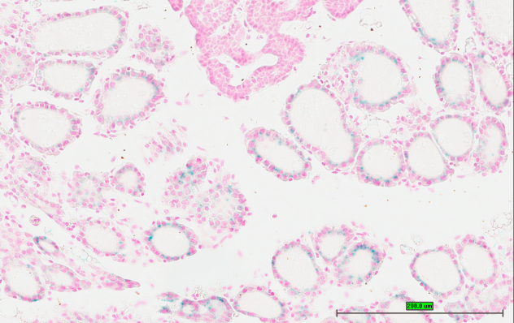
Figure 3b. Frozen Section (FS) Non-Specific Wildtype Staining
Small Intestine-Ileum
Thyroid
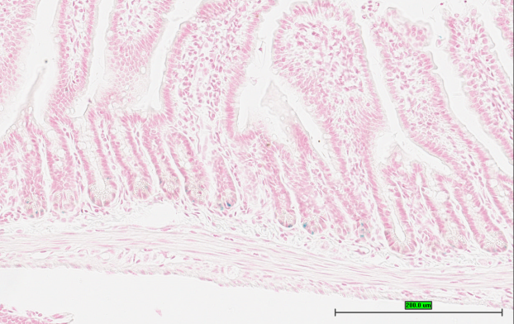
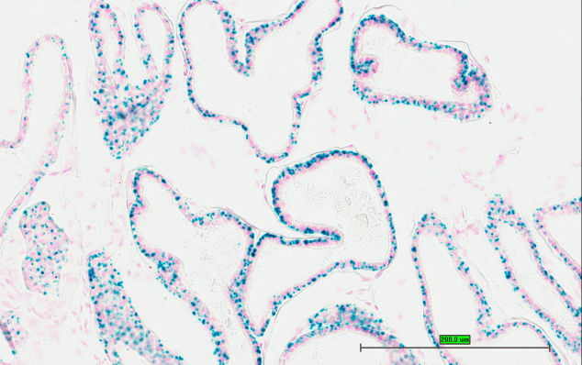
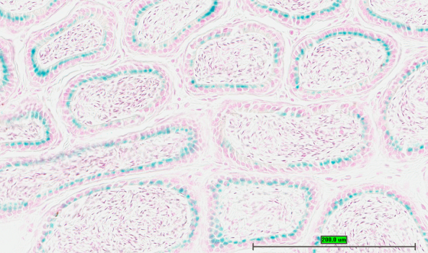
b
a

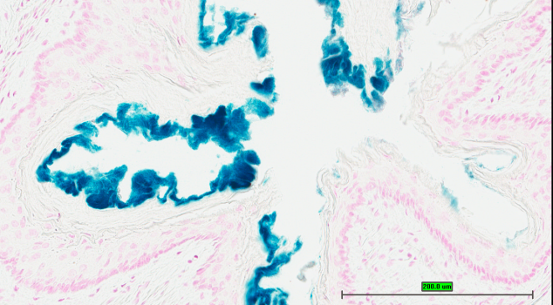
Esophagous
Epididymis
Epididymus
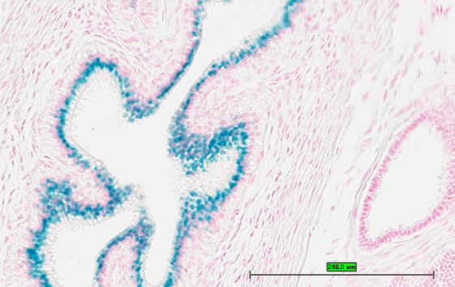
d
c

Vas Deferens
Prostate
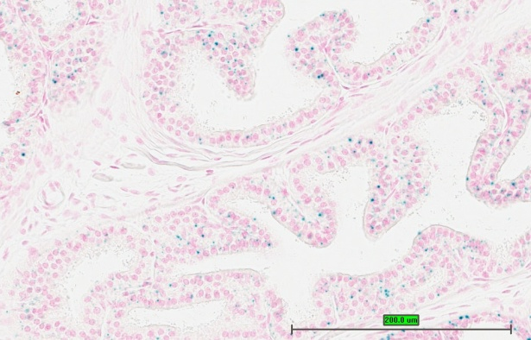
f
e

Coagulating Gland
g

Supplemental Figure 4.
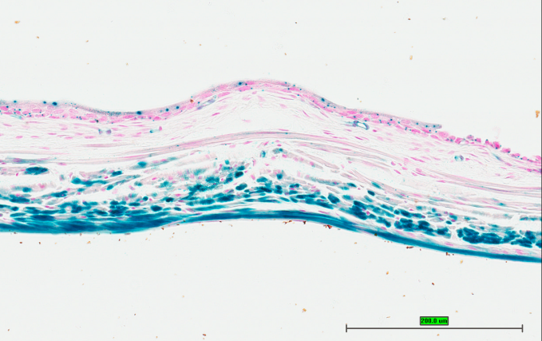
Ninj1 HET Cardiac Ventricle
Ninj1 HOM Cardiac Ventricle
c
b
a
Sik1 HOM Bladder
Sik1 HET Bladder
Slc7a13 HET Kidney
Slc7a13 HOM Kidney

Supplement Table 1. Repeatability of Staining by Tissue
Supplement Table 1. Repeatability of Staining by Tissue

Supplement Table 2

Supplement Table 2 (continued)

