Single haplotype assembly of the human genome from a hydatidiform mole

Karyn Meltz Steinberg¹, Valerie A. Schneider², Tina A. Graves-Lindsay¹, Robert S. Fulton¹, Richa Agarwala², John Huddleston^{3,4}, Sergey A. Shiryev², Aleksandr Morgulis², Urvashi Surti⁵, Wesley C. Warren¹, Deanna M. Church⁶, Evan E. Eichler^{3,4}, Richard K. Wilson¹

¹The Genome Institute at Washington University, St. Louis, MO; ²National Center for Biotechnology Information, National Library of Medicine, National Institutes of Health, Bethesda, MD; ³Department of Genome Sciences, University of Washington, Seattle, WA; ⁴Howard Hughes Medical Institute, University of Washington, Seattle, Washington 98195, USA; ⁵University of Pittsburgh, Pittsburgh, PA; ⁶Personalis, Inc. Menlo Park, CA

SUPPLEMENTAL DATA

Figures

Figure S1. a) Total number of base pairs for interchromosomal and intrachromosomal WGAC duplication events with sizes between 1 Kbp and 50 Kbp.

b) Total number of aligned base pairs for interchromosomal and intrachromosomal WGAC duplication events based on sequence identities between 0.9 and 1 in intervals of 0.005.

Figure S2. Venn diagram comparing duplications (>10 Kbp, >94% identity) in CHM1.1 reference assembly predicted by WGAC and WSSD analyses.

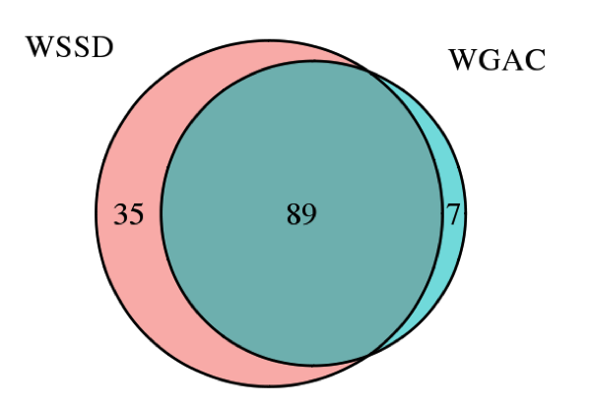

Figure S3. CH17 clone placements suggest the SMA region of CHM1_1.1 is incorrectly assembled. Graphical view of NC_018916.2 from 68.5-70.3 Mb. The grey bar at top represents the chromosome sequence, while the individual BAC clones (green) that comprise the assembly are shown directly below. Beneath this, purple bars show the RefSeq gene annotation of the region. The locations of the proximal SMN2 (left) and distal SMN1 (right) genes are highlighted with vertical lines. CH17 clone placements are shown as a series of horizontal lines with triangular ends representing the end placements. Clone placements located entirely within either the proximal or distal BAC clusters are largely concordant. These placements are consistent with the BAC insert sequence alignments that support these groupings. In contrast, clone placements spanning the gap between the two BAC clusters or spanning from WGS to the proximal cluster are predominantly discordant. Clone Placement legend:
Blue=concordant. Red=discordant. Solid triangle: unique end placement. Open triangle: multiple end placement.

Figure S4. A 79kbp gap in GRCh37 at chromosome 15q25.2 subsequently resolved in GRCh38 using CH17 BAC sequences. This region contains many GOLGA6L core duplicon genes and highly identical segmental duplications. The GRCh37 assembly contained RP11 clones on one side and RP13 clones on the other side flanking the gap. Using the BAC sequence resolved CH17 haplotype, the gap was filled in GRCh38.

Figure S5. Read length distribution of PacBio data used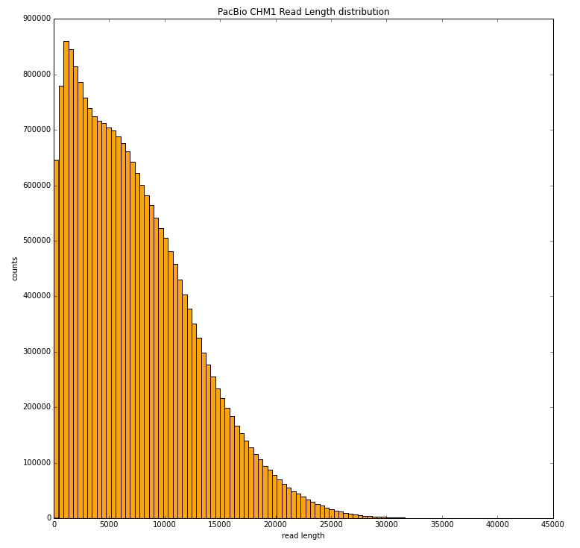

Tables (see excel file on figshare account)

Table S1. Regions improved with BAC sequences

Table S2. 549 novel genes in CHM1_1.1

Table S3. Clinical allele

Table S4. Summary of duplications in CHM1.1 reference assembly by WGAC and WSSD analyses

Table S5. Summary statistics of CHM1 variants called from CHM1 alignments to GRCh37

Table S6. RefSeq annotation of CHM1 variants from CHM1 alignments to GRCh37

Table S7. Summary statistics of CHM1 variants called from CHM1 alignments to CHM1_1.1 Assembly

Table S8. Thirty four regions of CHM1_1.1 assembly with SNV density per kb two standard deviations greater than the mean SNV density per kb

Table S9. Gene annotation of 34 regions from Table S8.

TableS10. BAC end sequence pair mapping summary statistics

Table S11. Illumina short read accessions

Table S12. Novel gene remap statistics

Table S13. Variant filters

Table S14. Pac Bio read statistics

The following is on figshare account: CHM1 Single Haplotype Assembly Supplementary Material http://dx.doi.org/10.6084/m9.figshare.1091429

Clinical Allele Analysis
report_NHGRI_GWAS_dbSNP137_ucsc_parsed_2CHM1_1.1.vcf.tsv
report_clinvar_20140211_parsed_GRCh37_clean2CHM1_1.1.vcf.tsv
PrepInput2VCF.ipynb
NHGRI_GWAS_dbSNP137_ucsc_parsed.vcf
GWAS_CHM1_1.1_allele_match.tsv
ClinVar_CHM1_1.1_allele_match.tsv
clinvar_20140211_parsed_GRCh37_clean.vcf
CHM1_1.1Remap2VCF.ipynb

Gene Annotation
alt_CHM1_1.1_top_level.gff3.gz
GRCh37.p13_top_level.gff3.gz
Summary files

Duplication Analysis
GenomicSuperDup.tab.zip
wssdGE10K_nogap.bed
nonredundant_duplication_by_assembly.tab
CHM1_1.1_repeatmasker.sorted.merged.bed.gz

PacBio
cliff_report_54_full_xchr
cliff_report_54_gtw10_lt108_xchr
54xPacBioAlignEvaluation.pdf

BAC end mapping
CH17_CHM1_1.1_placements.tsv.gz
CHM1_BAC_mapping.zip
GRCh37_BAC_mapping.zip
CHORI17_BAC_inversions.txt

SNV callsets
CHM1_to_GRCh37_lite_snvs.site_filtered.pass.vcf.gz
CHM1_to_CHM1_1.1_snvs.site_filtered.pass.vcf.gz

BioNano Analysis
BioNano_map_analysis.docx
CHM1_0825_vs_CHM1_1.1.xmap

