Figure S1. Heteroscedasticity of beta-value. (A) Relationship between standard deviation and mean beta value for each probe. (B) Plot of the between- and within-individual variation extracted from the random effects regression by bins of probe mean beta-values.
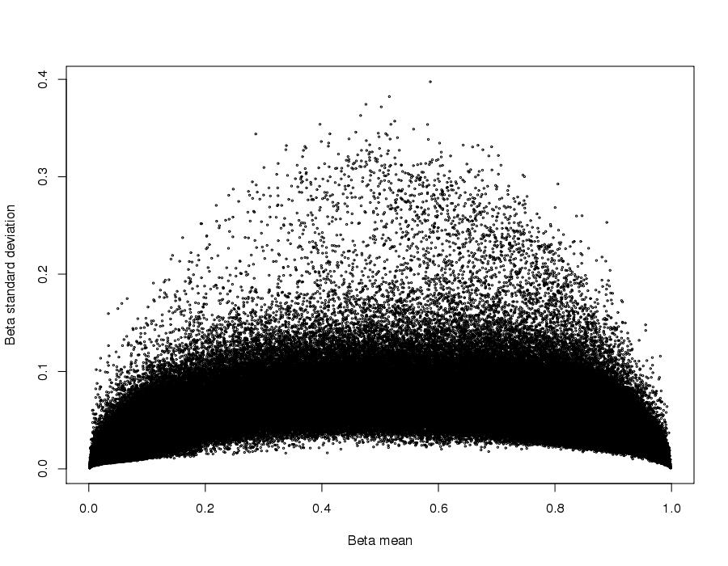
(A)

(B)
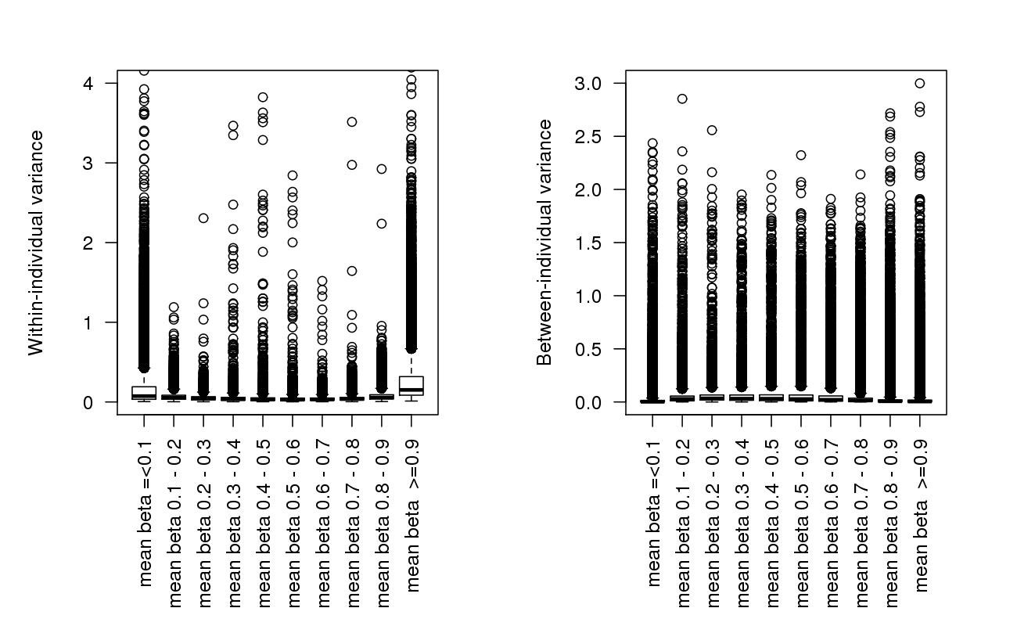

Figure S2. Relationship between R_{m} and h² with between- and within-individual variance. The top two figures show the relationship between R_{m} (y-axis) with bins of increasing between-individual variance (top left image) and within-individual variance (top right image). The bottom two images show the relationship between h² (y-axis) with bins of increasing between-individual variance (bottom left) and within-individual variance (bottom right).

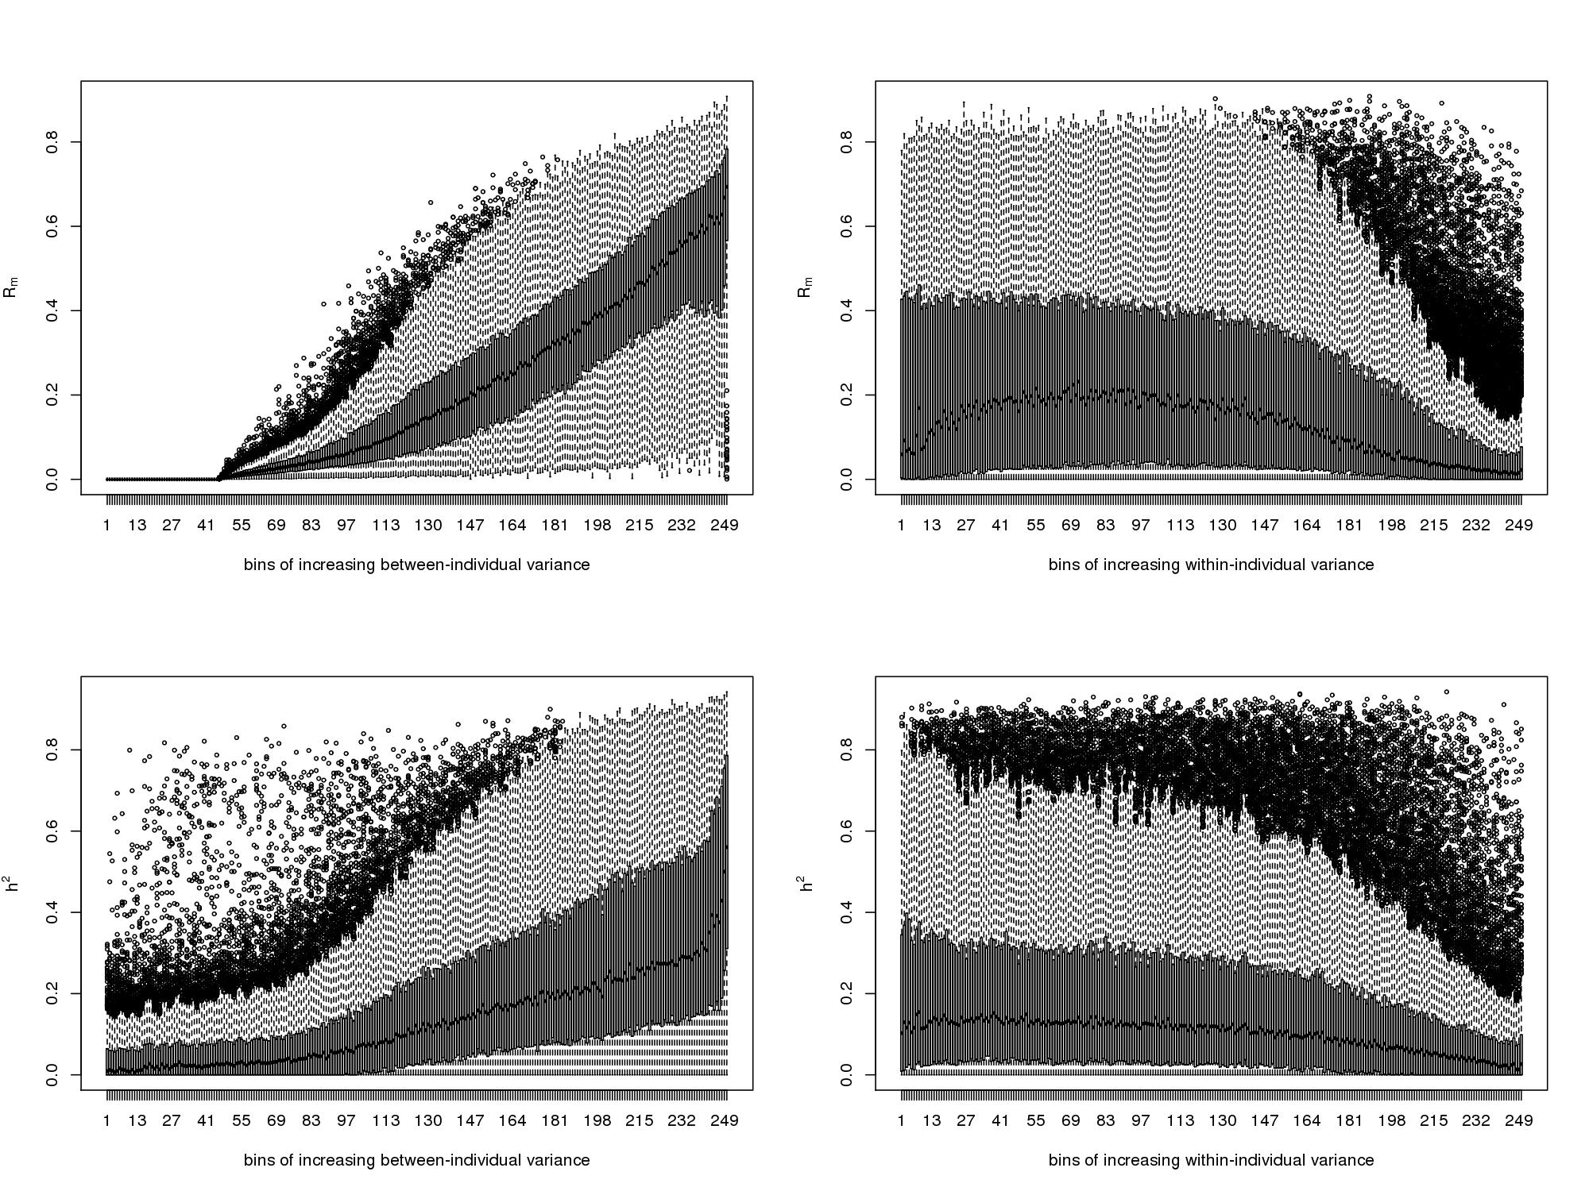

Figure S3. Distribution of R_{m} and h² by mean beta. (A) Distribution of R_{m} by bins of mean beta in LBC data. The first bin is the distribution for probes that were filtered out as all samples had beta-value ≤0.1 or all samples had beta-value ≥0.9 (14,930 probes). (B) Distribution of h² by bins of mean beta in BSGS data.
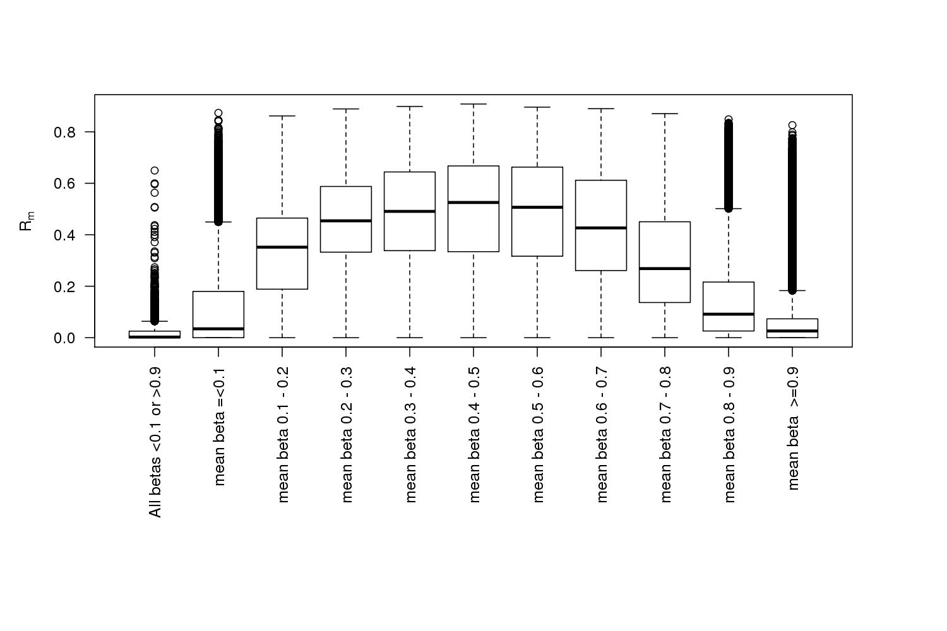
(A)

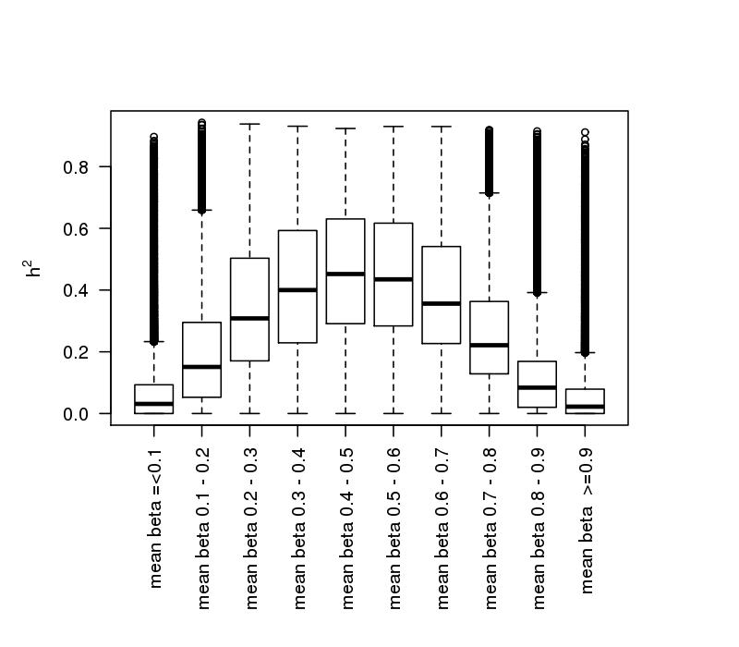
(B)

Figure S4. Distribution of Rm. Empirical distribution shown in white, null distribution derived from data permutation, shown in blue.

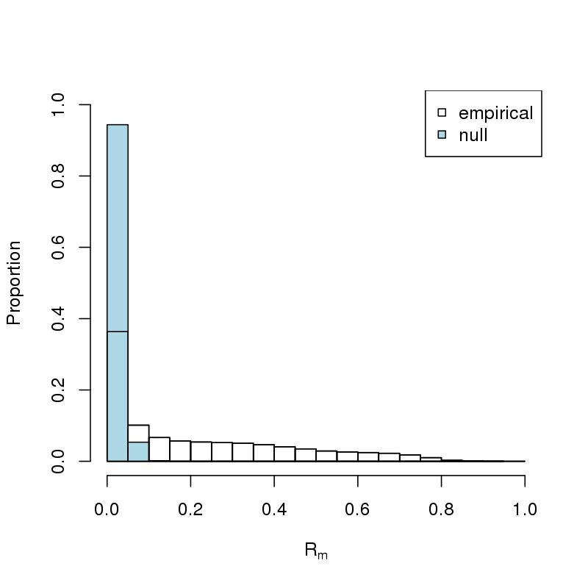

Figure S6 Distribution of R_{m} in 7 pairs of technical replicates from BSGS data. R_{m} was estimated after adjusting for array and position on the array using a generalised linear model with a logistic link function.

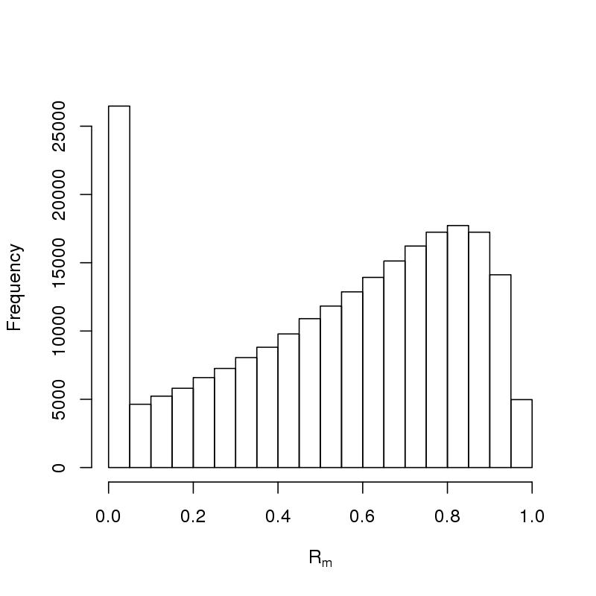

Figure S7. Correlation between R_{m} and h² in bins of mean beta-values
The relationship between R_{m} and h² in different bins of mean beta values in the BSGS data is shown below.

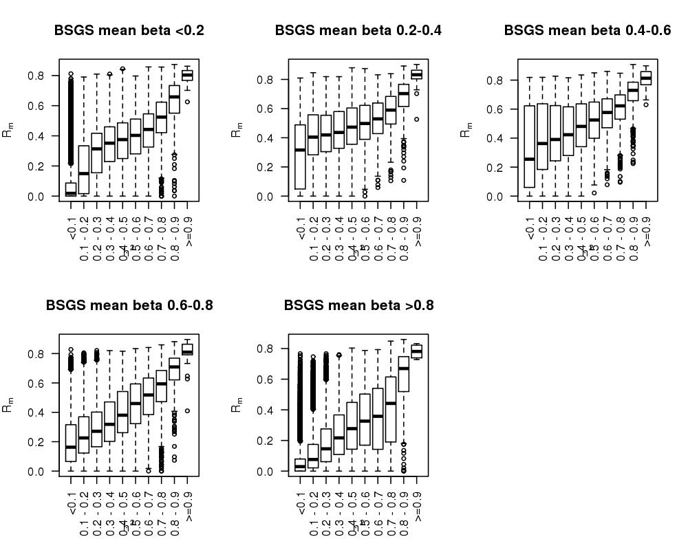

Figure S8. Distribution of R_{m} and h² for sex and smoking-associated CpG sites identified in LBC1936. (A) Correlation between R_{m} and h² for 305 CpG sites that were significantly associated with smoking status in LBC1936 was 0.53. (B) Correlation between R_{m} and h² for 3810 CpG sites that were significantly associated with smoking status in LBC1936 was 0.68.

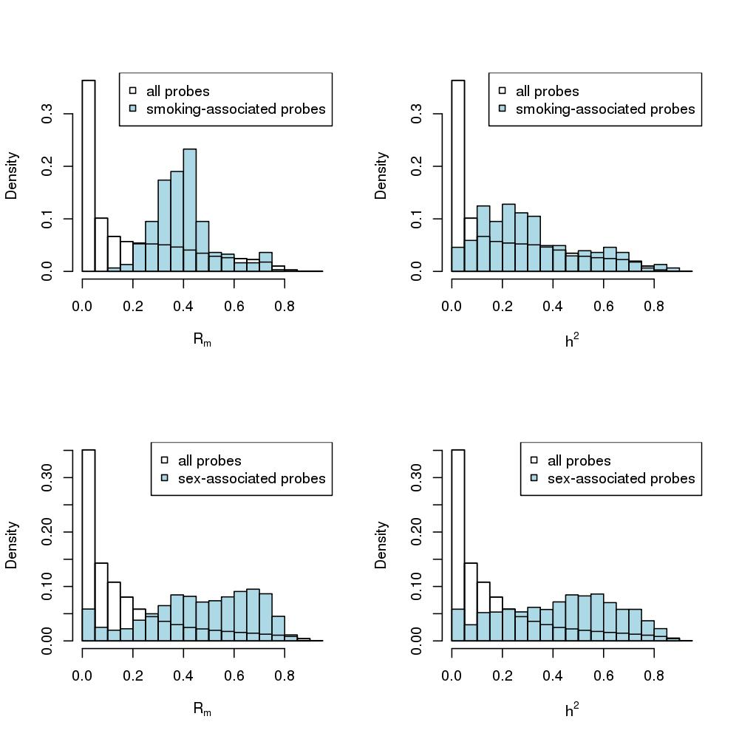
(A)

(B)

Figure S9. Inflation of R_{m} and h² due to probe overlap with SNPs and cross-hybridising potential. Distribution of R_{m} and h² is shown for different categories of probes: (A) CpG SNP probes which have a SNP at the target GpG site; (B) non-target CpG which have a SNP elsewhere in the probe; and (C) cross-hybridizing probes that have sequence similarity and therefore likely to hybridize to multiple regions in the genome.

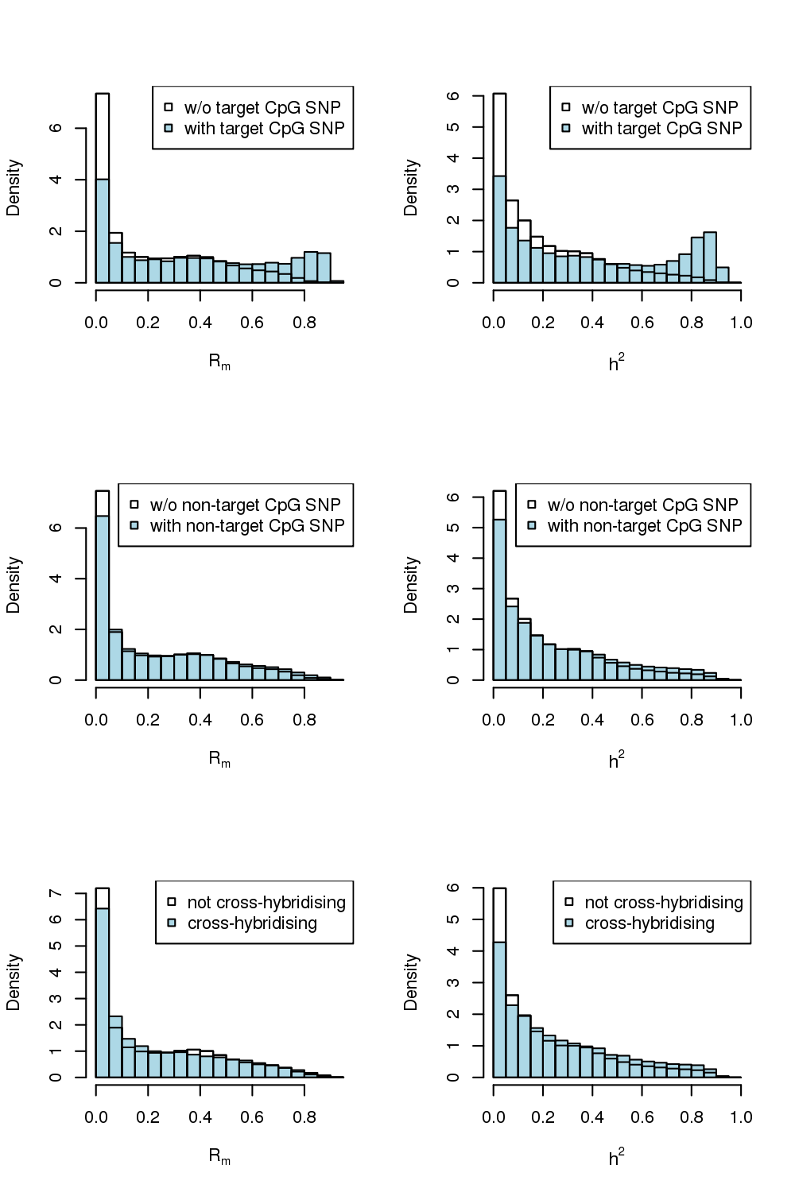

(A)

(B)

(C)

Table S1. SNP associations for top 10 CpG probes with highest R_{m} and h².

CpG Probe | CpG_chr | CpG_bp | R_{m} | h² | SNP | SNP_chr | SNP_bp | Cis/trans mQTL | R² | Association P-value
cg01903420 | 13 | 27295928 | 0.87 | 0.94 | rs1374010 | 13 | 27295317 | cis | 0.78 | 9.98E-93
cg07044115 | 10 | 123100181 | 0.87 | 0.93 | rs2420936 | 10 | 123208881 | cis | 0.81 | 3.47E-94
cg21950155 | 13 | 28555387 | 0.88 | 0.93 | rs4614573 | 13 | 28556252 | cis | 0.55 | 4.83E-65
cg26764761 | 16 | 87682142 | 0.89 | 0.93 | rs888647 | 16 | 87682804 | cis | 0.77 | 1.87E-96
cg07792871 | 6 | 29942706 | 0.90 | 0.92 | rs2523946 | 6 | 29941943 | cis | 0.82 | 1.57E-100
cg17052675 | 2 | 3827356 | 0.87 | 0.92 | rs13021385 | 2 | 3826387 | cis | 0.8 | 1.60E-93
cg21548813 | 6 | 291882 | 0.88 | 0.92 | rs11647994 | 16 | 35269324 | trans | 0.30 | 7.34E-35
cg24851651 | 11 | 66362959 | 0.9 | 0.92 | rs498045 | 11 | 66362997 | cis | 0.85 | 1.18E-101
cg21358336 | 17 | 6558440 | 0.88 | 0.92 | rs1443417 | 17 | 6493198 | cis | 0.52 | 3.14E-64
cg09812376 | 17 | 74270190 | 0.87 | 0.92 | rs71815 | 17 | 74270069 | cis | 0.72 | 3.62E-83

R² is the proportion of variance explained in the methylation signal by the associated SNP in BSGS data.

