Supplemental Materials for

The Landscape of Human STR Variation
Thomas Willems, Melissa Gymrek, Gareth Highnam,
David Mittelman, Yaniv Erlich

* To whom correspondence should be addressed (yaniv@wi.mit.edu)

This PDF file includes:
Supplemental Methods
Supplemental Tables 1-12
References
Supplemental Figures 1-4, 6-12

Supplemental Figure 5 is separately attached.

Supplemental Methods
Identifying STR loci in the human genome
Finding putative STR loci in the human genome
To identify putative STRs, we relied on the heuristic that these sequences should rarely occur in randomly generated sequences. To accomplish this aim, we determined the dinucleotide transition frequencies for each of the 22 autosomal chromosomes and 2 sex chromosomes. Then, for each chromosome, we used a second order Markov process to generate a random DNA sequence with the same length and transition frequencies. We repeated this process ten times for each chromosome. Next, Tandem Repeats Finder (TRF) (Benson 1999) was run on the random and real human chromosomes with a match weight of 2, a mismatch and indel penalty of 7, an 80% probability of matching and a 10% probability of an indel. In cases where TRF reported two overlapping STRs, we selected the locus with the highest score. For each chromosome, the repeats for periods 2-6bp were then analyzed separately to calculate the minimum TRF score where the number of repeats in the hg19 chromosomal sequence was at least 100 times greater than the mean number in the corresponding ten simulated chromosomes (Supplemental Figure 1a). These per-chromosome thresholds were combined into five genome-wide thresholds by taking the maximum threshold across all chromosomes (Supplemental Table 12). The identified repeats in hg19 were then filtered to only include those loci with a score above the threshold for its period. Finally, loci that originally overlapped other TRF results were removed, as these loci were generally very impure.

Comparison of STR thresholds to prior studies
For STRs without any indels or SNPs, our empirically determined TRF score cutoffs are equivalent to length thresholds of 11, 14, 14, 16 and 17 base pairs for STRs with 2-6 base pair motifs. A host of previous studies have attempted to determine length thresholds at which a repetitive locus can first be regarded as an STR. Fondon et al. examined WGS data from inbred Drosophila samples and quantified the proportion of variation at repetitive loci attributable to unit step changes. This study suggested that this form of variation, which is consistent with classical STR mutational models, begins to dominate when alleles are 13, 20, 23 and 27 base pairs in length for STR periods 2-5, cutoffs that are stricter than those that we determined. Another study by Kelkar et al. examined polymorphism levels and in-vitro polymerase slippage errors to determine a length threshold where slippage errors dominate. Both analyses suggested that 10 base pairs was the transition threshold for STRs with dinucleotide motifs, in good agreement with our 11 base pair threshold. Lai et al. utilized Markov and multi-type branching processes to match the distribution of repeats produced by a mutation model to those in the human genome, resulting in length thresholds of 8, 12, 16, 20 and 24 base pairs for STRs with 2-6 base pair motifs, respectively. Finally, Ananda et al. focused on uninterrupted STRs with motifs equal or smaller than 4bp. Their definition for an STR was loci with at least two consecutive repeat elements and that are shorter than ~10 repeat elements). In overall, previous thresholds are less conservative for low periods and more conservative for high periods, but agree qualitatively with our thresholds.

Repeat (bp) | Fondon | Kelkar | Lai |  | Ananda | This study
2 | 13 | 10 | 8 |  | 4 | 11
3 | 20 | - | 12 |  | 6 | 14
4 | 23 | - | 16 |  | 8 | 14
5 | 27 | - | 20 |  | - | 16
6 | - | - | 24 |  | - | 17

Incorporation of annotated STRs
To collate a set of annotated STR markers, we downloaded published PCR primers for the Marshfield markers from http://www.stanford.edu/group/rosenberglab/repeatsDownload.html (Pemberton et al. 2009.) We then utilized in silico PCR to determine the genomic coordinates of these primers. Locations for Y-STRs were obtained as described in our previous work (Gymrek et al. 2013) and locations for the CODIS markers were determined using PCR primers contained in the NIST database and the method outlined above. To integrate these markers into our reference set, we utilized BEDTools (Quinlan and Hall 2010) to remove any empirical loci that overlapped annotated loci. The remaining empirical loci combined with all annotated markers comprised our final STR reference.

Assessment of empirical score thresholds with a permissive call set
Having assembled a genome-wide STR reference, we sought to ensure that the chosen TRF score thresholds were appropriate. As dynamic expansions and contractions are hallmarks of STR loci, we examined the rates of polymorphism as a function of TRF score in a permissive call set generated using data from the 1000 Genomes.

To this end, we created a permissive reference by running TRF using relaxed parameters. In particular, we ran the program using a much lower score cutoff of 14 (instead of a score greater than equal to the empirical TRF thresholds) to identify a candidate set of STRs with repeat unit sizes of 2 to 5bp. The other parameters used to run TRF were match=2, indel=5, mismatch=5, match probability=80, indel probability=10, and minimum score=14. We removed STRs that localized to areas that might preclude unique mapping, such as large repeats or transposable elements. Transposons and other repetitive elements were identified using RepeatMasker and the TRF results in or within 20 bases of these regions were removed. We further removed any STRs that were located next to or within 20 bases of another STR. Finally, we pruned the list of STRs on the basis of empirically derived tract length thresholds and purity thresholds, developed in a previous study that characterized the minimum requirements of a sequence to mutate as an STR (Fondon JW et al., 2012), namely minimum tract lengths of 13, 20, 23, and 27bp for 2-5mers, respectively.

We then loaded this permissive reference to RepeatSeq and generated a preliminary STR call set using data from Phase 1 of the 1000 Genomes project.

Encouragingly, we found that loci around the cutoffs identified by running TRF on the random chromosomes were close to fixation. The mean heterozygosity rapidly increased shortly after the threshold (Supplemental Figure 1b). This phenomenon matches the hallmark of mature STRs that dynamically expand and contract.

We further quantified the number of polymorphic loci (heterozygosity > 2%) omitted and included by these score thresholds (Supplemental Table 1). These analyses revealed that less than 1% of loci omitted by the thresholds were polymorphic, while roughly 40% of included loci were polymorphic. In addition, our thresholds only omitted 1% of all polymorphic loci. Collectively, these analyses strongly suggest that our score thresholds are well calibrated and have a low false negative rate.

Call set integration
RepeatSeq (Highnam et al. 2012) and lobSTR (Gymrek et al. 2012) are currently the two primary tools utilized to genotype STRs in high-throughput sequencing data. As a result, to create the most accurate call set, we sought to assess their individual performance and potentially integrate their calls if it improved accuracy. lobSTR calls were generated as previously described (Methods) while RepeatSeq (available http://github.com/adaptivegenome/repeatseq) was run using default parameters on the read alignments produced by the 1000 Genomes project.

To assess call set performance, we utilized the Marshfield capillary electrophoresis (CE) genotypes generated for a subset of the 1000 Genomes samples (Rosenberg et al. 2005). The loci in this panel are highly polymorphic and provide a challenging test set to compare between lobSTR and RepeatSeq. We regressed the dosage produced by the method of interest (the sum of the predicted base pair differences from the reference allele) versus the dosage obtained from CE (Supplemental Figure 2A-B). Comparing the calls produced by the individual methods indicated that lobSTR outperformed RepeatSeq as the R² values were 0.71 and 0.4, respectively. While RepeatSeq produced more calls, they were in general strongly biased towards the reference allele genotype.

To integrate calls from RepeatSeq and lobSTR, we first had to combine the genotype likelihoods of lobSTR and RepeatSeq. While RepeatSeq reports $P\left(genotype | data\right),$ lobSTR reports $P (data|genotype)$. Therefore, we generated comparable posteriors for the lobSTR calls by using the population-wide occurrences of each STR allele in the lobSTR VCF “GT” field as a prior.

In total, we explored three different simplistic integration strategies. The first strategy selected the genotype with the highest posterior likelihood across both methods. This method assumes that the lobSTR and RepeatSeq posteriors are well calibrated and therefore defers to the method with the most confidence. We explored two variants of this strategy by considering a) only calls for which both methods produced genotypes and b) calls for which either method produced genotypes. The resulting R² values of 0.52 and 0.53 (Supplemental Figure 2C-D) indicated that the integrated calls outperformed those of RepeatSeq but were still inferior to those of lobSTR alone. The next integration strategy selected the genotype with the highest mean posterior. When we applied this strategy in combination with the two aforementioned variants, the R² values were nearly identical to those obtained by selecting the maximum posterior (Supplemental Figure 2E-F). Finally, we employed a simple strategy in which we only considered concordant calls. In addition to greatly limiting the number of calls, this strategy was surprisingly worse than the previous two integration strategies as it resulted in an of R² 0.46 (Supplemental Figure 2G).

In summary, despite various attempts to integrate RepeatSeq and lobSTR calls, our efforts were ultimately unsuccessful. Though the integrated calls were superior to those of RepeatSeq alone, they were ultimately inferior to lobSTR’s calls. The results of these efforts suggested that RepeatSeq calls had systematic biases and that these biases, when integrated with lobSTR calls, persisted. We therefore chose to proceed using only the lobSTR calls.

Homopolymer STRs
There is no consensus in the literature whether homopolymers are considered STRs or not (Ellegren 2004 vs. Payseur et al. 2010). Our original call set included homopolymer repeats. Similar to the other STR periods, we created a reference panel of homopolymers and genotyped them in all of the individuals. However, we found that the PCR stutter artifacts within the raw sequencing reads were too noisy to reliably recover STR alleles with such low sequencing coverage. For example, we examined the STR calls on the X chromosome of males. Ideally, we should observe only a single allele in this callset. However, we found that reads for homopolymer STRs have a ~20% chance of containing a stutter product rather than the original allele. This contrasts greatly with the estimated stutter rates for the other periods, which we estimated to be between ~2 and 4%. As a vast fraction of the calls use only 1 read, we were concerned about the quality of the data. In addition, mononucleotides showed low Mendelian inheritance patterns in the two trios (70% for homopolymers vs. >90% for other repeats). The low Mendelian inheritance for homopolymers never reached more than 85% even after analyzing STRs with more than 20 reads. Finally, there was no significant reduction in heterozygosity in exonic regions for homopolymer STRs. Based on these analyses, we decided to omit the homopolymer calls from out catalog.

Supplemental Tables

Supplemental Table 1. Polymorphism levels of loci omitted and included by TRF score cutoffs

 | Loci with score below threshold |  |  | Loci with score ≥ threshold
Period | Polymorphicª | Total | % Polymorphicª | Polymorphicª | Total | % Polymorphicª
2 | 227 | 40803 | 0.56% | 25431 | 47446 | 53.60%
3 | 28 | 4675 | 0.60% | 1178 | 7316 | 16.10%
4 | 17 | 9171 | 0.19% | 500 | 10500 | 4.76%
5 | 0 | 2237 | 0.00% | 81 | 2405 | 3.37%
All | 272 | 56886 | 0.48% | 27190 | 67667 | 40.18%
 | % Polymorphic Loci Removed |  | = 272/(272+27190) | = 0.99%
ª Loci were considered as polymorphic if their heterozygosity in the permissive call set was greater than 2%.

Supplemental Table 2. The distribution of STRs in the lobSTR reference

Period | Number of STRs
2 | 277822
3 | 77327
4 | 220859
5 | 72637
6 | 40867
Total | 689512

Supplemental Table 3. Population breakdown of genotyped samples

Population Abbreviation | Population Name | Continent | Super group | Number of Individuals
ASW | Americans of African Ancestry in SW USA | North America | African | 50
CEU | Utah Residents with Northern and Western European Ancestry | Europe | European | 74
CHB | Han Chinese in Beijing, China | Asia | East Asian | 82
CHS | Southern Han Chinese | Asia | East Asian | 98
CLM | Columbians from Medellin, Colombia | South America | Admixed American | 59
FIN | Finnish in Finland | Europe | European | 87
GBR | British in England and Scotland | Europe | European | 79
IBS | Iberian population in Spain | Europe | European | 16
JPT | Japanese in Tokyo, Japan | Asia | East Asian | 82
LWK | Luhya in Webuye, Kenya | Africa | African | 82
MXL | Mexican Ancestry from Los Angeles | North America | Admixed American | 58
PUR | Puerto Ricans from Puerto Rico | North America | Admixed American | 70
TSI | Toscani in Italia | Europe | European | 89
YRI | Yoruba in Ibadan, Nigeria | Africa | European | 83
Total |  |  |  | 1009

Supplemental Table 4. Marshfield concordance statistics

 | lobSTR A/A Call | lobSTR C/C Call | lobSTR A/B Call | lobSTR A/C Call | lobSTR C/D Call
Homozygous Marshfield  Sites (A/A) | 1465 (89.5%) | 119 (7.3%) | N/A | 52 (3.2%) | 1 (< .1%)
Heterozygous Marshfield  Sites (A/B) | 2681 (76.0%) | 290 (8.2%) | 452 (12.8%) | 95 (2.7%) | 9 (.3%)
Marshfield genotypes are always A/A or A/B.
lobSTR calls with C and/or D alleles indicate alleles that were not observed in the Marshfield genotype.
Supplemental Table 5. Y-STR PowerPlex concordance statistics

Locus | Correct Calls | Total Calls | % Correct
DYS481 | 14 | 19 | 73.68
DYS458 | 10 | 12 | 83.33
DYS533 | 60 | 66 | 90.91
DYS389I | 53 | 58 | 91.38
DYS392 | 36 | 39 | 92.31
DYS391 | 98 | 105 | 93.33
DYS456 | 47 | 50 | 94.00
DYS438 | 51 | 53 | 96.23
DYS393 | 57 | 59 | 96.61
DYS439 | 83 | 85 | 97.65
Y-GATA-H4 | 49 | 50 | 98.00
DYS549 | 66 | 67 | 98.51
DYS19 | 15 | 15 | 100.00
DYS437 | 14 | 14 | 100.00
DYS570 | 15 | 15 | 100.00
DYS576 | 26 | 26 | 100.00
DYS643 | 51 | 51 | 100.00
Total | 745 | 784 | 95.03

Supplemental Table 6. Comparing heterozygosities between populations.

 |  | Population B
 |  | CEU | FIN | GBR | TSI | ASW | LWK | YRI | CHB | CHS | JPT
Population A | CEU |  | 0.53 | 0.46 | 0.51 | 0.36 | 0.39 | 0.4 | 0.55 | 0.55 | 0.53
Population A | FIN | 0.47 |  | 0.43 | 0.48 | 0.35 | 0.38 | 0.38 | 0.53 | 0.53 | 0.5
Population A | GBR | 0.54 | 0.57 |  | 0.55 | 0.38 | 0.41 | 0.41 | 0.57 | 0.57 | 0.55
Population A | TSI | 0.49 | 0.52 | 0.45 |  | 0.36 | 0.39 | 0.39 | 0.54 | 0.54 | 0.52
Population A | ASW | 0.64 | 0.65 | 0.62 | 0.64 |  | 0.53 | 0.54 | 0.68 | 0.67 | 0.66
Population A | LWK | 0.61 | 0.62 | 0.59 | 0.61 | 0.47 |  | 0.51 | 0.65 | 0.64 | 0.63
Population A | YRI | 0.6 | 0.62 | 0.59 | 0.61 | 0.46 | 0.49 |  | 0.64 | 0.64 | 0.62
Population A | CHB | 0.45 | 0.47 | 0.43 | 0.46 | 0.32 | 0.35 | 0.36 |  | 0.5 | 0.46
Population A | CHS | 0.45 | 0.47 | 0.43 | 0.46 | 0.33 | 0.36 | 0.36 | 0.5 |  | 0.46
Population A | JPT | 0.47 | 0.5 | 0.45 | 0.48 | 0.34 | 0.37 | 0.38 | 0.54 | 0.54
Only the 10% most variable STRs were used. Each cell represents the fraction of loci for which population “A” had higher heterozygosity than population “B”.

Supplemental Table 7. Comparison of heterozygosity in noncoding and coding STRs

 | Mean Heterozygosity |  | Median Heterozygosity
Period | Non-coding | Coding | Non-coding | Coding | p-value | Adj. p-value
2 | 0.274 | 0.033 | 0.102 | 0.005 | 5.78E-38 | 1.74E-37
3 | 0.129 | 0.065 | 0.029 | 0.023 | 2.01E-46 | 1.21E-45
4 | 0.109 | 0.027 | 0.018 | 0.007 | 1.07E-09 | 1.60E-09
5 | 0.083 | 0.023 | 0.016 | 0.011 | 1.76E-03 | 2.11E-03
6 | 0.050 | 0.044 | 0.014 | 0.014 | 5.37E-02 | 5.37E-02

Supplemental Table 8 Allele frequency distributions for STR type subsets

Period | Number of  Loci | Length  Percentile (%) | Major Allele Length (bp)ª | Major Allele Frequency^{a,b} | MAF^{a,b,c}
2 | 253,809 | 0-25 | 12 | 97.95 | 1.17
2 | 253,809 | 25-50 | 16 | 96.44 | 2.17
2 | 253,809 | 50-75 | 25 | 88.64 | 7.02
2 | 253,809 | 75-100 | 38 | 53.52 | 16.03
3 | 71,582 | 0-25 | 15 | 98.85 | 0.51
3 | 71,582 | 25-50 | 18 | 98.67 | 0.67
3 | 71,582 | 50-75 | 22 | 98.28 | 0.94
3 | 71,582 | 75-100 | 32 | 95.64 | 2.68
4 | 195,264 | 0-25 | 14 | 99.34 | 0.27
4 | 195,264 | 25-50 | 18 | 99.24 | 0.31
4 | 195,264 | 50-75 | 23 | 98.96 | 0.49
4 | 195,264 | 75-100 | 35 | 95.72 | 2.73
5 | 64,320 | 0-25 | 17 | 99.33 | 0.27
5 | 64,320 | 25-50 | 20 | 99.25 | 0.30
5 | 64,320 | 50-75 | 24 | 99.16 | 0.36
5 | 64,320 | 75-100 | 34 | 98.60 | 0.75
6 | 30,063 | 0-25 | 17 | 99.30 | 0.28
6 | 30,063 | 25-50 | 21 | 99.31 | 0.28
6 | 30,063 | 50-75 | 23 | 99.30 | 0.29
6 | 30,063 | 75-100 | 32 | 99.24 | 0.36
ª The reported number is the median of all values within the length percentile bin.
^{b} Frequencies are given as percentages.
^{c} The frequency of the second most common STR allele.

Noncoding
Period | # | Min | Max | Mean | Median | Std
2 | 150786 | 0.000000 | 0.939653 | 0.047530 | 0.021502 | 0.065271
3 | 23800 | 0.000000 | 0.598273 | 0.049597 | 0.024203 | 0.064943
4 | 52990 | 0.000000 | 1.000000 | 0.059448 | 0.033743 | 0.071685
5 | 14051 | 0.000000 | 0.613375 | 0.057568 | 0.031983 | 0.070669
6 | 4388 | 0.000000 | 0.515795 | 0.044278 | 0.018717 | 0.061992
Coding
Period | # | Min | Max | Mean | Median | Std
2 | 159 | 0.000018 | 0.302767 | 0.036621 | 0.015788 | 0.054031
3 | 578 | 0.000008 | 0.329417 | 0.021228 | 0.005491 | 0.040571
4 | 43 | 0.000365 | 0.252399 | 0.064270 | 0.035360 | 0.069031
5 | 25 | 0.000424 | 0.306770 | 0.063047 | 0.046122 | 0.079567
6 | 47 | 0.000239 | 0.198657 | 0.043442 | 0.014114 | 0.055508
Supplemental Table 9. Rst levels between Africans, Asians, and Europeans

Supplemental Table 10. Coding STRs with non-reference major alleles
chrom | hg19 STR Start | hg19 STR Stop | Canonical Motif | Exon Start(s) | Exon Stop(s) | HGNC | WT  Allele Difference(bp) | WT Allele Freq(%) | Reference Allele Freq (%)
1 | 26608815 | 26608908 | ACCGGG | 26608789 | 26609060 | UBXN11 | -24 | 60.1 | 1.0
1 | 31905890 | 31905904 | AGC | 31905813 | 31906032 | SERINC2 | 3 | 75.0 | 24.3
1 | 209605637 | 209605676 | AGC | 209605548 | 209605694 | MIR205HG | -12 | 65.3 | 15.2
1 | 240255569 | 240255585 | CCG | 240255409 | 240257024 | FMN2 | -3 | 71.6 | 26.8
2 | 73613032 | 73613081 | AGG | 73612996 | 73613320 | ALMS1 | -6 | 51.0 | 8.3
2 | 88926730 | 88926754 | AGC | 88926484 | 88926792 | EIF2AK3 | -3 | 75.4 | 21.8
2 | 96780975 | 96780994 | AGG | 96780544 | 96781888 | ADRA2B | 9 | 66.0 | 32.5
2 | 241696826 | 241696873 | AGG | 241696735 | 241697011 | KIF1A | -3 | 68.1 | 23.0
3 | 42251578 | 42251609 | AGG | 42251258 | 42251749 | TRAK1 | 3 | 30.1 | 23.3
3 | 46751074 | 46751100 | AAG | 46751068 | 46751178 | TMIE | -3 | 73.1 | 23.9
3 | 49395674 | 49395693 | CCG | 49395459,  49395410 | 49395711,  49395710 | GPX1 | -6 | 60.6 | 12.2
3 | 113376105 | 113376147 | AGC | 113373790 | 113380272 | KIAA2018 | -3 | 35.8 | 9.1
3 | 183493744 | 183493772 | AGG | 183493702 | 183493911 | YEATS2 | -3 | 51.4 | 44.0
3 | 184429134 | 184429154 | AGG | 184428685 | 184429609 | MAGEF1 | 3 | 53.0 | 43.4
4 | 140651585 | 140651612 | AGC | 140651569 | 140651821 | MAML3 | -3 | 90.0 | 4.5
4 | 155244402 | 155244432 | AAAC | 155244389 | 155244481 | DCHS2 | -4 | 77.4 | 21.4
5 | 56177849 | 56177874 | AAC | 56177396 | 56178693 | MAP3K1 | -3 | 68.7 | 29.3
6 | 32191659 | 32191690 | AGC | 32191632 | 32191705 | NOTCH4 | -3 | 43.3 | 29.5
6 | 161519351 | 161519390 | AGC | 161519309 | 161519459 | MAP3K4 | -3 | 66.0 | 2.7
7 | 15725789 | 15725826 | ACC | 15725510 | 15726027 | MEOX2 | -3 | 66.4 | 23.1
8 | 11666214 | 11666257 | ACTCCC | 11666026 | 11666400 | FDFT1 | -6 | 92.7 | 1.9
8 | 144511954 | 144511983 | ACC | 144511514 | 144512576 | MAFA | -3 | 83.6 | 3.8
9 | 95237025 | 95237068 | ATC | 95236905 | 95237179 | ASPN | -3 | 42.2 | 15.4
10 | 21805467 | 21805518 | AGG | 21804024 | 21806751 | SKIDA1 | 6 | 50.6 | 40.4
12 | 6777065 | 6777113 | AGC | 6776879 | 6777281 | ZNF384 | -3 | 57.5 | 24.0
12 | 14720550 | 14720576 | AGC | 14720515 | 14720630 | PLBD1 | -3 | 66.3 | 32.8
12 | 76424917 | 76424968 | AGC | 76424315 | 76425521 | PHLDA1 | -3 | 95.6 | 0.0
12 | 122359386 | 122359417 | AGG | 122359211 | 122359589 | WDR66 | 15 | 79.5 | 20.0
12 | 124887059 | 124887110 | AGC | 124886949 | 124887107 | NCOR2 | 3 | 41.3 | 31.3
14 | 23744797 | 23744825 | ATC | 23744783 | 23746396 | HOMEZ | -3 | 50.6 | 43.3
14 | 23744827 | 23744852 | AGG | 23744783 | 23746396 | HOMEZ | -3 | 50.2 | 44.7
14 | 93154538 | 93154554 | CCG | 93154270 | 93154597 | RIN3 | -3 | 75.4 | 23.3
14 | 105996050 | 105996069 | CCG | 105995171 | 105996131 | TMEM121 | -3 | 50.2 | 49.0
15 | 78913058 | 78913089 | AGC | 78913054 | 78913136 | CHRNA3 | -3 | 75.2 | 22.4
17 | 6928020 | 6928049 | AGC | 6927719 | 6928082 | BCL6B | 3 | 58.5 | 34.9
17 | 7750167 | 7750216 | ACC | 7750136 | 7750334 | KDM6B | 6 | 51.5 | 2.4
17 | 17039562 | 17039596 | AGC | 17039532 | 17039764 | MPRIP | -3 | 66.2 | 15.6
17 | 17697094 | 17697134 | AGC | 17696262 | 17701827 | RAI1 | -3 | 60.8 | 18.5
18 | 48723138 | 48723163 | CCG | 48722936 | 48723690 | MEX3C | -9 | 61.2 | 37.3
18 | 72223582 | 72223608 | AGC | 72223572 | 72223701 | CNDP1 | 3 | 49.6 | 47.2
19 | 11558341 | 11558405 | AGG | 11558253 | 11558433,  11558412 | PRKCSH | -3 | 43.5 | 38.2
19 | 17397457 | 17397522 | AC | 17397188 | 17397524 | ANKLE1 | -14 | 26.4 | 7.9
19 | 56599438 | 56599454 | ACG | 56599388 | 56600461 | ZNF787 | -3 | 91.7 | 8.3
20 | 278688 | 278703 | CCG | 278227 | 279442 | ZCCHC3 | -3 | 90.4 | 9.2
20 | 44520238 | 44520263 | AGC | 44520207 | 44520401 | CTSA | -3 | 68.3 | 26.3
X | 57618726 | 57618749 | CCG | 57618481 | 57620893 | ZXDB | -12 | 60.5 | 38.6
X | 119387834 | 119387853 | ATC | 119387270 | 119389289 | ZBTB33 | 3 | 51.9 | 45.9
X | 120009227 | 120009252 | AGG | 120008749 | 120009524 | CT47B1 | -3 | 53.5 | 45.5
Frame-shifted alleles are in bold.

Supplemental Table 11 Common LoF alleles

chr | STR  start | STR  stop | bp from hg19 | Motif | # Samples | Exon Start | Exon Stop | Gene
4 | 155244402 | 155244432 | -4 | AAAC | 395 | 155244389 | 155244481 | DCHS2
9 | 35561913 | 35561938 | -8 | ACCC | 22 | 35561864 | 35562092 | FAM166B
10 | 81841429 | 81841443 | -4 | AAAG | 25 | 81841395 | 81841490 | TMEM254
10 | 81841429 | 81841443 | 1 | AAAG | 111 | 81841395 | 81841490 | TMEM254
10 | 81841429 | 81841443 | 2 | AAAG | 31 | 81841395 | 81841490 | TMEM254
19 | 55526092 | 55526121 | 4 | ACAG | 82 | 55525449 | 55526533 | GP6
20 | 48467310 | 48467334 | -1 | AC | 94 | 48467298 | 48467381 | SLC9A8

Supplemental Table 12. TRF score cutoffs

Period | Score Cutoff
2 | 22
3 | 28
4 | 28
5 | 32
6 | 34

Supplemental References
Ananda G, Walsh E, Jacob KD, Krasilnikova M, Eckert KA, Chiaromonte F, Makova KD. 2013. Distinct mutational behaviors differentiate short tandem repeats from microsatellites in the human genome. Genome biology and evolution 5(3): 606-620.

Benson G. Tandem repeats finder: a program to analyze DNA sequences. 1999. Nucleic Acids Res 27: 573-580.

Ellegren H. 2004. Microsatellites: simple sequences with complex evolution. Nature reviews genetics 5(6): 435-445.

Fondon JW, 3rd, Martin A, Richards S, Gibbs RA, Mittelman D. 2012. Analysis of microsatellite variation in Drosophila melanogaster with population-scale genome sequencing. PLoS One 7(3): e33036.

Gymrek M, Golan D, Rosset S, Erlich Y. 2012. lobSTR: A short tandem repeat profiler for personal genomes. Genome Res 22: 1154-1162.

Gymrek M, McGuire AL, Golan D, Halperin E, Erlich Y. 2013. Identifying personal genomes by surname inference. Science 339: 321-324.

Highnam G, Franck C, Martin A, Stephens C, Puthige A, Mittelman D. 2012. Accurate human microsatellite genotypes from high-throughput resequencing data using informed error profiles. Nucleic Acids Res 41: e32. doi:10.1093/nar/gks981.

Kelkar YD, Strubczewski N, Hile SE, Chiaromonte F, Eckert KA, Makova KD. 2010. What is a microsatellite: a computational and experimental definition based upon repeat mutational behavior at A/T and GT/AC repeats. Genome biology and evolution 2: 620-635.

Lai Y, Sun F. 2003. The relationship between microsatellite slippage mutation rate and the number of repeat units. Molecular biology and evolution 20(12): 2123-2131.

Payseur BA, Jing P, Haasl RJ. 2011. A genomic portrait of human microsatellite variation. Molecular biology and evolution 28(1): 303-312.

Pemberton TJ, Sandefur CI, Jakobsson M, Rosenberg NA. 2009. Sequence determinants of human microsatellite variability. BMC Genomics 10: 612.

Quinlan AR, Hall IM. 2010. BEDTools: a flexible suite of utilities for comparing genomic features. Bioinformatics 26: 841-842.

Rosenberg NA, Mahajan S, Ramachandran S, Zhao C, Pritchard JP, Feldman MW. 2005. Clines, clusters, and the effect of study design on the inference of human population structure. PLoS Genet 1: e70. Doi: 10.1371/journal.pgen.0010070.

Supplemental Figures
Supplemental Figure 1
Supplemental Figure 1: Evidence-based criteria for STR loci. (A) The TRF score threshold for each chromosome and motif length. These thresholds were calculated based on an FDR of 1% using the second-order Markov chain simulations (blue: 2mer, green: 3mer, red: 4mer, cyan: 5mer, purple: 6mer). (B) Validating the thresholds with a preliminary call set. The plots show the average heterozygosity levels (y-axis) for STRs in the permissive catalog as a function of their TRF scores (x-axis). P denotes the motif length in bp. The red line shows the thresholds that were selected for the final definition based on the Markov chain simulations. The putative STRs around the thresholds are close to fixation and STRs with TRF score above the threshold show a rapid increase in their heterozygosity. This indicates that the thresholds are well calibrated and include most of the STRs that are subject to contractions and expansions.

Supplemental Figure 2
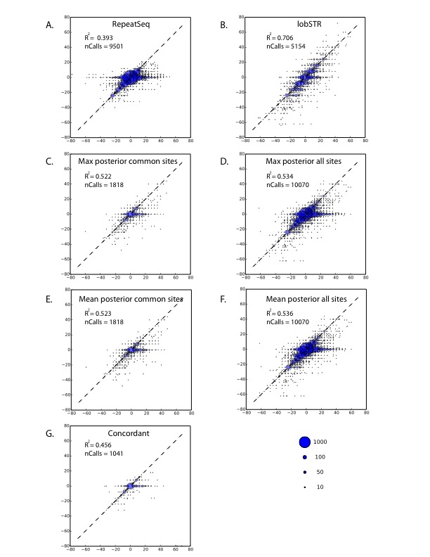
Supplemental Figure 2: Integration efforts for RepeatSeq and lobSTR. Each bubble plot shows the regression of the Marshfield capillary dosages (x-axis) with a different method to obtain STR calls from the 1000 Genomes (y-axis). The R² and number of calls (nCalls) are reported (A) RepeatSeq alone (B) lobSTR alone (C) RepeatSeq+lobSTR integration based on maximum posterior for sites that appeared in both datasets (D) RepeatSeq+lobSTR integration based on maximum posterior for sites that appeared in at least one dataset (E) RepeatSeq+lobSTR based on mean posterior for sites that appeared in both datasets (F) RepeatSeq+lobSTR based on mean posterior for sites that appeared in at least one dataset (G) RepeatSeq+lobSTR integration by reporting only genotypes concordant between the two methods. The best R² was obtained by lobSTR alone.
Supplemental Figure 3

Supplemental Figure 3: lobSTR dosage concordance with capillary electrophoresis for hemizygous Y-STRs. The dosage is reported as the base pair difference from the NCBI reference. The area of each bubble is proportional to the number of calls of the dosage combination and the broken line indicates the diagonal.

Supplemental Figure 4
Supplemental Figure 4: Influence of read depth on the accuracy of lobSTR genotypes for heterozygous sites in the Marshfield panel. The fraction of heterozygous individuals correctly genotyped increases monotonically with the minimum number of spanning reads.

Supplemental Figure 5
(see separate attachment)

Supplemental Figure 6
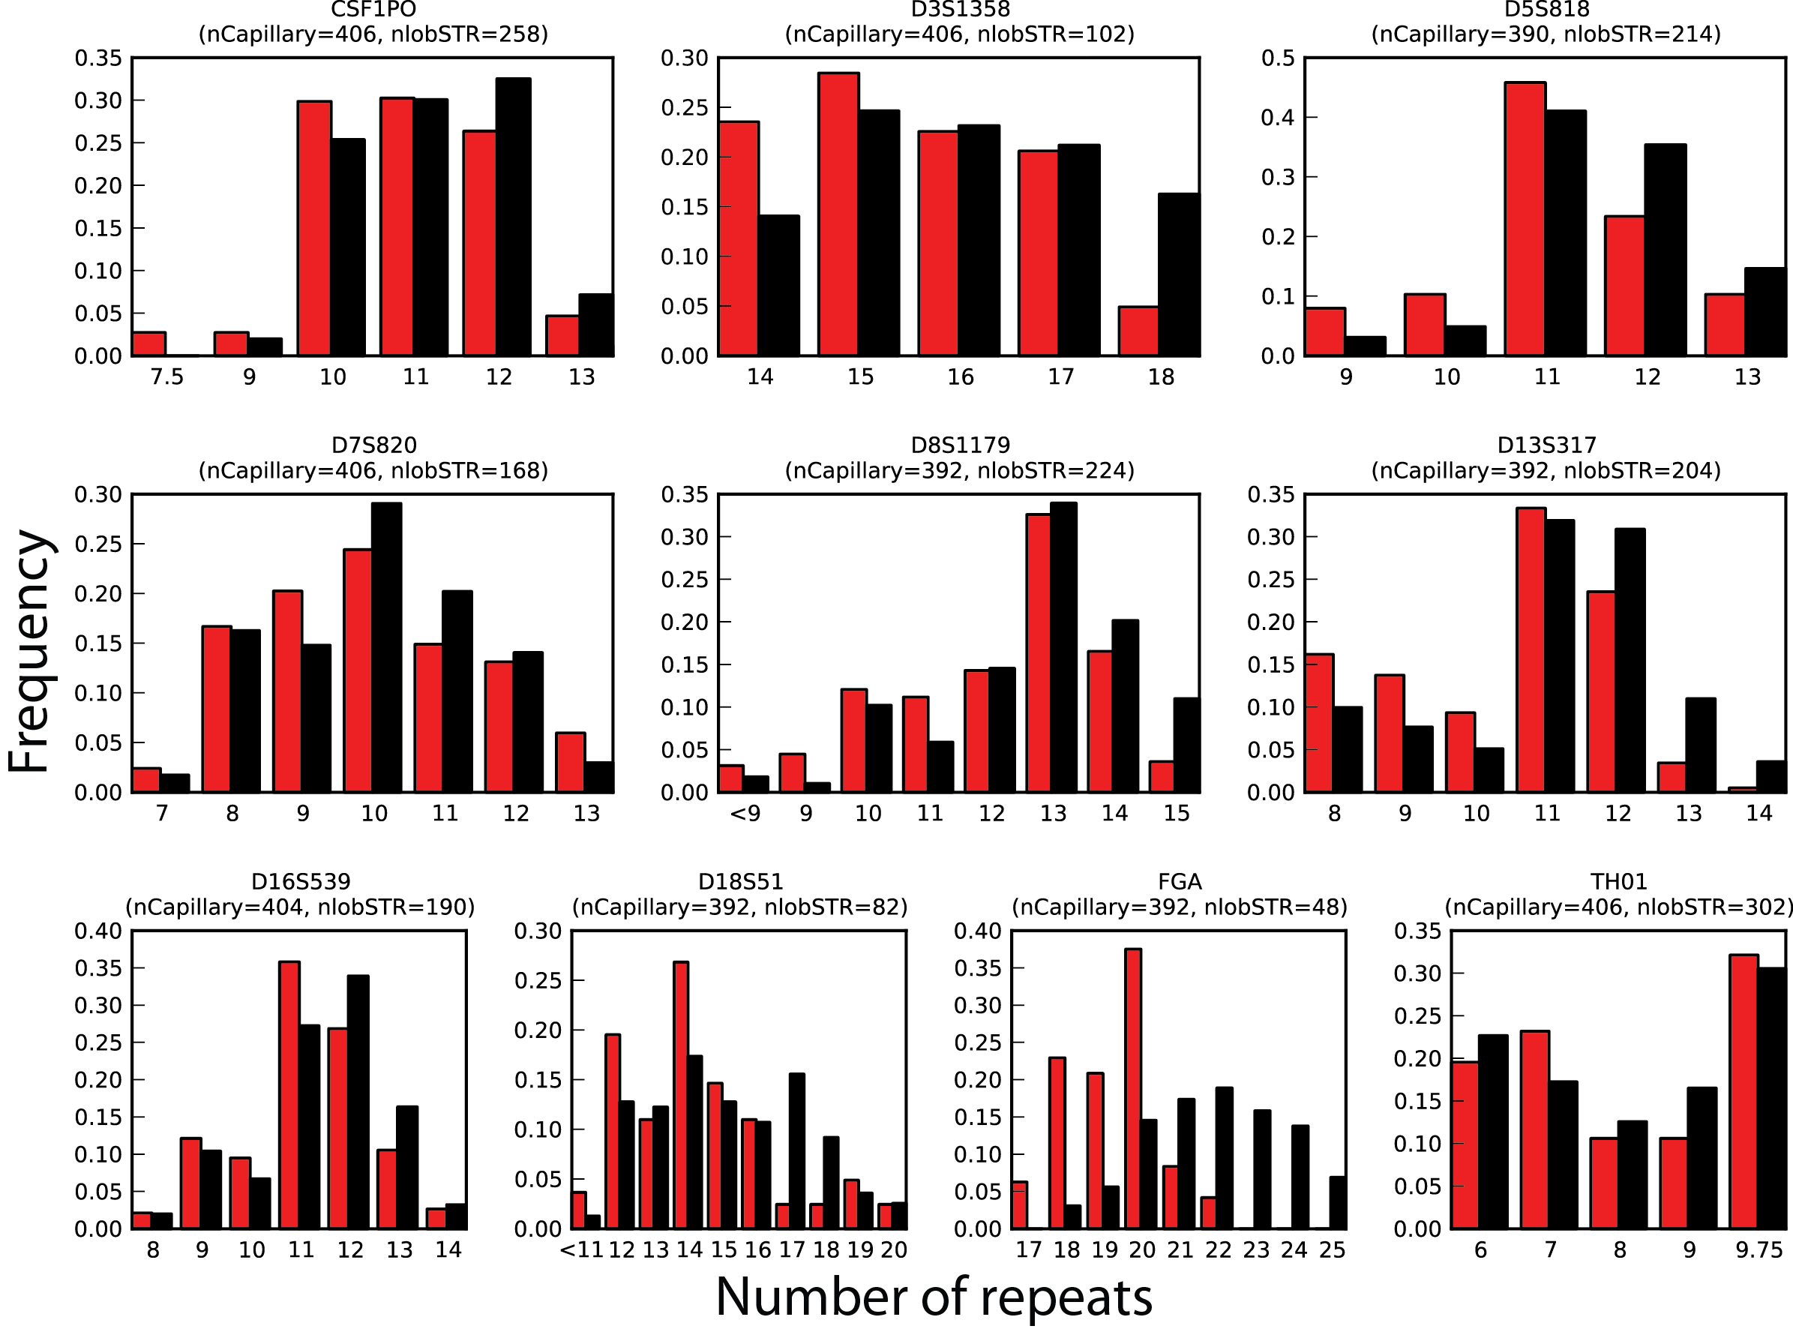
Supplemental Figure 6: Allelic spectra of the CODIS markers. Red: lobSTR, black: capillary electrophoresis. nlobSTR and nCapillary indicate the number of allele called in the respective call sets.

Supplemental Figure 7
Supplemental Figure 7: STR variability as a function of the length of the most common allele (base pairs). The mean heterozygosity of STRs increases monotonically with allele length for each of the five STR periods. Analysis was restricted to STRs whose most common allele matched the reference and with no indels or SNPs interrupting the STR motif (blue: 2mer, green: 3mer, red: 4mer, cyan: 5mer, purple: 6mer). The curves were smoothed by averaging the data points by a sliding window of ±2bp.

Supplemental Figure 8

Supplemental Figure 8: STR variability as a function of major allele allele length (bp) for impure STR loci. Analysis is stratified based on motif length (blue: 2mer, green: 3mer, red: 4mer, cyan: 5mer, purple: 6mer) and the purity of the STR (see methods) and is restricted to STRs whose major allele matches the reference. The curves were smoothed by averaging the data points by a sliding window of ±2bp.

Supplemental Figure 9
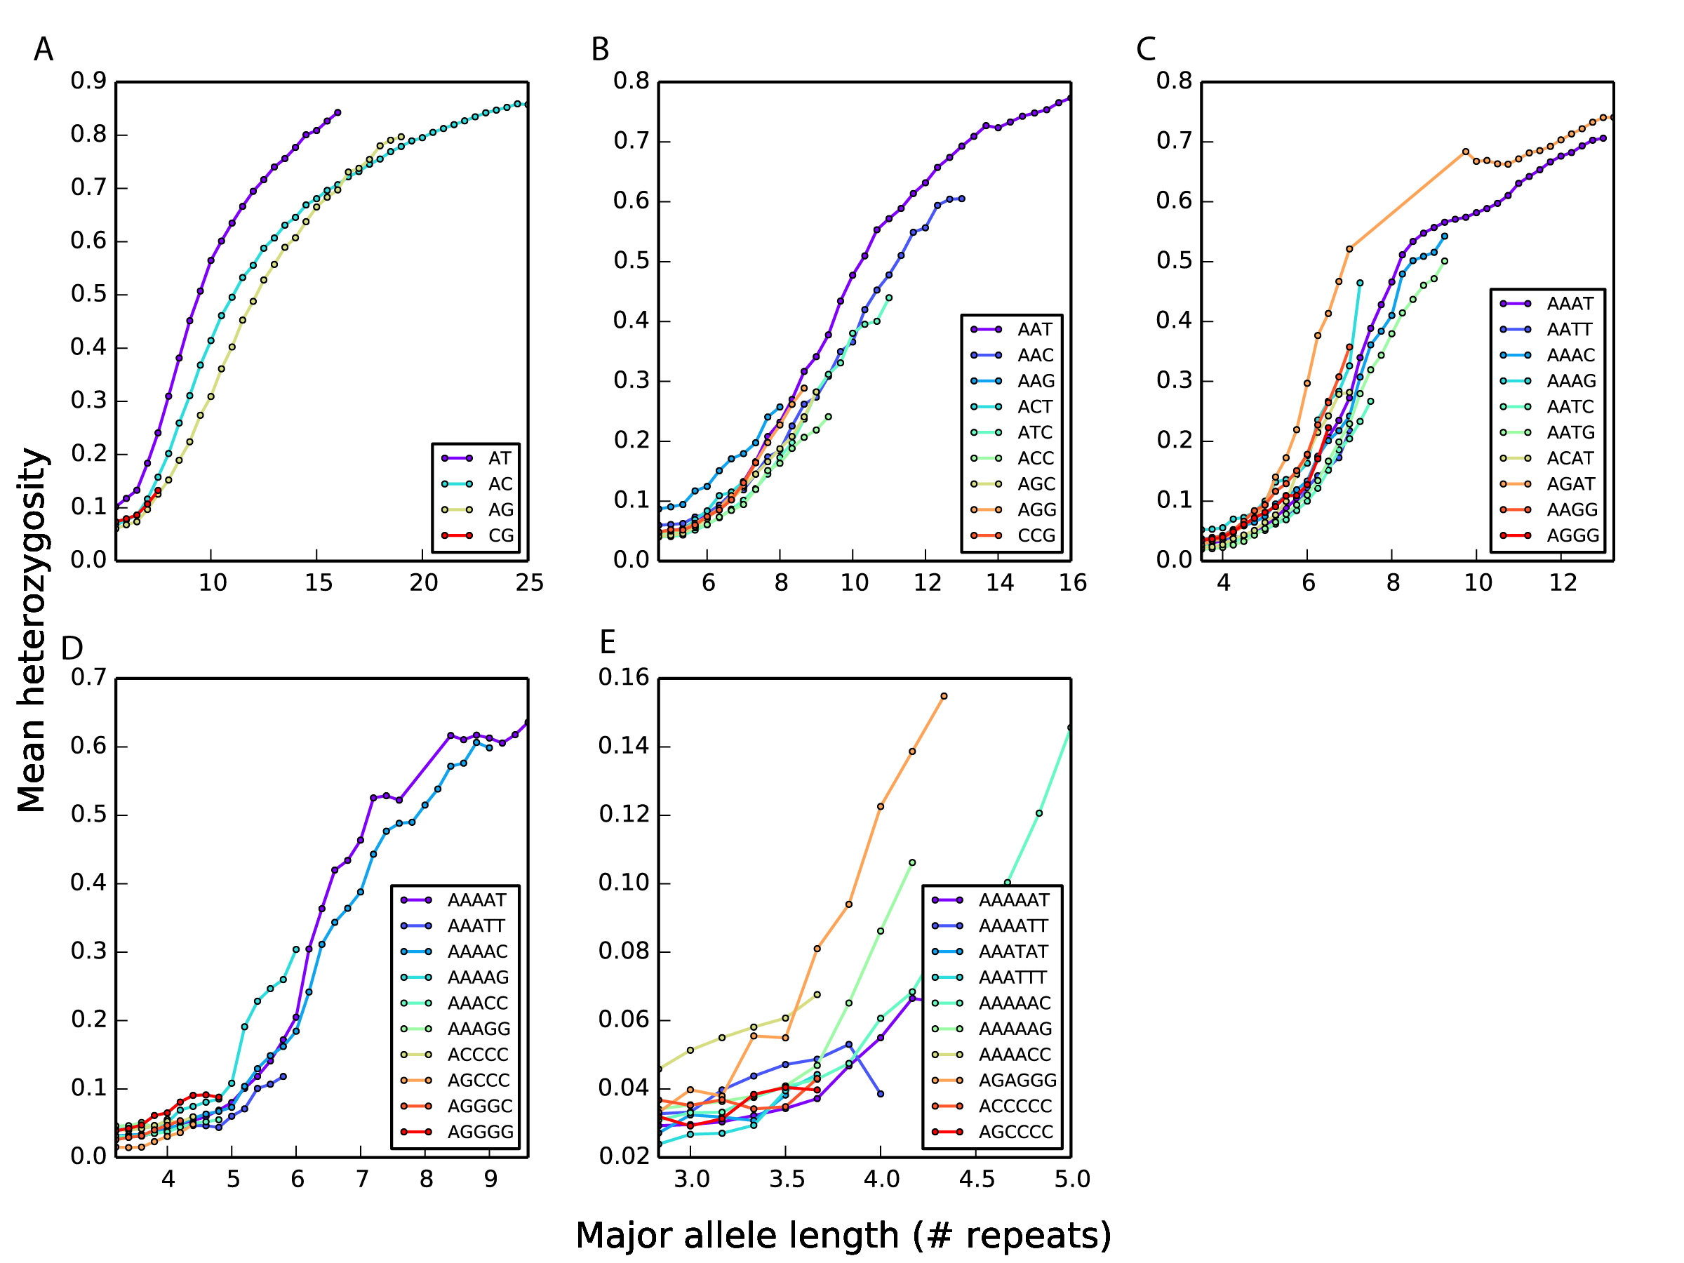

Supplemental Figure 9: STR variability as a function of length for (A) Dinucleotide, (B) Trinucleotide, (C) Tetranucleotide, (D) Pentanucleotide and (E) Hexanucleotide motifs. The motif sequences were converted to their canonical form, namely the sequence with the highest lexicographic order among all cyclic permutations of the STR motif from both strands (e.g. AATA repeat was converted to AAAT). For the same period, different motifs can have substantially different mean levels of variability. Analysis was restricted to STRs whose major allele matched the reference allele and to loci without any SNPs or indels that disrupted the motif sequence. The curves were smoothed by averaging the data points by a sliding window of ±2bp.

Supplemental Figure 10

Supplemental Figure 10: Patterns of STR variation (A) The cumulative distribution function of the number of alleles with MAF>5% stratified by motif length (blue: 2mer, green: 3mer, red: 4mer, cyan: 5mer, purple: 6mer) (B) The averaged allelic spectra of STRs. P denotes the motif length in bp. The 0 allele is the most common allele.
Supplemental Figure 11
Supplemental Figure 11: STR-SNP linkage disequilibrium on chromosome X stratified by motif length. P denotes the motif length in bp. Africans (red), Admixed Americans (green), Europeans (yellow) and East Asians (blue). Longer repeat motifs show an increase in the level of STR-SNP LD.

Supplemental Figure 12
Supplemental Figure 12: Linkage disequilibrium for SNPs and STRs on the X chromosome after STR allele binarization. Patterns of STR-SNP LD are invariant to STR allele binarization. As in the non-binarized case, SNP-SNP LD (dashed lines) generally exceeds SNP-STR LD (solid lines) across a range of distances and for Africans (red), Admixed Americans (green), Europeans (yellow) and East Asians (blue). Binarization was performed by mapping the most common STR allele and all alternate alleles to 0 and 1, respectively.

