Figure S1. The average density of SMART-seq reads across the entire length the transcripts.
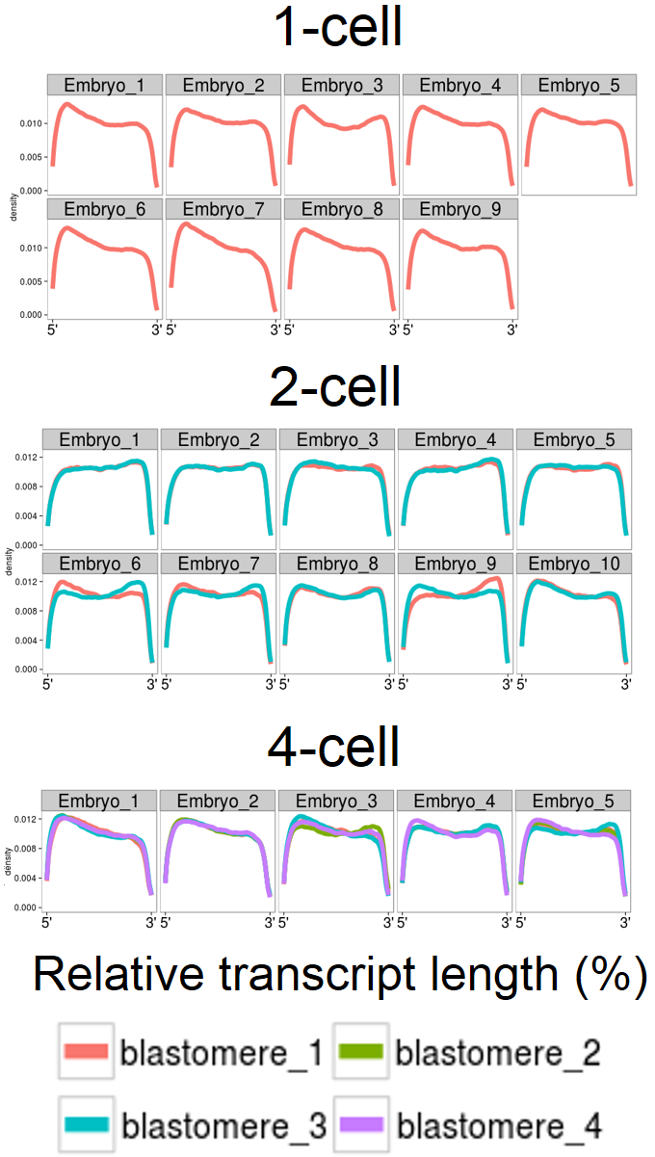
Figure S2. The RNA-seq data of Pou5f1 visualized in single-cell genome browser (http://singlecell.cepbrowser.org).
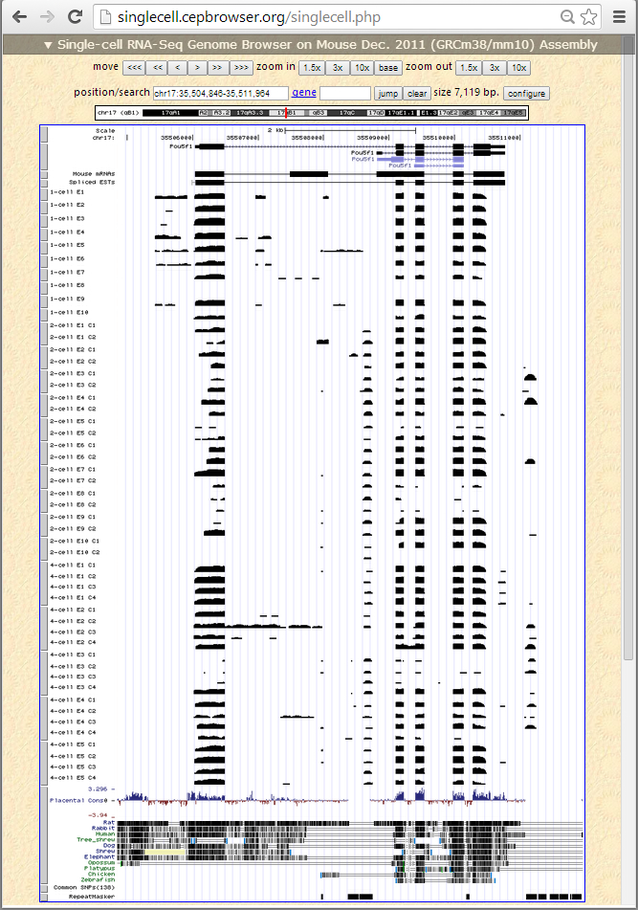
Figure S3. Clustering of single cells. Various CV cutoffs (1st column) were applied to select genes (2nd column). The selected genes are the dots above the line (representing CV) in the scatterplots (3rd column) of standard deviation (y-axis) vs. mean expression level (x-axis). The resulting clustering dendrogram of cells using the selected genes (4th column) shows progressive separation of sister blastomeres as the CV increases. Ei-Bj: blastomere j of embryo i.
Figure S4. GADD45A protein expression in eight 4-cell mouse embryos. For each embryo (row), the confocal images were captured from the same z stack from an immunocytochemistry assay of GADD45A (alexa-548, red) and alpha-tubulin (TUBA1A, alexa-488, green). Arrowheads point to the blastomeres that were derived from same mother cell. The focal planes were chosen to allow the visualization of the center of the embryo, in addition to the remainder structure of spindle apparatuses. DNA: DAPI fluorescence. DIC: Differential interference contrast image. Scale bar: 50μm.
6
8
1
7
3
2
5
4
Figure S5. Coverage plots of single-cell RNA-seq reads. Each row represents a cell. The gene models are at the bottom of the plots. (A) Zfp688, a candidate bimodality gene due to ZGA. (B) Rsph3a, a candidate bimodality gene due to blastomere-specific RNA depletion.

Figure S6. Bootstrap analysis of co-expression networks. After removing between-embryo variations, we generated 385 bootstrap datasets by resampling 6, 7, 8 or 9 embryos from the 2-cell embryos (A), and 15 datasets by resampling 3 or 4 embryos from the 4-cell embryos (B). The gene pairs within the top 10% highest correlations in 80% or more bootstrap datasets were retained, and then intersected with BioGRID documented protein-protein or regulatory interactions⁴. These intersected interactions are denoted as an edge, besides which is the number of times that this pair ranked in the top 10% by correlation in the bootstrap datasets.

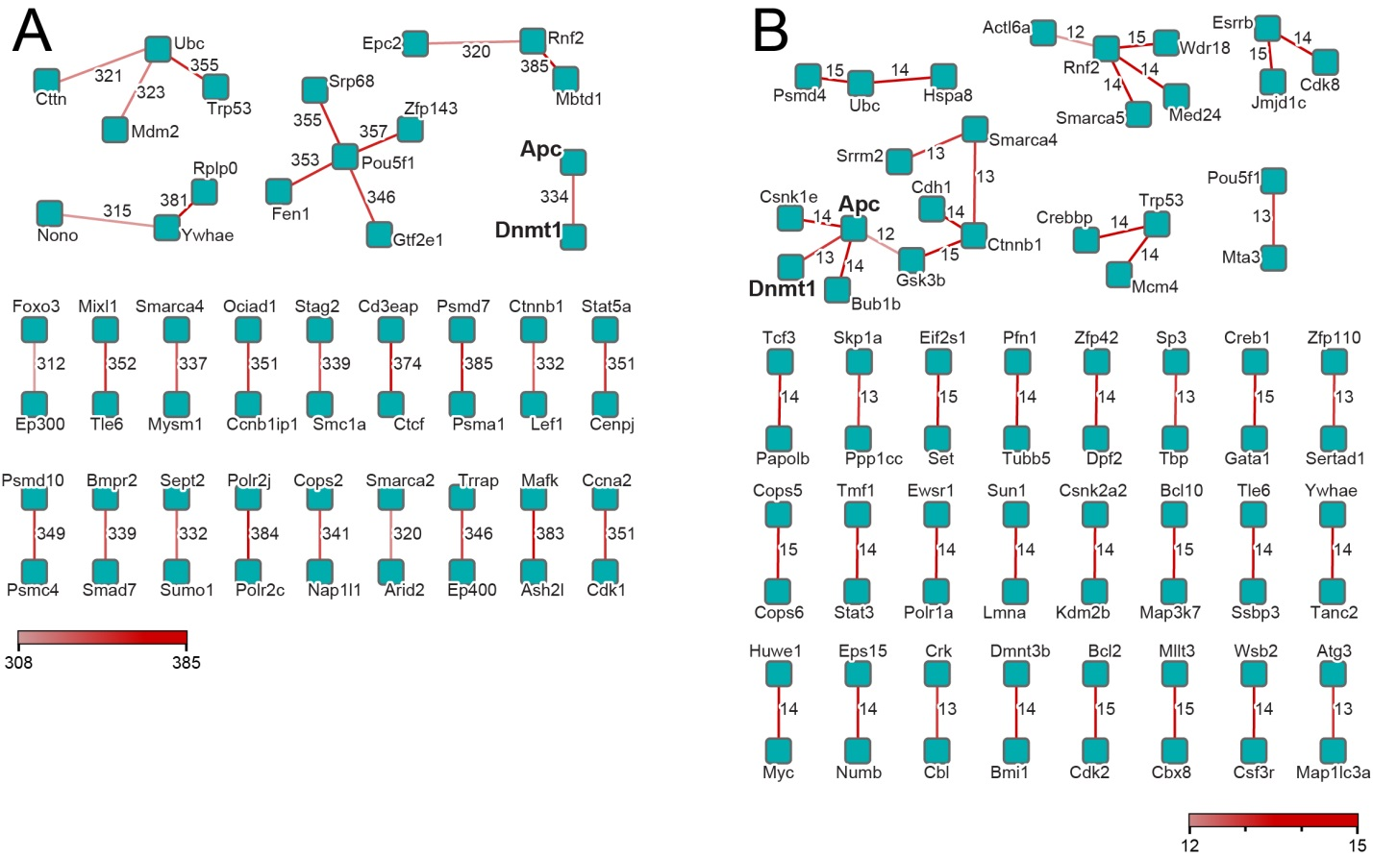
Figure S7. The genes with large total cell-to-cell variations are enriched with the genes showing bimodal expression patterns within each embryo. All detected genes are plotted with their standard deviations (y-axis) and mean expression levels (x-axis). The genes that exhibited within-embryo bimodal expression patterns are plotted in red (FDR < 0.05), black (0.05 ≤ FDR < 0.1), and dark blue (0.1 ≤ FDR < 0.3).

Figure S8. Quantitative real time PCR of 96 genes during fist two cleavages of mouse embryo development. (A) Expression data of 96 genes in zygotes, 2- and 4-cell mouse embryos. (B) Average gene expression (log₂ space) estimated by RNA-seq and qPCR (error bars: standard error, 2-cell N=90 genes, 4-cell N=78 genes). (C) Coefficient of variation estimated from data collected by RNA-seq and qPCR methods.
Table S1. Results of Dip test of deviation of unimodal distribution for inter-blastomere gene expression at 2-cell stage (FDR < 0.30).
Gene ID | Symbol | Dip statistic | p value | FDR
ENSMUSG00000001419 | Mef2d | 0.1754 | 0.0000 | 0.0000
ENSMUSG00000008036 | Ap2s1 | 0.1656 | 0.0000 | 0.0000
ENSMUSG00000026697 | Myoc | 0.1814 | 0.0000 | 0.0000
ENSMUSG00000027180 | Fbxo3 | 0.1699 | 0.0000 | 0.0000
ENSMUSG00000028274 | Rngtt | 0.1506 | 0.0000 | 0.0000
ENSMUSG00000036019 | Tmtc2 | 0.1648 | 0.0000 | 0.0000
ENSMUSG00000036155 | Mgat5 | 0.1825 | 0.0000 | 0.0000
ENSMUSG00000045251 | Zfp688 | 0.1522 | 0.0000 | 0.0000
ENSMUSG00000048398 | Gm5065 | 0.1487 | 0.0000 | 0.0000
ENSMUSG00000050288 | Fzd2 | 0.1731 | 0.0000 | 0.0000
ENSMUSG00000059179 | Gm8991 | 0.1807 | 0.0000 | 0.0000
ENSMUSG00000061479 | Snrpa | 0.1641 | 0.0000 | 0.0000
ENSMUSG00000071180 | Smim15 | 0.1454 | 0.0000 | 0.0000
ENSMUSG00000073471 | Rsph3a | 0.1526 | 0.0000 | 0.0000
ENSMUSG00000040325 | Vprbp | 0.1536 | 0.0002 | 0.0821
ENSMUSG00000041438 | Cirh1a | 0.1547 | 0.0002 | 0.0821
ENSMUSG00000044934 | Zfp367 | 0.1507 | 0.0002 | 0.0821
ENSMUSG00000052819 | Best2 | 0.1428 | 0.0002 | 0.0821
ENSMUSG00000063450 | Syne2 | 0.1443 | 0.0002 | 0.0821
ENSMUSG00000070576 | Mn1 | 0.1511 | 0.0002 | 0.0821
ENSMUSG00000011960 | Ccnt1 | 0.1413 | 0.0004 | 0.1263
ENSMUSG00000043923 | Ccdc84 | 0.1490 | 0.0004 | 0.1263
ENSMUSG00000053137 | Mapk11 | 0.1413 | 0.0004 | 0.1263
ENSMUSG00000053644 | Aldh7a1 | 0.1488 | 0.0004 | 0.1263
ENSMUSG00000070407 | Hs3st3b1 | 0.1426 | 0.0004 | 0.1263
ENSMUSG00000090451 | Gm6133 | 0.1465 | 0.0004 | 0.1263
ENSMUSG00000007815 | Rhoa | 0.1375 | 0.0006 | 0.1642
ENSMUSG00000017778 | Cox7c | 0.1385 | 0.0006 | 0.1642
ENSMUSG00000031661 | Nkd1 | 0.1487 | 0.0006 | 0.1642
ENSMUSG00000038612 | Mcl1 | 0.1439 | 0.0006 | 0.1642
ENSMUSG00000016758 | Bik | 0.1414 | 0.0008 | 0.1990
ENSMUSG00000030934 | Oat | 0.1361 | 0.0008 | 0.1990
ENSMUSG00000036223 | Ska1 | 0.1439 | 0.0008 | 0.1990
ENSMUSG00000003352 | Cacnb3 | 0.1361 | 0.0010 | 0.2052
ENSMUSG00000021068 | Nin | 0.1424 | 0.0010 | 0.2052
ENSMUSG00000024238 | Zeb1 | 0.1435 | 0.0010 | 0.2052
ENSMUSG00000038535 | Zfp280d | 0.1334 | 0.0010 | 0.2052
ENSMUSG00000041287 | Sox15 | 0.1362 | 0.0010 | 0.2052
ENSMUSG00000078813 | Leng1 | 0.1349 | 0.0010 | 0.2052
ENSMUSG00000092592 | Gm20449 | 0.1358 | 0.0010 | 0.2052
ENSMUSG00000021606 | Ndufs6 | 0.1350 | 0.0012 | 0.2345
ENSMUSG00000050106 | Tmc8 | 0.1428 | 0.0012 | 0.2345
ENSMUSG00000041153 | Osgin2 | 0.1345 | 0.0014 | 0.2672
ENSMUSG00000027160 | Ccdc34 | 0.1329 | 0.0016 | 0.2855
ENSMUSG00000033545 | Znrf1 | 0.1308 | 0.0016 | 0.2855
ENSMUSG00000045776 | Lrtm1 | 0.1326 | 0.0016 | 0.2855

Table S2. Results of Dip test of deviation of unimodal distribution for inter-blastomere gene expression at 4-cell stage (FDR < 0.30).
Gene ID | Symbol | Dip statistic | p value | FDR
ENSMUSG00000018479 | 1700125H20Rik | 0.1833 | 0.0000 | 0.0000
ENSMUSG00000029094 | Afap1 | 0.1788 | 0.0000 | 0.0000
ENSMUSG00000029098 | Acox3 | 0.1480 | 0.0000 | 0.0000
ENSMUSG00000031486 | Gpr124 | 0.1579 | 0.0000 | 0.0000
ENSMUSG00000034656 | Cacna1a | 0.1882 | 0.0000 | 0.0000
ENSMUSG00000036390 | Gadd45a | 0.1432 | 0.0000 | 0.0000
ENSMUSG00000039145 | Camk1d | 0.1497 | 0.0000 | 0.0000
ENSMUSG00000049571 | 9330101J02Rik | 0.1774 | 0.0000 | 0.0000
ENSMUSG00000059877 | Dph3b-ps | 0.1795 | 0.0000 | 0.0000
ENSMUSG00000071714 | Csf2rb2 | 0.1808 | 0.0000 | 0.0000
ENSMUSG00000073371 | Gm6594 | 0.1487 | 0.0000 | 0.0000
ENSMUSG00000092592 | Gm20449 | 0.1872 | 0.0000 | 0.0000
ENSMUSG00000096887 | Gm20594 | 0.1827 | 0.0000 | 0.0000
ENSMUSG00000019320 | Noxo1 | 0.1471 | 0.0002 | 0.0947
ENSMUSG00000022262 | Dnahc5 | 0.1429 | 0.0002 | 0.0947
ENSMUSG00000040189 | Ccdc114 | 0.1464 | 0.0002 | 0.0947
ENSMUSG00000069620 | Gm5250 | 0.1442 | 0.0002 | 0.0947
ENSMUSG00000001870 | Ltbp1 | 0.1361 | 0.0004 | 0.1610
ENSMUSG00000034109 | Golim4 | 0.1417 | 0.0004 | 0.1610
ENSMUSG00000040447 | Spns2 | 0.1400 | 0.0004 | 0.1610
ENSMUSG00000028524 | Sgip1 | 0.1408 | 0.0006 | 0.2196
ENSMUSG00000038593 | Tctn1 | 0.1418 | 0.0006 | 0.2196
ENSMUSG00000036155 | Mgat5 | 0.1466 | 0.0008 | 0.2478
ENSMUSG00000042607 | Asb4 | 0.1408 | 0.0008 | 0.2478
ENSMUSG00000070304 | Scn2b | 0.1396 | 0.0008 | 0.2478
ENSMUSG00000091028 | Gm10722 | 0.1407 | 0.0008 | 0.2478
ENSMUSG00000046605 | B3gntl1 | 0.1432 | 0.0010 | 0.2982

Table S3. Quantification of fluorescence intensity, statistical analysis and visual assessment of GADD45A expression in mouse embryos at 4-cell stage.
Embryo | GADD45Aª |  |  |  |  | T test p value |  |  | Visual contrast
 | cell 1 | cell 2 | cell 3 | cell 4 |  | Intensity^{b}  defined | Mitosis^{c}  defined |  | Intensity^{b}  defined | Mitosis^{c}  defined
1 | 2523.3 | 2859.0 | 1903.8 | 1947.7 |  | 0.0228 | 0.0228 |  | yes | yes
2 | 2693.2 | 2709.4 | 2380.8 | 2152.7 |  | 0.0314 | 0.0314 |  | yes | yes
3 | 3092.3 | 2950.8 | 2575.4 | 2214.9 |  | 0.0419 | 0.0419 |  | yes | yes
4 | 2503.4 | 2335.9 | 2715.7 | 2560.4 |  | 0.0980 | 0.0980 |  | yes | yes
5 | 1978.9 | 1930.1 | 2070.8 | 2070.8 |  | 0.0206 | 0.0206 |  | yes | yes
6 | 1907.1 | 1142.3 | 1915.9 | 1337.4 |  | 0.0102 | 0.4257 |  | yes | yes
7 | 3350.2 | 2543.5 | 2890.3 | 2554.3 |  | 0.0655 | 0.3292 |  | yes | possibly
8 | 2271.0 | 1896.3 | 2510.4 | 2034.8 |  | 0.0457 | 0.2982 |  | yes | possibly
ª AFU: arbitrary units of fluorescence. Cell 1 and 2 are descendent from the same mother cell; ^{b} two cells with greater AFU were compared with two cells with lower AFU; ^{c} pairs of cells with different mitotic descendancy (defined by the spindle apparatus) were compared.

Table S4. Gene ontology (GO) biological functions of genes potentially associated to the cell fate and decision making process at 4-cel stage.
Gene ID | Symbol | GO ID | GO term
ENSMUSG00000021650 | Ptcd2 | GO:0048468 | cell development
ENSMUSG00000021461 | Fancc | GO:0048468 | cell development
ENSMUSG00000030447 | Cyfip1 | GO:0048468 | cell development
ENSMUSG00000024563 | Smad2 | GO:0030154 | cell differentiation
ENSMUSG00000021650 | Ptcd2 | GO:0030154 | cell differentiation
ENSMUSG00000069565 | Dazap1 | GO:0030154 | cell differentiation
ENSMUSG00000021461 | Fancc | GO:0030154 | cell differentiation
ENSMUSG00000065954 | Tacc1 | GO:0030154 | cell differentiation
ENSMUSG00000006024 | Napa | GO:0030154 | cell differentiation
ENSMUSG00000015522 | Arnt | GO:0030154 | cell differentiation
ENSMUSG00000030447 | Cyfip1 | GO:0030154 | cell differentiation
ENSMUSG00000024563 | Smad2 | GO:0007166 | cell surface receptor linked signal transduction
ENSMUSG00000025357 | Dgka | GO:0007166 | cell surface receptor linked signal transduction
ENSMUSG00000039166 | Akap7 | GO:0007166 | cell surface receptor linked signal transduction
ENSMUSG00000024563 | Smad2 | GO:0048869 | cellular developmental process
ENSMUSG00000021650 | Ptcd2 | GO:0048869 | cellular developmental process
ENSMUSG00000069565 | Dazap1 | GO:0048869 | cellular developmental process
ENSMUSG00000021461 | Fancc | GO:0048869 | cellular developmental process
ENSMUSG00000065954 | Tacc1 | GO:0048869 | cellular developmental process
ENSMUSG00000006024 | Napa | GO:0048869 | cellular developmental process
ENSMUSG00000015522 | Arnt | GO:0048869 | cellular developmental process
ENSMUSG00000030447 | Cyfip1 | GO:0048869 | cellular developmental process
ENSMUSG00000024563 | Smad2 | GO:0048589 | developmental growth
ENSMUSG00000030447 | Cyfip1 | GO:0048589 | developmental growth
ENSMUSG00000024563 | Smad2 | GO:0032502 | developmental process
ENSMUSG00000021650 | Ptcd2 | GO:0032502 | developmental process
ENSMUSG00000057531 | Dtnbp1 | GO:0032502 | developmental process
ENSMUSG00000033501 | Crygs | GO:0032502 | developmental process
ENSMUSG00000069565 | Dazap1 | GO:0032502 | developmental process
ENSMUSG00000021461 | Fancc | GO:0032502 | developmental process
ENSMUSG00000036427 | Gpi1 | GO:0032502 | developmental process
ENSMUSG00000065954 | Tacc1 | GO:0032502 | developmental process
ENSMUSG00000079259 | Trim71 | GO:0032502 | developmental process
ENSMUSG00000022556 | Hsf1 | GO:0032502 | developmental process
ENSMUSG00000006024 | Napa | GO:0032502 | developmental process
ENSMUSG00000015522 | Arnt | GO:0032502 | developmental process
ENSMUSG00000026192 | Atic | GO:0032502 | developmental process
ENSMUSG00000030447 | Cyfip1 | GO:0032502 | developmental process
ENSMUSG00000038000 | Acd | GO:0032502 | developmental process
ENSMUSG00000024563 | Smad2 | GO:0009790 | embryonic development
ENSMUSG00000022556 | Hsf1 | GO:0009790 | embryonic development
ENSMUSG00000015522 | Arnt | GO:0009790 | embryonic development
ENSMUSG00000038000 | Acd | GO:0009790 | embryonic development
ENSMUSG00000072872 | Rybp | GO:0010468 | regulation of gene expression
ENSMUSG00000024563 | Smad2 | GO:0010468 | regulation of gene expression
ENSMUSG00000021650 | Ptcd2 | GO:0010468 | regulation of gene expression
ENSMUSG00000038116 | Phf20 | GO:0010468 | regulation of gene expression
ENSMUSG00000029814 | Igf2bp3 | GO:0010468 | regulation of gene expression
ENSMUSG00000055228 | Zfp935 | GO:0010468 | regulation of gene expression
ENSMUSG00000079215 | Zfp664 | GO:0010468 | regulation of gene expression
ENSMUSG00000022556 | Hsf1 | GO:0010468 | regulation of gene expression
ENSMUSG00000003662 | Ciao1 | GO:0010468 | regulation of gene expression
ENSMUSG00000008958 | Vps72 | GO:0010468 | regulation of gene expression
ENSMUSG00000015522 | Arnt | GO:0010468 | regulation of gene expression
ENSMUSG00000021258 | Ccnk | GO:0010468 | regulation of gene expression
ENSMUSG00000024563 | Smad2 | GO:0048731 | system development
ENSMUSG00000021650 | Ptcd2 | GO:0048731 | system development
ENSMUSG00000057531 | Dtnbp1 | GO:0048731 | system development
ENSMUSG00000033501 | Crygs | GO:0048731 | system development
ENSMUSG00000036427 | Gpi1 | GO:0048731 | system development
ENSMUSG00000065954 | Tacc1 | GO:0048731 | system development
ENSMUSG00000022556 | Hsf1 | GO:0048731 | system development
ENSMUSG00000006024 | Napa | GO:0048731 | system development
ENSMUSG00000015522 | Arnt | GO:0048731 | system development
ENSMUSG00000026192 | Atic | GO:0048731 | system development
ENSMUSG00000030447 | Cyfip1 | GO:0048731 | system development
ENSMUSG00000038000 | Acd | GO:0048731 | system development

Table S5. Within-embryo bimodal genes at the 2-cell stage, corresponding to Figure 3A.
 |  | Signaling |  | Regulator of
Gene | Behavior | Pathways | Function | Transcription | Epigenetics | mRNA | Protein | Cell
Fzd2 | SSwe >> SSbe  Bimodal | WNT | Receptor
Mgat5 | SSwe >> SSbe  Bimodal | WNT | Ligand biogenesis;  Direct target²³ |  |  |  |  | Adhesion, migration
Zeb1 | SSwe >> SSbe | WNT | Direct target²² | TF
Myoc | Bimodal  corr w. Ap2s1 | WNT | Receptor-binding¹⁶
Ap2s1 | Bimodal  corr w. Myoc | WNT | Endocytosis of WNT¹; Asso w. MYOC; WNT inducible¹¹.
Fbxo3 | Bimodal |  |  | TF activation | P300 ubiquitination |  | Degradation
Tmtc2 | Bimodal |  |  |  |  |  | Binding
Mef2d | Bimodal | Multiple | TF | TF | HDAC binding
Zfp688 | Bimodal |  |  | TF
Rngtt | Bimodal |  |  |  |  | 5’ capping | Phosphatase
Rsph3a | Bimodal | WNT, TGF-β, Hippo | SMAD3 binding^{8, 13}

Table S6. Within-embryo bimodal genes at the 4-cell stage, corresponding to Figure 3B.
 |  | Signaling |  | Regulator of
Gene | Behavior | Pathways | Function | Transcription | Epigenetics | mRNA | Protein / fatty acids | Cell
Acox3 | Bimodal;  Corr w. Camk1d | Multiple | SMAD binding⁵ |  |  |  | acyl-CoA dehydrogenase
Afap1 | Bimodal |  | Conversion of mechanical force into signaling ⁹ |  |  |  | SRC and aPKC binding * | Modulator of actin  filament
Cacna1a | Bimodal | MAPK, Calcium | Ca²⁺ channel
Camk1d | Bimodal;  Corr w. Acox3 | EGFR | Ca²⁺ dependent kinase | TF activation |  |  | Kinase
Csf2rb2 | Bimodal;  Corr w. Gpr124 |  | Receptor
Gadd45a | Bimodal | MAPK |  | P53 inducible, promoter binding
Gpr124 | Bimodal | GPCR | Receptor
Dph3b-ps | Bimodal
Unannotated genes
1700124H20Rik | Bimodal
9330101J02Rik | Bimodal
Gm20449 | Bimodal
Gm20594 | Bimodal
Gm6594 | Bimodal
* Afap1 interacts with atypical Protein kinase Cs (aPKC), including PKC-zeta and PKC-gamma ²⁰. aPKCs are involved in cell polarity and influence cell fate in PED ¹⁹.

Table S7. Gene pairs exhibiting large correlations at both 2-cell and 4-cell cell stages, corresponding to Figure 5C. Between-embryo variations were removed before calculation of correlations.

 |  | Signaling |  | Regulator of
Gene | Corr with | Pathway | Function | Transcription | Epigenetics | mRNA | Protein | Cell
Tcf3 | Bhmt2 | WNT | Core TF | TF
Bhmt2 | Tcf3 |  |  |  | Methyl transferase |  | Methyl transferase
Tbx3 | Tnfrsf12a | WNT | a.k.a. Brachury, induces Wnt8 and Wnt3a²² | TF
Tnfrsf12a | Tbx3 | TNF | Receptor
P53 | Zfp951 | Multiple |  | TF
Zfp951 | P53 |  |  | TF
Frs2 | Ramp2, Tchp | FGF | Receptor
Ramp2 | Frs2 | GPCR | Modifier
Tchp | Frs2 |  |  |  |  |  |  | Cytoskeleton remodeler
Bbs4 | Nxt2 |  |  |  |  |  | Transport to centrosome | Polarity²¹
Nxt2 | Bbs4 |  |  |  |  | Transport; Surveillance | Transport
Pdlim7 | Scamp4 | EGFR |  |  |  |  | PKC binding | Focal adhesion
Scamp4 | Pdlim7 |  |  |  |  |  | Transport
Aspm | Parp12 | EGFR | Key target¹⁰ |  |  |  |  | Centrosome positioning, asymmetric division^{11, 13, 18}
Parp12 | Aspm |  |  |  | HDAC, SUMO1 interaction |  | Post-translational modification
Lgr4 | Fbl | WNT | Receptor binding ⁷;  WNT agonist receptor ⁶
Fbl | Lgr4 |  |  |  |  | snRNP, processing
Cdk1 | Polr2f |  |  |  |  |  | Kinase | Cell cycle
Polr2f | Cdk1 |  |  | RNA pol II
Uchl3 | Uchl4 |  |  |  |  |  | Protease;  Deubiquitina-tion | Apical membrane recycling²
Uchl4 | Uchl3 |  |  |  |  |  | Proteolysis
Apc | Dnmt1 | WNT, Hippo | β-catenin binding |  |  |  |  | Germ-cell asymmetric division²⁴
Dnmt1 | Apc |  |  |  | DNA methylation

Table S8. Cell-polarity associated mRNAs implicated by bimodality or correlation, elaborating Tables S5-S7.
Gene | From | Function
Actin filament associated protein 1 (Afap1) | Table S6 | Interacts with atypical Protein kinase Cs (aPKC), including PKC-zeta and PKC-gamma²⁰. aPKCs are polarized in 8-cell blastomeres and regulate asymmetric division¹⁹. Knock-down of aPKCs in a 4-cell stage blastomere directs its progeny to the ICM¹⁹.
Bardet-Biedl syndrome 4 (Bbs4) | Table S7 | Regulates planar cell polarity²¹ likely by loading cargo onto a molecular motor for intracellular transportation¹².
Abnormal spindle homolog (Aspm) | Table S7 | Encodes a spindle pole/centrosome protein essential for neurogenic mitosis and possibly controlling the fate-switch to asymmetric cell division^{14, 18, 26}.
Adenomatous polyposis coli (Apc) | Table S7 | Regulates asymmetric division in germ-line stem cells²⁴. Its correlated gene Dnmt1 is a transcriptional target of the APC pathway³.
Ubiquitin carboxyl-terminal esterase L3 (Uchl3) and Uchl4 | Table S7 | Mammalian homologs of the yeast deubiquitinating enzymes (DUBs), which are essential for controlling cell polarity¹⁵. In mammals, UCHL3 concentrates at the apical side of polarized epithelial cells², heads of sperms²⁵ and is important for normal PED¹⁷.

Table S9. Genes* selected for transcript quantification by qPCR in zygotes, 2- and 4-cell mouse embryos.
RefSeq | Symbol | Gene
NM_007393 | Actb | actin, beta
NM_009677 | Ap1g1 | adaptor protein complex AP-1, gamma 1 subunit
NM_009679 | Ap2m1 | predicted gene 8717; adaptor protein complex AP-2, mu1
NM_007497 | Atf1 | predicted gene 1862; activating transcription factor 1; similar to activating transcription factor 1
NM_019426 | Atf7ip | activating transcription factor 7 interacting protein
NM_011497 | Aurka | aurora kinase A
NM_054078 | Baz2a | bromodomain adjacent to zinc finger domain, 2A
NM_001012273 | Birc5 | baculoviral IAP repeat-containing 5
NM_009764 | Brca1 | breast cancer 1
NM_009794 | Capn2 | calpain 2
NM_021531 | Carm1 | coactivator-associated arginine methyltransferase 1
NM_009832 | Ccnk | cyclin K; similar to cyclin K
NM_009864 | Cdh1 | cadherin 1
NM_153599 | Cdk8 | predicted gene 7107; cyclin-dependent kinase 8
NM_007673 | Cdx2 | caudal type homeo box 2
NM_133840 | Clp1 | CLP1, cleavage and polyadenylation factor I subunit, homolog (S. cerevisiae)
NM_181322 | Ctcf | CCCTC-binding factor
NM_009818 | Ctnna1 | catenin (cadherin associated protein), alpha 1
NM_017397 | Ddx20 | DEAD (Asp-Glu-Ala-Asp) box polypeptide 20
NM_148948 | Dicer1 | Dicer1, Dcr-1 homolog (Drosophila)
NM_023178 | Dmap1 | DNA methyltransferase 1-associated protein 1
NM_010066 | Dnmt1 | DNA methyltransferase (cytosine-5) 1
NM_007872 | Dnmt3a | DNA methyltransferase 3A
NM_001003961 | Dnmr3b | DNA methyltransferase 3B
NM_021876 | Eed | embryonic ectoderm development
NM_153178 | Euf2c2 | eukaryotic translation initiation factor 2C, 2
NM_010136 | Eomes | eomesodermin homolog (Xenopus laevis)
NM_027497 | Epc1 | enhancer of polycomb homolog 1 (Drosophila)
NM_007949 | Ercc2 | excision repair cross-complementing rodent repair deficiency, complementation group 2
NM_007966 | Evx1 | even skipped homeotic gene 1 homolog
NM_007991 | Fbl | similar to Fibrillarin; fibrillarin
NM_025995 | Fbxo5 | F-box protein 5
NM_008084 | Gapdh | glyceraldehyde-3-phosphate dehydrogenase
NM_008092 | Gata4 | GATA binding protein 4
NM_008130 | Gli3 | GLI-Kruppel family member GLI3
NM_020567 | Gmnn | geminin
NM_026496 | Grhl2 | grainyhead-like 2 (Drosophila)
NM_008228 | Hdac1 | histone deacetylase 1
NM_001130416 | Hdac6 | histone deacetylase 6
NM_008234 | Hells | helicase, lymphoid specific
NM_026748 | Ints1 | integrator complex subunit 1
NM_010578 | Itgb1 | integrin beta 1 (fibronectin receptor beta)
NM_001048177 | Jak2 | Janus kinase 2
NM_001003953 | Kdm2b | lysine (K)-specific demethylase 2B
NM_001038695 | Kdm3a | lysine (K)-specific demethylase 3A
NM_152895 | Kdm5b | lysine (K)-specific demethylase 5B
NM_001122733 | Kit | kit oncogene
NM_009769 | Klf5 | Kruppel-like factor 5
NM_026148 | Lims1 | LIM and senescent cell antigen-like domains 1
NM_145833 | Lin28a | lin-28 homolog (C. elegans)
NM_011162 | Mapk8ip1 | mitogen-activated protein kinase 8 interacting protein 1
NM_025315 | Med21 | mediator complex subunit 21
NM_008584 | Meox2 | mesenchyme homeobox 2
NM_001081049 | Mll1 | myeloid/lymphoid or mixed-lineage leukemia 1
NM_023773 | Mphosph8 | M-phase phosphoprotein 8
NM_028016 | Nnanog | similar to Nanog homeobox; Nanog homeobox
NM_001081475 | Nasp | nuclear autoantigenic sperm protein (histone-binding); similar to nuclear autoantigenic sperm protein; NASP
NM_172268 | Nup214 | nucleoporin 214
NM_001113213 | Odf2 | outer dense fiber of sperm tails 2; similar to outer dense fiber of sperm tails 2
NM_011045 | PcnA | proliferating cell nuclear antigen; similar to proliferating cell nuclear antigen (DNA polymerase delta auxiliary protein)
NM_011072 | Pfn1 | profilin 1
NM_021308 | Piwil2 | piwi-like homolog 2 (Drosophila)
NM_008891 | Pnn | pinin
NM_011871 | Prkra | protein kinase, interferon inducible double stranded RNA dependent activator
NM_013768 | Prmt5 | protein arginine N-methyltransferase 5
NM_134129 | Prpf19 | PRP19/PSO4 pre-mRNA processing factor 19 homolog (S. cerevisiae)
NM_012025 | Racgap1 | Rac GTPase-activating protein 1; predicted gene 1859
NM_001166409 | Rbm3 | predicted gene 15453; RNA binding motif protein 3
NM_009055 | Rfx1 | regulatory factor X, 1 (influences HLA class II expression)
NM_023133 | Rps19 | predicted gene 4327; predicted gene 8683; similar to 40S ribosomal protein S19; predicted gene 4510; predicted gene 13143; predicted gene 9646; ribosomal protein S19; predicted gene 9091; predicted gene 6636; predicted gene 14072
NM_175303 | Sall4 | sal-like 4 (Drosophila)
NM_030241 | Setd8 | SET domain containing (lysine methyltransferase) 8; predicted gene 8590
NM_001159589 | Sirt1 | sirtuin 1 (silent mating type information regulation 2, homolog) 1 (S. cerevisiae)
NM_153056 | Sirt7 | sirtuin 7 (silent mating type information regulation 2, homolog) 7 (S. cerevisiae)
NM_001039090 | Skil | SKI-like
NM_011417 | Smarca4 | SWI/SNF related, matrix associated, actin dependent regulator of chromatin, subfamily a, member 4
NM_001039233 | Smarca5 | predicted gene 13034; SWI/SNF related, matrix associated, actin dependent regulator of chromatin, subfamily a, member 5
NM_011427 | Snail1 | snail homolog 1 (Drosophila)
NM_009222 | Snap23 | synaptosomal-associated protein 23; similar to Synaptosomal-associated protein 23 (SNAP-23) (Vesicle-membrane fusion protein SNAP-23) (Syndet)
NM_009238 | Sox4 | SRY-box containing gene 19; SRY-box containing gene 4
NM_001085370 | Speg | SPEG complex locus
NM_011514 | Suv39H1 | suppressor of variegation 3-9 homolog 1 (Drosophila)
NM_022015 | Taf8 | TAF8 RNA polymerase II, TATA box binding protein (TBP)-associated factorq
NM_009335 | Tcfap2c | transcription factor AP-2, gamma
NM_001080979 | Tead4 | TEA domain family member 4
NM_016897 | Timm23 | predicted gene 10171; translocase of inner mitochondrial membrane 23 homolog (yeast); predicted gene 7493; predicted gene 10273; predicted gene 10233
NM_027194 | Tm2d2 | TM2 domain containing 2
NM_026775 | Tmed10 | transmembrane emp24-like trafficking protein 10 (yeast); predicted gene 4024
NM_144925 | Tnrc6a | trinucleotide repeat containing 6a
NM_009054 | Trim27 | tripartite motif-containing 27
NM_001081362 | Trrap | transformation/transcription domain-associated protein
NM_134024 | Tubg1 | tubulin, gamma 1
NM_011657 | Tulp3 | tubby-like protein 3
NM_009458 | Ube2b | ubiquitin-conjugating enzyme E2B, RAD6 homology (S. cerevisiae)
NM_009503 | Vcp | similar to Transitional endoplasmic reticulum ATPase (TER ATPase) (15S Mg(2+)-ATPase p97 subunit) (Valosin-containing protein) (VCP); valosin containing protein
NM_001168281 | Wwtr1 | WW domain containing transcription regulator 1
* Genes are associated to pre-implantation stages of development according to knockout models or reference in the literature.
References to supplementary materials
1 J. T. Blitzer, and R. Nusse, 'A Critical Role for Endocytosis in Wnt Signaling', Bmc Cell Biology, 7 (2006).
2 M. B. Butterworth, R. S. Edinger, H. Ovaa, D. Burg, J. P. Johnson, and R. A. Frizzell, 'The Deubiquitinating Enzyme Uch-L3 Regulates the Apical Membrane Recycling of the Epithelial Sodium Channel', J Biol Chem, 282 (2007), 37885-93.
3 P. M. Campbell, and M. Szyf, 'Human DNA Methyltransferase Gene Dnmt1 Is Regulated by the Apc Pathway', Carcinogenesis, 24 (2003), 17-24.
4 A. Chatr-Aryamontri, B. J. Breitkreutz, S. Heinicke, L. Boucher, A. Winter, C. Stark, J. Nixon, L. Ramage, N. Kolas, L. O'Donnell, T. Reguly, A. Breitkreutz, A. Sellam, D. Chen, C. Chang, J. Rust, M. Livstone, R. Oughtred, K. Dolinski, and M. Tyers, 'The Biogrid Interaction Database: 2013 Update', Nucleic Acids Res, 41 (2013), D816-23.
5 F. Colland, X. Jacq, V. Trouplin, C. Mougin, C. Groizeleau, A. Hamburger, A. Meil, J. Wojcik, P. Legrain, and J. M. Gauthier, 'Functional Proteomics Mapping of a Human Signaling Pathway', Genome Res, 14 (2004), 1324-32.
6 W. B. de Lau, B. Snel, and H. C. Clevers, 'The R-Spondin Protein Family', Genome Biol, 13 (2012), 242.
7 A. Glinka, C. Dolde, N. Kirsch, Y. L. Huang, O. Kazanskaya, D. Ingelfinger, M. Boutros, C. M. Cruciat, and C. Niehrs, 'Lgr4 and Lgr5 Are R-Spondin Receptors Mediating Wnt/Beta-Catenin and Wnt/Pcp Signalling', EMBO Rep, 12 (2011), 1055-61.
8 S. Grimsby, H. Jaensson, A. Dubrovska, M. Lomnytska, U. Hellman, and S. Souchelnytskyi, 'Proteomics-Based Identification of Proteins Interacting with Smad3: Srebp-2 Forms a Complex with Smad3 and Inhibits Its Transcriptional Activity', Febs Letters, 577 (2004), 93-100.
9 B. Han, X. H. Bai, M. Lodyga, J. Xu, B. B. Yang, S. Keshavjee, M. Post, and M. Liu, 'Conversion of Mechanical Force into Biochemical Signaling', J Biol Chem, 279 (2004), 54793-801.
10 S. Horvath, B. Zhang, M. Carlson, K. V. Lu, S. Zhu, R. M. Felciano, M. F. Laurance, W. Zhao, S. Qi, Z. Chen, Y. Lee, A. C. Scheck, L. M. Liau, H. Wu, D. H. Geschwind, P. G. Febbo, H. I. Kornblum, T. F. Cloughesy, S. F. Nelson, and P. S. Mischel, 'Analysis of Oncogenic Signaling Networks in Glioblastoma Identifies Aspm as a Molecular Target', Proc Natl Acad Sci U S A, 103 (2006), 17402-7.
11 I. Kim, W. J. Pan, S. A. Jones, Y. X. Zhang, X. W. Zhuang, and D. Q. Wu, 'Clathrin and Ap2 Are Required for Ptdins(4,5)P-2-Mediated Formation of Lrp6 Signalosomes', Journal of Cell Biology, 200 (2013), 419-28.
12 J. C. Kim, J. L. Badano, S. Sibold, M. A. Esmail, J. Hill, B. E. Hoskins, C. C. Leitch, K. Venner, S. J. Ansley, A. J. Ross, M. R. Leroux, N. Katsanis, and P. L. Beales, 'The Bardet-Biedl Protein Bbs4 Targets Cargo to the Pericentriolar Region and Is Required for Microtubule Anchoring and Cell Cycle Progression', Nat Genet, 36 (2004), 462-70.
13 W. Kim, E. J. Bennett, E. L. Huttlin, A. Guo, J. Li, A. Possemato, M. E. Sowa, R. Rad, J. Rush, M. J. Comb, J. W. Harper, and S. P. Gygi, 'Systematic and Quantitative Assessment of the Ubiquitin-Modified Proteome', Molecular Cell, 44 (2011), 325-40.
14 N. Kouprina, A. Pavlicek, N. K. Collins, M. Nakano, V. N. Noskov, J. Ohzeki, G. H. Mochida, J. I. Risinger, P. Goldsmith, M. Gunsior, G. Solomon, W. Gersch, J. H. Kim, J. C. Barrett, C. A. Walsh, J. Jurka, H. Masumoto, and V. Larionov, 'The Microcephaly Aspm Gene Is Expressed in Proliferating Tissues and Encodes for a Mitotic Spindle Protein', Hum Mol Genet, 14 (2005), 2155-65.
15 I. Kouranti, J. R. McLean, A. Feoktistova, P. Liang, A. E. Johnson, R. H. Roberts-Galbraith, and K. L. Gould, 'A Global Census of Fission Yeast Deubiquitinating Enzyme Localization and Interaction Networks Reveals Distinct Compartmentalization Profiles and Overlapping Functions in Endocytosis and Polarity', PLoS Biol, 8 (2010).
16 H. S. Kwon, H. S. Lee, Y. Ji, J. S. Rubin, and S. I. Tomarev, 'Myocilin Is a Modulator of Wnt Signaling', Molecular and Cellular Biology, 29 (2009), 2139-54.
17 N. R. Mtango, M. Sutovsky, A. Susor, Z. Zhong, K. E. Latham, and P. Sutovsky, 'Essential Role of Maternal Uchl1 and Uchl3 in Fertilization and Preimplantation Embryo Development', J Cell Physiol, 227 (2012), 1592-603.
18 SY Peng, SY Lin, and HC Hsu, 'Aspm (Asp (Abnormal Spindle) Homolog, Microcephaly Associated (Drosophila))', in Atlas Genet Cytogenet Oncol Haematol (2009).
19 B. Plusa, S. Frankenberg, A. Chalmers, A. K. Hadjantonakis, C. A. Moore, N. Papalopulu, V. E. Papaioannou, D. M. Glover, and M. Zernicka-Goetz, 'Downregulation of Par3 and Apkc Function Directs Cells Towards the Icm in the Preimplantation Mouse Embryo', J Cell Sci, 118 (2005), 505-15.
20 Y. Qian, J. M. Baisden, L. Cherezova, J. M. Summy, A. Guappone-Koay, X. Shi, T. Mast, J. Pustula, H. G. Zot, N. Mazloum, M. Y. Lee, and D. C. Flynn, 'Pc Phosphorylation Increases the Ability of Afap-110 to Cross-Link Actin Filaments', Mol Biol Cell, 13 (2002), 2311-22.
21 A. J. Ross, H. May-Simera, E. R. Eichers, M. Kai, J. Hill, D. J. Jagger, C. C. Leitch, J. P. Chapple, P. M. Munro, S. Fisher, P. L. Tan, H. M. Phillips, M. R. Leroux, D. J. Henderson, J. N. Murdoch, A. J. Copp, M. M. Eliot, J. R. Lupski, D. T. Kemp, H. Dollfus, M. Tada, N. Katsanis, A. Forge, and P. L. Beales, 'Disruption of Bardet-Biedl Syndrome Ciliary Proteins Perturbs Planar Cell Polarity in Vertebrates', Nat Genet, 37 (2005), 1135-40.
22 E. Sanchez-Tillo, O. de Barrios, L. Siles, M. Cuatrecasas, A. Castells, and A. Postigo, 'Beta-Catenin/Tcf4 Complex Induces the Epithelial-to-Mesenchymal Transition (Emt)-Activator Zeb1 to Regulate Tumor Invasiveness', Proc Natl Acad Sci U S A, 108 (2011), 19204-9.
23 P. K. Sengupta, M. P. Bouchie, and M. A. Kukuruzinska, 'N-Glycosylation Gene Dpagt1 Is a Target of the Wnt/Beta-Catenin Signaling Pathway', J Biol Chem, 285 (2010), 31164-73.
24 Y. M. Yamashita, D. L. Jones, and M. T. Fuller, 'Orientation of Asymmetric Stem Cell Division by the Apc Tumor Suppressor and Centrosome', Science, 301 (2003), 1547-50.
25 Y. J. Yi, G. Manandhar, M. Sutovsky, R. Li, V. Jonakova, R. Oko, C. S. Park, R. S. Prather, and P. Sutovsky, 'Ubiquitin C-Terminal Hydrolase-Activity Is Involved in Sperm Acrosomal Function and Anti-Polyspermy Defense During Porcine Fertilization', Biol Reprod, 77 (2007), 780-93.
26 X. Zhong, L. Liu, A. Zhao, G. P. Pfeifer, and X. Xu, 'The Abnormal Spindle-Like, Microcephaly-Associated (Aspm) Gene Encodes a Centrosomal Protein', Cell Cycle, 4 (2005), 1227-9.

