Supplemental Materials

Supplemental Methods 2
Supplemental Figures 11
Supplemental Fig. S1. Reduced CG methylation in KO MEFs at UDP
glucuronosyltransferase gene families 11
Supplemental Fig. S2. Gene expression in KO MEFs
Supplemental Fig. S3. Relationship of CG methylation and gene expression at CpG island promoter 12
Supplemental Fig. S4. Differential gene expression in KO MEFs compared to WT MEFs 13
Supplemental Fig. S5. Gene expression at lincRNA 13
Supplemental Fig. S6. Biological replicates of H3K27me3 ChIP-seq 14
Supplemental Fig. S7. ChIPs validation for H3K27me3 enriched regions 15
Supplemental Fig. S8. De-repression of repeat subclasses in KO MEFs 16
Supplemental Fig. S9. Relationship of repeat de-repression, repeat length and CG methylation changes 17
Supplemental Fig. S10. ChIPs analysis for H3K9 methylation at selected repeat elements 17

Supplemental Tables 18
Supplemental Table S3. Primer list for ChIPs and Bisulfite sequence 18 Supplemental Table S4. Aligned read numbers of RNA-seq and ChIP-seq experiments 20
References 21

Supplemental Methods
CG methylation analysis
The protocol was followed as described previously (Lister et al. 2008; Lister et al. 2009). Five microgram of genomic DNA was extracted from frozen cell pellets of ES, WT primary murine embryonic fibroblasts (MEFs) and KO (Hells-/-) MEFs. Primary MEFs were derived from day13.5 embryos of Hells+/- heterozygotes matings and represent littermates. Samples were prepared between passage 1 and 2. The DNeasy Blood &Tissue Kit (Qiagen) was used for DNA extraction and the DNA was spiked with 25 ng unmethylated Lambda cl857 Sam7 DNA (Promega), serving as control for successful bisulfite treatment.

The DNA was fragmented with a Covaris S2 (Covaris) to 75–175 bp for single-read libraries, followed by end repair and addition of a 3’A base. Cytosine-methylated adapters (Illumina) were ligated to the sonicated DNA and then subjected to sodium bisulphite conversion using the MethylCode kit (Life Technologies) as per the manufacturer’s instructions. MethylC-seq libraries were sequenced using the Illumina Genome Analyzer II (GA II) as per manufactures's instructions. Image analysis and base calling were performed with the standard Illumina pipeline (Firecrest v1.3.4 and Bustard v1.3.4), performing automated matrix and phasing calculations on the PhiX control that was run in the eighth lane of each flowcell. Final sequence coverage was obtained by sequencing all libraries for a sample separately, thus reducing the incidence of ‘clonal’ reads which share the same alignment position and probably originate from the same template molecule in each PCR. The coverage and sequencing depth of CpG sites for each sample is as follows: the total number of CpG sites covered is 34177715 (ES), 37422208 (KO MEF), 34700701 (WT MEF), the average coverage at covered CpG sites is 6.5 (ES), 8.4 (KO MEF), 7.6 (WT MEF). The sodium bisulfite non-conversion rate was calculated as the percentage of cytosines sequenced at cytosine reference positions in the Lambda genome.
Single-read MethylC-seq sequences were processed and aligned as described previously (Lister et al. 2008; Lister et al. 2009), except an additional filter was added to remove any mapped reads in which a read-C base was aligned to a reference-T base. All sequence alignments were performed against the reference mouse genome mm9. For CG methylation data extraction, methylated cytosines with greater to or equal to 5 sequence reads (with the exception of data presentation in Fig1) were used. Methylation values are expressed as fraction (number of methylated cytosine/ number of reads for a specific site) or as percentage with total methylation equal to 100% (equal to a fraction of 1.0). Differentially methylated regions (DMRs) were determined in 5kb tiles throughout the genome and showed a difference of mean CG methylation values (WT MEF CG methylation value minus KO MEF CG methylation value) greater than 0.4 (Stroud et al. 2013) with an estimated FDR of < 0.1% using the R function qvalue. The complete set of RefSeq genes was downloaded from the UCSC website (http://hgdownload.cse.ucsc.edu/goldenPath/ mm9/database/refGene.txt.gz). Complete sets of Non-protein-coding sequences were downloaded from Ensemble Biomart GRCm38.p2 antisense, lincRNA, miRNA, rRNA, snoRNA (http://useast.ensembl.org/index.html).
Mean promoter methylation was computed from TSS and flanking regions2kb upstream and 2kb downstream of TSS) of protein-coding genes (n=23,350) located on autosomes.
For further validation, bisulfite sequencing was performed at single loci. Genomic DNA was isolated using DNeasy Blood&Tissue Kit (Qiagen) from MEFs, and 0.5ug genomic DNA was bisulfite-converted and purified with the DNA MethylDetector (55001, Active Motif), followed by PCR with the specific bisulfite primers (Supplemental Table S3). PCR products were purified and cloned using PCR cloning kit (Qiagen), 10 clones for each sample were sequenced to identify the methylation status of cytosines using general sequencing (Macrogen USA).
CG methylation and expression level assessment for Repeat sequences
Mouse (Mus musculus) repeat sequences (270) were downloaded from the RepeatMasker library (http://www.repeatmasker.org/). We used BLASTClust (http://www.ncbi.nlm.nih.gov/Web/Newsltr/Spring04/blastlab.html) to make a non-redundant 221-sequence set from those 270 sequences. We then compared each repeat sequence from the non-redundant set to M. musculus genomic sequence (mm9) using blastn (http://blast.ncbi.nlm.nih.gov/Blast.cgi?CMD=Web&PAGE_TYPE=BlastHome), with the identity threshold set as 0.8; 2377352 locations in Mus musculus genome were identified as repeat sequences.
After locating the repeat sequences in mouse genome, we calculated methylation changes in Hells-/- compared to wild type MEF cells at each location. We identified the total number of CG pair at each repeat location, designated as N. The methylation change in Hells-/- MEF is calculated using:
$$∆mCG=(\sum_{n=1}^{N}{mCG{\left(n\right)}_{KO}- \sum_{n=1}^{N}{mCG{\left(n\right)}_{WT})}}/\sum_{n=1}^{N}{mCG{\left(n\right)}_{WT}}$$
Since each repeat sequence appears at multiple sites in the genome and there are both positive and negative changes, we divided the sites into two groups, those that show an increase and those that show a decrease in methylation. We then calculated an average of the ratios across all repeat sites in the two groups, for each repeat sequence.
The expression of the repeat sequences was obtained by mapping the RNA-seq reads that cannot be mapped to refseq mRNAs to the repeat sequences library. The mapping was carried out using the software bwa (Li and Durbin 2009) allowing up to 4 mismatches for each read. Expression values were calculated as average read coverage over the length normalized by the corresponding total RNA-seq library size.
ChIP-seq and qPCR analysis
ChIPs was performed as previously described (Yu et al. 2014). Chromatin was sheared by sonication to about 100–300 base pair fragments using the sonicator 3000 (Misonix inc) in sonication buffer (1mM EDTA, 0.05mM EGTA, 10 mM Tris pH8.0, 0.5% Sarkosyl solution). 10ul Protein G magnetic beads with antibodies against specific histone modifications were added to 500ul sonicated chromatin solution, and 150ul of ChIP Cocktail Mix (400mM NaCl, 0.4% Sodium Deoxycholate, 4% Triton-X 100) were added per ChIP experiment and incubated overnight on a rotating platform at 4 ℃ with brisk shaking. Magnetic beads were separated according to the manufacture's protocol, and reverse crosslinking was performed. DNA was extracted with phenol/chloroform and precipitated with ethanol plus glycogen (Invitrogen) as a carrier. For ChIP sequencing, the precipitated products were first tested for enrichment by qPCR and the DNA was quantified by Agilent Technologies 2100 Bioanalyzer. ChIP DNA libraries were made following Illumina ChIP-seq library preparation kit and subjected to Illumina sequencing (GAIIx) at the CCR-Sequencing Facility, National Cancer Institute. All samples were sequenced with a standard 36 bp single-end sequencing protocol, and RTA 1.8.70.0 software was used for basecall analysis. Reads were aligned to mouse genome build mm9 as reference genome with a mismatch error rates =<0.05%. Reads that mapped to multiple locations in the genome were discarded. Supplemental TableS4 represents the number of read alignments per sample. For analysis only data from autosomes was used.
For ChIP-qPCR analysis, the following Chip-grade antibodies were used: H3K9me2 (Abcam, ab1220), H3K9me3 (Abcam, ab8898), pan-H3 (Abcam, ab1791) and normal rabbit IgG (Millipore, 12-370). Precipitated DNA was re-suspended in 60 μl of Nuclease-Free water (Invitrogen) and analyzed by qPCR using the specific primers shown in Supplementary Table S3 (For repeat elements, the primers were previously reported (Matsui et al. 2010; Rowe et al. 2010), a transcriptionally active gene, GAPDH, was used as a negative control). The normalization method for ChIP analysis is percent of input. Every ChIPs result represents two independent experiments (mean and s.d. of n=2). For p-value computation the student t-test was applied. For all qPCR, iQ SYBR Green Supermix was used in iCycler instrument (Bio-rad) according to the manufacturer's instructions
ChIP-seq analysis
Biological replicates were evaluated for correlation as previously described (Shen et al. 2012). In brief, reads were sorted in bins of 1kb. Samples were normalized based on total aligned reads (Supplemental Table S4), and input signals were subtracted from sample signals. Peak detection (genomic bins that contained statistically significant ChIP-seq enrichment) was performed using Partek Genomics Suite at an FDR<0.05. Each read was extended toward the interior of the sequenced fragment (about 135-150bp), based on the strand of the alignment. H3K4me3peaks and H3K27me3 peaks were determined at a window of 200bp and selected at an FDR<0.05 over their respective input. Genes were scored positive for H3K4me3 if a peak was identified within 2.5kb upstream or downstream of the TSS. POL II peaks were determined at a window of 300bp and selected at an FDR<0.05 over their respective input. For high resolution profiles of POL II association to TSSs the number of normalized ChIP-seq reads was tabulated in 5 bp windows across the genome. For Evaluation of genome tiles, reads were quantified over 5kb and normalized for total read number and input values. The complete set of RefSeq genes was downloaded from the UCSC website (http://hgdownload.cse.ucsc.edu/goldenPath/ mm9/database/refGene.txt.gz).

RNA-seq library generation and analysis
The purified mRNA was fragmented into small pieces using divalent cations under elevated temperature. First strand cDNA synthesis was performed using reverse transcriptase and random primers (Life Technologies). Second strand cDNA synthesis was followed by a step of DNA end repair, addition of a 3’A base and adaptor ligation. After purification and PCR amplification the final cDNA library was generated based on the mRNA-seq Library Preparation Protocol from Illumina. RNA-seq quality assessment was performed using FASTQC. To evaluate the abundance of transcripts, each set of WT and KO MEF samples and their biological replicates were analyzed independently using Partek Genomics Suite software. Reads per kilobase of exon per million mapped reads (RPKM) were calculated for all murine genes using reference genome mm9 build from NCBI. Pearson correlation for RPKM values comparing WT to KO samples were R=0.97 for each independent sample. For analysis of differential expression of transcripts the p-value was calculated from a log-likelihood ratio test as described previously (Mortazavi et al. 2008). Significantly differential expressed transcripts were selected based on a p-value <0.05 and a change of expression (WT/KO) of at least two fold in both biological replicates. For presentation of delta methylation changes and expression changes (Fig. S3), a value of 0.0001 was added to zero RPKM values, and the ratio of genes that are not significantly changed based on the p-value is set as one. For Pathway analysis we used Functional Annotation Clustering in David. The p-value represents the EASE score, a modified Fisher exact p-value as described (http://david.abcc.ncifcrf.gov/home.jsp).

Statistical analysis
For CG methylation analysis differences (Fig1B) (Fig2A, B) the paired t-tests and Wilcoxon signed-rank tests were applied and the differences of the paired observations were all highly significant with p values < 0.0001.
For H3K27me3 peak differences (Fig5B) the Exact Pearson chi-square tests was applied.
In order to test whether or not the DMR regions that overlap the LADs are larger than what one might expect by chance, we assumed the DMR regions were randomly positioned on the genome. This resulted in a sequence of randomly positioned DMR regions each of which followed a Bernoulli distribution with successively smaller success parameters, probabilities of overlapping a LAD. Assume that
L_{B} = the length of the LAD blocks
N_{B} = the number of the LAD blocks
L_{p} = ∑ L_{i} the length of the DMR regions
Each DMR region has length L_{i} = 1, hence
N_{d} = L_{d} = the number of DMR regions
∆ = 1 = the length of any DMR region L_{i}
L_{B} + N_{B}∆ = L_{B} + N_{B} = the length of the genome where the first randomly positioned DMR region will overlap a LAD block. This is because the DMR region will overlap a LAD block if it falls within ∆/2 of any LAD block, on either side of the block, and there are N_{B} blocks.
L_{G} = the length of the genome
p_{max} = (L_{B} + N_{B}) / L_{G} = the probability that the first randomly positioned DMR region will overlap a LAD block.
After N_{d} – 1 randomly positioned DMR regions, the region where LAD overlaps can occur will have been reduced by approximately ( (L_{B} + N_{B}) / L_{G} ) L_{d} while the length of the genome will have been reduced by approximately L_{d.} Hence for the last positioned DMR region, the probability of overlap will be
P_{min} = ( (L_{B} + N_{B}) - ( (L_{B} + N_{B}) / L_{G} ) ( (N_{d} – 1 )/ N_{d}) L_{d}) / ( L_{G} - ( (N_{d} – 1 )/ N_{d}) L_{d})
Let ∆ be the N_{d} incremental changes in the probability of a DMR region overlapping a LAD block: ∆ = (P_{max} - P_{min} )/ N_{d}
The I’th randomly positioned DMR region has a Bernoulli distribution with success parameter
p_{max} - (i-1) ∆. Let X be the number of overlapping DMR regions. Then under the assumption of random positioning of the DMR regions, the expected value of X, E(X) can be expressed as the sum (all sums are finite sums going from 1 to N_{d})
E(X) = ∑ p_{max} - (i-1) ∆, The variance of X,Var(X;H₀), is given by the sum
Var(X;H₀) = ∑ (p_{max} - (i-1) ∆)(1 - p_{max} + (i-1) ∆)
The standard deviation of X, SD(X; H₀), equals the square root of Var(X;H₀). Furthermore, under the assumption H₀ of random positioning, the standardized observed number of overlapping regions, Z = (X - E(X))/ SD(X; H₀) has a standard normal distribution. The p value for testing the hypothesis H₀ of random positioning is p = 2(1-Φ(Z)), where Φ is the standard normal distribution function. The standard deviation can be estimated when the hypothesis is not assumed to hold by replacing p_{max} with the observed proportion of overlapping DMR regions, p_{obs} = X/ N_{d.} in the formula for Var(X;H₀). If SD(X;obs) represents the resulting estimated standard deviation a 95% confidence interval for E(X) is (X – 1.96 SD(X;obs), X + 1.96 SD(X;obs)). Dividing by N_{d} we obtain a 95% confidence interval for the expected proportion E(X/ N_{p.}). All p values for the test of random assignment of DMR regions are <0.0001. All 95% confidence regions are far from the expected proportion of DMR overlaps under random assignments.

Supplemental Figures
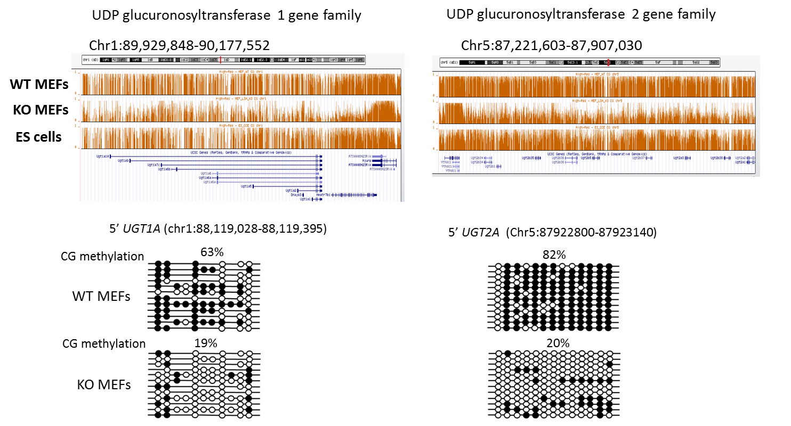
Supplemental Fig. S1 Reduced CG methylation in KO MEFs at UDP glucuronosyltransferase gene families.
Genome browser view presenting CG methylation ratios (fraction of methylated CG/CG) in WT MEFs, KO MEFs and ES cells at the two UDP glucuronosyl-transferase gene clusters (upper panels). The lower panels represent bisulfite sequencing analysis of UGT1A and UGT2A genes comparing WT MEFs and KO MEFs. The black circle represents a methylated cytosine, the open circle an unmethylated cytosine.

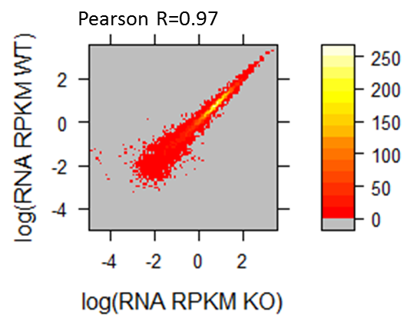
RNA-seq2

Supplemental Fig. S2 Gene expression analysis in KO MEFs compared to WT MEFs. Heatmap scatterplot analysis presenting the relative transcript abundance levels (RPKM values) of RNA-seq analysis in WT MEFs and KO MEFs. The Pearson correlation value is R=0.97. The results present biological replicates of Fig 4B.

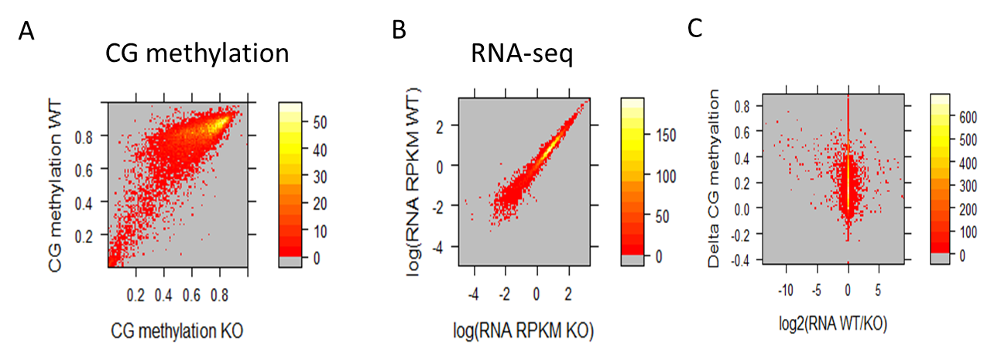
Supplemental Fig. S3 Relationship of CG methylation and gene expression.
A. Heatmap scatterplot analysis presenting the mean values of promoter CG methylation in WT MEFs and KO MEFs. The promoters have been selected for the presence of a CpG island (n=12,334)
B. Heatmap scatterplot analysis presenting RPKM values of RNA-seq analysis for CpG island genes comparing WT and KO MEFs.
C. Heatmap scatterplot analysis presenting the delta values of mean promoter CG methylation (WT minus KO) (Y axis), and relative transcript abundance level (log2 RPKM values WT/KO) (X axis).
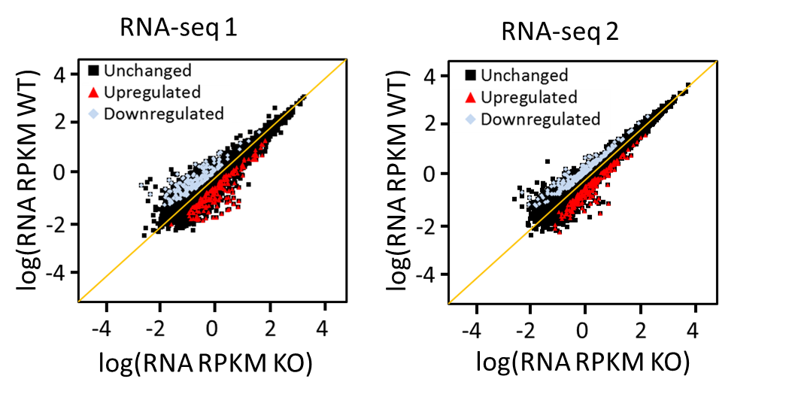
Supplemental Fig. S4 Differential gene expression in KO MEFs compared to WT MEFs
Heatmap scatterplot analysis representing relative transcript abundance levels (RPKM values) of RNA-seq analysis for protein-coding genes (n=23,350) of WT and KO MEFs in two biological replicates. Up-regulated genes (red n= 262), down-regulated genes (blue n=243).

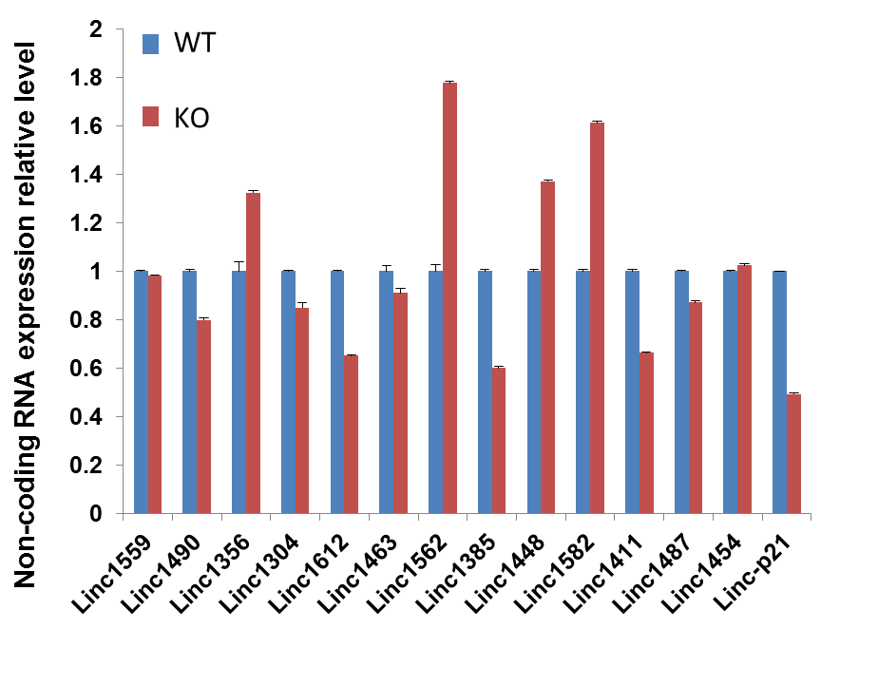
Supplemental Fig. S5 Gene expression of lincRNA.
Real-time PCR analysis for transcript levels at selected lincRNA genes that play a regulatory role in gene expression (Guttman et al. 2011) and are located in DMRs.

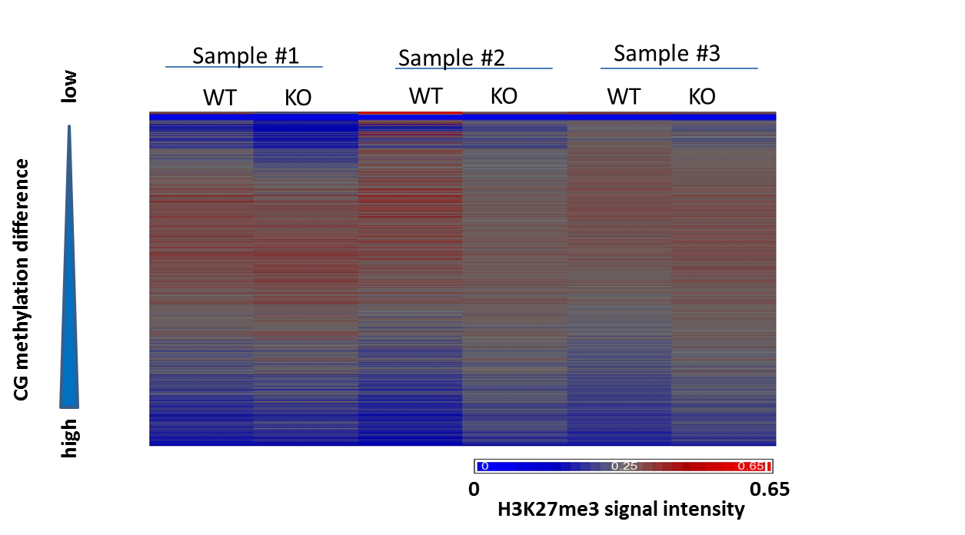

Supplemental Fig. S6 Three biological replicates of H3K27me3 Chip-seq. H3K27me3 signal distribution at 5kb regions of chr 1. The tiles have been ranked from low to high according their CG methylation difference (WT CG methylation minus KO MEF CG methylation).

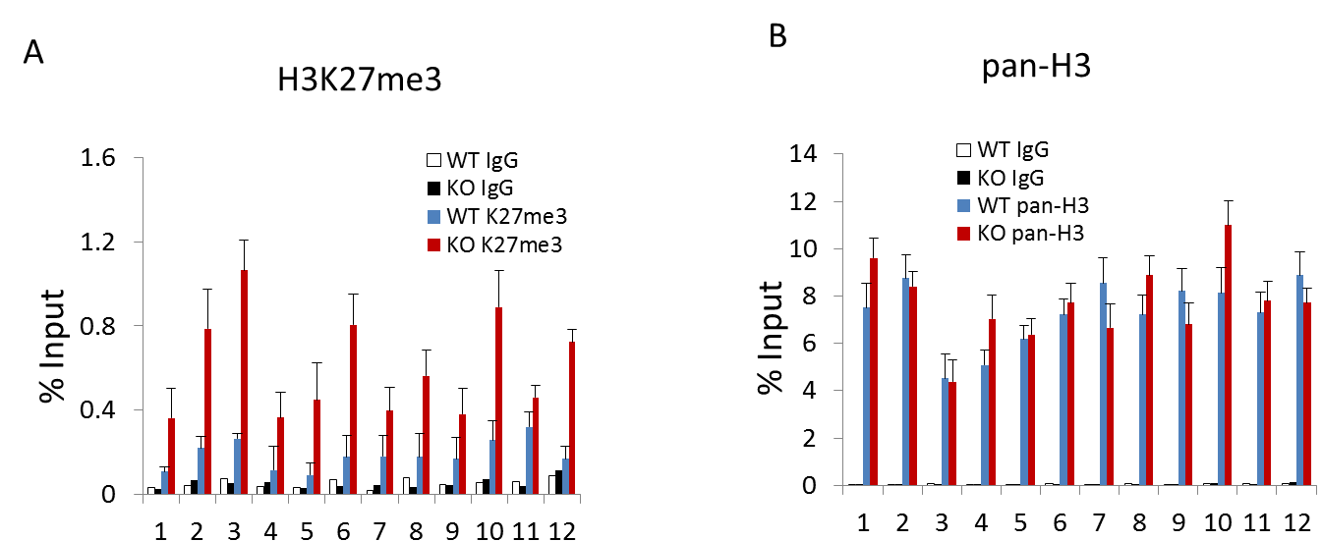
Supplemental Fig. S7 ChIPs validation for H3K27me3 enriched regions
Real-time PCR analysis after ChIPs with specific antibodies directed against H3K27me3 modification (A) or a pan-H3 antibody (B) to determine enrichment at 12 selected loci that are located within DMRs and relatively enriched for H3K27me3 in KO MEFs compared to WT MEFs. All bars show the average enrichment and standard deviation (±SD) from two independent ChIP experiments (duplicates).
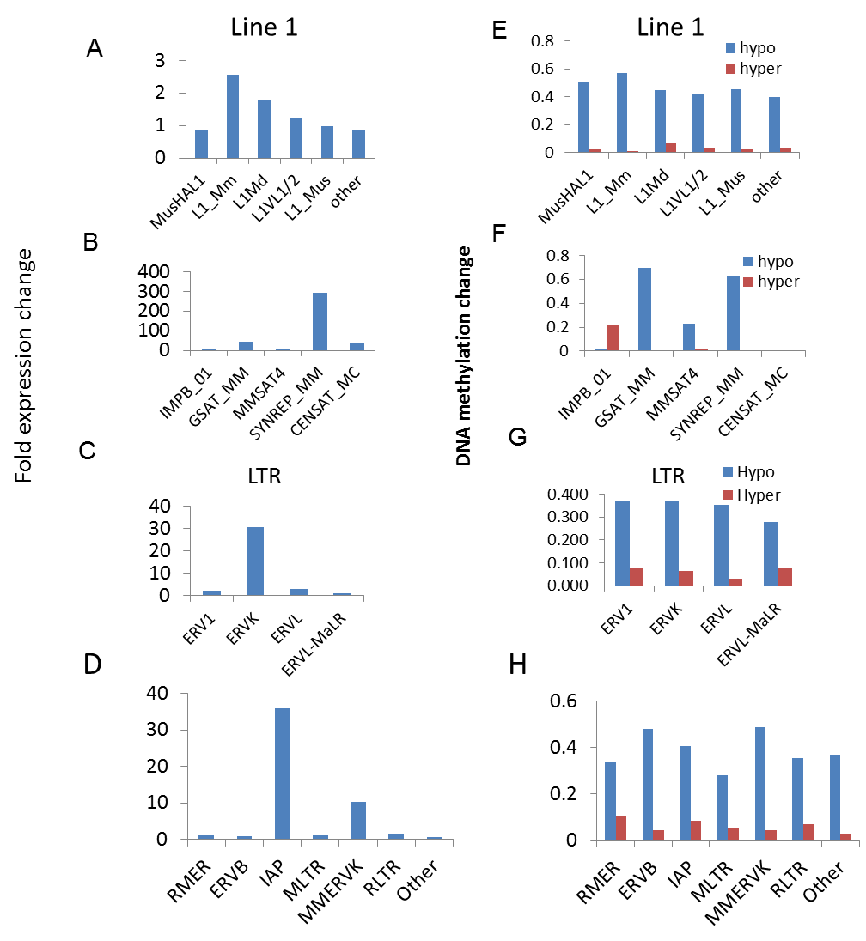
Supplemental Fig. S8 De-repression of repeat subclasses in KO MEFs
A.- D. Bar graph representing repeat element gene expression as fold changes of KO over WT levels (log2) at repeat sequences: LINE elements (A), Satellites (B), endogenous retroviral elements (LTR)(C) and ERVK (D).
E.-H. Bar graph representing CG methylation changes for the same repeat classes as indicated in A.-D. Hypo-methylation represents CG methylation reduction in KO MEFs compared to WT MEFs, hyper-methylation represents CG methylation increases in KO MEFs compared to WT MEFs.
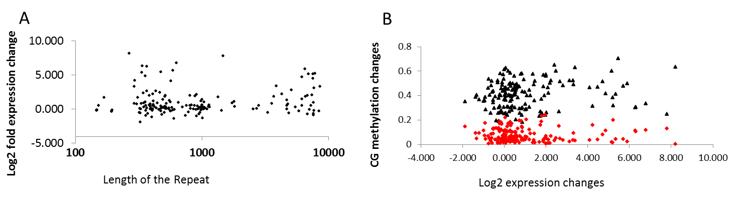
Supplemental Fig. S9 Relationship of repeat de-repression and repeat length and CG methylation changes
A. Scatterplot analysis of transcriptional changes for differentially expressed repeat classes (more than twofold) and average length of the repeat class.
B. Scatterplot analysis of DNA methylation changes with hypomethylation in KO MEFs (black) and hypermethylation in KO MEFs (red), and repeat expression changes (KO/WT).

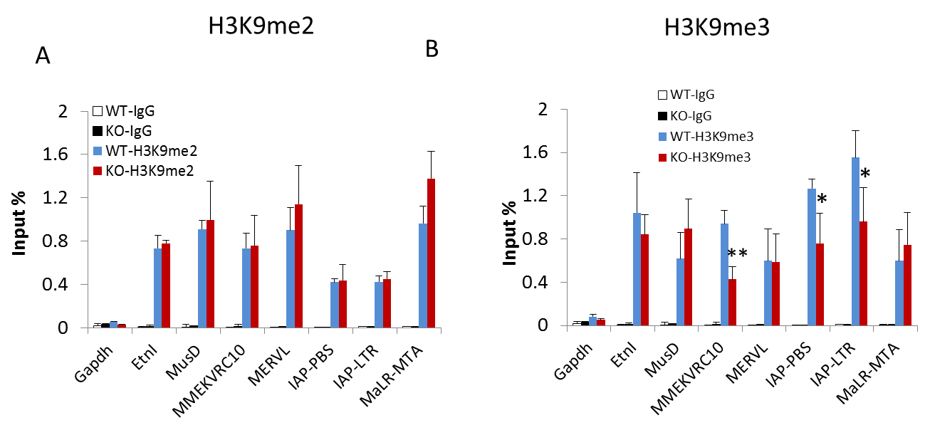
Supplemental Fig. S10 ChIPs analysis for H3K9 methylation at selected repeat elements
ChIPs analysis with specific antibodies directed against H3K9me2 (A) or H3K9me3 (B) followed by Real-time PCR analysis to determine enrichment at selected loci. *P<0.05, ** P<0.01.

Supplemental Tables
Supplemental Table S3. Primer list for ChIPs and Bisulfite sequencing

H3K27me3 and H3 ChIPs Primer Sequences
Name | Forward Sequence (5’to 3’) | Reverse Sequence (5’to 3’)
K27me3-ChIP-1 | AGGTTCAGGGGTGGTCCAAC | CACACATCGGTCACAGAACATC
K27me3-ChIP-2 | GCCACACACATTCTAGTAGTGCC | TGTCTTGTCCCTGATTTTAGTGG
K27me3-ChIP-3 | GCATATTGACTTGTTCTGTTTCCA | GCTGCAAAGGATAAGAGAAAGC
K27me3-ChIP-4 | TTCATGAGCTATGTCCTCGGTC | GTTATTCCATAAACAACAGCCTCC
K27me3-ChIP-5 | CCTTCAGACATAGCTGCCAAGG | TTCCTGAGACTCCTATGCCAAAG
K27me2-ChIP-6 | GATGGTCACTCACAGTATCAGCAA | AGGGTATGTTTCACATTGCTATAGG
K27me3-ChIP-7 | AAGACTACCAGCCCAGGGATG | TGGTTGCTTGTCTGGTTTGTTAG
K27me3-ChIP-8 | TCCGAGGGTCTGAGTATCAAAC | CAAAGAAGCACTGACAGATAGACC
K27me3-ChIP-9 | TCCTAACCTACTGTGTCTGTGTGC | TTTACATGGGCACACCAAGC
K27me3-ChIP-10 | CATGGACCTTTCTTTCCGAGG | GACAACACCCAGTCGGGATAAG
K27me3-ChIP-11 | TTGCCTCTTCCTCTTGTAGTGG | ATGAATCGTGCCTGCTACAGA
K27me3-ChIP-12 | GGTCTGGGCTTTGTAGCTTTTC | CAAATCAATGTAGTCTCCAACGTC

Repeat Primer Sequences
Name | Forward primers (5’to 3’) | Reverse primers (5’to 3’)
Gapdh | ATCCTGTAGGCCAGGTGATG | AGGCTCAAGGGCTTTTAAGG
IAP-PBS | CGTGAGAACGCGTCGAATAA | TTCTGGTTCTGGAATGAGGG
MusD-PBS | TGAGCTTTGATCAGTATGAAATTG | GTGAACGGTTCGACTGAGAA
IAP-LTR | GCTCCTGAAGATGTAAGCAATAAAG | CTTCCTTGCGCCAGTCCCGAG
ETn1 | GTTAAACCCGAGCGCTGGTTC | GCTATAAGGCCCAGAGAGAAATTTC
MERVL_LTR | CTTCCATTCACAGCTGCGACTG | CTAGAACCACTCCTGGTACCAAC
MMERVK10C_LTR | TTCGCCTCTGCAATCAAGCTCTC | TCGCTCRTGCCTGAAGATGTTTC
MaLR-MTA | ATGTTTTGGGGAGGACTGTG | AGCCCCAGCTAACCAGAAC

Bisulfite Primer Sequences
Name | Sequence (5’to 3’) | Chromosome position
5’ MRGPRA3 | F: AGTTTTGGTTTCGTTTTATGATTTTG  R: CCTTATACACAAATACAAAAATAAACTC | Chr7:54942279-54942527
5’ MRGPRA1 | F: ATTTTTAGGGAATTGGAGGATGT  R: CTCCCAAAACACTCACAAAAACT | Chr7:54613232-54613512
5’ UGT1A1 | F:GTTAAGTTTTATTGTTGAATTTAAGT  R: CCCTTCTCCTACTTCATAACTATATA | Chr: 88,119,028-88,119,395
5’ UGT2A1 | F: GAGTGGTATGGTTGTATGTGAAG  R: AATCTCTCAAAATACAACTCTTACA | Chr5:87922800-87923140
PCDH7A | F: GTTTTTGATAATTGTGGTAGTTTGG  R: CACCTCCAAATAAATACTACACTC | Chr18:37133626-37133902
5’PCDHB6 | F: GAAAATTATTGTAGTAAATGTGTTGGA  R: ATTACTTTCAAAAATCCTTTCTCCC | Chr18:37493287-37493587
5’PCDHGA1 | F: TTTTGAGTGATTAGTTTT  R: CACTATCCAAAAATCAACAT | Chr18: 37812364-37812709

Supplemental Table S4
Aligned reads number of RNA-seq and ChIP-seq experiments
SAMPLE | TYPE | READ #
WT1 | RNA PE | 23921811
WT2 | RNA PE | 30855503
KO1 | RNA PE | 22838801
KO2 | RNA PE | 25564728
WT1 | input | 23335883
WT1 | Pol II | 24425621
WT1 | H3K27me3 | 21436478
KO1 | input | 25678768
KO1 | Pol II | 23778562
KO1 | H3K27me3 | 25820536
WT2 | Input | 23387459
WT2 | Pol II | 23185189
WT2 | H3K27me3 | 26344713
KO2 | Input | 21874452
KO2 | Pol II | 20135081
KO2 | H3K27me3 | 22573625
WT3 | input | 23755131
WT3 | H3K27me3 | 13883550
KO3 | input | 17763775
KO3 | H3K27me3 | 12993732
WT1 | H3K4me3 | 25340029
KO1 | H3K4me3 | 19898210

Reference

Guttman M, Donaghey J, Carey BW, Garber M, Grenier JK, Munson G, Young G, Lucas AB, Ach R, Bruhn L et al. 2011. lincRNAs act in the circuitry controlling pluripotency and differentiation. Nature 477(7364): 295-300.
Li H, Durbin R. 2009. Fast and accurate short read alignment with Burrows-Wheeler transform. Bioinformatics 25(14): 1754-1760.
Lister R, O'Malley RC, Tonti-Filippini J, Gregory BD, Berry CC, Millar AH, Ecker JR. 2008. Highly integrated single-base resolution maps of the epigenome in Arabidopsis. Cell 133(3): 523-536.
Lister R, Pelizzola M, Dowen RH, Hawkins RD, Hon G, Tonti-Filippini J, Nery JR, Lee L, Ye Z, Ngo QM et al. 2009. Human DNA methylomes at base resolution show widespread epigenomic differences. Nature 462(7271): 315-322.
Matsui T, Leung D, Miyashita H, Maksakova IA, Miyachi H, Kimura H, Tachibana M, Lorincz MC, Shinkai Y. 2010. Proviral silencing in embryonic stem cells requires the histone methyltransferase ESET. Nature 464(7290): 927-931.
Mortazavi A, Williams BA, McCue K, Schaeffer L, Wold B. 2008. Mapping and quantifying mammalian transcriptomes by RNA-Seq. Nat Methods 5(7): 621-628.
Rowe HM, Jakobsson J, Mesnard D, Rougemont J, Reynard S, Aktas T, Maillard PV, Layard-Liesching H, Verp S, Marquis J et al. 2010. KAP1 controls endogenous retroviruses in embryonic stem cells. Nature 463(7278): 237-240.
Shen Y, Yue F, McCleary DF, Ye Z, Edsall L, Kuan S, Wagner U, Dixon J, Lee L, Lobanenkov VV et al. 2012. A map of the cis-regulatory sequences in the mouse genome. Nature 488(7409): 116-120.
Stroud H, Greenberg MV, Feng S, Bernatavichute YV, Jacobsen SE. 2013. Comprehensive Analysis of Silencing Mutants Reveals Complex Regulation of the Arabidopsis Methylome. Cell.
Yu W, Briones V, Lister R, McIntosh C, Han Y, Lee EY, Ren J, Terashima M, Leighty RM, Ecker JR et al. 2014. CG hypomethylation in Lsh-/- mouse embryonic fibroblasts is associated with de novo H3K4me1 formation and altered cellular plasticity. Proc Natl Acad Sci U S A 111(16): 5890-5895.

