T-cell receptor repertoires share a restricted set of public and abundant CDR3 sequences that are associated with self-related immunity

Asaf Madi^{1,*}, Eric Shifrut^{1,*}, Shlomit Reich-Zeliger¹, Hilah Gal¹, Katharine Best², Wilfred Ndifon¹, Benjamin Chain², Irun R. Cohen^{1,} †, Nir Friedman^{1,} †
¹Department of Immunology, Weizmann Institute of Science, Rehovot 76100, Israel
²Division of Infection and Immunity, The Cruciform Building, UCL, Gower Street, London, WC1 6BT, UK
*These authors contributed equally to this work.
†Corresponding author. E-mail: irun.cohen@weizmann.ac.il (I.R.C.), nir.friedman@weizmann.ac.il (N.F.).

SUPPLEMENTARY MATERIALS

Methods

Library preparation for TCR-seq
Libraries were prepared and pre-processed as published (Ndifon et al. 2012). Briefly, we extracted total RNA from T cells using RNeasy Mini Kit (Qiagen, Hilden, Germany). The RNA was then reverse transcribed using SuperScript II reverse transcriptase (RT) enzyme (Invitrogen, La Jolla, CA). The primer for the RT reaction was a TCR Cβ-specific primer linked to the 3'-end Illumina sequencing adapter. The resulting cDNA was then amplified using PCR (Phusion; Finnzymes) with a Cβ-3’adp primer and Vβ-specific 5’ primers. Each Vβ-specific primer was anchored to a restriction site sequence for the ACUI restriction enzyme. PCR products were then cleaned using QIAquick PCR purification kit (Qiagen, Hilden, Germany), followed by enzymatic digestion with ACUI enzyme (New England BioLabs, Ipswich, MA). Then, the 5’Illumina adaptor (dsDNA, with NN overhang) were ligated (T4 ligase; Fermentas, Vilnius, Lithuania). The adaptors also contained 3-nucleotide long tags for multiplexing of samples to the same Illumina sequencing run. A second round of PCR amplification was performed, using universal primers for the 5’ and 3’ Illumina adapters. Final PCR products were run on a 2% agarose gel, cut at the desired length (~250bp), and purified using Wizard SV Gel and PCR Clean-Up System (Promega, Madison, WI) to produce the final library. The libraries were sequenced using Genome Analyzer II or HiSeq2000 (Illumina).

Pre-processing and error correction for raw reads
We filtered out raw reads containing bases with Q-value ≤30, and then separated the remaining reads according to their barcodes. Next, we aligned the reads to each of the germline Vβ/Jβ gene segments from IMGT (Lefranc et al. 2009) using the Smith-Waterman algorithm. Each read was assigned its best-aligning Vβ/Jβ if the number of matching nucleotides (alignment length) was above a threshold, 11nt for Vβ, 9nt for Jβ. To reduce the effect of sequencing errors, we used hierarchical clustering to group reads assigned the same Vβ and Jβ genes and are with an edit distance less than 2. Then, we annotated the sequences by matching the Dβ to the junction, identifying deleted / inserted nucleotides and elongated the read to its full CDR3β length (by IMGT convention). Finally, we translated the nt sequences into amino-acid (aa) CDR3β. We used only sequences that are in-frame (i.e. no stop codons), have a copy number of at least 2 and have less than 2bp enzyme cleavage error. These are referred to as annotated reads (see Table S1). We also corrected the copy-number, to adjust for PCR and sub-sampling bias, as published (Ndifon et al. 2012).

Supporting information
1. Sequencing depth is positively correlated with higher fraction of public CDR3 sequences
To measure the effect of sampling bias, we down sampled our dataset by randomly selecting increasing number of unique CDR3 sequences from each sample. We then measured the level of sharing for every down-sampled dataset of 28 virtual reprtoires, for 100 iterations. In Figure S1, we show the results for the 3 bottom and top sharing groups. As expected, the fraction of the sequences in the private sharing group (S=1) decreases with sample size, as more sequences have a chance to be present in more than one sample. All other sharing groups, including public sequences (S=28), grow with sample size. This analysis indicates that with our current sequencing depth, we are most likely to under-estimate the actual level of publicness in the population.
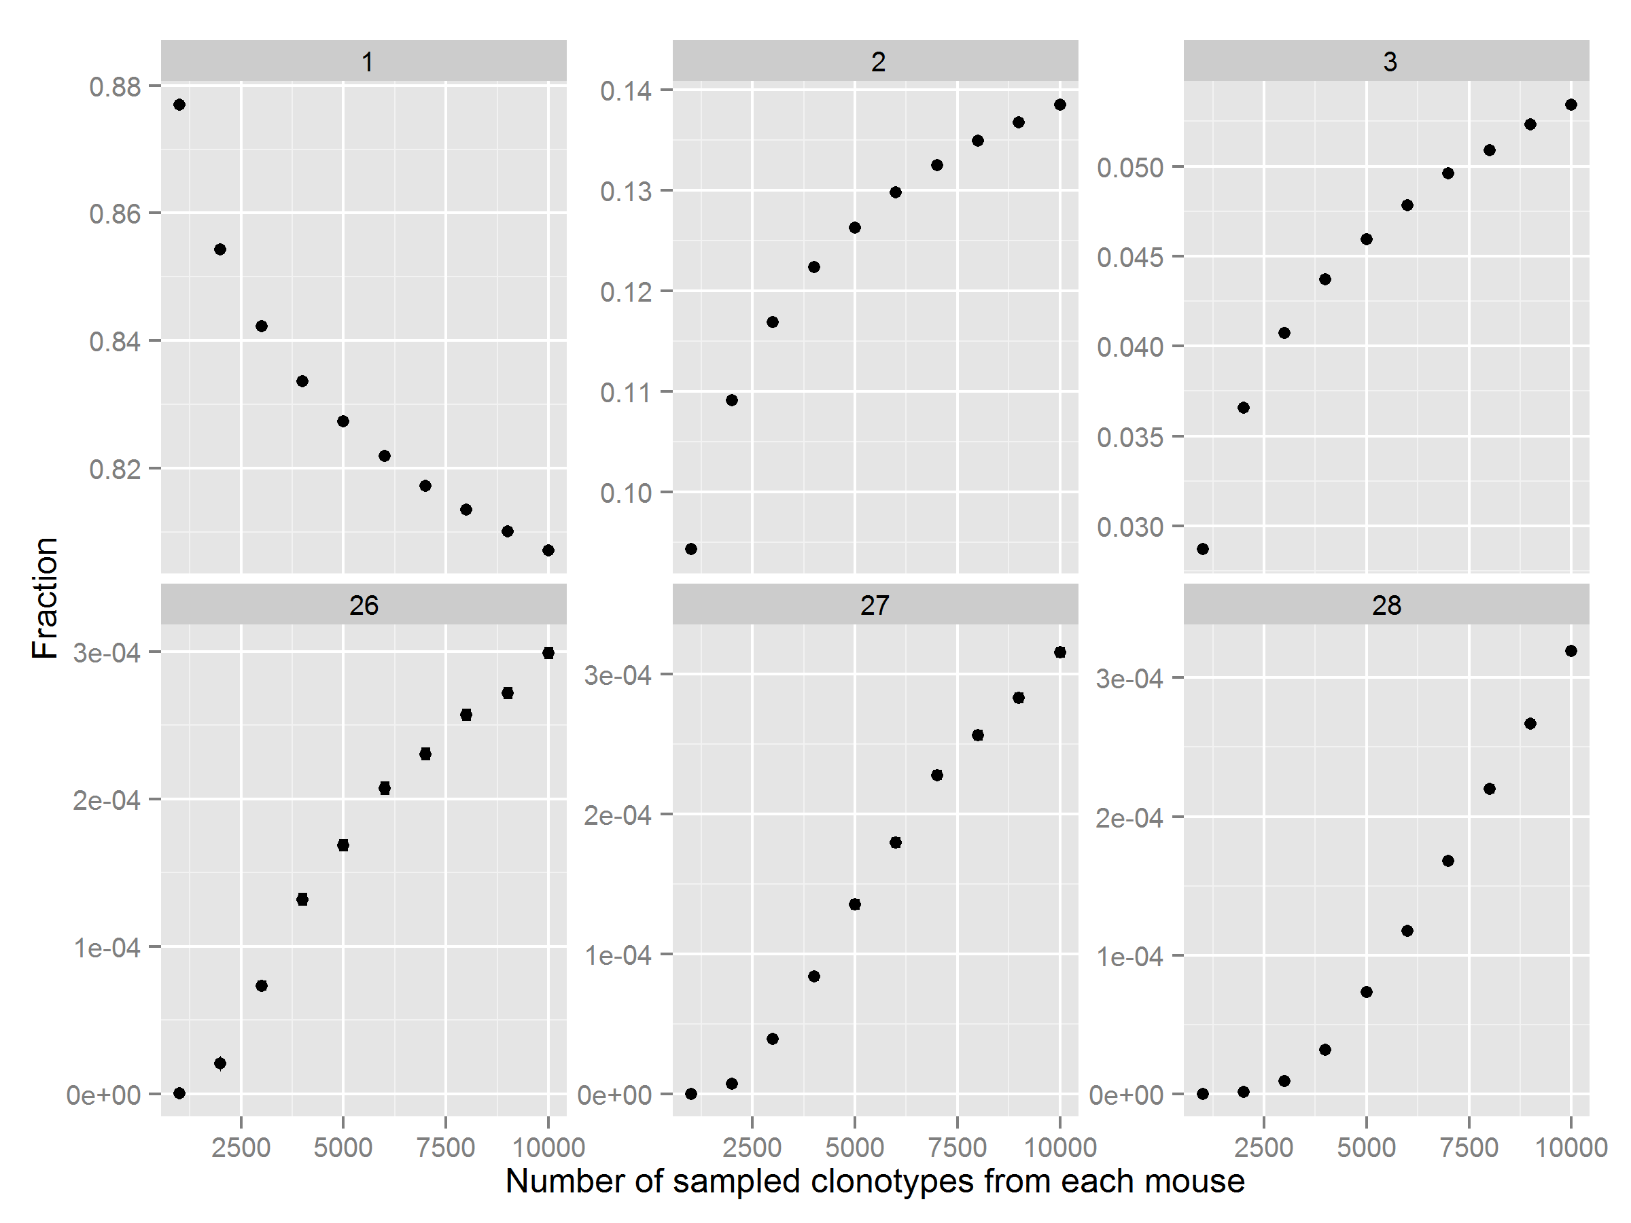

Figure S1. Fraction of unique CDR3 sequences found in different sharing groups in increasing sample sizes. Each panel shows the fraction of the total number of unique CDR3 aa seuqences in a specific sharing level (top: S=1,2,3; bottom: S-26,27,28), as function the number of sequences in down-sampled datasets. We observe that public sequences (bottom-right panel) are estimated to take a larger fraction of the total repertoire as more sequences are sampled.
2. Public CDR3β segments manifest a higher average frequency than private CDR3β segments
We plot here the frequency distribution of all sequences depicted in Figure 1C (main text), binned to sharing groups. The frequencies of the private CDR3β group manifest a wide spread and long right tail, reflecting most sequences with low frequencies and few sequences with very high frequencies. It is also evident that the distributions shift towards higher frequency as the level of sharing increases.
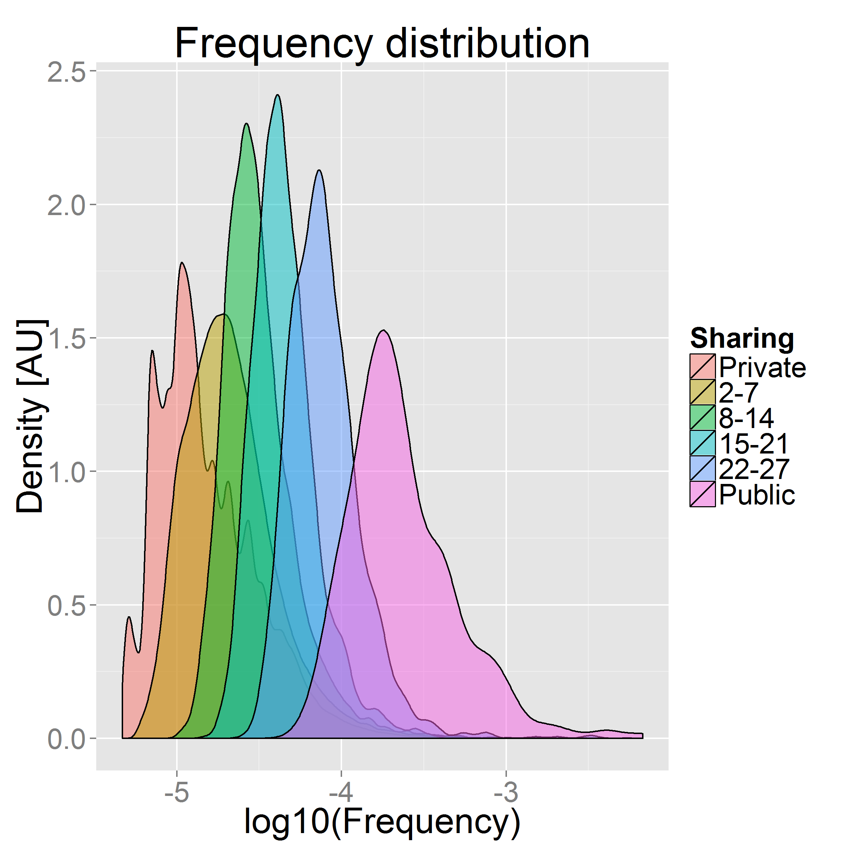
Figure S2. Normalized frequency distributions for all CDR3 aa sequences found in our dataset, binned according to their sharing level.

3. Simulation of TCR repertoires show that convergent recombination is an important determinant of sharing levels of CDR3β aa sequences
Using in silico generated TCR repertoires, we examined the effect of recombination biases on convergent recombination (i.e. number of nt sequences encoding for CDR3 aa sequence) and on sharing levels. Similar to the trend observed in the data (Fig. 2A), convergent recombination is positively correlated with sharing level.
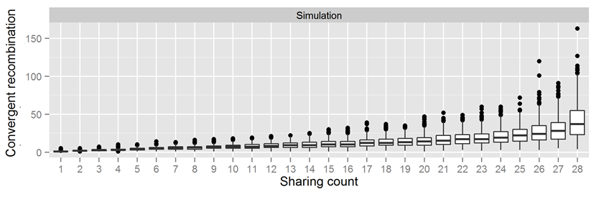

Figure S3. Convergent recombination across sharing levels. Boxplot depicts the distribution of values for convergent recombination, as found in simulation A of TCR repertoires, for each sharing category. Consistent with the experimental data, public sequences are encoded by many different nucleotide sequences, while private sequences are encoded by very few sequences.
4. Public CDR3β aa sequences are not restricted by MHC haplotype
The analysis of previously annotated CDR3 sequences showed that shared CDR3 aa sequences are found in experiments that used mouse strains of different MHC haplotypes. To verify this, we searched for the 289 public CDR3 aa sequences (found in CD4⁺ T cells from C57BL/6 mice) in samples from other MHC contexts: CD8⁺ T cells from C57BL/6 mice (n=2, H2^{b}, MHC-I), CD4⁺ T cells from C3H.SW mice (n=3, H2^{b}, MHC-II) and CD4⁺ T cells from C3H.HeSnJ mice (n=3, H2^{k}, MHC-II). Figure S4 shows that almost all of the 289 CDR3 aa sequences were also found in these T cells, across the different MHC contexts.
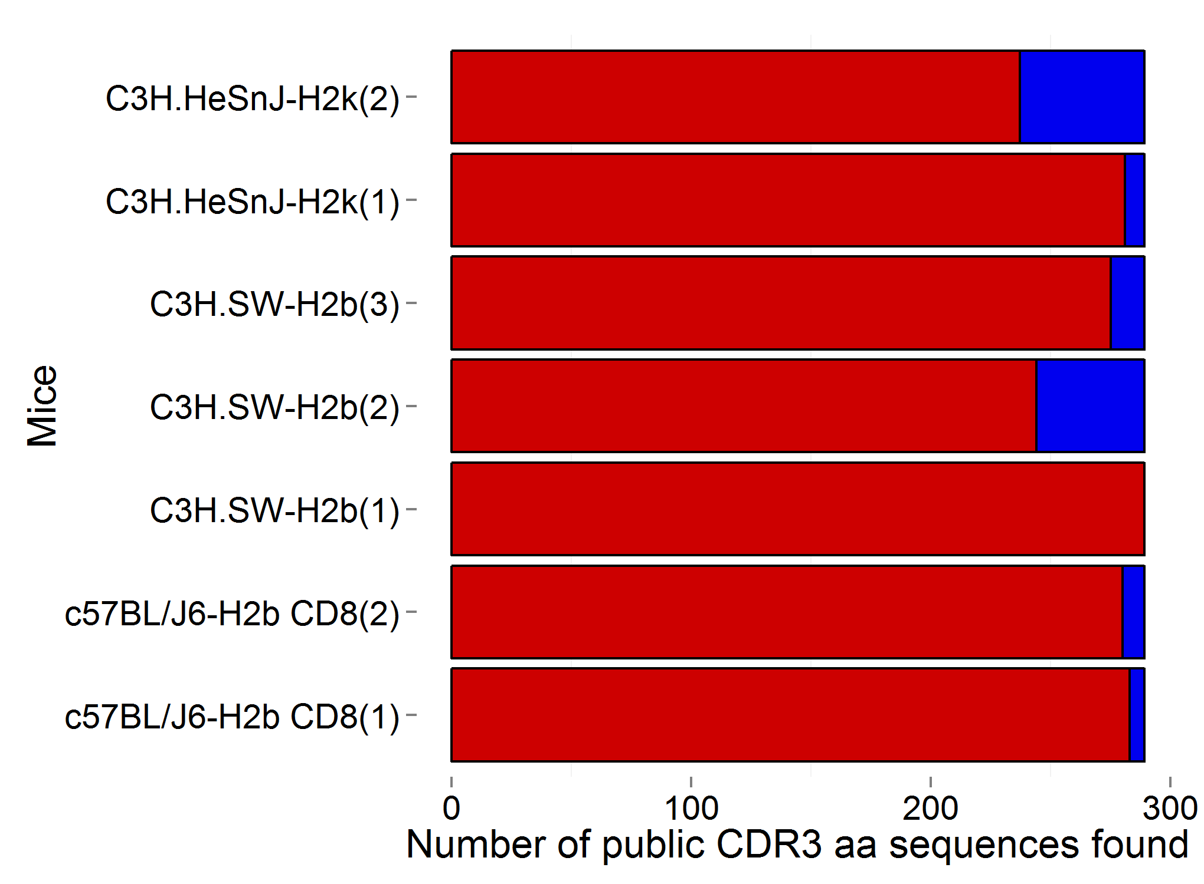
Figure S4. Public CDR3 sequences are shared across MHC haplotypes. The red bars indicate the number of CDR3 aa sequences from the list of 289 public sequences, which were found in T cells of different MHC context. Each row corresponds to one mouse, with the MHC context indicated to the left.

5. Vβ usage in public CDR3 sequences is shaped by the MHC haplotype
We find that the same CDR3β sequence is encoded by different Vβ gene segments in different MHC haplotypes. To quantify this phenomenon, we calculated the weighted mean frequency of V segment usage for each of the 289 public CDR3-types, in each of the different MHC groups. Figure S5 shows the resulting patterns of V segment usage for four public CDR3 aa sequences, in the form of a pie chart. Two additional examples are shown in Figure 6A of the main text. Note the relative similarity between CD4⁺ T cells from the C57BL/6 mice (first column) and C3H.SW mice (second column), both bearing the H2^{b} haplotype, and their dissimilarity to the C3H.HeSnJ H2^{k} haplotype and the C57BL/6 CD8⁺ T cells.
To quantify this effect globally, the pattern of V segment usage for all public CDR3 aa sequences in each sample group was compared by calculating its Pearson correlation to the pattern of V segment usage by CD4⁺ T cells from the 28 C57BL/6 mice. We then calculated the mean correlation coefficient between each T cell group and the CD4⁺ C57BL/6 group, which is presented in Figure 6B of the main text. The figure shows that higher similarity with the CD4⁺ T cells of C57BL/6 mice was detected for the C3H.SW mice, which shares the same MHC haplotype, whereas CD4⁺ T cells of from the C3H.HeSnJ strain (H2^{k} haplotype) and the CD8⁺ T cells derived from the C57BL/6 strain showed a lower similarity.
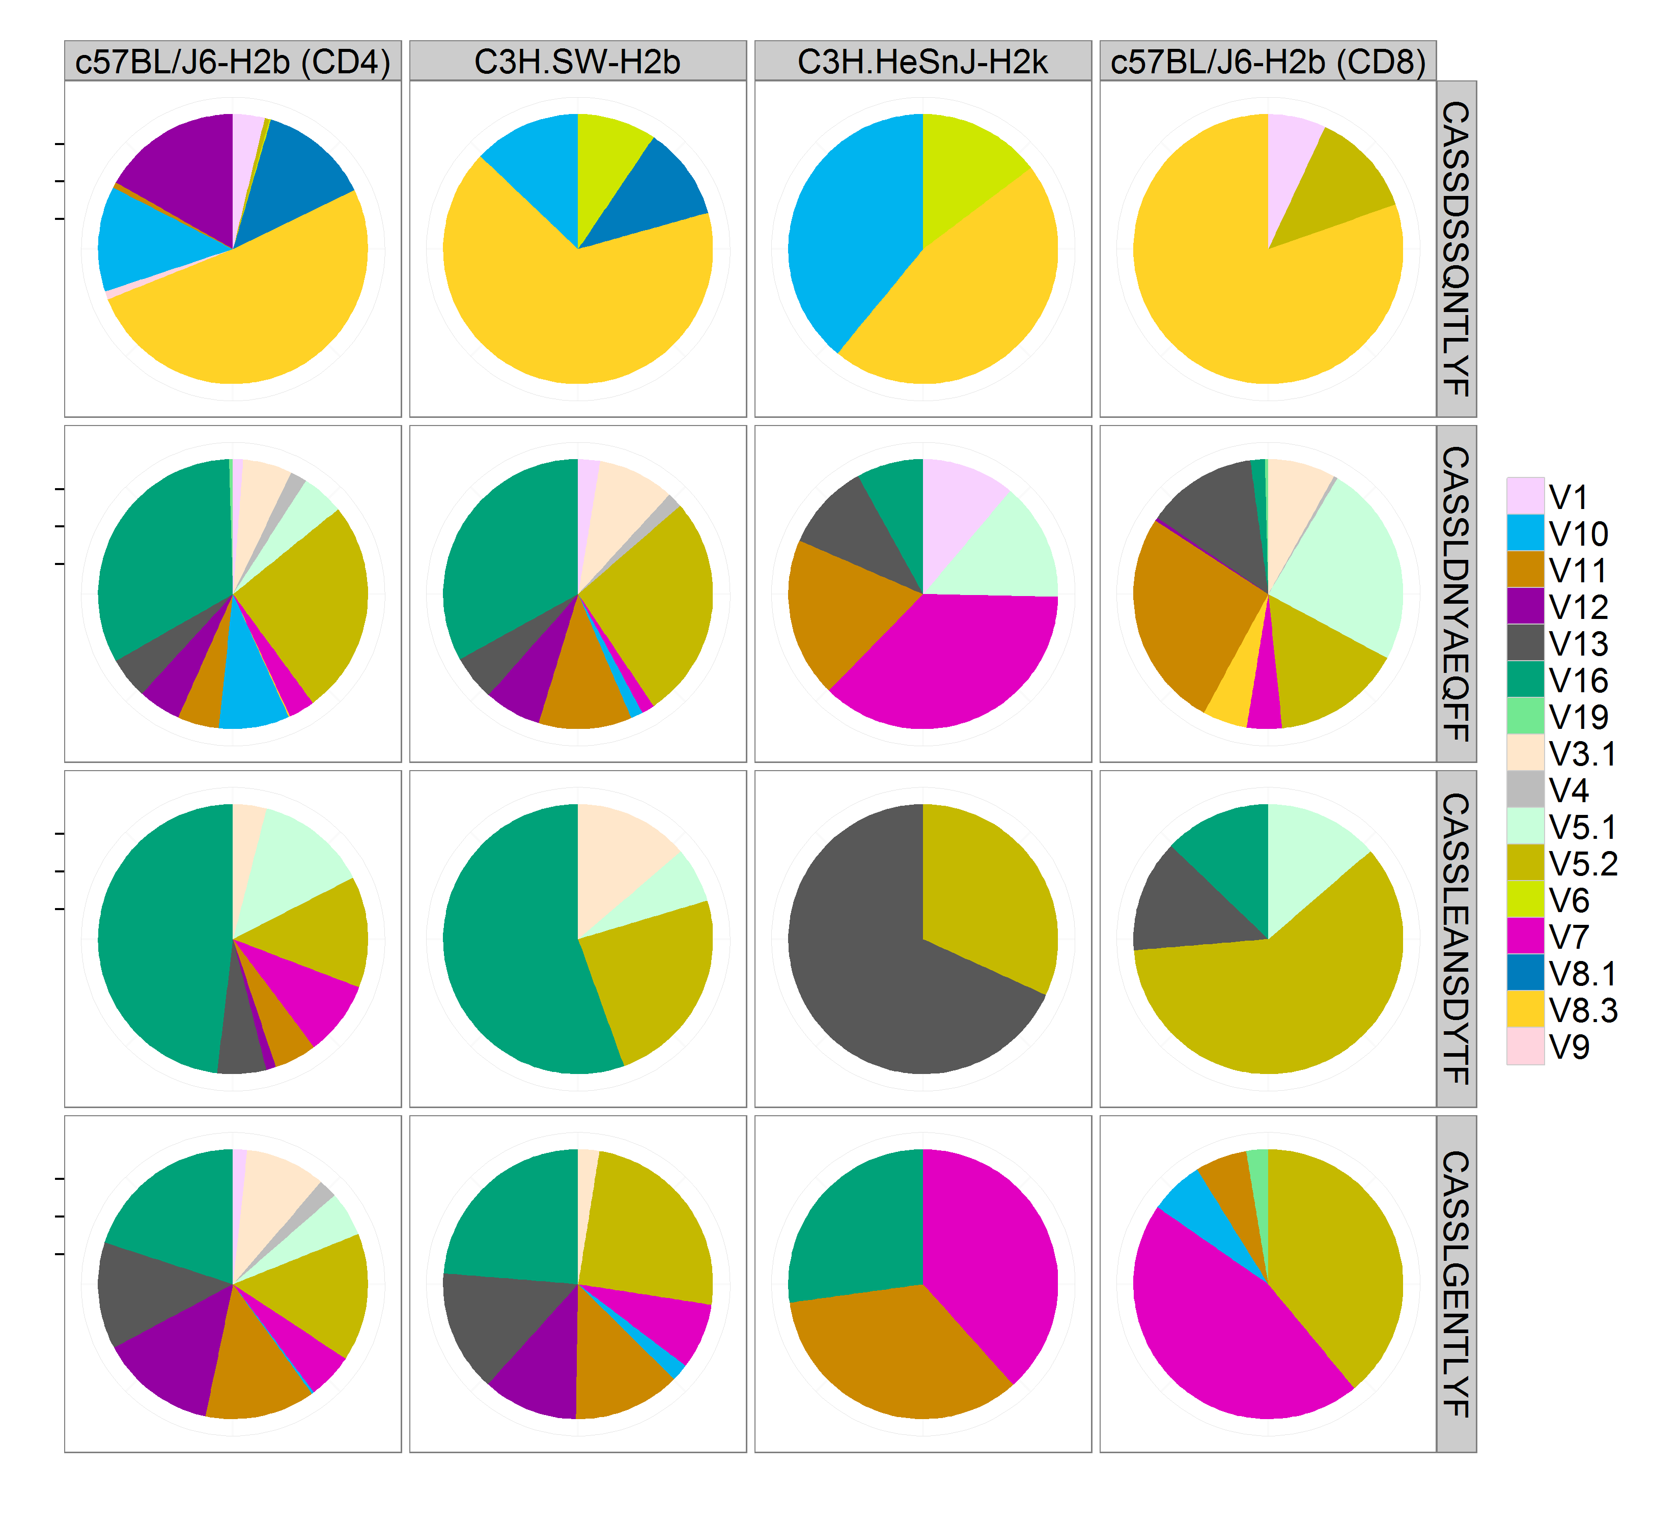
Figure S5. Patterns of V segment usage of four public CDR3 aa sequences, in T cells that interact with different MHC molecules.

6. Genetic code degeneracy cannot explain measured convergent recombination values
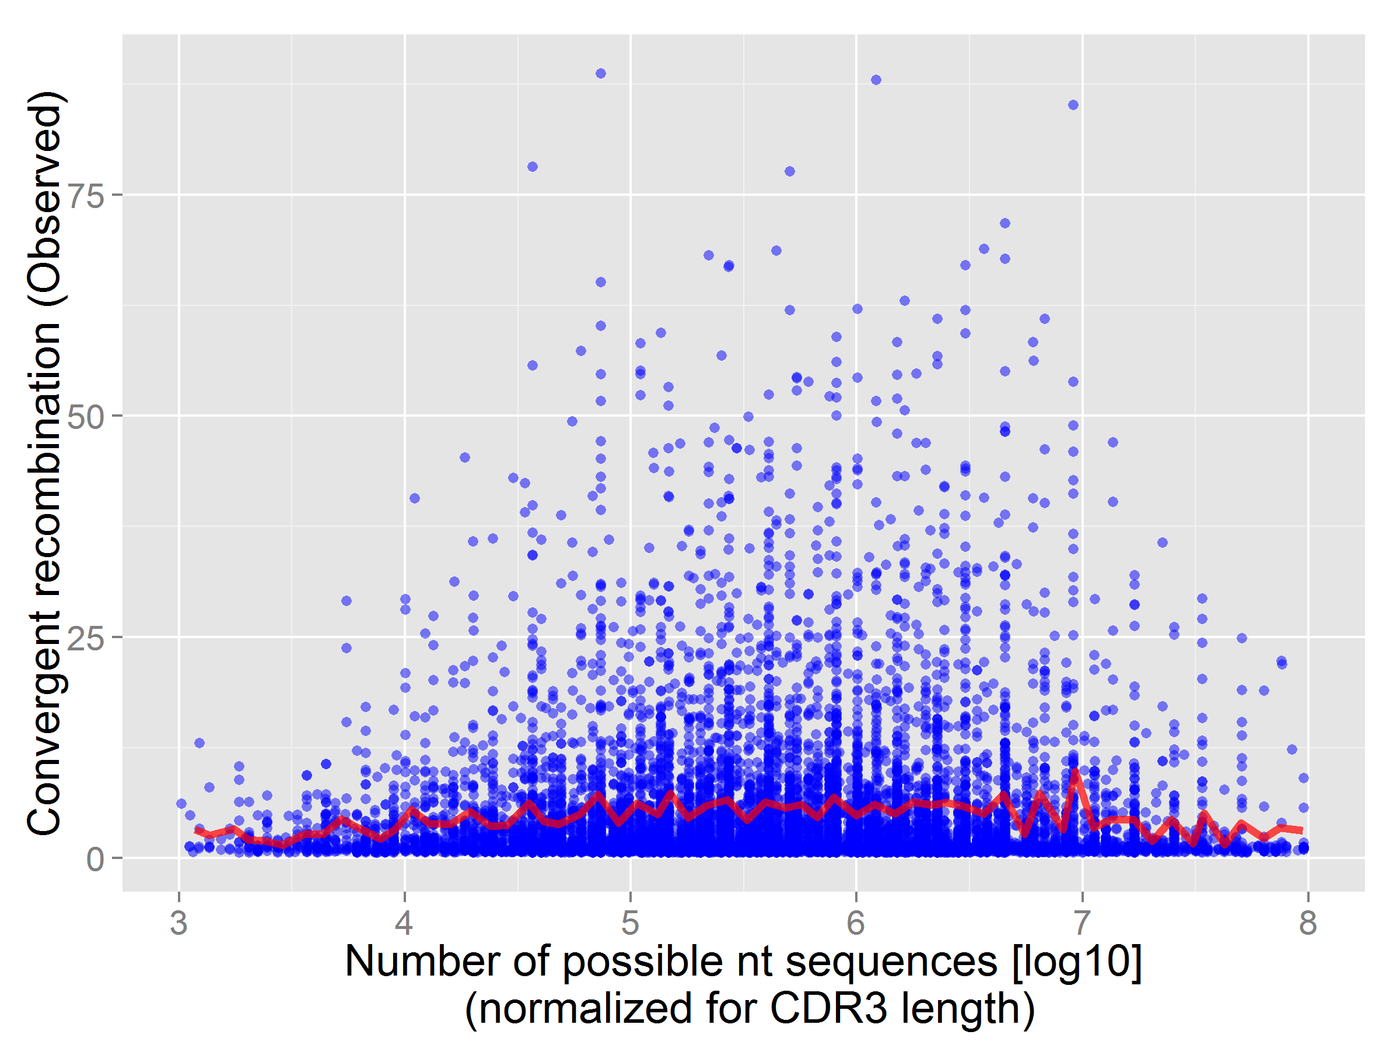
10,000 aa CDR3 sequences were sampled from our data. For each sequence, the potential number of nt sequences that can encode it was calculated (“reverse translation”, using genetic code degeneracy). We plot in Figure S6 the number of observed nt sequences (i.e. convergent recombination in the data, y-axis) vs. number of coding nt potential (normalized for length as longer CDR3 have more options). The red line is the mean of the y-axis values for each bin. No correlation is detected between the potential and observed nt diversity (R²=0.02), thus we conclude that convergent recombination cannot be explained just by the degeneracy of the genetic code.

Figure S6. Convergent recombination as a function of coding potential. Each dot is an amino-acid CDR3 sequence. Y-axis shows the convergent recombination (CR) value as measured in data; X-axis shows the number of all possible nucleotide sequences that can potentially encode for that aa sequences. No correlation is observed between these two properties. Red line is the mean CR.

Table S1: Samples’ summary
Sample | Immunization | Annotated reads* | Unique reads (nt) | Unique AA sequences
1 | Untreated | 86,523 | 22,838 | 18,063
2 | Untreated | 53,026 | 24,632 | 19,671
3 | Untreated | 64,654 | 22,004 | 17,779
4 | Untreated | 101,075 | 41,323 | 31,407
5 | Untreated | 216,533 | 78,613 | 58,612
6 | Untreated | 27,045 | 12,507 | 10,784
7 | Untreated | 91,998 | 32,683 | 25,807
8 | Untreated | 38,729 | 20,329 | 18,248
9 | Untreated | 155,857 | 60,678 | 49,388
10 | Untreated | 32,251 | 18,903 | 15,531
11 | Untreated | 42,585 | 19,113 | 15,403
12 | Untreated | 137,894 | 55,037 | 40,455
13 | CFA | 84,731 | 38,774 | 32,133
14 | CFA | 123,187 | 42,970 | 33,300
15 | CFA | 156,212 | 69,699 | 54,460
16 | CFA | 63,832 | 25,063 | 21,563
17 | CFA | 92,015 | 32,286 | 27,335
18 | CFA | 106,855 | 43,474 | 35,601
19 | CFA | 24,583 | 14,358 | 12,229
20 | CFA+OVA | 156,762 | 53,669 | 43,152
21 | CFA+OVA | 105,386 | 42,989 | 34,224
22 | CFA+OVA | 52,878 | 21,613 | 18,441
23 | CFA+OVA | 52,302 | 19,571 | 16,889
24 | CFA+OVA | 118,978 | 45,789 | 38,195
25 | CFA+OVA | 104,616 | 44,567 | 37,112
26 | CFA+OVA | 40,477 | 22,413 | 18,129
27 | CFA+OVA | 21,267 | 11,784 | 9,888
28 | CFA+OVA | 67,123 | 31,016 | 24,185
*Annotated reads = reads which were unambiguously mapped to V and J segments, have a consensus CDR3 and encode for a sense (in-frame) CDR3 amino acid sequence. Also, we filtered out reads with cleavage error > 2 or were found only once in a sample, to minimize noise (see methods). The copy number shown here is normalized to account for PCR biases and effects of experimental sub-sampling of library material, as published (Ndifon et al. 2012) .

Table S2: Annotated TCRs from the literature
*CR = Convergent recombination found in our data
*Dominant V = Dominant Vβ segment found in our data
*Dominant J = Dominant Jβ segment found in our data

Immune Model | Mouse strain | H2 haplotype | Antigen | CDR3 aa | CR* | Dominant V* | Dominant J* | Category | Ref.
SLE | (NZB X SWR)F1 | d/q F1 | Co-culture with syngeneic B cells producing anti-DNA autoantibodies. | CASGDAGAANSDYTF | 1 | V8.2 | J1.2 | Autoimmune | (Adams et al. 1991)
 |  |  |  | CASGDAGAAAEQFF | 1 | V8.2 | J2.1 | Autoimmune | (Adams et al. 1991)
 |  |  |  | CASGDAGAAETLYF | 3 | V8.2 | J2.3 | Autoimmune | (Adams et al. 1991)
 |  |  |  | CASGDRDYAEQFF | 4 | V8.2 | J2.1 | Autoimmune | (Adams et al. 1991)
 |  |  |  | CASSDGQYAEQFF | 7 | V8.1 | J2.1 | Autoimmune | (Adams et al. 1991)
 |  |  |  | CASSGDRDAEQFF | 4 | V8.3 | J2.1 | Autoimmune | (Adams et al. 1991)
 |  |  |  | CASSDDRGGGTEVFF | 1 | V8.1 | J1.1 | Autoimmune | (Adams et al. 1991)
 |  |  |  | CASSQDPGGAETLYF | 3 | V4 | J2.3 | Autoimmune | (Adams et al. 1991)
 |  |  |  | CASSQGDWGYEQYF | 4 | V1 | J2.7 | Autoimmune | (Adams et al. 1991)
Diabetes | NOD | g7 | Spontaneously reactive to p277 peptide of HSP60 | CASSLGGNQDTQYF | 53 | V16 | J2.5 | Autoimmune | (Tikochinski et al. 1999)
 |  |  |  | CASSSLGGNQDTQYF | 7 | V9 | J2.5 | Autoimmune | (Tikochinski et al. 1999)
Diabetes | NOD | g7 | Spontaneously generated islet-reactive T cell clones | CASRLGNQDTQYF | 8 | V6 | J2.5 | Autoimmune | (Nakano et al. 1991)
 |  |  |  | CASGGYEQYF | 9 | V8.2 | J2.7 | Autoimmune | (Nakano et al. 1991)
 |  |  |  | CASSLGTTNTGQLYF | 16 | V16 | J2.2 | Autoimmune | (Nakano et al. 1991)
 |  |  |  | CGAGQGGNTLYF | 2 | V15 | J1.3 | Autoimmune | (Nakano et al. 1991)
EAE | B10.PL/J | u | Immunized with MBP peptide Ac1–9 | CASGDAGGGYEQYF | 6 | V8.2 | J2.7 | Autoimmune | (Menezes et al. 2007)
 |  |  |  | CASGDAGGSYEQYF | 11 | V8.2 | J2.7 | Autoimmune | (Menezes et al. 2007)
 |  |  |  | CASSGTDQDTQYF | 12 | V8.3 | J2.5 | Autoimmune | (Menezes et al. 2007)
 |  |  |  | CASSLDWDNQDTQYF | 2 | V5.2 | J2.5 | Autoimmune | (Menezes et al. 2007)
CIA | DBA/1LacJ | q | Immunized with bovine collagen type II | CASSQVGNQDTQYF | 9 | V1 | J2.5 | Autoimmune | (Osman et al. 1993)
 |  |  |  | CASSRTANTGQLYF | 20 | V12 | J2.2 | Autoimmune | (Osman et al. 1993)
COPD | BALB/cJ | d | Chronic exposure to cigarette smoke | CASRLTSSAETLYF | 1 | V3.1 | J2.3 | Autoimmune | (Motz et al. 2008)
 |  |  |  | CASRLTSYNSPLYF | 1 | V12 | J1.6 | Autoimmune | (Motz et al. 2008)
 |  |  |  | CASSFGDSDYTF | 7 | V7 | J1.2 | Autoimmune | (Motz et al. 2008)
 |  |  |  | CASSLGNSDYTF | 37 | V5.2 | J1.2 | Autoimmune | (Motz et al. 2008)
 |  |  |  | CASSSGNSDYTF | 20 | V10 | J1.2 | Autoimmune | (Motz et al. 2008)
 |  |  |  | CASSSANSDYTF | 18 | V7 | J1.2 | Autoimmune | (Motz et al. 2008)
 |  |  |  | CASSHRASDYTF | 3 | V4 | J1.2 | Autoimmune | (Motz et al. 2008)
 |  |  |  | CASSFGGSDYTF | 7 | V16 | J1.2 | Autoimmune | (Motz et al. 2008)
 |  |  |  | CASSFEGSDYTF | 1 | V1 | J1.2 | Autoimmune | (Motz et al. 2008)
 |  |  |  | CASGTGGSDYTF | 2 | V8.2 | J1.2 | Autoimmune | (Motz et al. 2008)
 |  |  |  | CASSGTVNNQAPLF | 2 | V8.3 | J1.5 | Autoimmune | (Motz et al. 2008)
 |  |  |  | CASSFTNNNQAPLF | 1 | V7 | J1.5 | Autoimmune | (Motz et al. 2008)
 |  |  |  | CASSFPGNNQAPLF | 1 | V11 | J1.5 | Autoimmune | (Motz et al. 2008)
PMEL (gp100) | C57BL/6 | b | Cells were sorted using tetramers to the Db epitope of PMEL (gp100) | CASRDGSYNSPLYF | 1 | V6 | J1.6 | Cancer | (Rizzuto et al. 2009)
 |  |  |  | CASSSTGYYAEQFF | 2 | V7 | J2.1 | Cancer | (Rizzuto et al. 2009)
 |  |  |  | CASSLSTGYYAEQFF | 1 | V3.1 | J2.1 | Cancer | (Rizzuto et al. 2009)
 |  |  |  | CASSSGGGYAEQFF | 7 | V16 | J2.1 | Cancer | (Rizzuto et al. 2009)
MDM2 | C57BL/6 | b | Immunized with hMDM2(81–88) peptide | CASGDWGYEQYF | 15 | V8.2 | J2.7 | Cancer | (Stanislawski et al. 2001)
Glycopeptide | CBA/J | k | Immunized to hemoglobin (67–76) peptide substituted with Thr( α -D-GalNAc) in position 72 | CASSPGQTYAEQFF | 3 | V5.2 | J2.1 | Cancer | (Jensen et al. 1999)
TRP53 (P53) | C57BL/6, expressing HLA-A | b/  (HLA)-A*0201 | p53(264–272)A2.1 | CASSLSGGGTEVFF | 5 | V3.1 | J1.1 | Cancer | (Kuball et al. 2005)
Tumor associated | C57BL/6 chimeric mice | HLA-DR4/H2Ed | T cell neoplasms | CASSHSGNTLYF | 13 | V4 | J1.3 | Cancer | (Raffegerst et al. 2009)
 |  |  |  | CASSIRDKNTLYF | 5 | V6 | J2.4 | Cancer | (Raffegerst et al. 2009)
 |  |  |  | CASSLGLGVGAETLYF | 2 | V10 | J2.3 | Cancer | (Raffegerst et al. 2009)
 |  |  |  | CASSGTANTEVFF | 16 | V8.3 | J1.1 | Cancer | (Raffegerst et al. 2009)
 |  |  |  | CASSWDRNYAEQFF | 5 | V10 | J2.1 | Cancer | (Raffegerst et al. 2009)
 |  |  |  | CASSRRPYEQYF | 1 | V9 | J2.7 | Cancer | (Raffegerst et al. 2009)
Tumor infiltrating Tregs | C57BL/6 | b | TC-1 tumor cells expressing HPV16-E6 and HPV16-E7  proteins and derived from primary mouse lung epithelial  cells. | CASSGTGKDTQYF | 10 | V8.1 | J2.5 | Cancer | (Sainz-Perez et al. 2012)
 |  |  |  | CASSGTGEDTQYF | 14 | V8.3 | J2.5 | Cancer | (Sainz-Perez et al. 2012)
 |  |  |  | CASSGTGQDTQYF | 21 | V8.3 | J2.5 | Cancer | (Sainz-Perez et al. 2012)
 |  |  |  | CASSGTGDDTQYF | 1 | V8.1 | J2.5 | Cancer | (Sainz-Perez et al. 2012)
 |  |  |  | CASSGTGRDTQYF | 9 | V8.3 | J2.5 | Cancer | (Sainz-Perez et al. 2012)
 |  |  |  | CASSGRGQDTQYF | 4 | V6 | J2.5 | Cancer | (Sainz-Perez et al. 2012)
 |  |  |  | FCASSGGGQDTQYF | 6 | V8.3 | J2.5 | Cancer | (Sainz-Perez et al. 2012)
 |  |  |  | CASSGQGQDTQYF | 2 | V8.3 | J2.5 | Cancer | (Sainz-Perez et al. 2012)
 |  |  |  | CASSGLGQDTQYF | 6 | V8.1 | J2.5 | Cancer | (Sainz-Perez et al. 2012)
 |  |  |  | CASTGTGQDTQYF | 7 | V10 | J2.5 | Cancer | (Sainz-Perez et al. 2012)
 |  |  |  | CASSGLGEDTQYF | 11 | V8.3 | J2.5 | Cancer | (Sainz-Perez et al. 2012)
 |  |  |  | CASSGQGEDTQYF | 9 | V8.1 | J2.5 | Cancer | (Sainz-Perez et al. 2012)
 |  |  |  | CASSILGDTGQLYF | 3 | V6 | J2.2 | Cancer | (Sainz-Perez et al. 2012)
 |  |  |  | CASGGAYEQYF | 4 | V5.2 | J2.7 | Cancer | (Sainz-Perez et al. 2012)
 |  |  |  | CASSTTGTYEQYF | 1 | V10 | J2.7 | Cancer | (Sainz-Perez et al. 2012)
 |  |  |  | CASSDEGGQNTLYF | 7 | V8.1 | J2.4 | Cancer | (Sainz-Perez et al. 2012)
GVHD | C57BL/6 and BALB/cJ | b | C57BL/6 H-2b) anti BALB/cJ (H-2d) | CASSPGQSNERLFF | 18 | V5.2 | J1.4 | Allograft | (Rangarajan et al. 2012)
 |  |  |  | CASSIWGNYAEQFF | 8 | V6 | J2.1 | Allograft | (Rangarajan et al. 2012)
 |  |  |  | CASSDAREPQYF | 1 | V8.3 | J2.5 | Allograft | (Rangarajan et al. 2012)
 |  |  |  | CASSGRNTGQLYF | 9 | V8.3 | J2.2 | Allograft | (Rangarajan et al. 2012)
 |  |  |  | CGASDSSGNTLYF | 2 | V15 | J1.3 | Allograft | (Rangarajan et al. 2012)
 |  |  |  | CASSLEGDTEVFF | 19 | V11 | J1.1 | Allograft | (Rangarajan et al. 2012)
 |  |  |  | CASKTDGNTLYF | 1 | V3.1 | J1.3 | Allograft | (Rangarajan et al. 2012)
 |  |  |  | CASSIGTGGYAEQFF | 6 | V6 | J2.1 | Allograft | (Rangarajan et al. 2012)
 |  |  |  | CASSDGWGQNTLYF | 2 | V8.1 | J2.4 | Allograft | (Rangarajan et al. 2012)
 |  |  |  | CASSDWGGYEQYF | 9 | V8.3 | J2.7 | Allograft | (Rangarajan et al. 2012)
 |  |  |  | CASSQEGGNTEVFF | 8 | V1 | J1.1 | Allograft | (Rangarajan et al. 2012)
 |  |  |  | CASSDAGNYEQYF | 5 | V8.1 | J2.7 | Allograft | (Rangarajan et al. 2012)
 |  |  |  | CASSAGGADTQYF | 1 | V8.3 | J2.5 | Allograft | (Rangarajan et al. 2012)
 |  |  |  | CASSPGQGDTGQLYF | 6 | V19 | J2.2 | Allograft | (Rangarajan et al. 2012)
 |  |  |  | CASSSTWGNYAEQFF | 1 | V10 | J2.1 | Allograft | (Rangarajan et al. 2012)
 |  |  |  | CGARESSYEQYF | 1 | V15 | J2.7 | Allograft | (Rangarajan et al. 2012)
 |  |  |  | CGARSSQNTLYF | 7 | V15 | J2.4 | Allograft | (Rangarajan et al. 2012)
Minor histoincompatability | C.B10-H2^{b} (BALB.B), C57BL/10SnJ (B10), B10.129-H4^{b} (21 M), and C57BL/6ByJ (B6) mice. | b | C57BL/10SnJ (B10) | CASSLGGQNTLYF | 105 | V16 | J2.4 | Allograft | (Johnston et al. 1997)
Minor histoincompatability |  | b | C57BL/10SnJ (B10) | CASSQDWGGSYEQYF | 3 | V1 | J2.7 | Allograft | (Johnston et al. 1997)
Minor histoincompatability |  | b | C57BL/6ByJ (B6) | CASSFGTGYEQYF | 6 | V13 | J2.7 | Allograft | (Johnston et al. 1997)
Minor histoincompatability |  | b | C57BL/6ByJ (B6) | CASSGQGNYAEQFF | 17 | V8.3 | J2.1 | Allograft | (Johnston et al. 1997)
Minor histoincompatability |  | b | C57BL/6ByJ (B6) | CASSFWGGDAEQFF | 2 | V12 | J2.1 | Allograft | (Johnston et al. 1997)
Schistosoma mansoni | CBA/J mice and a TCR transgenic strain. | k | Immunized with S. mansoni | CASSQGTGGNTGQLYF | 4 | V1 | J2.2 | Pathogens | (Hogan et al. 2002)
 |  |  |  | CASSQDANTGQLYF | 3 | V4 | J2.2 | Pathogens | (Hogan et al. 2002)
Trypanosoma cruzi | BALB/c | d | Immunized with recombinant transsialidase, an immunodominant T. cruzi antigen. | CASSITDTNTEVFF | 1 | V6 | J1.1 | Pathogens | (Hiyane et al. 2006)
Histoplasma capsulatum | C57BL/6 | b | Immunized with H. capsulatum strain G217B | CASSQDYRANTEVFF | 2 | V1 | J1.1 | Pathogens | (Scheckelhoff and Deepe 2006)
 |  |  |  | CASSQPGQSNERLFF | 2 | V4 | J1.4 | Pathogens | (Scheckelhoff and Deepe 2006)
 |  |  |  | CASSQDGTANERLFF | 2 | V4 | J1.4 | Pathogens | (Scheckelhoff and Deepe 2006)
 |  |  |  | CASSQVGYNSPLYF | 3 | V1 | J1.6 | Pathogens | (Scheckelhoff and Deepe 2006)
 |  |  |  | CASSQLGQNYAEQFF | 1 | V4 | J2.1 | Pathogens | (Scheckelhoff and Deepe 2006)
 |  |  |  | CASSQEMGENTLYF | 1 | V4 | J2.4 | Pathogens | (Scheckelhoff and Deepe 2006)
 |  |  |  | CASSQQGYNSPLYF | 5 | V1 | J1.6 | Pathogens | (Scheckelhoff and Deepe 2006)
P. berghei | BALB/c mice | b | Immunized with P. berghei sporozoite | CASSSRYEQYF | 15 | V7 | J2.7 | Pathogens | (Casanova et al. 1991)
 |  |  |  | CASSVTGSNTEVFF | 1 | V8.3 | J1.1 | Pathogens | (Casanova et al. 1991)
 |  |  |  | CASSPTGRNTEVFF | 6 | V19 | J1.1 | Pathogens | (Casanova et al. 1991)
 |  |  |  | CASGDGNQAPLF | 4 | V8.2 | J1.5 | Pathogens | (Casanova et al. 1991)
 |  |  |  | CASSFRDRGNYAEQFF | 1 | V7 | J2.1 | Pathogens | (Casanova et al. 1991)
Influenza | C57BL/J | b | Immunized with HKx31 (H3N2) influenza A virus | CASSSGGSNTGQLYF | 2 | V16 | J2.2 | Pathogens | (Kedzierska et al. 2006)
 |  |  |  | CASSQSGGSNTGQLYF | 1 | V4 | J2.2 | Pathogens | (Kedzierska et al. 2006)
 |  |  |  | CASGGANTGQLYF | 3 | V8.2 | J2.2 | Pathogens | (Kedzierska et al. 2006)
 |  |  |  | CASGGGNTGQLYF | 3 | V8.2 | J2.2 | Pathogens | (Kedzierska et al. 2006)
 |  |  |  | CASSRGGANTGQLYF | 2 | V9 | J2.2 | Pathogens | (Kedzierska et al. 2006)
 |  |  |  | CASSRGGGNTGQLYF | 1 | V9 | J2.2 | Pathogens | (Kedzierska et al. 2006)
 |  |  |  | CAWSLKGGANTGQLYF | 1 | V14 | J2.2 | Pathogens | (Kedzierska et al. 2006)
 |  |  |  | CASSARTANTEVFF | 1 | V8.3 | J1.1 | Pathogens | (Kedzierska et al. 2006)
Vesicular stomatitis virus (VSV) | F2 cross of CBA and C57BL/6 bearing a TCR α chain (Vα2) transgene. | b | Immunized with a peptide of the nucleoprotein, of VSV. | CASSFVGSYEQYF | 1 | V12 | J2.7 | Pathogens | (Wang et al. 1998)
 |  |  |  | CASSFHISYNSPLYF | 1 | V13 | J1.6 | Pathogens | (Wang et al. 1998)
 |  |  |  | CASSFGVNSDYTF | 1 | V10 | J1.2 | Pathogens | (Wang et al. 1998)
 |  |  |  | CASSLGVGDTQYF | 6 | V12 | J2.5 | Pathogens | (Wang et al. 1998)
 |  |  |  | CASSFGVSYEQYF | 4 | V13 | J2.7 | Pathogens | (Wang et al. 1998)
 |  |  |  | CASSLGTGGKQFF | 1 | V13 | J2.1 | Pathogens | (Wang et al. 1998)
 |  |  |  | CASSPGTGVEQYF | 10 | V12 | J2.7 | Pathogens | (Wang et al. 1998)
 |  |  |  | CASSPGTGQAPLF | 4 | V12 | J1.5 | Pathogens | (Wang et al. 1998)
Lymphocytic choriomeningitis virus (LCMV) | P14 TcR a-transgenic mice were generated by injection of the P14 TcR a construct which contained the H-2Kb promoter, P14 TcR a cDNA, P-globin fragment and IgH enhancer. P14 TcR P-transgenic mice. |  | Immunized with the LCMV-WE variant peptides. | CASSDGANTEVFF | 9 | V8.3 | J1.1 | Pathogens | (Brandle et al. 1991)
 |  |  |  | CASSDQANTEVFF | 5 | V8.3 | J1.1 | Pathogens | (Brandle et al. 1991)
 |  |  |  | CASSDSANTEVFF | 10 | V8.1 | J1.1 | Pathogens | (Brandle et al. 1991)
 |  |  |  | CASSDAGANTEVFF | 12 | V8.3 | J1.1 | Pathogens | (Brandle et al. 1991)
 |  |  |  | CASSDNANSDYTF | 2 | V8.3 | J1.2 | Pathogens | (Brandle et al. 1991)
 |  |  |  | CASSDAGHSPLYF | 1 | V8.3 | J1.6 | Pathogens | (Brandle et al. 1991)
Murine leukemia virus (MuLV) | (BALB/c x B6)(CB6)F1 | b, b, bc, b | Immunized with fragments of the F-MuLV env gene | CASSQDWGFQDTQYF | 2 | V1 | J2.5 | Pathogens | (Iwashiro et al. 1993)
 |  |  |  | CAWSRTGGNSDYTF | 3 | V14 | J1.2 | Pathogens | (Iwashiro et al. 1993)

Supplementary material references
Adams S, Leblanc P, Datta SK. 1991. Junctional region sequences of T-cell receptor beta-chain genes expressed by pathogenic anti-DNA autoantibody-inducing helper T cells from lupus mice: possible selection by cationic autoantigens. Proc Natl Acad Sci U S A 88(24): 11271-11275.
Brandle D, Burki K, Wallace VA, Rohrer UH, Mak TW, Malissen B, Hengartner H, Pircher H. 1991. Involvement of both T cell receptor V alpha and V beta variable region domains and alpha chain junctional region in viral antigen recognition. Eur J Immunol 21(9): 2195-2202.
Casanova JL, Romero P, Widmann C, Kourilsky P, Maryanski JL. 1991. T cell receptor genes in a series of class I major histocompatibility complex-restricted cytotoxic T lymphocyte clones specific for a Plasmodium berghei nonapeptide: implications for T cell allelic exclusion and antigen-specific repertoire. J Exp Med 174(6): 1371-1383.
Hiyane MI, Boscardin SB, Rodrigues MM. 2006. The non-palindromic adaptor-PCR method for the identification of the T-cell receptor genes of an interferon-gamma-secreting T-cell hybridomaspecific for trans-sialidase, an immunodominant Trypanosoma cruzi antigen. Braz J Med Biol Res 39(3): 345-354.
Hogan LH, Wang M, Suresh M, Co DO, Weinstock JV, Sandor M. 2002. CD4+ TCR repertoire heterogeneity in Schistosoma mansoni-induced granulomas. J Immunol 169(11): 6386-6393.
Iwashiro M, Kondo T, Shimizu T, Yamagishi H, Takahashi K, Matsubayashi Y, Masuda T, Otaka A, Fujii N, Ishimoto A et al. 1993. Multiplicity of virus-encoded helper T-cell epitopes expressed on FBL-3 tumor cells. J Virol 67(8): 4533-4542.
Jensen T, Hansen P, Faurskov Nielsen A, Meldal M, Komba S, Werdelin O. 1999. Shared structural motifs in TCR of glycopeptide-recognizing T cell hybridomas. Eur J Immunol 29(9): 2759-2768.
Johnston SL, Borson ND, Wettstein PJ. 1997. Spectratyping of TCRs expressed by CTL-infiltrating minor histocompatibility antigen-disparate allografts. J Immunol 159(11): 5233-5245.
Kedzierska K, Venturi V, Field K, Davenport MP, Turner SJ, Doherty PC. 2006. Early establishment of diverse T cell receptor profiles for influenza-specific CD8(+)CD62L(hi) memory T cells. Proc Natl Acad Sci U S A 103(24): 9184-9189.
Kuball J, Schmitz FW, Voss RH, Ferreira EA, Engel R, Guillaume P, Strand S, Romero P, Huber C, Sherman LA et al. 2005. Cooperation of human tumor-reactive CD4+ and CD8+ T cells after redirection of their specificity by a high-affinity p53A2.1-specific TCR. Immunity 22(1): 117-129.
Lefranc MP, Giudicelli V, Ginestoux C, Jabado-Michaloud J, Folch G, Bellahcene F, Wu Y, Gemrot E, Brochet X, Lane J et al. 2009. IMGT, the international ImMunoGeneTics information system. Nucleic Acids Res 37(Database issue): D1006-1012.
Menezes JS, van den Elzen P, Thornes J, Huffman D, Droin NM, Maverakis E, Sercarz EE. 2007. A public T cell clonotype within a heterogeneous autoreactive repertoire is dominant in driving EAE. J Clin Invest 117(8): 2176-2185.
Motz GT, Eppert BL, Sun G, Wesselkamper SC, Linke MJ, Deka R, Borchers MT. 2008. Persistence of lung CD8 T cell oligoclonal expansions upon smoking cessation in a mouse model of cigarette smoke-induced emphysema. J Immunol 181(11): 8036-8043.
Nakano N, Kikutani H, Nishimoto H, Kishimoto T. 1991. T cell receptor V gene usage of islet beta cell-reactive T cells is not restricted in non-obese diabetic mice. J Exp Med 173(5): 1091-1097.
Ndifon W, Gal H, Shifrut E, Aharoni R, Yissachar N, Waysbort N, Reich-Zeliger S, Arnon R, Friedman N. 2012. Chromatin conformation governs T-cell receptor Jbeta gene segment usage. Proc Natl Acad Sci U S A 109(39): 15865-15870.
Osman GE, Toda M, Kanagawa O, Hood LE. 1993. Characterization of the T cell receptor repertoire causing collagen arthritis in mice. J Exp Med 177(2): 387-395.
Raffegerst SH, Hoelzlwimmer G, Kunder S, Mysliwietz J, Quintanilla-Martinez L, Schendel DJ. 2009. Diverse hematological malignancies including hodgkin-like lymphomas develop in chimeric MHC class II transgenic mice. PLoS One 4(12): e8539.
Rangarajan H, Yassai M, Subramanian H, Komorowski R, Whitaker M, Gorski J, Drobyski WR. 2012. Emergence of T cells that recognize nonpolymorphic antigens during graft-versus- host disease. Blood 119(26): 6354-6364.
Rizzuto GA, Merghoub T, Hirschhorn-Cymerman D, Liu C, Lesokhin AM, Sahawneh D, Zhong H, Panageas KS, Perales MA, Altan-Bonnet G et al. 2009. Self-antigen-specific CD8+ T cell precursor frequency determines the quality of the antitumor immune response. J Exp Med 206(4): 849-866.
Sainz-Perez A, Lim A, Lemercier B, Leclerc C. 2012. The T-cell receptor repertoire of tumor-infiltrating regulatory T lymphocytes is skewed toward public sequences. Cancer Res 72(14): 3557-3569.
Scheckelhoff MR, Deepe GS, Jr. 2006. Pulmonary V beta 4+ T cells from Histoplasma capsulatum-infected mice respond to a homologue of Sec31 that confers a protective response. J Infect Dis 193(6): 888-897.
Stanislawski T, Voss RH, Lotz C, Sadovnikova E, Willemsen RA, Kuball J, Ruppert T, Bolhuis RL, Melief CJ, Huber C et al. 2001. Circumventing tolerance to a human MDM2-derived tumor antigen by TCR gene transfer. Nat Immunol 2(10): 962-970.
Tikochinski Y, Elias D, Steeg C, Marcus H, Kantorowitz M, Reshef T, Ablamunits V, Cohen IR, Friedmann A. 1999. A shared TCR CDR3 sequence in NOD mouse autoimmune diabetes. Int Immunol 11(6): 951-956.
Wang F, Ono T, Kalergis AM, Zhang W, DiLorenzo TP, Lim K, Nathenson SG. 1998. On defining the rules for interactions between the T cell receptor and its ligand: a critical role for a specific amino acid residue of the T cell receptor beta chain. Proc Natl Acad Sci U S A 95(9): 5217-5222.

