Genomic analysis of the causative agents of coccidiosis in domestic chickens

Supplemental Tables and Figures

Adam J Reid^{1*}, Damer P Blake^{2,3}, Hifzur R Ansari⁴, Karen Billington³, Hilary P Browne¹, Josephine Bryant¹, Matt Dunn¹, Stacy S Hung⁵, Fumiya Kawahara⁶, Diego Miranda-Saavedra⁷, Tareq B Malas⁴, Tobias Mourier⁸, Hardeep Naghra^{1,9}, Mridul Nair⁴, Thomas D Otto¹, Neil D Rawlings¹⁰, Pierre Rivailler^{3,11}, Alejandro Sanchez-Flores¹², Mandy Sanders¹, Chandra Subramaniam³, Yea-Ling Tay^{13,14}, Yong Woo⁴, Xikun Wu^{3,15}, Bart Barrell^{1¥¨}, Paul H Dear¹⁶, Christian Doerig¹⁷, Arthur Gruber¹⁸, Alasdair C Ivens¹⁹, John Parkinson⁵, Marie-Adèle Rajandream^{1†}, Martin W Shirley²⁰, Kiew-Lian Wan^{13,14}, Matthew Berriman¹, Fiona M Tomley^{2,3*}, Arnab Pain^{4*}

Supplemental Tables 3
Supplemental Table S1. Genome assembly statistics for tier 1 and tier 2 Eimeria genomes in comparison to the key apicomplexan species Toxoplasma gondii and Plasmodium falciparum. 3
Supplemental Table S2. Genome assembly stats for tier 3 genomes. 5
Supplemental Table S3. Assignment of optical map scaffolds to chromosomes. 6
Supplemental Table S4. Gene Ontology terms associated with E. tenella genes containing Homopolyermic Amino Acid Repeats (HAARs) and those without HAARs. 7
Supplemental Table S5. Putative structural context of 65 Homopolymeric Amino Acid Repeats (HAARS). 9
Supplemental Table S6. Novel gene families of the Eimeria genus. 13
Supplemental Table S7. Kinases of Eimeria and related species. 14
Supplemental Table S8. Distribution of LTR retrotransposon copy number across species. 15
Supplemental Table S9. The gene targets and gene-specific primers used in the single parasite RT-PCR screen of SAG transcription. 16
Supplemental Figures 18
Supplemental Figure S1. Density of small tandem repeats across Eimeria genomes. 18
Supplemental Figure S2. Structural context of HAARs in homology models. 19
Supplemental Figure S3. K_{a}/K_{s} ratios for sag, esf1 and esf2 gene families. 21
Supplemental Figure S4. Heatmap showing the conservation of individual metabolic pathways for E. tenella, T. gondii, and N. caninum. 22
Supplemental Figure S5. Distribution of the Api-AP2 family of DNA-binding domains and genes across the Apicomplexa. 23
Supplemental Figure S6. Clustering of ApiAP2 domain-containing genes across the Apicomplexa. 25
Supplemental Figure S7. Neighbour-joining phylogeny of Ty3/Gypsy LTR retrotransposon reverse transcriptases. 26
Supplemental Figure S8. Domain structures of chromovirus consensuses. 27
Supplemental Figure S9. Expression pattern for an example LTR retrotransposon from E. tenella. 28
Supplemental Datasets 30
Supplemental Dataset S1. Details of gene families of interest. 30
Supplemental Dataset S2. K_{a}/K_{s} ratios 30
Supplemental Dataset S3. Metabolic annotation for E. tenella genes 30
References 31

Supplemental Tables

Supplemental Table S1. Genome assembly statistics for tier 1 and tier 2 Eimeria genomes in comparison to the key apicomplexan species Toxoplasma gondii and Plasmodium falciparum.
Completeness of the genomes is shown both as a percentage of core eukaryotic genes (using CEGMA; Parra et al. 2007) and this same percentage but relative to the well-sequenced coccidian Toxoplasma gondii to highlight the common lack of some of these genes in this group. There is a more complete genome sequence for P. falciparum but it has an even more reduced genome. † Figure taken from Reid et al. (2012).

 | Eimeria tenella Houghton | E. necatrix Houghton | E. acervulina Houghton | E. maxima Weybridge | Toxoplasma gondii Me49 | Plasmodium falciparum 3D7
Genome assembly size (Mb) | 51.8 | 55.2 | 46.1 | 46.2 | 63.0 | 23.3
Scaffolds | 4664 | 3707 | 3415 | 3564 | 322 | 14
N50 (kb) | 204 | 40 | 33 | 27 | 6401 | 1688
Chromosomes | 14 | 14 | 14 | 14 | 14 | 14
Protein coding genes | 8603 | 8627 | 6867 | 6057 | 7286 † | 5383
CEGMA completeness (%) | 83.1 | 80.6 | 83.5 | 79.0 | 84.7 | 75.8
Completeness relative to T. gondii (%) | 98.1 | 95.2 | 98.6 | 93.3 | 100 | -
G+C content (%) | 57.7 | 58.9 | 56.0 | 54.0 | 52.3 | 19.4
Mean gene length (bp) | 1569 | 1653 | 2011 | 1997 | 2341 | 2292
Gene density (genes per kb) | 0.165 | 0.156 | 0.148 | 0.131 | 0.121 | 0.231
Percent of genome encoding proteins | 25.9 | 25.8 | 29.9 | 26.1 | 28.3 | 53.0
Map size (Mb) | 51.5 | 60.6 | 49.8 | 47.4 | - | -
No. optical contigs | 15 | 16 | 15 | 15 | - | -
Mb (%) sequence assembly aligned to optical map | 23.9 (46) | 20.8 (37.6) | 14.2 (30.7) | 15.7 (34.0) | - | -

Supplemental Table S2. Genome assembly stats for tier 3 genomes.

 | Eimeria brunetti Houghton | E. mitis Houghton | E. praecox Houghton
Genome assembly size (Mb) | 65.6 | 69.5 | 56.7
Scaffolds (>500bp) | 5317 | 15978 | 12929
N50 (kb) | 34 | 9 | 9
Protein coding genes | 8711 | 10077 | 7635

Supplemental Table S3. Assignment of optical map scaffolds to chromosomes.
Where possible we used known markers and pre-existing sequence data to assign our optical scaffolds to previously described chromosomes. The markers described were previously described in (Lim et al. 2012).

Optical map scaffold | Size (Mbp) | Chr, assignment | Evidence
1 | 0.958 | 1 | Ling et al. (2007)
2 | 1.017 | 2 | Lim et al. (2012)
3 | 1.627 | 3 | Etmic3 (chr3)
4 | 1.846 | - | -
5 | 2.679 | 5 | Etmic4 (chr 5)
6 | 3.090 | - | -
7 | 3.338 | 6/7 | Sag15-17 (chr6/7)
8 | 3.683 | - | -
9 | 3.823 | 9 | Etmic5 (chr 9), sag5 (chr 9/10), sag7 (chr 9/10)
10 | 3.808 | - | -
11 | 4.118 | - | -
12 | 4.298 | 11 | Sag1-2 (chr 11)
13 | 4.950 | 13 | Etmic1 (chr 13)
14 | 5.595 | 4 | Sag20 (chr 4)
15 | 6.631 | - | -

Supplemental Table S4. Gene Ontology terms associated with E. tenella genes containing Homopolyermic Amino Acid Repeats (HAARs) and those without HAARs.
Those genes from E. tenella containing HAARs and those which did not contain HAARs were subjected to a Gene Ontology enrichment analysis using GO::TermFinder (Boyle et al. 2004). The P value was adjusted for multiple hypothesis testing and a cutoff of 0.001 was used.

Ontology | Term Id | Name | P value
 | Genes without repeats
Biological Process | GO:0006412 | Translation | 1.72E-8
 | GO:0006333 | chromatin assembly or disassembly | 1.44E-5
 | GO:0010467 | gene expression | 2.15E-5
 | GO:0006259 | DNA metabolic process | 6.95E-5
 | GO:0006325 | chromatin organization | 2.49E-4
 | GO:0006139 | nucleobase, nucleoside, nucleotide and nucleic acid metabolic process | 1.22E-3
Molecular Function | GO:0003735 | structural constituent of ribosome | 3.77E-10
 | GO:0003723 | RNA binding | 3.50E-7
 | GO:0034061 | DNA polymerase activity | 2.79E-6
 | GO:0003676 | nucleic acid binding | 3.97E-6
 | GO:0016779 | nucleotidyltransferase activity | 7.55E-5
 | GO:0004190 | aspartic-type endopeptidase activity | 1.18E-4
 | GO:0003682 | chromatin binding
Cellular Component | GO:0043228 | non-membrane-bounded organelle | 1.13E-15
 | GO:0032991 | macromolecular complex | 8.57E-13
 | GO:0030529 | ribonucleoprotein complex | 3.76E-11
 | GO:0005840 | ribosome | 1.39E-10
 | GO:0005622 | intracellular | 4.64E-08
 | GO:0044444 | cytoplasmic part | 6.76E-08
 | GO:0044422 | organelle part | 2.25E-07
 | GO:0000785 | chromatin | 1.97E-06
 | Genes with repeats
Biological Process | - | - | -
Molecular Function | - | - | -
Cellular Component | - | - | -

Supplemental Table S5. Putative structural context of 65 Homopolymeric Amino Acid Repeats (HAARS).
Where a HAAR was in an E. tenella protein sequence for which we could identify a structurally solved homologue in the Protein DataBank with >40% sequence identity we assessed the likely structural position of that HAAR. Thirty-five repeats were poly-alanine and often represented substitutions rather than insertions, although the longest alanine repeats were insertions which tended to be associated with helical regions of the structure. Poly-alanine tracts of greater than ten residues have been shown to form alpha-helices, while shorter tracts of around seven residues tend to form beta sheets (Perutz et al. 2002). Glutamine HAARs were almost always insertions and tended to be longer than alanine HAARs. They were rarely associated with helical structure, preferring mixtures of loops and turns, sometimes involving stranded regions. Poly-glutamine repeats have been shown to form beta sheets (Perutz et al. 1994). Serine HAARs also tended to be inserted, also generally in loop or turn regions, usually with medium to high solvent accessibility. The repeat type is described by the amino acid contained therein, in single-letter code. A repeat is described as aligned to sequence if the majority of that repeat is aligned is mostly aligned to residues in the PBD entry.

Etenella Id | PDB Id | Description | Identity (%) | BLAST E-value | Repeat type | Length | Aligned to sequence? | Close to disorder? | Secondary structure | Surface accessibility
ETH_00001015 | 3bo7D | Isomerase | 50.26 | 8.00E-44 | Q | 22 | No | Yes | Unclear | High
ETH_00001015 | 3bo7D | “ | 50.26 | 8.00E-44 | S | 8 | No | No | Loop | Low
ETH_00002115 | 2xgjA | DOB1 | 40.99 | 8.00E-166 | Q | 8 | No | Yes | Between helices | High
ETH_00002115 | 2xgjA | “ | 40.99 | 8.00E-166 | R | 5 | No | Yes | Between helices | High
ETH_00002115 | 2xgjA | “ | 40.99 | 8.00E-166 | S | 7 | No | No | Within turn | High
ETH_00002830 | 3kvwA | Kinase | 46.39 | 3.00E-69 | S | 5 | Yes | No | T/E | High/Low
ETH_00004005 | 1fmwA | Myosin II Heavy chain | 47.03 | 1.00E-44 | S | 12 | No | No | Turn between helices | Low?
ETH_00005580 | 2z5oA | Transportin-1 | 40.06 | 8.00E-46 | L | 6 | Yes | No | Helix | Med
ETH_00006120 | 3eg9A | Sec23/24 | 46.14 | 9.00E-179 | A | 12 | No | No | Loop | Med
ETH_00007745 | 2x2zE | AMA1 | 41.37 | 6.00E-74 | A | 5 | Yes | No | Helix | High
ETH_00007745 | 2x2zE | “ | 41.37 | 6.00E-74 | A | 5 | Yes | No | E/S | High
ETH_00008600 | 2pc4C | Fructose-bisphosphate aldolase | 63.56 | 4.00E-100 | A | 8 | No | No | B/G | Low/Med
ETH_00009385 | 1gpmC | GMP SYNTHETASE | 41.24 | 3.00E-110 | A | 8 | Unclear | No | Unclear | Unclear
ETH_00009385 | 1gpmC | “ | 41.24 | 3.00E-110 | A | 7 | Unclear | No | Unclear | Unclear
ETH_00009385 | 1gpmC | “ | 41.24 | 3.00E-110 | A | 6 | Unclear | No | Unclear | Unclear
ETH_00011755 | 3hkzA | DNA-directed RNA polymerase subunit A' | 44.01 | 8.00E-119 | S | 7 | Unclear | No | Loop | High
ETH_00011830 | 2bpiB | FE-superoxide dismutase | 52.66 | 1.00E-58 | A | 6 | Yes | No | Helix | Med
ETH_00011965 | 4d8rj | T-complex protein 1 subunit beta | 49.57 | 2.00E-100 | A | 5 | No | No | Within strand | Med
ETH_00011965 | 4d8rj | “ | 49.57 | 2.00E-100 | A | 5 | Yes | No | Helix | Med
ETH_00011965 | 4d8rj | “ | 49.57 | 2.00E-100 | Q | 5 | Unclear | No | B/E | Med
ETH_00012130 | 3cf3C | Transitional endoplasmic reticulum ATPase | 42.41 | 2.00E-43 | S | 6 | No | No | T | Med
ETH_00012790 | 1ul1Z | Flap endonuclease | 43.89 | 7.00E-59 | A | 6 | No | No | T | Med
ETH_00012790 | 1ul1Z | “ | 43.89 | 7.00E-59 | A | 10 | No | Yes | Helix | High
ETH_00012790 | 1ul1Z | “ | 43.89 | 7.00E-59 | L | 5 | Yes | No | Helix | Med
ETH_00012790 | 1ul1Z | “ | 43.89 | 7.00E-59 | S | 8 | No | No | T | Med
ETH_00013460 | 3lreB | Kinesin-like protein | 45.1 | 3.00E-63 | L | 5 | Yes | No | Helix | Med/High
ETH_00015660 | 1hzjB | UDP-galactose 4-epimerase | 48.99 | 7.00E-70 | A | 7 | No | No | S/Loop | Low/Med
ETH_00016495 | 1gadP | Phosphate dehydrogenase | 51.2 | 2.00E-82 | A | 5 | Yes | No | Helix | Med
ETH_00016495 | 1gadP | “ | 51.2 | 2.00E-82 | S | 8 | No | No | S/T | Med
ETH_00017170 | 1ohdA | Phosphatase | 40.18 | 9.00E-75 | S | 9 | No | No | Loop/S | Low
ETH_00017345 | 1vfzA | Kinesin | 42.54 | 5.00E-64 | S | 21 | No | No | T/S/Loop | High
ETH_00017345 | 1vfzA | “ | 42.54 | 5.00E-64 | S | 14 | No | No | T/Loop | High
ETH_00017545 | 2i44C | Phosphatase | 61.07 | 5.00E-85 | A | 5 | No | No | Loop | High
ETH_00017545 | 2i44C | “ | 61.07 | 5.00E-85 | A | 6 | Yes | No | Helix | High
ETH_00019210 | 1y8xA | Ubiquitin-conjugating enzyme | 49.09 | 3.00E-42 | A | 9 | No | No | Strand | Low/Med
ETH_00019555 | 2ctsA | Citrate synthetase | 42.07 | 3.00E-72 | A | 6 | Yes | No | Helix | Low/Med
ETH_00020150 | 3pdbD | Aspartate aminotransferase | 47.15 | 2.00E-97 | A | 5 | Yes | No | Helix | Med/High
ETH_00021540 | 3dgzA | Thioredoxin reductase 2 | 42.12 | 1.00E-67 | Q | 11 | No | No | T/Loop | Low/Med
ETH_00021540 | 3dgzA | “ | 42.12 | 1.00E-67 | S | 21 | No | No | T/Loop | High
ETH_00021645 | 1byuB | GTP-binding protein | 74.4 | 1.00E-89 | D | 5 | Yes | No | T/Loop | High
ETH_00022315 | 3f9vA | MCM | 42.33 | 3.00E-70 | A | 6 | No | No | E | Med
ETH_00022315 | 3f9vA | “ | 42.33 | 3.00E-70 | A | 13 | No | No | E | Med
ETH_00023060 | 2v4uA | CTP synthase 2 | 50.43 | 6.00E-56 | A | 5 | Yes | No | H/Loop/E | Low/High
ETH_00023685 | 1q79A | Poly(A) polymerase alpha | 40.76 | 2.00E-80 | A | 5 | No | No | S/H | Low/High
ETH_00023685 | 1q79A | “ | 40.76 | 2.00E-80 | A | 8 | Unclear | No | H/T/S | High
ETH_00024295 | 3gw0A | Uroporphyrinogen decarboxylase | 43.93 | 7.00E-62 | A | 5 | Yes | No | Helix | Low/Med
ETH_00025015 | 1iy2A | FtsH | 56.37 | 3.00E-41 | G | 5 | Yes | No | T/Loop | High
ETH_00025760 | 2ywhA | GTP-binding protein LepA | 41.84 | 2.00E-66 | A | 5 | Yes | No | S/Loop/E | Med
ETH_00025760 | 2ywhA | “ | 41.84 | 2.00E-66 | A | 5 | No | No | Loop | Low/Med
ETH_00025760 | 2ywhA | “ | 41.84 | 2.00E-66 | A | 12 | No | No | Loop | Low/Med
ETH_00026155 | 1nbmD | F1-ATPase | 66.67 | 1.00E-151 | A | 5 | Yes | No | S/B/Loop | Low/High
ETH_00026155 | 1nbmD | “ | 66.67 | 1.00E-151 | Q | 13 | No | No | S | High
ETH_00026155 | 1nbmD | “ | 66.67 | 1.00E-151 | Q | 7 | No | No | E/S | Low/Med
ETH_00026155 | 1nbmD | “ | 66.67 | 1.00E-151 | Q | 7 | No | No | E/S | Low/Med
ETH_00027740 | 1zbqF | Hydroxysteroid Dehydrogenase | 52.52 | 1.00E-75 | A | 13 | No | No | S/Loop | Med
ETH_00027740 | 1zbqF | “ | 52.52 | 1.00E-75 | Q | 12 | No | No | S/Loop | Med
ETH_00028570 | 3qo8A | Seryl-tRNA synthetase | 47.19 | 8.00E-118 | A | 9 | No | Yes | Loop/B | High
ETH_00028570 | 3qo8A | “ | 47.19 | 8.00E-118 | A | 5 | Yes | No | Helix | Med/High
ETH_00028570 | 3qo8A | “ | 47.19 | 8.00E-118 | Q | 8 | No | No | E | Med/High
ETH_00028715 | 1j1cB | Kinase | 56.42 | 4.00E-104 | S | 11 | No | No | Unclear | Unclear
ETH_00031110 | 3f9vA | MCM | 42.36 | 1.00E-61 | Q | 7 | - | - | - | -
ETH_00031570 | 3eu5B | Protein farnesyltransferase | 43.75 | 2.00E-63 | A | 5 | Yes | No | Helix | Low
ETH_00035190 | 2h1rB | dimethyladenosine transferase | 55.27 | 7.00E-82 | A | 10 | Yes | No | H/T | Med
ETH_00040380 | 1aszB | Asp-tRNA synthetase | 51.6 | 4.00E-47 | Q | 6 | Yes | No | Loop/S/T/H | Med/High
ETH_00040515 | 3mweB | ATP-citrate synthase | 40.61 | 2.00E-58 | L | 5 | Yes | No | E | Low
ETH_00042040 | 1dj3B | Adenylosuccinate synthetase | 42 | 4.00E-45 | A | 6 | Yes | No | H | Low

Supplemental Table S6. Novel gene families of the Eimeria genus.
We have annotated those orthoMCL clusters which were specific to Eimeria species, based on their sequence properties and frequency in each species.

 |  | esf1 | esf2 | esf3 | esf4 | esf5 | esf6
Signal peptide |  | None | None | None | None | None | None
GPI anchor |  | None | None | None | None | None | None
Trans-membrane domains |  | Yes | Yes | None | None | None | None
Known domains |  | Molybdopterin (Interpro: PS00559) | None | None | None | None | None
Tandemly arrayed? |  | Maybe | Yes | Yes | Maybe | Maybe | Yes
# members
 | E. tenella | 42 | 23 | 17 | 9 | 9 | 10
 | E. necatrix | 40 | 22 | 0 | 0 | 2 | 7
 | E. maxima | 20 | 4 | 0 | 0 | 1 | 6
 | E. acervulina | 18 | 2 | 0 | 0 | 1 | 2
 | E. brunetti | 50 | 10 | 0 | 0 | 1 | 3
 | E. mitis | 30 | 2 | 0 | 0 | 1 | 3
 | E. praecox | 25 | 4 | 0 | 0 | 1 | 5

Supplemental Table S7. Kinases of Eimeria and related species.
Numbers marked with an asterisk were derived directly from Talevich and Kannan (2013). The frequency of ROPK subfamilies present in Eimeria is shown, additional subfamilies present only in T. gondii are not.

Kinase group | Eimeria tenella | Eimeria necatrix | Eimeria maxima | Eimeria acervulina | P. falciparum | T. gondii | B. bovis
AGC | 9 | 11 | 10 | 9 | 6 | 15 | 4
CAMK | 21 | 21 | 14 | 20 | 19 | 29 | 7
CK1 | 2 | 2 | 3 | 3 | 1 | 3 | 1
CMGC | 11 | 10 | 10 | 12 | 22 | 20 | 15
STE | 2 | 2 | 2 | 3 | 2 | 2 | 1
TKL | 3 | 4 | 4 | 5 | 6 | 6 | 0
NEK | 1 | 2 | 2 | 4 | 4 | 4 | 1
FIKK | 1 | 1 | 1 | 1 | 19 | 1 | 0
OPK | 0 | 0 | 0 | 0 | 5 | 1 | 0
ROP kinases | 28* | 28 | 13 | 21 | 0 | 55* | 0
(ROP21/27 | 1 | 1 | 1 | 2 | - | 1 | -)
(ROP35 | 2 | 2 | 1 | 2 | - | 1 | -)
(Eten1 | 3 | 3 | 0 | 3 | 0 | 0 | 0)
(Eten2a | 1 | 1 | 0 | 0 | 0 | 0 | 0)
(Eten2b | 1 | 1 | 0 | 1 | 0 | 0 | 0)
(Eten3 | 7 | 7 | 3 | 4 | 0 | 0 | 0)
(Eten4 | 2 | 2 | 2 | 2 | 0 | 0 | 0)
(Eten5 | 4 | 4 | 1 | 1 | 0 | 0 | 0)
(Eten6 | 1 | 1 | 1 | 1 | 0 | 0 | 0)
(Unique | 6 | 6 | 4 | 5 | 0 | 5 | 0)
PDHK | 1 | 0 | 0 | 1 | 0 | 4 | 0
PIKK | 2 | 2 | 2 | 3 | 3 | 8 | 4
RIO | 1 | 2 | 2 | 2 | 2 | 2 | 2
Total | 82 | 85 | 63 | 84 | 89 | 128 | 35

Supplemental Table S8. Distribution of LTR retrotransposon copy number across species.
Full-length subfamilies are the classifications for full-length copies found in each genome as described in Figure S4. Numbers in brackets are the number of full-length copies of each subfamily.

 | Full-length copies | Full-length subfamily | Fragmented
E. tenella | 19 | eimten1LTR (19) | 777
E. necatrix | 11 | eimten1LTR (11) | 1353
E. maxima | 2 | eimmax1LTR (2) | 1061
E. acervulina | 0 |  | 1232
E. praecox | 1 | eimpra1LTR (1) | 2315
E. brunetti | 2 | eimbru1LTR (1),  eimbru2LTR (1) | 2821
E. mitis | 4 | eimmit1LTR (1),  eimmit2aLTR (2),  eimmit2cLTR (1) | 2842

Supplemental Table S9. The gene targets and gene-specific primers used in the single parasite RT-PCR screen of SAG transcription.
Primers panels used in multiplex 1 with Eimeria tenella sporozoites, multiplex 2 with second generation merozoites.

Gene | Accession No. | Multiplex | Primer (forwards 5' - 3') | Primer (reverse 5' - 3') | RT conc^{n} (µM)* | 1º PCR conc^{n} (µM)
5S rDNA | AY943287 | 1, 2 | TCATCACCCAAAGGGATT | TTCATACTGCGTCTAATGCAC | 0.05 | 0.005
SAG23 | AJ586547 | 1 | TGACCATGGTCTCAGCAAAACAGCCTCC | AATAGGACAGTTGCGACGCT | 0.2 | 0.015
SAG22 | AJ586551 | 1 | TGACCATGTGCCTGGACACCATAAACAA | ATGGGTGAATGGGATTACGA | 0.2 | 0.015
SAG13 | AJ586543 | 1 | TGACCATGACAAGTAGCAACAGCGCCTT | AGACGCATTGATGAGAGCCT | 0.2 | 0.015
SAG14 | AJ586545 | 1 | TGACCATGGGTCCGACAAAGCTTCATGT | TTTTGTGCTGCTCGATTGTC | 0.2 | 0.015
SAG59 | - | 1 | TGACCATGCCCAATTGCAAGGAAACTGT | AAAGCAGCAGGTGTCGTCTT | 0.2 | 0.015
SAG53 | - | 1 | TGACCATGCCTTGGCAACAGTACCCAGT | CATCCTTGAATGGGCTGTTT | 0.2 | 0.015
SAG1 | AJ586531 | 1 | TGACCATGTTTGCCTACTACCCCGTCAC | ATGGTTGTGACCTTGCTTCC | 0.2 | 0.015
SAG31 | - | 1 | TGACCATGGGTGAGAAAAGCTGCAGGAC | TGAAGGTCTGATTGGGGAAG | 0.2 | 0.015
SAG19 | AJ586544 | 2 | CAAAACAGCCTCAGCACAAACAT | ACAGAGCATTGTAAAGCTCCGCT | 0.2 | 0.015
SAG20 | AJ586549 | 2 | TGACCATGGTCTCAGCAAAACAGCCTCC | GGAGCTTGTGCAGCATCATA | 0.2 | 0.015
SAG17 | AJ586541 | 2 | TGACCATGGCTCTCCAACCAGAGACAGG | GTCTTCCGGTTTGATTGCAT | 0.2 | 0.015
SAG15 | AJ586550 | 2 | TGACCATGGACCCGGTCTGTTGACTTGT | TTGCGATTTCAAGTGCTGTC | 0.2 | 0.015
SAG7 | AJ586533 | 2 | TGACCATGTGCACTAAAGCCACTGCATC | GCGATGAAGAGTGCACAAAA | 0.2 | 0.015
SAG12 | AJ586534 | 2 | TGACCATGCAGTGCTTCGACGAAATCAA | AATGCCAAAAACAACCAAGC | 0.2 | 0.015
SAG37 | - | 2 | TGACCATGGTAAGGCTTGATTGCTTCGC | TTTTTAACATCCGTGGGGAA | 0.2 | 0.015
SAG3 | AJ586553 | 2 | TGACCATGAAGGACGGGTTTCCTCTGTT | AAAAAGCCCGTAGGGAAAAA | 0.2 | 0.015

*Concentration of the reverse (3’) primer used during multiplex target-specific reverse transcription.

Supplemental Figures

Supplemental Figure S1. Density of small tandem repeats across Eimeria genomes.
(A) Repeat density was calculated in 1kbp windows across each genome assembly for tier 1 and 2 genomes. The distributions suggest two distinct subdistributions, one peaking at zero and another peaking at ~0.2-0.3 depending on the genome. Ninety-seven percent of orthologous genes were conserved in being in either R or P regions between E. tenella and E. necatrix. Between E. tenella and E. acervulina only 77.8% were conserved and between E. tenella and E. maxima 81.6% were conserved. The location of the repeat-rich regions therefore changes over evolutionary time and genes appear to be able to move in and out of these regions. (B) The density of short tandem repeats in homologous regions (identity >=50% and length>= 500bp) is greater in E. necatrix then E. tenella, consistent with a general increase in the density of repeats across the E. necatrix genome. Regression was performed using the lowess function in the R software environment.

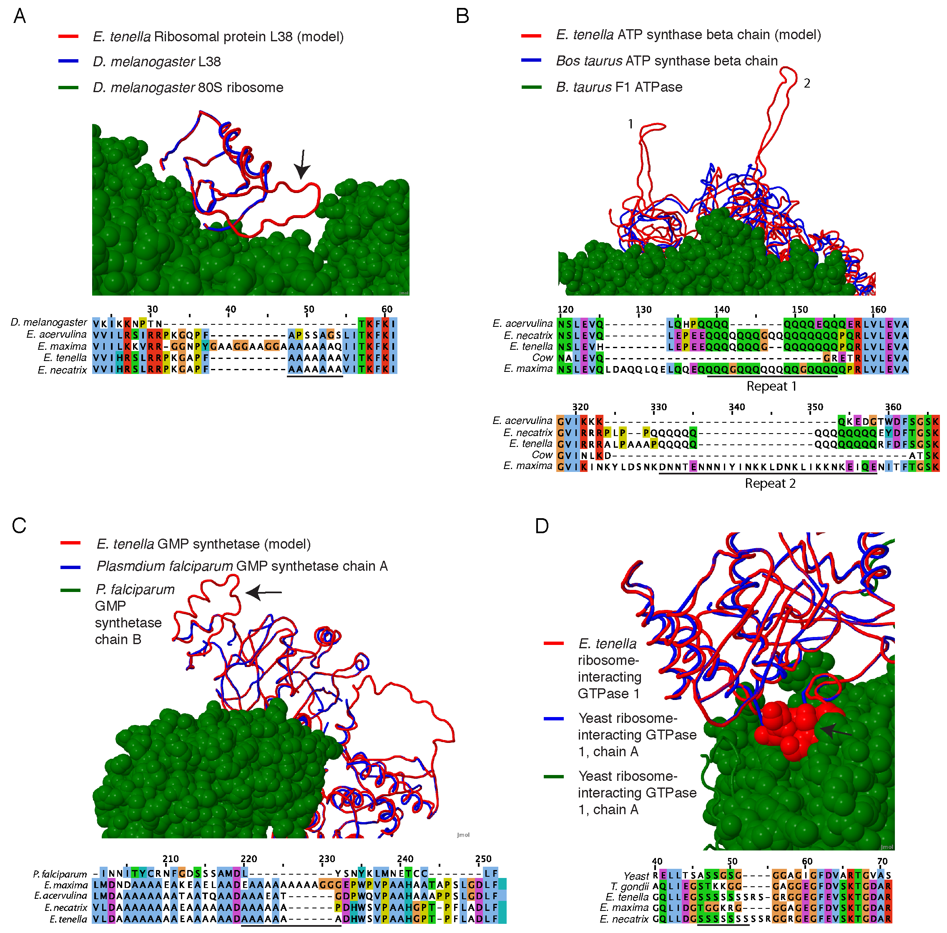

Supplemental Figure S2. Structural context of HAARs in homology models.
(A) E. tenella ribosomal protein L38 (ETH_00013290) was modeled using the Drosophila melanogaster template 3J39k. It shows that the repeat represents an insertion relative to the template which is on the surface of the ribosome. (B) E. tenella ATP synthase beta chain (ETH_00026155) was modeled using the bovine template 1h8eE. This sequence has two large HAARs which are insertions relative to the template. These are located on the surface of the ATP synthase. (C) E. tenella GMP synthetase was modeled on the P. falciparum template 3u0wA. The sequence has a single HAAR which is located in a region at the surface of the template protein which is disordered. (D) E. tenella ribosome-interacting GTPase 1 (ETH_00025450; red chain) was modeled on the yeast orthologue template (PDB:4A9A). The model shows a serine HAAR buried at the interface of two domains (blue and green chains). This region is disordered (unobserved) in the yeast crystal structure.

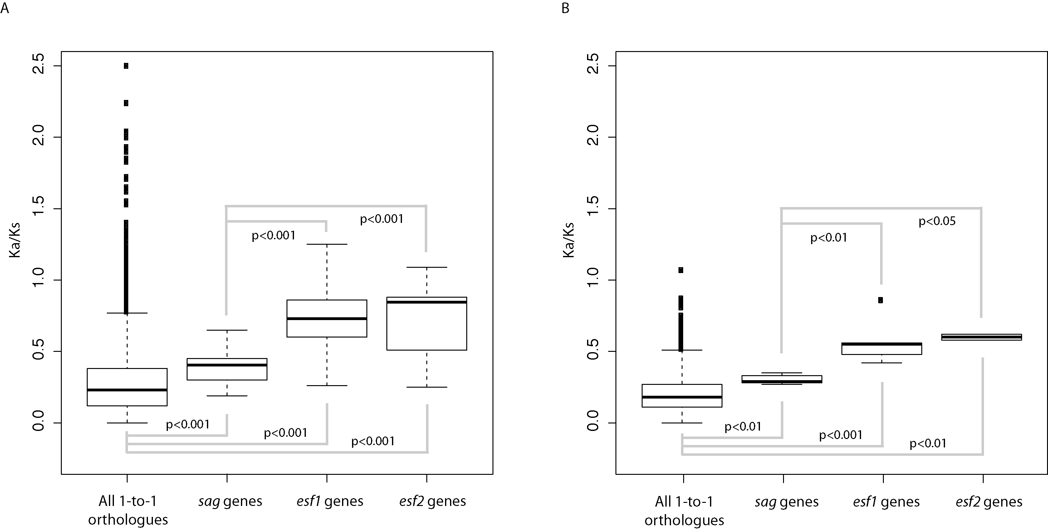

Supplemental Figure S3. K_{a}/K_{s} ratios for sag, esf1 and esf2 gene families.
(A) Analysis of 1-to-1 orthologues of E. tenella and E. necatrix show that the sag, esf1 and esf2 gene families tend to have higher K_{a}/K_{s} ratios than all genes by the Wilcoxon rank sum test. Furthermore, esf1 and esf2 families have significantly higher ratios than sag genes. This suggests that esf1 and esf2 are under relaxed selection and is suggestive of a role in host-parasite interactions as they may be diversifying in an arms race with the host. (B) This finding was replicated when calculating K_{a}/K_{s} between E. acervulina and E. maxima, showing that these families are under evolving in a similar fashion in both lineages of Eimeria infected domestic chickens.

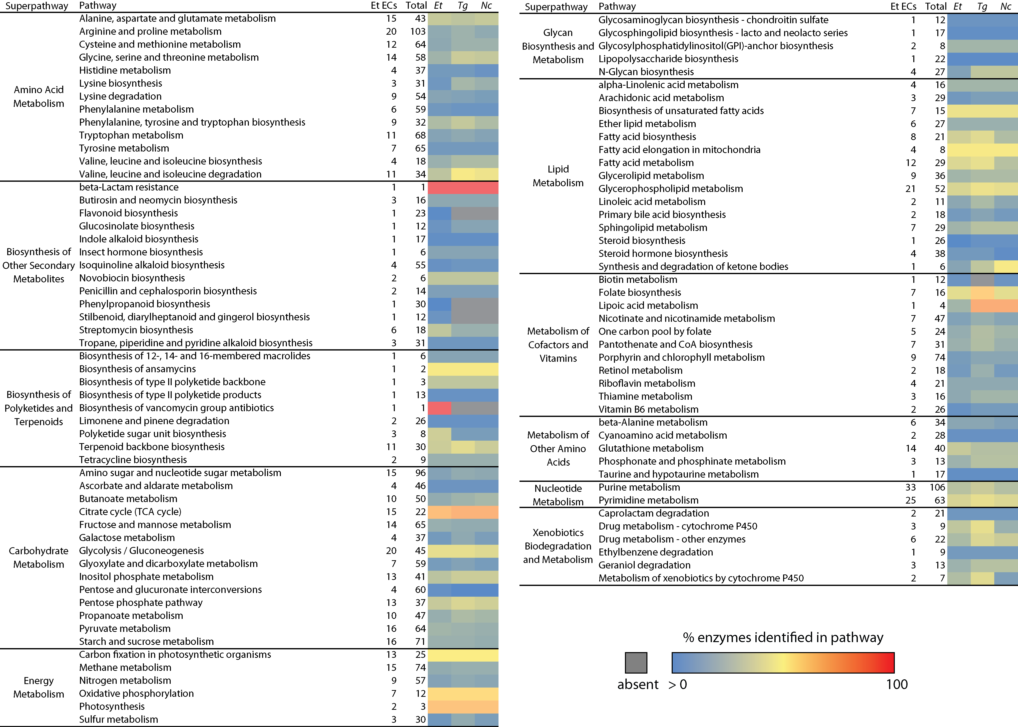

Supplemental Figure S4. Heatmap showing the conservation of individual metabolic pathways for E. tenella, T. gondii, and N. caninum.
Each row indicates an individual metabolic pathway grouped by their superclass membership (defined by KEGG). Coloured tiles indicate the level of conservation (percentage of enzymes detected) of each pathway within each species. For T. gondii, enzymes are based on the integration of BRENDA, ToxoDB, DETECT in addition to those shared by all three of BLAST, PRIAM, and KEGG. A similar integration is performed for identifying N. caninum enzymes, but with an additional dataset of the enzymes corresponding to T. gondii orthologs.

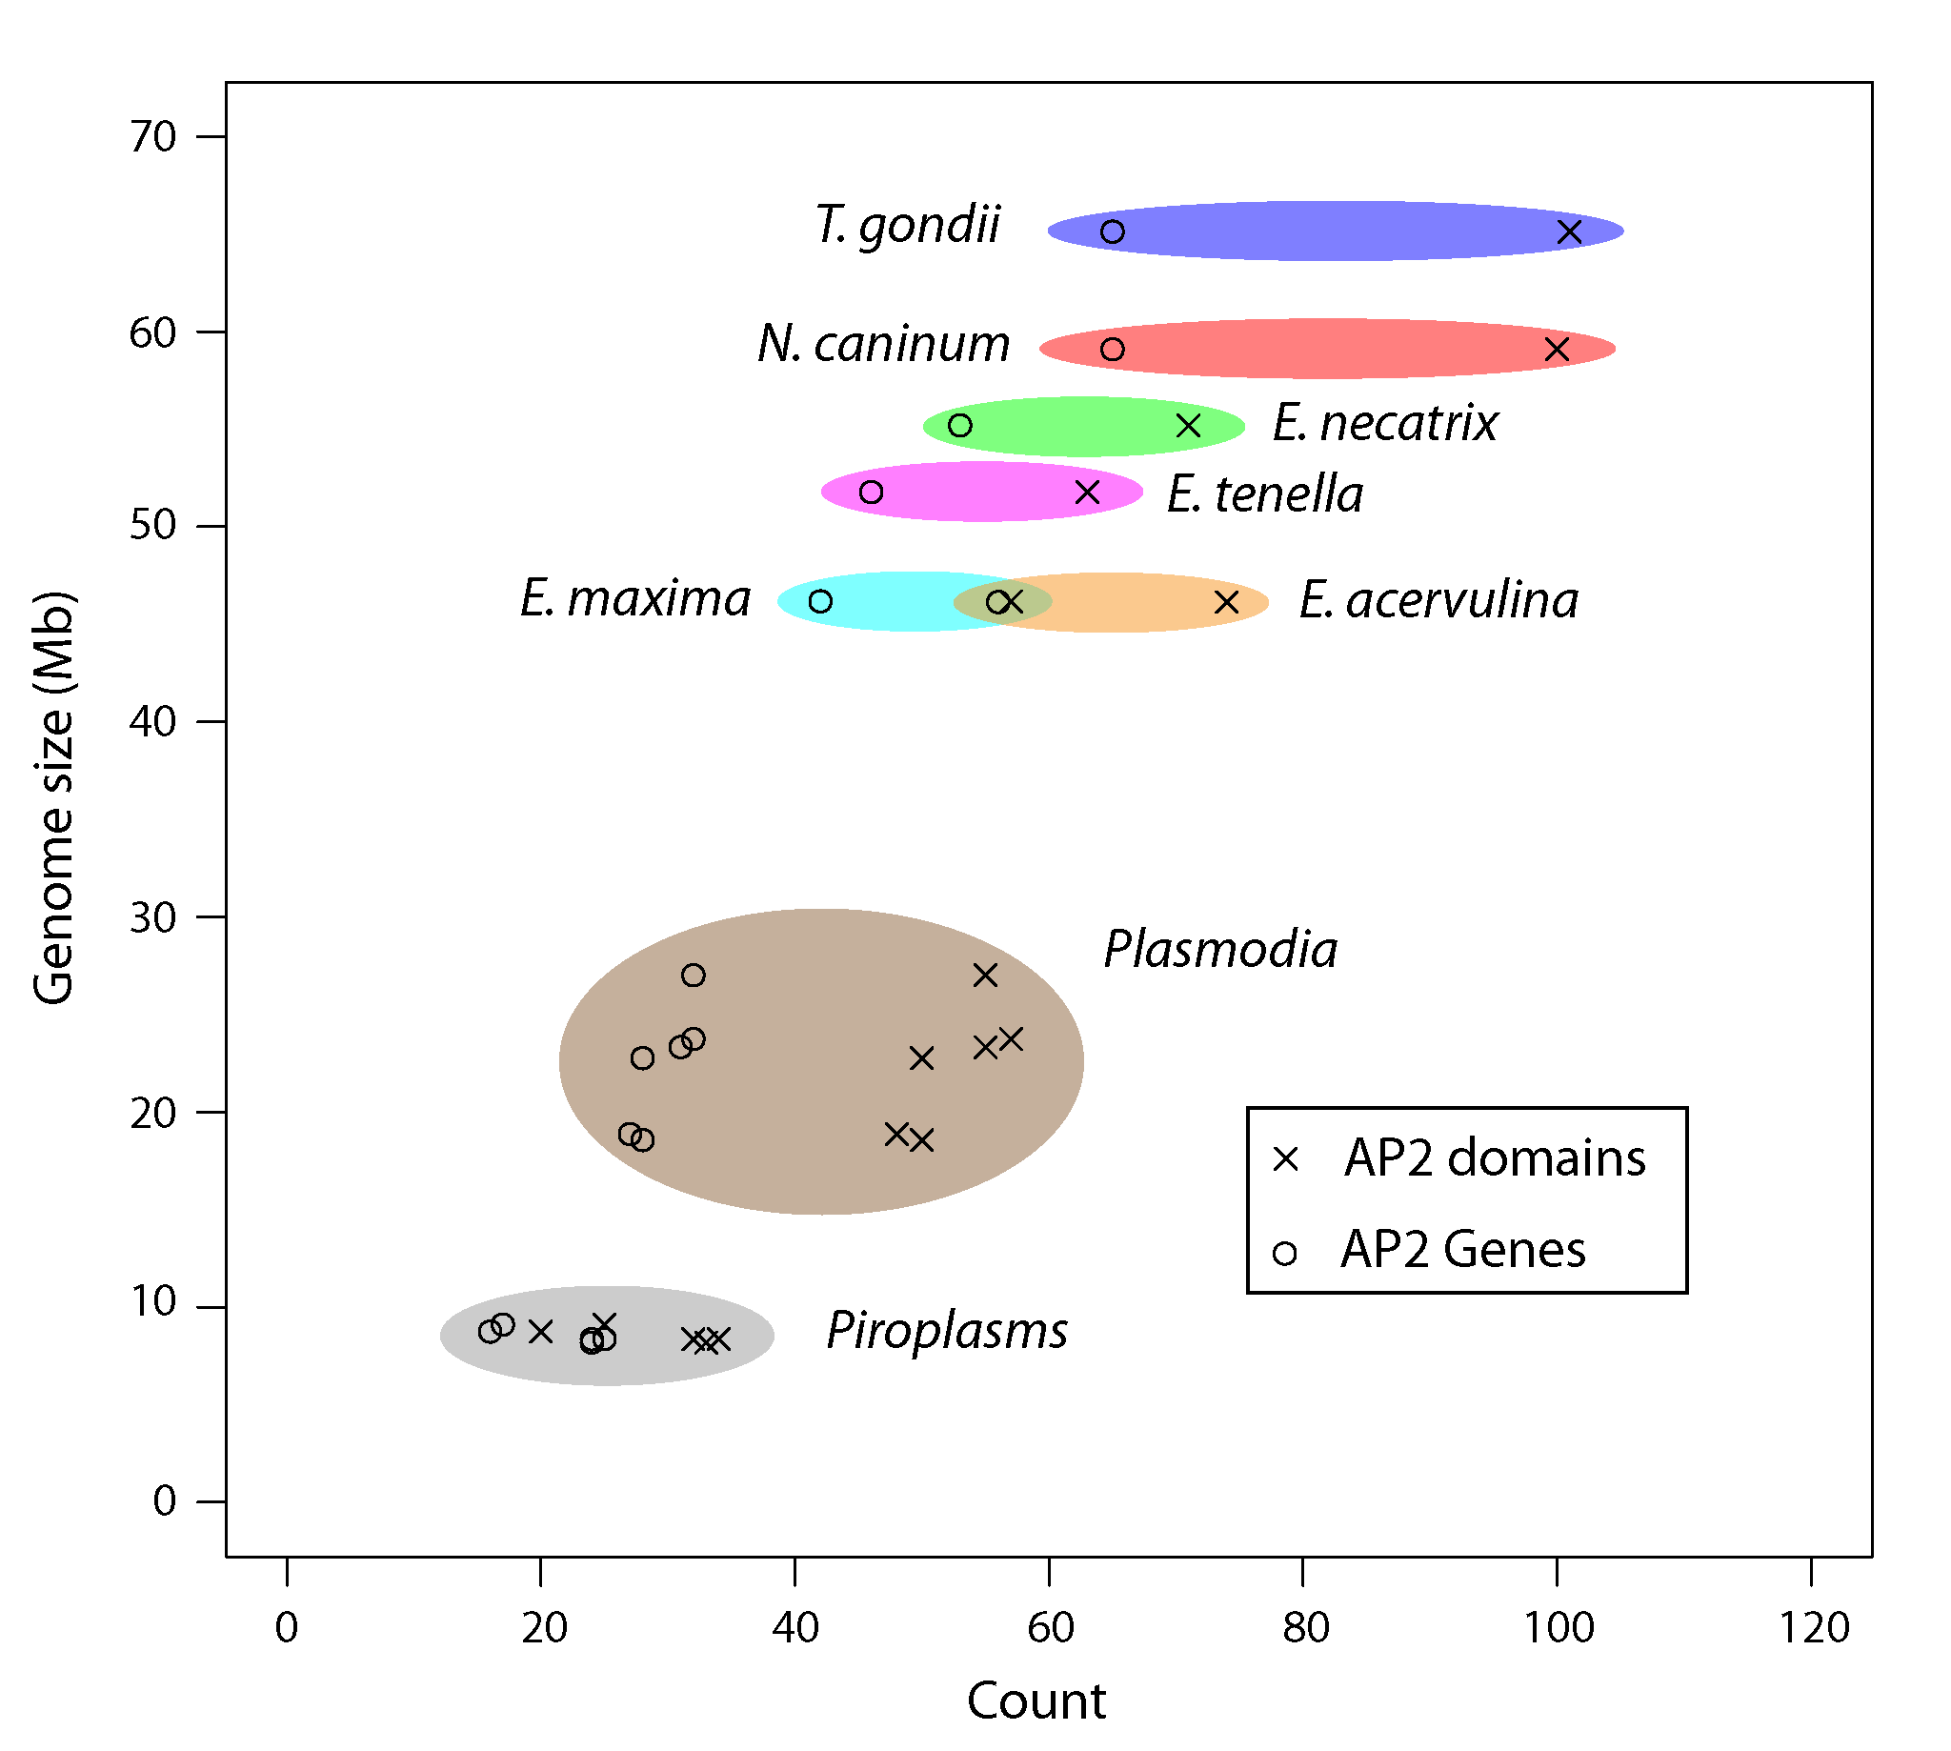

Supplemental Figure S5. Distribution of the Api-AP2 family of DNA-binding domains and genes across the Apicomplexa.
The number of genes containing AP2 domains is correlated with genome size across the Apicomplexa. We compiled the proteomes from public databases such as EupathDB and NCBI Genome database (http://www.ncbi.nlm.nih.gov/genome). We searched for the presence of AP2 domain (PF00847) in predicted Eimeria proteomes and related species using the ‘pfam_scan.pl’ script (ftp://ftp.sanger.ac.uk/pub/databases/Pfam/Tools/PfamScan.tar.gz) with default parameters, which is profiles’s GA gathering cutoff (20.50). The second step was through manual curation using TBLASTN to identify additional Ap2 family orthologues due to missed genes predictions during automated annotation. We used AP2 genes identified through pfam_scan.pl as query and formatted seven Eimeria genomes as database with >=70% identity match and e-value of 1e⁻⁵ cutoff.

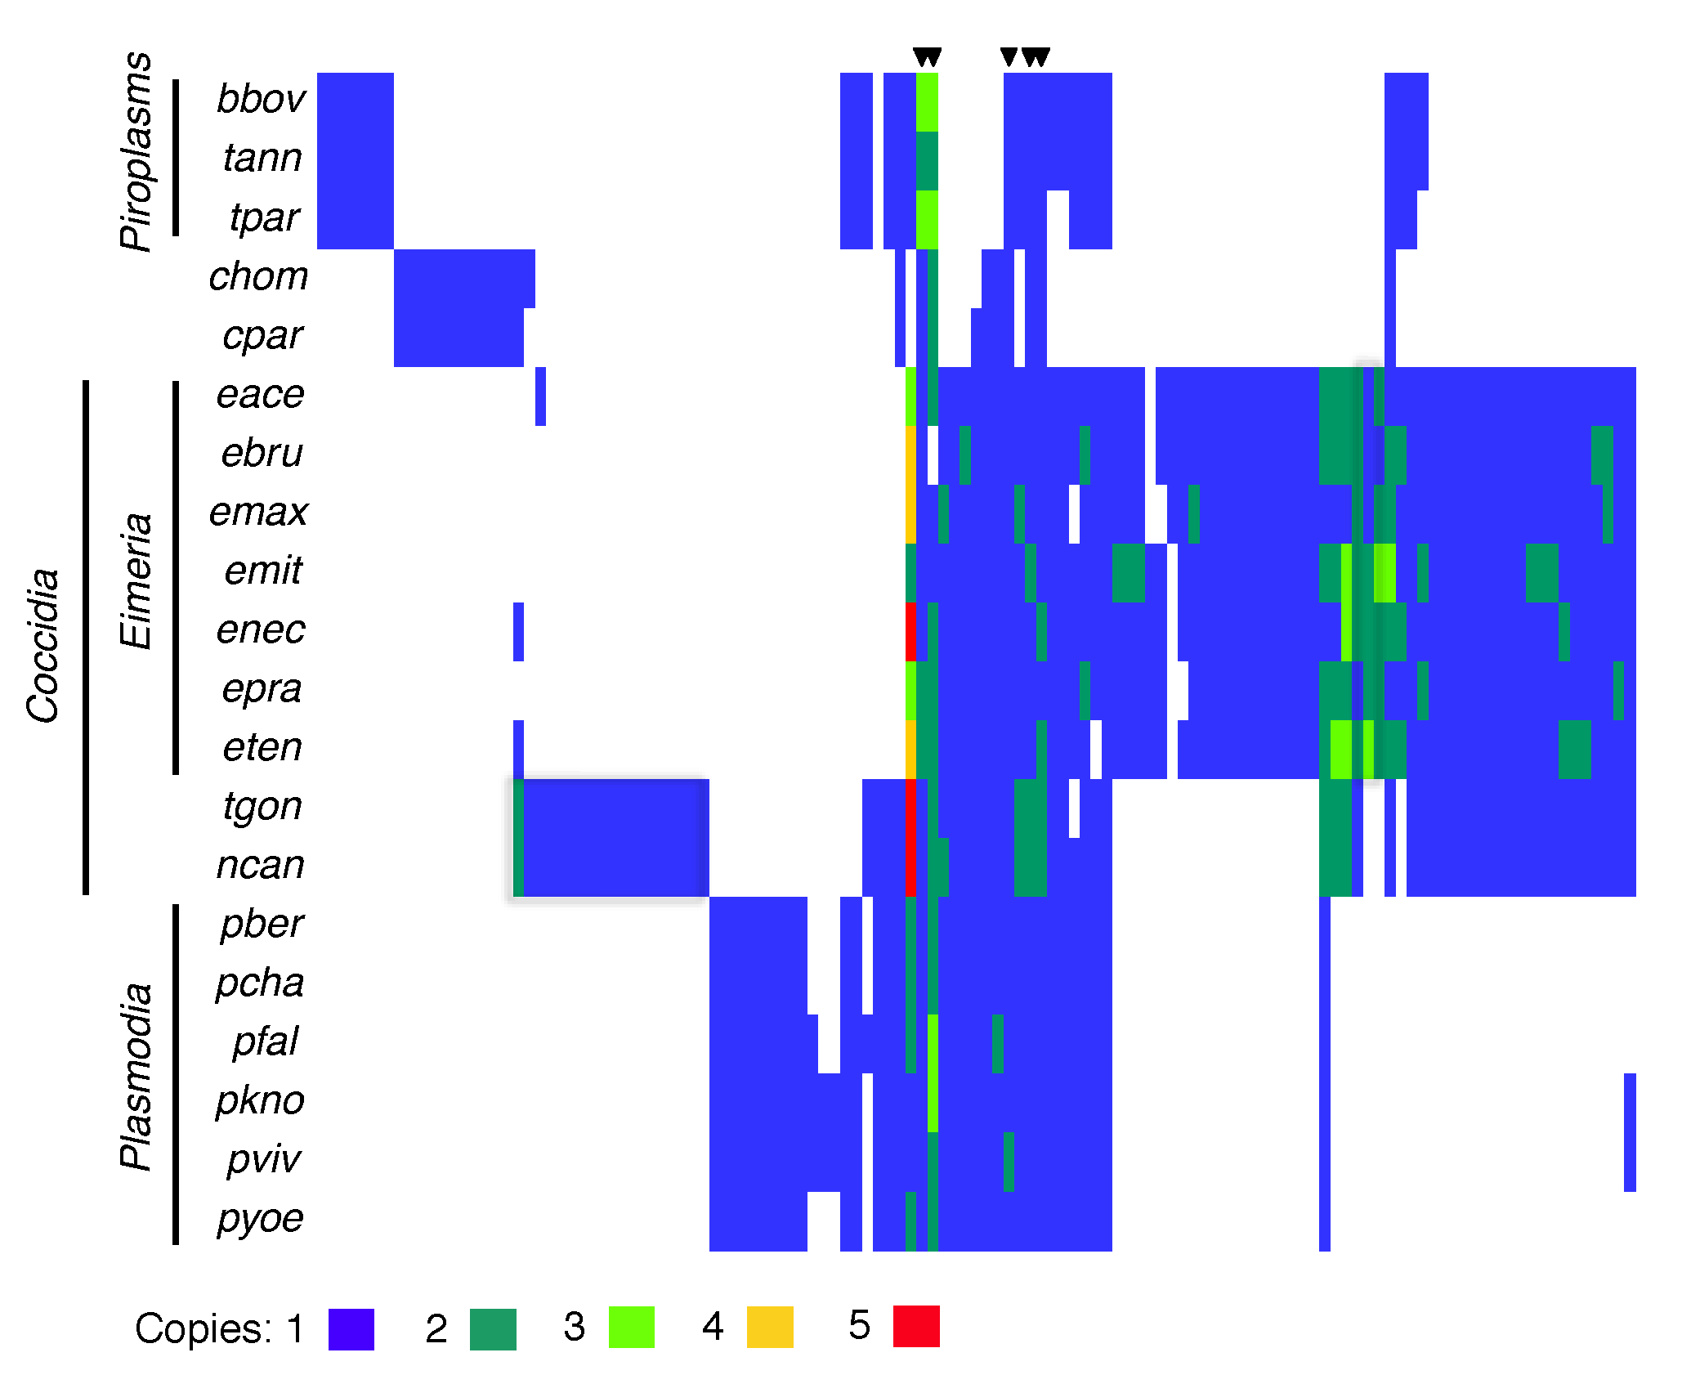

Supplemental Figure S6. Clustering of ApiAP2 domain-containing genes across the Apicomplexa.
The OrthoMCL groups for apiAP2 genes are plotted as a heatmap. Each column represents a particular orthologous group with the number of genes per species in that group represented by colour. We identified five orthologous groups conserved across the apicomplexa, marked with arrows (in order left to right: apiap2_og_336, apiap2_og _90, apiap2_og _1428, apiap2_og _546, apiap2_og _456)

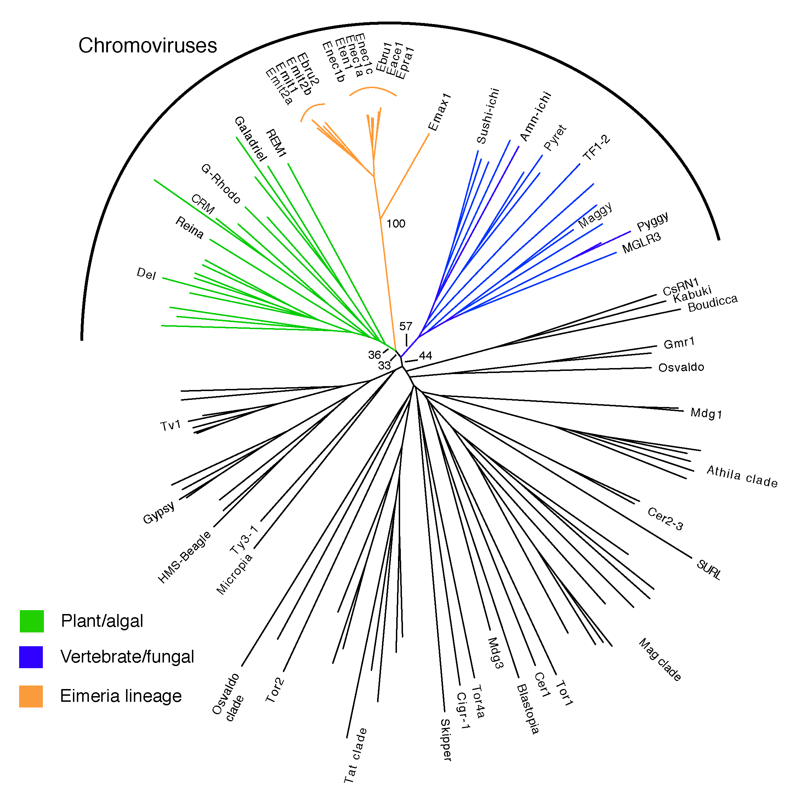

Supplemental Figure S7. Neighbour-joining phylogeny of Ty3/Gypsy LTR retrotransposon reverse transcriptases.
Eimeria LTR retrotransposons fall within the chromoviruses and indeed have chromodomains in addition to reverse transcriptases, which typifies this group. Bootstrapping (1000 replicates) shows that it is not clear whether Eimeria chromoviruses are most related to the plant/algal or vertegrate/fungal lineages.

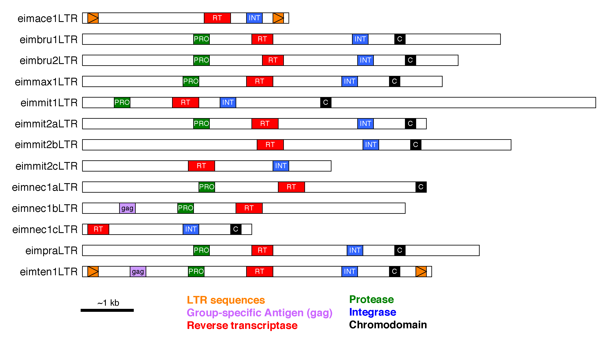

Supplemental Figure S8. Domain structures of chromovirus consensuses.
Chromovirus sequences were clustered and representative examples extracted from these clusters. Their domain structures were determined using HMMsearch. Full-length copies show homology to gag knuckle, aspartyl protease, reverse transcriptase, integrase and the chromodomain; RNase H was seen in some cases. The gag gene is always reduced to the gag knuckle and both gag and pol open reading frames are always interrupted with stop codons suggesting that the genes are not functional.

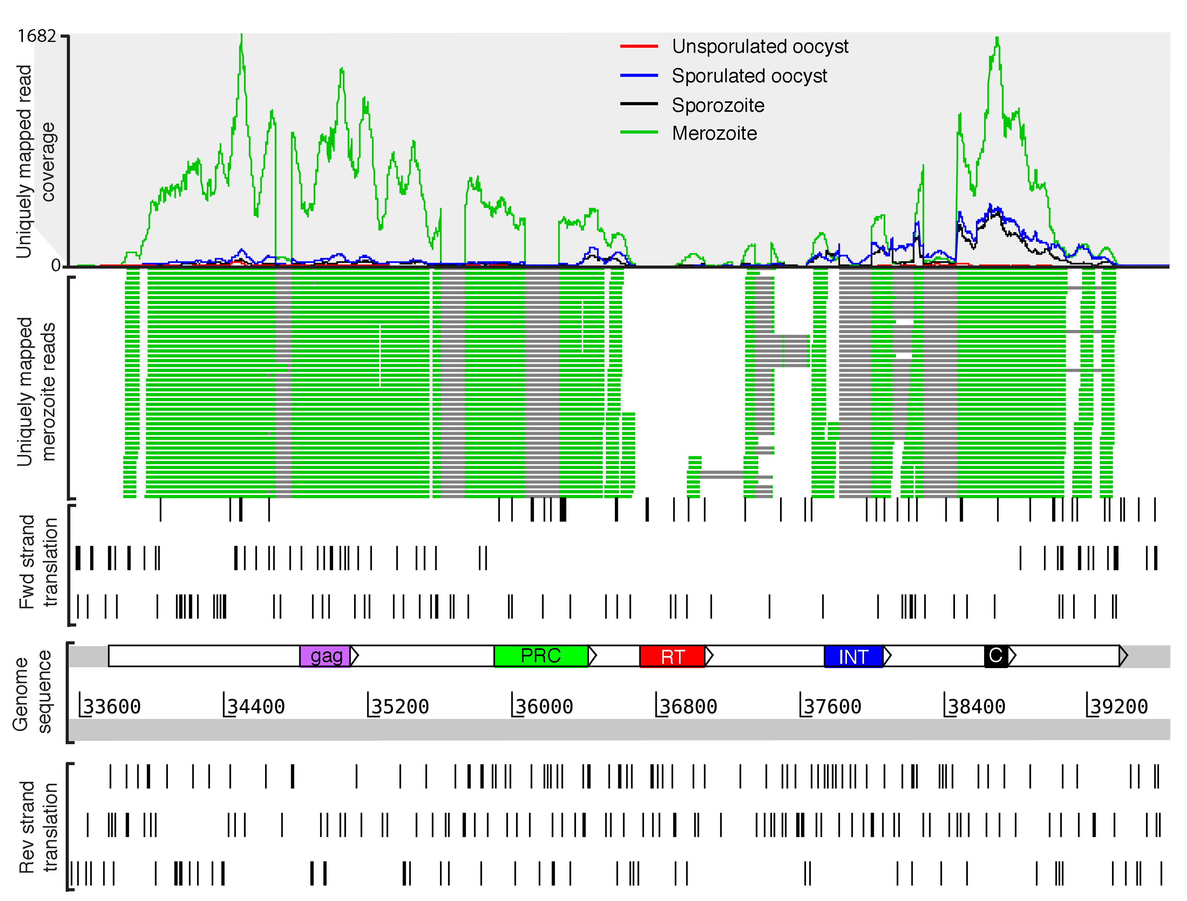

Supplemental Figure S9. Expression pattern for an example LTR retrotransposon from E. tenella.
Transcriptome read coverage from four life stages is shown in the top panel, mapped to ETH_00060060, an example eimten1LTR from E. tenella, on scaffold Eth_scaff28. Only reads mapping uniquely to this region of the genome are shown. The dip in coverage in the middle of the element is at least partly due to the reduced uniqueness of the element around the reverse transcriptase, which is the more conserved part of the element. The second panel shows individual reads mapping from the merozoite stage in green and, in grey, where they are broken over putative introns. Note that no reads were identified bridging the two halves of the transposon separated by the putative reverse transcriptase domain (in red), even when including non-uniquely mapping reads, suggesting that there are two transcripts at this locus. This is also suggested by differences in read coverage between the two ends in the sporulated oocyst and sporozoite stages. Nonsense mutations in the forward frame translation suggest that open reading frames expected of an intact retrotransposon are not present and putative splice sites interrupt several of the predicted domains. Canonical donor and acceptor sites around the putative introns are located on the reverse strand suggesting that transcription is of the reverse complement of the sequence, which coded for the ancestral retrotransposon. Between strains of E. tenella (Houghton, Wisconsin and Nippon) we find only one transposon that varied in copy number. This suggests that if retrotransposition events do still occur in E. tenella they are rare. It is currently unclear whether these transposons are merely degraded or whether their expression and splicing relates to function.

Supplemental Datasets

Supplemental Dataset S1. Details of gene families of interest.
This spreadsheet lists genes which we have assigned to different genes families: novel, Eimeria-specific families (tab 1), rhoptry kinase families (tab 2), ApiAP2 transcription factors (tab 3), orthologous groups of ApiAP2 transcription factors across Apicomplexa (tab 4).

Supplemental Dataset S2. K_{a}/K_{s} ratios
K_{a}/K_{s} ratios for pairwise alignments between one-to-one orthologues are presented in two sheets. Firstly where E. tenella genes where compared againsts one-to-one orthologues for from each other genome (tab 1), secondly for E. acervulina against each other genome.

Supplemental Dataset S3. Metabolic annotation for E. tenella genes
Enzyme Commission term assignments for each E. tenella gene based on BLAST, DETECT, PRIAM and T. gondii orthologue information.

References

Boyle EI, Weng S, Gollub J, Jin H, Botstein D, Cherry JM, Sherlock G. 2004. GO::TermFinder--open source software for accessing Gene Ontology information and finding significantly enriched Gene Ontology terms associated with a list of genes. Bioinformatics 20(18): 3710-3715.
Lim LS, Tay YL, Alias H, Wan KL, Dear PH. 2012. Insights into the genome structure and copy-number variation of Eimeria tenella. BMC Genomics 13: 389.
Parra G, Bradnam K, Korf I. 2007. CEGMA: a pipeline to accurately annotate core genes in eukaryotic genomes. Bioinformatics 23(9): 1061-1067.
Perutz MF, Johnson T, Suzuki M, Finch JT. 1994. Glutamine repeats as polar zippers: their possible role in inherited neurodegenerative diseases. Proc Natl Acad Sci U S A 91(12): 5355-5358.
Perutz MF, Pope BJ, Owen D, Wanker EE, Scherzinger E. 2002. Aggregation of proteins with expanded glutamine and alanine repeats of the glutamine-rich and asparagine-rich domains of Sup35 and of the amyloid beta-peptide of amyloid plaques. Proc Natl Acad Sci U S A 99(8): 5596-5600.
Reid AJ, Vermont SJ, Cotton JA, Harris D, Hill-Cawthorne GA, Konen-Waisman S, Latham SM, Mourier T, Norton R, Quail MA et al. 2012. Comparative genomics of the apicomplexan parasites Toxoplasma gondii and Neospora caninum: Coccidia differing in host range and transmission strategy. PLoS Pathog 8(3): e1002567.
Talevich E, Kannan N. 2013. Structural and evolutionary adaptation of rhoptry kinases and pseudokinases, a family of coccidian virulence factors. BMC evolutionary biology 13: 117.

