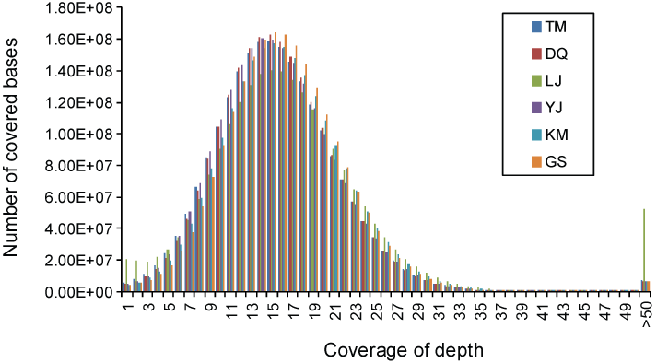
Supplemental Figure 1. Sequencing depth distributions of the six breeds. For each breed, the sequencing depths of ten individuals were averaged for plotting. The mode of each distribution is 15× and most of the bases are covered with a depth ranging from 2 to 30×.

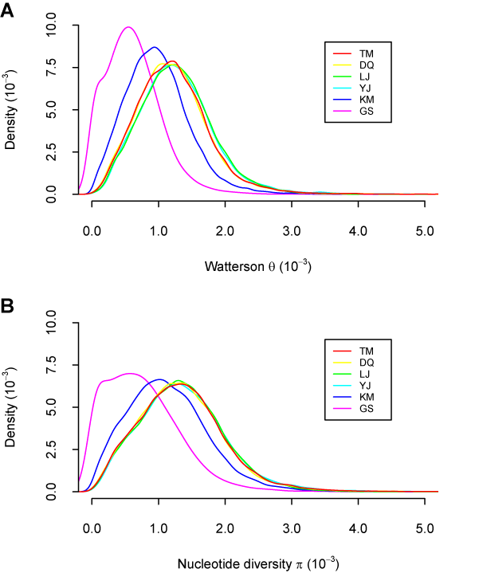
Supplemental Figure 2. Distributions of (A) Watterson’s θ and (B) nucleotide diversity π across the genome. Both statistics were calculated for a 100 kb sliding window along the genome. Only SNPs on autosomes were considered.

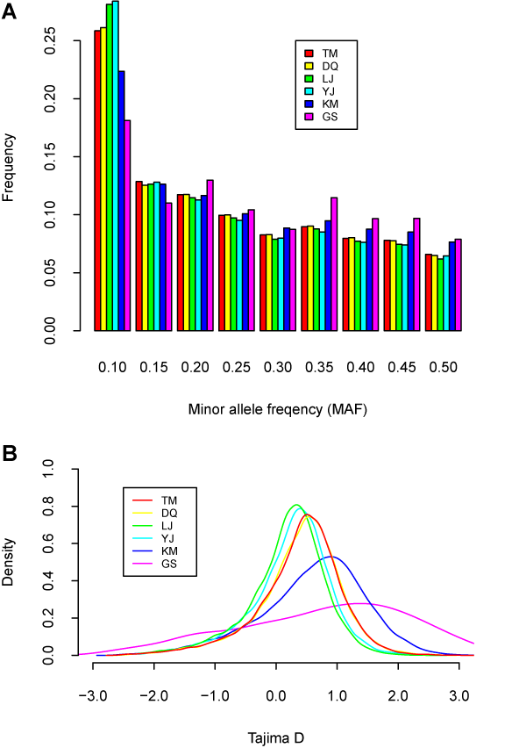
Supplemental Figure 3. Distributions of (A) minor allele frequency and (B) Tajima's D across the genome. Alleles with frequency lower than 0.10 were not considered because of the insufficient sample size. The Tajima’s D was calculated for a 100 kb sliding window along the genome.

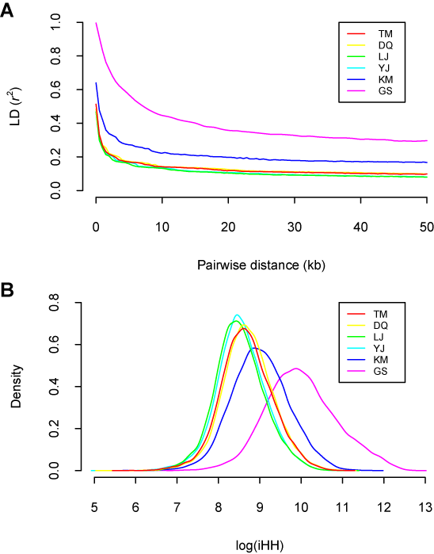
Supplemental Figure 4. Levels of linkage disequilibrium across the genome. (A) The correlation coefficient (r²) between two markers decays with the increase of their pairwise distance. The average r² against distances was plotted using lowess regression in R. (B) Distributions of integrated haplotype homozygosity (iHH). The iHH was calculated for a 100 kb sliding window along the genome.

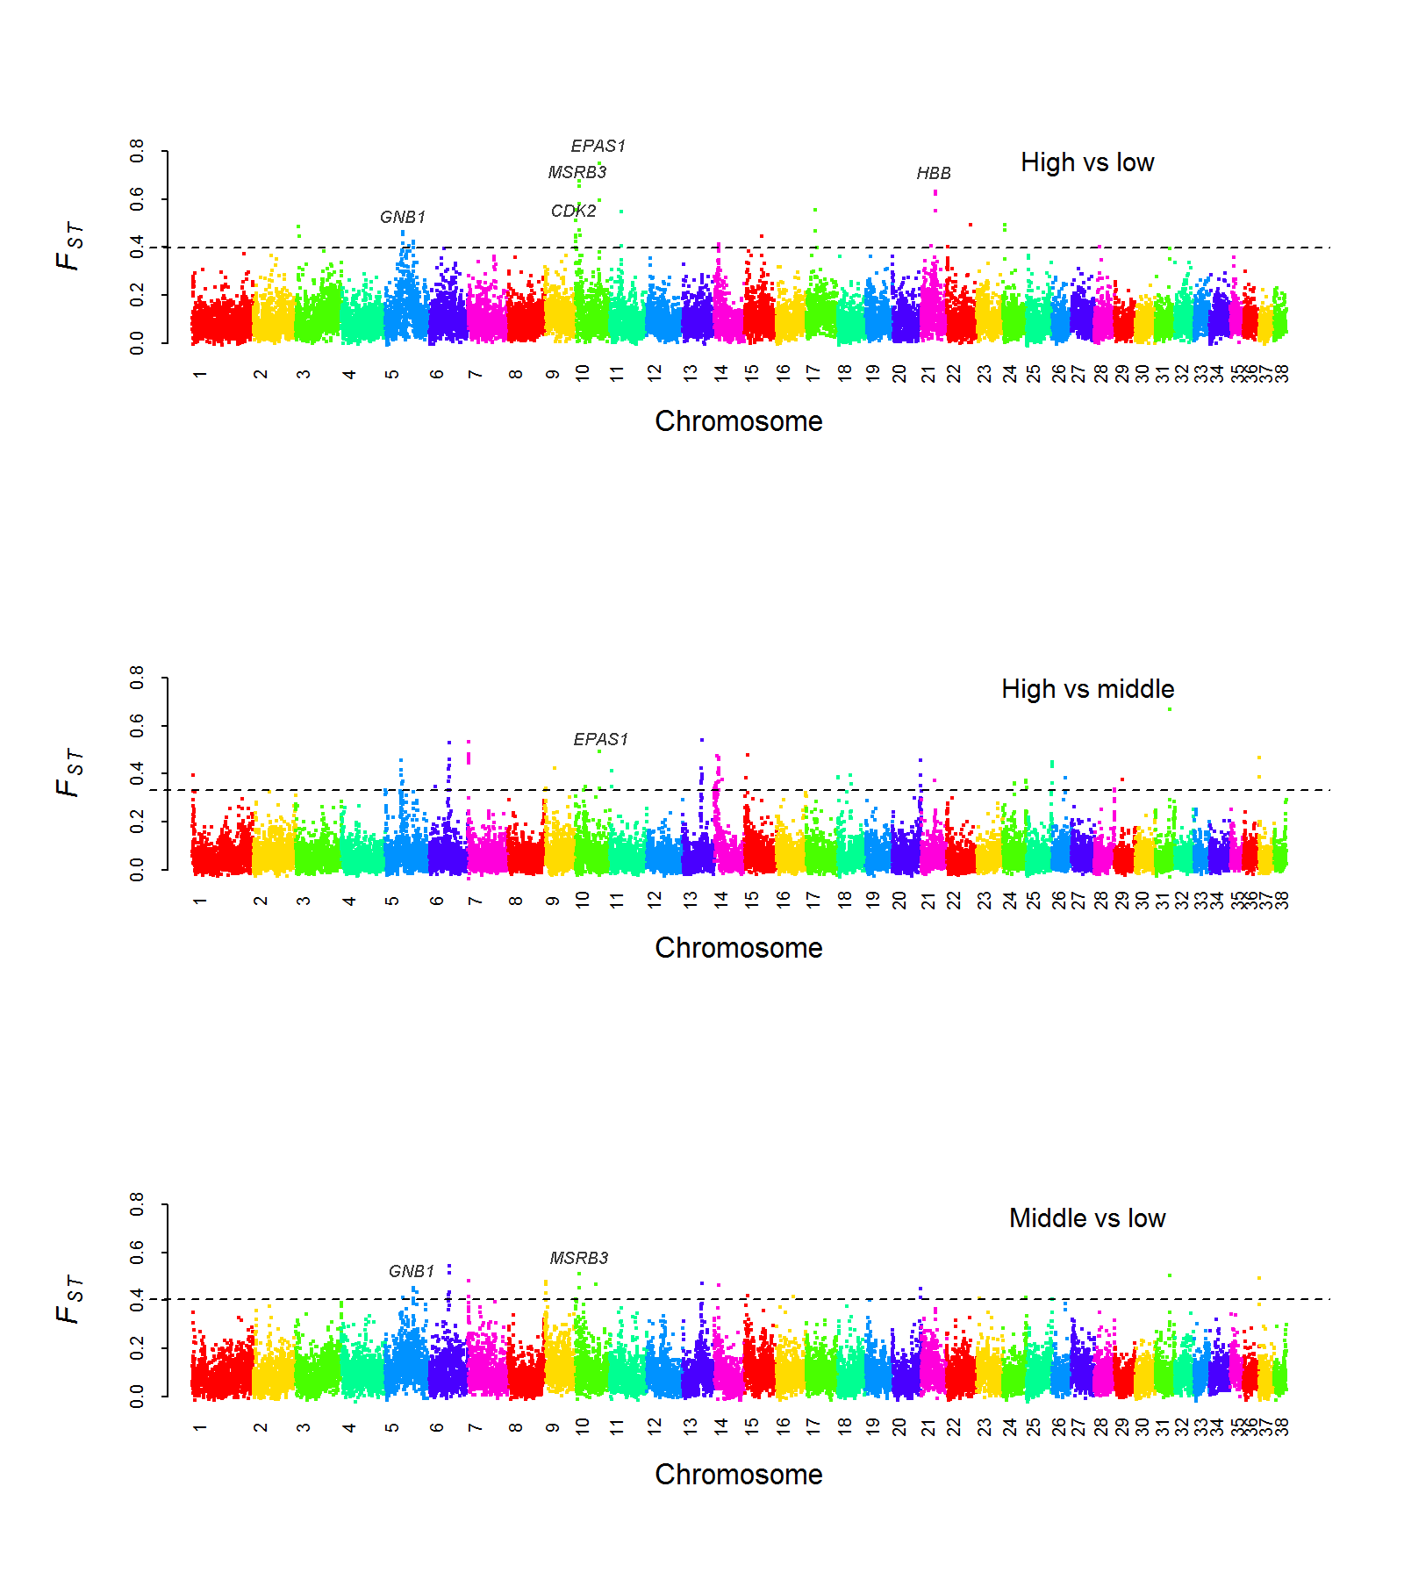
Supplemental Figure 5. Manhattan plot of F_{ST} between the high- (TM, DQ), middle- (LJ) and low- (YJ, KM, GS) altitude breeds. The F_{ST} was calculated for each 100 kb autosomal window. The dashed line denotes the threshold of Z(F_{ST}) = 5. The locations of five oxygen-response genes are labeled.

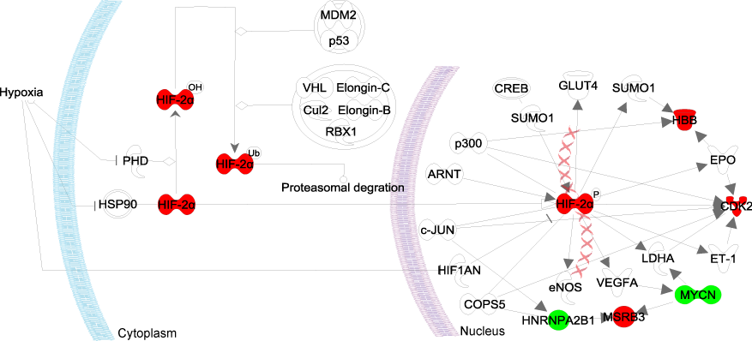
Supplemental Figure 6. EPAS1 signaling pathway. The image was created using the Ingenuity Pathways Analysis (IPA) platform by connecting genes we identified with genes in the hypoxia signaling pathway and HIF-1α signaling pathway from the Ingenuity knowledgebase. The molecules and interactions are shown according to the IPA conventions. The red molecules are genes identified by our selective sweep analysis and belonging to the GO categories ‘response to oxygen levels’ and ‘response to oxidative stress’. The green molecules are mediators that connect the identified genes and the canonical pathways. GNB1 is not shown in the image as it has too many connections with the pathways.

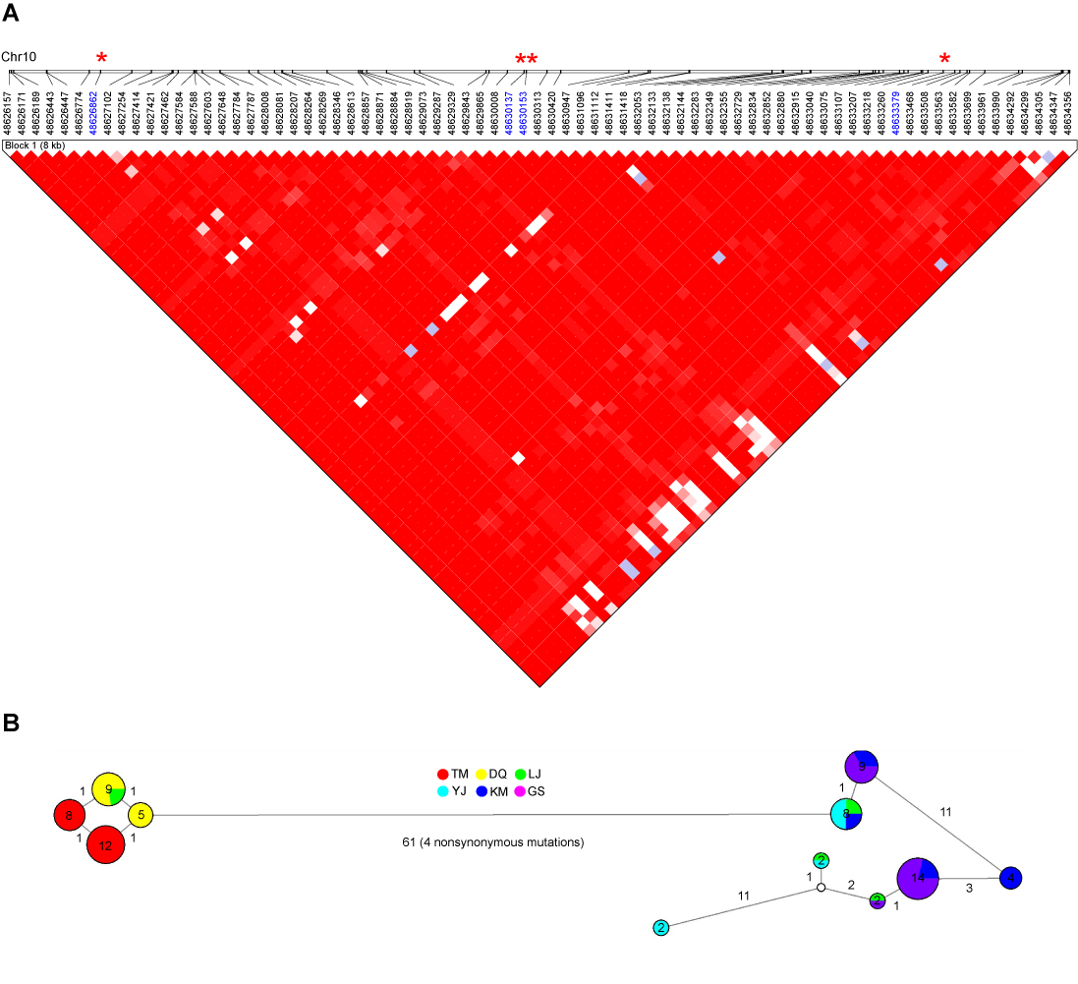
Supplemental Figure 7. LD block and haplotypes comprising the four non-synonymous mutations in EPAS1. (A) LD block showing pairwise correlation coefficients (r²) between two SNP sites. The colors range from white to red with the increase of r² from 0 to 1. The r² were calculated based on all the six breeds and only SNP sites with MAF ≥ 0.1 were considered. Positions of the non-synonymous mutations are indicated by red stars. (B) Network of haplotypes in the LD block. Each node represents a haplotype and the node size is proportional to the haplotype frequency. The distribution of a haplotype in the six breeds is represented by pie chart. The edge length is proportional to the number of mutations between two haplotypes. Only haplotypes with frequency > 1 were included.

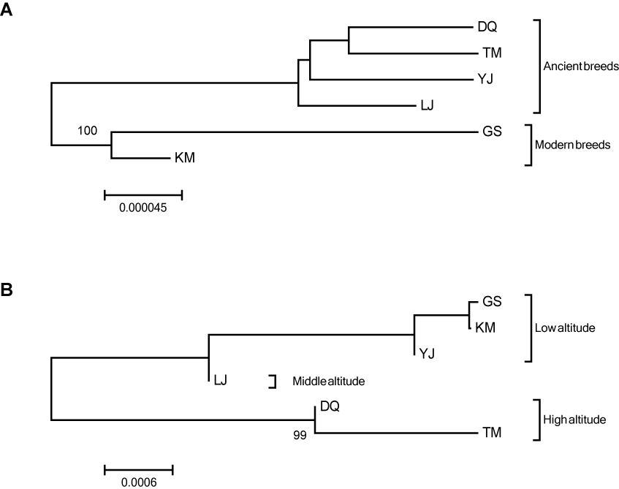
Supplemental Figure 8. Neighbor-joining tree of the six breeds reconstructed from SNP data. (A) Genome-wide SNPs. (B) SNPs in the EPAS1 haplotype. The evolutionary distance is measured by net nucleotide substitutions per site.

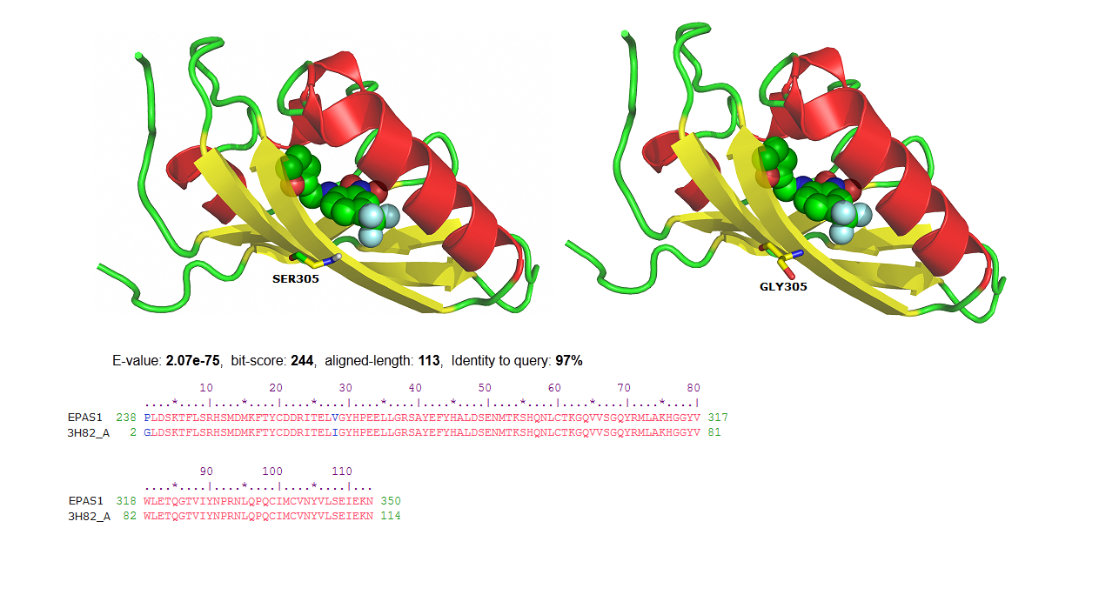
Supplemental Figure 9. Predicted model of PAS domain in dog EPAS1. The model was predicted on the basis of the human EPAS1 PAS-B crystal structure (PDB ID: 3H82; an artificial ligand is shown in the structure). The location of mutated residue G305S is marked in the structure, which was predicted to increase the thermodynamic stability of the domain (ΔΔG = -3.09 kcal/mol). Amino acid alignment between dog and human EPAS1 PAS-B show 97% sequence identity. The alignment indicates (|) identical, (:) similar, and (.) dissimilar residues.

Supplemental Table 1. Number of reads and bases in quality control.
Breed | Sample | Raw data |  | Filter low quality reads |  | Trim low quality ends
Breed | Sample | Reads | Bases | Reads | Bases | Reads | Bases
TM | DQZA01 | 4.67E+08 | 4.72E+10 | 4.00E+08 | 4.04E+10 | 3.87E+08 | 3.79E+10
TM | DQZA06 | 4.57E+08 | 4.25E+10 | 4.00E+08 | 3.72E+10 | 3.91E+08 | 3.55E+10
TM | DQZA12 | 4.72E+08 | 4.39E+10 | 4.10E+08 | 3.81E+10 | 4.00E+08 | 3.63E+10
TM | DQZA18 | 4.24E+08 | 4.24E+10 | 3.55E+08 | 3.55E+10 | 3.39E+08 | 3.26E+10
TM | DQZA19 | 4.50E+08 | 4.50E+10 | 3.77E+08 | 3.77E+10 | 3.63E+08 | 3.48E+10
TM | DQZA23 | 4.72E+08 | 4.72E+10 | 3.93E+08 | 3.93E+10 | 3.77E+08 | 3.62E+10
TM | DQZA33 | 4.73E+08 | 4.73E+10 | 4.16E+08 | 4.16E+10 | 4.04E+08 | 3.94E+10
TM | DQZA55 | 4.42E+08 | 4.42E+10 | 3.71E+08 | 3.71E+10 | 3.58E+08 | 3.44E+10
TM | DQZA80 | 4.77E+08 | 4.77E+10 | 4.18E+08 | 4.18E+10 | 4.06E+08 | 3.95E+10
TM | DQZA81 | 4.79E+08 | 4.79E+10 | 4.17E+08 | 4.17E+10 | 4.05E+08 | 3.94E+10
DQ | DQ25 | 4.66E+08 | 4.66E+10 | 4.16E+08 | 4.16E+10 | 4.05E+08 | 3.94E+10
DQ | DQ28 | 4.83E+08 | 4.83E+10 | 4.30E+08 | 4.30E+10 | 4.20E+08 | 4.10E+10
DQ | DQ29 | 4.53E+08 | 4.53E+10 | 3.80E+08 | 3.80E+10 | 3.68E+08 | 3.57E+10
DQ | DQ32 | 4.91E+08 | 4.91E+10 | 3.98E+08 | 3.98E+10 | 3.84E+08 | 3.72E+10
DQ | DQ33 | 4.58E+08 | 4.58E+10 | 4.12E+08 | 4.12E+10 | 4.02E+08 | 3.92E+10
DQ | DQ45 | 3.89E+08 | 3.89E+10 | 3.45E+08 | 3.45E+10 | 3.37E+08 | 3.28E+10
DQ | DQ52 | 5.01E+08 | 5.01E+10 | 4.26E+08 | 4.26E+10 | 4.13E+08 | 4.00E+10
DQ | DQ54 | 3.87E+08 | 3.87E+10 | 3.32E+08 | 3.32E+10 | 3.23E+08 | 3.12E+10
DQ | DQ59 | 4.06E+08 | 4.10E+10 | 3.69E+08 | 3.73E+10 | 3.60E+08 | 3.55E+10
DQ | DQ60 | 4.62E+08 | 4.62E+10 | 4.10E+08 | 4.10E+10 | 3.99E+08 | 3.87E+10
LJ | LJ1 | 4.68E+08 | 4.68E+10 | 4.15E+08 | 4.15E+10 | 4.06E+08 | 3.98E+10
LJ | LJ12 | 4.66E+08 | 4.66E+10 | 4.14E+08 | 4.14E+10 | 4.06E+08 | 3.98E+10
LJ | LJ13 | 4.65E+08 | 4.65E+10 | 3.98E+08 | 3.98E+10 | 3.87E+08 | 3.80E+10
LJ | LJ2 | 3.95E+08 | 3.95E+10 | 3.55E+08 | 3.55E+10 | 3.48E+08 | 3.42E+10
LJ | LJ6 | 4.39E+08 | 4.39E+10 | 3.80E+08 | 3.80E+10 | 3.71E+08 | 3.61E+10
LJ | LJ8 | 4.61E+08 | 4.61E+10 | 3.96E+08 | 3.96E+10 | 3.83E+08 | 3.73E+10
LJ | WM3 | 3.66E+08 | 3.66E+10 | 3.34E+08 | 3.34E+10 | 3.28E+08 | 3.23E+10
LJ | YL1 | 4.57E+08 | 4.57E+10 | 3.99E+08 | 3.99E+10 | 3.90E+08 | 3.80E+10
LJ | YL5 | 4.54E+08 | 4.54E+10 | 3.98E+08 | 3.98E+10 | 3.89E+08 | 3.80E+10
LJ | YL7 | 4.27E+08 | 4.27E+10 | 3.82E+08 | 3.82E+10 | 3.74E+08 | 3.67E+10
YJ | YJ01 | 4.83E+08 | 4.83E+10 | 4.20E+08 | 4.20E+10 | 4.09E+08 | 3.97E+10
YJ | YJ03 | 4.89E+08 | 4.89E+10 | 3.85E+08 | 3.85E+10 | 3.65E+08 | 3.48E+10
YJ | YJ08 | 4.95E+08 | 4.95E+10 | 3.79E+08 | 3.79E+10 | 3.58E+08 | 3.40E+10
YJ | YJ10 | 5.13E+08 | 5.13E+10 | 3.88E+08 | 3.88E+10 | 3.63E+08 | 3.44E+10
YJ | YJ14 | 4.89E+08 | 4.89E+10 | 3.74E+08 | 3.74E+10 | 3.50E+08 | 3.33E+10
YJ | YJ15 | 4.91E+08 | 4.91E+10 | 4.01E+08 | 4.01E+10 | 3.81E+08 | 3.64E+10
YJ | YJ16 | 5.07E+08 | 5.07E+10 | 3.93E+08 | 3.93E+10 | 3.69E+08 | 3.46E+10
YJ | YJ17 | 5.11E+08 | 5.11E+10 | 3.99E+08 | 3.99E+10 | 3.78E+08 | 3.59E+10
YJ | YJ21 | 4.91E+08 | 4.91E+10 | 3.91E+08 | 3.91E+10 | 3.78E+08 | 3.64E+10
YJ | YJ26 | 4.95E+08 | 4.95E+10 | 4.08E+08 | 4.08E+10 | 3.94E+08 | 3.82E+10
KM | KD106 | 4.03E+08 | 4.06E+10 | 2.98E+08 | 3.00E+10 | 2.91E+08 | 2.86E+10
KM | KD107 | 4.66E+08 | 4.71E+10 | 4.25E+08 | 4.29E+10 | 4.16E+08 | 4.10E+10
KM | KD110 | 4.63E+08 | 4.63E+10 | 4.08E+08 | 4.08E+10 | 4.00E+08 | 3.90E+10
KM | KD113 | 4.78E+08 | 4.78E+10 | 4.20E+08 | 4.20E+10 | 4.10E+08 | 4.01E+10
KM | KD117 | 4.77E+08 | 4.77E+10 | 4.16E+08 | 4.16E+10 | 4.06E+08 | 3.96E+10
KM | KD207 | 4.36E+08 | 4.40E+10 | 4.00E+08 | 4.04E+10 | 3.91E+08 | 3.86E+10
KM | KD208 | 4.94E+08 | 4.99E+10 | 4.48E+08 | 4.52E+10 | 4.38E+08 | 4.30E+10
KM | KD215 | 4.46E+08 | 4.50E+10 | 3.55E+08 | 3.59E+10 | 3.48E+08 | 3.43E+10
KM | KD222 | 3.94E+08 | 3.97E+10 | 3.63E+08 | 3.66E+10 | 3.55E+08 | 3.50E+10
KM | KD223 | 4.69E+08 | 4.74E+10 | 4.26E+08 | 4.30E+10 | 4.16E+08 | 4.09E+10
GS | DKD301 | 4.59E+08 | 4.59E+10 | 4.05E+08 | 4.05E+10 | 3.81E+08 | 3.69E+10
GS | DKD302 | 4.77E+08 | 4.77E+10 | 4.24E+08 | 4.24E+10 | 3.99E+08 | 3.89E+10
GS | DKD303 | 4.71E+08 | 4.71E+10 | 4.15E+08 | 4.15E+10 | 3.90E+08 | 3.80E+10
GS | DKD304 | 4.76E+08 | 4.76E+10 | 4.03E+08 | 4.03E+10 | 3.88E+08 | 3.77E+10
GS | DKD305 | 4.52E+08 | 4.52E+10 | 3.86E+08 | 3.86E+10 | 3.74E+08 | 3.63E+10
GS | DKD306 | 4.59E+08 | 4.59E+10 | 4.04E+08 | 4.04E+10 | 3.95E+08 | 3.84E+10
GS | DKD307 | 4.75E+08 | 4.75E+10 | 4.20E+08 | 4.20E+10 | 4.10E+08 | 3.98E+10
GS | DKD308 | 4.79E+08 | 4.79E+10 | 3.95E+08 | 3.95E+10 | 3.78E+08 | 3.55E+10
GS | DKD309 | 4.80E+08 | 4.80E+10 | 4.23E+08 | 4.23E+10 | 4.13E+08 | 4.01E+10
GS | DKD310 | 4.86E+08 | 4.86E+10 | 4.22E+08 | 4.22E+10 | 3.88E+08 | 3.74E+10

Supplemental Table 2. Reads mapping statistics and coverage of depth.
Breed | Sample | Non-redundant reads | Mapped reads | Properly paired reads | Properly mapped bases | Mean depthª
TM | DQZA01 | 3.86E+08 | 3.85E+08 | 3.82E+08 | 3.85E+10 | 16.22
TM | DQZA06 | 3.90E+08 | 3.89E+08 | 3.85E+08 | 3.58E+10 | 14.75
TM | DQZA12 | 3.99E+08 | 3.98E+08 | 3.94E+08 | 3.66E+10 | 15
TM | DQZA18 | 3.38E+08 | 3.37E+08 | 3.34E+08 | 3.33E+10 | 13.75
TM | DQZA19 | 3.62E+08 | 3.61E+08 | 3.58E+08 | 3.57E+10 | 15.13
TM | DQZA23 | 3.77E+08 | 3.76E+08 | 3.72E+08 | 3.71E+10 | 15.72
TM | DQZA33 | 4.03E+08 | 4.02E+08 | 3.98E+08 | 3.98E+10 | 16.35
TM | DQZA55 | 3.58E+08 | 3.57E+08 | 3.54E+08 | 3.53E+10 | 14.54
TM | DQZA80 | 4.05E+08 | 4.04E+08 | 4.01E+08 | 4.00E+10 | 16.36
TM | DQZA81 | 4.05E+08 | 4.04E+08 | 4.00E+08 | 4.00E+10 | 16.38
DQ | DQ25 | 4.02E+08 | 4.01E+08 | 3.97E+08 | 3.97E+10 | 16.29
DQ | DQ28 | 4.17E+08 | 4.16E+08 | 4.12E+08 | 4.12E+10 | 16.91
DQ | DQ29 | 3.67E+08 | 3.66E+08 | 3.63E+08 | 3.62E+10 | 14.83
DQ | DQ32 | 3.83E+08 | 3.83E+08 | 3.79E+08 | 3.79E+10 | 15.44
DQ | DQ33 | 4.00E+08 | 3.99E+08 | 3.94E+08 | 3.95E+10 | 16.22
DQ | DQ45 | 3.36E+08 | 3.35E+08 | 3.31E+08 | 3.32E+10 | 13.62
DQ | DQ52 | 4.12E+08 | 4.12E+08 | 4.08E+08 | 4.07E+10 | 17.05
DQ | DQ54 | 3.22E+08 | 3.21E+08 | 3.18E+08 | 3.18E+10 | 13.36
DQ | DQ59 | 3.59E+08 | 3.59E+08 | 3.55E+08 | 3.58E+10 | 14.68
DQ | DQ60 | 3.97E+08 | 3.96E+08 | 3.92E+08 | 3.92E+10 | 16.47
LJ | YL1 | 3.88E+08 | 3.88E+08 | 3.84E+08 | 3.84E+10 | 16.11
LJ | YL5 | 3.88E+08 | 3.87E+08 | 3.85E+08 | 3.84E+10 | 16.15
LJ | YL7 | 3.72E+08 | 3.71E+08 | 3.69E+08 | 3.68E+10 | 15.51
LJ | LJ1 | 4.05E+08 | 4.04E+08 | 4.01E+08 | 4.01E+10 | 16.82
LJ | LJ12 | 4.04E+08 | 4.04E+08 | 4.01E+08 | 4.00E+10 | 16.73
LJ | LJ13 | 3.86E+08 | 3.85E+08 | 3.83E+08 | 3.82E+10 | 15.66
LJ | LJ2 | 3.47E+08 | 3.46E+08 | 3.43E+08 | 3.43E+10 | 14.03
LJ | LJ6 | 3.70E+08 | 3.69E+08 | 3.67E+08 | 3.66E+10 | 14.99
LJ | LJ8 | 3.82E+08 | 3.82E+08 | 3.78E+08 | 3.78E+10 | 15.39
LJ | WM3 | 3.28E+08 | 3.27E+08 | 3.24E+08 | 3.24E+10 | 13.33
YJ | YJ01 | 4.07E+08 | 4.07E+08 | 4.03E+08 | 4.03E+10 | 17.06
YJ | YJ03 | 3.65E+08 | 3.64E+08 | 3.61E+08 | 3.60E+10 | 15.26
YJ | YJ08 | 3.57E+08 | 3.56E+08 | 3.53E+08 | 3.52E+10 | 14.47
YJ | YJ10 | 3.63E+08 | 3.62E+08 | 3.59E+08 | 3.58E+10 | 15.1
YJ | YJ14 | 3.50E+08 | 3.49E+08 | 3.46E+08 | 3.45E+10 | 14.27
YJ | YJ15 | 3.80E+08 | 3.71E+08 | 3.68E+08 | 3.67E+10 | 15.11
YJ | YJ16 | 3.69E+08 | 3.68E+08 | 3.65E+08 | 3.63E+10 | 15.27
YJ | YJ17 | 3.77E+08 | 3.76E+08 | 3.73E+08 | 3.72E+10 | 15.67
YJ | YJ21 | 3.77E+08 | 3.77E+08 | 3.74E+08 | 3.72E+10 | 15.25
YJ | YJ26 | 3.94E+08 | 3.93E+08 | 3.89E+08 | 3.89E+10 | 16
KM | KD106 | 2.90E+08 | 2.89E+08 | 2.86E+08 | 2.87E+10 | 11.79
KM | KD107 | 4.16E+08 | 4.15E+08 | 4.12E+08 | 4.15E+10 | 17.02
KM | KD110 | 3.99E+08 | 3.98E+08 | 3.95E+08 | 3.94E+10 | 16.15
KM | KD113 | 4.09E+08 | 4.09E+08 | 4.06E+08 | 4.05E+10 | 16.66
KM | KD117 | 4.05E+08 | 4.04E+08 | 4.01E+08 | 4.01E+10 | 16.47
KM | KD207 | 3.90E+08 | 3.89E+08 | 3.85E+08 | 3.89E+10 | 16.35
KM | KD208 | 4.36E+08 | 4.35E+08 | 4.30E+08 | 4.35E+10 | 18.29
KM | KD215 | 3.47E+08 | 3.46E+08 | 3.42E+08 | 3.46E+10 | 14.53
KM | KD222 | 3.54E+08 | 3.53E+08 | 3.49E+08 | 3.53E+10 | 14.75
KM | KD223 | 4.13E+08 | 4.12E+08 | 4.08E+08 | 4.12E+10 | 17.25
GS | DKD301 | 3.79E+08 | 3.78E+08 | 3.74E+08 | 3.75E+10 | 15.35
GS | DKD302 | 3.98E+08 | 3.97E+08 | 3.93E+08 | 3.93E+10 | 16.5
GS | DKD303 | 3.89E+08 | 3.88E+08 | 3.85E+08 | 3.85E+10 | 15.78
GS | DKD304 | 3.87E+08 | 3.86E+08 | 3.82E+08 | 3.83E+10 | 15.63
GS | DKD305 | 3.69E+08 | 3.68E+08 | 3.65E+08 | 3.65E+10 | 14.94
GS | DKD306 | 3.94E+08 | 3.93E+08 | 3.90E+08 | 3.90E+10 | 16.23
GS | DKD307 | 4.09E+08 | 4.08E+08 | 4.04E+08 | 4.04E+10 | 16.87
GS | DKD308 | 3.77E+08 | 3.76E+08 | 3.72E+08 | 3.67E+10 | 15.35
GS | DKD309 | 4.11E+08 | 4.10E+08 | 4.06E+08 | 4.05E+10 | 16.94
GS | DKD310 | 3.87E+08 | 3.86E+08 | 3.83E+08 | 3.83E+10 | 16.02
ª Only reads mapped to autosomes were used to calculated the coverage of depth.

Supplemental Table 3. Number of SNPs and indels before and after filtering.
Breed | Raw or filtered | Total SNPs | Homozygous SNPs | Heterozygous SNPs | Transition (Ts) | Tranversion (Tv) | Ts/Tv ratio | Total indels
TM | Raw | 10549266 | 467012 | 10082254 | 7102815 | 3446451 | 2.06 | 3550586
TM | Filtered | 9920205 | 366926 | 9553279 | 6806472 | 3113733 | 2.19 | 2367482
DQ | Raw | 10502132 | 476161 | 10025971 | 7066396 | 3435736 | 2.06 | 3573889
DQ | Filtered | 9879829 | 373887 | 9505942 | 6770978 | 3108851 | 2.18 | 2371143
LJ | Raw | 10974106 | 385258 | 10588848 | 7370647 | 3603459 | 2.05 | 3543228
LJ | Filtered | 10222950 | 275624 | 9947326 | 6987755 | 3235195 | 2.16 | 2397289
YJ | Raw | 11026994 | 451754 | 10575240 | 7409061 | 3617933 | 2.05 | 3761445
YJ | Filtered | 10391381 | 350609 | 10040772 | 7108584 | 3282797 | 2.17 | 2418303
KM | Raw | 8604617 | 466554 | 8138063 | 5750784 | 2853833 | 2.02 | 3086943
KM | Filtered | 8080911 | 368558 | 7712353 | 5505930 | 2574981 | 2.14 | 2040832
GS | Raw | 6160658 | 1081986 | 5078672 | 4096989 | 2063669 | 1.99 | 2607072
GS | Filtered | 5736155 | 953546 | 4782609 | 3892089 | 1844066 | 2.11 | 1649891

Supplemental Table 4. Number of annotated SNPs in different gene regions.
Breed | Intergenicª | ncRNA^{b} | UTR^{c} | Intronic | Splicing | Exonic^{d}
 |  |  |  |  |  | Synonymous | Non-synonymous | Stop altering^{e}
TM | 6740952 | 5852 | 64673 | 3036167 | 341 | 41564 | 30655 | 456
DQ | 6721418 | 5796 | 64517 | 3015432 | 330 | 41389 | 30895 | 469
LJ | 6979631 | 5860 | 60848 | 3111349 | 334 | 37291 | 27542 | 508
YJ | 7076149 | 6113 | 68316 | 3163600 | 353 | 43693 | 33178 | 550
KM | 5511354 | 4636 | 52982 | 2453223 | 317 | 33103 | 25059 | 441
GS | 3906036 | 3358 | 37801 | 1746639 | 224 | 23495 | 18467 | 323
ª Including "intergenic", "upstream" and "downstream" given by ANNOVAR.
^{b} Including "ncRNA_exonic", "ncRNA_intronic", "ncRNA_splicing" and "ncRNA_UTR".
^{c} Including "UTR5” and "UTR3".
^{d} Including "exonic" and "exonic;splicing".
^{e} Including "stopgain SNV" and "stoploss SNV".

Supplemental Table 5. Number of annotated indels in different gene regions.
Breed | Intergenicª | ncRNA^{b} | UTR^{c} | Intronic | Splicing | Exonic^{d}
 |  |  |  |  |  | Frameshift^{e} | Nonframeshift^{f} | Stop altering^{g}
TM | 1784684 | 913 | 17714 | 897763 | 280 | 2141 | 1297 | 39
DQ | 1798645 | 923 | 18032 | 904839 | 303 | 2220 | 1319 | 37
LJ | 1798884 | 878 | 16853 | 902190 | 230 | 1672 | 881 | 47
YJ | 1825578 | 980 | 18338 | 913637 | 282 | 2291 | 1426 | 43
KM | 1549243 | 770 | 15318 | 772097 | 283 | 1983 | 1119 | 43
GS | 1321106 | 677 | 13069 | 661442 | 250 | 1735 | 889 | 30
ª Including "intergenic", "upstream" and "downstream" given by ANNOVAR.
^{b} Including "ncRNA_exonic", "ncRNA_intronic", "ncRNA_splicing" and "ncRNA_UTR".
^{c} Including "UTR5” and "UTR3".
^{d} Including "exonic" and "exonic;splicing".
^{e} Including "frameshift deletion", "frameshift insertion" and "frameshift substitution".
^{f} Including "nonframeshift deletion", "nonframeshift insertion" and "nonframeshift substitution".
^{g} Including "stopgain SNV" and "stoploss SNV".

Supplemental Table 6. Genomic regions highly differentiated (Z(F_{ST})>5) between high-, middle- and low-altitude breeds.
Chromosome | Window start | Window end | Marker number | Overall |  | High vs low |  | High vs middle |  | Middle vs low |  |  | Genes included
 |  |  |  | F_{ST} | Z(F_{ST}) | F_{ST} | Z(F_{ST}) | F_{ST} | Z(F_{ST}) | F_{ST} | Z(F_{ST}) |  | Genes included
10 | 48600000 | 48700000 | 1078 | 0.624 | 10.830 | 0.749 | 10.968 | 0.494 | 8.024 | 0.21 |  | 1.844 | EPAS1
10 | 8000000 | 8100000 | 638 | 0.571 | 9.750 | 0.678 | 9.767 | 0.16 | 1.861 | 0.511 |  | 6.749 | MSRB3
10 | 8100000 | 8200000 | 624 | 0.531 | 8.935 | 0.653 | 9.345 | 0.177 | 2.175 | 0.452 |  | 5.788
21 | 28100000 | 28200000 | 1370 | 0.51 | 8.507 | 0.623 | 8.838 | 0.247 | 3.466 | 0.351 |  | 4.142 | ENSCAFG00000006135,ENSCAFG00000030672,OR51V1,ENSCAFG00000031701,ENSCAFG00000024181,ENSCAFG00000029518,ENSCAFG00000029568,ENSCAFG00000030286
21 | 28200000 | 28300000 | 942 | 0.508 | 8.466 | 0.633 | 9.007 | 0.235 | 3.245 | 0.323 |  | 3.685 | OR51B4,ENSCAFG00000029662,OR51B5,OR51B6,ENSCAFG00000006184,ENSCAFG00000030286
10 | 48500000 | 48600000 | 875 | 0.474 | 7.773 | 0.596 | 8.381 | 0.339 | 5.164 | 0.197 |  | 1.632 | EPAS1
10 | 100000 | 200000 | 257 | 0.466 | 7.610 | 0.557 | 7.722 | 0.266 | 3.817 | 0.405 |  | 5.022 | ENSCAFG00000031189,ITGA7,ENSCAFG00000000061,RDH5,CD63,GDF11,SARNP
10 | 8200000 | 8300000 | 520 | 0.464 | 7.569 | 0.582 | 8.145 | 0.262 | 3.743 | 0.275 |  | 2.903
21 | 28000000 | 28100000 | 1024 | 0.464 | 7.569 | 0.553 | 7.654 | 0.184 | 2.304 | 0.364 |  | 4.354 | ENSCAFG00000029441,OR52A1,ENSCAFG00000032056,ENSCAFG00000032322
31 | 28200000 | 28300000 | 9 | 0.463 | 7.549 | 0.395 | 4.983 | 0.67 | 11.271 | 0.349 |  | 4.109 | ENSCAFG00000009309,ENSCAFG00000009315
17 | 19000000 | 19100000 | 222 | 0.446 | 7.203 | 0.554 | 7.671 | 0.197 | 2.544 | 0.267 |  | 2.773 | NCOA1
10 | 300000 | 400000 | 237 | 0.445 | 7.182 | 0.51 | 6.927 | 0.308 | 4.592 | 0.402 |  | 4.973 | PMEL17,CDK2,ENSCAFG00000029813,RAB5B,SUOX,IKZF4,ENSCAFG00000031955
11 | 23600000 | 23700000 | 577 | 0.434 | 6.958 | 0.548 | 7.570 | 0.064 | 0.090 | 0.368 |  | 4.419 | CXCL14
5 | 56700000 | 56800000 | 268 | 0.421 | 6.693 | 0.424 | 5.474 | 0.254 | 3.595 | 0.453 |  | 5.804 | ENSCAFG00000019232,SLC35E2B,NADK,GNB1
5 | 56400000 | 56500000 | 272 | 0.413 | 6.530 | 0.397 | 5.017 | 0.326 | 4.924 | 0.441 |  | 5.608 | ENSCAFG00000027074,ACAP3,PUSL1,CPSF3L,GLTPD1,TNFRSF4,SDF4,B3GALT6,FAM132A,UBE2J2,SCNN1D
10 | 500000 | 600000 | 217 | 0.395 | 6.163 | 0.442 | 5.778 | 0.274 | 3.964 | 0.364 |  | 4.354 | ENSCAFG00000027982,RNF41,NABP2,SLC39A5,ANKRD52,COQ10A,CS,SMARCC2
13 | 37800000 | 37900000 | 311 | 0.395 | 6.163 | 0.278 | 3.006 | 0.541 | 8.891 | 0.472 |  | 6.114 | CYHR1,KIFC2,FOXH1,SHARPIN,VPS28,ADCK5,CPSF1,SLC39A4,TONSL
5 | 56500000 | 56600000 | 404 | 0.386 | 5.980 | 0.416 | 5.338 | 0.072 | 0.237 | 0.393 |  | 4.826 | GLTPD1,TAS1R3,DVL1,MXRA8,AURKAIP1,CCNL2,MRPL20,ANKRD65,TMEM88B,VWA1,ATAD3A
24 | 3100000 | 3200000 | 231 | 0.375 | 5.756 | 0.495 | 6.674 | 0.234 | 3.226 | 0.106 |  | 0.149
31 | 29300000 | 29400000 | 2 | 0.375 | 5.756 | 0.351 | 4.240 | 0.11 | 0.938 | 0.506 |  | 6.668 | SNORA70,ENSCAFG00000032220,ENSCAFG00000009541
10 | 1400000 | 1500000 | 185 | 0.373 | 5.715 | 0.391 | 4.916 | 0.269 | 3.872 | 0.396 |  | 4.875 | SHMT2,R3HDM2
10 | 400000 | 500000 | 272 | 0.372 | 5.694 | 0.449 | 5.896 | 0.185 | 2.322 | 0.289 |  | 3.131 | ZC3H10,ERBB3,PA2G4,ESYT1,MYL6B,SMARCC2
24 | 3000000 | 3100000 | 294 | 0.371 | 5.674 | 0.472 | 6.285 | 0.269 | 3.872 | 0.153 |  | 0.915 | INSM1,C20orf26,ENSCAFG00000005278
22 | 48900000 | 49000000 | 417 | 0.369 | 5.633 | 0.492 | 6.623 | 0.114 | 1.012 | 0.233 |  | 2.219
14 | 8300000 | 8400000 | 220 | 0.366 | 5.572 | 0.399 | 5.051 | 0.423 | 6.714 | 0.193 |  | 1.567 | LRRC4
14 | 8400000 | 8500000 | 191 | 0.366 | 5.572 | 0.412 | 5.271 | 0.459 | 7.378 | 0.105 |  | 0.132
28 | 10200000 | 10300000 | 324 | 0.366 | 5.572 | 0.4 | 5.068 | 0.198 | 2.562 | 0.352 |  | 4.158 | U6
17 | 18900000 | 19000000 | 221 | 0.363 | 5.511 | 0.466 | 6.184 | 0.127 | 1.252 | 0.222 |  | 2.039
3 | 5400000 | 5500000 | 448 | 0.36 | 5.450 | 0.486 | 6.522 | 0.079 | 0.366 | 0.264 |  | 2.724
14 | 8500000 | 8600000 | 204 | 0.359 | 5.429 | 0.407 | 5.186 | 0.469 | 7.563 | 0.089 |  | -0.128
7 | 800000 | 900000 | 427 | 0.357 | 5.389 | 0.182 | 1.383 | 0.533 | 8.743 | 0.481 |  | 6.260 | LGR6,ENSCAFG00000010570,PTPN7,GPR37L1
10 | 8500000 | 8600000 | 462 | 0.355 | 5.348 | 0.448 | 5.879 | 0.081 | 0.403 | 0.322 |  | 3.669
5 | 41900000 | 42000000 | 419 | 0.352 | 5.287 | 0.37 | 4.561 | 0.194 | 2.488 | 0.333 |  | 3.848 | ENSCAFG00000026606,PEMT,ENSCAFG00000018534,RASD1,MED9
6 | 28400000 | 28500000 | 555 | 0.352 | 5.287 | 0.394 | 4.966 | 0.212 | 2.820 | 0.31 |  | 3.473 | SNORD45,PDXDC1,NTAN1,RRN3
10 | 7900000 | 8000000 | 477 | 0.351 | 5.266 | 0.472 | 6.285 | 0.123 | 1.178 | 0.22 |  | 2.007 | U6
9 | 700000 | 800000 | 337 | 0.348 | 5.205 | 0.266 | 2.803 | 0.34 | 5.182 | 0.468 |  | 6.048 | ENSCAFG00000005732
15 | 33900000 | 34000000 | 433 | 0.348 | 5.205 | 0.447 | 5.862 | 0.289 | 4.241 | 0.104 |  | 0.116
6 | 39900000 | 40000000 | 348 | 0.346 | 5.164 | 0.163 | 1.061 | 0.433 | 6.898 | 0.544 |  | 7.287 | NHLRC4,RHOT2,C16orf13,WDR90,FAM195A,WFIKKN1,PIGQ,C16orf11,CAPN15
5 | 34800000 | 34900000 | 626 | 0.345 | 5.144 | 0.464 | 6.150 | 0.047 | -0.224 | 0.306 |  | 3.408 | ENSCAFG00000027855,MYH1
5 | 56600000 | 56700000 | 403 | 0.343 | 5.103 | 0.366 | 4.493 | 0.067 | 0.145 | 0.387 |  | 4.728 | C1orf233,ATAD3A,TMEM240,SSU72,MIB2,MMP23B,ENSCAFG00000019232
5 | 33000000 | 33100000 | 407 | 0.341 | 5.063 | 0.325 | 3.800 | 0.358 | 5.514 | 0.352 |  | 4.158 | C17orf59,AURKB,CTC1,PFAS,RANGRF,SLC25A35,ARHGEF15
5 | 34600000 | 34700000 | 636 | 0.341 | 5.063 | 0.457 | 6.031 | 0.195 | 2.507 | 0.133 |  | 0.589 | MYH13,MYH8
5 | 41400000 | 41500000 | 288 | 0.341 | 5.063 | 0.353 | 4.273 | 0.282 | 4.112 | 0.364 |  | 4.354 | MYO15A,DRG2,GID4,ATPAF2
17 | 21700000 | 21800000 | 353 | 0.341 | 5.063 | 0.398 | 5.034 | 0.141 | 1.510 | 0.3 |  | 3.310 | ENSCAFG00000005180,RBKS
5 | 34700000 | 34800000 | 361 | 0.338 | 5.001 | 0.454 | 5.981 | 0.131 | 1.326 | 0.211 |  | 1.860 | MYH8,MYH4,MYH1
5 | 35300000 | 35400000 | 619 | 0.336 | 4.961 | 0.33 | 3.885 | 0.191 | 2.433 | 0.412 |  | 5.136
5 | 34900000 | 35000000 | 620 | 0.334 | 4.920 | 0.417 | 5.355 | 0.206 | 2.710 | 0.224 |  | 2.072 | MYH3,SCO1,ADPRM,TMEM220
10 | 200000 | 300000 | 218 | 0.334 | 4.920 | 0.397 | 5.017 | 0.198 | 2.562 | 0.306 |  | 3.408 | ENSCAFG00000000069,ENSCAFG00000000071,TMEM198,MMP19,WIBG,DGKA,PMEL17
13 | 37700000 | 37800000 | 302 | 0.333 | 4.900 | 0.275 | 2.955 | 0.389 | 6.086 | 0.389 |  | 4.761 | ENSCAFG00000001554,ENSCAFG00000001559,HSF1,DGAT1,TMEM249,ENSCAFG00000001588,FBXL6
3 | 6100000 | 6200000 | 655 | 0.332 | 4.879 | 0.446 | 5.846 | 0.068 | 0.163 | 0.242 |  | 2.365
6 | 38900000 | 39000000 | 330 | 0.331 | 4.859 | 0.154 | 0.909 | 0.531 | 8.707 | 0.434 |  | 5.494 | ACA64,SNORA64,SNORA64,ENSCAFG00000032381,NTHL1,SLC9A3R2,ENSCAFG00000029888,ZNF598,ENSCAFG00000031645,GFER,NOXO1,TBL3,RNF151,ENSCAFG00000019472,NDUFB10
9 | 600000 | 700000 | 381 | 0.331 | 4.859 | 0.275 | 2.955 | 0.289 | 4.241 | 0.432 |  | 5.462 | ENSCAFG00000032216,FSCN2,ACTG1,ENSCAFG00000005732,NPLOC4,C17orf70
10 | 0 | 100000 | 327 | 0.331 | 4.859 | 0.425 | 5.491 | 0.026 | -0.612 | 0.376 |  | 4.549 | ENSCAFG00000028808,ENSCAFG00000000049,ENSCAFG00000000051,ENSCAFG00000000054,METTL7B,ITGA7
14 | 8200000 | 8300000 | 414 | 0.331 | 4.859 | 0.205 | 1.771 | 0.398 | 6.252 | 0.463 |  | 5.967 | SND1
15 | 5900000 | 6000000 | 250 | 0.331 | 4.859 | 0.202 | 1.721 | 0.477 | 7.710 | 0.421 |  | 5.282 | STK40,EVA1B,SH3D21,THRAP3
37 | 800000 | 900000 | 352 | 0.325 | 4.736 | 0.093 | -0.122 | 0.466 | 7.507 | 0.495 |  | 6.488 | C2orf88,HIBCH
6 | 39800000 | 39900000 | 304 | 0.32 | 4.635 | 0.088 | -0.206 | 0.462 | 7.433 | 0.517 |  | 6.847 | ENSCAFG00000022867,MSLN,CHTF18,GNG13,RPUSD1,MSLNL,NARFL,HAGHL,CCDC78,METRN,FBXL16,WDR24,JMJD8,STUB1,RHBDL1,RHOT2
5 | 32200000 | 32300000 | 252 | 0.319 | 4.614 | 0.265 | 2.786 | 0.416 | 6.585 | 0.347 |  | 4.076 | DVL2,PHF23,GABARAP,CTDNEP1,ELP5,CLDN7,SLC2A4,ENSCAFG00000016128,EIF5A,GPS2,ENSCAFG00000016148,ACAP1
9 | 300000 | 400000 | 266 | 0.313 | 4.492 | 0.319 | 3.699 | 0.331 | 5.016 | 0.277 |  | 2.936 | MYADML2,TSPAN10,NOTUM,PYCR1,MAFG,SIRT7,PCYT2,NPB,ANAPC11,ALYREF,LRRC45,STRA13,ASPSCR1
13 | 37900000 | 38000000 | 321 | 0.308 | 4.390 | 0.283 | 3.090 | 0.387 | 6.049 | 0.295 |  | 3.229 | PPP1R16A,GPT,MFSD3,RECQL4,LRRC24,LRRC14,C8orf82,ARHGAP39
22 | 3100000 | 3200000 | 395 | 0.308 | 4.390 | 0.401 | 5.085 | 0.278 | 4.038 | 0.091 |  | -0.096 | LPAR6
14 | 8600000 | 8700000 | 258 | 0.307 | 4.370 | 0.347 | 4.172 | 0.413 | 6.529 | 0.109 |  | 0.198 | SND1
7 | 300000 | 400000 | 262 | 0.306 | 4.349 | 0.135 | 0.588 | 0.461 | 7.415 | 0.416 |  | 5.201 | ENSCAFG00000010412,ENSCAFG00000030988,KDM5B
21 | 20400000 | 20500000 | 449 | 0.305 | 4.329 | 0.405 | 5.152 | 0.102 | 0.791 | 0.177 |  | 1.306
5 | 32900000 | 33000000 | 445 | 0.302 | 4.268 | 0.257 | 2.650 | 0.363 | 5.607 | 0.339 |  | 3.946 | U8,ALOX12B,ALOXE3,HES7,PER1,ENSCAFG00000017001,TMEM107
9 | 1700000 | 1800000 | 336 | 0.302 | 4.268 | 0.226 | 2.126 | 0.256 | 3.632 | 0.478 |  | 6.211 | TBC1D16
13 | 38000000 | 38100000 | 413 | 0.302 | 4.268 | 0.266 | 2.803 | 0.381 | 5.939 | 0.313 |  | 3.522 | COMMD5,ZNF7,ZNF517
1 | 1100000 | 1200000 | 299 | 0.301 | 4.247 | 0.234 | 2.262 | 0.395 | 6.197 | 0.351 |  | 4.142 | NFATC1,ATP9B
20 | 57300000 | 57400000 | 666 | 0.301 | 4.247 | 0.128 | 0.470 | 0.456 | 7.323 | 0.45 |  | 5.755 | ENSCAFG00000027299,APC2,ADAMTSL5,MBD3,MEX3D,PLK5,REEP6,PCSK4
11 | 23500000 | 23600000 | 498 | 0.3 | 4.227 | 0.404 | 5.136 | 0.145 | 1.584 | 0.151 |  | 0.882 | NEUROG1
5 | 32300000 | 32400000 | 291 | 0.296 | 4.145 | 0.211 | 1.873 | 0.455 | 7.304 | 0.331 |  | 3.816 | ZBTB4,ACAP1,TNK1,PLSCR3,ACADVL,ENSCAFG00000023205,NLGN2,C17orf74,TMEM102,FGF11,CHRNB1
6 | 38700000 | 38800000 | 267 | 0.296 | 4.145 | 0.15 | 0.842 | 0.419 | 6.640 | 0.424 |  | 5.331 | cfa-mir-1842,ENSCAFG00000026498,ENSCAFG00000019379,RNPS1,DNASE1L2,ECI1,E4F1,PGP,BRICD5,MLST8,CASKIN1,TRAF7
25 | 50900000 | 51000000 | 668 | 0.296 | 4.145 | 0.204 | 1.755 | 0.448 | 7.175 | 0.349 |  | 4.109 | KIF1A,ENSCAFG00000029684,ENSCAFG00000012788
6 | 38300000 | 38400000 | 448 | 0.294 | 4.105 | 0.189 | 1.501 | 0.369 | 5.717 | 0.406 |  | 5.038 | ENSCAFG00000030445,SRRM2,TCEB2,PRSS33,PRSS27,ZG16B,PRSS22
5 | 46700000 | 46800000 | 720 | 0.293 | 4.084 | 0.405 | 5.152 | 0.109 | 0.920 | 0.139 |  | 0.687 | 5S_rRNA,ITGB3BP,ALG6
7 | 400000 | 500000 | 338 | 0.289 | 4.003 | 0.156 | 0.943 | 0.446 | 7.138 | 0.391 |  | 4.794 | KDM5B
25 | 50700000 | 50800000 | 609 | 0.287 | 3.962 | 0.151 | 0.859 | 0.44 | 7.027 | 0.404 |  | 5.005 | ENSCAFG00000012744,ENSCAFG00000030158
23 | 4100000 | 4200000 | 705 | 0.282 | 3.860 | 0.299 | 3.361 | 0.021 | -0.704 | 0.408 |  | 5.071 | PDCD6IP
21 | 27100000 | 27200000 | 892 | 0.281 | 3.840 | 0.316 | 3.648 | 0.372 | 5.773 | 0.098 |  | 0.018 | OR51F1,ENSCAFG00000032229,ENSCAFG00000028889,ENSCAFG00000029863,ENSCAFG00000031838
25 | 50800000 | 50900000 | 418 | 0.28 | 3.819 | 0.203 | 1.738 | 0.431 | 6.861 | 0.314 |  | 3.539 | GPR35,ENSCAFG00000032707,KIF1A
5 | 56200000 | 56300000 | 443 | 0.274 | 3.697 | 0.262 | 2.735 | 0.11 | 0.938 | 0.409 |  | 5.087 | HES4,PLEKHN1,C1orf170,ISG15,AGRN,ENSCAFG00000028544,RNF223,C1orf159
5 | 63700000 | 63800000 | 559 | 0.273 | 3.677 | 0.275 | 2.955 | 0.108 | 0.902 | 0.435 |  | 5.511 | TCF25,SPIRE2,FANCA,ENSCAFG00000028840
11 | 3600000 | 3700000 | 373 | 0.273 | 3.677 | 0.308 | 3.513 | 0.411 | 6.492 | 0.044 |  | -0.862 | YTHDC2
13 | 36600000 | 36700000 | 707 | 0.272 | 3.656 | 0.166 | 1.112 | 0.424 | 6.732 | 0.34 |  | 3.962 | BAI1
7 | 1000000 | 1100000 | 359 | 0.271 | 3.636 | 0.099 | -0.020 | 0.473 | 7.636 | 0.371 |  | 4.468 | TIMM17A,ENSCAFG00000010633,IPO9
10 | 40300000 | 40400000 | 790 | 0.271 | 3.636 | 0.092 | -0.139 | 0.302 | 4.481 | 0.468 |  | 6.048 | MFSD9,SLC9A2
13 | 38400000 | 38500000 | 740 | 0.266 | 3.534 | 0.21 | 1.856 | 0.397 | 6.234 | 0.271 |  | 2.838 | IREB2,WFS1
18 | 26100000 | 26200000 | 495 | 0.266 | 3.534 | 0.188 | 1.484 | 0.357 | 5.496 | 0.332 |  | 3.832 | cfa-mir-129-2
7 | 900000 | 1000000 | 433 | 0.259 | 3.391 | 0.118 | 0.301 | 0.481 | 7.784 | 0.333 |  | 3.848 | ENSCAFG00000029225,ELF3,RNPEP
5 | 35500000 | 35600000 | 540 | 0.258 | 3.371 | 0.16 | 1.011 | 0.368 | 5.699 | 0.319 |  | 3.620
5 | 31600000 | 31700000 | 363 | 0.254 | 3.289 | 0.139 | 0.656 | 0.393 | 6.160 | 0.327 |  | 3.751 | PFN1,RNF167,SLC25A11,ENSCAFG00000023813,KIF1C,INCA1,CAMTA2,SPAG7,ENO3
6 | 39400000 | 39500000 | 514 | 0.254 | 3.289 | 0.11 | 0.165 | 0.386 | 6.031 | 0.38 |  | 4.614 | UNKL,GNPTG,TSR3,BAIAP3,UBE2I,ENSCAFG00000019593
9 | 18100000 | 18200000 | 94 | 0.253 | 3.269 | 0.155 | 0.926 | 0.422 | 6.695 | 0.292 |  | 3.180 | ENSCAFG00000028735,ENSCAFG00000013770
13 | 37500000 | 37600000 | 367 | 0.252 | 3.249 | 0.126 | 0.436 | 0.369 | 5.717 | 0.367 |  | 4.402 | ENSCAFG00000030148,ENSCAFG00000029569,SHARPIN,CYC1,PLEC,GRINA,SPATC1,ENSCAFG00000032288,OPLAH,EXOSC4,GPAA1
15 | 2000000 | 2100000 | 231 | 0.252 | 3.249 | 0.097 | -0.054 | 0.384 | 5.994 | 0.38 |  | 4.614 | 7SK,SCMH1,SLFNL1,CTPS1
24 | 46300000 | 46400000 | 1239 | 0.248 | 3.167 | 0.069 | -0.528 | 0.374 | 5.810 | 0.414 |  | 5.168 | OSBPL2,ADRM1,LAMA5,CABLES2,ENSCAFG00000012676,RBBP8NL
26 | 27100000 | 27200000 | 1104 | 0.247 | 3.147 | 0.077 | -0.392 | 0.383 | 5.976 | 0.389 |  | 4.761 | PRAME,ENSCAFG00000013622
14 | 8000000 | 8100000 | 261 | 0.246 | 3.126 | 0.175 | 1.264 | 0.369 | 5.717 | 0.286 |  | 3.082 | IMPDH1,PRRT4,RBM28
20 | 56900000 | 57000000 | 956 | 0.246 | 3.126 | 0.087 | -0.223 | 0.351 | 5.385 | 0.411 |  | 5.119 | AP3D1,IZUMO4,MOB3A,MKNK2,BTBD2
7 | 700000 | 800000 | 371 | 0.244 | 3.086 | 0.1 | -0.004 | 0.476 | 7.692 | 0.322 |  | 3.669 | PPP1R12B,UBE2T,LGR6
11 | 3500000 | 3600000 | 312 | 0.242 | 3.045 | 0.27 | 2.870 | 0.346 | 5.293 | 0.043 |  | -0.878 | B4GALT7,ENSCAFG00000000228,TMED9,YTHDC2
13 | 37200000 | 37300000 | 340 | 0.241 | 3.025 | 0.135 | 0.588 | 0.361 | 5.570 | 0.334 |  | 3.865 | TIGD5,ZNF623,PYCRL,TSTA3,ZC3H3,GSDMD,NAPRT1,EEF1D
14 | 2200000 | 2300000 | 712 | 0.239 | 2.984 | 0.263 | 2.752 | 0.35 | 5.367 | 0.056 |  | -0.666 | ENSCAFG00000001251
37 | 400000 | 500000 | 388 | 0.236 | 2.923 | 0.049 | -0.866 | 0.389 | 6.086 | 0.385 |  | 4.696 | ASNSD1,ANKAR,OSGEPL1
10 | 16800000 | 16900000 | 304 | 0.235 | 2.902 | 0.121 | 0.351 | 0.332 | 5.035 | 0.35 |  | 4.125 | ENSCAFG00000031984,MIOX,ADM2,ENSCAFG00000000612,ENSCAFG00000030366,PPP6R2,NCAPH2,LMF2
14 | 5800000 | 5900000 | 423 | 0.233 | 2.861 | 0.287 | 3.158 | 0.474 | 7.655 | 0.033 |  | -1.041
14 | 6400000 | 6500000 | 211 | 0.228 | 2.760 | 0.057 | -0.730 | 0.364 | 5.625 | 0.37 |  | 4.451 | cfa-mir-335,COPG2,ENSCAFG00000031473,MEST
20 | 55900000 | 56000000 | 770 | 0.228 | 2.760 | 0.154 | 0.909 | 0.393 | 6.160 | 0.248 |  | 2.463 | DOHH,C19orf77,NFIC
16 | 34500000 | 34600000 | 679 | 0.226 | 2.719 | 0.1 | -0.004 | 0.205 | 2.691 | 0.417 |  | 5.217
14 | 400000 | 500000 | 198 | 0.223 | 2.658 | 0.124 | 0.402 | 0.338 | 5.145 | 0.294 |  | 3.213 | ENSCAFG00000024874
14 | 8100000 | 8200000 | 292 | 0.222 | 2.637 | 0.094 | -0.105 | 0.332 | 5.035 | 0.33 |  | 3.799 | cfa-mir-129-1,LEP
18 | 25600000 | 25700000 | 721 | 0.221 | 2.617 | 0.119 | 0.318 | 0.394 | 6.179 | 0.282 |  | 3.017 | cfa-mir-210,ENSCAFG00000028503,RASSF7,PHRF1,PTDSS2,RNH1,K-RAS,LRRC56,C11orf35
24 | 47000000 | 47100000 | 1620 | 0.221 | 2.617 | 0.103 | 0.047 | 0.343 | 5.238 | 0.337 |  | 3.913 | COL20A1,CHRNA4,KCNQ2
6 | 38800000 | 38900000 | 298 | 0.22 | 2.597 | 0.074 | -0.443 | 0.333 | 5.053 | 0.363 |  | 4.337 | ENSCAFG00000026712,SNORD60,RAB26,PKD1,TSC2,NTHL1
25 | 51000000 | 51100000 | 1312 | 0.219 | 2.576 | 0.123 | 0.385 | 0.361 | 5.570 | 0.287 |  | 3.099 | ENSCAFG00000031521,SNED1
28 | 40800000 | 40900000 | 943 | 0.213 | 2.454 | 0.101 | 0.013 | 0.336 | 5.108 | 0.318 |  | 3.604 | 5S_rRNA,cfa-mir-202,VENTX,ADAM8,TUBGCP2
5 | 700000 | 800000 | 658 | 0.211 | 2.413 | 0.165 | 1.095 | 0.334 | 5.072 | 0.209 |  | 1.827 | B3GAT1,GLB1L2
24 | 23300000 | 23400000 | 495 | 0.207 | 2.332 | 0.181 | 1.366 | 0.362 | 5.588 | 0.175 |  | 1.273 | ASIP
14 | 7800000 | 7900000 | 341 | 0.195 | 2.087 | 0.082 | -0.308 | 0.405 | 6.382 | 0.219 |  | 1.990 | FLNC,CCDC136,OPN1SW,CALU
18 | 200000 | 300000 | 782 | 0.194 | 2.067 | 0.122 | 0.368 | 0.383 | 5.976 | 0.174 |  | 1.257
24 | 46400000 | 46500000 | 1769 | 0.194 | 2.067 | 0.074 | -0.443 | 0.367 | 5.680 | 0.285 |  | 3.066 | cfa-mir-133c,cfa-mir-1-1,GATA5
10 | 19100000 | 19200000 | 1011 | 0.192 | 2.026 | 0.039 | -1.035 | 0.347 | 5.311 | 0.311 |  | 3.490 | TBC1D22A
14 | 3000000 | 3100000 | 748 | 0.186 | 1.904 | 0.194 | 1.585 | 0.361 | 5.570 | 0.041 |  | -0.911 | AKR1B1
6 | 11100000 | 11200000 | 394 | 0.185 | 1.883 | 0.179 | 1.332 | 0.346 | 5.293 | 0.06 |  | -0.601 | BHLHA15,RPL23A,TECPR1,LMTK2
18 | 100000 | 200000 | 315 | 0.181 | 1.802 | 0.109 | 0.149 | 0.389 | 6.086 | 0.146 |  | 0.801 | ENSCAFG00000032173,ABCA13
6 | 39300000 | 39400000 | 456 | 0.176 | 1.700 | 0.049 | -0.866 | 0.331 | 5.016 | 0.269 |  | 2.805 | ENSCAFG00000031348,ENSCAFG00000019542,TELO2,ENSCAFG00000029361,CLCN7,CCDC154,C16orf91,UNKL
14 | 3100000 | 3200000 | 456 | 0.173 | 1.639 | 0.142 | 0.706 | 0.349 | 5.348 | 0.114 |  | 0.279 | SLC35B4,LRGUK
14 | 15600000 | 15700000 | 603 | 0.173 | 1.639 | 0.121 | 0.351 | 0.375 | 5.828 | 0.132 |  | 0.573 | U6
24 | 23500000 | 23600000 | 586 | 0.173 | 1.639 | 0.107 | 0.115 | 0.357 | 5.496 | 0.154 |  | 0.931
29 | 16300000 | 16400000 | 590 | 0.173 | 1.639 | 0.151 | 0.859 | 0.377 | 5.865 | 0.098 |  | 0.018 | SGK3
14 | 3500000 | 3600000 | 351 | 0.162 | 1.414 | 0.098 | -0.037 | 0.359 | 5.533 | 0.13 |  | 0.540
14 | 3600000 | 3700000 | 365 | 0.154 | 1.251 | 0.104 | 0.064 | 0.344 | 5.256 | 0.101 |  | 0.067

Supplemental Table 7. Dating the selective sweeps at regions containing oxygen-responsive genes
Sweep region | Candidate gene | Z(F_{ST}) |  |  | Sweep date
Sweep region | Candidate gene | Middle vs low | High vs middle | High vs low | Sweep date
Chr10: 48600000-48700000 | EPAS1 | 1.844 | 8.024 | 10.968 | Middle to high
Chr10: 8000000-8100000 | MSRB3 | 6.749 | 1.861 | 9.767 | Low to middle
Chr21: 28100000-28200000 | HBB | 4.142 | 3.466 | 8.838 | Low to high
Chr10:300000-400000 | CDK2 | 4.973 | 4.592 | 6.927 | Low to high
Chr5: 56700000-56800000 | GNB1 | 5.804 | 3.595 | 5.474 | Low to middle

Supplemental Table 8. Four non-synonymous mutations in EPAS1.
Genomic location | Reference allele | Mutant allele | Amino acid variant (ENSCAFP00000003819) | Amino acid variant (XP_531807.2) | SIFT score and consequence
chr10:48626862 (+) | G | A | G305S | G411S | 0.04 (deleterious)
chr10:48630137 (+) | T | G | D494E | D600E | 0.30 (tolerated)
chr10:48630153 (+) | G | A | V500M | V606M | 0.13 (tolerated)
chr10:48633379 (+) | C | T | P750S | P856S | 0.49 (tolerated)

Supplemental Table 9. Hematologic and hemorheologic parameters of adult indigenous dogs and Tibetan Mastiffs from continuous altitudes.
Parameter | Indigenous dog 500 m (n = 27) | Indigenous dog 1500 m (n = 84) | Indigenous dog 2500 m (n = 144) | Indigenous dog 3000 m (n = 69) | Tibetan Mastiff 3000 m (n = 62)
Red blood cell (RBC) (10⁶/ul) | 6.66  (0.92) | 7.73  (0.98) | 8.14  (0.84) | 7.52  (0.94) | 8.01  (0.81)
Hemoglobin (HGB) (g/L) | 127.78  (19.59) | 155.29  (21.58) | 170.05  (19.21) | 165.07  (23.62) | 174.89  (18.44)
Hematocrit (HCT) (%) | 43.74  (6.13) | 50.81  (6.75) | 54.34  (5.91) | 50.23  (6.74) | 54.56  (5.34)
Mean corpuscular volume (MCV) (fl) | 65.83  (4.2) | 65.86  (4.66) | 66.88  (3.52) | 66.96  (4.42) | 68.29  (3.78)
Mean corpsular hemoglobin (MCH) (pg) | 19.13  (1.29) | 20.06  (1.68) | 20.86  (1.27) | 21.91  (1.66) | 21.85  (1.39)
Mean corpuscular hemoglobin concentration (MCHC) (g/L) | 291.26  (7.46) | 305.14  (15.35) | 312.44  (8.07) | 327.86  (11.57) | 315.51  (38.41)
Red blood cell distribution width (RDW) (%) | 15.19  (1.47) | 14.88  (1.45) | 14.17  (1.12) | 13.5  (1.34) | 12.94  (1.26)
Plasma viscosity (mPa·s) | 1.6  (0.29) | 1.77  (0.48) | 1.81  (0.31) | 2.26  (0.49) | 2.41  (0.89)
Relative index of low shear | 12.78  (3.43) | 13.16  (5.52) | 12.71  (2.82) | 11.33  (3.34) | 11.79  (4.57)
Relative index of high shear | 2.27  (0.63) | 2.36  (0.92) | 2.29  (0.57) | 2.02  (0.62) | 2.13  (0.73)
Erythrocyte aggregation index (AI) | 5.65  (0.53) | 5.59  (0.55) | 5.6  (0.51) | 5.64  (0.46) | 5.5  (0.59)
Viscometric aggregation index (VAI) | 3.88  (0.37) | 3.84  (0.38) | 3.84  (0.35) | 3.87  (0.31) | 3.77  (0.4)
Casson viscosity (mPa·s) | 2.89  (0.85) | 3.13  (0.77) | 3.26  (0.75) | 3.54  (0.85) | 3.85  (0.87)
RBC internal viscosity (mPa·s) | 0.64  (0.12) | 0.71  (0.19) | 0.72  (0.12) | 0.91  (0.2) | 0.96  (0.36)
Low shear flow resistance (10⁹ SI) | 60.08  (15.04) | 64.13  (12.34) | 66.9  (11.65) | 73.59  (15.38) | 77.76  (18.47)
Middle shear flow resistance (10⁹ SI) | 34.08  (9.3) | 36.73  (8.08) | 38.28  (7.8) | 41.72  (9.33) | 44.91  (9.9)
High shear flow resistance (10⁹ SI) | 25.12  (7.13) | 27.16  (6.33) | 28.3  (6.17) | 30.74  (7.13) | 33.29  (7.42)
Fibrinogen (g/L) | 3.52  (0.65) | 3.89  (1.06) | 3.97  (0.68) | 4.98  (1.09) | 5.3  (1.97)
Yield stress (mPa) | 7.78  (1.93) | 8.23  (1.57) | 8.59  (1.48) | 9.54  (2.03) | 9.91  (2.87)
Relative index of middle shear | 3.08  (0.84) | 3.19  (1.26) | 3.1  (0.74) | 2.74  (0.82) | 2.88  (1)
* Values are represented as mean (standard deviation) in adult dogs.

Supplemental Table 10. Association test between EPAS1 genotypes and blood-related traits in DQ.
Parameter | DQ genotype ª
Parameter | AA  (n = 40) | GA  (n = 29) | ANOVA  P-value
Red blood cell (RBC) (10⁶/ul) | 7.4  (0.78) | 7.56  (1.17) | 0.5
Hemoglobin (HGB) (g/L) | 160.46  (22.11) | 165.52  (26.81) | 0.4
Hematocrit (HCT) (%) | 49.26  (6.27) | 50.14  (7.72) | 0.61
Mean corpuscular volume (MCV) (fl) | 66.67  (4.65) | 66.58  (4.48) | 0.93
Mean corpsular hemoglobin (MCH) (pg) | 21.62  (1.79) | 21.89  (1.66) | 0.54
Mean corpuscular hemoglobin concentration (MCHC) (g/L) | 324.84  (10.23) | 329.21  (10.74) | 0.09
Red blood cell distribution width (RDW) (%) | 13.29  (1.43) | 13.83  (1.42) | 0.12
Plasma viscosity (mPa·s) | 2.29  (0.38) | 2.26  (0.48) | 0.75
Relative index of low shear | 10.62  (3.61) | 12.05  (3.56) | 0.12
Relative index of high shear | 1.9 (0.63) | 2.15 (0.67) | 0.12
Erythrocyte aggregation index (AI) | 5.6  (0.38) | 5.64  (0.46) | 0.72
Viscometric aggregation index (VAI) | 3.84  (0.26) | 3.87  (0.32) | 0.72
Casson viscosity (mPa·s) | 3.37  (0.75) | 3.77  (0.96) | 0.06
RBC internal viscosity (mPa·s) | 0.92  (0.15) | 0.9  (0.19) | 0.75
Low shear flow resistance (10⁹ SI) | 69.62  (13.84) | 78.14  (16.22) | 0.03
Middle shear flow resistance (10⁹ SI) | 39.64  (8.34) | 44.43  (10.32) | 0.04
High shear flow resistance (10⁹ SI) | 29.25  (6.35) | 32.77  (7.99) | 0.05
Fibrinogen (g/L) | 5.04  (0.83) | 4.97  (1.05) | 0.75
Yield stress (mPa) | 8.98  (1.82) | 10.1  (2.04) | 0.04
Relative index of middle shear | 2.58  (0.86) | 2.92  (0.89) | 0.12
* Values are represented as mean (standard deviation) in adult dogs.
ª G: reference allele; A: mutant allele.

