LaSSO, a strategy for genome-wide mapping of intronic lariats and branch-points using RNA-seq

Danny Asher Bitton, Charalampos Rallis, Daniel Charlton Jeffares, Graeme Christopher Smith, Yuan Yi Constance Chen, Sandra Codlin, Samuel Marguerat and Jürg Bähler

Supplemental Figures, Tables and Notes

Supplemental Figure 1. Reproducibility of expression levels between biological replicates in dbr1Δ and wild-type cells.
(A) Expression levels for 7022 transcripts.
(B) Expression levels for 12,384 exons.
(C) Expression levels for 5361 introns. The Pearson’s correlation coefficients are indicated for each graph.

Supplemental Table 1. Differentially expressed loci and differentially spliced introns identified by DESeq and SE (FC: Fold-Change). For accessions and p-values see Supplemental Table 2.
Method/  Cutoff |  | ncRNA | Protein-coding | Pseudo | rRNA | snoRNA | snRNA | Introns | tRNA
DESeq  FC >2  p <0.05 | UP | 199 | 124 | 2 | 0 | 2 | 0 | 1399 | 20
DESeq  FC >2  p <0.05 | Down | 39 | 166 | 1 | 2 | 15 | 0 | 27 | 10
p <0.05  No FC  Cutoff | UP | 299 | 418 | 3 | 0 | 7 | 0 | 1435 | 21
p <0.05  No FC  Cutoff | Down | 145 | 2430 | 6 | 2 | 25 | 3 | 48 | 12
SE  FC >2  q <0.05 | Up | N/A | N/A | N/A | N/A | N/A | N/A | 2 | N/A
SE  FC >2  q <0.05 | Down | N/A | N/A | N/A | N/A | N/A | N/A | 576 | N/A
q <0.05  No FC  Cutoff | Up | N/A | N/A | N/A | N/A | N/A | N/A | 4 | N/A
q <0.05  No FC  Cutoff | Down | N/A | N/A | N/A | N/A | N/A | N/A | 638 | N/A

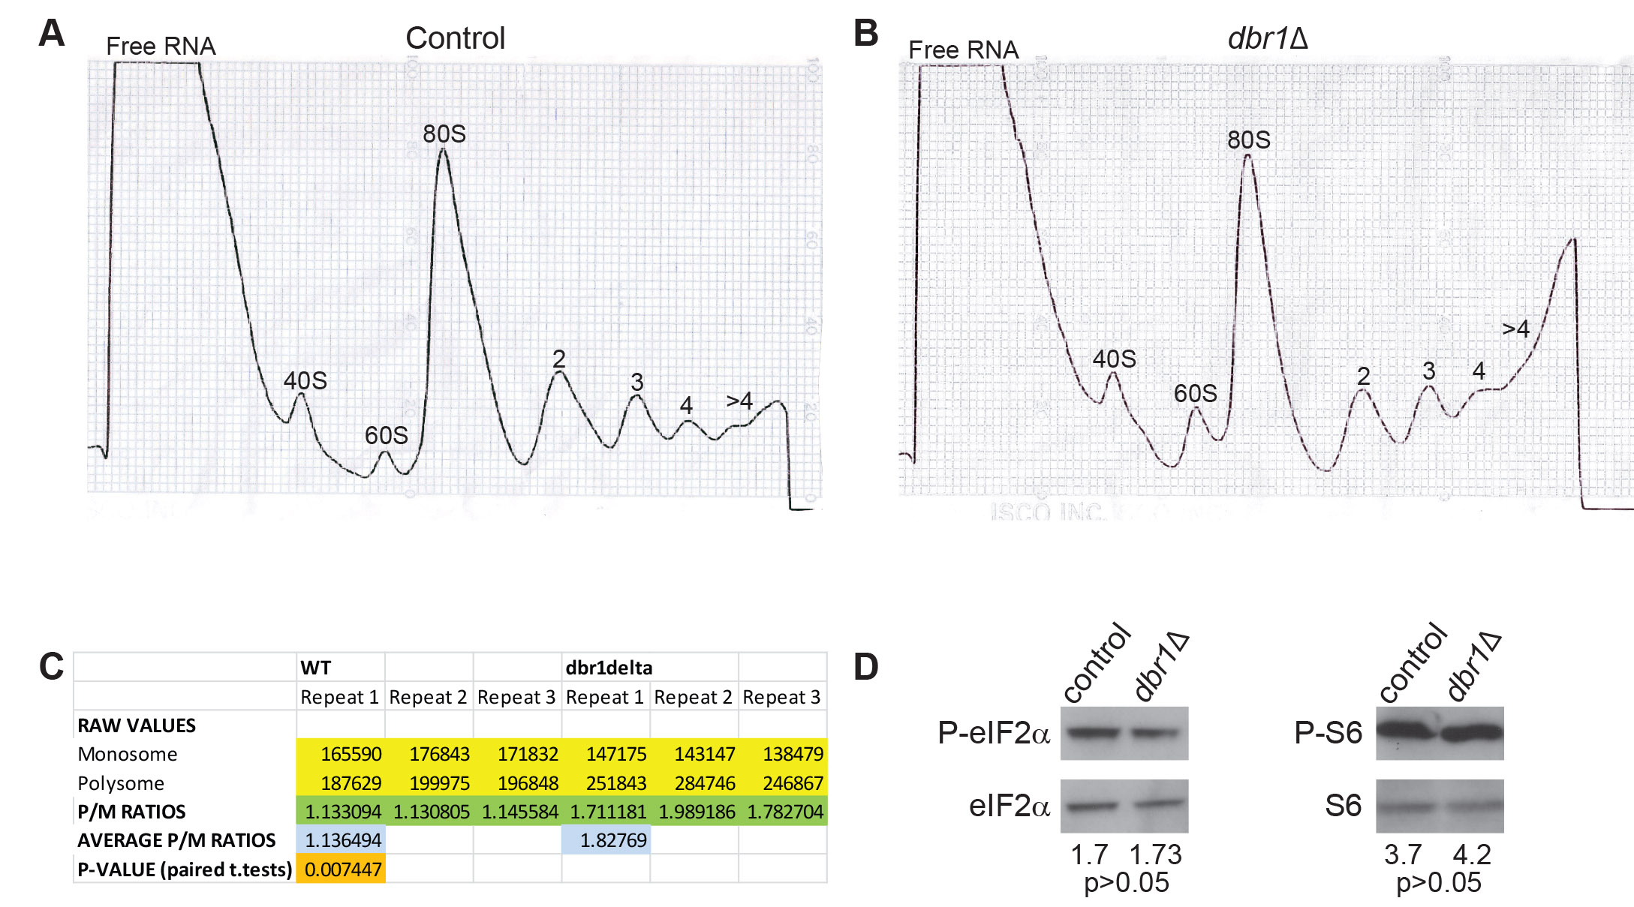

Supplemental Figure 2. Dbr1p affects protein translation.
Polysome profiles of wild-type (A) and dbr1Δ (B) cells. 40S: small ribosomal subunit, 60S: large ribosomal subunit, 80S: monosome. Numbers over peaks represent transcripts associated with 2, 3, 4 or more ribosomes.
(C) Summary of monosome and polysome AUC (Area Under Curve of the monosome and polysomes peaks) data for 3 independent biological repeats.
(D) Western blots showing phosphorylation status of eIF2α and ribosomal S6 proteins in wild-type (control) and dbr1Δ cells. Total eIF2α and S6 proteins were used as loading controls. Quantifications were performed using the ImageJ software, and significance was assessed using a paired t-test.

Supplemental Figure 3. Introns showing increased levels in dbr1Δ cells tend to be significantly longer.
Blue: 1399 introns increased in dbr1Δ cells as identified by DESeq (adjusted p <0.05). Red: An intron set of the same number was randomly selected from the remaining intron pool (i.e., 3962 introns). Length distributions were compared using Wilcoxon rank sum test (p <2.2e-16).

Supplemental Figure 4. Splicing efficiency in dbr1Δ cells as a function of intron length.
(A) The proportion of introns that showed significantly lower SE in dbr1Δ compared to wild-type cells within a given intron-length bin (grey: p <0.05; black: not significant). SE quantified by exon-intron and exon-exon junction reads. For a given intron, splicing efficiency was compromised in both biological replicates of dbr1Δ.
(B) SE of the significant intron set as a function of their length (dark and light blue: biological replicates of wild-type; red and pink: biological replicates of dbr1Δ; green: mean log₁₀ of relative SE fold-change mutant/wild-type).

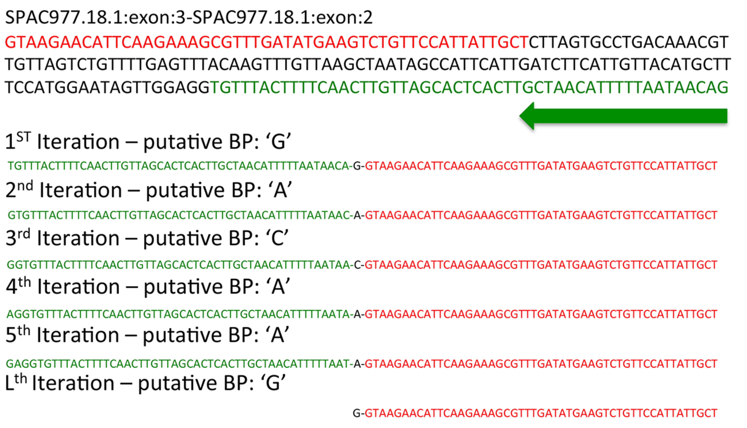

Supplemental Figure 5. Example of several iterations of the algorithm when intron sequence is used as input (red and green represents the 5’ and 3’ segments of the intronic sequence, respecively). The algorithm works 3’ to 5’, selecting one base at the time as the putative branch-point until all nucleotides are considered. LaSSO then combines the 5’ segment with the branch-point and the 3’ segment to produce a lariat sequence.

Supplemental Table 3. Numbers of mappable and unmapped reads

 | Total Reads | Mappable Reads | Unmapped reads | Lariat reads | Lariat / Mappable  (%)
dbr1Δ_1 | 37,571,054 | 24,088,951 | 7,570,026 | 61,623 | 0.25
dbr1Δ_2 | 41,737,273 | 19,677,647 | 14,552,518 | 46,343 | 0.24
wt_1 | 40,284,814 | 24,884,157 | 7,203,803 | 255 | 0.001
wt_2 | 58,356,430 | 35,691,739 | 9,446,583 | 456 | 0.001

Supplemental Figure 6. Clustering of branch-points.
For each intron, we defined a primary branch-point as the one supported by the highest number of RNA-seq reads (i.e. position 0 on the X axis). Thereafter, we aligned all the remaining branch-points within the same intron relative to the primary branch-point position. In this plot, lariats were grouped and colored based on the types of their primary branch-points only (first letter in each group, as indicated). The total numbers of lariats in each group, along with the total numbers of reads, are shown. Note that for simplicity only lariats located within 10 bases upstream (negative values) or downstream (positive values) are shown here.

Supplemental Note 1. Clustered branch-points seem to be generated during library preparation.

Several lines of evidence indicated that clustering around the primary branch-point was likely to be technical rather than biological. First, there was a very low number of lariats (82/5060; 1.6%) for which adenine was not the primary or secondary branch-point (Supplemental Fig. 6). Second, fuzziness was retained even when only perfectly matched reads were considered (data not shown), suggesting that read alignments were not the source for these clustered mappings. Although at first glance it appeared that uridine and even guanine were identified as primary branch-points (Supplemental Fig. 6), a manual inspection of all lariat reads that marked ‘U’ (254) or ‘G’ (3) as the branch-point revealed that in ~62% of these cases an adenine residue was within 1-2 bases and showed only a slightly lower signal or the branch-site sequence matched the known branch-site consensus sequences (160/257 lariats; Supplemental Table 4; highlighted in yellow). Therefore, these cases provide plausible examples where reads caused by skipping during reverse transcription outnumbered lariat reads that carry the correct adenine signature. In cases where there was no adenine within 1-2 bases of the primary uracil, there was an alternative lariat sequence with adenine branch-point downstream supported by a lower number of reads (49/257 lariats; Supplemental Table 4; highlighted in blue). Finally, for the remaining ~18% of lariats with ‘U’ or ‘G’ as a branch-point, the number of lariat reads was very low (45/257 lariats; Supplemental Table 4), and it is possible that a nearby ‘A’ residue could act as branch-point. Although unlikely, we cannot rule out the possibility that these ‘U’ residues may represent less frequently used branch-points. An exceptional example that may strengthen the latter possibility was a single group-II, self-spliced intron of the cox1 gene, for which the ‘U’ branch-point was supported by a relatively high read number (35). Furthermore, this branch-point was independently validated by RT-PCR (Supplemental Fig. 7; Supplemental Table 6), followed by Sanger sequencing, and it was located at the very 3’-end of the intron, implying a near circular lariat. However, the other group-II intron of the cob1 gene had a primary adenine branch-point identified by 180 lariat reads that was also confirmed by RT-PCR and Sanger sequencing (Supplemental Fig. 7; Supplemental Table 6). Thus, both group-II mitochondrial lariats provide evidence for the involvement of Dbr1 in their processing, in agreement with previous in vitro studies. In summary, our analysis, together with previous reports, strongly indicates that inaccuracies introduced by the reverse transcriptase may lead to a high number of lariat reads that sometimes outnumber or completely mask the real branch-point signal nearby. Nevertheless, we cannot rule out the possibility of cellular mistakes during the first splicing reaction or that other residues might be used as branch-points on some occasions.

Supplemental Figure 7. Modified LaSSO algorithm to account only for adenine branch-points.

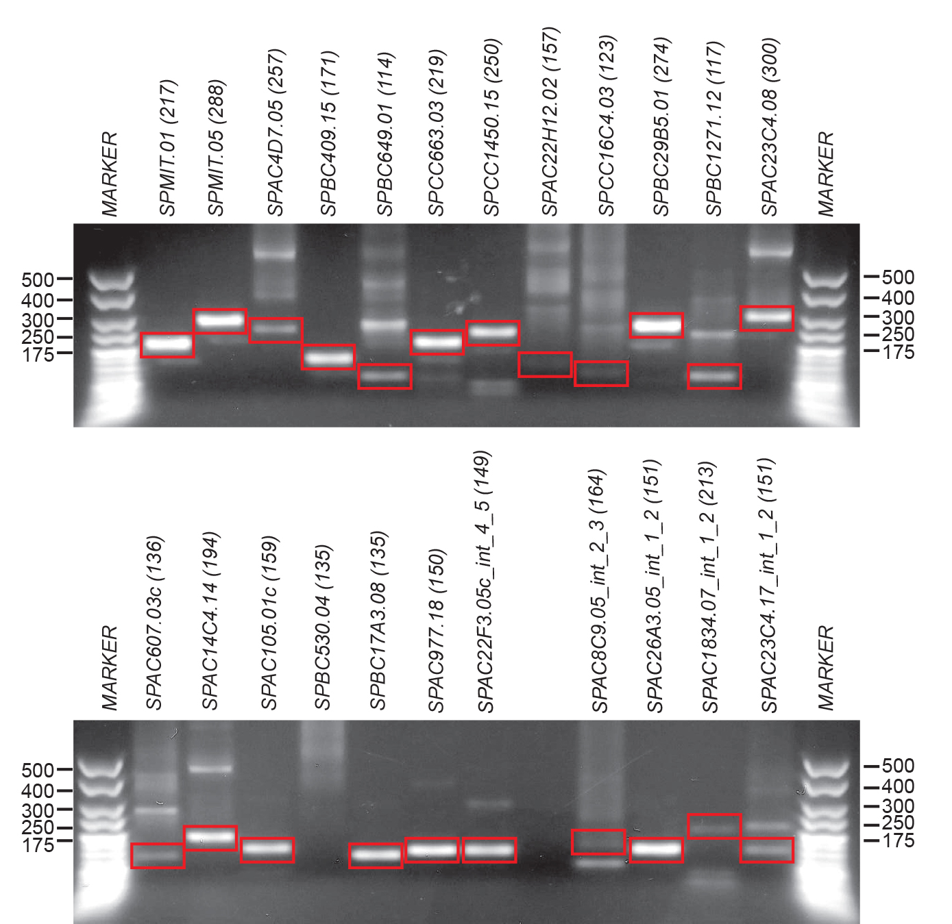

Supplemental Figure 8. Validation of lariats by lariat-specific RT-PCR.
A total of 23 lariats of varying length and expression levels were selected, of which 5 corresponded to exon-skipping events (bottom gel – last five samples). Expected PCR products are highlighted in red frames with systematic gene names and expected PCR product length in parentheses. All products were gel-purified and sequenced by Sanger sequencing. Primers, sequences determined by Sanger sequencing, and intron accession numbers are provided in Supplemental Table 6.

Supplemental Figure 9. Lariat read quantification.
(A) Number of lariat reads (X axis; log₂ scale; 1236 lariats with at least 3 reads) against the number of exon-exon junction read counterparts (Y axis; log₂ scale) in dbr1Δ cultures (only one biological repeat is shown for simplicity). Each point represents an intron (1236 in total).
(B) The mean lariat to junction reads ratio in dbr1Δ cells (ratios >10 not shown). Lariat to junction ratios were mostly below 1 (median =0.59). In 38% of cases (471/1236; lariat reads cutoff >3), the mean lariat to junction ratio exceeded 1.

Supplemental Note 2. Comparison between LaSSO- and FELINES-derived branch sites in RNA-seq and 2D-Lariat-seq datasets.

LaSSO and FELINES identified the same primary branch sites in 1104 and 818 introns interrogated in our data and in 2D-Lariat-seq data (Supplemental Tables 6-7). In addition, in 23 and 26 cases, FELINES predicted branch-sites that were identified as alternate branch-sites in our and 2D-Lariat-seq datasets, respectively. Given sequencing errors, the limited efficiency of the reverse transcriptase to transcribe through the 2’-5’ bond, and the fact that our clustering algorithm uses an arbitrary read cutoff to define primary and secondary sites, it is likely that in some cases the secondary branch-point will serve as the primary one, particularly when there are subtle differences in read numbers between primary and secondary branch-points. In the case of fuzzy branch-points, it is reasonable to assume that the branch-point closer to 3’-end of the intron is the primary branch point; when branch-points are far apart from each other, however, this assumption is no longer tenable since both could potentially serve as branch sites. We flagged introns that had their secondary branch site closer to the 3’-end of the intron than their primary site (Supplemental Tables 6-7).
Overall, there was a correspondence of ~91% between LaSSO and FELINES when both LaSSO’s primary and secondary branch-site sequences were considered (1127/1236 and 844/930 in our data and the 2D-Lariat-seq data, respectively). For the remaining 109 introns in our data and 86 introns in the 2D-Lariat-seq data, FELINES failed to predict the correct branch-site sequence even though they were supported by a high number of sequence reads (median =23 in our dataset, and median =17 in 2D-Lariat-seq dataset).
LaSSO and FELINES broadly agreed that most branch-site sequences corresponded to the known consensus ‘YURAY’. However, LaSSO identified a small set of 20 and 30 branch sites (with 12 in common) in our and 2D-Lariat-seq datasets, respectively, that corresponded to a slightly different branch-site sequence than the consensus. FELINES highlighted only 7 and 8 unusual branch sites (with 5 in common) in the set of introns interrogated in our and 2D-Lariat-seq datasets, respectively (Supplemental Tables 6-7). Also there was an overlap between FELINES and LaSSO in both datasets: 3 and 5 were in common in our data and 2D-Lariat-seq data, respectively. Importantly, since consensus sequences were derived from primary branch-site sequences defined by LaSSO, in some cases there may be a secondary branch site supported by fewer reads but more similar to the consensus. Nevertheless, where unusual branch-sites are detected in two independent studies by two different methods and are supported by strong experimental evidence, these are likely to represent real unorthodox sites. We flagged introns where the primary and secondary branch-site sequences differed from the consensus sequence (Supplemental Tables 6-7). Given the ~9% error rate of FELINES and the limitation that only ~33% of S. pombe branch-site sequences were experimentally characterised by LaSSO using two independent datasets, it is possible that among the entire set of S. pombe introns, the branch-site consensus sequence points towards a more degenerate consensus (Supplemental Table 8).

Supplemental Table 9. Position-specific frequencies of the 4 bases used to generate the consensus sequence in Fig. 5C.
Position/Nucleotide | A | C | G | U
LaSSO (RNA-seq)
-5 | 215 | 94 | 103 | 824
-4 | 697 | 17 | 327 | 195
-3 | 3 | 1057 | 4 | 172
-2 | 1 | 1 | 0 | 1234
-1 | 1137 | 11 | 61 | 27
0 | 1236 | 0 | 0 | 0
1 | 11 | 954 | 4 | 267
FELINES
-5 | 251 | 104 | 110 | 771
-4 | 679 | 30 | 315 | 212
-3 | 3 | 1078 | 1 | 154
-2 | 2 | 0 | 1 | 1233
-1 | 1111 | 1 | 119 | 5
0 | 1236 | 0 | 0 | 0
1 | 0 | 880 | 0 | 356
LaSSO (2D-Lariat-seq)
-5 | 183 | 66 | 69 | 612
-4 | 518 | 13 | 245 | 154
-3 | 6 | 777 | 5 | 142
-2 | 7 | 2 | 1 | 920
-1 | 857 | 9 | 46 | 18
0 | 930 | 0 | 0 | 0
1 | 11 | 690 | 7 | 222
LaSSO (Human dataset) No cutoff
-5 | 69 | 57 | 68 | 93
-4 | 74 | 61 | 53 | 99
-3 | 45 | 86 | 50 | 106
-2 | 41 | 41 | 33 | 172
-1 | 66 | 95 | 50 | 76
0 | 287 | 0 | 0 | 0
1 | 45 | 78 | 62 | 102
LaSSO (Human dataset) ≥3 read cutoff
-5 | 22 | 14 | 15 | 15
-4 | 19 | 9 | 15 | 23
-3 | 11 | 19 | 17 | 19
-2 | 10 | 4 | 7 | 45
-1 | 15 | 18 | 13 | 20
0 | 66 | 0 | 0 | 0
1 | 11 | 20 | 10 | 25
LaSSO (Human dataset) ≥3 read cutoff. Only the proximal branch-sites (located up to 128 bases upstream of the annotated 3’ splice acceptor site)
-5 | 21 | 14 | 14 | 14
-4 | 19 | 9 | 13 | 22
-3 | 10 | 17 | 17 | 19
-2 | 10 | 3 | 6 | 44
-1 | 14 | 18 | 13 | 18
0 | 63 | 0 | 0 | 0
1 | 9 | 20 | 10 | 24

Supplemental Figure 10. Consensus sequences generated for upstream and downstream introns implicated in the 48 skipping events identified here.
(A) Consensus for all upstream introns for which the 5’-end formed the lariat structure (consensus was constructed from both experimental and predicted branch-site sequences, 48 in total).
(B) Consensus for all downstream introns for which the adenine branch-point attacked the corresponding upstream introns from (A) to form the lariat structure (consensus was constructed from experimental branch-site sequences that utilized the same, canonical branch-point as the downstream intron branch-point, 33 sequences in total).

Supplemental Figure 11. Distance between branch-points identified by LaSSO and the split-read algorithm described by Taggart et al. (2012).
A total of 425 lariats within a total of 153 common introns were compared across the two studies. A total of 328/425 branch-points were identical (i.e. distance 0). Compared to the branch-points identified by Taggart et al. (2012), 67 were identified by LaSSO to be closer to the 3’ splice acceptor site (negative values, only 64 that were up to10 bp apart are shown here), and only 30 were identified by LaSSO to be further away from the 3’ splice acceptor site (positive values).

Supplemental Note 3. Comparison between branch-point identification by Taggart et al. and our study.

There were substantial technical differences between our study and the one by Taggart et al. (2012) that led to poor overlap between the two sets of identified branch-points. These differences include the use of different databases, read trimming approaches, algorithm settings such as mismatches tolerated, read overhang across lariats, limiting the distance of potential branch-point from the 3’ splice acceptor site and, most importantly, the expected base at the branch-point. Taggart et al. identified 2066 lariat reads via the split-read algorithm. Nevertheless, they reported that most of the inferred branch-points from the reference genome sequence were not expected to be adenine (66%, 1365/2066, Supplementary Fig. 4 in Taggart et al. 2012), leaving only 701 potential reads to overlap with our study. Given these differences, we were able to recover only ~21% (425/2066) lariats representing 153 introns that were identified by Taggart et al. 2012; yet these represent the majority (~60%, 425/701) of their predicted adenine-based branch-points.

Only in ~77% of the cases (328/425) the same branch-point was detected by both studies; in the remaining instances LaSSO identified a branch-point nearby, typically a few bases closer to the annotated 3’ splice acceptor site (67/425) or, less often (30/425), within a few bases upstream of the branch-point identified by Taggart et al. (Supplemental Fig. 11). Importantly, when we relaxed the filtering criteria, such as allowing overhang across the junction to be as low as 5 bp, we could recover up to 82% (574/701) of the adenine-bases branch-points reported by Taggart et al. (data not shown). These data suggest that many of the lariat reads identified by Taggart et al. (2012) correspond to fuzzy reads, which were mapped to the correct branch-site, but did not pinpoint precisely the branch-point (i.e., reads that reflect the technical errors introduced by the reverse transcriptase). This effect is not surprising given that the split-read algorithm allows mapping to non-adenine branch-points. This issue, together with the differences between the two methods noted earlier, can explain why LaSSO did not identify the remaining 79% of lariat reads reported by Taggart et al. (2012). Furthermore, unlike the split-read algorithm, LaSSO does not restrict the distance of the branch-site from the 3’ splice acceptor site to 500 bases, offering the advantage of identifying any distal branch-points and branch-points reflecting exon-skipping events (Supplemental Table 12).

Supplemental Figure 12. Proximal and distal branch-points as a function of corresponding intron lengths.
(A) Scatter plot showing the location of primary branch-points identified by LaSSO for 287 annotated human introns as a function of corresponding intron lengths. A human RNA-seq dataset (GEO accession number GSE30611) was used to search against an adenine-based human lariat database. Proximal branch-points (red) are those within 128 bases upstream of the 3’ splice acceptor site. Distal branch-points (black) are located >128 bases upstream of the acceptor site (branch-points supported by at least 1 read); r – Pearson’s correlation coefficient; both axes in log2 scale.
(B) The location of primary branch-points identified by LaSSO for 1236 nuclear S. pombe introns as a function of the corresponding intron lengths. RNA-seq data derived from dbr1Δ and wild-type cells were aligned against the S. pombe adenine-based lariat database. Proximal branch-points (red) are those within 30 bases upstream of the 3’ splice acceptor site. Distal branch-points (black) are located >30 bases upstream of the acceptor site (branch-points supported by at least 3 reads).
(C) As in (A) but showing 34 human introns whose branch-sites were implicated in exon skipping. Intron length corresponds to the length of the 3’ terminal intron where the lariat is formed.
(D) As in (B) but showing 48 S. pombe introns whose branch-sites were implicated in exon skipping. Intron length corresponds to the length of the 3’ terminal intron where the lariat is formed.

Supplemental Figure 13. Human branch-site consensus sequence.
Consensus sequence generated using 63 proximal human branch-sites identified by LaSSO (supported by ≥3 reads and up to 128 bases upstream of the 3’ splice acceptor site). The actual base frequencies in each position are indicated in Supplemental Table 8.

