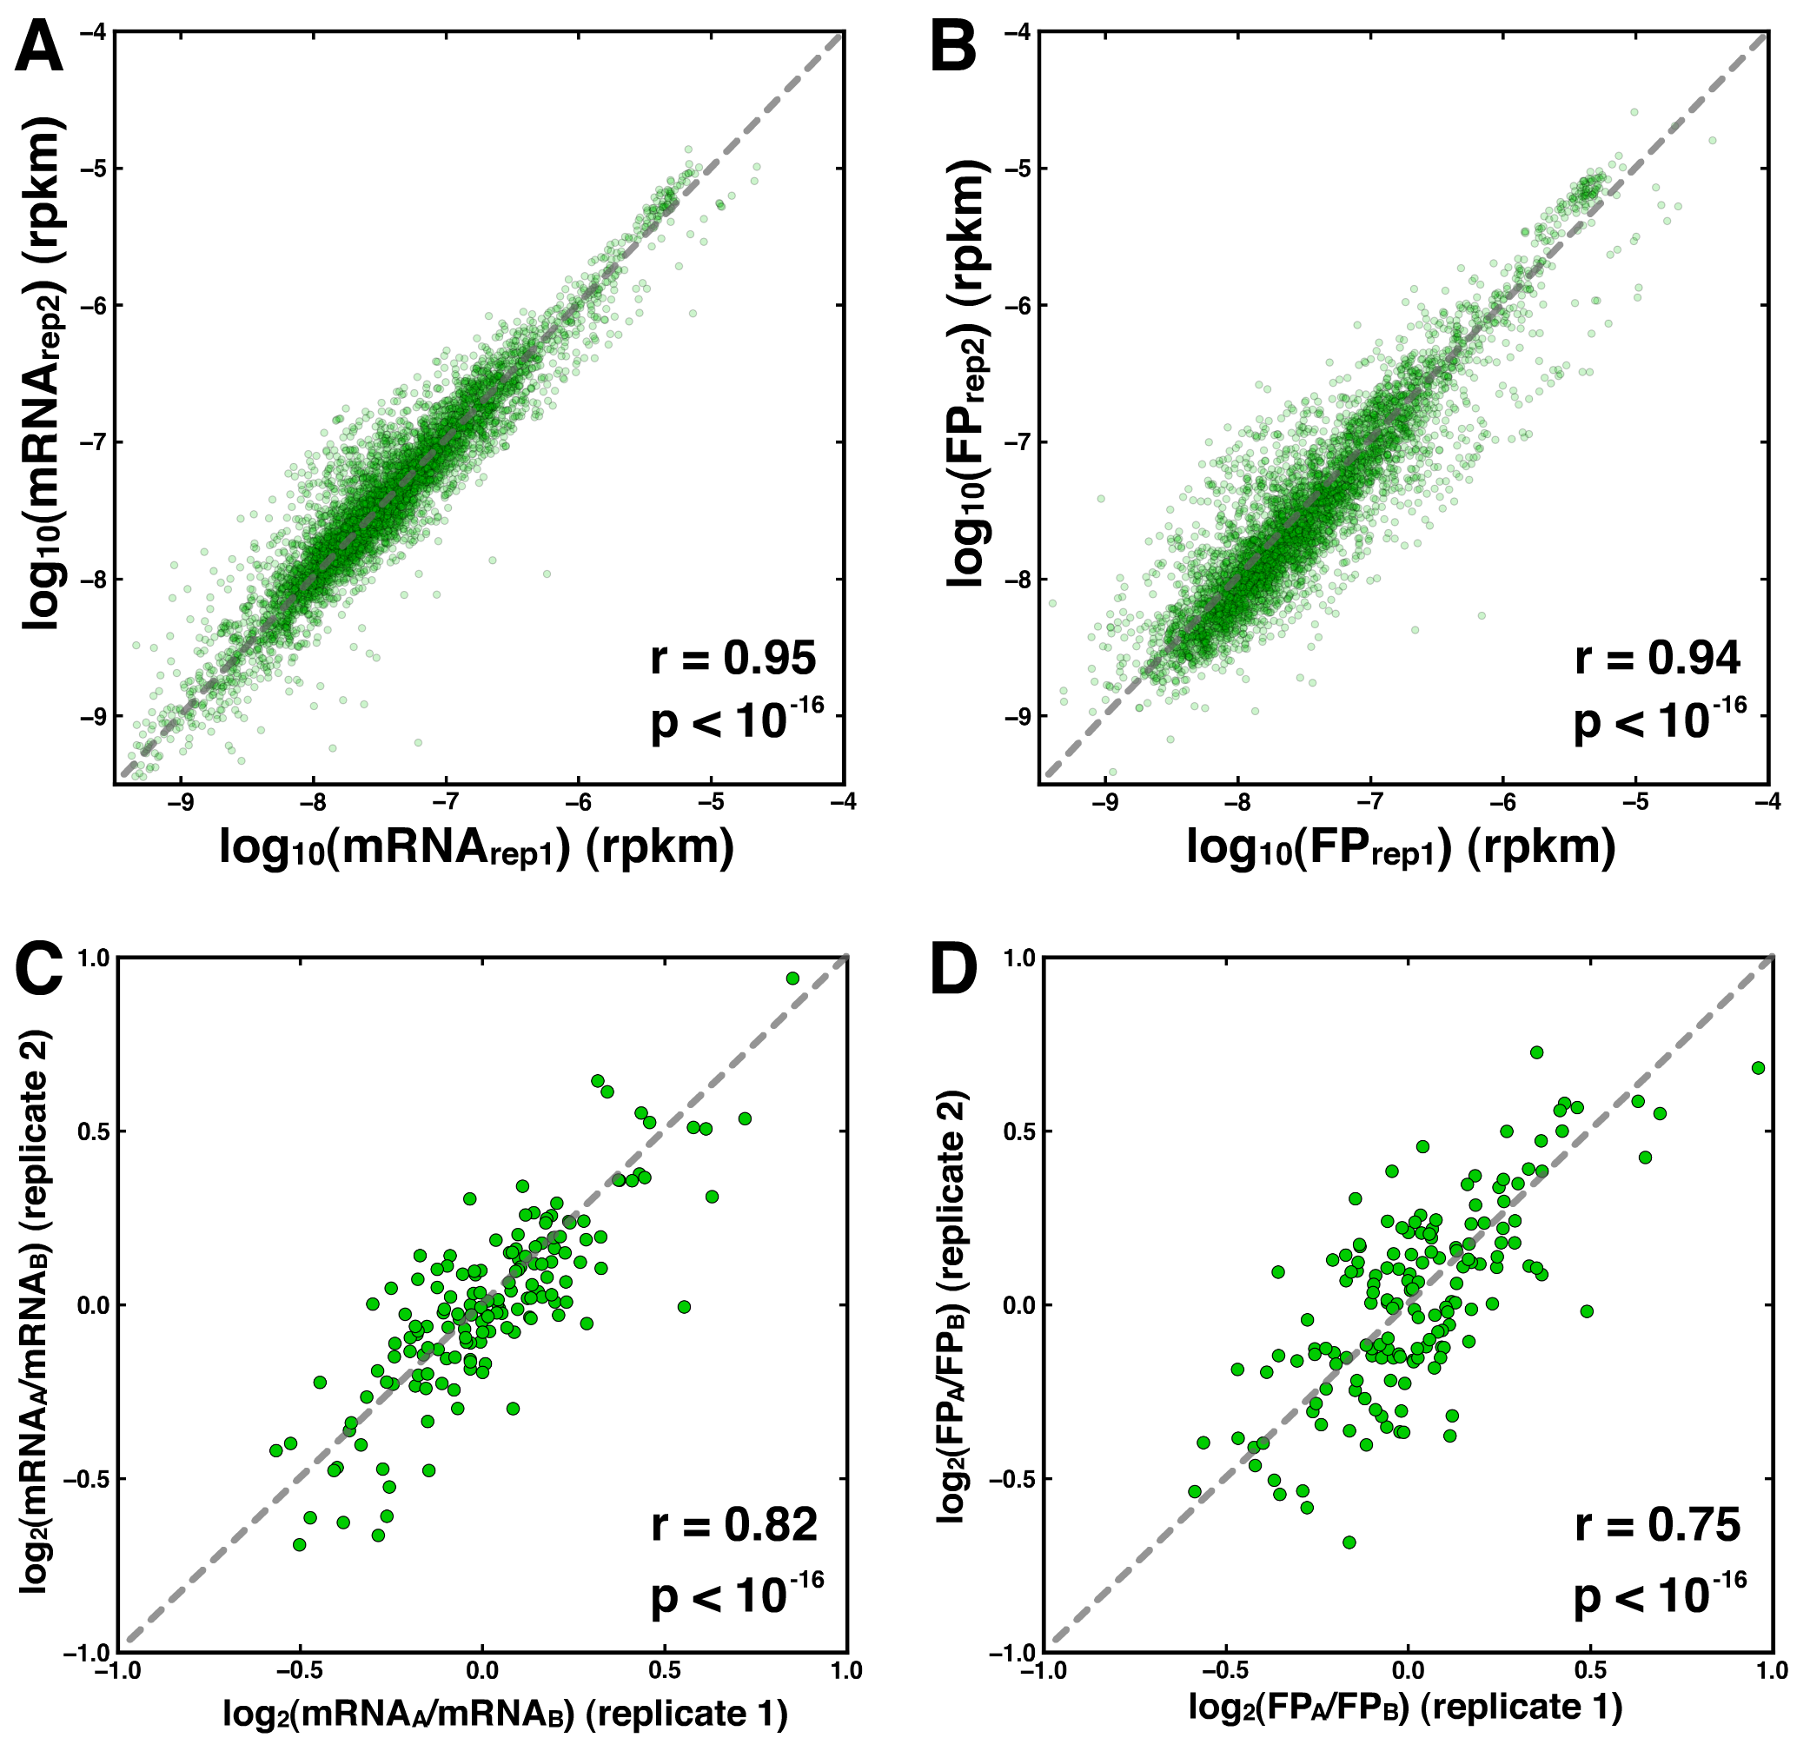

Figure S1. Reproducibility across biological replicates. (A,B) For each gene, the read density for mRNAs (A) and FPs (B) in each biological replicate. (C,D) Reproducibility mRNA_{ALFD} (C) and FP_{ALFD} (D) between the two replicates. Since the second replicate was sequenced more deeply than the first, only genes with more than 300 allele-specific reads in each replicate are shown here; once reproducibility across replicates was established, reads from both replicates were pooled for all subsequent analyses to enhance signal detection.

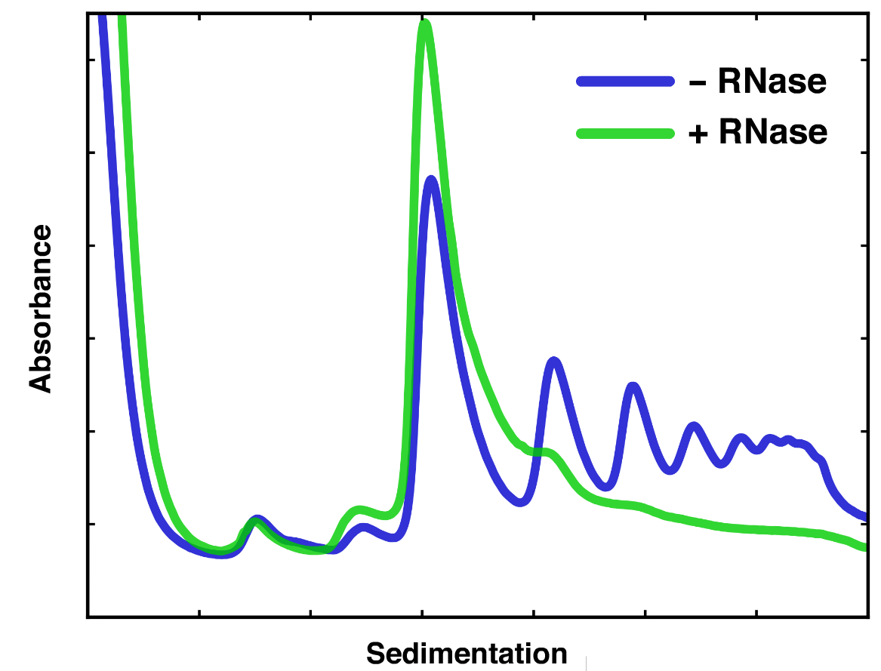

Figure S2. Polysome profiles in the presence and absence of RNase. Representative polysome profiles from C. albicans strain SC5314 lysed in the presence of Blasticidin S and then processed with or without RNase.

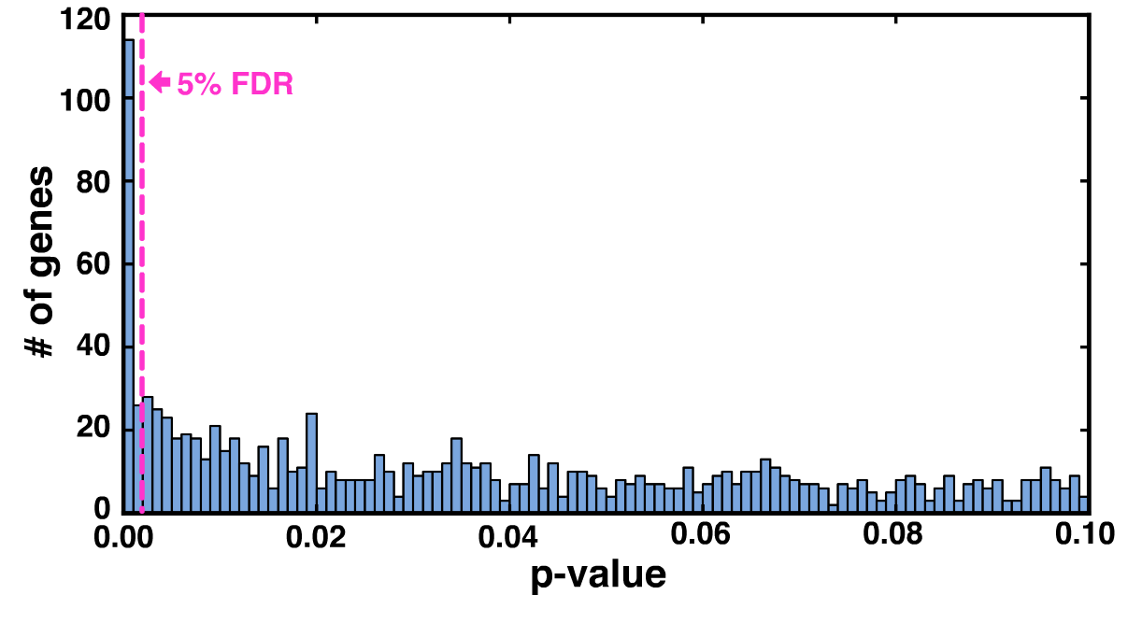
Figure S3. P-value distribution. P-values calculated from z-scores based on bootstrap distributions were compiled into a histogram. The 5% FDR cutoff was determined from a ranked list of p-values, where a gene i passed the threshold if p-value_{i} < (5% * (rank_{i} / # of genes)).
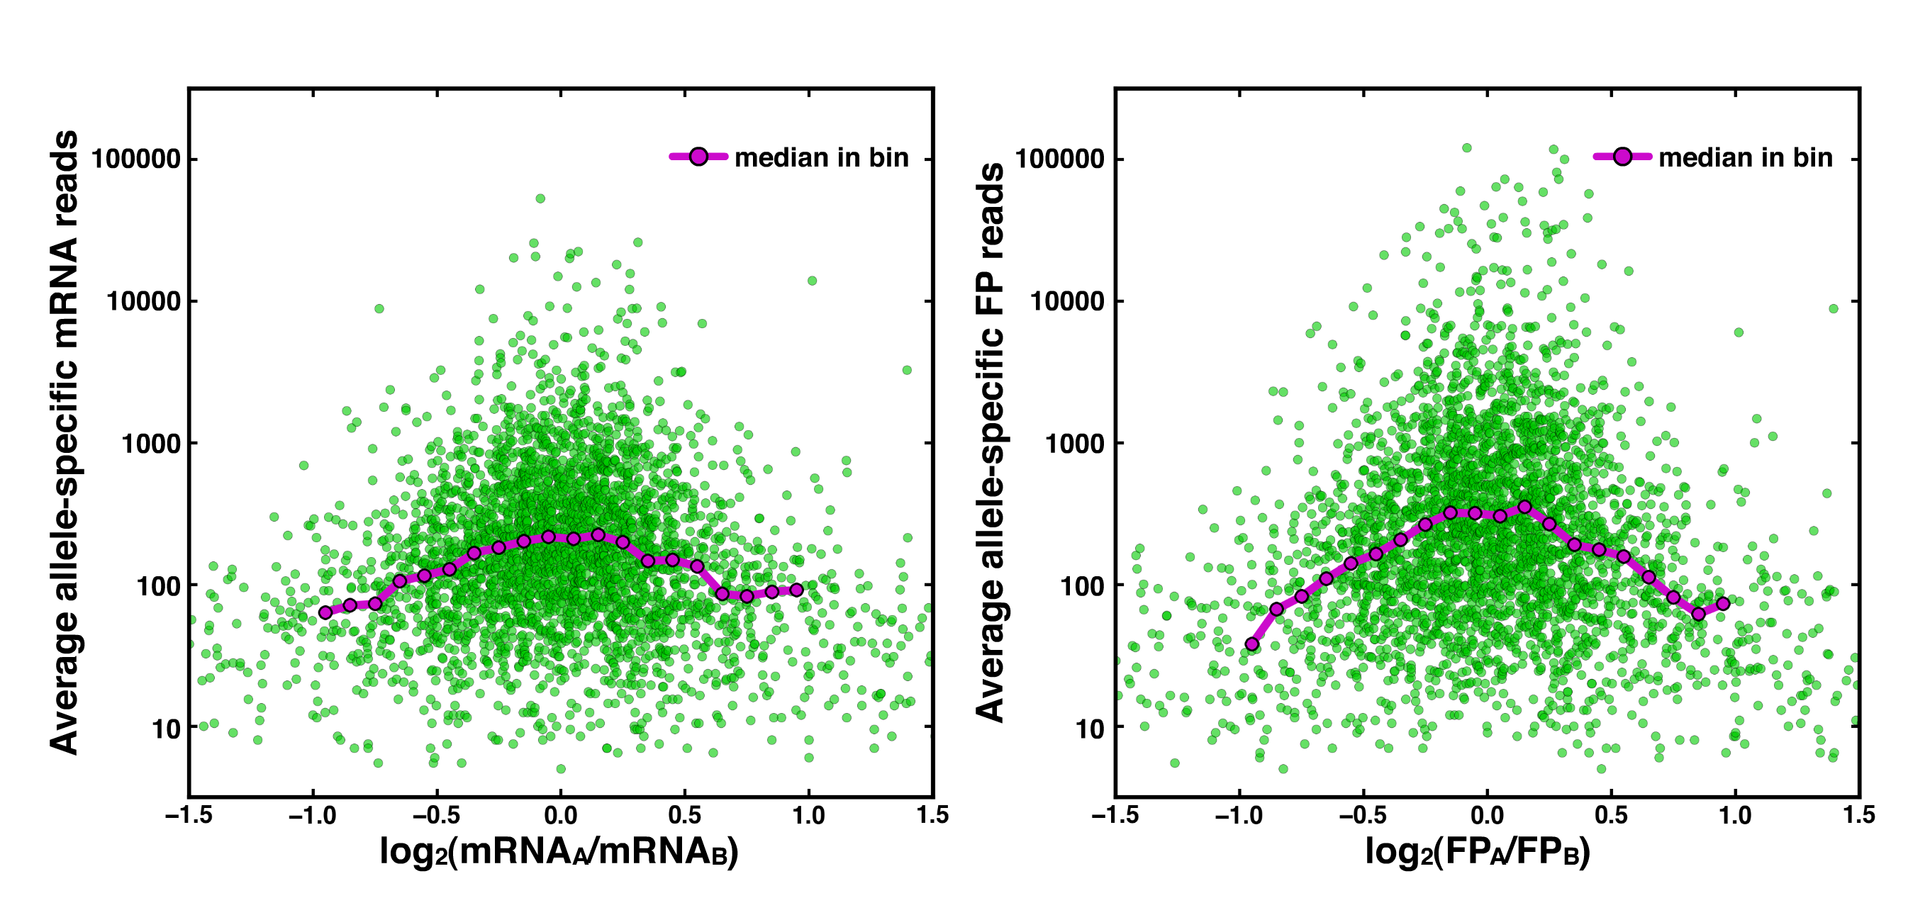

Figure S4. Relationship between expression level and the extent of allelic bias. For mRNA (left) and FP (right), green points represent genes where the x-axis indicates the log-fold-difference in allelic expression, and the y-axis plots the average number of allele-specific reads (e.g., (mRNA_{A} + mRNA_{B}) / 2). The pink line represents the median of green values. Highly expressed genes tend to have lower allelic bias, yet even genes with log-fold-differences of magnitude 1, median read counts are in excess of 50.

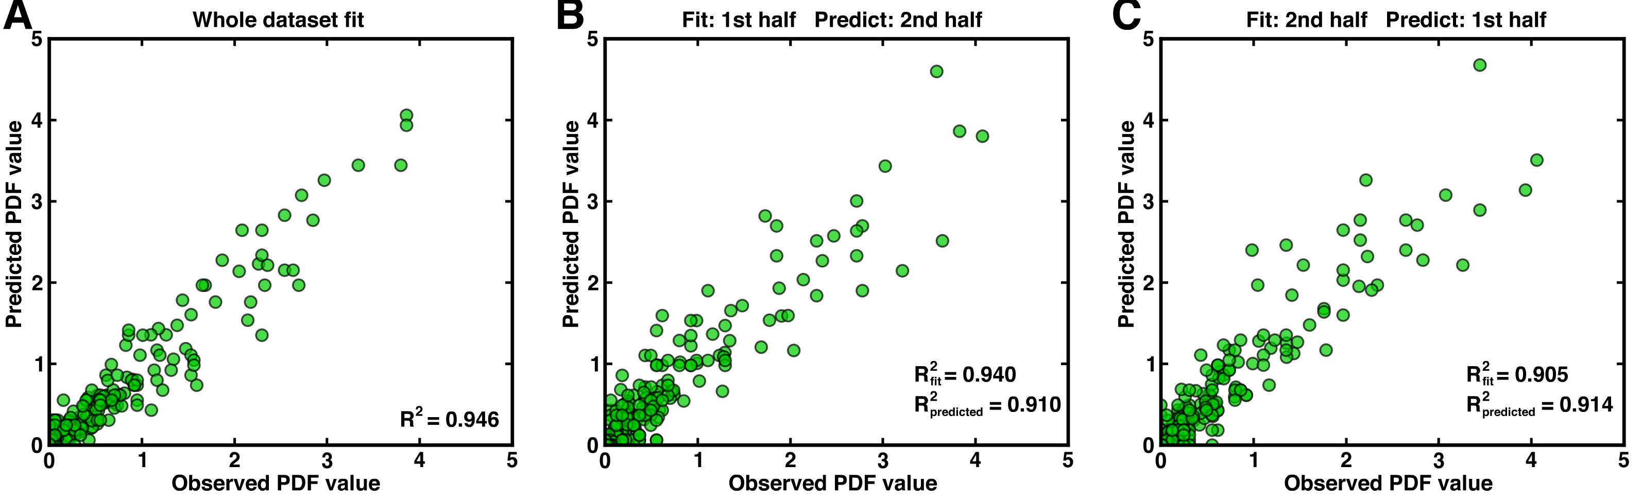
Figure S5. Fit statistics and cross-validation of stochastic model. (A-C) Each green point represents a bin in the heat-map PDF plots of Fig. 3E-G. (A) Observed versus simulation-generated data when the simulation was fit to the entire population of genes depicted in Fig. 3A-C. (B,C) Both iterations of two-fold cross validation in which the simulation was fit on one half of data and then evaluated for fit to the second half. R² values are comparable for both the original fit and the prediction, suggesting that the model is not simply overfitting the training data.

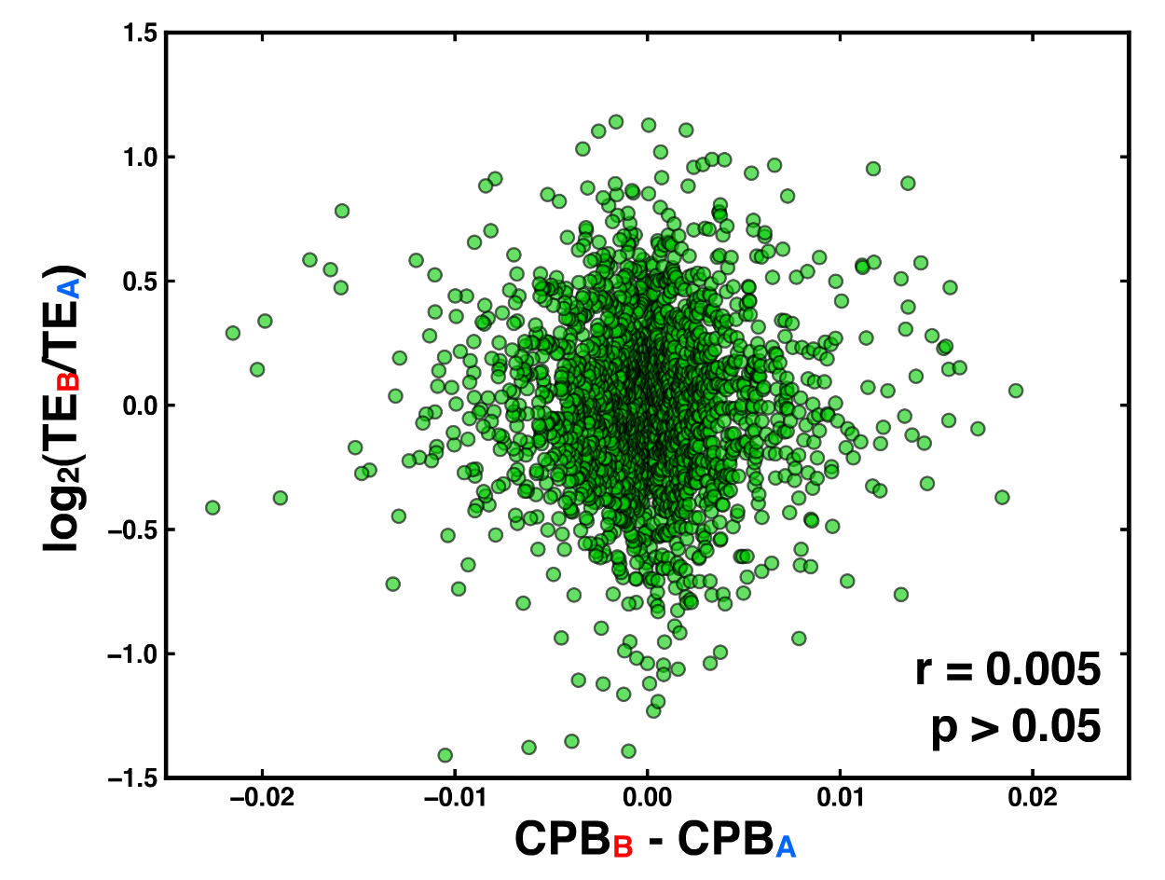

Figure S6. Codon-pair bias does not correlate with TE_{ALFD}. Each green point represents a gene with its difference in allelic codon-pair bias plotted versus TE_{ALFD}.

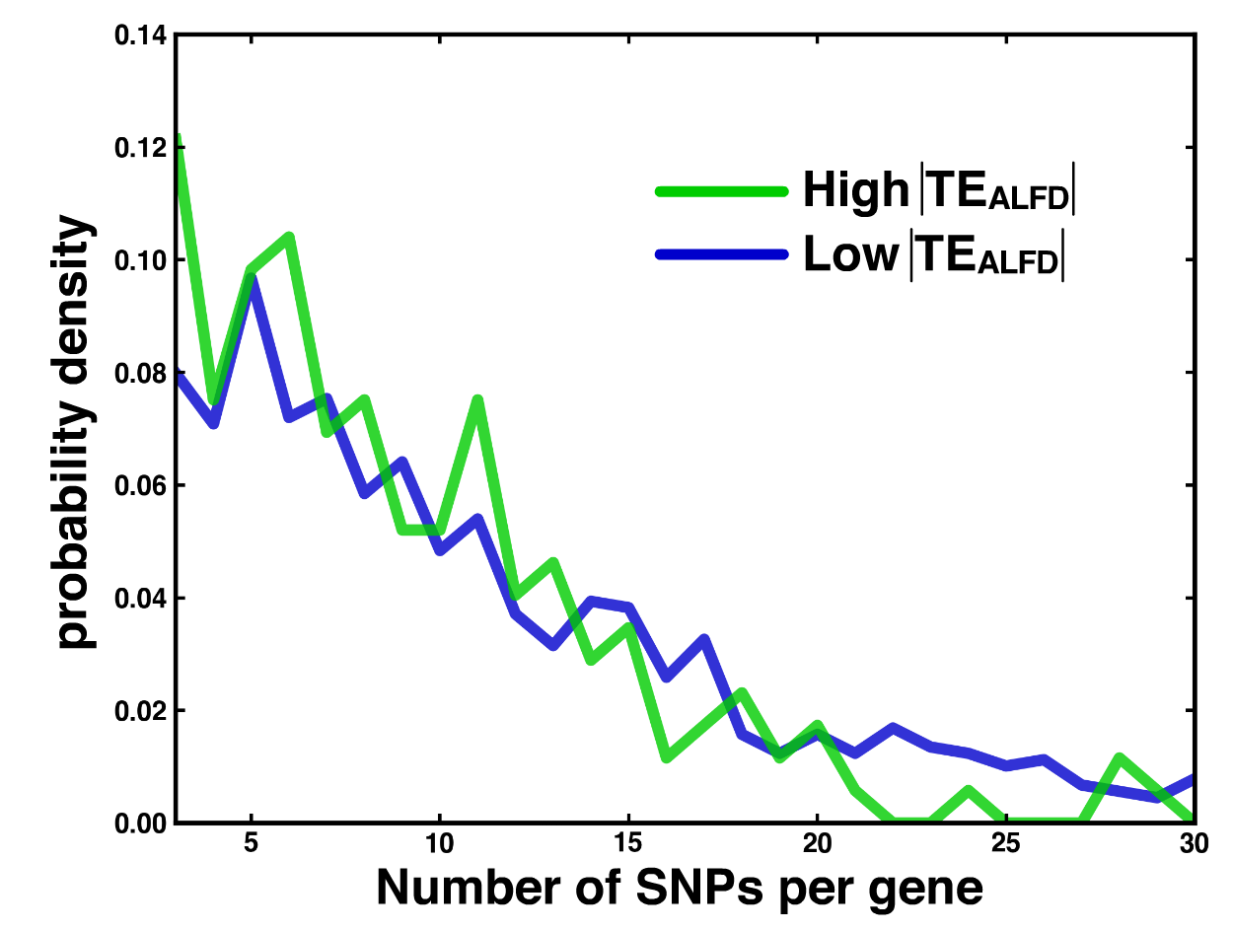

Figure S7. Genes with high and low TE_{ALFD} values have comparable numbers of SNPs. Probability density functions for genes with a 50% allelic difference in TE (“High TE_{ALFD}”) and the 1000 genes with the lowest allelic difference in TE (“Low TE_{ALFD}”) are shown. The distributions are not significantly different (KS test, p > 0.2).

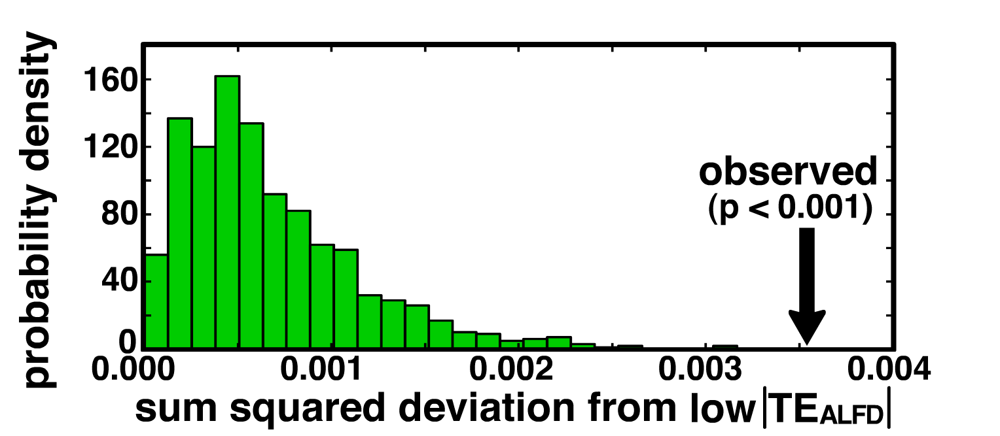

Figure S8. Positional distribution of SNPs is different for high- and low-|TE_{ALFD}| gene sets. The probability density function shows the sum-squared deviations between the low-|TE_{ALFD}| group and 1,000 subsamples—each with 200 genes—from that group (see Methods). The observed value indicates the sum-squared deviation between the averaged PDFs from high- and low-|TE_{ALFD}| gene sets.

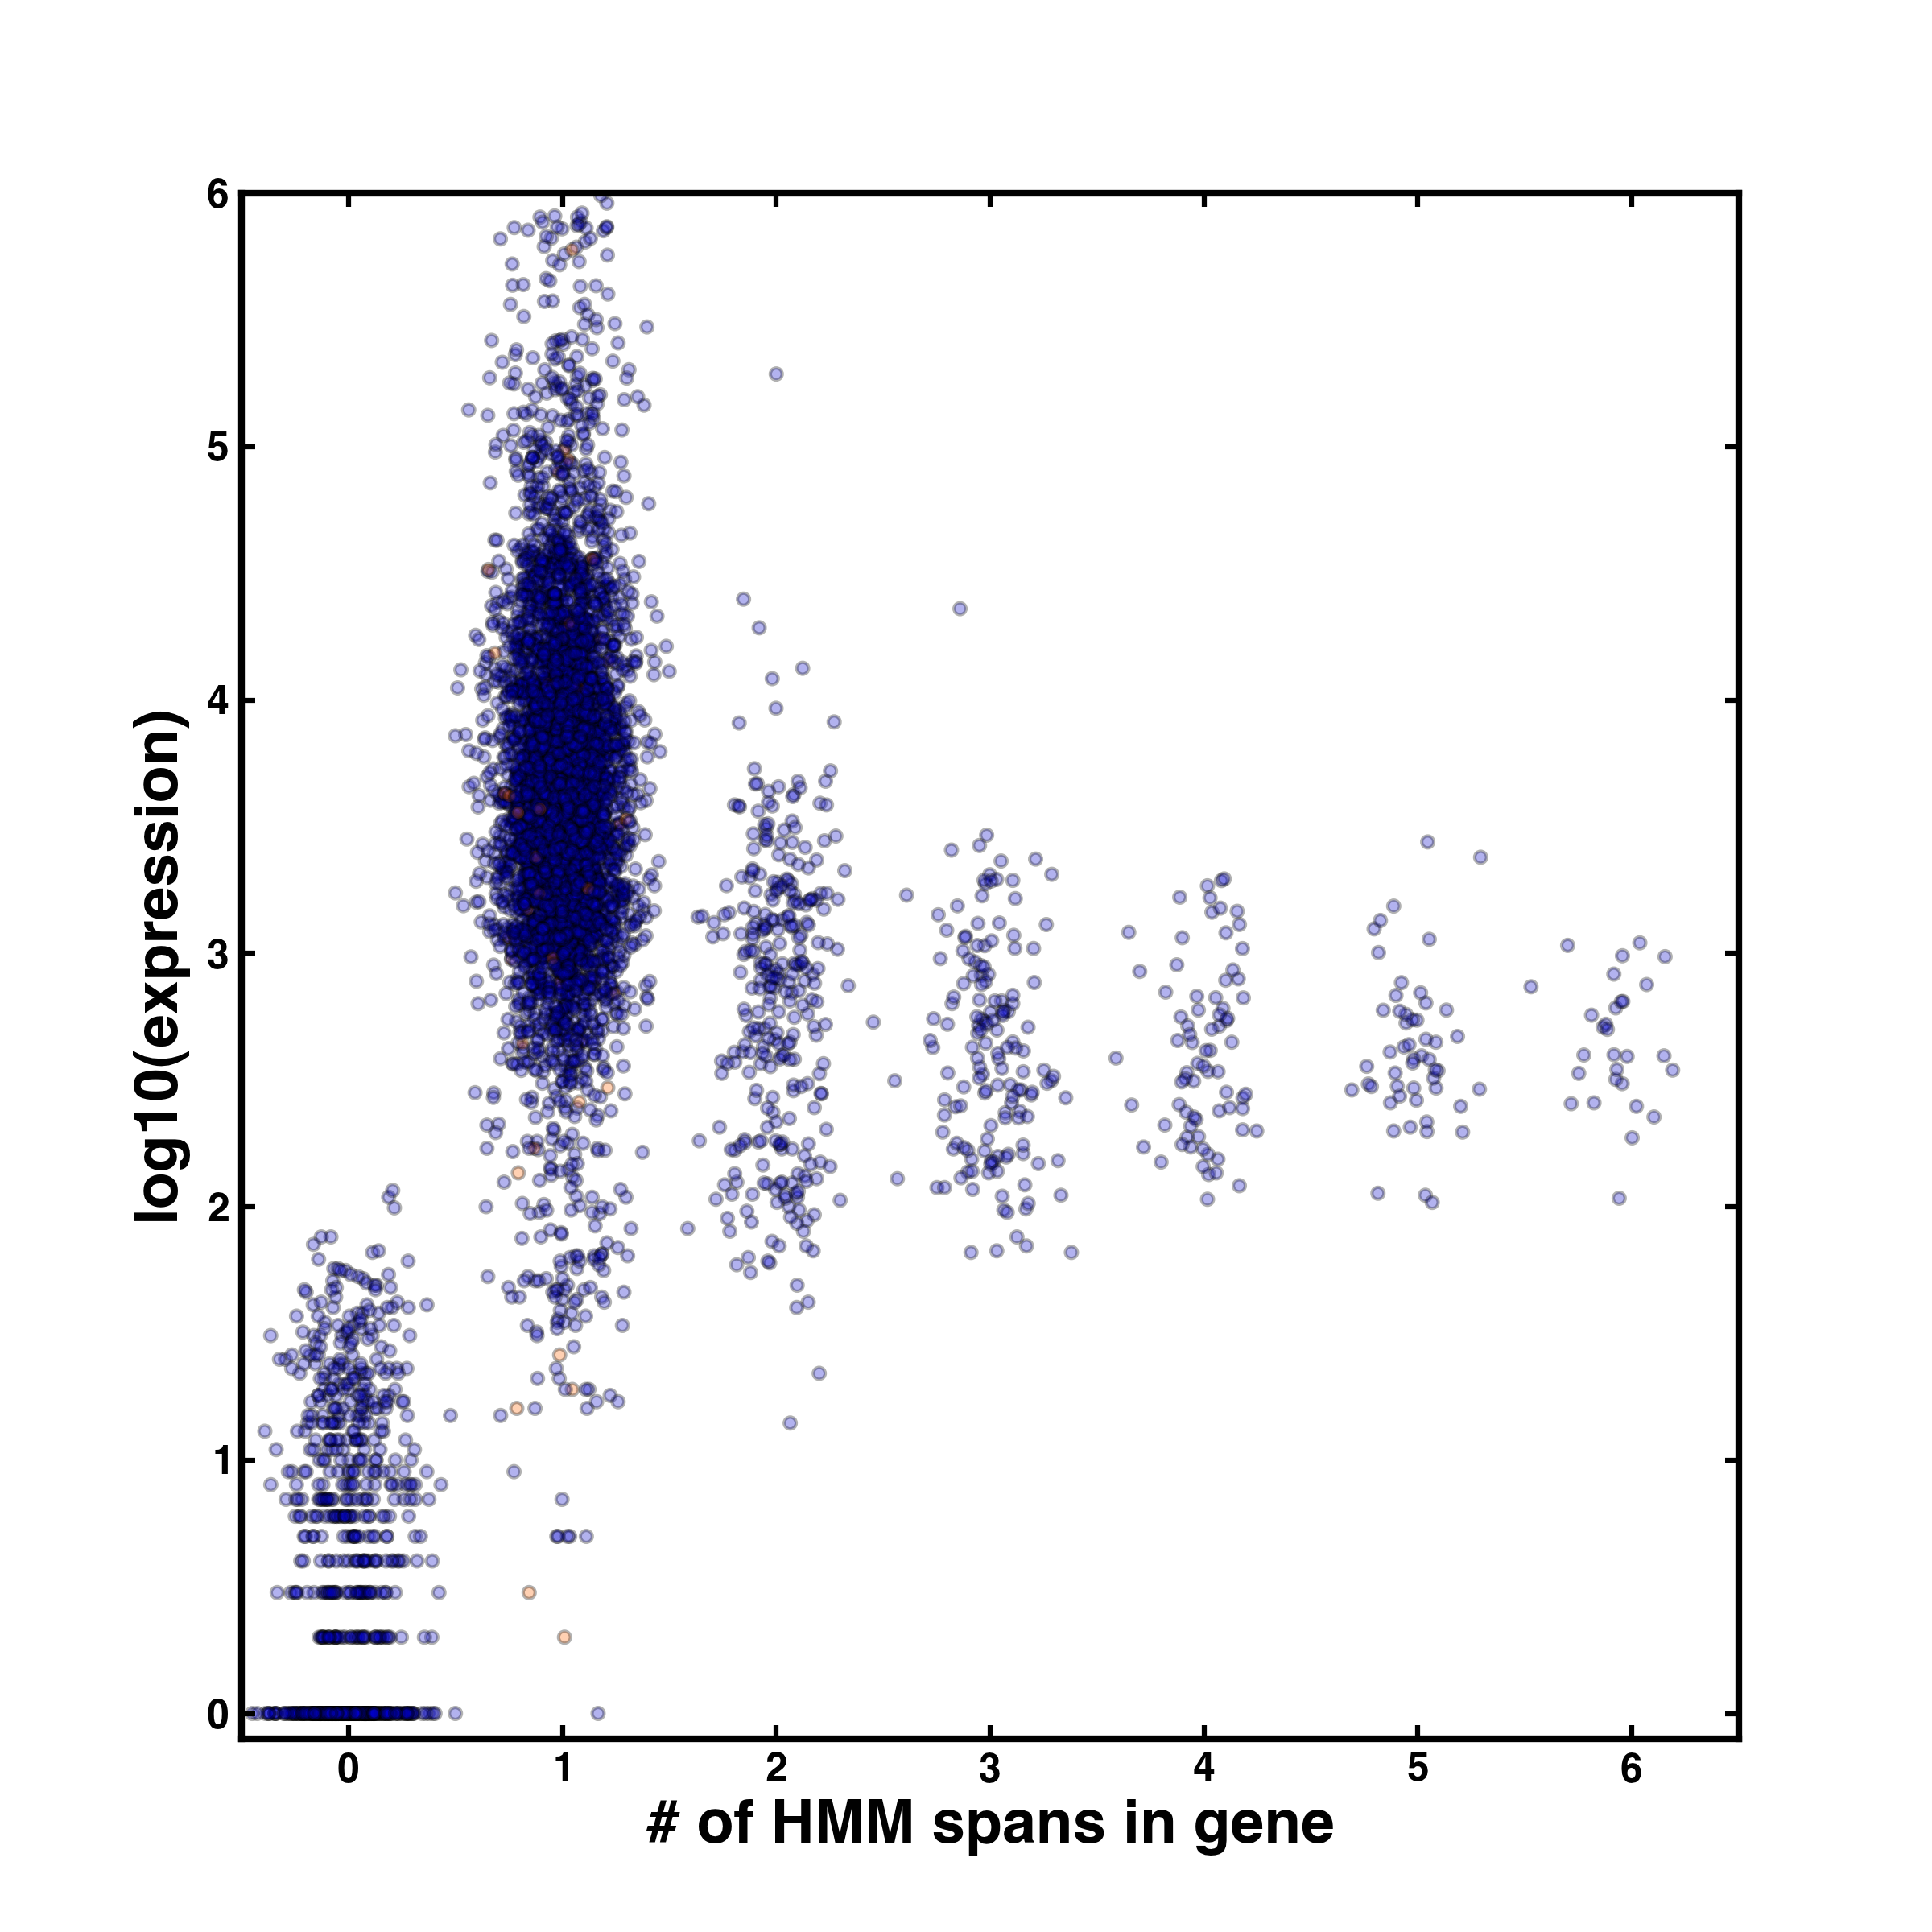
Figure S9. HMM identifies independent coding regions. Each point represents a gene, with the gene’s number of FP reads on the y-axis and the number of HMM-identified “Coding” spans that correspond to the gene on the x-axis. For 81% of all genes, the HMM identifies a single “Coding” span, and it performs best for genes with at least 100 FP reads. Only 1.6% of “Coding” spans—indicated in orange—include more than one adjacent annotated gene; in such cases, each gene’s boundaries were expanded to include only its proximal half of the intergenic region.

Parameter | Value | Description | Source
k₁ | 5 | Transcription mean | Fig. 3A
k₂ | 1.3 | Transcription std. dev. | Fig. 3A
k₃ | 0.16 | Transcription allelic noise | Fig. 3A
k₄ | 0.25 | Translation mean | Fig. 3B
k₅ | 0.77 | Translation std. dev. | Fit
k₆ | 0.2 | Translation allelic noise | Fit

Table S1. Simulation parameters. The parameters generating the best stochastic model fit from Fig. 3 are shown.

Primer | Sequence | µl in cocktail
oDM011 | /5Biosg/GGCCATGCGATTCGAAAAGTTATTATGAATCATCAAAGA | 1
oDM012 | /5Biosg/AAACGACGCTCAAACAGGCATGCCCTCCGGAATA | 3
oDM013 | /5Biosg/TACCTTCTTCAAATTACAACTCGGACGCCAAAAA | 10
oDM014 | /5Biosg/ACCTCCAGCTCCGCTTCATTGAATAAGTAAAAAAACTA | 20
oDM015 | /5Biosg/ACATCAGGATCGGTCGATGGTGCACCCTAAA | 2
oDM016 | /5Biosg/ACTTTCGTTCTTGATTAATGAAAACGTCCTTGGTAAA | 1
oDM017 | /5Biosg/AACCAATCCGGAGGCCTCACTAAGCCATTCAAA | 1
oDM018 | /5Biosg/CCAGAGGGCGCAATGTGCGTTCAAAGATTCGATGATT | 20
oDM019 | /5Biosg/AACGACGCTCAAACAGGCATGCCCTCCGGAATAC | 1
oDM020 | /5Biosg/ATTCTATTATTCCATGCTAATATATTCGAGCAAAGG | 4

Table S2. rRNA subtraction oligos. DNA oligos were resuspended in TE to 20µM and then mixed into a cocktail of 63µl. 16µl of this cocktail were used in the rRNA subtraction step of the ribosome profiling protocol. Proportions were selected based on the relative abundances of rRNA fragments in deep sequencing data from a footprint library prepared in the absence of rRNA subtraction.

