Supplemental Information

Gene disruption by cell-penetrating peptide-mediated delivery of Cas9 protein and guide RNA

Suresh Ramakrishna¹, Abu-Bonsrah Kwaku Dad¹, Jagadish Beloor², Ramu Gopalappa¹, Sang-Kyung Lee², and Hyongbum Kim^{1, 3}

¹Graduate School of Biomedical Science and Engineering/College of Medicine, Hanyang University, Seoul, South Korea.
²Dept of Bioengineering and Institute for Bioengineering and Biopharmaceutical Research, Hanyang University, Seoul 133 791, South Korea

³Corresponding author. Tel: +82-2-2220-2424, Fax: +82-2-2220-2422, Email: hkim1@hanyang.ac.kr

Table of Contents
Supplemental Figures and Table
Supplemental Figure 1. Expression of His-tagged Cas9 protein in BL21 E. coli cells.
Supplemental Figure 2.SDS-PAGE of purified Cas9 protein.
Supplemental Figure 3. In vitro DNA cleavage by the purified Cas9 protein.
Supplemental Figure 4. Mass spectrometry of the Cas9 and Cas9-m9R.
Supplemental Figure 5. Repeated treatments with Cas9-m9R and sgRNA:9R increase both on- and off-target mutations.
Supplemental Figure 6. Analysis of off-target effects.
Supplemental Figure 7. Comparison of the effects of CPP-mediated versus plasmid-mediated RGEN delivery on endogenous gene modification.
Supplementary Figure 8. Generation of clones containing RGEN-induced mutations by Cas9-m9R and sgRNA:9R treatment.
Supplemental Table 1. The sequences of oligonucleotides used in this study.
Supplemental Figure 1. Expression of His-tagged Cas9 protein in BL21 E. coli cells.
SDS-PAGE of insoluble (pellet) and soluble fractions after induction of protein expression at 30°C overnight (left) or at 37°C for 4 h (right). Arrows indicate the expected position of the Cas9 protein. IPTG, isopropyl-β-D-thiogalactopyranoside.

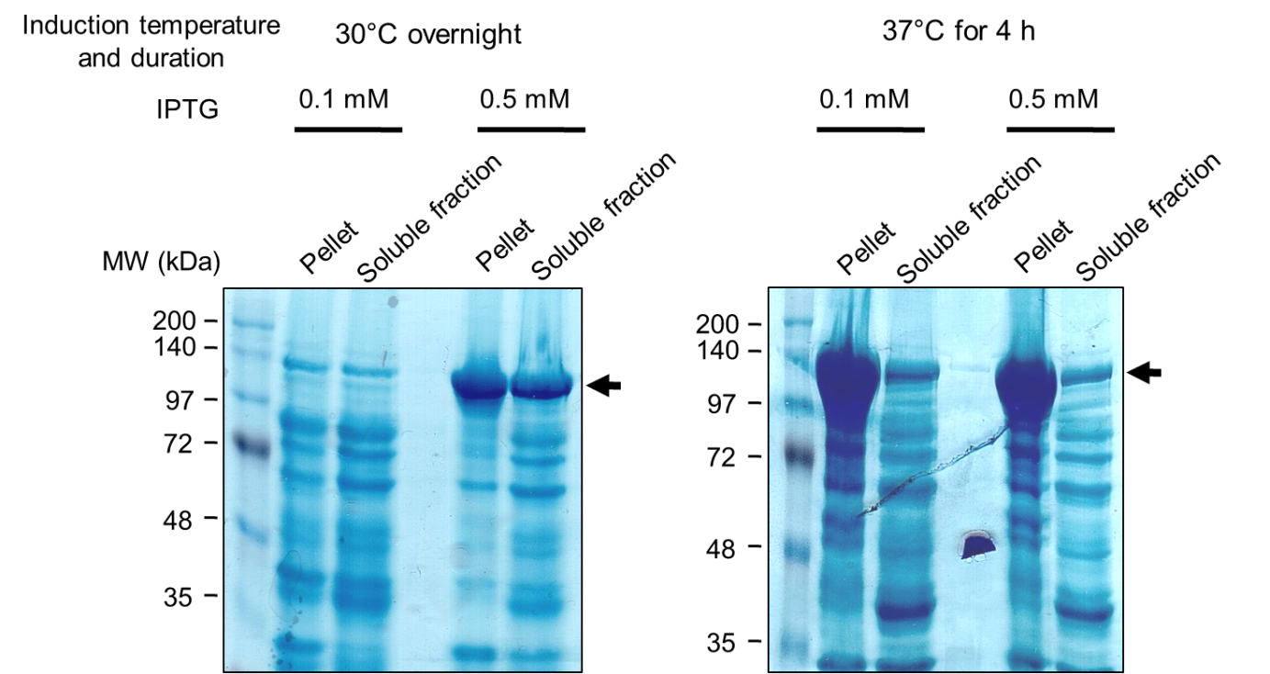

Supplemental Figure 2.SDS-PAGE of purified Cas9 protein.
(a) The His-tagged Cas9 protein was purified from the soluble fraction using a Ni-NTA column. (b) Elution fractions 2-4 were pooled and used as the source of Cas9-m9R. Arrows indicate the expected position of the Cas9 protein.
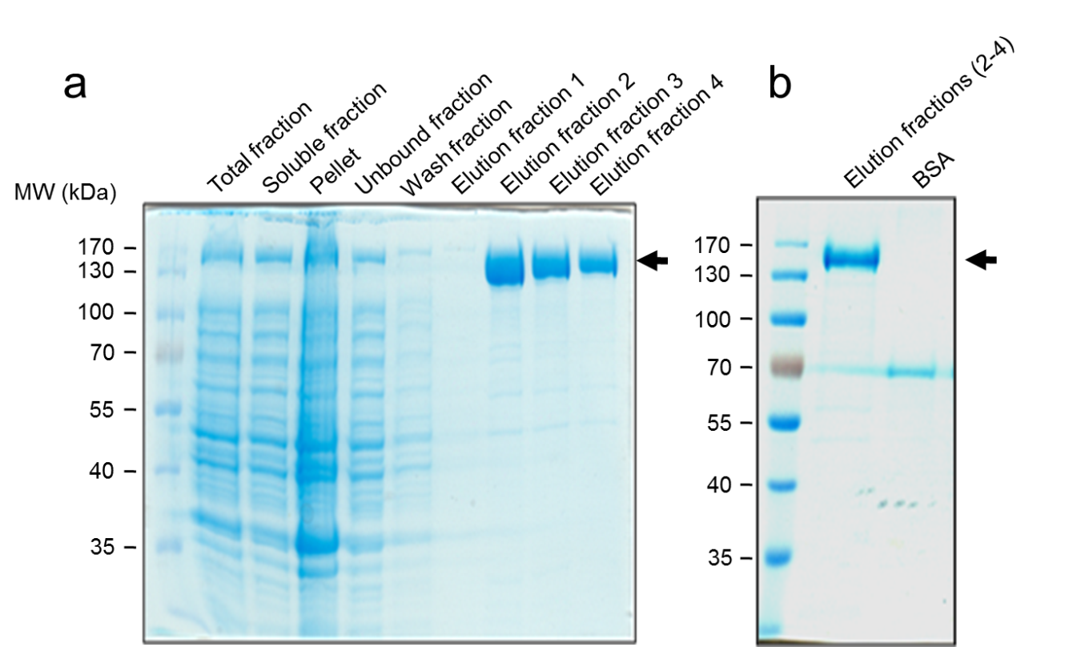

Supplemental Figure 3. In vitro DNA cleavage by the purified Cas9 protein.
A circular plasmid containing an RGEN target sequence from the human CCR5 gene was incubated with purified Cas9 protein and sgRNA targeting the sequence. The same plasmid without the target sequence was used as a control.

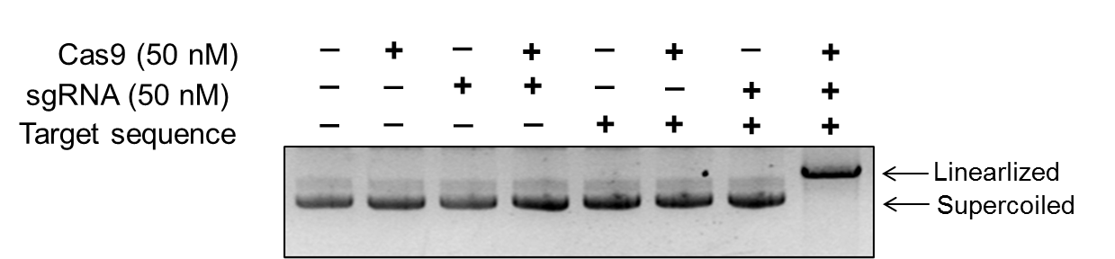

Supplemental Figure 4. Mass spectrometry of the Cas9 and Cas9-m9R.

Cas9 with a C-terminal cysteine residue (Cas9-Cys) and Cas9 without this residue (Cas9) were incubated with maleimide-linked CPP (4-maleimidobutyryl-4G9R4L; for brevity, m9R), dialyzed to remove unconjugated m9R, and analyzed using a MALDI-TOF/TOF mass spectrometer equipped with a HM2 TUVO high mass detection system. Blue, red, and green arrows indicate the peaks of Cas9-Cys (theoretical molecular weight, 165.4 kDa), Cas9-Cys-m9R (167.6 kDa), and Cas9 (165.3 kDa), respectively. A suitable amount of Cas9-Cys was conjugated with m9R, whereas Cas9 without a C-terminal cysteine was not conjugated with m9R.
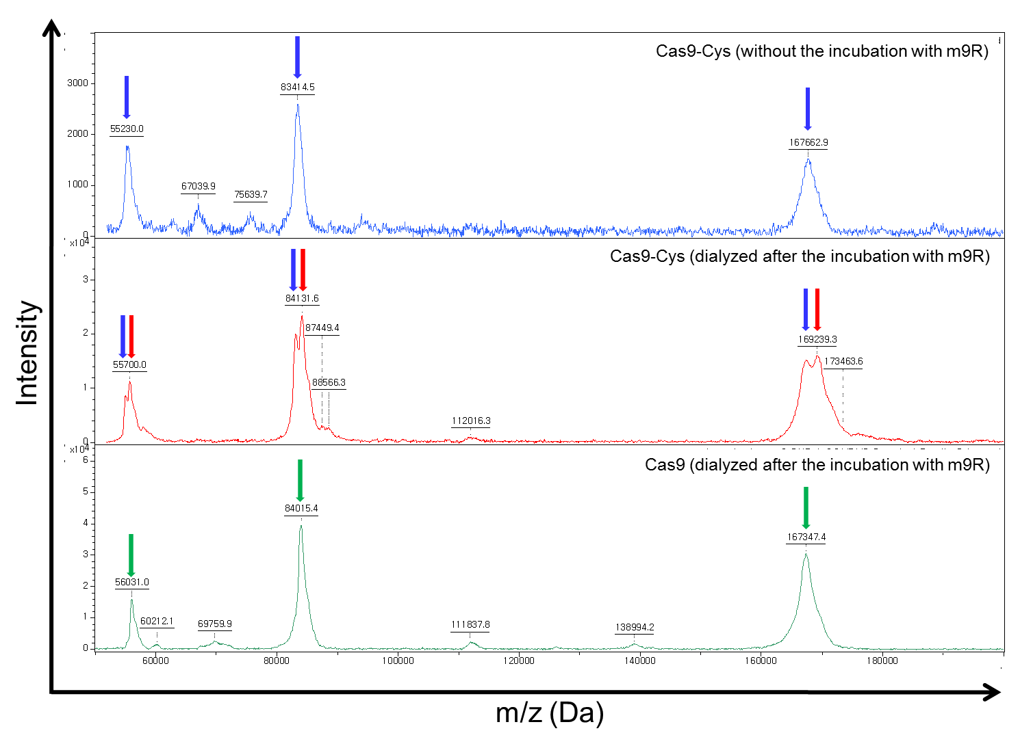

Supplemental Figure 5. Repeated treatments with Cas9-m9R and sgRNA:9R increase both on- and off-target mutations.
HEK293T cells were simultaneously treated with Cas9-m9R and sgRNA:9R targeting the EMX1 gene or AAVS1-AS2 locus (one treatment/day). The number of treatments is indicated. The resulting mutation frequencies were determined using the T7E1 assay three days after the first treatment. The arrow heads indicate the expected position of DNA bands cleaved by T7E1.

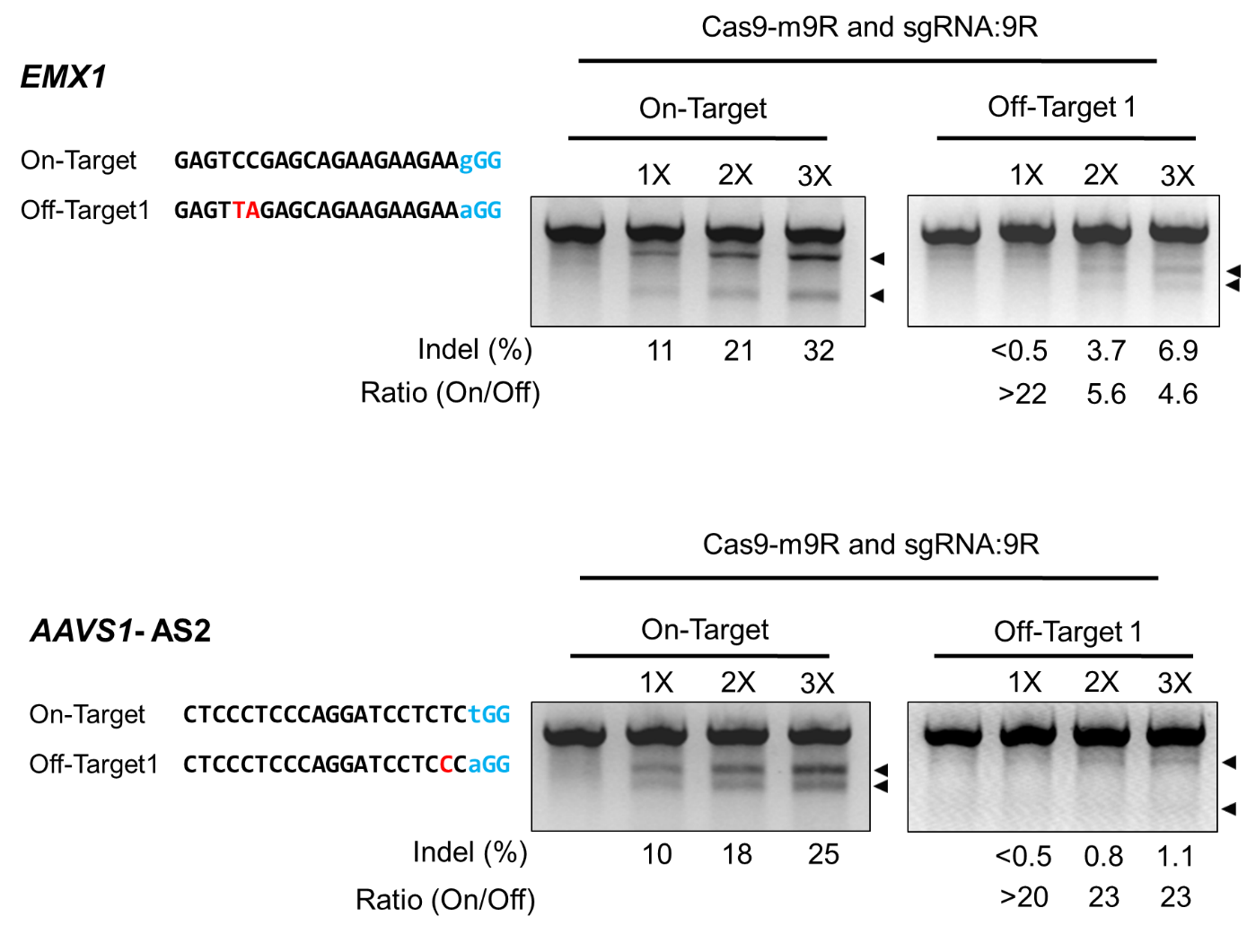

Supplemental Figure 6. Analysis of off-target effects.
HEK293T cells were treated with Cas9-m9R and sgRNA:9R directly (PR, protein and RNA) or transfected with plasmids encoding Cas9 and sgRNA (Plasmid) targeting the CCR5 gene. Mutation frequencies at potential off-target sites were detected using the T7E1 assay. The protospacer adjacent motif sequence and mismatched bases are shown in blue and red, respectively. The arrow head indicates the expected position of DNA bands cleaved by T7E1.

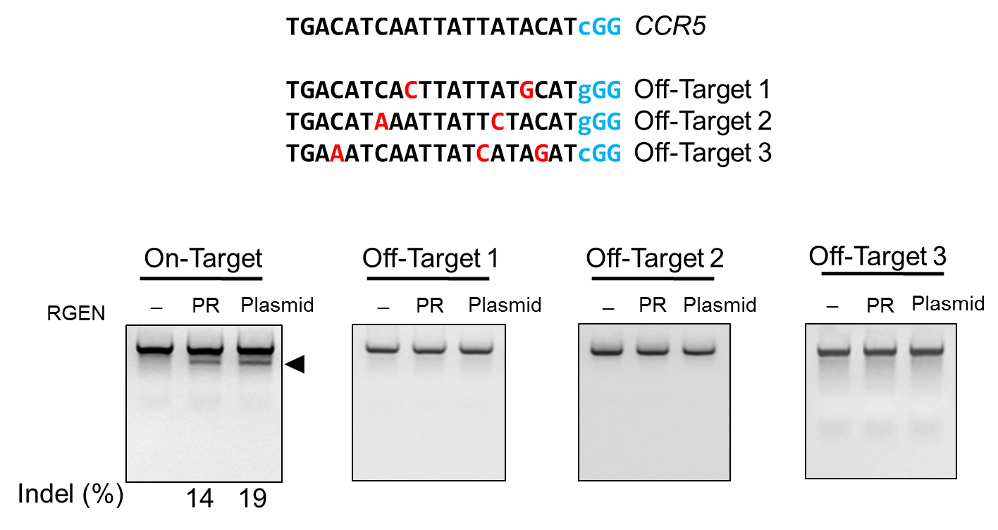

Supplemental Figure 7. Comparison of the effects of CPP-mediated versus plasmid-mediated RGEN delivery on endogenous gene modification.
HEK293T cells were treated with Cas9-m9R and sgRNA:9R directly (PR, protein and RNA) or transfected with plasmids encoding Cas9 and sgRNA (Plasmid) targeting the CCR5 and ABCC11 gene, and the resulting mutation frequencies were determined by the T7E1 assay. The arrow heads indicate the expected position of DNA bands cleaved by T7E1.
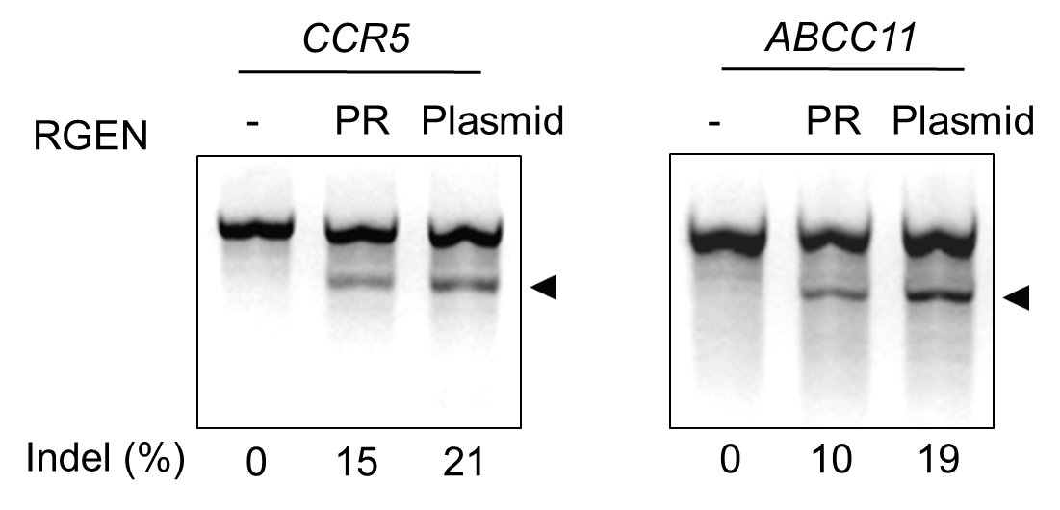

Supplementary Figure 8. Generation of clones containing RGEN-induced mutations by Cas9-m9R and sgRNA:9R treatment.
HEK293T cells were transfected with a magnetic reporter and treated once per day with Cas9-m9R and sgRNA:9R for three days. Three days after the first treatment, cells expressing H-2K^{k} from the activated reporter were magnetically separated and plated into 96-well plates. Single cell-derived colonies were then selected. Genomic DNA isolated from the clones was analyzed using the T7E1 assay and sequencing. DNA sequences of the CCR5 wild-type (WT) and mutant clones are shown. The target sequence complementary to sgRNA is underlined. The protospacer adjacent motif is shown in red. The cleavage site is indicated by a red arrow head. The column on the right indicates the number of inserted or deleted bases.

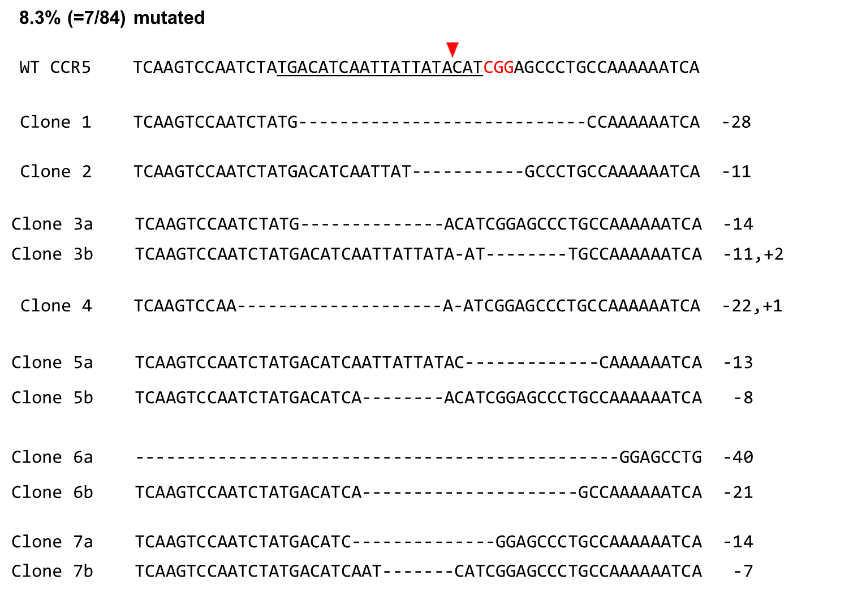
Supplemental Table 1. The sequences of oligonucleotides used in this study.

In vitro transcription templates
Direction | Gene | Sequence (5’ to 3’)
sgRNA Forward | CCR5 | GAAATTAATACGACTCACTATAGGTGACATCAATTATTATACAT  GTTTTAGAGCTAGAAATAGCAAGTTAAAATAAGGCTAGTCCG
sgRNA Forward | ABCC11 | GAAATTAATACGACTCACTATAGGGCAGCATCATACTTCCCCCA  GTTTTAGAGCTAGAAATAGCAAGTTAAAATAAGGCTAGTCCG
sgRNA Forward | EMX1 | GAAATTAATACGACTCACTATAGTCACCTCCAATGACTAGGGGTTTTAGAGCTAGAAATAGCAAGTTAAAATAAGGCTAGTCCG
sgRNA Forward | AAVS1-AS2 | GAAATTAATACGACTCACTATAGGCTCCCTCCCAGGATCCTCTCGTTTTAGAGCTAGAAATAGCAAGTTAAAATAAGGCTAGTCCG
sgRNA Forward | AAVS1-S3 | GAAATTAATACGACTCACTATAGGGGGAGGGAGAGCTTGGCAGGGTTTTAGAGCTAGAAATAGCAAGTTAAAATAAGGCTAGTCCG
sgRNA Reverse |  | AAAAAAGCACCGACTCGGTGCCACTTTTTCAAGTTGATAACGG  ACTAGCCTTATTTTAACTTGC

Target sequences are in bold and the T7 promoter sequence is underlined.

List of primers used for nested and hemi-nested PCR
Gene or locus | Direction | Sequence (5’ to 3’)
CCR5 | FP1 | CTCCATGGTGCTATAGAGCA
CCR5 | RP | GCCCTGTCAAGAGTTGACAC
CCR5 | FP2 | GAGCCAAGCTCTCCATCTAGT
ABCC11 | FP1 | TCTGTCAATCCTTGCTGTGC
ABCC11 | RP | CACAGCACCTTCCTCAAACA
ABCC11 | FP2 | GGTCCCTCATTCTGCAGGTA
EMX1 | FP1 | GAGGAGCTAGGATGCACAGC
EMX1 | RP1 | TGAACGCGTTTGCTCTACCA
EMX1 | FP2 | CTGCCATCCCCTTCTGTGAAT
EMX1 | RP2 | AATCTACCACCCCAGGCTCT

AAVS1-AS2 | FP1 | GGAGTTTTCCACACGGACAC
AAVS1-AS2 | RP1 | CCCCTATGTCCACTTCAGGA
AAVS1-AS2 | FP2 | TGCTTCTCCTCTTGGGAAGT
AAVS1-AS2 | RP2 | CGGTTAATGTGGCTCTGGTT
AAVS1-S3 | FP1 | GGAGTTTTCCACACGGACAC
AAVS1-S3 | RP1 | CCCCTATGTCCACTTCAGGA
AAVS1-S3 | FP2 | TGCTTCTCCTCTTGGGAAGT
AAVS1-S3 | RP2 | CGGTTAATGTGGCTCTGGTT

Primers used in the T7E1 assay for Off-target analysis

Gene | Off-Targets | Direction | Sequence (5’ to 3’)
EMX1 | Off-Target1 | FP | TTGAGATGGCTGTTCAGAGG
EMX1 | Off-Target1 | RP | TTGAGACATGGGGATAGAATCA
EMX1 | Off-Target1 | FP1 | GTGGGGAGATTTGCATCTGT
EMX1 | Off-Target1 | RP1 | CAATGGGAAGGACAGCTTCT
AAVS1-AS2 | Off-Target1 | FP | CAGGCTCCTTGTTCTTCTGG
AAVS1-AS2 | Off-Target1 | RP | AAGCCATGGTCTGCTTCACT
AAVS1-AS2 | Off-Target1 | FP1 | TGCAGGAAAAAGTTGCAGTG
AAVS1-AS2 | Off-Target1 | RP1 | GGCCAAACTGGAGAGACAGA
AAVS1-S3 | Off-Target1 | FP | CAGCTTCCTGGAAAGACCTG
AAVS1-S3 | Off-Target1 | RP | GGTTTTGGCCTGACTGTGTT
AAVS1-S3 | Off-Target1 | FP1 | TATCTCCTCTCCCCCTGCTT
AAVS1-S3 | Off-Target1 | RP1 | GAGCTGCCTGACTTCCCTAA

