Supplementary Information

A biochemical landscape of A-to-I RNA editing in the human brain transcriptome

Masayuki Sakurai¹, Hiroki Ueda¹, Takanori Yano¹, Shunpei Okada¹, Hideki Terajima¹, Totai Mitsuyama², Atsushi Toyoda³, Asao Fujiyama³, Hitomi Kawabata¹ and Tsutomu Suzuki^{1,*}

Supplementary methods

Preparation of poly(A)+ RNA
Total RNA (50 μg) from an adult human brain (male, age 30 years old; BioChain Institute Inc.) was dissolved in 100 μl binding buffer consisting of 20 mM Tris-HCl (pH 7.5), 100 mM NaCl, 1 mM EDTA (pH 7.5) and 0.1% (v/v) N-lauryl sarcosinate. The RNA solution was incubated at 65°C for 10 min and chilled on ice. Streptavidin-coated magnetic beads (60 μl of Dynabeads MyOne Streptavidin C1, 12 mg/ml, Invitrogen) were washed four times with TE buffer [10 mM Tris-HCl (pH 7.5) and 1 mM EDTA (pH 7.5)]. Subsequently, 200 pmol of biotinylated oligo(T) LNA/DNA (5’-Biotin-TtTtTtTtTtTtTtTtTtTt-3’; T and t indicate LNA and DNA, respectively) was mixed with the streptavidin beads in 100 μl TE buffer and then incubated for 10 min at 37°C with gentle shaking. The beads were washed once with 100 μl TE buffer and twice with the binding buffer. The RNA was then added to the washed beads and incubated at 37°C for 10 min with gentle shaking. The beads were then washed three times with binding buffer, resuspended in 50 μl water and incubated at 65°C for 10 min. The eluate was separated using a magnetic separator and transferred to a new tube. The tube was spun briefly and the supernatant was transferred to a new tube. The poly(A)+ RNA was then purified again by repeating the same procedure. The quality of the RNA was checked using a 2100 Bioanalyzer (Agilent Technologies).

ICE-seq
The cDNA for paired-end RNA-seq analysis using a Genome Analyzer II (Illumina) was performed basically as described in the manufacturer’s protocol (Illumina RNA-seq PE Sample Prep protocol, v3.6). First, 100 ng of cyanoethylated poly(A)+ RNA was fragmented in 20 μl of 1x fragmentation buffer (most reagents and buffers are supplied with the mRNA-seq 8-Sample Prep Kit, Illumina) at 95°C for 5 min. Next, 2 μl of the fragmentation stop solution was added to the mixture and incubated on ice. The RNA fragments were precipitated by ethanol, dissolved in 11.1 μl water, mixed with 3 μg (1 μl) of random primer, incubated at 65°C for 5 min, and chilled on ice. The RNA/primer solution (12.1 μl) was mixed with 5x 1st strand buffer (4 μl), 100 mM DTT (2 μl), 25 mM dNTP (0.4 μl) and RNaseOUT (0.5 μl), and then pre-incubated at 25°C for 2 min. Subsequently, 200 U (1 μl) Superscript III (Invitrogen) was added to the mixture for 1st strand cDNA synthesis. The reaction was carried out under the following conditions: 25°C for 10 min, 50°C for 50 min, 70°C for 15 min, and hold at 4°C. For 2nd strand synthesis, water (62.8 μl), 10x second strand buffer (10 μl), and 25 mM dNTP (1.2 μl) were added, and the mixture was left on ice for 5 min. The reaction was started by adding 2 U RNase H (1 μl) and 50 U DNA polymerase I (5 μl), and incubating at 16 °C for 2.5 h. The cDNA was recovered in 50 μl EB buffer (QIAGEN) from a Qiaquick PCR purification kit (QIAGEN). Next, end-repair was performed in a 100 μl mixture containing the eluted cDNA (50 μl), 10x end-repair buffer (10 μl), 25 mM dNTP (1.6 μl), water (27.4 μl), 15 U T4 DNA polymerase (5 μl), 5 U Klenow DNA polymerase (1 μl), and 50 U OPTIkinase (5 μl, USB) at 20°C for 30 min. The cDNA was recovered in 50 μl EB buffer, dried, and dissolved in 32 μl of water. Next, A-base addition was performed in a 50 μl mixture composed of the cDNA (32 μl), A-tailing buffer (5 μl), 1 mM dNTP (10 μl), and 15 U Klenow 3’ to 5’ exo (3 μl) at 37°C for 30 min. The cDNA was recovered in 50 μl EB buffer, dried, and dissolved in 23 μl of water. Next, adaptor ligation was performed in a 50 μl mixture composed of the cDNA (23 μl), DNA ligase buffer (25 μl), PE adaptor oligo mix (1 μl), and DNA ligase (1 μl) at 25°C for 15 min. The cDNA was recovered in 50 μl 0.2× EB buffer and concentrated to a volume of 10 μl. The cDNA was then subjected to 2% agarose gel electrophoresis (10 ×10 cm, LO3 agarose, Takara) in 1x TAE buffer for 100 min at 100 V at 4°C. After staining with SYBR GOLD (Invitrogen), the 300 bp cDNA band was cut from the gel, recovered using a Qiaquick gel extraction kit (QIAGEN), eluted into 50 μl EB buffer, dried, and dissolved in 37 μl of water. Next, PCR amplification of the 300 bp cDNA was performed in a 50 μl mixture composed of the cDNA (37 μl), 5x cloned Phu Buffer (10 μl), PCR primer 1.0 (1 μl), PCR primer 2.0 (1 μl), 25 mM dNTP (0.5 μl), and Phu polymerase (0.5 μl). The conditions were as follows: 98°C for 30 s, followed by 20 cycles of 98°C for 10 s, 65°C for 30 s, and 72°C for 30 s, and a final step of 72 °C for 5 min. The amplified cDNA was recovered in 50 μl 0.2× EB buffer, concentrated to 10 μl, and again subjected to 2% agarose gel electrophoresis. The 300 bp cDNA band was cut from the gel and recovered as above. The size and quality of the cDNA was confirmed using a DNA 1000 kit and Bioanalyzer (Agilent). The cDNAs for CE-, CE+ and CE++ conditions were subsequently analyzed using a Genome Analyzer II (Illumina) according to the manufacturer’s protocol.

Read mapping and data processing
Using the Genome Analyzer II (Illumina), 75 nt from both ends of the 300 bp cDNAs were sequenced with 11, 12 and 13 lanes for CE-, CE+ and CE++ conditions, respectively. The total read numbers from each sample are shown in Figure 2A. The original data sets have been deposited at the DRA site with the annotation number DRA000478 (ftp://ftp.ddbj.nig.ac.jp/ddbj_database/dra/fastq). To ensure data set quality, the base-call quality values (QV or PhredScore) of the sequence reads were averaged at each cycle of the sequencing reaction (from 1 to 75). In some cases, a set of reads were trimmed by removing bases bearing QV less than 10. The lengths of the sequence reads in six lanes and two lanes were trimmed to 65 and 60, respectively. The trimmed reads were then mapped to UCSC Genes (on hg18 version, a total of 66,803 genes) as the transcriptome reference and NCBI build 36.1 (hg18) as the human genome reference. dbSNP (Ver. 130 and 137, http://www.ncbi.nlm.nih.gov/SNP/) and Repeat masker track (http://genome.ucsc.edu/) were also used.
Read mappings were executed in parallel on Linux cluster machines in which a fastq sequence file from each lane was divided into 20 portions, each of which was mapped to the reference sequences using BWA aligner (v5.1)(Li and Durbin 2009) as short read mapping software, allowing four mismatches to the genomic reference or five mismatches to the transcriptome reference. Default values were used for the other parameters of the BWA aligner. In this process, 68.1% (CE-), 53.2% (CE+) and 56.3% (CE++) of the total reads in each condition were mapped to the genome reference (Figure 2A), while 67.2% (CE-), 52.6% (CE+) and 54.8% (CE++) of the total reads were mapped to the transcriptome reference. To avoid misalignment, reads uniquely mapped to specific regions in the genome reference were accepted. Considering the redundancy of the transcriptome reference sequence, reads that mapped to up to two regions were accepted. For reads mapped to more than three regions in the transcriptome reference, only those reads with paired ends mapped with the proper pair flg, which is assigned by the BWA aligner, were accepted. Approximately 90% of the mapped reads were accepted as unique reads using this process (Figure 2A).
The mapped reads were compared to the reference sequences, and mismatched bases were counted to calculate the matching identity (%) for each read. As A-to-G mismatches for both references and T-to-C mismatches for the genome reference are candidates for A-to-I editing, these mismatches were treated as matched bases when calculating matching identity. Reads with low matching identity (<95%) and reads containing indel(s) were subjected to local realignment to the reference sequence using the Smith Waterman algorithm(Smith and Waterman 1981). Realigned reads with matching identities lower than 95% were discarded.

Calculation of RPKM value
To estimate the distribution of gene expression, the Cov value (base coverage for each gene) and RPKM value (Reads Per Kilo-base per Million reads)(Mortazavi et al. 2008) were calculated from the mapped reads. Both values describe the depth of read coverage across the whole gene, which can be calculated with the following equation, in which Cb, L and Nb stand for the number of mapped bases for each gene, the length of each gene and the total number of mapped bases in each experiment, respectively.
Cov = $\frac{Cb}{L}$ (1)
RPKM = $\frac{{10}^{9}}{Nb}$ Cov (2)
In this analysis, the Nb values for the CE-, CE+ and CE++ samples were 18,298,649,195, 16,671,896,010 and 18,680,567,735, respectively. Thus, the RPKM and Cov values for each condition were calculated as follows:
RPKM (CE-)= 0.0546Cov(CE-) (3)
RPKM (CE+)= 0.060Cov(CE+) (4)
RPKM (CE++)= 0.0535Cov(CE++) (5)
One RPKM value corresponds to approximately 20 Cov in each of our experiments.

Data screening of A-to-G sites

Data processing framework.
For efficient processing of the massive data sets obtained by the mapped reads, we developed a MapReduce pipeline named FastPass, which was implemented by Java (https://sourceforge.net/p/fastpassngs/). FastPass is designed based on the concept of MapReduce(Langmead et al. 2009; McKenna et al. 2010) and reference-based data compression(Hsi-Yang Fritz et al. 2011). FastPass compresses the data obtained from the mapped reads by extracting the start/end positions of the mapped reads and counts of mismatched bases at genomic positions (Figure S2). The read positions and mismatched base counts are then output to indexed bpos and bdiff binary files, respectively. These processes were executed in parallel using Linux cluster machines and all bpos and bdiff files were collected and merged. The mismatched base counts and positions were then restored from the merged information and registered in the local MySQL database.

Defining editing candidates
Using the CE- dataset, all mismatched sites mapped to the cDNA or genome reference were collected if more than eight aligned reads at each site had bases different from those in the reference sequence. A-to-G mismatches in both reference sequences and T-to-C mismatches in the genome reference were selected as editing candidates. Non-A-to-G or non-T-to-C mismatches were also collected as negative controls for editing. The total numbers of those positions are shown in Figure S3. The A-to-I editing candidates were subjected to subsequent filtering steps to remove false positive sites, as described below.

ICE score calculation
For measuring changes in G-base counts (Ng) upon cyanoethylation, the ΔNg value was defined. ΔNg is a logarithmic ratio value that represents the decrease in Ng in CE+ (or CE++) compared to that of CE- samples. Each Ng value is added to 1 to avoid infinity values in the ratios. For non-A-to-G (or non-T-to-C) sites, the same calculation was applied to define ΔNn(CE+) and ΔNn(CE++):
ΔNg (CE+) =$\log_{2}\left(\frac{Ng (CE+)+1}{Ng (CE-)+1}\right)$ (6)
ΔNg (CE++) =$\log_{2}\left(\frac{Ng (CE++)+1}{Ng (CE-)+1}\right)$ (7)
ΔNg (CE+) versus ΔNg (CE++) was plotted for all A-to-G mismatch sites (Figure 4AB). In this scatter plot, the ICE score was defined as the distance of each point from the origin as follows:
ICE score = $\sqrt{{ΔNg(CE+)}^{2}+{ΔNg(CE++)}^{2}}$ (8)

First binomial test for base-call quality
From the geometric mean of base-call quality QV (PhredScore), an error probability p was calculated at each mismatched site according to the following equation:
QV = -10log₁₀p (9)
The binomial (random chance) probability (P1) of k read numbers of mismatches at each site where n read numbers are mapped in total was calculated as follows:
$P1=p^{k}{\left(1-p\right)}^{n-k}$ (10)
To simplify the calculation, the binomial probability was approximated by the normal distribution (Z1 value) as follows:
Z1 = $\frac{k-μ}{\sqrt{σ^{2}}}$ (11)
The mean and standard deviation are described as μ = np and σ² = np (1-p), respectively.
As shown in Figure S18A, the ICE score versus Z1 for each A-to-G site was plotted. The higher the Z1 value, the lower the probability of sequence error at the candidate site. Considering the distribution of known editing sites in the plot, candidate sites were defined as those with Z1 values higher than 10 and 15 for the cDNA and genomic references, respectively.

Second binomial test for basecall quality
In the Illumina Genome Analyzer II system, sequencing errors do not occur equally for all types of base substitutions. For example, base substitutions between A and C and between G and T occur more frequently than other types of substitutions(Li et al. 2009). If A-to-G substitutions artificially originate from such sequence errors, A-to-C or A-to-T substitutions should be observed as frequently as A-to-G substitutions at each position. Since these sites have low base-call quality, most artificial substitutions should be eliminated by the first binomial test. However, a second binomial test was required to estimate the independence of A-to-G substitutions from other substitutions in the total reads mapped to the reference. To determine the base substitution rate caused by sequencing error, mismatched sites with low base-call quality (Z1<0) that were not the result of SNP sites were identified and statistics on the base substitution frequency at each site were calculated. The base substitution rates (q) of A-to-G and T-to-C were determined to be 0.209 and 0.292, respectively. The second binomial test for a sequencing error was then conducted with the error likelihood based on the null hypothesis that the substitution was artificial and created by a sequencing error. The binomial probability (P2) was approximated by the normal distribution (Z2 value), and the mean and standard deviation were described as μ = kq and σ² = kq (1-q), respectively, where g and k stand for G-base counts and total mismatched reads at each position, respectively, as follows:
Z2 = $\frac{g-μ}{\sqrt{σ^{2}}}$ (12)
Considering the distribution of known editing sites in the plot (Figure S18B), candidate sites with Z2 values higher than 5 and 4 for the cDNA and genomic references, respectively, were examined.

Mapping quality
The following process was required to eliminate sites with low mapping quality (MQ) provided by the BWA aligner. The MQ values of reads that included candidate sites were averaged at each site. In the case of the genomic reference sequence, sites with average MQ values lower than 22.5 and higher than 40 were excluded. In addition, the number of mismatches (NM) to the reference sequence for reads covering the candidate sites were averaged at each site. Sites with average NM values higher than 3.5 for the transcriptome reference or 4.5 for the genomic reference were omitted.

Unreliable sites
If non-A-to-G mismatches were located near the site of an editing candidate with a close mutation ratio, this site was discarded as an unreliable site. A-to-G (T-to-C) sites that possessed at least two non-A-to-G (non-T-to-C) sites within the region from -75 to +75 nt of the candidate editing site were selected. The mutation ratio of these sites was then compared to that of the candidate site. If the mutation ratio difference fell to within 0.1, the candidate site was discarded as unreliable.

Removal of SNPs
Candidate editing sites registered as SNPs in the dbSNP130 as well as dbSNP137(Sherry et al. 2001) were discarded.

Identifying A-to-G sites by ICE score
Finally, A-to-G sites from both reference sequences and the T-to-C sites from the genome reference sequence were selected if they had more than 20 total read counts, more than 10 Ng, and scores higher than 0.1 Gr and 1.75 ICE. Gr = the ratio of Ng in total read counts. For CDS candidates, A-to-G sites with more than 8 Ng, and scores higher than 0.1 Gr and 1.4 ICE were selected.

RNA interference
The A172 glioblastoma cell line was grown in Dulbecco’s modified Eagle’s medium (SIGMA) supplemented with 10% fetal bovine serum (SIGMA). siRNAs targeting human ADAR mRNA (sense strand, 5’-CCGCCAUCAUUAUGAAAAAAG-3’) and human ADARB1 mRNA (sense strand, 5’-GCACUGAUGUGAAGGAAAAAG-3’) were designed using siExplorer(Katoh and Suzuki 2007). As a negative control, an siRNA targeting luciferase (sense strand, 5’-CGUACGCGGAAUACUUUCGAAG-3’) was used. A172 cells were transfected with siRNAs (final concentration, 1 nM) using reverse-transfection as directed in the Lipofectamine RNAiMAX kit (Invitrogen). Total RNA was extracted from the A172 cells using the miRNeasy kit (QIAGEN) 3.5 days after transfection. To estimate the efficiency of ADAR mRNA knock-down, qRT-PCR was performed. Total RNA (~1 µg) was treated with RQ1 RNase-free DNase (Promega) and reverse-transcribed with an anchored-oligo(dT)₁₈ primer and a random hexamer using the Transcriptor First Strand cDNA Synthesis Kit (Roche). The incubation conditions were as follows: 25°C for 10 min, 50°C for 30 min, 55°C for 30 min, and 85°C for 5 min. ADAR and ADARB1 in the synthesized cDNA (equivalent to 25 ng of total RNA) was quantified by qRT-PCR using LightCycler 480 SYBR Green I Master Mix (Roche) with a LightCycler 480 instrument (Roche) and the following sets of primers: 5’- AGCACCTTCCATGACCAGATAG -3’ and 5’- AGAGAAACCTGATGAAGCCTCTC-3’for human ADAR mRNA; 5’- GGGAGAAACAAGAAGCTTGCCA-3’ and 5’- GCATCTTTAACATCTGTGCCTG-3’ for human ADARB1 mRNA; 5’- CTGGCACCACACCTTCTAC-3’ and 5’- GGCATACCCCTCGTAGATG-3’ for human ACTB as an internal control. The cycling conditions were as follows: 95°C for 10 min, followed by 50 cycles of 95°C for 10 s, 60°C for 15 s and 72°C for 15 s.

Gene Ontology analysis
All protein-coding mRNAs found to have editing sites were subjected to Gene ontology enrichment analysis using GeneTrailExpress(Keller et al. 2008)(http://genetrail.bioinf.uni-sb.de/index.php) and DAVID(Huang da et al. 2009) (http://david.abcc.ncifcrf.gov/home.jsp).

Supplementary Results

Q-to-R editing site in CDK13
The Q-to-R editing site in cyclin-dependent kinase 13 (CDK13) was found to have high editing frequency (92%) among the ADAR-mediated editing sites (Table S3 and Figure S5O). Although high editing frequency in tissues or clinical specimens is not maintained in cultured cells in most cases, a high level of editing at this site was maintained in A172 cells. In addition, the amino acid and nucleotide sequences surrounding the Q-to-R editing site (position chr 7 + 39990548) in exon 1 of CDK13 are highly conserved among mammals, indicating that editing at this site is widely conserved in mammals. We confirmed that the corresponding site in the mouse homolog is also edited (data not shown). These results indicate the functional importance of this editing site. CDK13 is a cyclin-dependent serine/threonine protein kinase originally identified as a human homolog of cell division cycle 2 (cdc2)-like kinases from Schizosaccharomyces pombe(Lapidot-Lifson et al. 1992). Knockdown of this mRNA using an antisense-oligonucleotide in murine bone marrow cultures resulted in the selective impairment of megakaryocyte development, suggesting that CDK13 is involved in the regulation of hematopoiesis. Several reports suggest that ADAR is associated with hematopoiesis. In ADAR-null mice, which have an embryonic lethal phenotype at gestational day 11.5–12, widespread apoptosis and defective hematopoiesis were observed(Wang et al. 2004). ADAR is essential for the maintenance of both fetal and adult hematopoietic stem cells(Hartner et al. 2009), and the editing activity of ADAR is required for hematopoietic progenitor cell survival(XuFeng et al. 2009). Defective Q-to-R editing in CDK13 may be associated with the defective hematopoiesis observed in ADAR-null mice. CDK13 also plays a role in mRNA splicing through phosphorylation of the splicing factor ASF/SF(Even et al. 2006; Chen et al. 2007). Further studies will be necessary to clarify the role of the Q-to-R editing in CDK13 function.

S-to-R editing site in NOVA1 mRNA
In NOVA1 (neuro-oncological ventral antigen 1) mRNA, we identified the S-to-R editing site (position 392) whose editing frequency was low (Gr=0.32) (Table S3 and Figure S5P-ABC). NOVA1 is a neuron-specific RNA-binding protein, a member of the Nova family of paraneoplastic disease antigens, and it regulates neuron-specific alternative splicing that is essential for neuronal viability(Jensen et al. 2000). The editing site is located within a short hairpin structure formed by 60 nt dsRNA in the last exon of NOVA1 mRNA (Figure S5P-A). When aligned with sequences from other primates and murine homologs, the nucleotide sequence flanking the editing site, as well as the hairpin structure, are highly conserved. The frequency of S-to-R editing was examined in various brain tissues by Sanger sequencing (Figure S5P-D). The editing frequency in each part of the brain differed substantially. Adult whole brain had approximately 50% editing frequency. The pons showed the highest editing frequency at 72%, while the thalamus had the lowest frequency at 27%. Other regions showed intermediate levels of editing, ranging from 42% to 62%. No editing was observed in cultured cells from human neuroblastoma or glioblastoma (data not shown), and low editing frequency was observed in human fetal brain (Figure S5P-D) and murine fetal brain (E18 and P0) (data not shown). Thus, the S-to-R editing site in NOVA1 mRNA is a developmentally-regulated editing site.

Validation of RDD sites by the ICE-method
A subset of RDD sites(Bahn et al. 2012) in human glioblastoma U87MG cells (kindly provided by Prof. Yasuhiro Matsumura of National Cancer Center Hospital, Japan) was examined by the ICE-method. According to Bahn et al (2011)(Bahn et al. 2012), they estimated their RDD sites by calculating likelihood values (LLR). The LLR average of whole sites was 9.52±9.74 (the lower threshold of LLR is 2). Total RNA from U87MG cells was cyanoethylated under mild conditions (CE+) and strong conditions (CE++). As positive controls, two A-to-I editing sites in CDK13 and FOXRED2 were confirmed by the ICE-method (Figure S14AB). We then randomly selected 76 RDD sites whose LLR average was 14.97±16.17 from the list published by Bahn et al (2011)(Bahn et al. 2012) for validation by the ICE-method. Among them, 44 sites were amplified by RT-PCR and analyzed by the ICE-method (Table S11). As shown in Figure S14C, D, E, F and Table S11, 25 sites were confirmed to be edited, whereas 19 sites were found to be false-positives. Thus, only 56.8% of the RDDs were confirmed by the ICE-method. The LLR averages of 25 positive and 19 negative sites were calculated to be 10.6 ± 7.1 and 19.7 ± 20.6, respectively. The results suggested that the LLR values for RDD were not sufficient to reliably predict A-to-I editing sites. In this small scale validation using a single same cell type, we were able to show the advantage of the ICE-method over RDD to identify A-to-I editing sites. In the 19 negative sites, we found two false-positive sites produced by mapping errors, as reported recently(Piskol et al. 2013). The cDNA of SON mRNA containing the candidate site was mapped to a pseudogene in chr1, not to the true gene in chr 21, which caused an A-to-G mismatch (Figure S15). A similar mapping error was observed in the candidate site in YWHAZ mRNA (Figure S16).

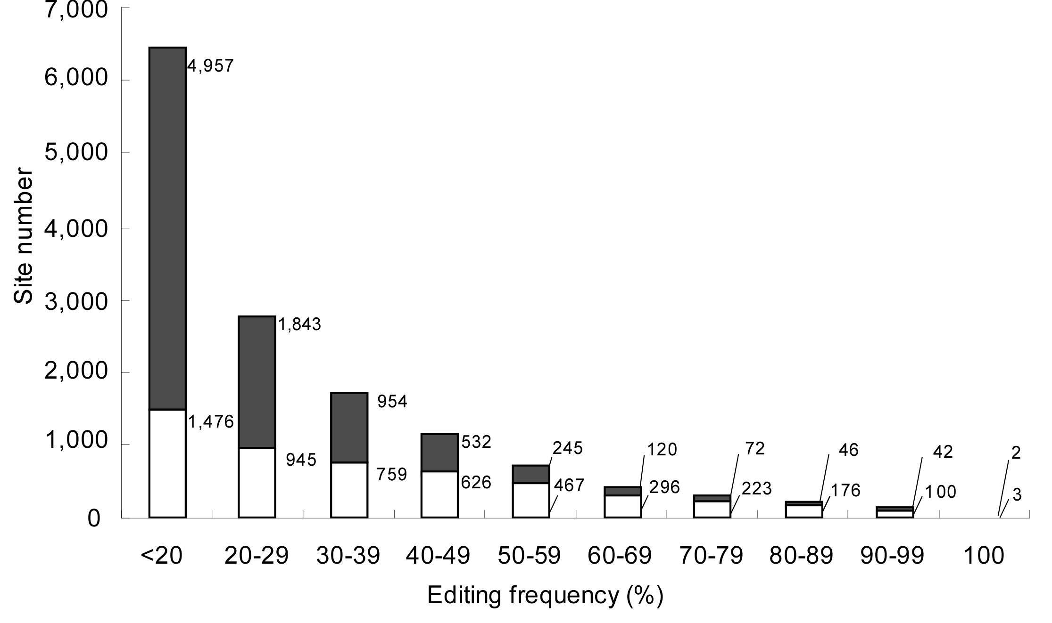

Figure S1 Editing frequency of 13,884 editing sites determined by ICE-method

The editing frequency of each site was calculated using the regression line described previously(Sakurai et al. 2010). The numbers of editing sites at each template ratio are compiled in the histogram. Gray and white boxes represent novel and known sites, respectively.

A

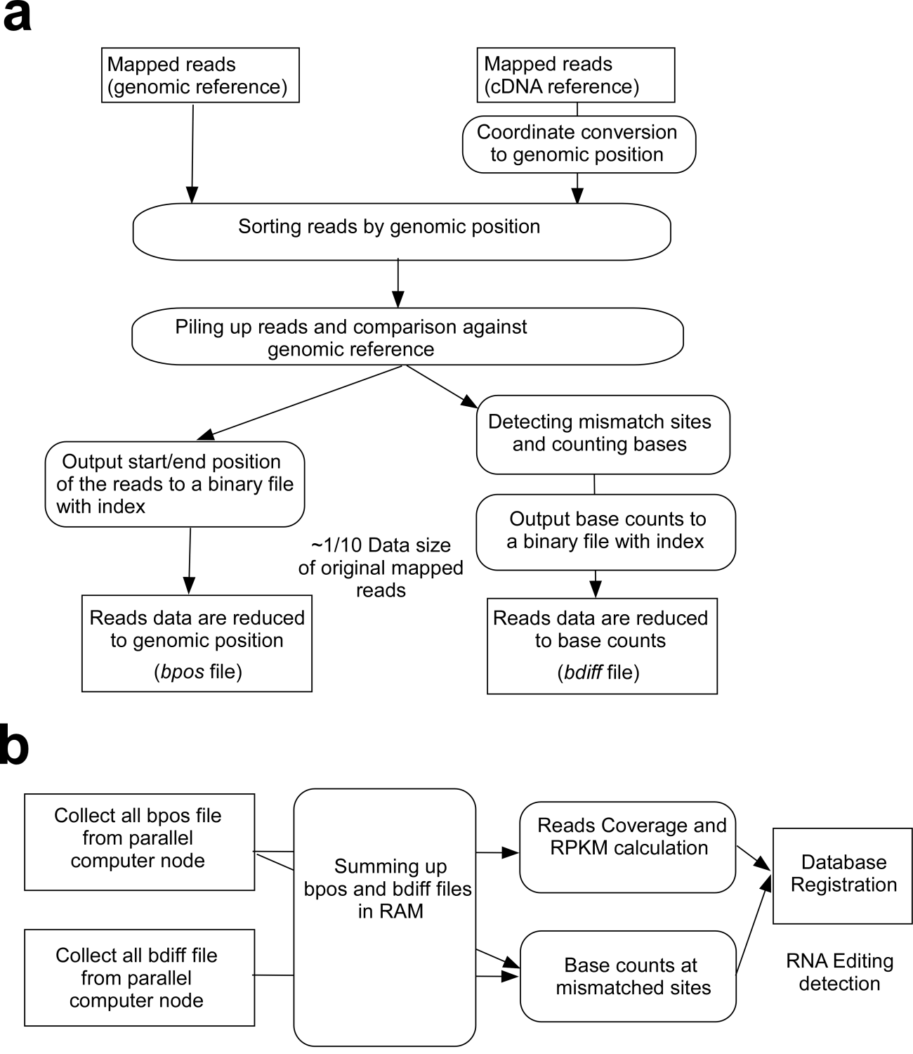
B

Figure S2 Data processing flow of FastPass
(A) Mapping and data reducing using parallel computer nodes. RNA-seq reads are typically separated into chunk and mapped to the reference. Coordinates of mapped positions were converted to genomic positions in the case of the transcriptome reference. Then, the reads were sorted according to the genomic positions and piled up, compared against the genomic reference to detect mismatch sites. The positions of mismatch sites and nucleotide base counts at every site were output to a binary file with index (bdiff file). At the same time, the start and end positions of the reads were output to another binary file with index (bpos file). Data size was reduced to about one tenth of the original data size of the mapped reads by only extracting positions and the differences from the genomic reference.
(B) Data merging and RNA editing detection. The bpos and bdiff files were collected and summed up in RAM. Note that, bpos and bdiff files were created by different computer nodes in parallel. By summing up bpos files, Coverage and RPKM values were calculated. Also, base counts at mismatch sites were calculated from these files. Those data were further analyzed in MySQL database to filter out false positive candidates of the editing sites.

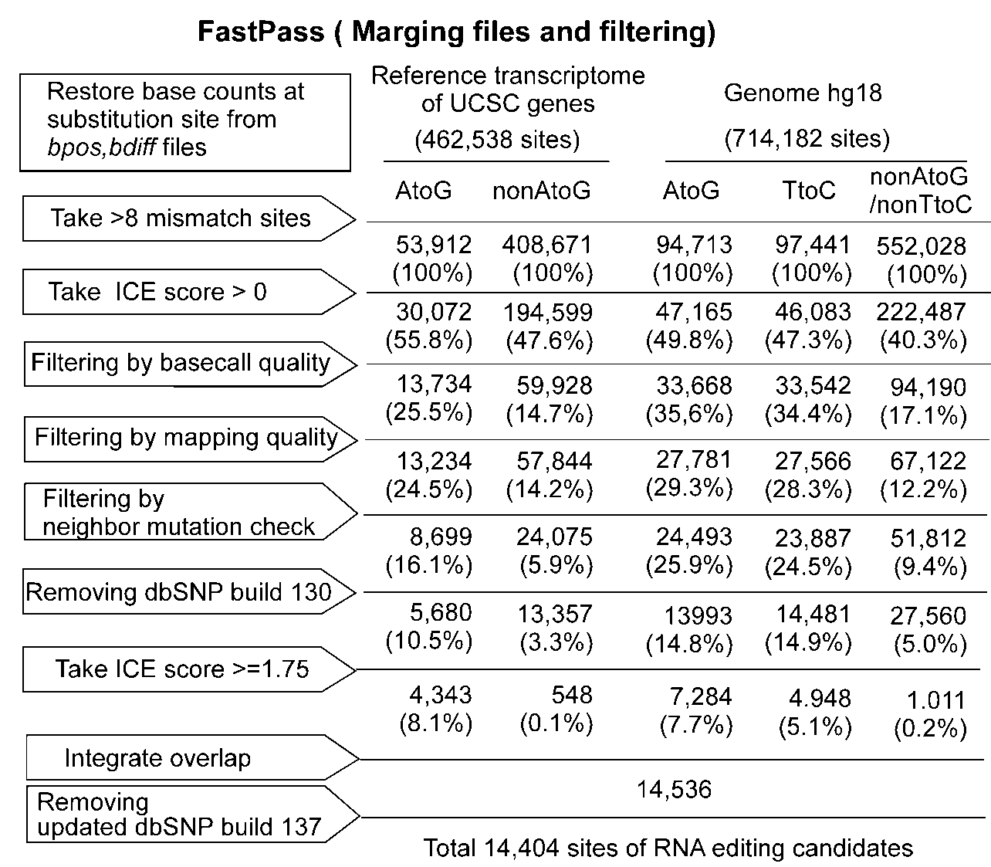

Figure S3 Filtering processes of the editing candidates

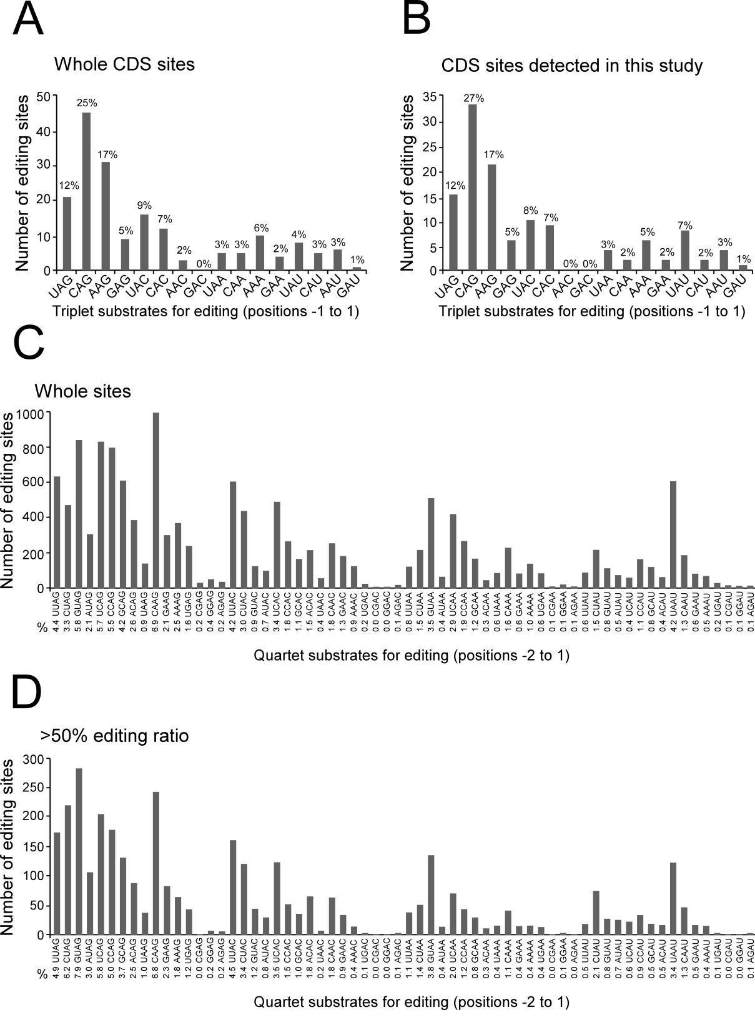
Figure S4 Triplet and quadruplet preferences of A-to-I editing.
Statistics of triplet sequences (positions -1 to 1) centered on the edited A are analyzed with whole CDS sites (A) and CDS sites detected in this study (B).
Statistics of quadruplet sequences (positions -2 to 1) are analyzed with a full dataset of ICE-seq (C) and the sites with more than 50% editing frequency (D).


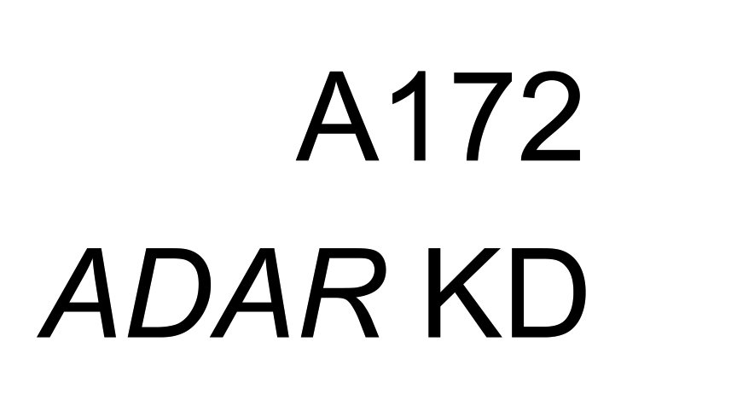
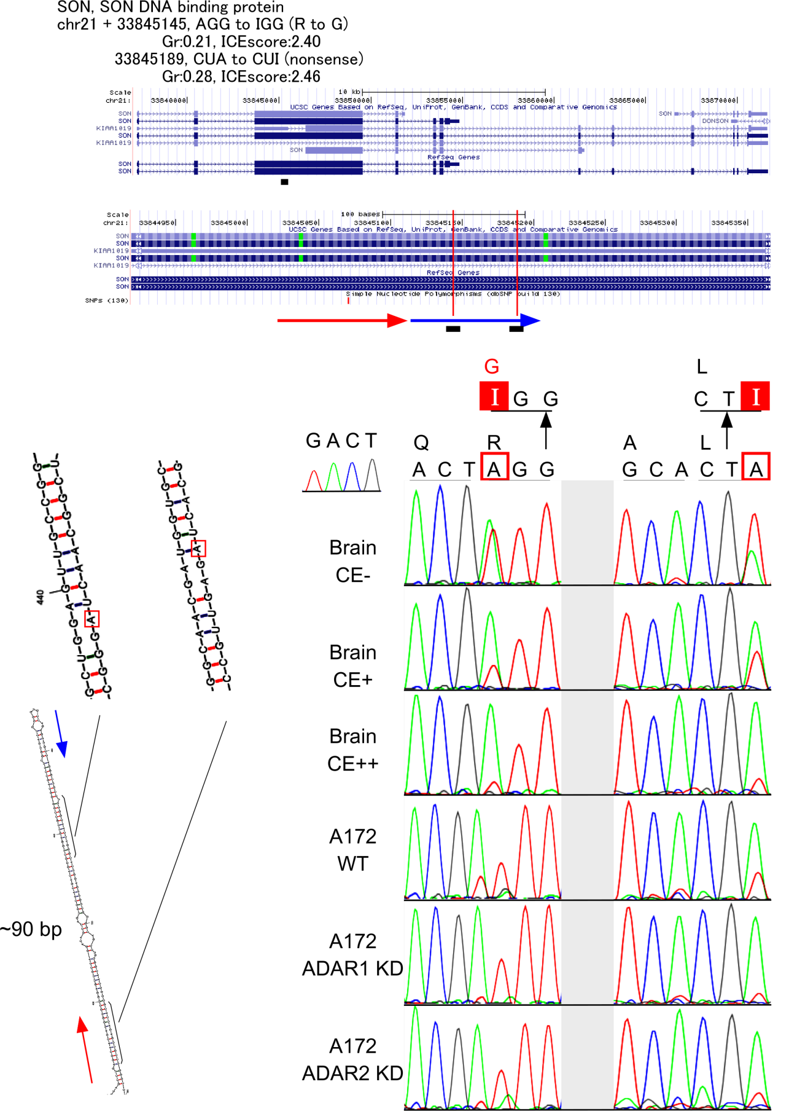

Figure S5 Novel editing sites in CDS

(A) R-to-G site in SON mRNA

All snapshots of genomic regions shown in Figures S5-S12 were obtained from USCS genome browser (hg18).

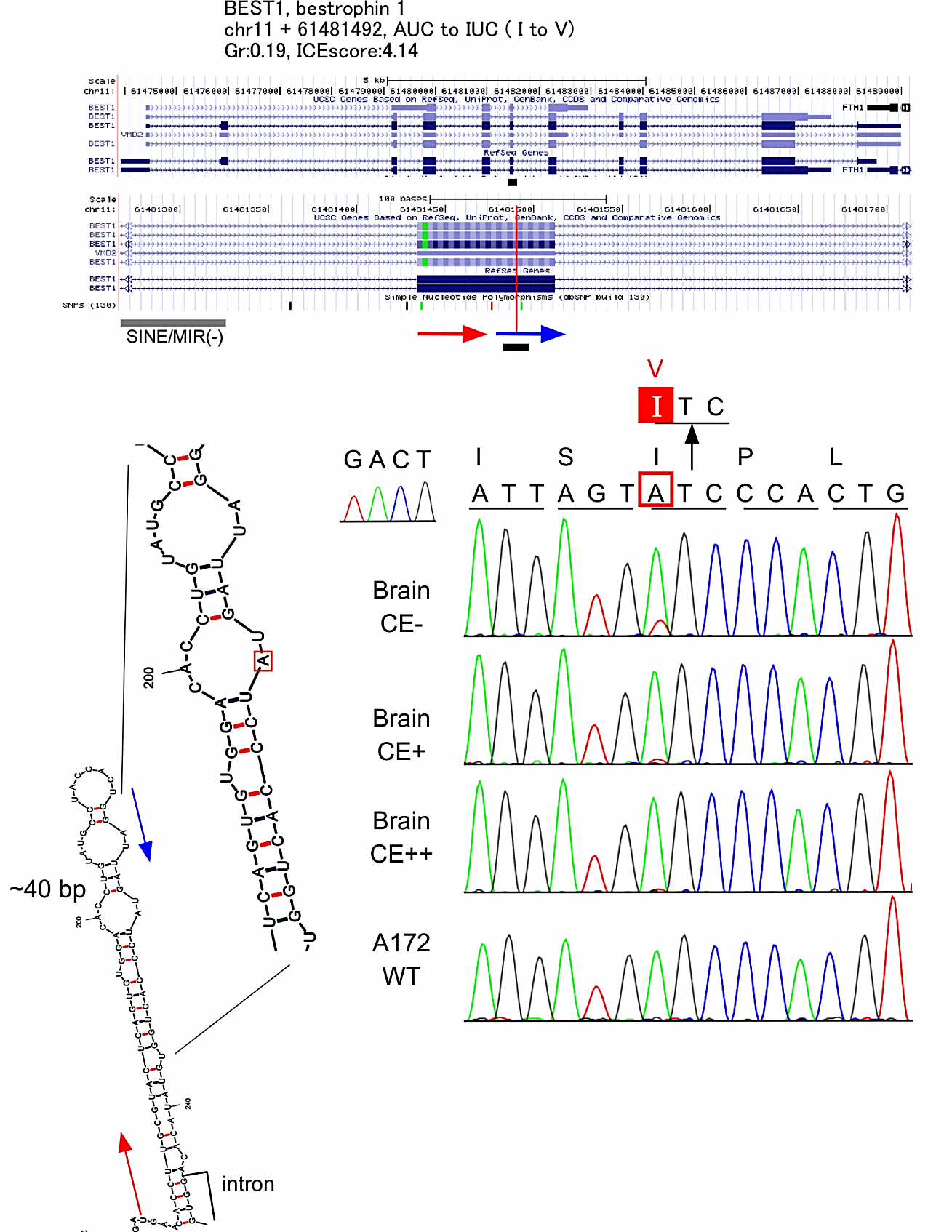

(B) I-to-V site in BEST1 mRNA (bestrophin 1)

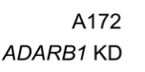
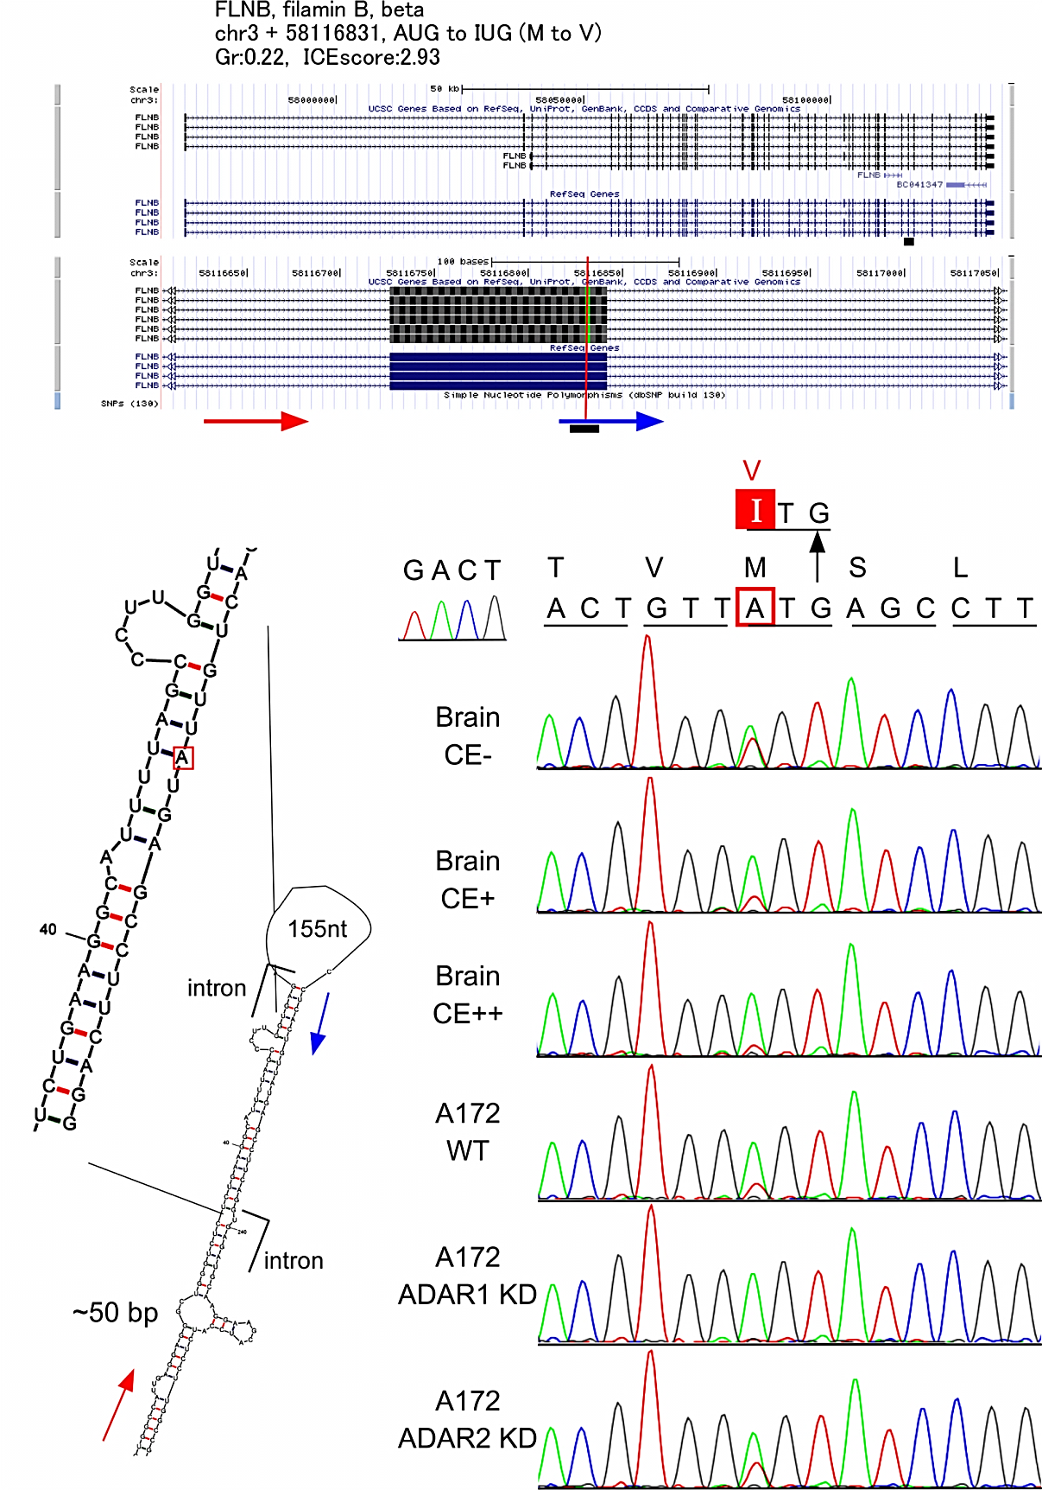

(C) M-to-V site in FLNB mRNA (filamin B, beta)

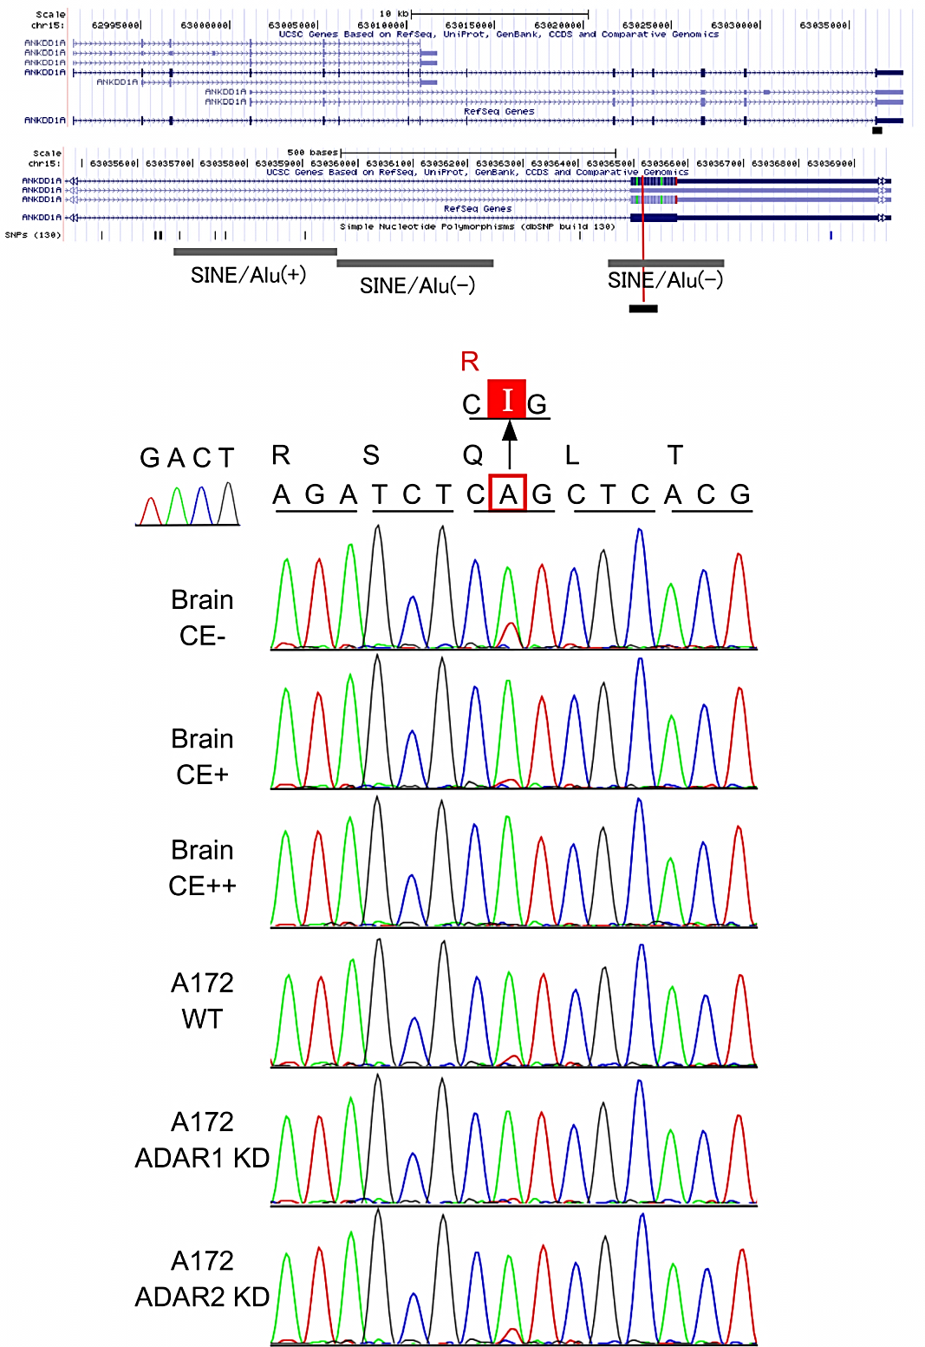

(D) Q-to-R site in ANKDD1A mRNA (ankyrin repeat and death domain containing 1A)

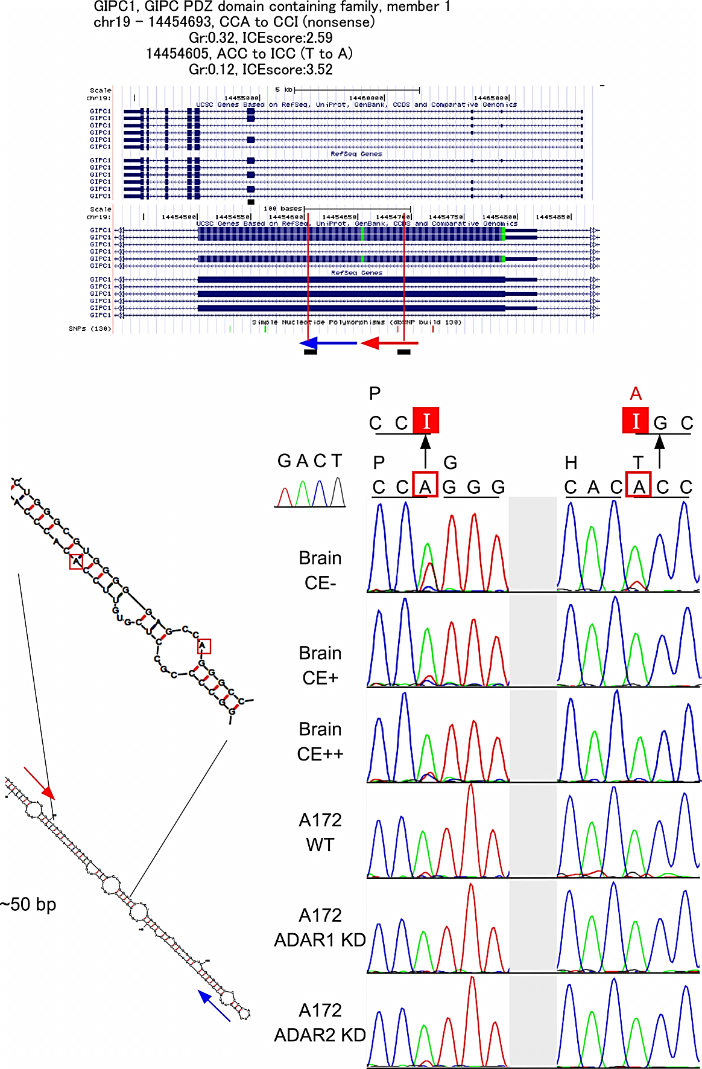

(E) T-to-A site in GIPC1 mRNA

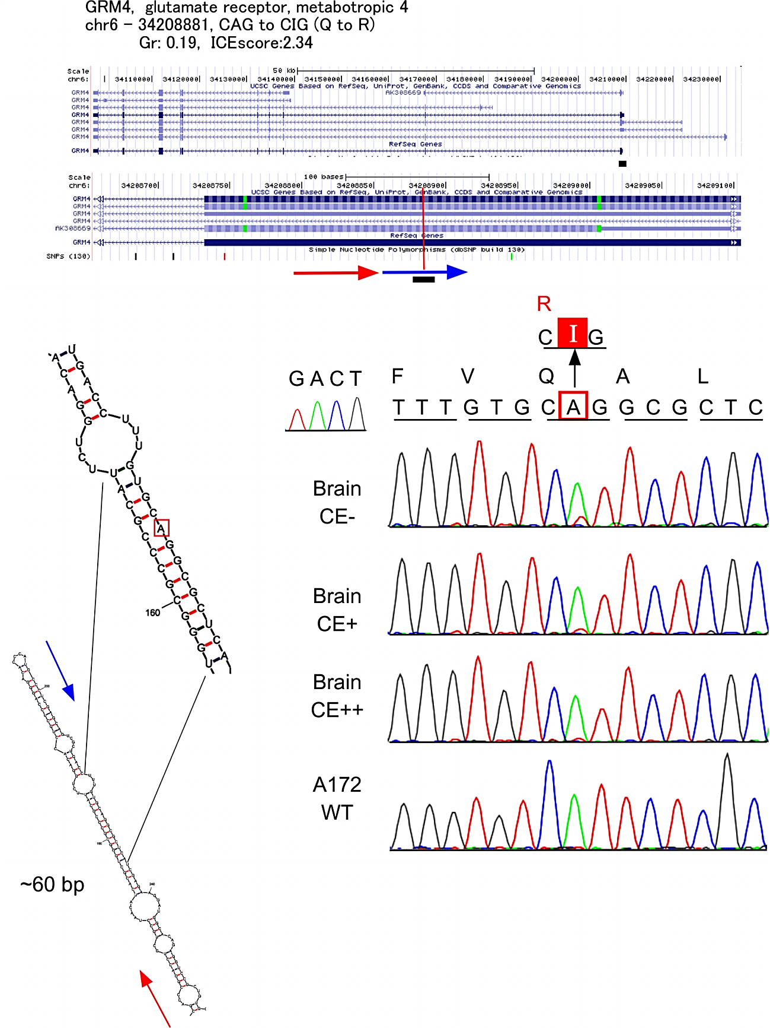

(F) Q-to-R site in GRM4 mRNA (glutamate receptor, metabotropic 4)

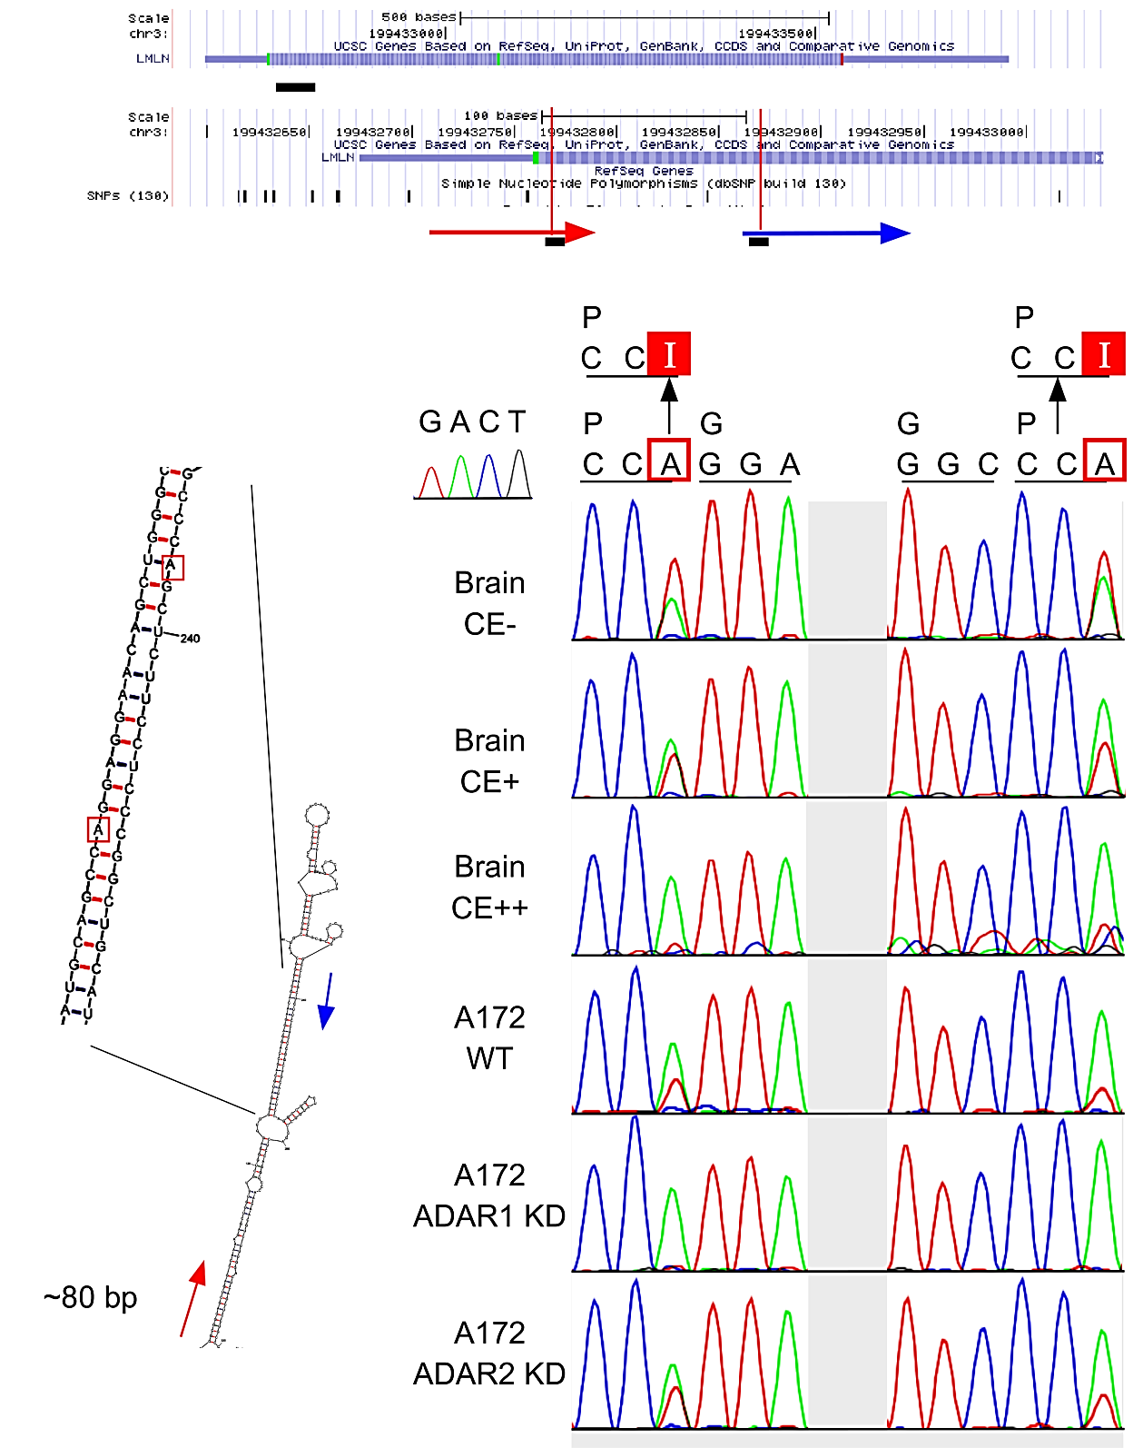

(G) P-to-P sites in LMLN mRNA (leishmanolysin-like, metallopeptidase M8 family)

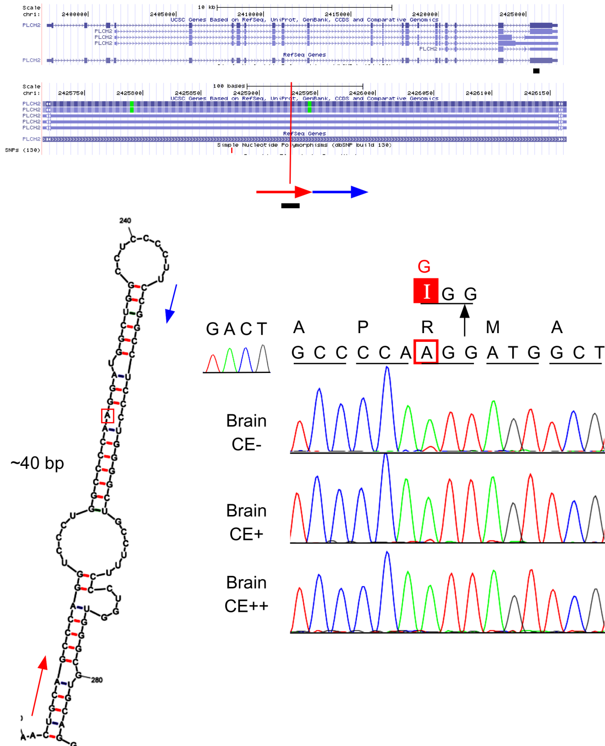

(H) R-to-G site in PLCH2 mRNA (phospholipase C, eta 2)

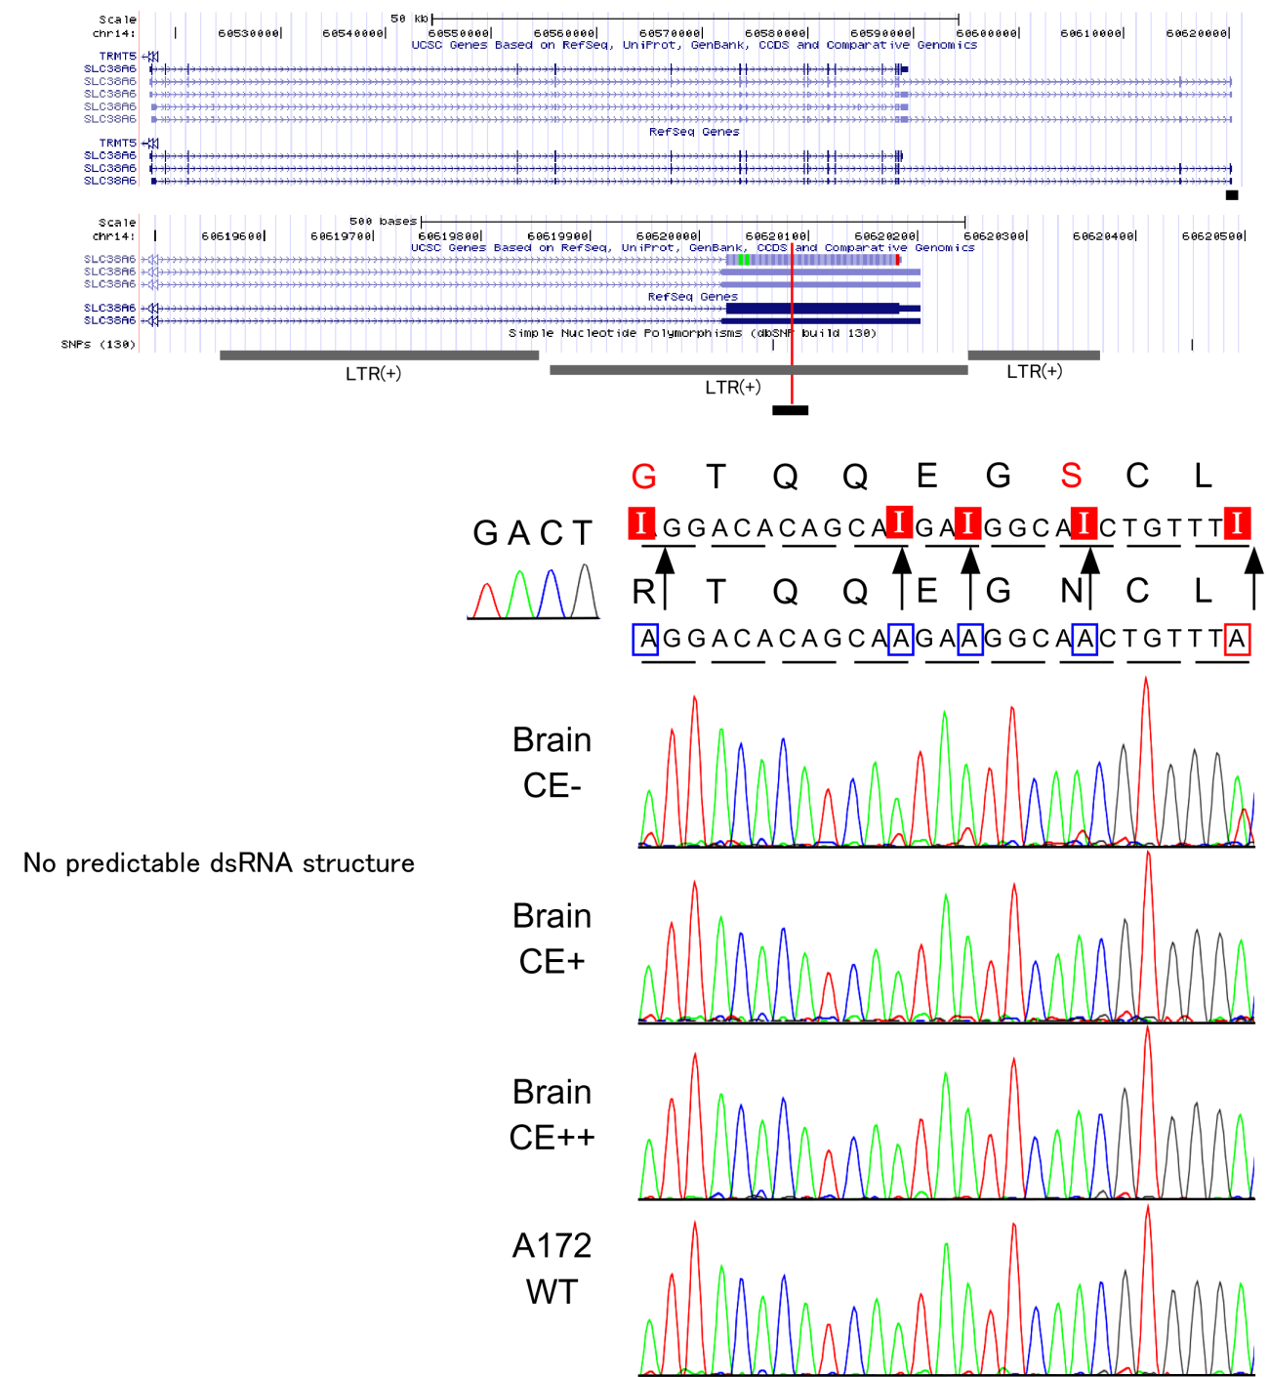

(I) Multiple editing in SLC38A6 mRNA

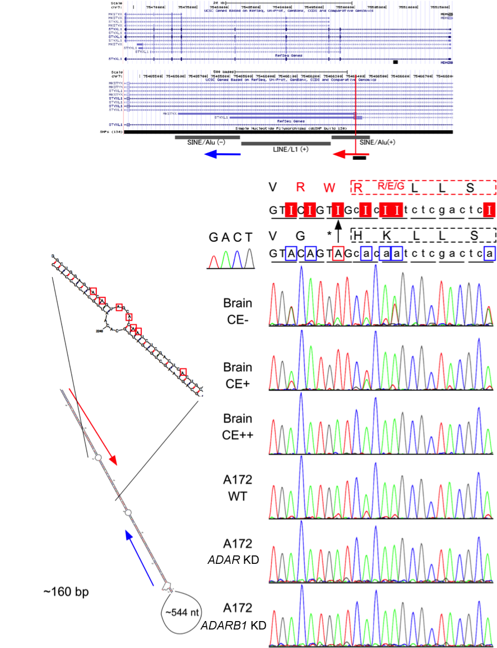

(J) Stop-to-W and G-to-R sites in STYXL1 mRNA

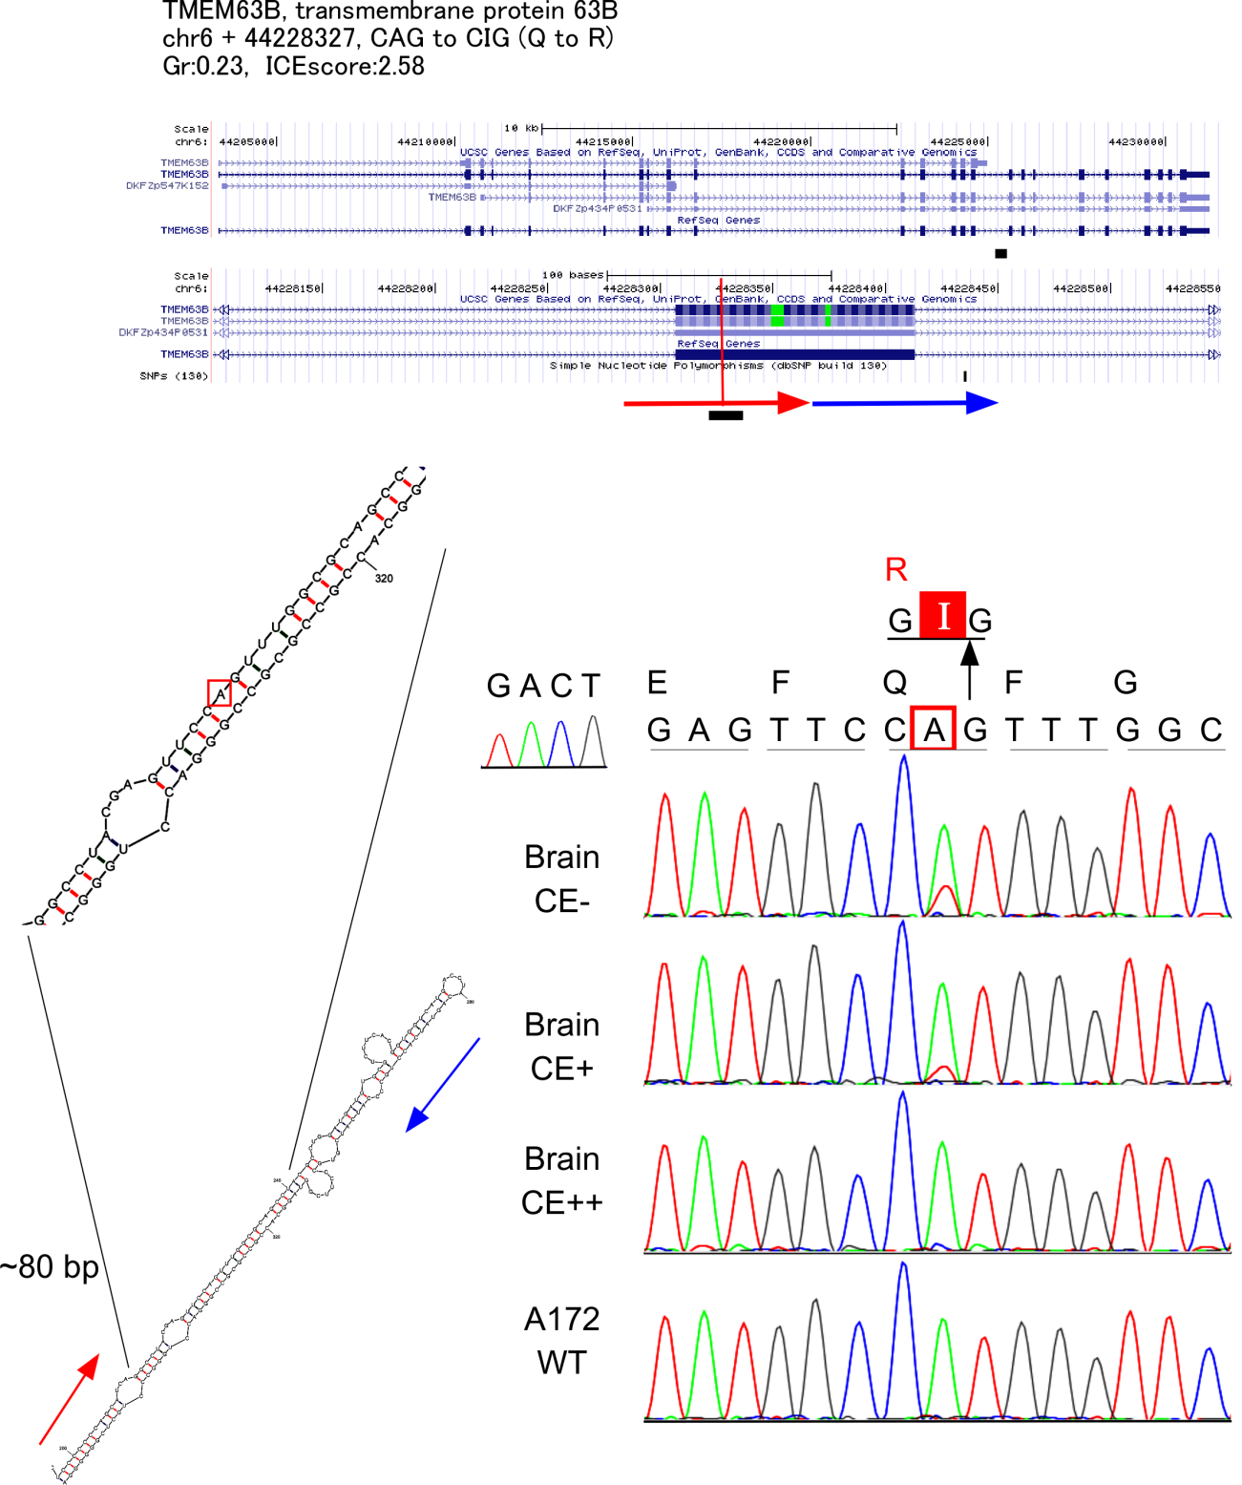

(K) Q-to-R site in TMEM63B mRNA (transmembrane protein 63B)

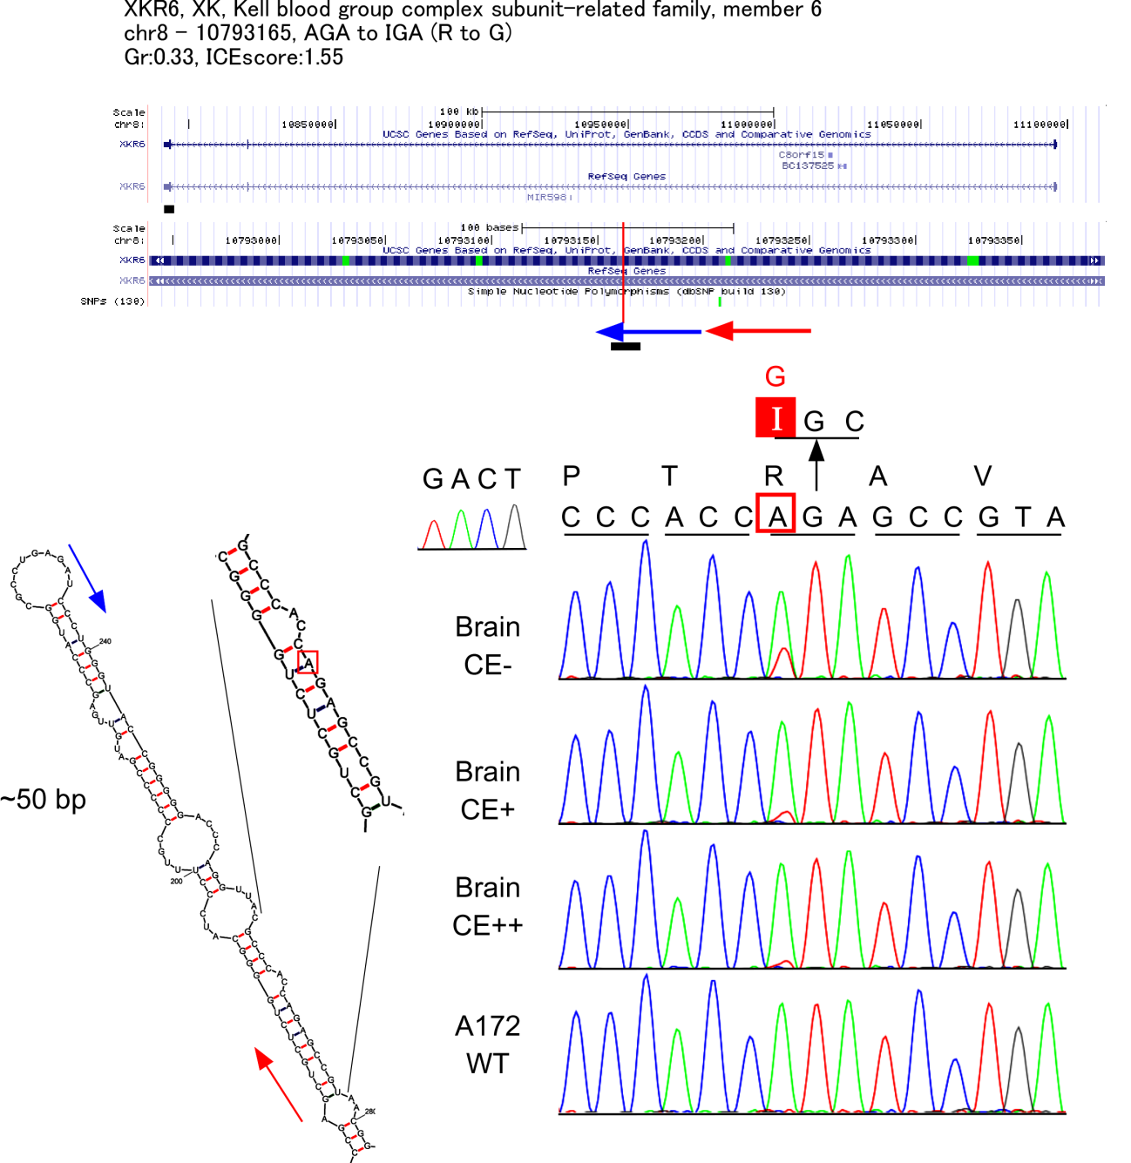

(L) R-to-G site in XKR6 mRNA

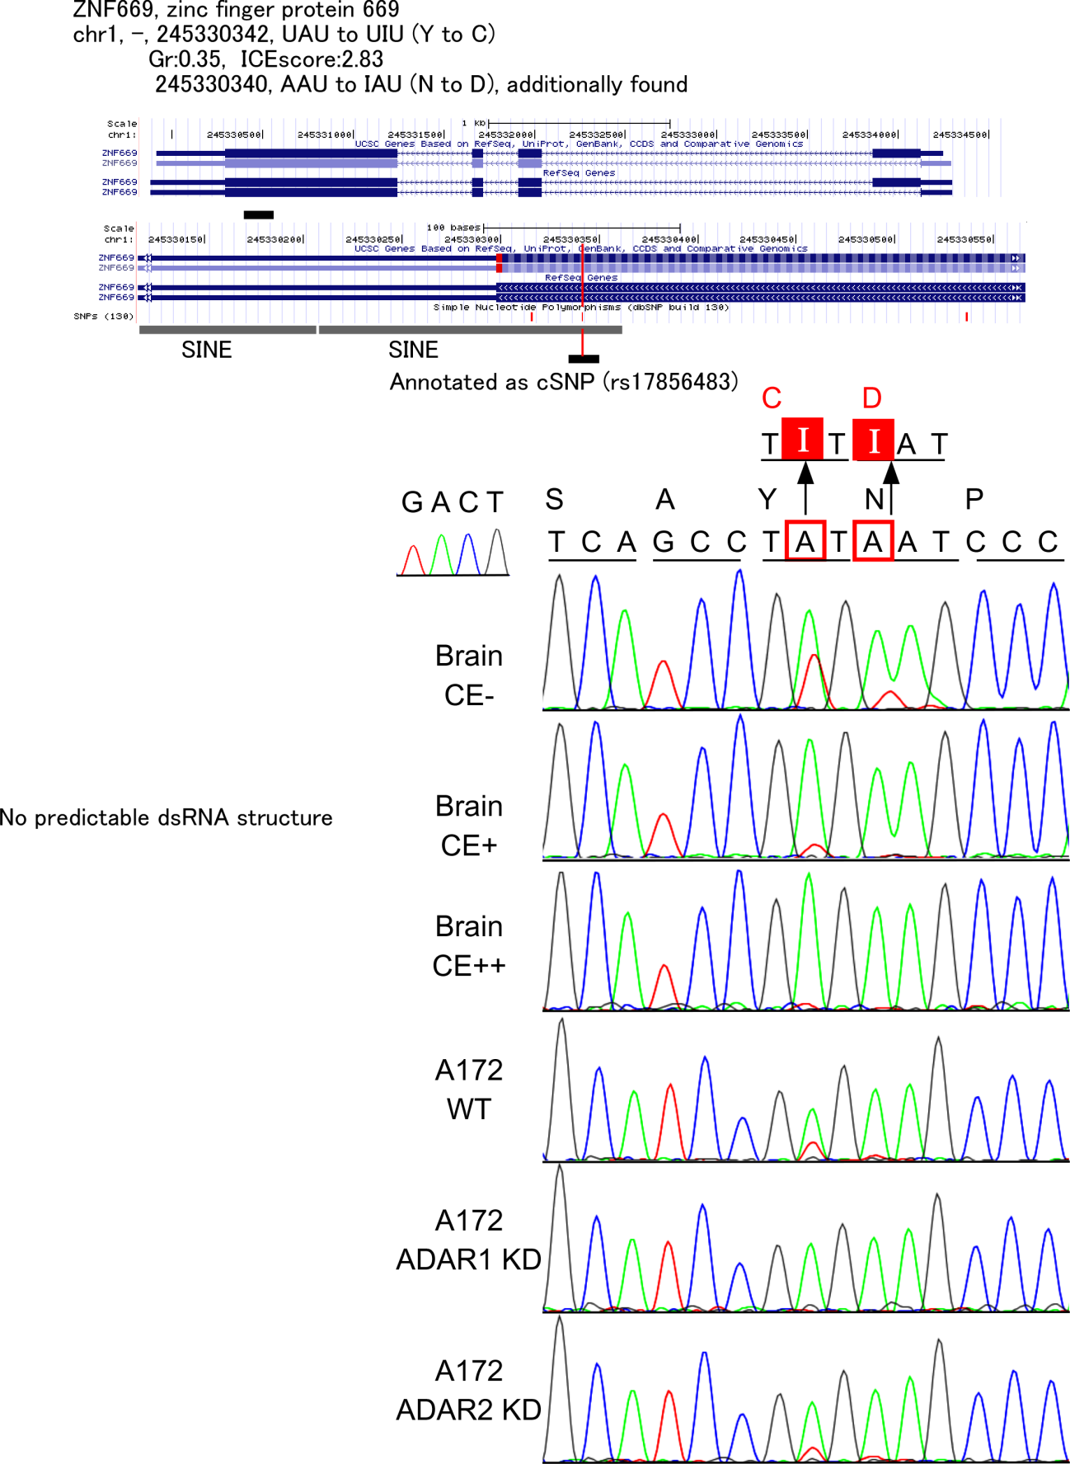

(M) Y-to-C and N-to-D sites in ZNF669 mRNA

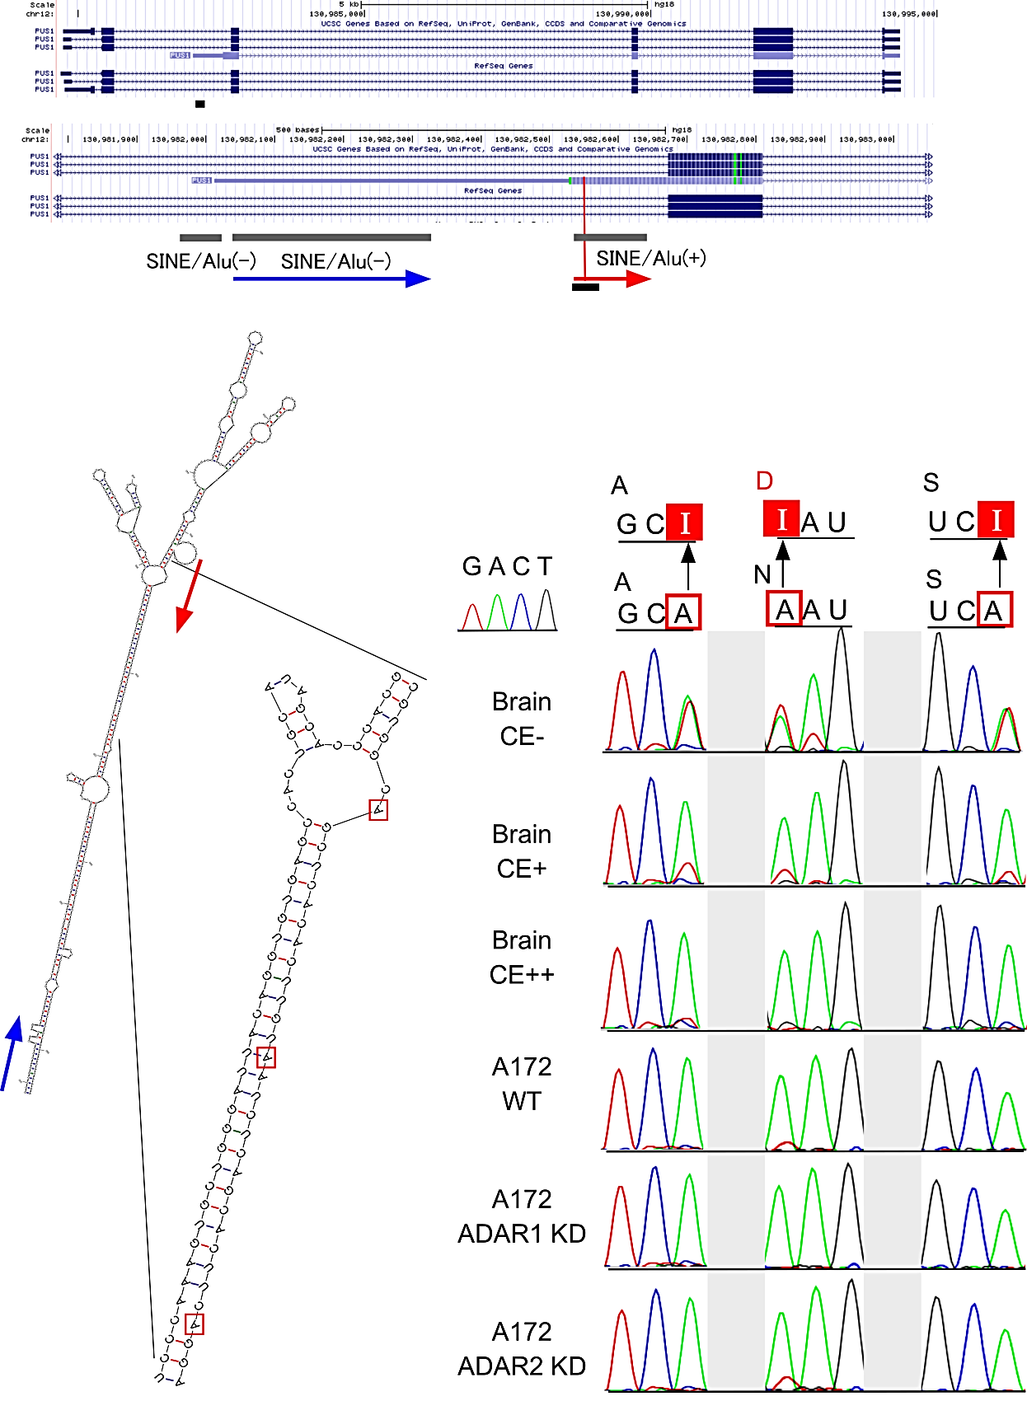

(N) N-to-D site in PUS1 mRNA

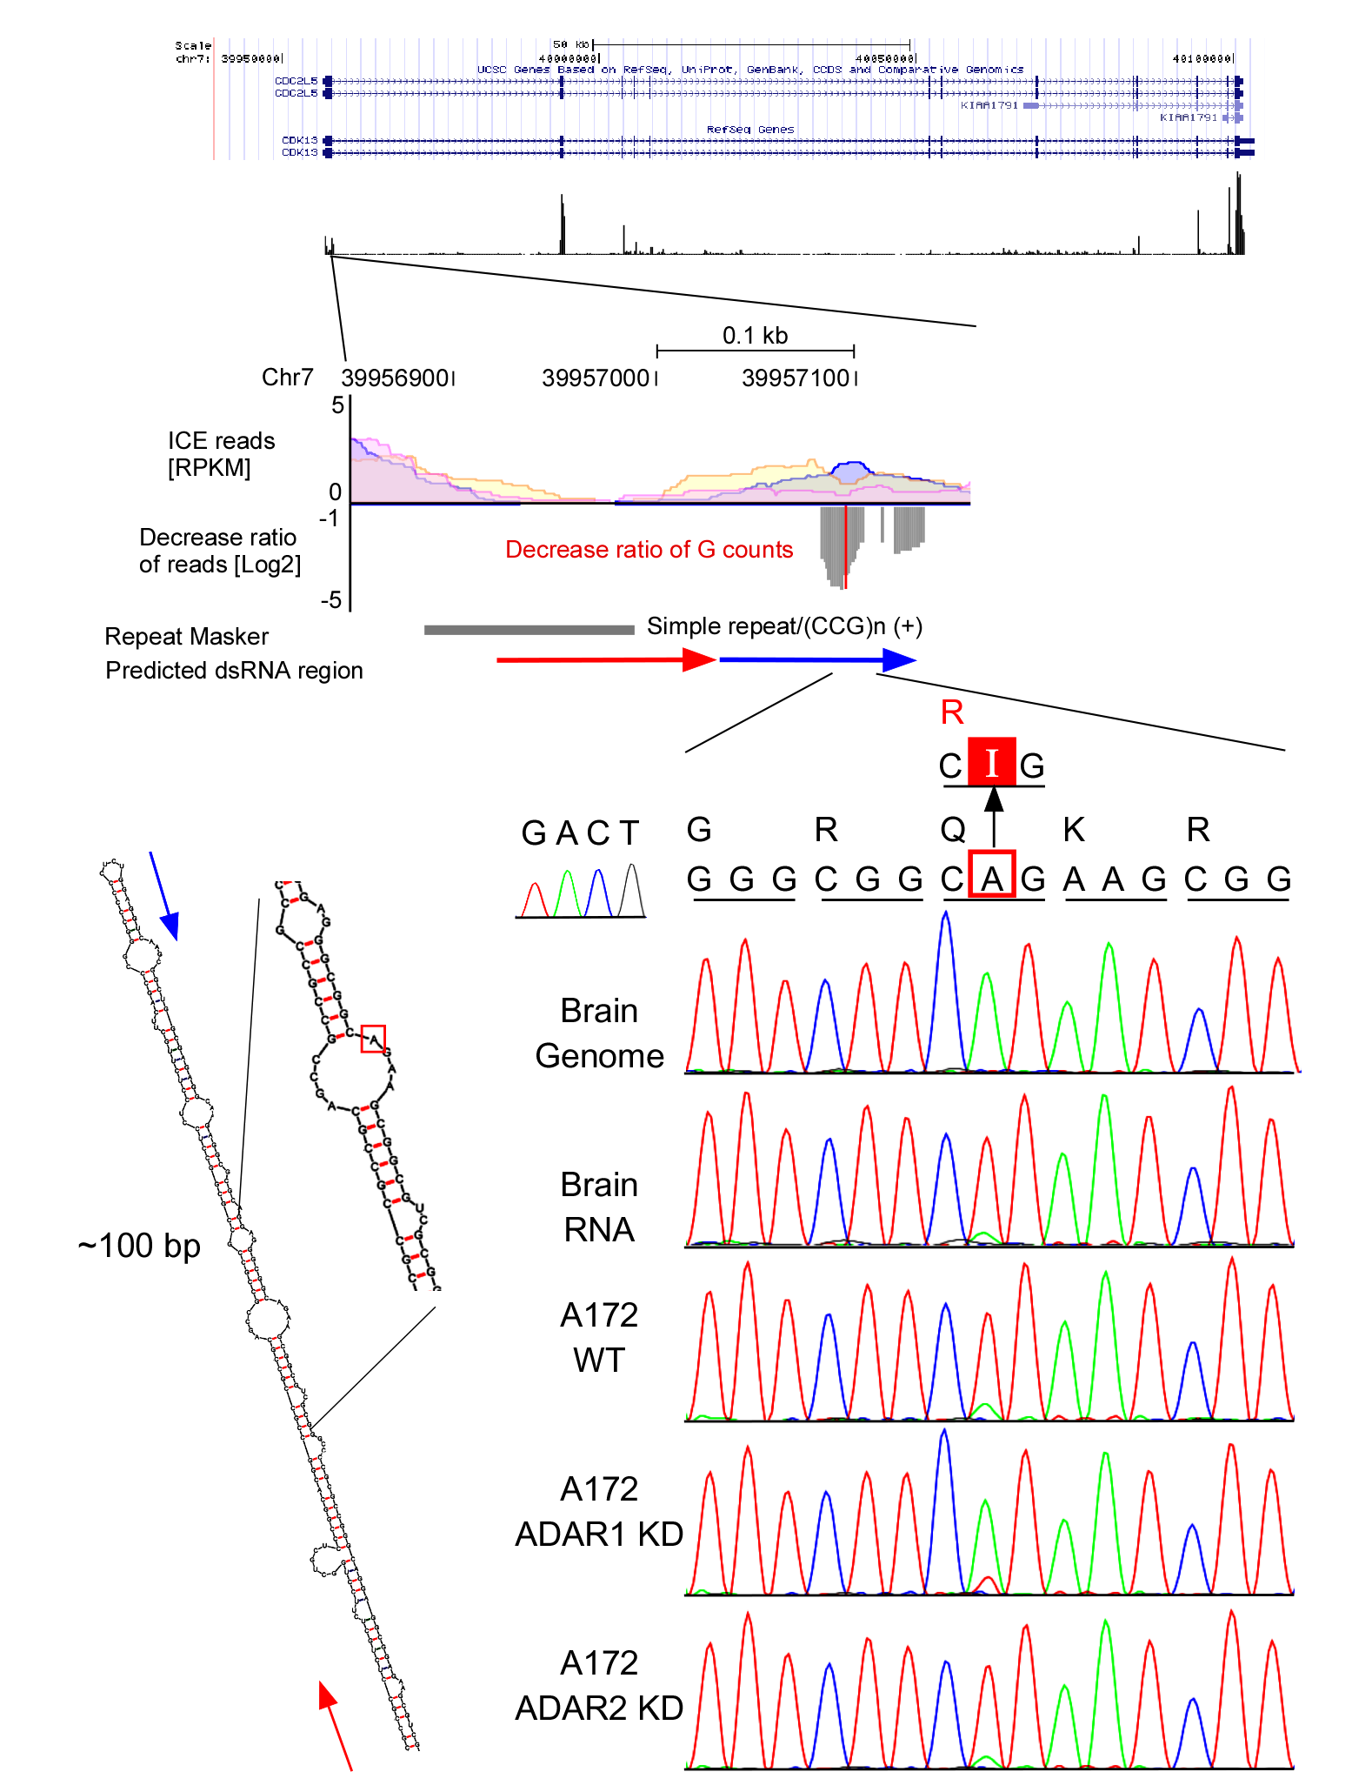

(O) Q-to-R site in CDK13 mRNA
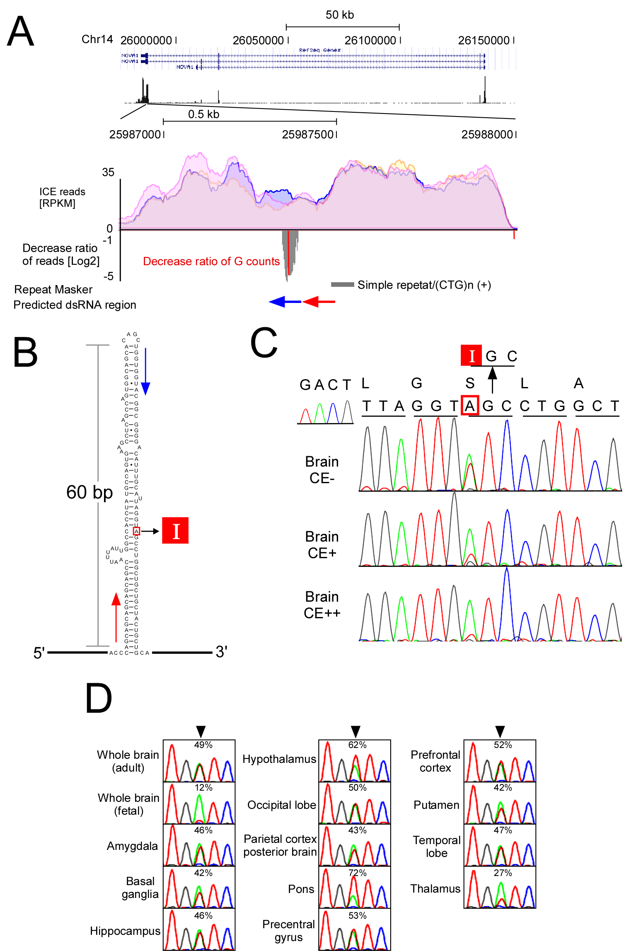
G
(P) S-to-G editing in NOVA1 mRNA
(A) Genome-wide view of exon 1 in NOVA1 mRNA piled up with the reads of ICE-seq. Top panel shows a histogram of the mapped reads of CE- condition at genomic locus of NOVA1. Second panel shows a close-up view of the region with the S-to-G editing site piled with the mapped reads in conditions of CE- (blue), CE+ (orange) and CE++ (pink). Third panels show decreased read ratio upon cyanoethylation (gray downward peaks) and editing sites with decreased ratio of G-base counts upon cyanoethylation (red bar). Potential pairing regions in RNA are shown as blue and red arrows.
(B) Secondary structure of the region around the S-to-G editing site.
(C) Chromatograms of Sanger sequence of the S-to-G editing site in conditions of CE- (top), CE+ (middle) and CE++ (bottom).
(D) Variable editing frequency of the S-to-G editing sites in various brain tissues analyzed by Sanger sequence

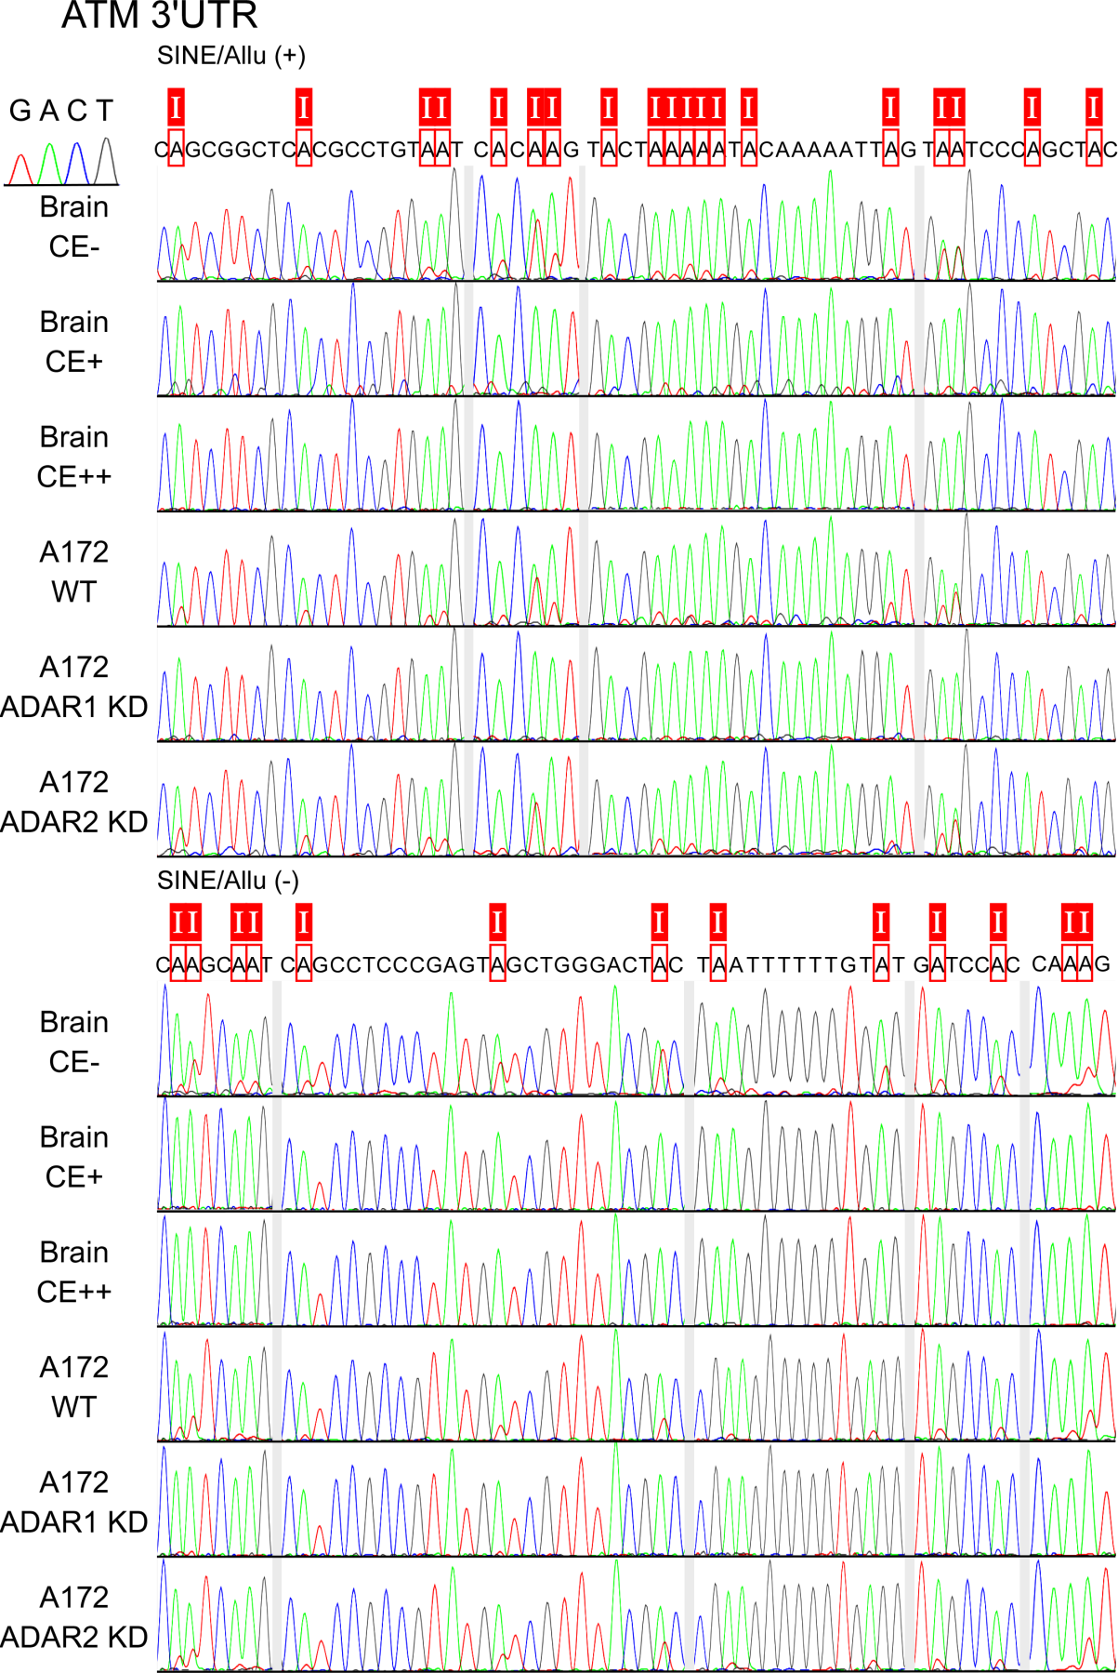

Figure S6 Editing cluster in long dsRNA formed with the plus and minus Alu elements. (A) Sanger sequencing of 3' UTR of ATM mRNA

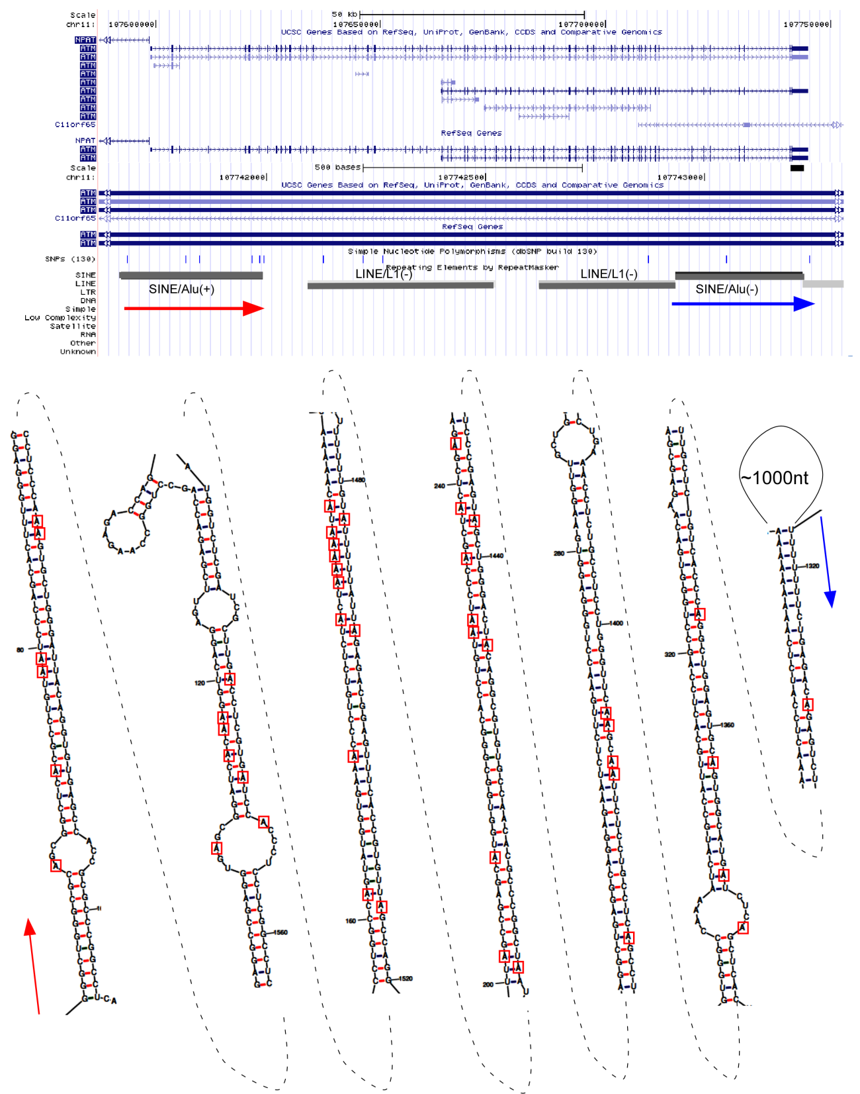

(B) Editing cluster of Alu elements in 3' UTR of ATM mRNA

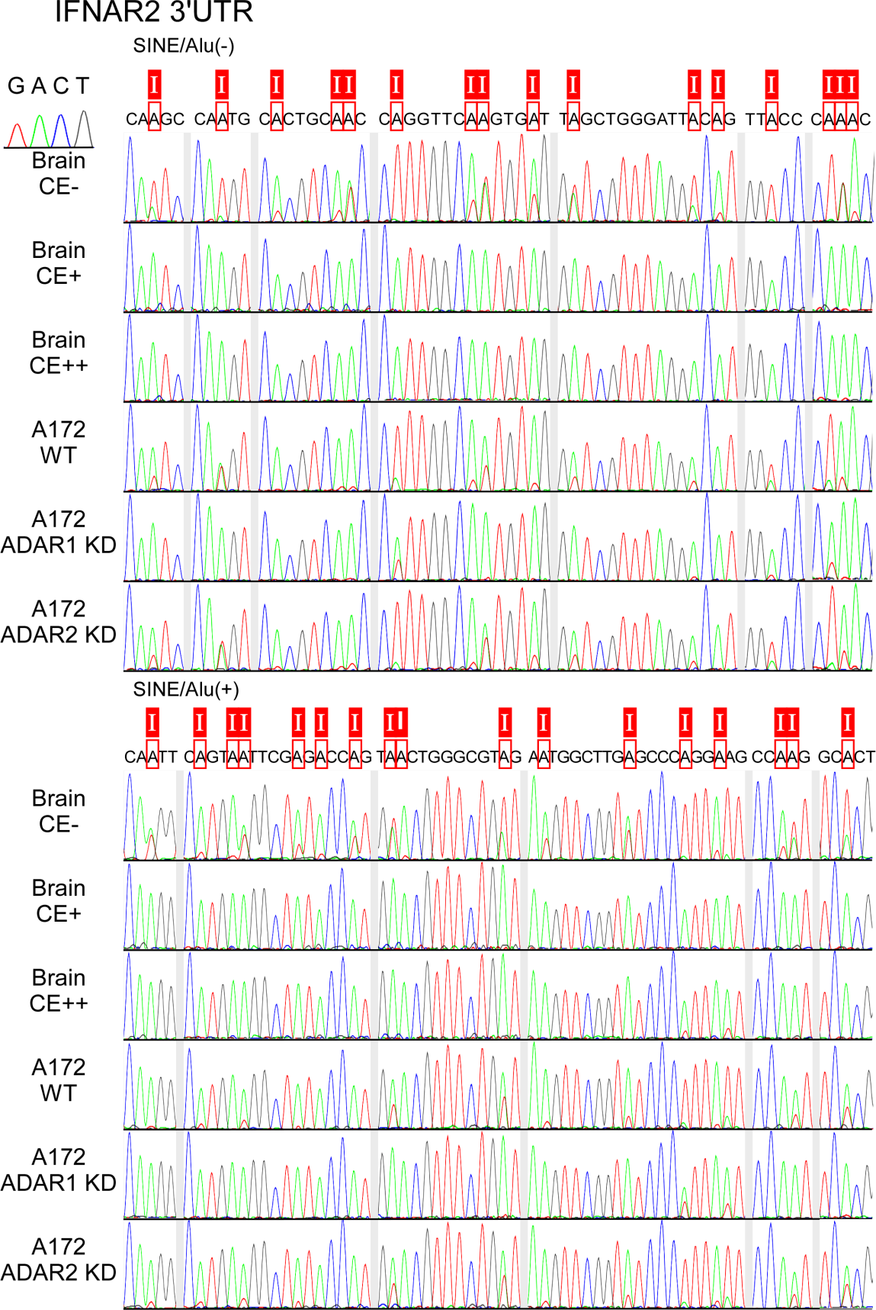

(C) Sanger sequencing of 3' UTR of IFNAR2 mRNA

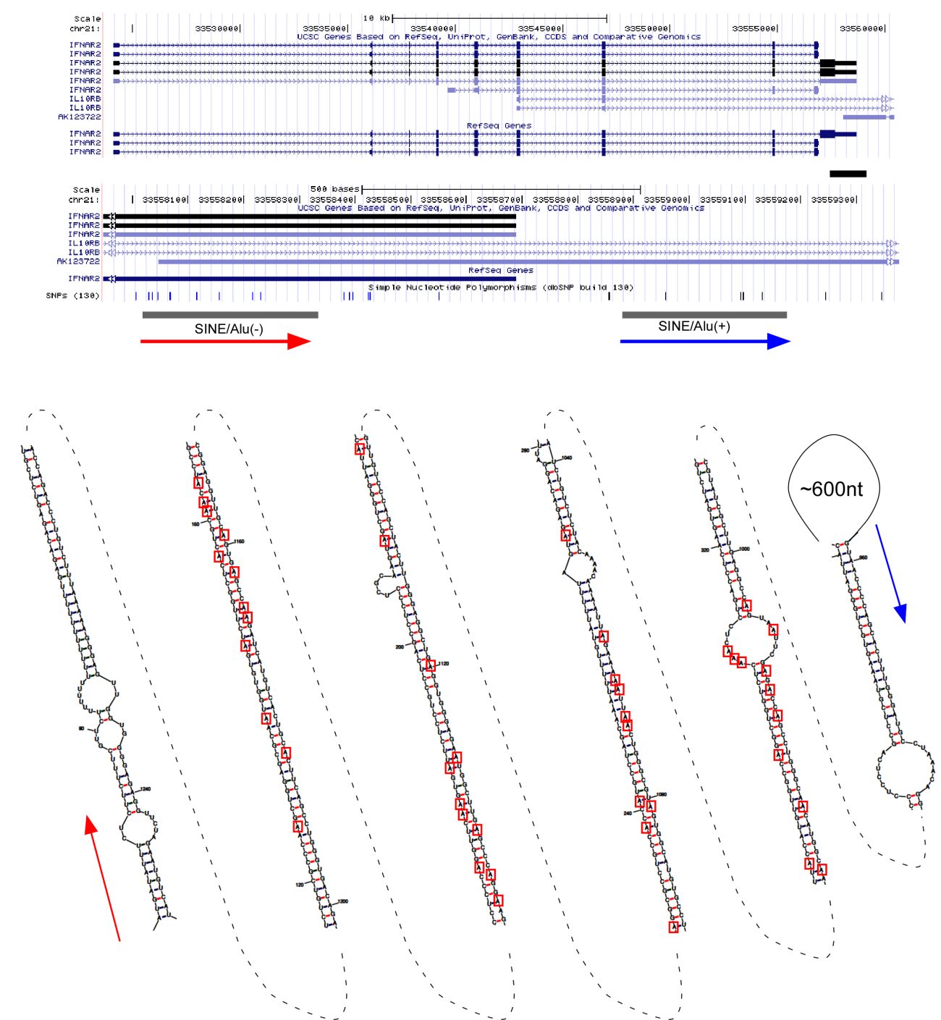

(D) Editing cluster of Alu elements in 3' UTR of IFNAR2 mRNA

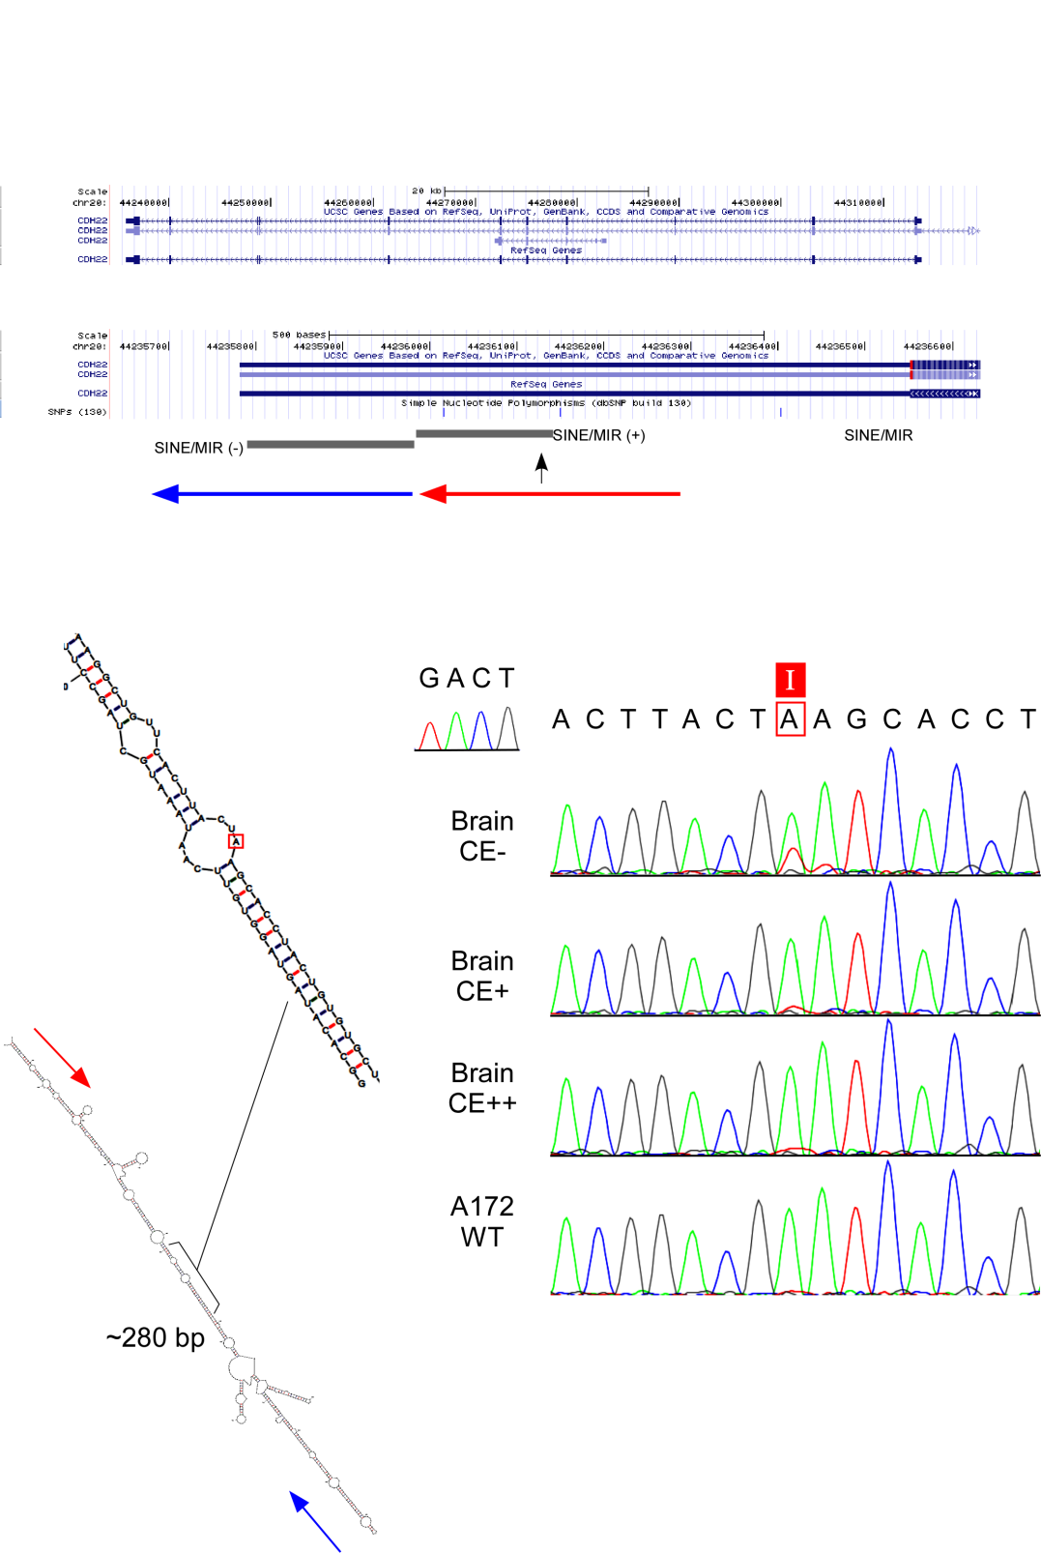

Figure S7 A-to-I editing of SINE/MIR in 3'UTR of CDH22 mRNA

(position: around chr20, -, 44802728)

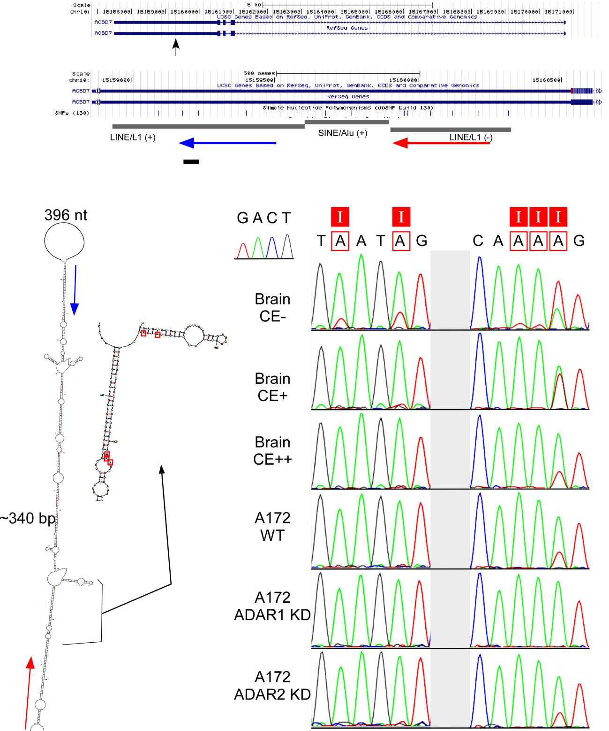

Figure S8 A-to-I editing in LINE/L1

(A) A-to-I editing of LINE/L1(PB4) in 3'UTR of ACBD7 mRNA

(position: around chr10, -,15119311-15119278)

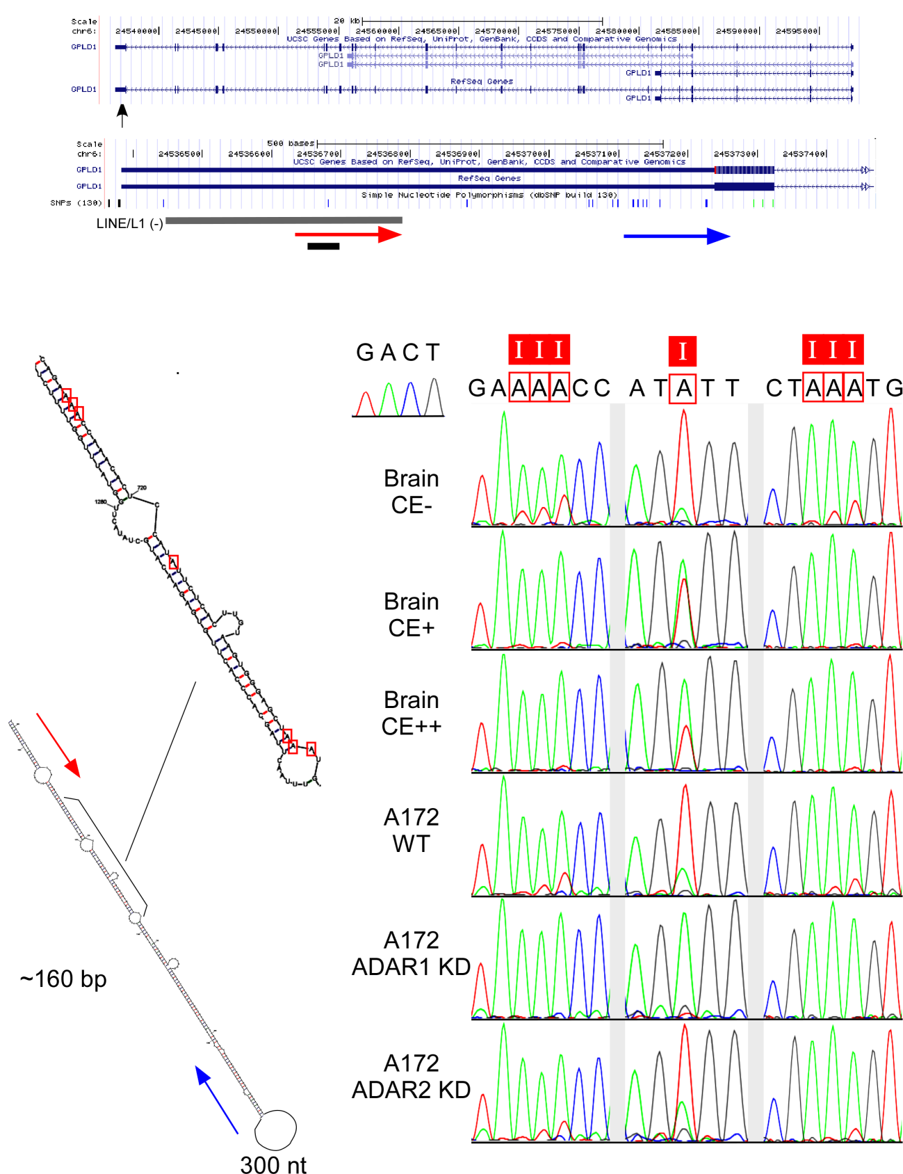

(B) A-to-I editing of LINE/L1(PA12) in 3'UTR of GPLD1 mRNA

(position: around chr6, -, 24428679-24428704)

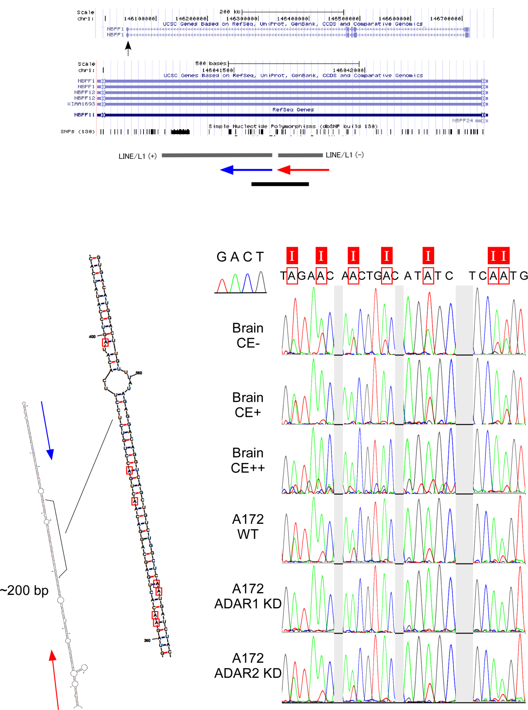

(C) A-to-I editing of LINE/L1(MC4) in 3'UTR of NBPF1 mRNA

(position: around chr1, -, 147575104-147575147)

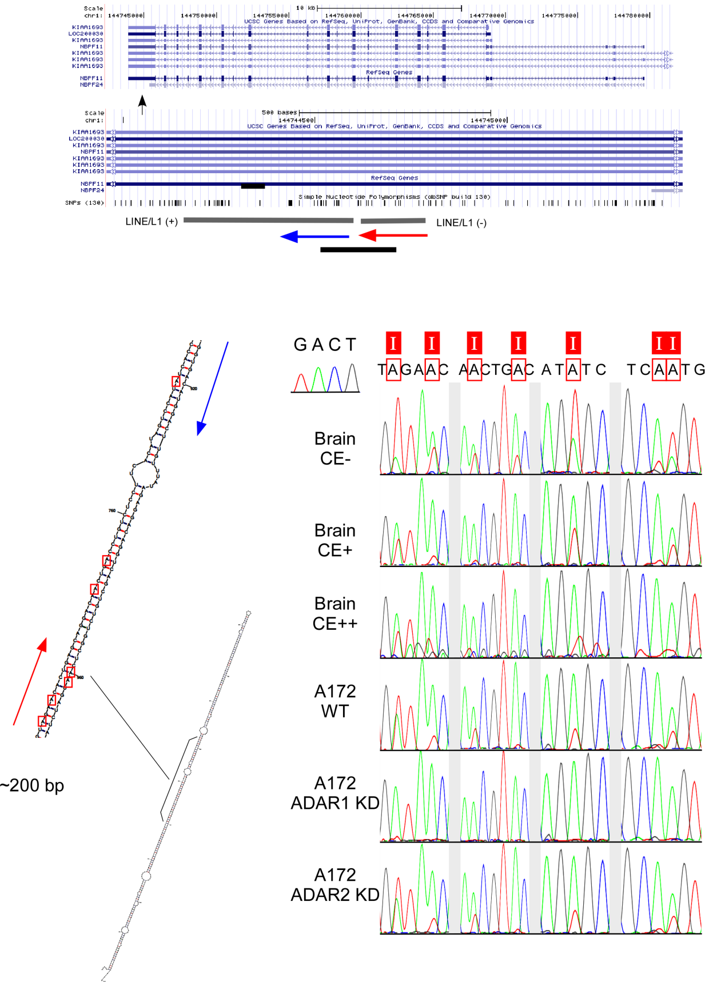

(D) A-to-I editing of LINE/L1(MC4) in 3'UTR of NBPF11 mRNA

(position: around chr1, -, 146033323-146033369)

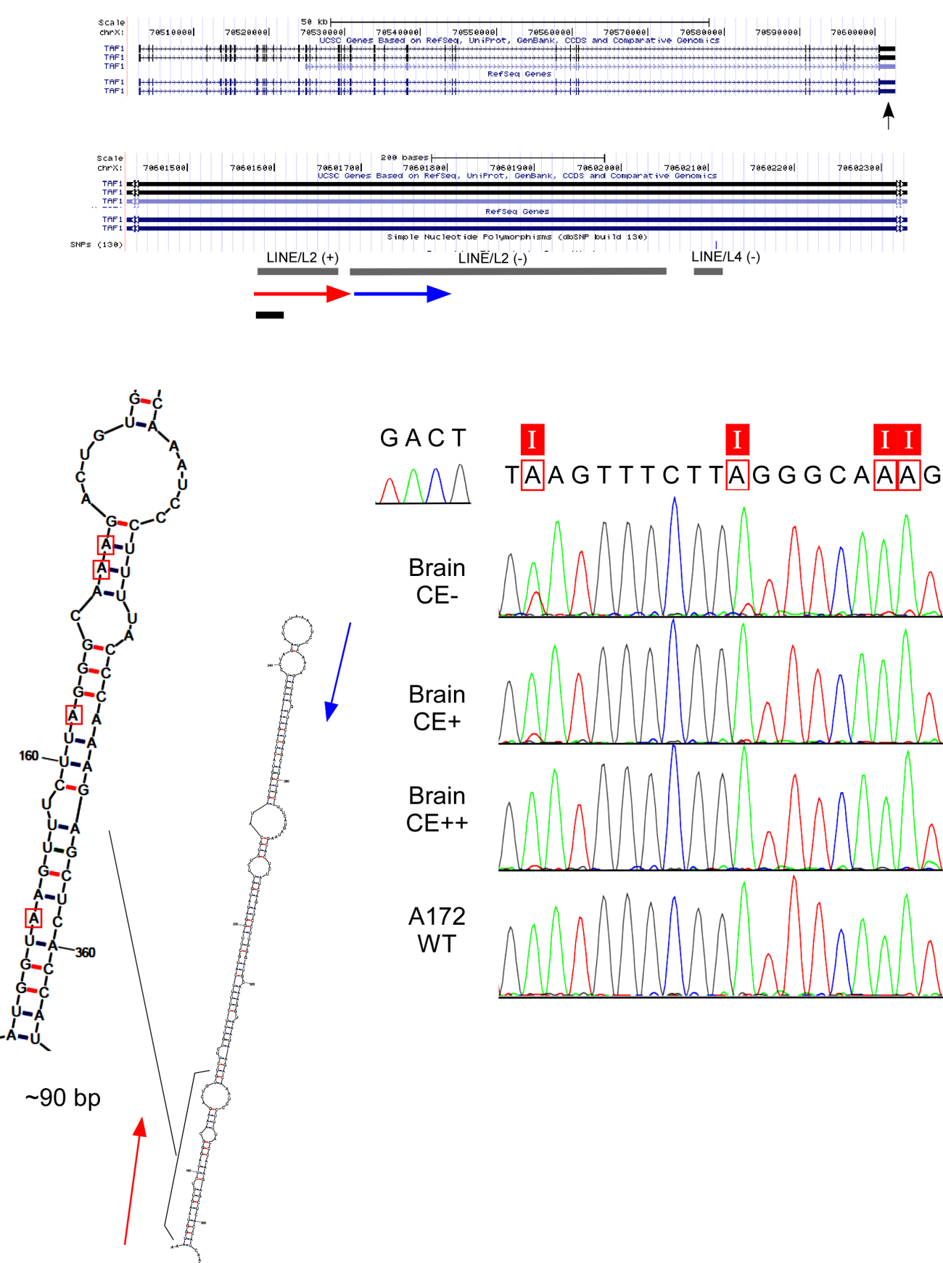

Figure S9 A-to-I editing of LINE/L2c in 3'UTR of TAF1 mRNA

(position: around chrX, +, 70684858)

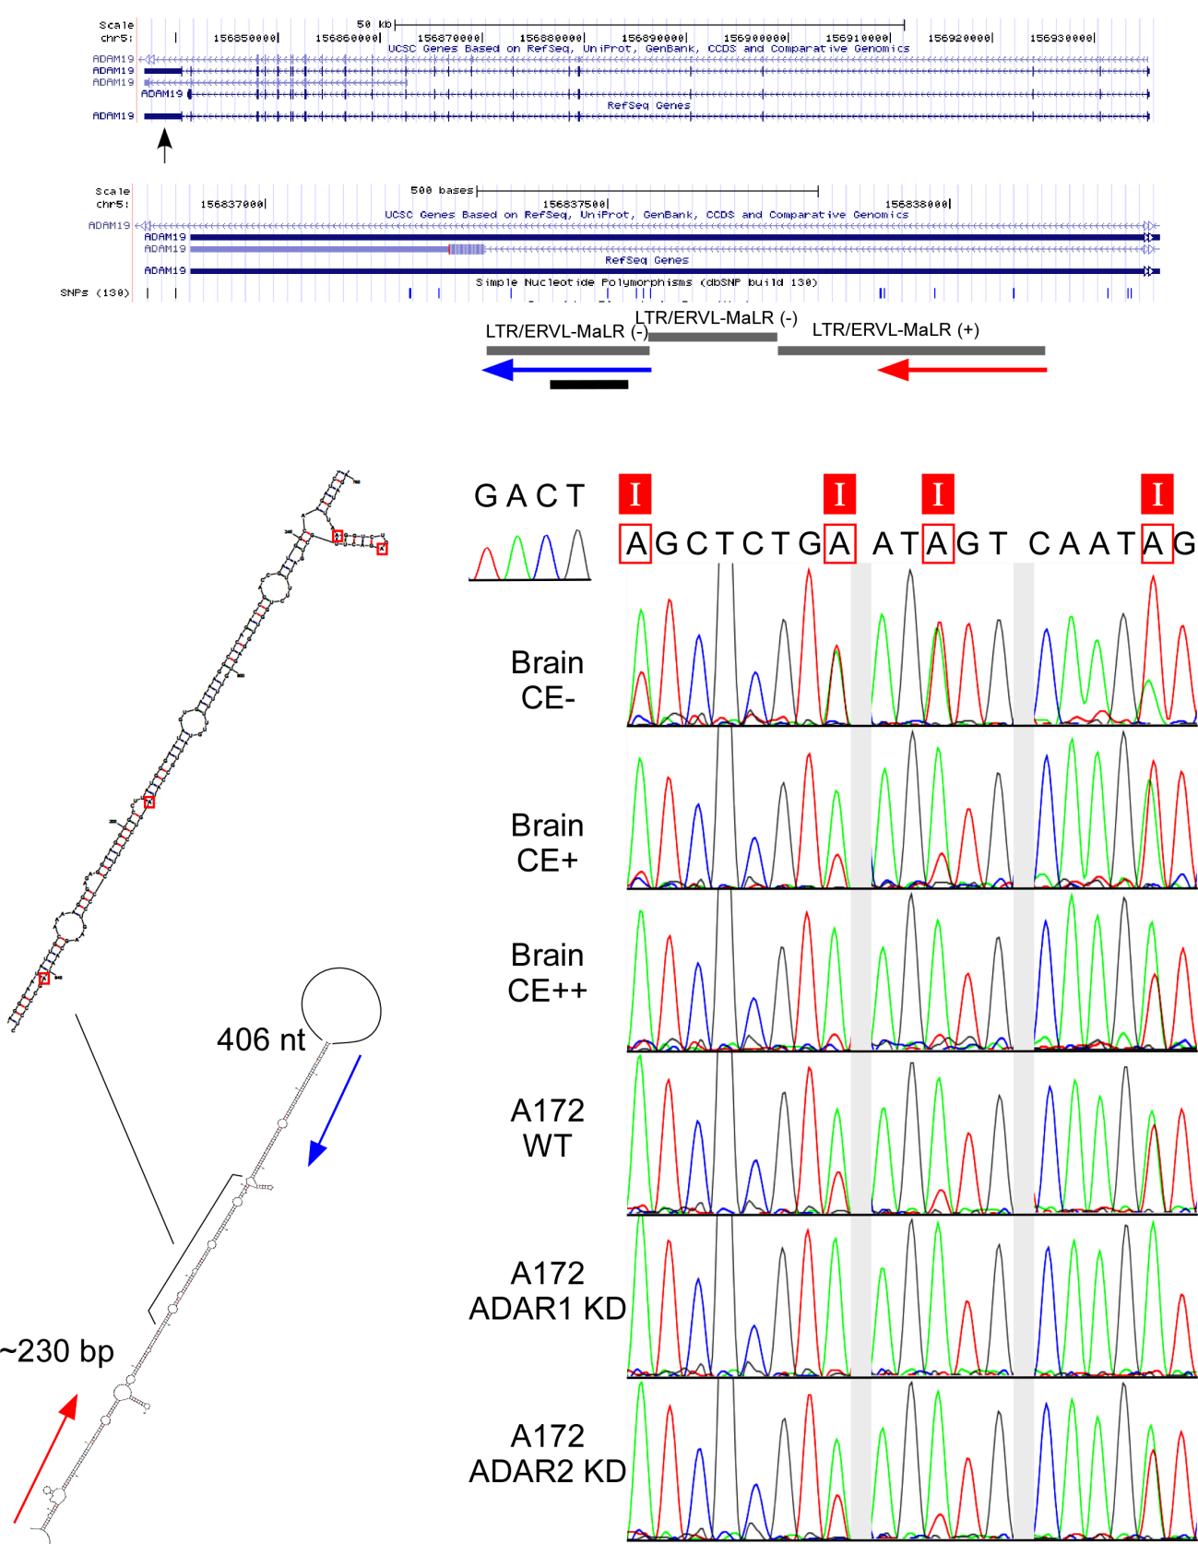

Figure S10 A-to-I editing in LTRs

(A) A-to-I editing of LTR/ERVL-MaLR/MER92B in 3'UTR of ADAM19 mRNA

(position: around chr5, -, 156904831-156904965)

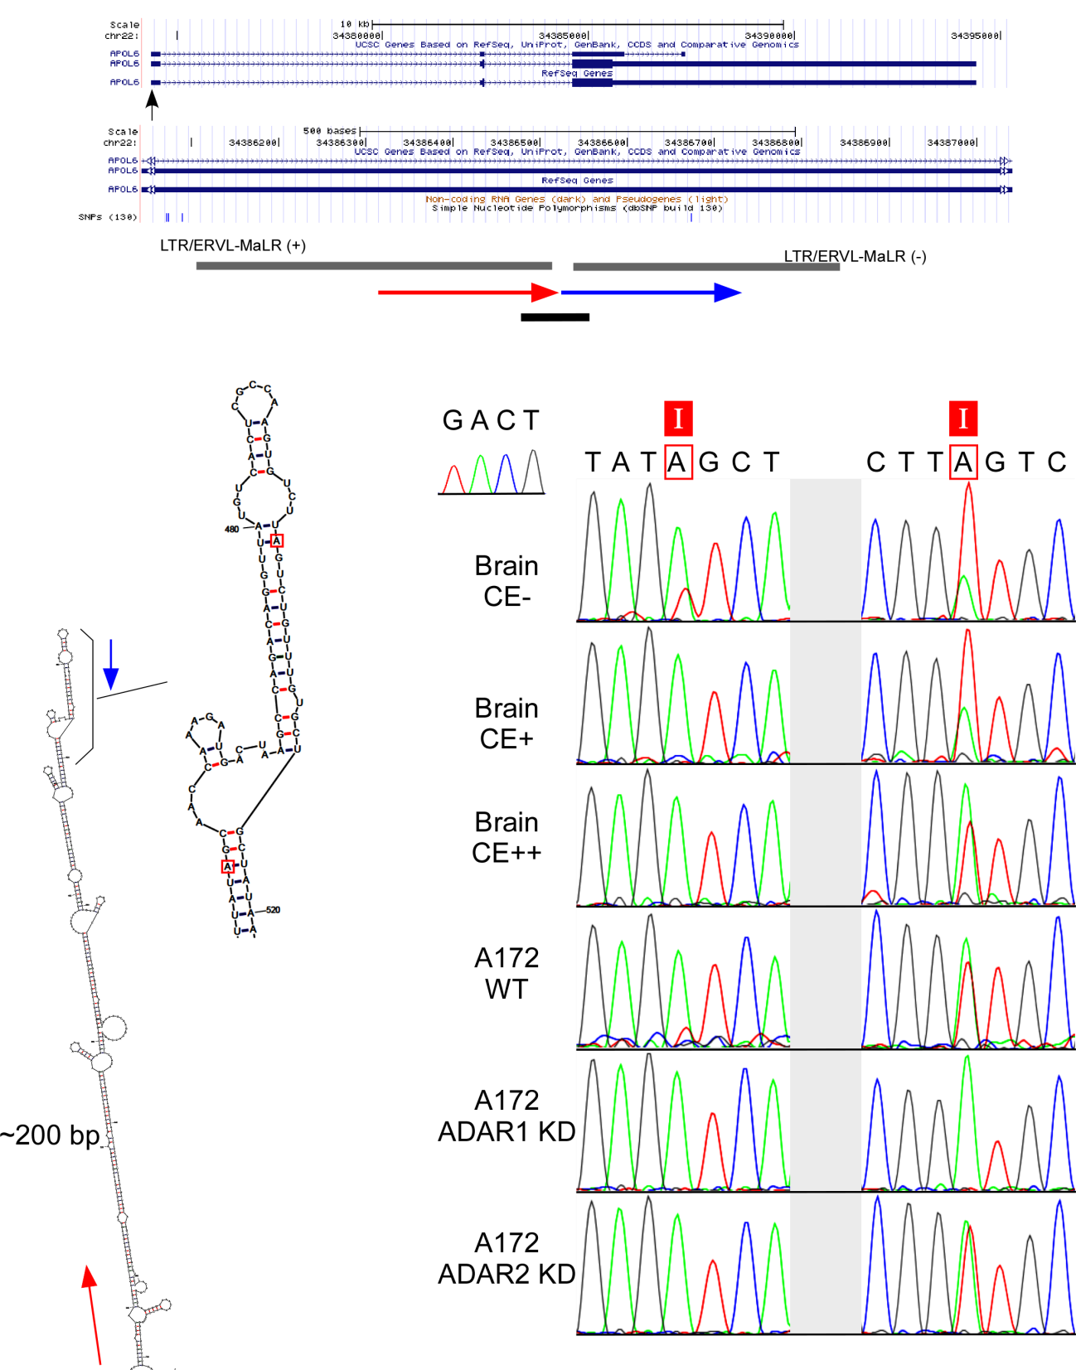

(B) A-to-I editing of LTR/ERVL-MaLR in 3'UTR of APOL6 mRNA

(position: around chr22, +, 36056598)

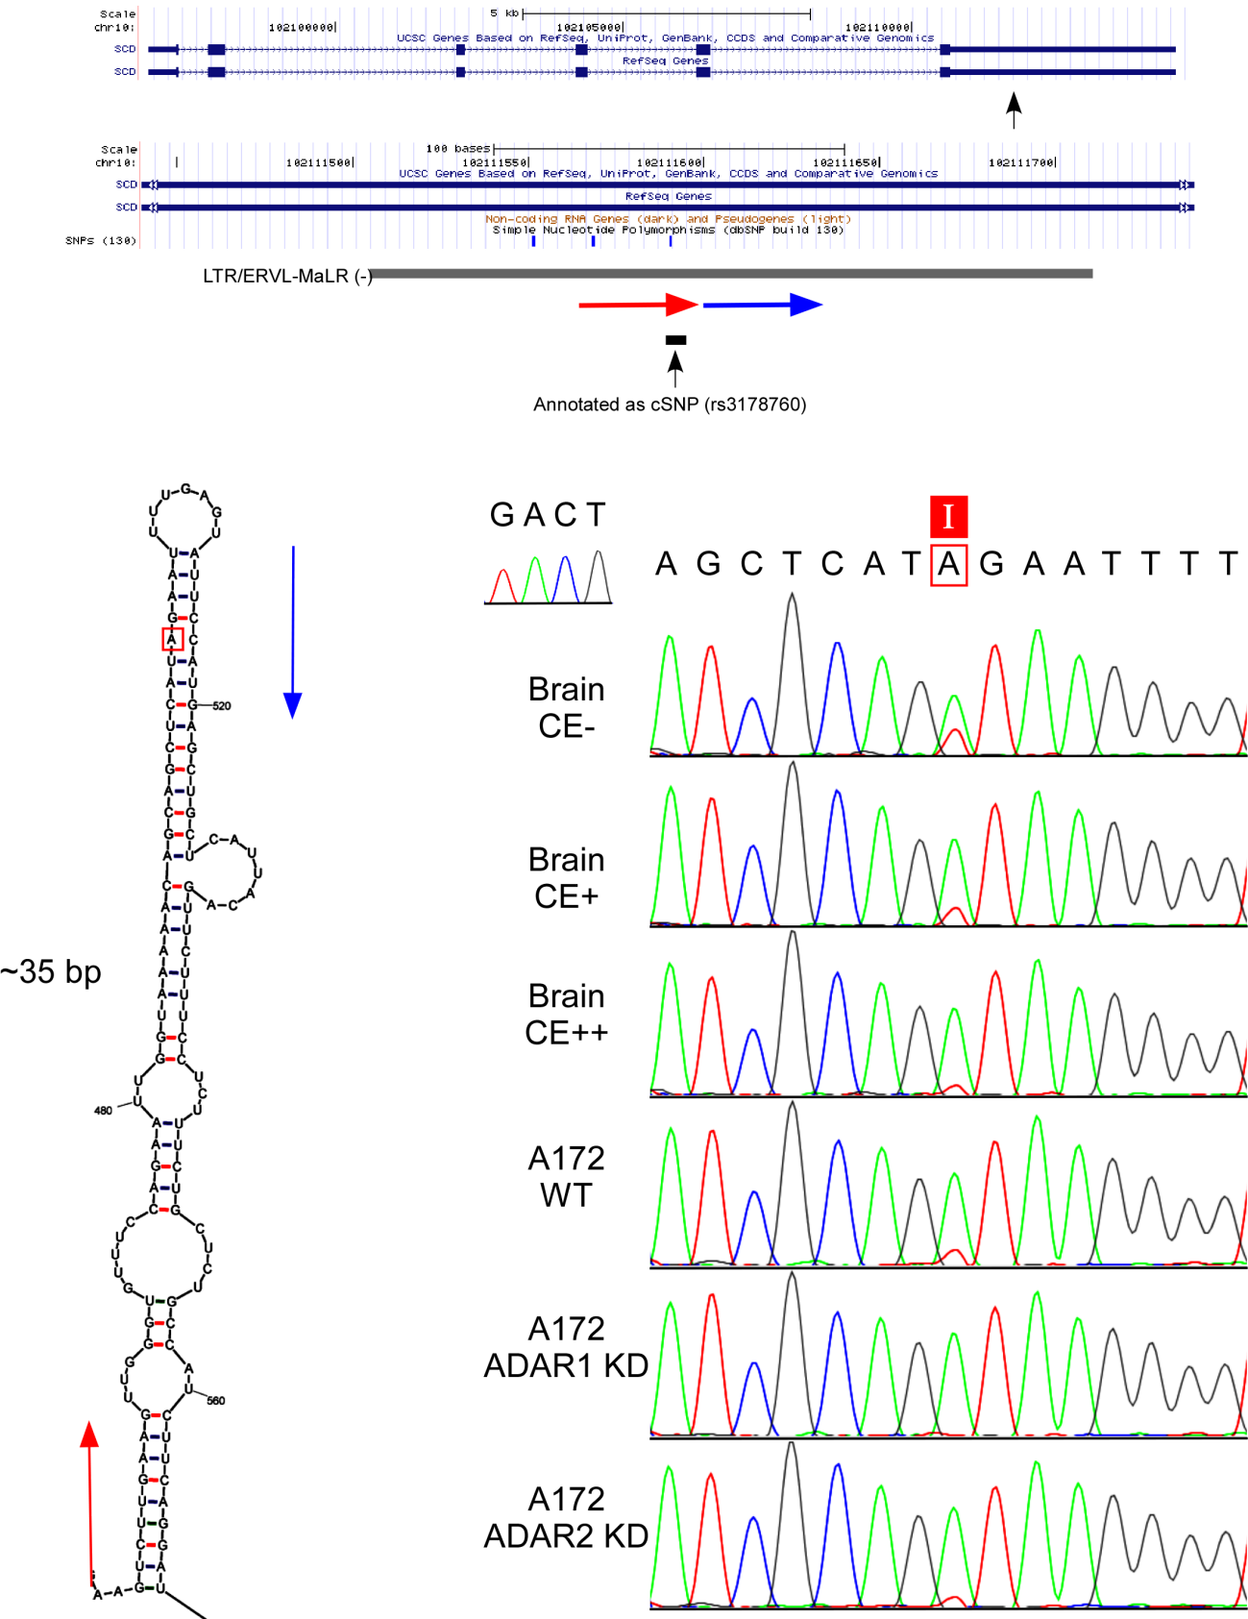

(C) A-to-I editing of LTR/ERVL-MaLR in 3'UTR of SCD mRNA

(position: around chr10, 102121601)

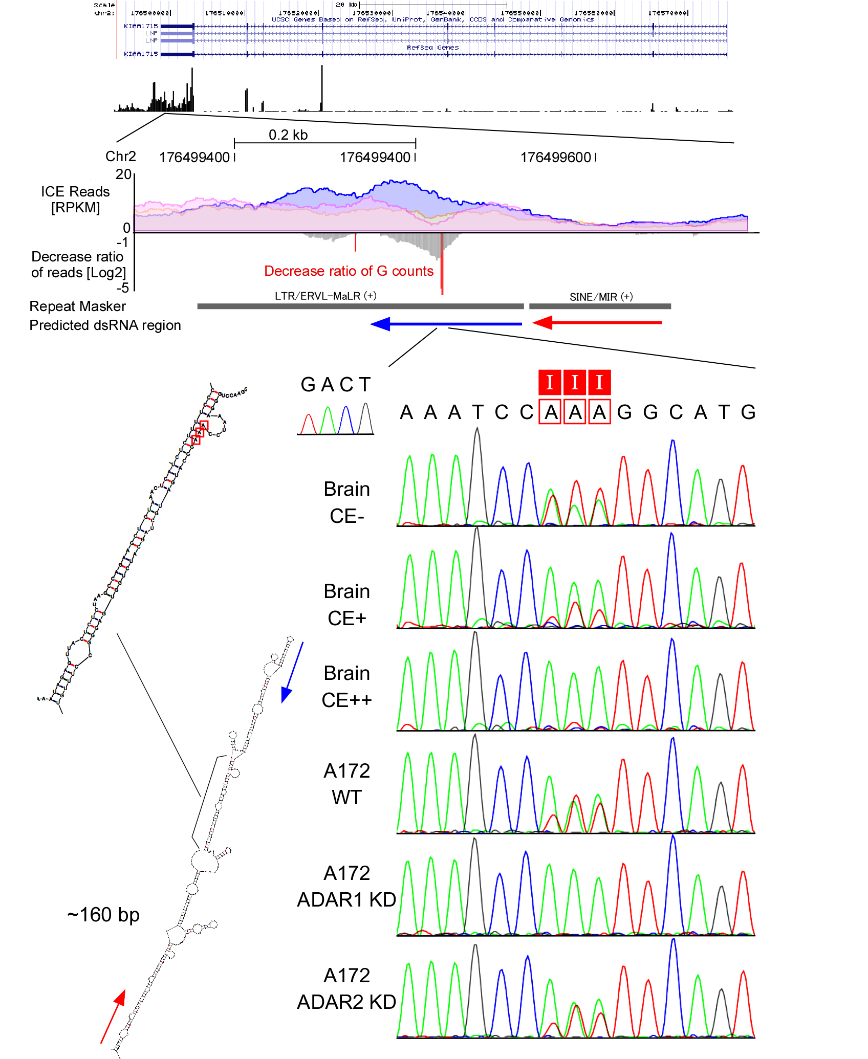

(D) A-to-I editing of LTR/ERVL-MaLR in 3'UTR of LNP (KIAA1715)

(position: around chr2, -, 176791084-176791183)

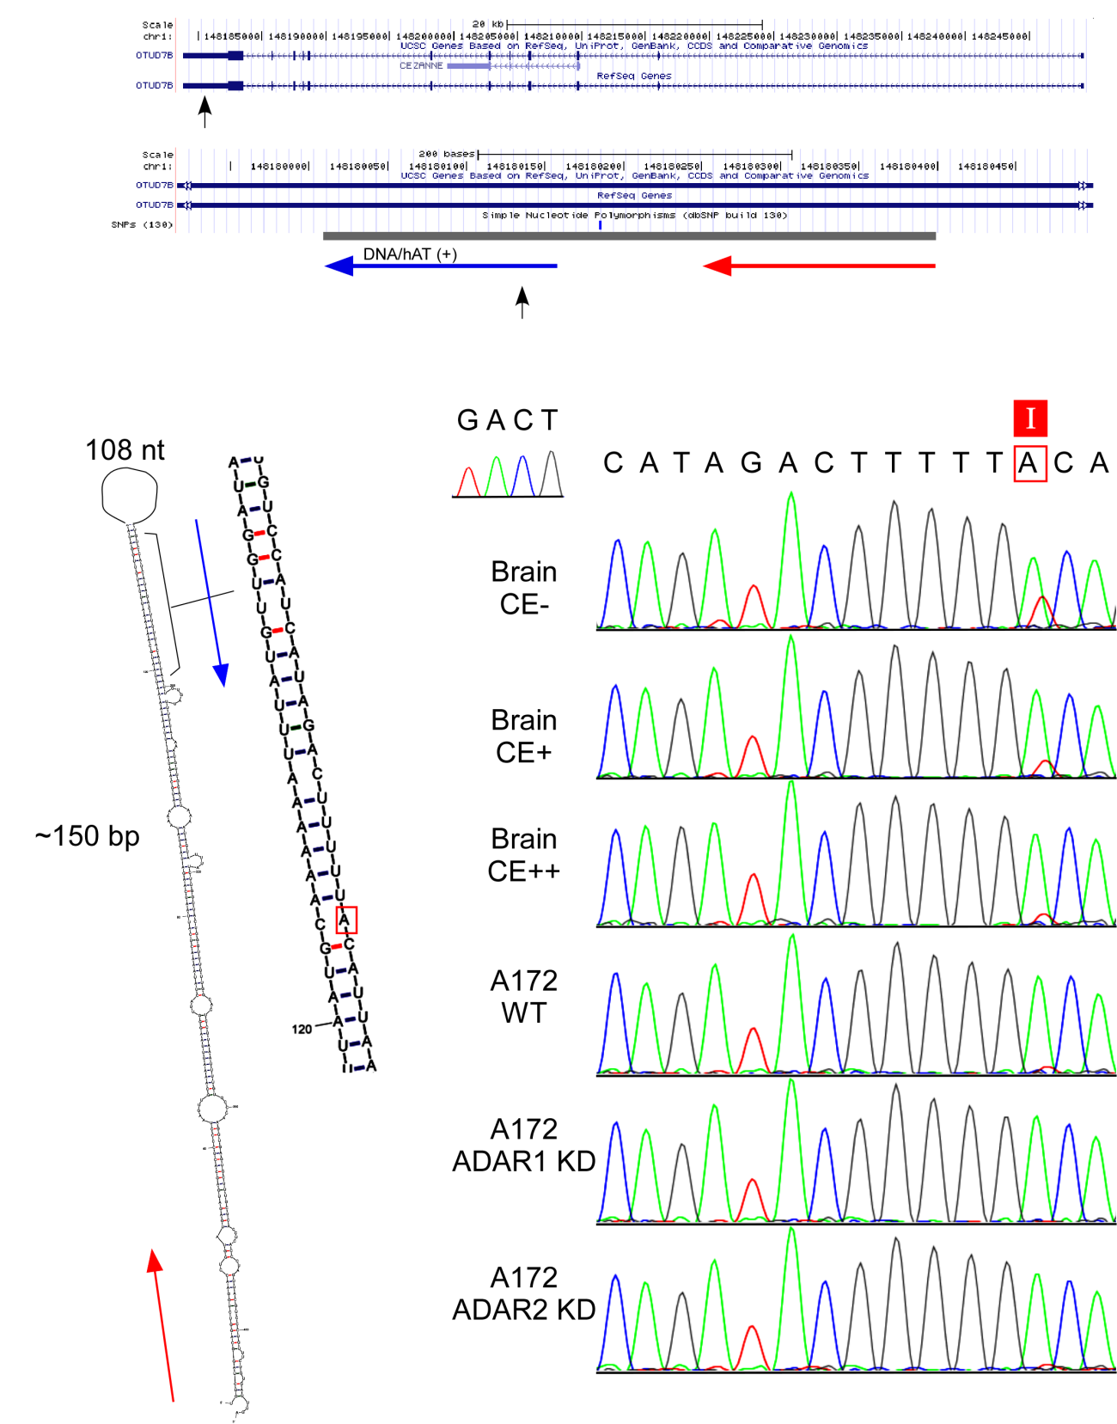

Figure S11 A-to-I editing in DNA transposons

(A) A-to-I editing of DNA/hAT/MER96B in 3'UTR of OTUD7B mRNA

(position: around chr1, -, 149913513)

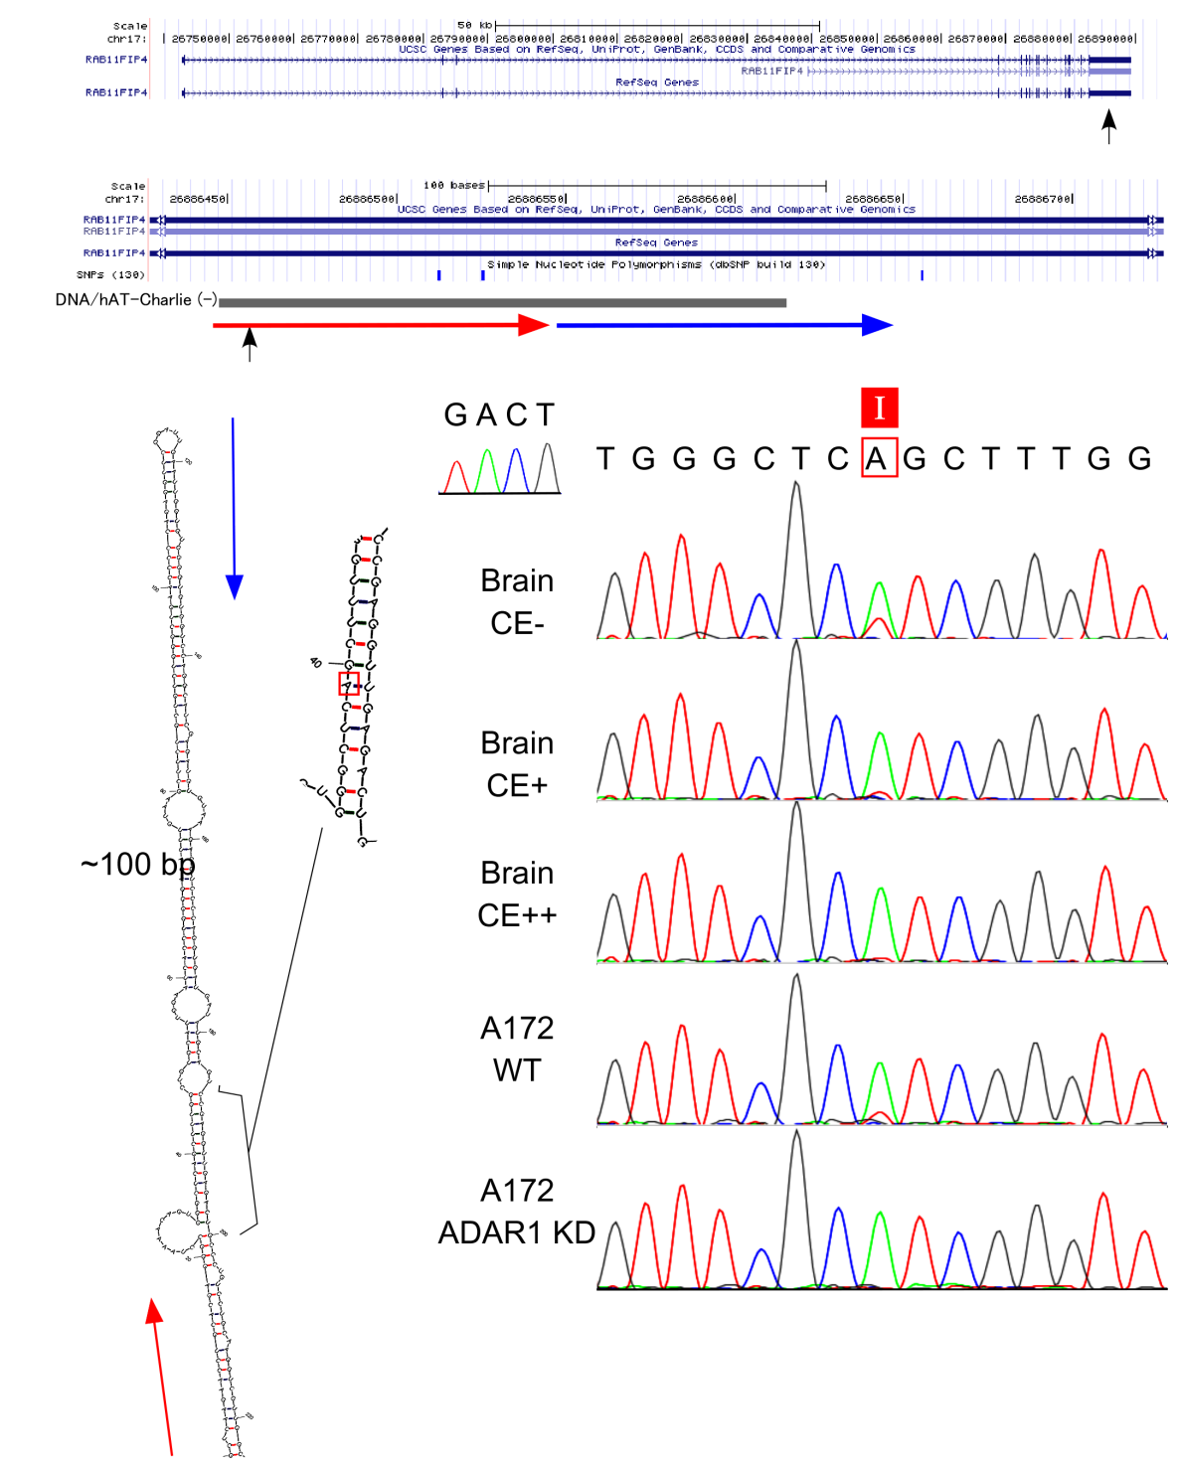

(B) A-to-I editing of DNA/hAT-Chrlie/MER5B in 3'UTR of RAB11FIP4 mRNA

(position: around chr17, +, 29862338)

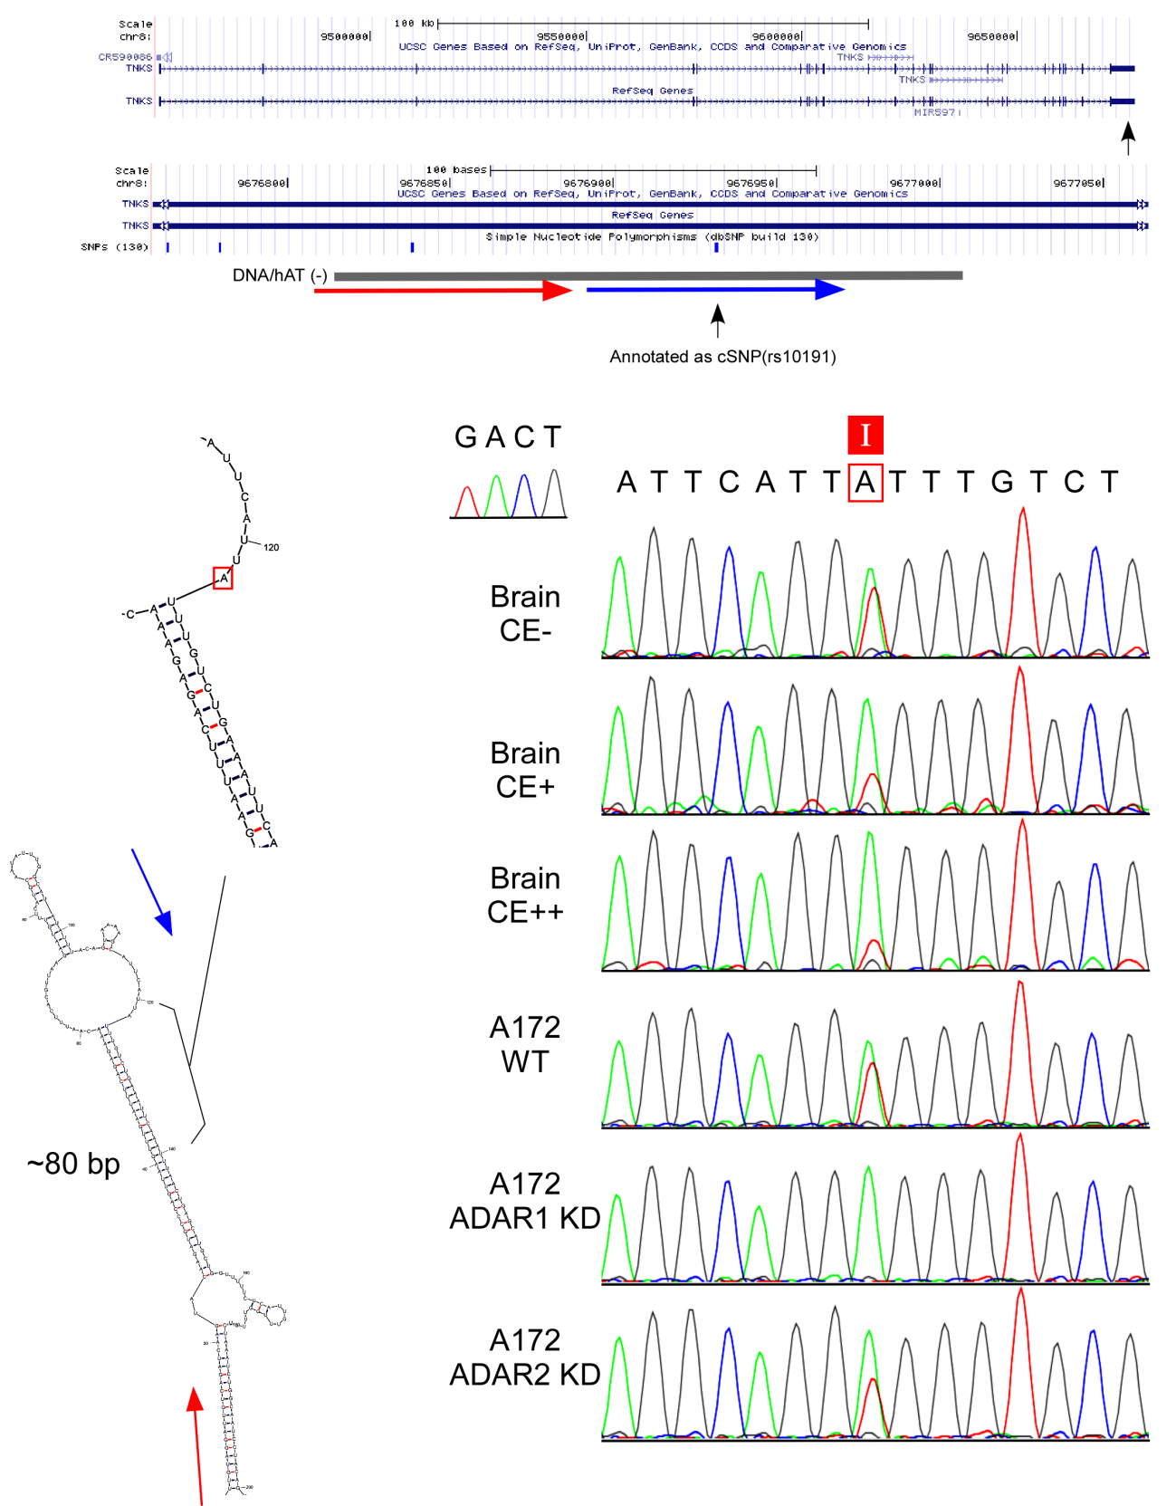

(C) A-to-I editing of DNA/hAT/MER53 in 3'UTR of TNKS mRNA

(position: around chr8, +, 9639522)

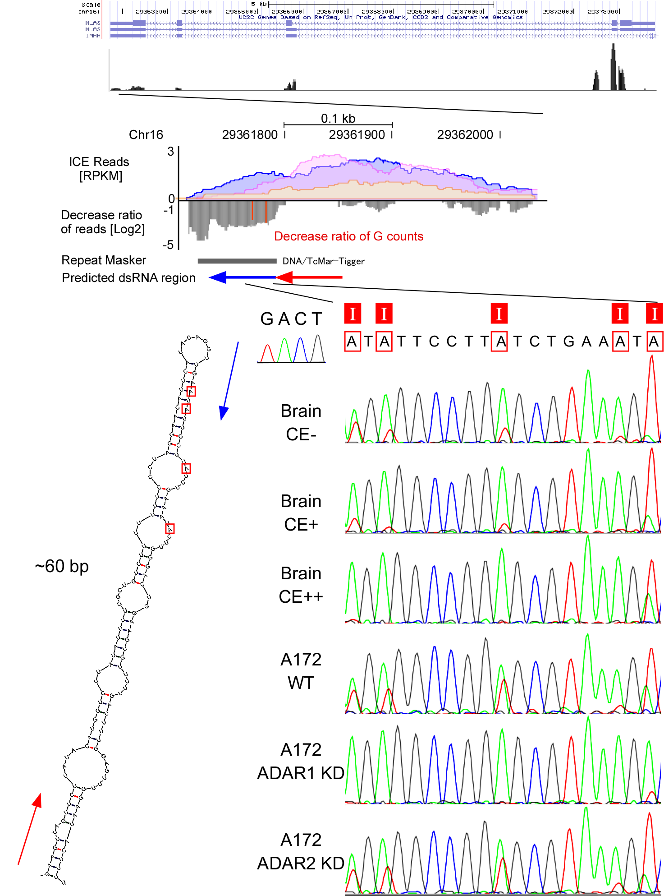

(D) A-to-I editing of DNA/TcMar-Tigger in 3'UTR of SLC7A5P1mRNA

(position: around chr16, -, 29454297)

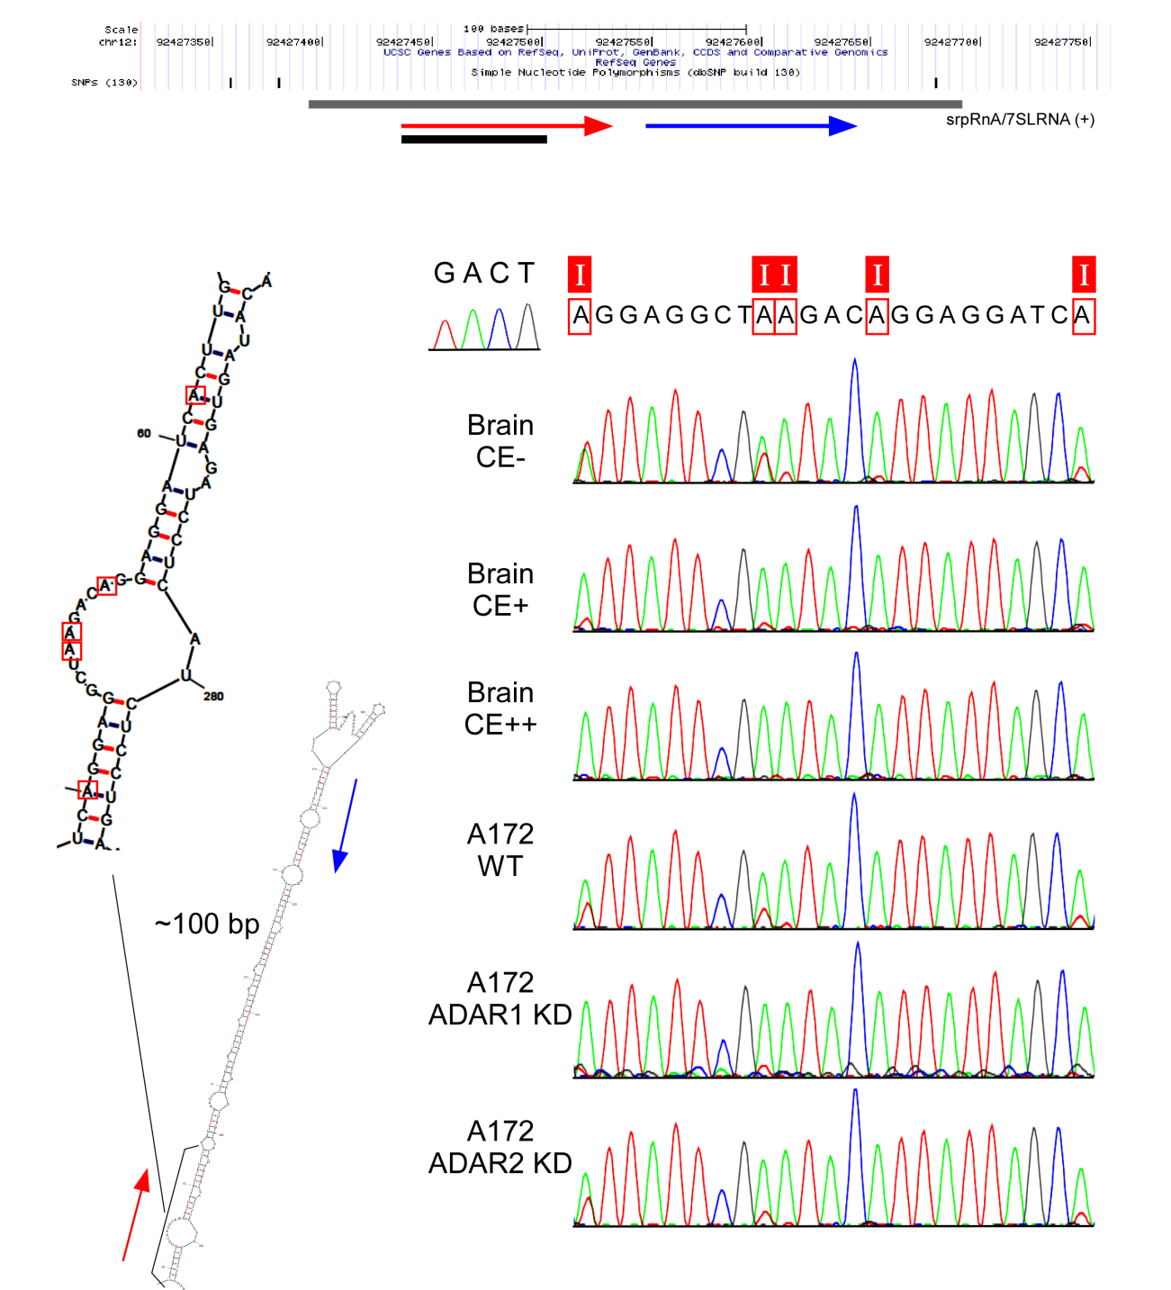

Figure S12 A-to-I editing in 7SLRNA-like regions

(A) A-to-I editing of 7SLRNA-like in non-annotation region

(position: around chr12, +, 93903302-93903324)

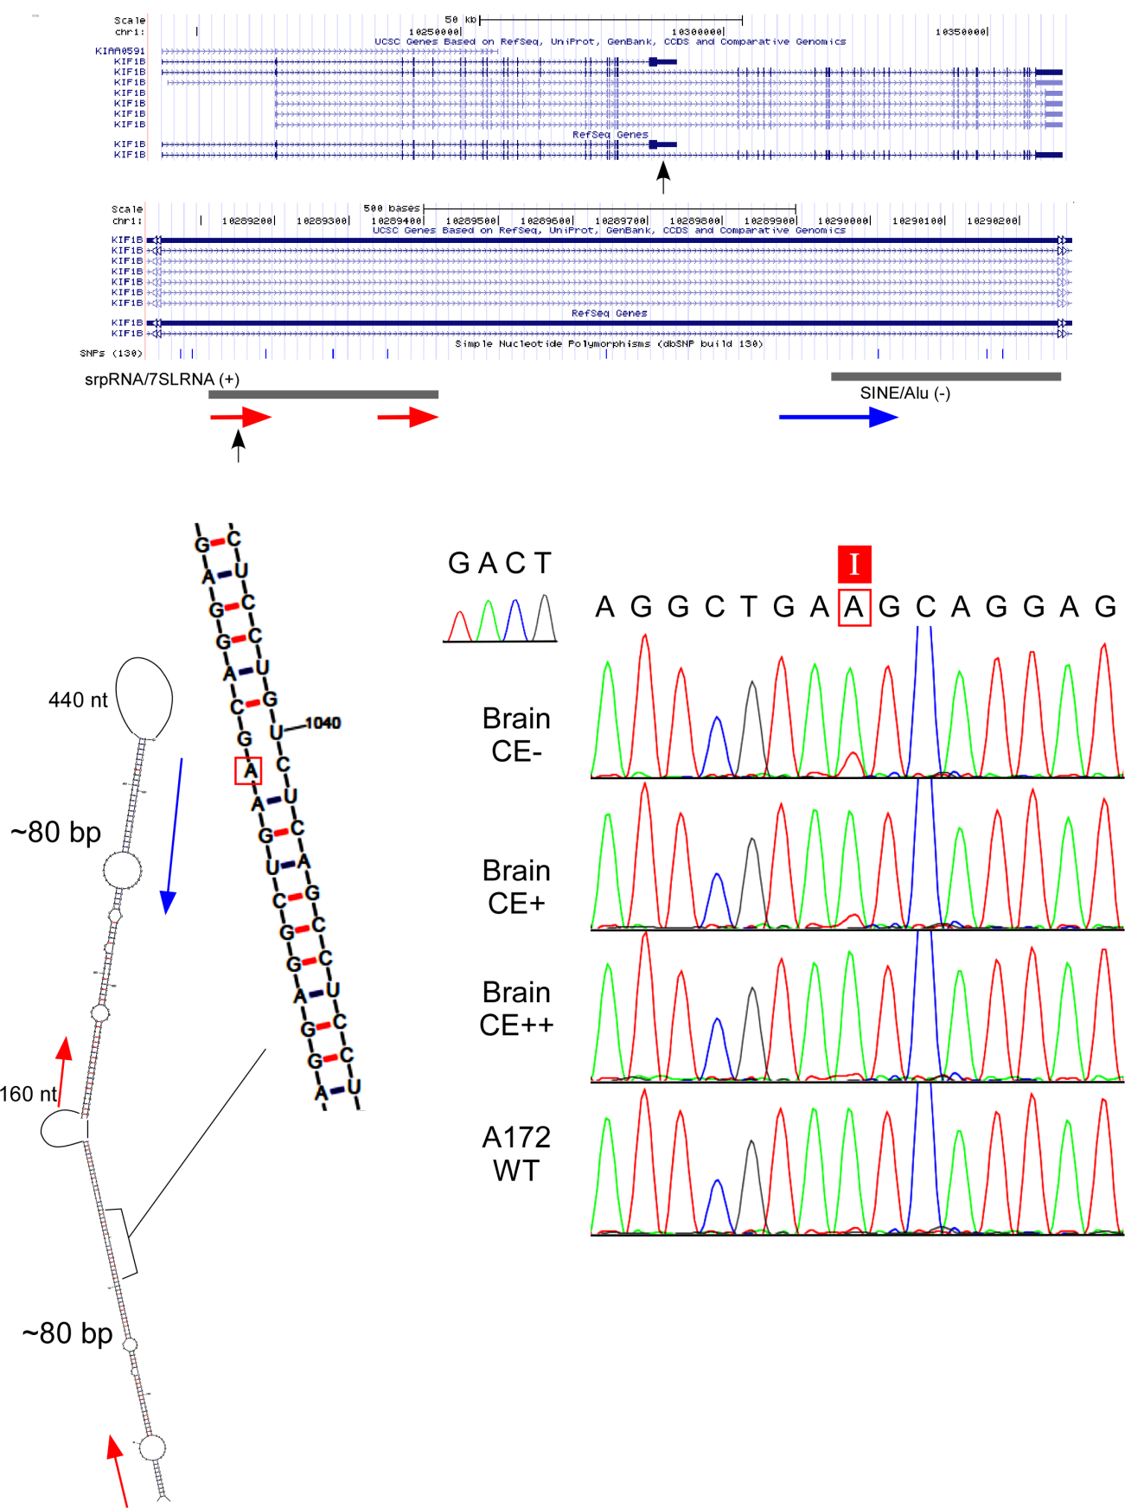

(B) A-to-I editing of 7SLRNA-like in 3'UTR of KIF1B mRNA

(position: around chr1,+, 10366572)

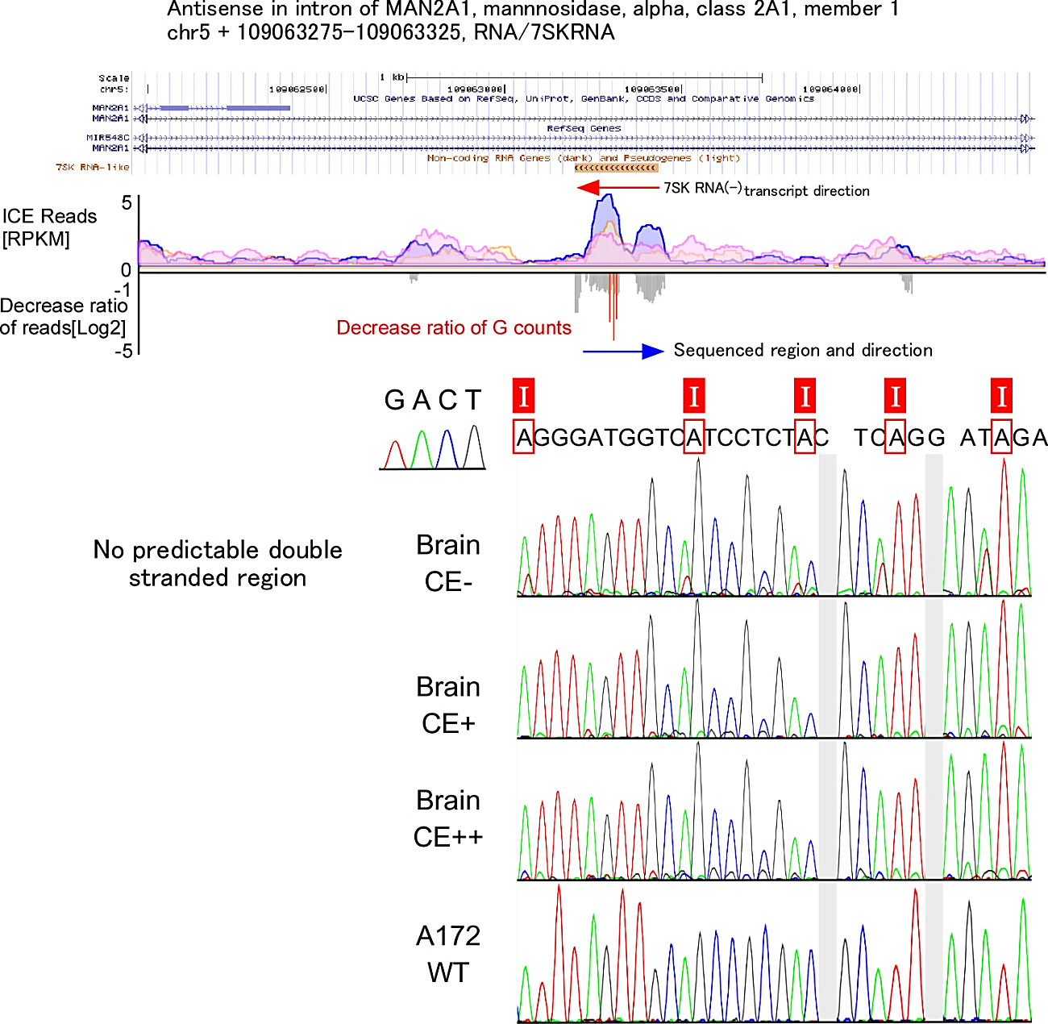

Figure S13 A-to-I editing of 7SKRNA-like in intronic region of MAN2A1 mRNA

(position: around chr5 + 109035376-109035386)

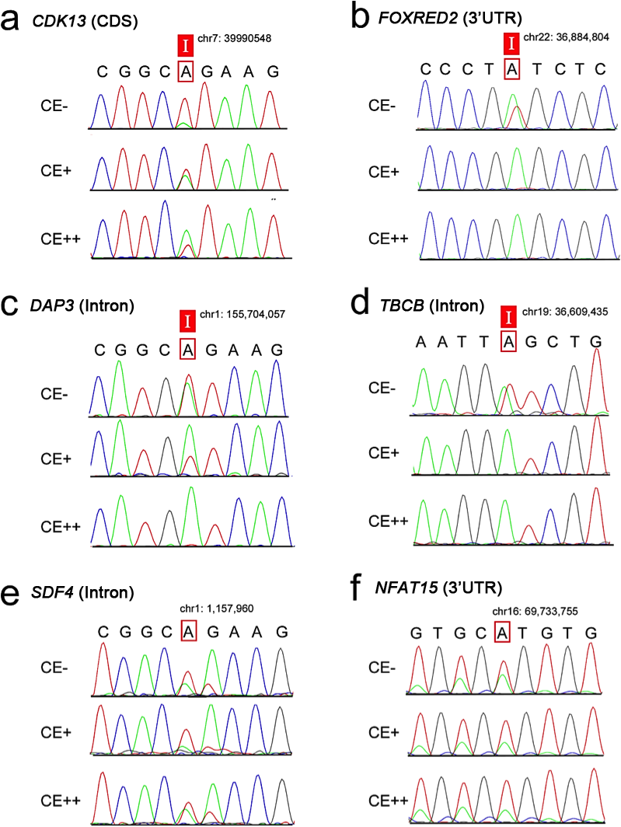
D
F
E
C
B
A

Figure S14 Validation of RDD sites in U87MG cell by ICE-method.
Sequencing chromatograms of the A-to-I editing site in CDK13 mRNA (A) and FOXRED2 (B) in conditions of CE-(top), CE+(middle) and CE++(bottom). For illustration in the validation of RDD sites by ICE-method, two positive sites in DAP3 (C) and TBCB (D), and two negative sites in SDF4 (E) and NFAT15 (F) are shown.

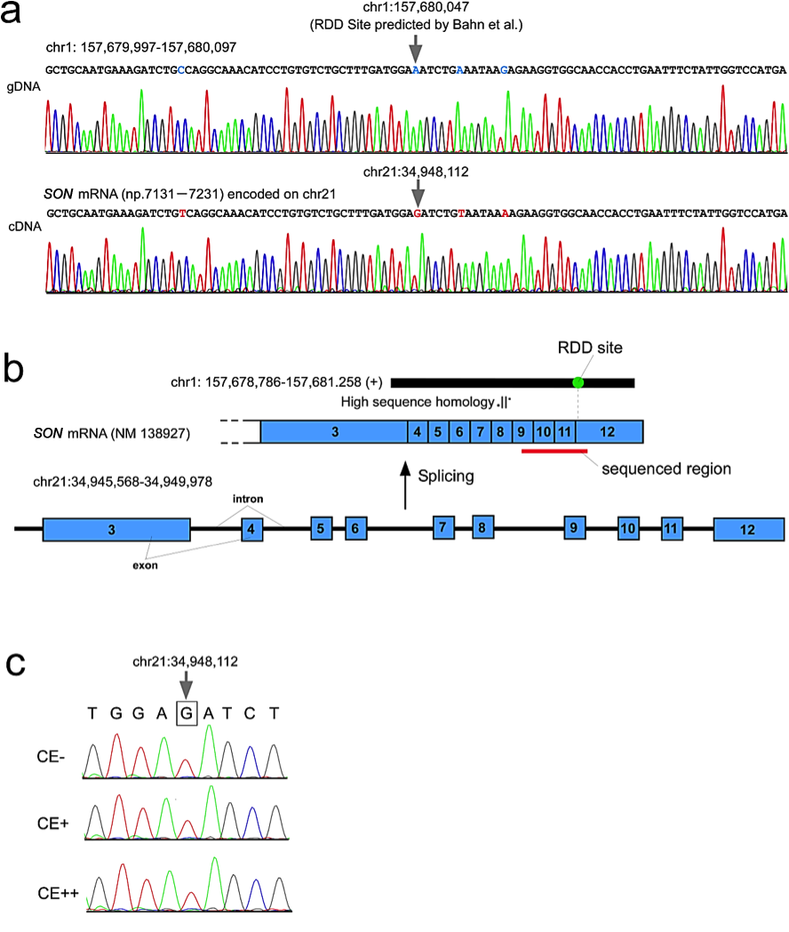
C
B
A
C
B
A
Figure S15 Mapping error of RDD site in SON mRNA.
(A) Sequencing chromatograms of the genomic region (top) including the RDD site (chr1:157,680,047) predicted by Bahn et al.(Bahn et al. 2012) and cDNA (bottom) for SON mRNA encoded on chromosome 21. They have high sequence similarity. The adenosine at the RDD site (chr1:157,680,047) corresponds to guanosine at chr21:34,948,112 in SON mRNA.
(B) The plus strand (+) of genomic region in chromosome 1 (black bar, 157,678,786-157,681.258) has a high sequence similarity with the cDNA covering exons 3-12 of SON mRNA encoded on chromosome 21. The RDD site (closed green circle, chr1:157,680,047) corresponds to the site (chr21:34,948,112) in exon 10 of SON mRNA encoded on chromosome 21. The sequenced region is shown by red bar.
(C) Sequencing chromatograms around the RDD site in SON mRNA in conditions of CE-(top), CE+(middle) and CE++(bottom).

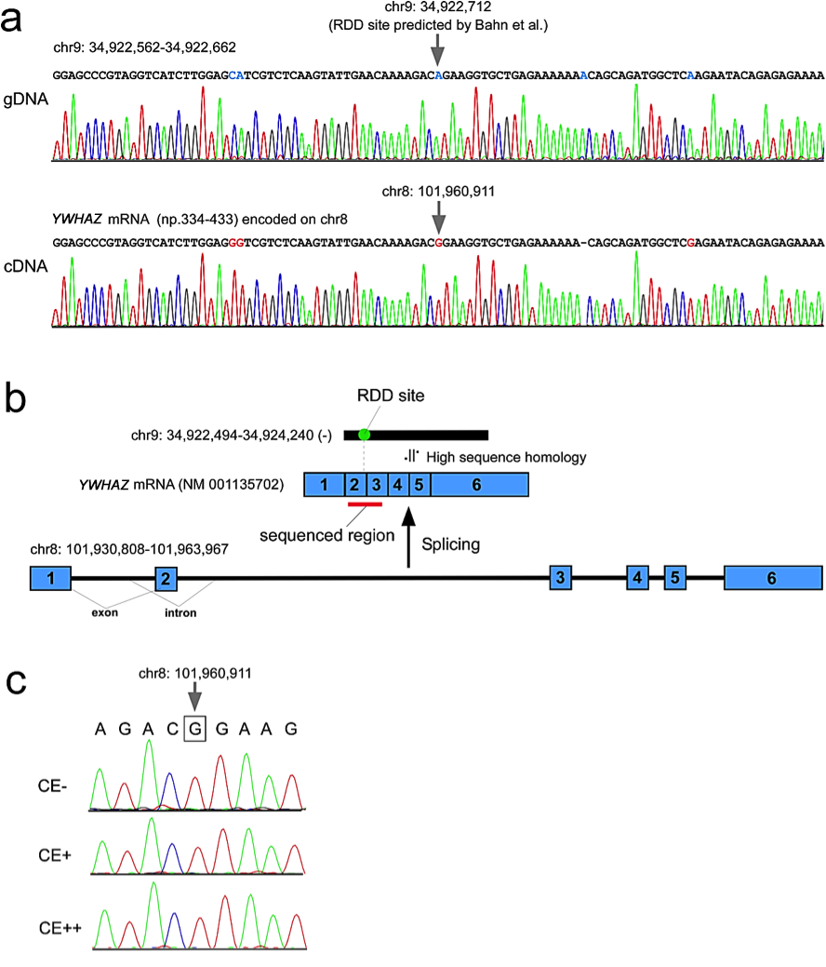
C
B
A
Figure S16 Mapping error of RDD site in YWHAZ mRNA.
(A) Sequencing chromatograms of the genomic region (top) including the RDD site (chr9: 34,922,712) predicted by Bahn et al.(Bahn et al. 2012) and cDNA (bottom) for YWHAZ mRNA encoded on chromosome 8. They have high sequence similarity. The adenosine at the RDD site (chr9: 34,922,712) corresponds to guanosine at chr8: 101,960,911 in YWHAZ mRNA.
(B) The minus strand (-) of genomic region in chromosome 9 (black bar, 34,922,494-34,924,240) has a high sequence similarity with the cDNA covering exons 2-6 of YWHAZ mRNA encoded on chromosome 8. The RDD site (closed green circle, chr9: 34,922,712) corresponds to the site (chr8: 101,960,911) in exon 2 of YWHAZ mRNA encoded on chromosome 8. The sequenced region is shown by red bar.
(C) Sequencing chromatograms around the RDD site in YWHAZ mRNA in conditions of CE-(top), CE+(middle) and CE++(bottom).

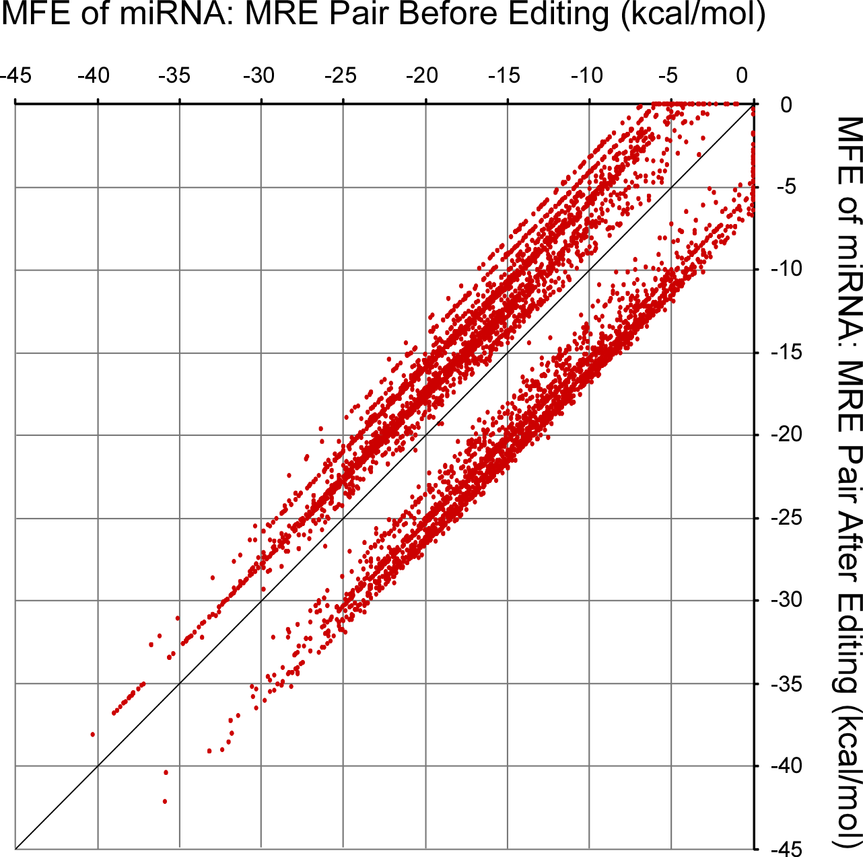

Figure S17 MEF plot of miRNA-MRE
Scatter plot of predicted miRNA-MRE binding energies (minimum free energy, MFE) before editing (x-axis) versus those after editing (y-axis). The MFE value for each miRNA-MRE pair was obtained by the followings. The sequence data set of 3’UTR was retrieved from UCSC genome browser. The virtual data set of edited 3’ UTR was created by converting all A-to-I editing sites to Gs. MREs for human miRNAs deposited in miRBase (release 15) were predicted by miRanda(Enright et al. 2003) (with options “-sc 1 -en -1” for maximum sensitivity) from the data set of unedited 3’UTR for loss-type or the data set of the edited 3’UTR for gain-type. In total, we identified 6,467 miRNA-MRE pairs bearing only one editing site in the seed matches consisting of 3,504 pairs destabilized by the editing (loss-type) and 2,963 pairs stabilized by the editing (gain-type). The binding energies for each miRNA-MRE pair before and after editing were calculated by an algorithm with inosine-associated energy parameters(Wright et al. 2007).
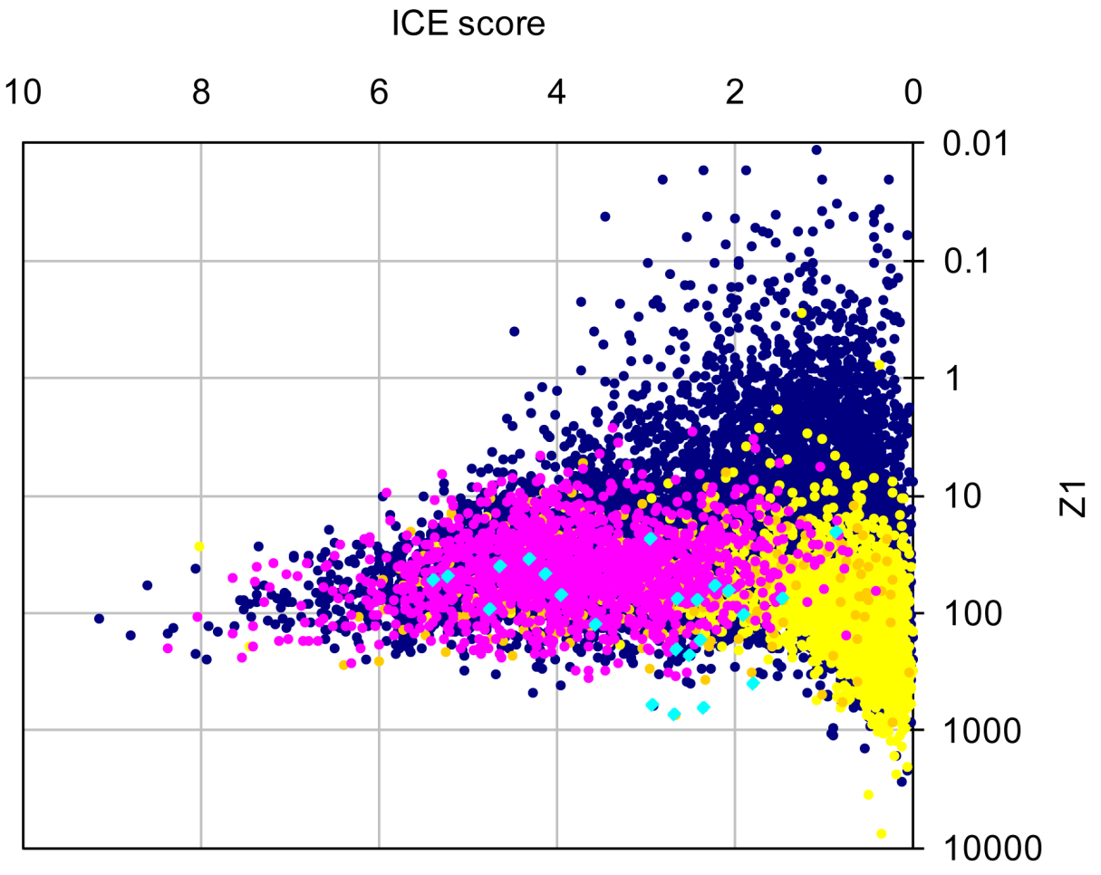
Figure S18 Binominal tests for base call quality
(A) Plots of ICE score versus Z1 for A-to-G sites

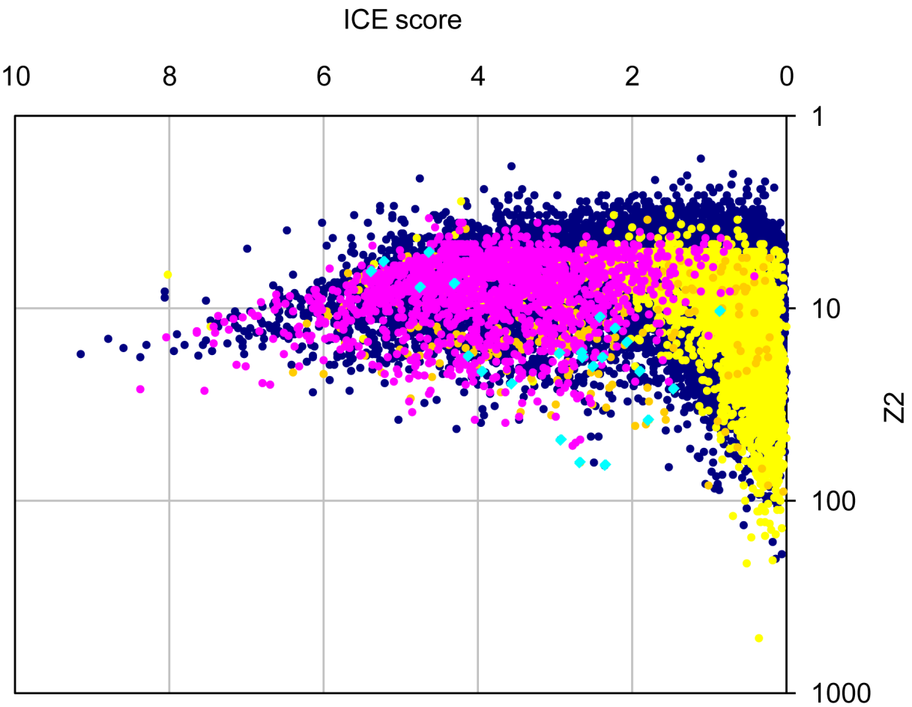
(B) Plots of ICE score versus Z2 for A-to-G sites

List of Tables

Table S1A. 13,884 sites identified by ICE-method
Table S1B. 8,847 novel editing sites identified by ICE-method
Table S1C. 17,745 editing sites merged with our previous study
Table S1D. List of primers for 1,686 regions
Table S2. List of UCSC genes with RPKM values in CE- condition
Table S3. 105 known editing sites in CDS
Table S4. 1,963 editing sites in non-CDS
Table S5A. 14,393 A-to-G candidates before validation by ICE-seq
Table S5B. 129 editing candidates in CDS for validation
Table S6. 99 additional editing candidates in CDS for validation
Table S7A. 931 sites for validation
Table S7B. List of primers for validation of 931 sites by ICE-method
Table S8. 86 candidates still needed to be examined
Table S9. 19,791 novel sites identified in this study
Table S10. List of 2,114 genes whose transcripts are edited (1,258 newly edited)
Table S11. 44 RDD sites validated by ICE method.
Table S12. Potential miRNA-MRE pairs in 3’UTRs affected by A-to-I editing
Table S13. Gene ontology analysis of genes whose transcripts are edited

Supplementary references

Bahn JH, Lee JH, Li G, Greer C, Peng G, Xiao X. 2012. Accurate identification of A-to-I RNA editing in human by transcriptome sequencing. Genome Res 22(1): 142-150.
Chen HH, Wong YH, Geneviere AM, Fann MJ. 2007. CDK13/CDC2L5 interacts with L-type cyclins and regulates alternative splicing. Biochemical and biophysical research communications 354(3): 735-740.
Enright AJ, John B, Gaul U, Tuschl T, Sander C, Marks DS. 2003. MicroRNA targets in Drosophila. Genome biology 5(1): R1.
Even Y, Durieux S, Escande ML, Lozano JC, Peaucellier G, Weil D, Geneviere AM. 2006. CDC2L5, a Cdk-like kinase with RS domain, interacts with the ASF/SF2-associated protein p32 and affects splicing in vivo. J Cell Biochem 99(3): 890-904.
Hartner JC, Walkley CR, Lu J, Orkin SH. 2009. ADAR1 is essential for the maintenance of hematopoiesis and suppression of interferon signaling. Nat Immunol 10(1): 109-115.
Hsi-Yang Fritz M, Leinonen R, Cochrane G, Birney E. 2011. Efficient storage of high throughput DNA sequencing data using reference-based compression. Genome Res 21(5): 734-740.
Huang da W, Sherman BT, Lempicki RA. 2009. Systematic and integrative analysis of large gene lists using DAVID bioinformatics resources. Nat Protoc 4(1): 44-57.
Jensen KB, Dredge BK, Stefani G, Zhong R, Buckanovich RJ, Okano HJ, Yang YY, Darnell RB. 2000. Nova-1 regulates neuron-specific alternative splicing and is essential for neuronal viability. Neuron 25(2): 359-371.
Katoh T, Suzuki T. 2007. Specific residues at every third position of siRNA shape its efficient RNAi activity. Nucleic Acids Res 35(4): e27.
Keller A, Backes C, Al-Awadhi M, Gerasch A, Kuntzer J, Kohlbacher O, Kaufmann M, Lenhof HP. 2008. GeneTrailExpress: a web-based pipeline for the statistical evaluation of microarray experiments. BMC Bioinformatics 9: 552.
Langmead B, Schatz MC, Lin J, Pop M, Salzberg SL. 2009. Searching for SNPs with cloud computing. Genome biology 10(11): R134.
Lapidot-Lifson Y, Patinkin D, Prody CA, Ehrlich G, Seidman S, Ben-Aziz R, Benseler F, Eckstein F, Zakut H, Soreq H. 1992. Cloning and antisense oligodeoxynucleotide inhibition of a human homolog of cdc2 required in hematopoiesis. Proc Natl Acad Sci U S A 89(2): 579-583.
Li H, Durbin R. 2009. Fast and accurate short read alignment with Burrows-Wheeler transform. Bioinformatics 25(14): 1754-1760.
Li R, Li Y, Fang X, Yang H, Wang J, Kristiansen K. 2009. SNP detection for massively parallel whole-genome resequencing. Genome Res 19(6): 1124-1132.
McKenna A, Hanna M, Banks E, Sivachenko A, Cibulskis K, Kernytsky A, Garimella K, Altshuler D, Gabriel S, Daly M et al. 2010. The Genome Analysis Toolkit: a MapReduce framework for analyzing next-generation DNA sequencing data. Genome Res 20(9): 1297-1303.
Mortazavi A, Williams BA, McCue K, Schaeffer L, Wold B. 2008. Mapping and quantifying mammalian transcriptomes by RNA-Seq. Nature methods 5(7): 621-628.
Piskol R, Peng Z, Wang J, Li JB. 2013. Lack of evidence for existence of noncanonical RNA editing. Nature biotechnology 31(1): 19-20.
Sakurai M, Suzuki T. 2011. Biochemical identification of A-to-I RNA editing sites by the inosine chemical erasing (ICE) method. Methods Mol Biol 718: 89-99.
Sakurai M, Yano T, Kawabata H, Ueda H, Suzuki T. 2010. Inosine cyanoethylation identifies A-to-I RNA editing sites in the human transcriptome. Nat Chem Biol 6(10): 733-740.
Sherry ST, Ward MH, Kholodov M, Baker J, Phan L, Smigielski EM, Sirotkin K. 2001. dbSNP: the NCBI database of genetic variation. Nucleic Acids Res 29(1): 308-311.
Smith TF, Waterman MS. 1981. Identification of common molecular subsequences. J Mol Biol 147(1): 195-197.
Wang Q, Miyakoda M, Yang W, Khillan J, Stachura DL, Weiss MJ, Nishikura K. 2004. Stress-induced apoptosis associated with null mutation of ADAR1 RNA editing deaminase gene. J Biol Chem 279(6): 4952-4961.
Wright DJ, Rice JL, Yanker DM, Znosko BM. 2007. Nearest neighbor parameters for inosine x uridine pairs in RNA duplexes. Biochemistry 46(15): 4625-4634.
XuFeng R, Boyer MJ, Shen H, Li Y, Yu H, Gao Y, Yang Q, Wang Q, Cheng T. 2009. ADAR1 is required for hematopoietic progenitor cell survival via RNA editing. Proc Natl Acad Sci U S A 106(42): 17763-17768.

