Supplemental Material

An unbiased resource of novel SNP markers provides a new chronology for the human Y chromosome and reveals deep phylogenetic structure in Africa

Rosaria Scozzari, Andrea Massaia, Beniamino Trombetta, Giovanna Bellusci, Natalie M. Myres, Andrea Novelletto, Fulvio Cruciani

Figure S1. Scatterplot of number of variable positions as a function of captured fragment length.

Figure S2. Comparison between markers here described and previously known.

Figure S3. Comparison between two dating methods.

Figure S4. Y chromosome tree obtained with BEAST.

Figure S5. Results of the phylogeographic analysis using a Bayesian method as implemented in BEAST.

Figure S6. Results of the phylogeographic analysis using a parsimony based method (S-DIVA) as implemented in RASP.

Table S1. List of subjects entered in the experimental design and their haplogroups.

Table S2. List of variable positions and inferred mutational events defining the branches of the tree shown in Figure 2 (nomenclature of branches according to Figure S2).

Table S3. List of positions displaying in all samples the alternative base as compared to the reference sequence.

Table S4. List of mutations in protein coding regions.

Table S5. Summary of the 2356 mutational events for which ancestral/derived alleles were unequivocally determined.

Table S6. Clusters of variants observed in the present study.

Table S7. Absolute frequencies of major MSY haplogroups in 73 African populations.

Table S8. Genomic coordinates for the five X-degenerate regions of the MSY selected for the present study.

Table S9. List and genomic coordinates of the 5,274 fragments of the capture probe set covering the 5 selected MSY regions.

Figure S1. Scatterplot of number of variable positions as a function of captured fragment length.
The red bars indicate the upper boundary of the 99.9% C.I. for the expected number of mutations (using Poisson distributions with means equal to the expected number of variants given the fragment’s length).

Figure S2. Comparison between markers here described and previously known.
Same tree as in Fig. 2 showing the branch nomenclature used in the main text (in brackets), and the number of previously known SNPs (dbSNP, build 135) in each branch (in red, before the slash) as compared to the number of SNPs described in this work (in red, after the slash).
Figure S3. Comparison between two dating methods.
Scatter plot of ages (kya) for the 20 nodes shown in Fig. 2 estimated with rho (X-axis) and BEAST (Y-axis).
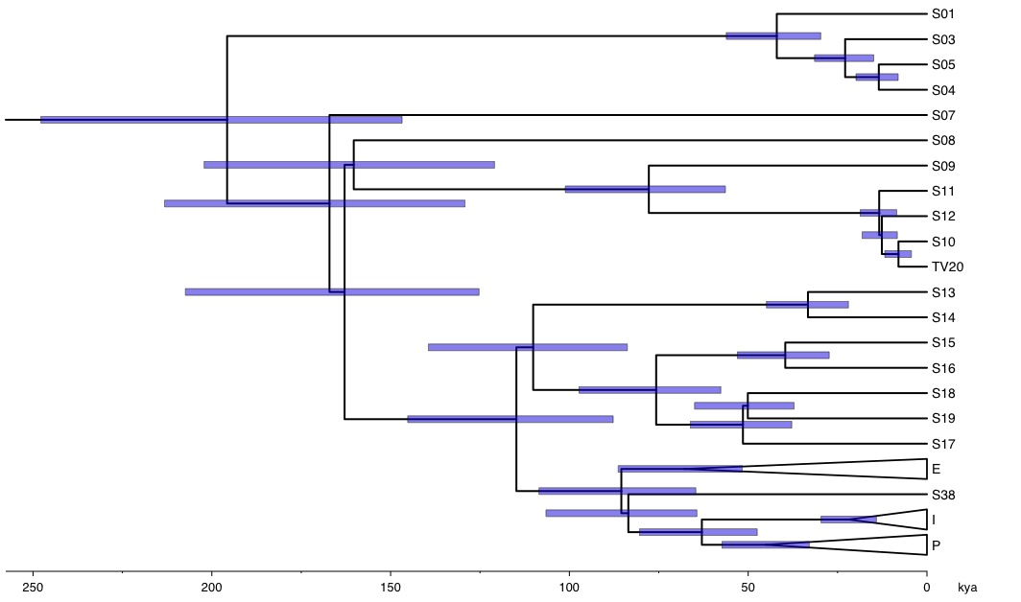
Figure S4. Y chromosome tree obtained with BEAST.
Y chromosome tree obtained with BEAST (see Methods), showing the estimated age of nodes. Branch tips are aligned to present. X-axis reports the age from present in thousand years (kya). Blue bars indicate the 95% HPD. Note that the program resolves the multifurcation of branches 16-18 (Supplemental Fig. S2) into two consecutive bifurcations.
Figure S5. Results of the phylogeographic analysis using a Bayesian method as implemented in BEAST.
Pie charts reflect the probability of the respective geographic areas, as coded in legend, with the greater probability explicitly indicated.
Figure S6. Results of the phylogeographic analysis using a parsimony based method (S-DIVA) as implemented in RASP.
Pie charts reflect the probability of the respective geographic areas, as coded in legend, allowing for single or combined distributions.
Table S1. List of subjects entered in the experimental design and their haplogroups.

Sample | Haplogroup |  | Region | Country | Population | Reference^{b}
Sample | by lineageª | by mutation
S01 | A1b* | A-V148* | Central America | Colombia | General population | 1
S03 | A1b1* | A-V150* | Western Africa | Ghana | General population | 2
S04 | A1b1a* | A-V195*(xP114) | Central Africa | Cameroon | General population | 1
S05 | A1b1a* | A-V195*(xP114) | Northern America | USA | General population | 1
S07 | A1a* | A-M31*(xV14) | Western Africa | Mali | General population | 1
S08 | A2a | A-M114 | Southern Africa | Republic of South Africa | Kung ^{c} | 2,3
S09 | A3b1b | A-V11 | Southern Africa | Republic of South Africa | Khwe ^{c} | 2,3
TV20 | A3b2* | A-M13* | Europe | Greece | General population | 1
S10 | A3b2* | A-M13* | Europe | Italy | Sardinian ^{d} | 1
S11e | A3b2* | A-M13* | Eastern Africa | Kenya | Maasai ^{d} | 1
S12 | A3b2c | A-V3 | Eastern Africa | Ethiopia | Ethiopian Jews ^{d} | 1,3
S13 | B1* | B-M236* | Central Africa | Cameroon | Bamileke ^{d} | 3
S14 | B1a | B-M146 | Western Africa | Burkina Faso | General population | 2
S15 | B2a* | B-M150* | Western Africa | Mali | General population | 2
S16 | B2a1a2a2* | B-M109* | Central Africa | Cameroon | Fali ^{d} | 2
S17 | B2b1 | B-P6 | Southern Africa | Republic of South Africa | Kung ^{c} | 1,3
S18 | B2b* | B-M112*(xP6,P7) | Southern Africa | Republic of South Africa | Kung ^{c} | 1,3
S19 | B2b3* | B-M30 | Central Africa | Cameroon | Ngambai ^{d} | 3
S38 | C7 | C-V20 | Europe | Italy | General population | 2,4
18 samples ^{f} | E (includes E1 and E2) | E-M40 | Africa, Europe, Asia, and America | see footnote h | see footnote h | 1,3,5,6,7
3 samples | I2a | E-P37.2 | Europe | see footnote h | see footnote h | 1
28 samples ^{g} | P (includes Q and R) | P-M45 | Africa, Europe, Asia, and America | see footnote h | see footnote h | 1,4,8
ª Haplogroup nomenclature according to Scozzari et al. (2012), Batini et al. (2011) (for haplogroup B2b), and Karafet et al. (2008) (for haplogroups E, I, and P)
^{b} References: (1) present study; (2) Scozzari et al. (2012) PLoS One 7:e49170; (3) Cruciani et al. (2002) AJHG 70:1197-1214; (4) Cruciani et al. (2011) AJHG 88:814-818;
(5) Cruciani et al. (2004) AJHG 74:1014-1022; (6) Cruciani et al. (2007) MBE 24:1300–1311; (7) Trombetta et al. (2011) PLoS One 6:e16073; (8) Cruciani et al. (2010) EJHG 18:1186-1187
^{c} Subsistence mode: hunters/gatherers
^{d} Subsistence mode: food producers
^{e} DNA from cell culture
^{f} Four DNAs from cell culture
^{g} One DNA from cell culture
^{h} Samples belonging to haplogroups E, I and P come from different countries and populations

Table S2. List of variable positions and inferred mutational events defining the branches of the tree shown in Figure 2 (nomenclature of branches according to Supplemental Figure S2).

Provided as a separate spreadsheet.
Table S3. List of positions displaying in all samples the alternative base as compared to the reference sequence.

Y Chromosome Position (GRCh37/hg19) | Reference allele | Alternative allele
7844490 | G | A
8694916 | A | G
14639427 | C | A
14641542 | T | G
14644698 | C | T
14644742 | C | T
14753989 | T | C
14777842 | C | T
14871976 | T | C
14958218 | C | T
15027529 | T | G
15086183 | C | G
15180091 | A | C

Table S4. List of mutations in protein coding regions.

Provided as a separate spreadsheet.

Table S5. Summary of the 2,356 mutational events for which ancestral/derived alleles were unequivocally determined.

Ancestral allele | Derived allele |  |  |  | Total
Ancestral allele | A | C | G | T | Total
A |  | 106 | 329 | 87 | 522
C | 151 |  | 106 | 384 | 641
G | 450 | 115 |  | 113 | 678
T | 83 | 328 | 104 |  | 515
Total | 684 | 549 | 539 | 584 | 2356

Table S6. Clusters of variants observed in the present study.

Tree branchª | Number of variants | Instances of two variants within 100 bp | Instances of two variants within 1000 bp | Instances of three variants within 1000 bp | Instances of four variants within 1000 bp
1 | 94 | 2 | 6 | 1 | 0
2 | 56 | 1 | 4 | 0 | 0
3 | 11 | 0 | 0 | 0 | 0
4 | 18 | 0 | 2 | 0 | 0
5 | 7 | 0 | 0 | 0 | 0
6 | 10 | 0 | 0 | 0 | 0
7 | 14 | 0 | 0 | 0 | 0
8 | 28 | 0 | 0 | 0 | 0
9 | 136 | 2 | 6 | 0 | 0
10 | 7 | 0 | 0 | 0 | 0
11 | 2 | 0 | 0 | 0 | 0
12 | 136 | 2 | 10 | 1 | 0
13 | 66 | 1 | 1 | 0 | 0
14 | 75 | 1 | 2 | 0 | 0
15 | 51 | 0 | 0 | 0 | 0
16 | 10 | 0 | 0 | 0 | 0
17 | 11 | 0 | 0 | 0 | 0
18 | 5 | 0 | 0 | 0 | 0
19 | 8 | 0 | 0 | 0 | 0
20 | 9 | 0 | 0 | 0 | 0
21 | 53 | 0 | 1 | 0 | 0
22 | 4 | 0 | 0 | 0 | 0
23 | 66 | 0 | 1 | 0 | 0
24 | 34 | 0 | 0 | 0 | 0
25 | 28 | 0 | 0 | 0 | 0
26 | 33 | 0 | 2 | 0 | 0
27 | 28 | 0 | 0 | 0 | 0
28 | 38 | 1 | 2 | 0 | 0
29 | 32 | 0 | 0 | 0 | 0
30 | 27 | 0 | 0 | 0 | 0
31 | 1 | 0 | 0 | 0 | 0
32 | 62 | 0 | 2 | 0 | 0
33 | 43 | 0 | 1 | 0 | 0
34 | 51 | 0 | 1 | 0 | 0
35 | 32 | 0 | 1 | 0 | 0
36 | 17 | 0 | 1 | 0 | 0
37 | 1 | 0 | 0 | 0 | 0
38 | 78 | 1 | 3 | 0 | 0
39 | 22 | 0 | 0 | 0 | 0
40 | 38 | 0 | 0 | 0 | 0
41 | 20 | 0 | 0 | 0 | 0
1/8 | 36 | 1 | 6 | 0 | 0
36-internal | 542 | 5 | 9 | 2 | 1
40-internal | 48 | 0 | 0 | 0 | 0
41-internal | 304 | 2 | 6 | 0 | 0
Total | 2392 | 19 | 67 | 4 | 1
ª Tree branch nomenclature as in Fig. S2

Table S7. Absolute frequencies of major MSY haplogroups in 73 African populations.

Provided as a separate spreadsheet.

Table S8. Genomic coordinates for the five X-degenerate regions of the MSY selected for the present study.

Region number | Start position (GRCh37/hg19) | End position (GRCh37/hg19) | Size (bp)
1 | 2689001 | 2910620 | 221620
2 | 6655519 | 6673610 | 18092
3 | 7540722 | 8740721 | 1200000
4 | 14629842 | 15962456 | 1332615
5 | 18553379 | 19550033 | 996655

Table S9. List and genomic coordinates of the 5,274 fragments of the capture probe set covering the 5 selected MSY regions.

Provided as a separate spreadsheet.

