SUPPLEMENTAL MATERIALS

Neither level of expression, nor extreme mRNA cis ratios explain the observed excess of opposing differences in cis regulation at both regulatory levels

Two potential non-biological explanations could produce an excess of opposing instances of transcriptional versus translational cis divergence. First, there could be a non-linear relationship between RPKM estimates of abundance from the mRNA and Ribo fractions. For instance, if Ribo abundance was systematically underestimated for highly expressed genes, a reduced mRNA abundance in one of the parental alleles in the hybrid would lead to an increase in measured relative translational efficiency, producing a signal of opposing changes where none exists (a systematic overestimate of Ribo abundance among genes with low expression would produce a similar effect). The opposite non-linear relationships—where Ribo abundance is systematically over-estimated among highly expressed genes or under-estimated among genes with low expression—would lead to an excess of reinforcing transcriptional versus translational cis divergence. However, we observe that both opposing and reinforcing mRNA/translational cis divergence are represented across the range of mRNA expression levels (estimated from the mean RPKMs across combined S. cerevisiae and S. paradoxus hybrid replicates; Supplemental Fig. S7A). Furthermore, the distribution of mRNA expression levels for genes with opposing or reinforcing cis divergence are not significantly different from that of one another (Kruskal-Wallis rank sum test, p = 0.46; Supplemental Fig. S7B).
Second, we could be systematically overestimating the hybrid mRNA cis ratio (or underestimating the hybrid translational cis ratio) in some fraction of orthologs, leading to an excess of opposing divergence among orthologs with high absolute ^{Sc}/_{Sp} mRNA/Ribo. The opposite effect would produce an excess of reinforcing divergence. However, again the distribution of translational cis ratios for genes with opposing or reinforcing cis divergence is represented across the range absolute mRNA cis ratios (Supplemental Fig. S7C) and neither the distribution of absolute mRNA cis ratios, nor absolute translational cis ratios, is significantly different between the two classes (Kruskal-Wallis rank sum test, p = 0.94 and 0.75 for the mRNA and translational levels, respectively; Supplemental Fig. S7D).

Analysis of the relationship between genomic sequence and regulatory divergence
The ability to accurately measure ASE in hybrid or mixed parental samples is dependent on having a sufficient number of fixed sequence differences between orthologs to confidently assign short reads (or hybridize labeled samples on microarrays) to each parental allele (De Veale et al. 2012). Indeed, we observed a significant correlation between the degree of sequence divergence (measured as % divergence; see Supplemental Methods) in the CDSs of orthologs and the absolute magnitude of cis-regulatory divergence (Spearman’s ρ = 0.12 and 0.097, p < 1 × 10⁻¹⁵ and p = 3.9 × 10⁻⁹ for the mRNA and translational levels, respectively). In addition, we observed a slight but significantly lower % divergence among orthologs with non-significant cis divergence at the mRNA level (Kruskal-Wallis test, p = 0.00070); however, this effect disappears by removing the 380 (~10%) least divergent orthologs (p = 0.054), indicating that it is being driven by the most highly conserved genes. No such relationship between % divergence and our ability to detect significant cis-divergence at the translational level was observed (p = 0.41). Removal of the 380 least divergent orthologs from our dataset had no qualitative impact on our observation of an excess of opposing cis-divergence between regulatory levels (data not shown).
Local variability in mutation rates may lead to similar patterns of divergence in neighboring locations in the genome (e.g., promoters and their associated CDSs; Hellman et al. 2005). As expected, sequence divergence in promoter regions (defined as -200 to -1 nt relative to the transcriptional start site [TSS]), 5′ UTRs and 3′ UTRs are significantly positively correlated with divergence in their CDSs (Spearman’s ρ = 0.20, 0.20, and 0.21, p < 10⁻¹⁵, for promoter regions, 5′ UTRs and 3′ UTRs, respectively). Therefore, in order to account for the possibility that any relationships detected in divergence at non-CDS regions spuriously reflects CDS divergence, we performed a multiple regression analysis testing for independent association between the magnitude of the absolute ^{Sc}/_{Sp} cis-ratio at either level and divergence in the promoter, the 5′ UTR, the CDS, or the 3′ UTR (see Supplemental Methods). At the mRNA level, we found that % divergence in the 5′ UTRs was significantly correlated with the absolute ^{Sc}/_{Sp} cis-ratio (p = 0.015), while % divergence in promoters and 3′ UTRs was not (p = 0.41 and 0.22, respectively). At the translational level, only divergence in the 3′ UTR was significantly correlated when controlling for the effect of CDS (p = 0.002). However, a recent study found that translational dynamics were strongly related to nucleotide sequences in the 5′ UTR immediately adjacent to the start codon (Dvir et al. 2013). Therefore we performed the same analysis as above using only divergence of the first 50 bp of the 5′ UTR (and analyzing those UTRs that were >= 50 bp in length). In this case, the relationship between divergence in the 5′ UTR and the absolute mRNA cis ratio improved (p = 0.0042), and became the strongest predictor of absolute cis divergence at the translational level (p = 0.00069 and 0.0087, for the last 50 bp of the 5′ UTR and the 3′ UTR, respectively). These results may suggest that 5′ UTRs harbor elements that regulate either (or both) mRNA abundance and translation; however, a recent study by Pelechano et al. (2013) found that most genes of S. cerevisiae produce multiple isoforms with alternative TSSs. Therefore, it is also possible that our observations in the 5′ UTRs and promoters simply reflect an inability precisely define the boundaries of these elements (if precision in such boundaries exists).

Analysis of the relationship between divergence in mRNA secondary structure and translation

We determined the minimum free energy (MFE) in sliding 41 nucleotide windows using a 10 bp step, for the region -100 to +100 surrounding the first nucleotide of the start codon of the 3,665 orthologs analyzed in the hybrid data (see Methods in the main text) using RNAfold with default parameters (Hofacker et al. 1994). For each window, we calculated ΔMFE (MFE_{Scer} – MFE_{Spar}) and determined its correlation with either log₂(^{Sc}/_{Sp} mRNA cis or translational cis). In this case, we found a positive correlation where reduced secondary structure (higher MFE) is associated with increased expression. We observed several windows with significant positive correlations in the translational cis ratio and no negative correlations, consistent with the notion that changes in secondary structure can affect translational efficiency in the expected direction (Supplemental Fig. S10). Note that in all cases, correlation coefficients are < 0.1, suggesting that ΔMFE can explain only a small fraction of the variance in translational efficiency. At the same time we observed an opposite relationship with the mRNA cis ratio (Supplemental Fig. S10), which could reflect a relationship between sequence composition and transcriptional dynamics in the 5′ UTR/promoter region or, alternatively the preferential sequenceability of transcripts with particular nucleotides associated with stronger secondary structure in their 5′ ends (i.e., G and C; Zheng et al. 2011). Because sequence, whether via mRNA secondary structure or not, affects sequenceability of NGS libraries (Zheng et al. 2011), it may confound results derived from computational prediction of ΔMFE. However, we note that the relationship observed in windows beginning at +30 are unique to the translational cis ratio, supporting an effect of secondary structure on translation at the beginning of the CDS (e.g., Tuller et al. 2011).

No evidence that translation in 5′ UTRs is a significant determinant of cis-regulatory divergence in translational efficiency
Allele-specific presence and/or translation of uORFs could provide a plausible mechanism explaining divergence of translational efficiency in cis. A well-studied example of this phenomenon is the GCN4 system in S. cerevisiae, which represses translation of the main ORF via four uORFs under nutrient rich conditions, and activates translation in response to amino acid starvation (Hinnebush 1997). However, a recent riboprofiling analysis of yeast meiosis found that changes in translation of most uORFs were positively correlated with translation of the main ORF, indicating that the former’s repressive effects are far from universal (Brar et al. 2012).
Identification of homologous uORFs between even closely related species is challenging, due both to their short lengths (the median length of annotated uORFs in the S. cerevisiae genome is 33 nucleotides) as well as the lack of evidence for translation or function at many potential uORFs (Ingolia et al. 2009). Therefore, we first compared patterns of upstream translation in the Ribo samples in both species using the annotated 5′ UTRs of S. cerevisiae as well as an equivalent length of sequence upstream of the start codon in S. paradoxus (via these criteria, 90% of annotated 5′ UTRs expressed in the mRNA fractions are detected in both species). The 5′ UTR with the highest average coverage between species was GCN4, strongly suggesting that its function in stress response remains conserved. Evidence of translation was observed in 387 and 373 5′ UTRs in S. cerevisiae and S. paradoxus, respectively (see Supplemental methods) (Supplemental Table S5). Significant translation was detected in both species in 223 5′ UTRs; very few upstream sequences (51) showed species-specific evidence of translation (i.e., reads mapping in both replicates of one species, but no reads mapping in either replicate of the other). Interestingly, orthologs with detectible 5′ UTR translation in both species are significantly over-represented for genes involved in stress response (p = 2.1 × 10⁻⁶) suggesting that the mechanism of translational repression employed by GCN4 may not be unique. There is no significant excess of orthologs with cis-regulatory divergence in translational efficiency among those with detectible translation in their 5′ UTRs (χ² = 0.09, p = 0.76). Furthermore, there is no evidence of a negative correlation between detection of significant 5′ UTR translation in one species and allele-specific translation bias favoring the other (χ² test, p > 0.05 in all cases; note that because of the low number of reads mapping to 5′ UTRs we simply asked if the directionality of bias was the same or opposite without assigning a significance to the bias). This remains the case when restricting the analysis only to orthologs with species-specific 5′ UTR translation.
While it is possible that some uORFs act in a species-specific cis fashion to affect translational efficiency, the small proportion of orthologs with significant upstream translation (~14%) and their lack of enrichment among orthologs with cis divergence in translation makes it unlikely that this is a significant mechanism explaining divergence in translational efficiency. In addition, a recent study by Pelechano and colleagues (2013) noted that many S. cerevisiae transcripts express alternative mRNAs that can exclude potential uORFs. Supporting their findings, we also observe that orthologs with significant 5′ UTR translation in both species and that contain uORFs that are in the 5′ UTRs of all detected transcripts (63) show significantly reduced mean hybrid translational efficiency when compared to those orthologs with upstream translation but lacking uORFs (Kruskal-Wallis rank sum test, p = 0.0059). Therefore a systematic analysis of species-specific uORF action will likely require characterizing the alternative transcriptional landscape of both species, coupled to a more thorough identification of translated uORFs using riboprofiling modified to specifically detect sites of translational initiation (e.g., Ingolia et al. 2011).

SUPPLEMENTAL METHODS
Riboprofiling library construction
The following modifications were made to the method of Ingolia (2010): Cryo-grinding of lysates was performed in a Retsch Mixer-Mill MM 301 (Retsch Technology GmbH) at maximum frequency for two 1.5 minute cycles with immersion in liquid N₂ before grinding, in between cycles, and following grinding. After purification of the cryo-ground lysate, RNA abundance was determined from the A₂₆₀ measured using a Nanodrop 2000c (Thermo Scientific) and 1000 µg of RNA was subjected to density gradient centrifugation for monosome isolation. Gradients were fractionated and fractions corresponding to the 80S monosome were collected using a Biocomp Instruments Gradient Station attached to a Foxy Jr Fraction Collector (Teledyne Isco). RNA was extracted from the sucrose gradient fractions using the RNeasy Mini Kit (Qiagen). Total RNA was isolated from the purified lysate using the Epicenter MasterPure™ Yeast RNA Purification Kit beginning with 500 µg of lysate RNA diluted to 125 µl using polysome lysate buffer. Following circularization, the libraries were subjected to an rRNA subtraction step as described in Brar et al. (2012).
NGS libraries were sequenced as follows: Hybrids: mRNA and Ribo fractions were each sequenced on individual lanes of a flowcell. Parents: one replicate of mRNA and both replicates of the Ribo fraction libraries were combined to approximately equal proportion and sequenced on individual lanes of a flowcell. The second replicate of the mRNA fraction for each parental strain was kept separate and sequenced on an individual lane of the flowcell in order to compare the sequence obtained from our strains to the genome assemblies and reannotate any single nucleotide polymorphisms (see below). Combined parental mRNA replicate two was subsequently generated by randomly combining 60,000,000 reads from each of the two parental replicates in silico.

Iterative mapping of riboprofiling reads
Reads were mapped according to the method of Ingolia et al. (2010) as follows: Beginning with the individual parental mRNA samples, we first excluded any reads that, when trimmed to 23 bases from the 5′ end, mapped to the complete rDNA sequence of S. cerevisiae allowing 3 mismatches and a maximum of 20 mapping locations using Bowtie version 0.12 (Langmead et al. 2009). Remaining reads from the parental mRNA samples were mapped to their respective genomes allowing no multimappers, and a single mismatch. Mapping reads were filtered such that no more than 30 bp (31 bp if the 3′ most base ended with an A), and no less than 27 bp (28 if the 3′ most base was an A) from the 5′ end of the read mapped uniquely. These were used to reannotate the genome assemblies by identifying nucleotides that were overlapped by at least 10 reads differing at a specific nucleotide with the reference genomes at a frequency >= to 0.8, and that did not introduce nonsense mutations in annotated genes (the absence of true nonsense mutations was confirmed in the five cases where substitutions were detected by the presence of abundant Ribo fraction read coverage 3′ of the putative stop codon). This identified 239 and 605 differences between our data and the S. cerevisiae and S. paradoxus assemblies, respectively. Replicate reads from all samples were then mapped to a concatenation of the updated assemblies, as above, but allowing no mismatches.
S. cerevisiae and S. paradoxus show sufficient divergence at the nucleotide level (~5%) that the 27-30 nt RNA fragments produced by the riboprofiling protocol mapped uniquely to most genomic regions (~87% when accounting for non-unique regions both within and between the two genomes). In order to analyze only unique mapping nucleotides, non-unique mapping nucleotides were identified by truncating each of the species’ genomes into overlapping 27 bp fragments in single-base increments along each chromosome. These fragments were then mapped back to the concatenation of the two species’ genomes using Bowtie allowing no mismatches and removing all locations spanned by reads mapping to more than a single location (multi-mapping reads).

Identification of high-confidence Scannell et al. (2011) orthologs
From the list of genes orthologous between S. cerevisiae and S. paradoxus, we identified those that in both species a) began with an ATG and terminated in a canonical stop codon (TAA, TAG, TGA), b) had a sequence length that was divisible by three, c) lacked in-frame stop codons, d) lacked any ‘N’ nucleotides in their genomic sequence, e) were annotated as either possessing or lacking introns in both species, and f) possessed at least 100 uniquely mappable nucleotides. Furthermore, we required that the lengths of both orthologs be within 50% of one another and excluded genes that were annotated as having a different number of introns in the Scannell et al. (2011) S. cerevisiae annotation than in the Saccharomyces Genome Database (SGD; Cherry et al. 2012) annotation available as of 14 August 2012. The Scannell et al. (2011) annotation provides spliced, processed mRNA sequences for each annotated gene, however the positions of introns are not indicated in the genomic annotation files. These were obtained by using BLAT (Kent 2002) to map each species’ mRNA to its respective genome. Intron flanking segments of 84 of the 105 intron containing mRNAs mapped uniquely and were retained for analysis. Finally we eliminated orthologs for LYS2 (Scer_2.299) as its knockout in the S. cerevisiae parental strain was used as a selectable marker as well as CTR3 (Scer_12.598) as it is interrupted by a Ty2 transposon in BY strains of S. cerevisiae. Our final analysis set contained 4,640 orthologs between the two parental species (Supplementary Table S1).

Applying the method of Bullard et al. (2010) to detect significant mRNA ASE
The test involves resampling, with replacement, the base-level read coverage of each parental allele 10,000 times, under two conditions: 1) using the S. cerevisiae marginal nucleotide frequencies (π_{c} = π_{c}[A], π_{c}[C], π_{c}[G], π_{c}[T]) and the S. cerevisiae length, L_{c}, and 2) using the S. paradoxus marginal nucleotide frequencies π_{p} and the S. paradoxus length, L_{p}. A started log₂ ratio (total base level coverage from π_{c},L_{c} + 1 / total base level coverage from π_{p},L_{p} + 1), denoted as log₂(^{Sc+1}/_{Sp+1}), was obtained from each resampling representing the variation in log₂(^{Sc+1}/_{Sp+1} mRNA) ratios expected between alleles due only to differential base frequencies and length. The two null distributions (one per allele) were compared against the observed started log₂(^{Sc+1}/_{Sp+1} mRNA) ratio in order to obtain a two-tailed p value based on how often the observed ratio was outside of the bounds of the null distribution. If both replicates agreed in the direction of parental bias, we retained the least significant p-value in either replicate as a measure of the significance of differential expression.

Detecting significant trans-regulatory divergence using parental data
For the purpose of analyzing trans-divergence, we focused on those orthologs with a minimum of 100 reads mapping among both alleles within all replicate mRNA fraction. Furthermore, we removed any ortholog identified as being differentially expressed among different mating types (18 orthologs; Galitski et al. 1999), and/or ploidy levels (35 orthologs; Wu et al. 2010) as the S. cerevisiae strain BY4716 is haploid while the S. paradoxus CBS432 strain is diploid. Ploidy level has previously been shown to have no significant effect on estimates of trans-regulatory divergence between these species (Tirosh et al. 2009). The 3,634 remaining orthologs were used to test for significant trans regulatory divergence at both levels using the same approach as outlined above, modified as follows: For the test of significant trans regulatory divergence in mRNA abundance, we sought to reject the null hypothesis that log₂(parental ^{Sc+1}/_{Sp+1} mRNA) was not significantly different from log₂(hybrid ^{Sc+1}/_{Sp+1} mRNA). Therefore, we resampled the CDS base-level coverage of the S. cerevisiae allele using π_{c} and L_{c} and the S. paradoxus allele using π_{p} and L_{p} 10,000 times in the each replicate of the parental mRNA fraction. Each resampling was used to generate a distribution of log₂(parental ^{Sc+1}/_{Sp+1} mRNA) ratios, which takes into account the variability in read coverage across each allele. These distributions were then compared to the mean observed log₂(hybrid ^{Sc+1}/_{Sp+1} mRNA) to generate a p-value. The same resampling was then repeated reciprocally in each hybrid mRNA fraction replicate, which was then compared to mean observed log₂(parental ^{Sc+1}/_{Sp+1} mRNA). As above, if the directionality of difference agreed among all individual replicate comparisons (i.e., both observed replicate log₂(hybrid ^{Sc+1}/_{Sp+1} mRNA) had to agree in direction when compared to both observed replicate log₂(parental ^{Sc+1}/_{Sp+1} mRNA), the least significant of the four p-values was retained.
For the test of significant trans regulatory divergence in translation, we sought to reject the null hypothesis that log₂(parental ^{Sc+1}/_{Sp+1} Ribo) was not significantly different from sum of log₂(hybrid ^{Sc+1}/_{Sp+1} Ribo) and log₂(parental ^{Sc+1}/_{Sp+1} mRNA). Therefore, we resampled the CDS base-level coverage of the S. cerevisiae allele using π_{c} and L_{c} and the S. paradoxus allele using π_{p} and L_{p} 10,000 times in each replicate of the parental Ribo fraction and compared the resulting distributions the sum of the mean observed log₂(hybrid ^{Sc+1}/_{Sp+1} Ribo) and log₂(parental ^{Sc+1}/_{Sp+1} mRNA) to generate a p-value. The same resampling was then repeated reciprocally to generate two permuted distributions where each replicate permutation of log₂(hybrid ^{Sc+1}/_{Sp+1} Ribo) was summed with one or the other replicate permutation of log₂(parental ^{Sc+1}/_{Sp+1} mRNA) with equal probability. If the directionality of difference between the both log₂(parental ^{Sc+1}/_{Sp+1} Ribo) and the mean summed ratios agreed, the least significant of the four p-values was retained. Differences significant at 5% FDR were retained.

Criteria for identification of candidate C-terminal extensions
We combined the two replicate Ribo fractions in the hybrids and parents for the purpose of assessing if a candidate C-terminal extension was translated (however, Supplemental Table S4 indicates if reads were detected in both replicates). A number of different criteria were used to assess the potential validity of 3′ readthrough: Readthrough was considered species-specific if ≥ 5 reads mapped to the extension in both the combined hybrid and combined parental replicates in one species but < 3 mapped in either of the combined samples in the other species. In order to consider read through conserved between species, in addition to meeting the above criteria, we required 1) the presence of ≥ 5 mapping reads in one species and ≥ 3 reads in the other species in both the combined hybrid and the combined parental replicates 2) the absence of frame shifting indels in the aligned C-terminal extensions. Conserved read through candidates were then scored as ‘Good’ if the ratio of non-synonymous substitutions per non-synonymous site (Ka) to synonymous substitutions per synonymous site (Ks) was < 0.8 as determined by aligning the putative extension using DIALIGN-TX version 1.0.0 (Subramanian et al. 2005) and RevTrans version 1.4 (Wernersson and Pedersen 2003), followed by KaKs Calculator version 2.0 using the ‘NG’ method (Zhang et al. 2006), or ‘Poor’ if it was ≥ 0.8 and/or translation was detected using the conserved criteria in only the hybrid or parental combined replicates. In cases where the Ks was 0, candidates were considered ‘Good’ if they experienced ≤ 2 non-synonymous substitutions.

Analysis of translation in 5′ UTRs
Ribo samples were mapped to the regions identified as S. cerevisiae 5′ UTRs (see Methods in the main text) by Nagalakshmi et al. (2008) and the sequence of an equivalent length upstream of the annotated AUG codon of S. paradoxus orthologs. We required at least five reads mapping to at least one species in both hybrid replicates to classify a 5′ UTR as translated in a single species, and at least five reads mapping in both replicates of both species to be translated in both. For the analysis of Pelechano et al. (2013) uORFs, we obtained their list of genes in S. cerevisiae whose uORFs were upstream of the main ORF in all transcripts detected.

SUPPLEMENTAL REFERENCES
DeVeale B, van der Kooy D, Babak T. 2012. Critical evaluation of imprinted gene expression by RNA-Seq: a new perspective. PLoS Genet 8: e1002600.

Galitski T, Saldanha AJ, Styles CA, Lander ES, Fink GR. 1999. Ploidy regulation of gene expression. Science 285: 251-254.

Hellmann I, Prüfer K, Ji H, Zody MC, Pääbo S, Ptak SE. 2005. Why do human diversity levels vary at a megabase scale? Genome Res 15: 1222-1231.

Hinnebusch AG. 1997. Translational regulation of yeast GCN4. A window on factors that control initiator-trna binding to the ribosome. J Biol Chem 272: 21661-21664.

Hofacker IL, Fontana W, Stadler PF, Bonhoeffer LS, Tacker M, Schuster P. 1994. Fast Folding and Comparison of RNA Secondary Structures. Monatsh Chem 125: 167-188.

Kent WJ. 2002. BLAT--the BLAST-like alignment tool. Genome Res 12: 656-664.

Storey JD. 2002. A direct approach to false discovery rates. J Roy Statist Soc Ser B 64: 479-498.

Wernersson R, Pedersen AG. 2003. RevTrans - Constructing alignments of coding DNA from aligned amino acid sequences. Nucl Acids Res 31: 3537-3539.

Wu CY, Rolfe PA, Gifford DK, Fink GR. 2010. Control of transcription by cell size. PLoS Biol 8: e1000523.

Zhang Z, Li J, Zhao XQ, Wang J, Wong GK, Yu J. 2006. KaKs_Calculator: calculating Ka and Ks through model selection and model averaging. Genomics Proteomics Bioinformatics 4: 259-263.

SUPPLEMENTAL TABLES

Supplemental Table S2. Overview of the location within annotated transcripts where reads from each fraction and replicate map. Reads were assigned to each feature based on the mapping location of their 5′ ends (see Methods). The number of reads mapping to each feature is indicated along with their proportion (Prop.) calculated as the fraction of reads mapping to the feature divided by the fraction of total mappable bases in that feature. Mapping locations of the mRNA fractions are 3′ biased as expected from RNA-seq data. The Ribo fractions are more strongly biased towards reads mapping in the CDS, again as expected from previous ribosome profiling studies (e.g., Ingolia et al. 2009). We note the inconsistent number of reads mapping to 3′ UTRs in the hybrid Ribo fraction may affect our ability to identify C-terminal peptide extensions (see main manuscript), therefore the all candidates for C-terminal extensions with reads derived from both fractions are indicated in Supplementary Table 4.

 |  | CDS |  | Introns |  | 5′ UTR |  | 3′ UTR
 |  | 10,403,087 |  | 16,741 |  | 511,468 |  | 970,922
Sample | Rep | Reads | Prop. | Reads | Prop. | Reads | Prop. | Reads | Prop.
Hybrid mRNA Fraction | 1 | 13,830,192 | 0.99 | 9,309 | 0.42 | 370,715 | 0.54 | 1,705,144 | 1.31
Hybrid mRNA Fraction | 2 | 13,970,968 | 0.98 | 10,278 | 0.45 | 416,530 | 0.60 | 1,853,799 | 1.40
Hybrid Ribo Fraction | 1 | 7,923,111 | 1.14 | 148 | 0.01 | 32,562 | 0.09 | 28,057 | 0.04
Hybrid Ribo Fraction | 2 | 5,341,475 | 1.09 | 286 | 0.04 | 35,249 | 0.15 | 239,745 | 0.52
Parental mRNA Fraction | 1 | 9,528,924 | 0.99 | 8,279 | 0.54 | 269,978 | 0.57 | 1,150,185 | 1.29
Parental mRNA Fraction | 2 | 13,723,361 | 0.98 | 12,402 | 0.55 | 341,516 | 0.50 | 1,865,146 | 1.43
Parental Ribo Fraction | 1 | 7,454,237 | 1.12 | 193 | 0.02 | 39,329 | 0.12 | 121,750 | 0.20
Parental Ribo Fraction | 2 | 15,488,748 | 1.13 | 252 | 0.01 | 83,251 | 0.12 | 137,296 | 0.11

SUPPLEMENTAL FIGURES

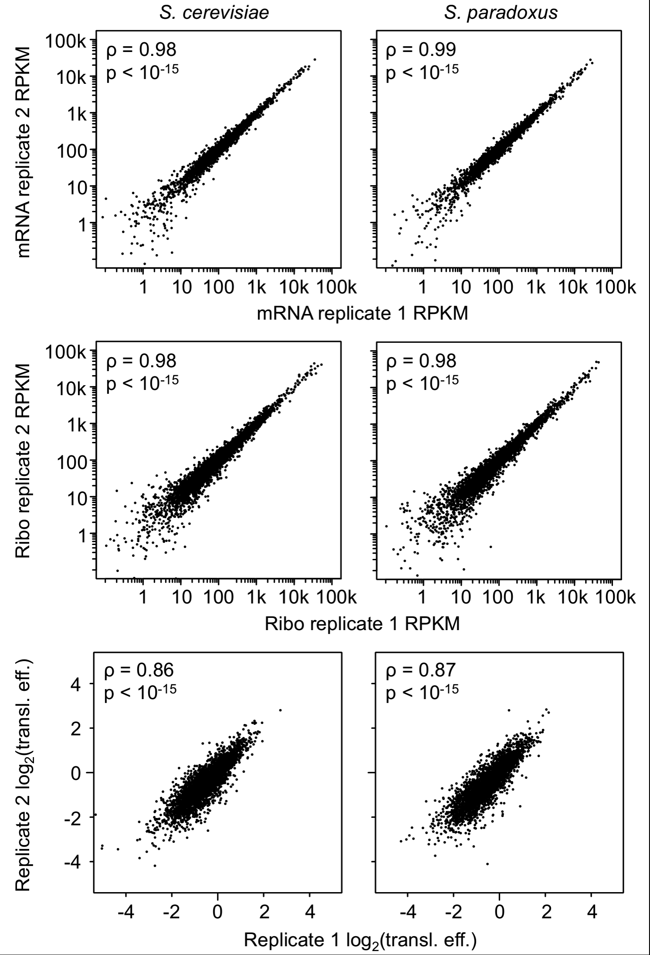

Supplemental Figure S1. Comparisons of hybrid biological replicate allele-specific RPKM abundance estimates for all 4,640 orthologs. S. cerevisiae RPKMs are shown on the left while S. paradoxus estimates are on the right. The mRNA fraction (A) is shown above the Ribo fraction (B). C) Comparison between hybrid biological replicates of the estimated translational efficiencies for the 3,665 orthologs with sufficient coverage to test for significant cis-regulatory divergence at both regulatory levels. Spearman’s correlation coefficients (ρ) indicate that all abundance measurements are highly reproducible. Transl. eff: Translational efficiency.
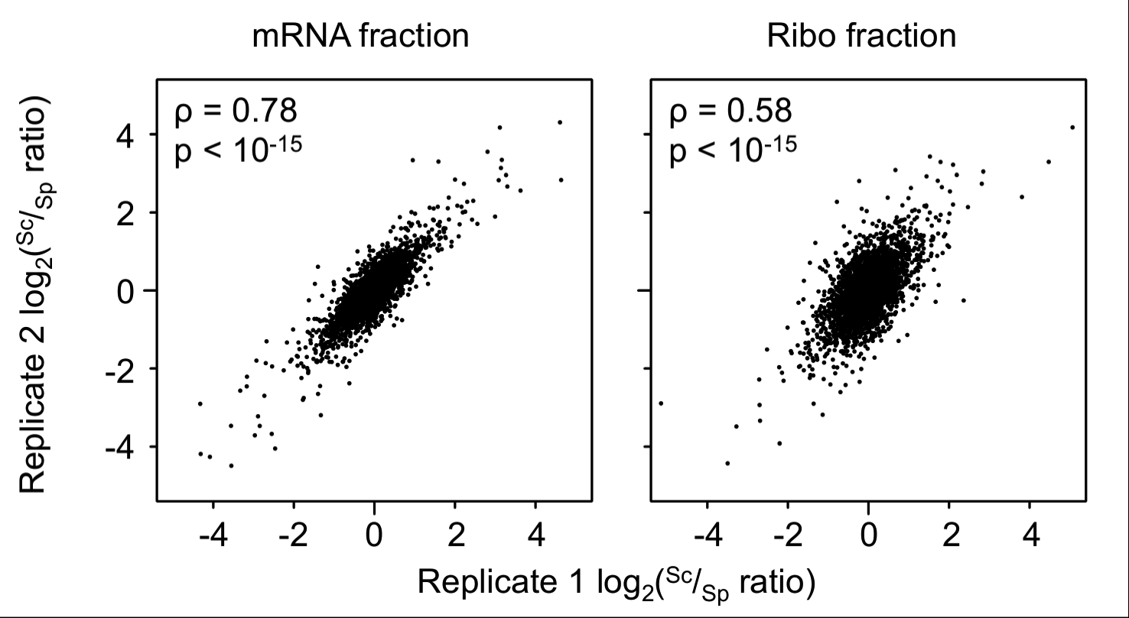
Supplemental Figure S2. Comparison of the estimated ^{Sc}/_{Sp} allelic ratios for the hybrid mRNA and Ribo fractions. Spearman’s correlation coefficients (ρ) are shown in each panel. mRNA fraction ^{Sc}/_{Sp} ratios estimates are more reproducible, likely owing to both the greater number of mapping reads obtained from these fractions, and the more even distribution of coverage along the CDS of transcripts (Ingolia et al. 2009).

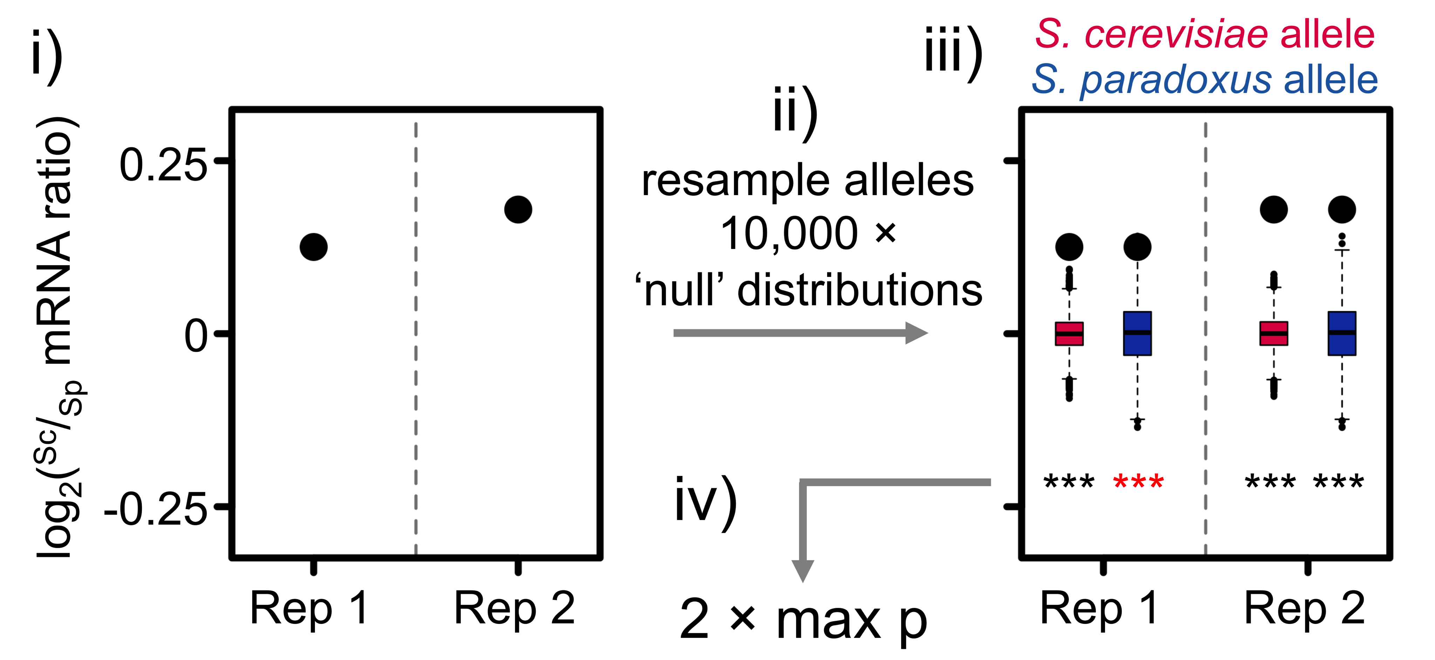

Supplemental Figure S3. Detection of significant divergence in mRNA abundance using the resampling approach of Bullard et al. (2010). The test is based upon rejecting the null hypothesis that the mRNA ^{Sc}/_{Sp} ratios are not significantly different from one. (i) The observed mRNA ^{Sc}/_{Sp} ratios (black circles) were obtained directly from the replicate mRNA fractions. (ii) In each fraction, the base-level coverage of each allele is resampled with replacement first using the S. cerevisiae marginal nucleotide frequencies and length, then using the S. paradoxus marginal nucleotide frequencies and length. As the same allele is resampled using the base composition and length parameters from both alleles, the expected log₂ ratio should be near 0 with any deviation capturing the expected inter-allelic variation due only to base composition, length differences, and read coverage. This resampling was performed 10,000 times, (iii) generating a distribution of ‘null’ ratios for each allele in each fraction (S. cerevisiae, red boxplots; S. paradoxus, blue boxplots). The ratio within each replicate was compared to the null distributions generated from each allele within the same replicate, for which a two-tailed p-value was calculated (note that the circles indicating the ratios in panel iii have been drawn over the permuted distributions of each allele for ease of comparison to the ‘null’ distributions). If all comparisons agreed in the parental direction of allelic bias (in the above example, S. cerevisiae), then (iv) the highest p-value (least significant as indicated by the red asterisks) was used as the representative for the test.

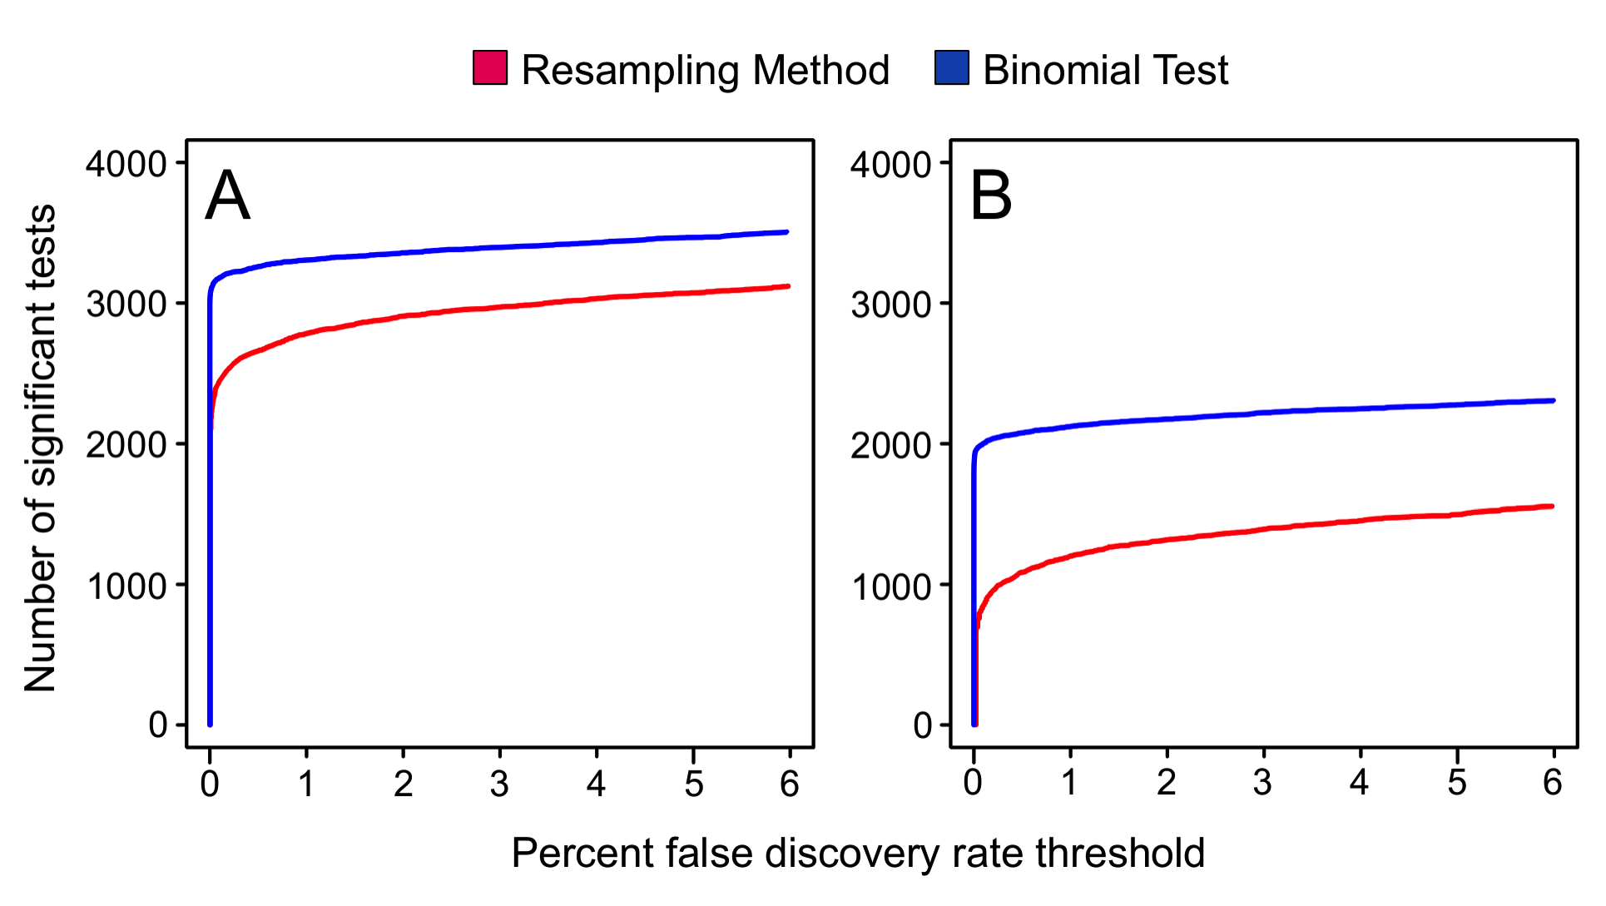

Supplemental Figure S4. Comparison between the number of genes showing significant regulatory divergence at increasing FDR thresholds between the resampling method as implemented in this study and the binomial test performed on the same data. The resampling based approach used in the current study is more conservative than the binomial test at both the mRNA (A) and translational (B) levels. However, this was more pronounced in the latter, as the resampling approach takes into account the increased variance in read coverage distribution in the Ribo fraction. Curves were generated using the ‘qvalue’ package in R (Storey 2002).

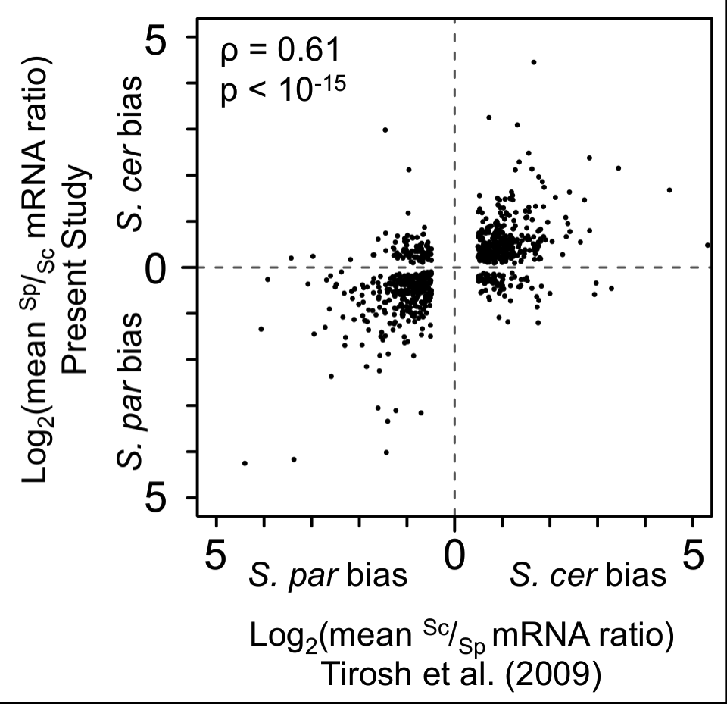

Supplemental Figure S5. Comparison of the results of the present study to the transcriptional cis-regulatory divergence estimated from Tirosh et al. (2009). Estimates of the degree of bias among genes showing significant cis-regulatory divergence in the transcriptional fraction agree well with the microarray-based analysis of transcriptional regulatory divergence in these species despite differences in the techniques employed (Spearman correlation coefficient in estimated ^{Sc}/_{Sp} mRNA ratio, ρ = 0.61, p < 10⁻¹⁵).

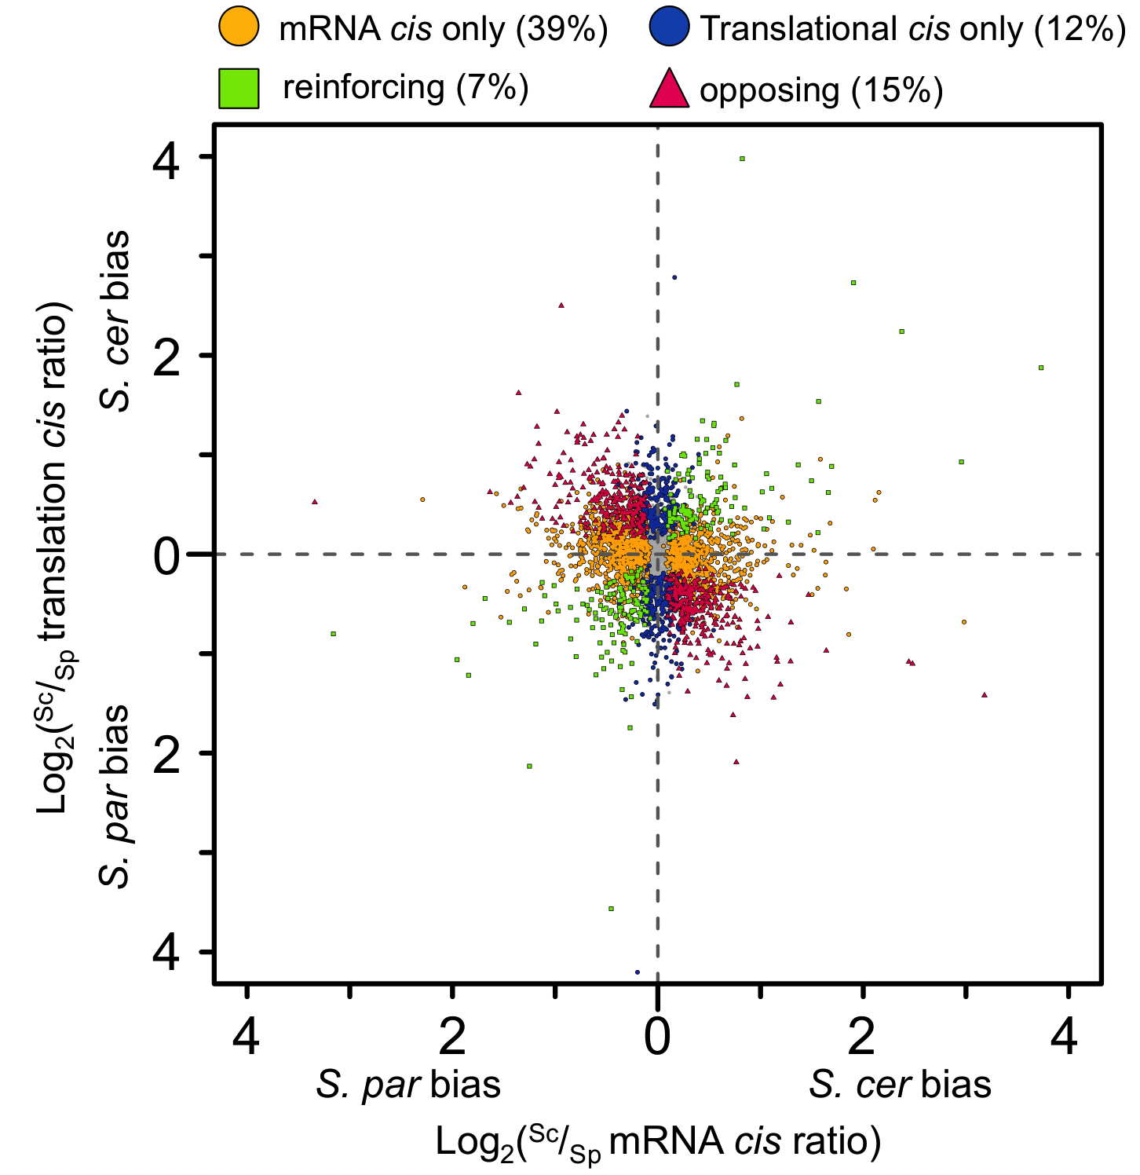

Supplemental Figure S6. Reproduction of Fig. 2A with the range of axes expanded to show the position of all 3,665 orthologs. S. cer, S. cerevisiae; S. par, S. paradoxus.

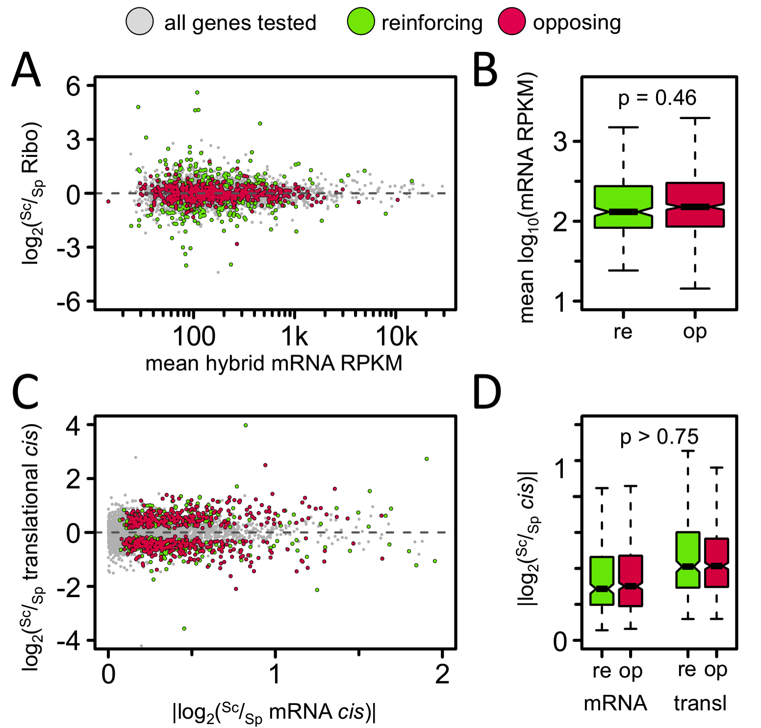

Supplemental Figure S7. No systematic biases are observed in mRNA expression levels or magnitudes of the cis ratios of orthologs with opposing or reinforcing mRNA vs. translational cis divergence. (A) Scatterplot of mean transcriptional RPKM (across both species and all replicates) vs. log₂(^{Sc}/_{Sp} Ribo mRNA) of orthologs with opposing (red) or reinforcing (green) mRNA vs. translational cis divergence. All genes tested are shown in grey. As can be seen, both types of divergence are observed across the range of expression levels. (B) Boxplot of the distribution of mRNA RPKMs for genes with reinforcing (re) or opposing divergence (op). The distributions are not significantly different (Kruskal-Wallis rank sum test, p = 0.46). (C) Scatterplot of absolute ^{Sc}/_{Sp} mRNA cis vs. log₂(^{Sc}/_{Sp} translational cis) of the same categories. Again, as can be seen, both types of divergence are observed across the range of cis magnitudes and (D) neither the distributions |log₂(^{Sc}/_{Sp} mRNA cis)| nor |log₂(^{Sc}/_{Sp} translational cis)| are significantly different among opposing vs. reinforcing orthologs (p = 0.94 and 0.75, for the mRNA and translational [transl] levels, respectively).
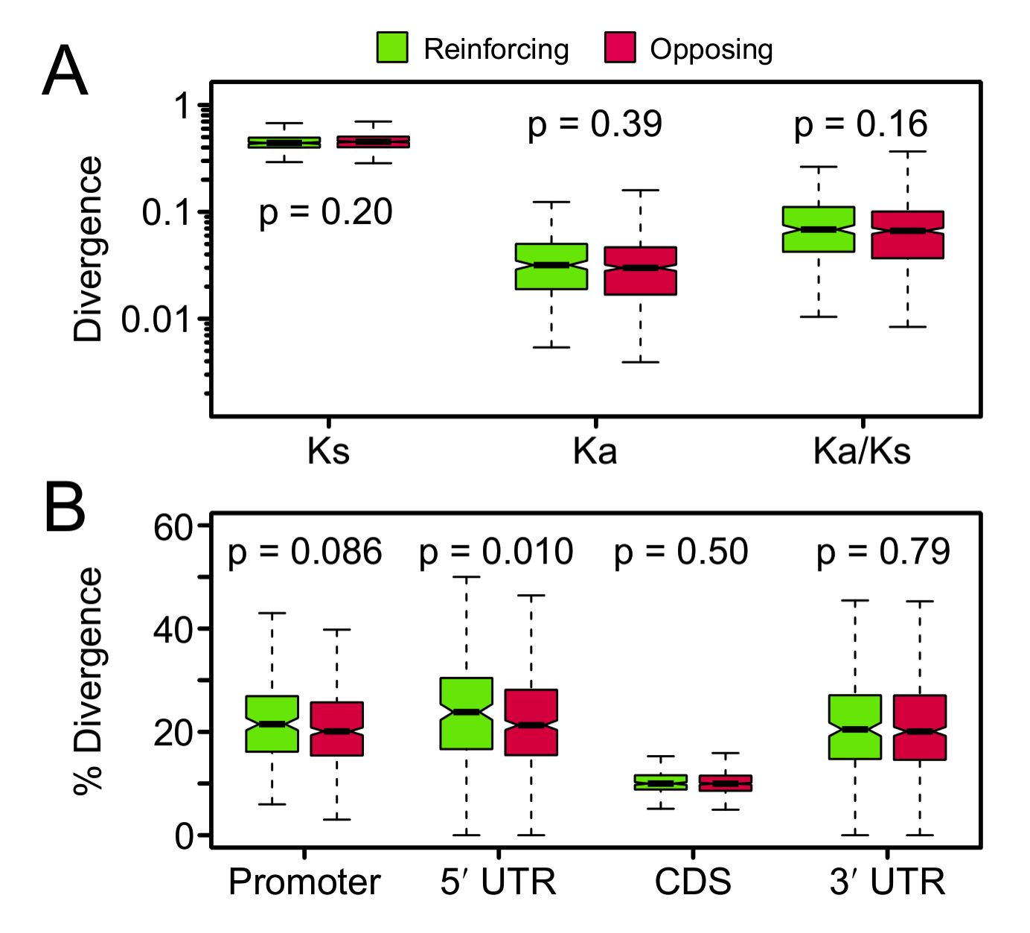

Supplemental Figure S8. Boxplot comparing (A) substitution rates in the CDSs or (B) levels of nucleotide divergence of orthologs with reinforcing (green) or opposing (red) cis-regulatory divergence between regulatory levels. Promoters are defined as 200 bp upstream of the TSS. P-values for the comparisons between categories using Kruskal-Wallis rank sum tests are shown above or below each category. The only significant comparison is a slightly reduced level of nucleotide divergence in the 5′ UTRs of orthologs with opposing divergence.

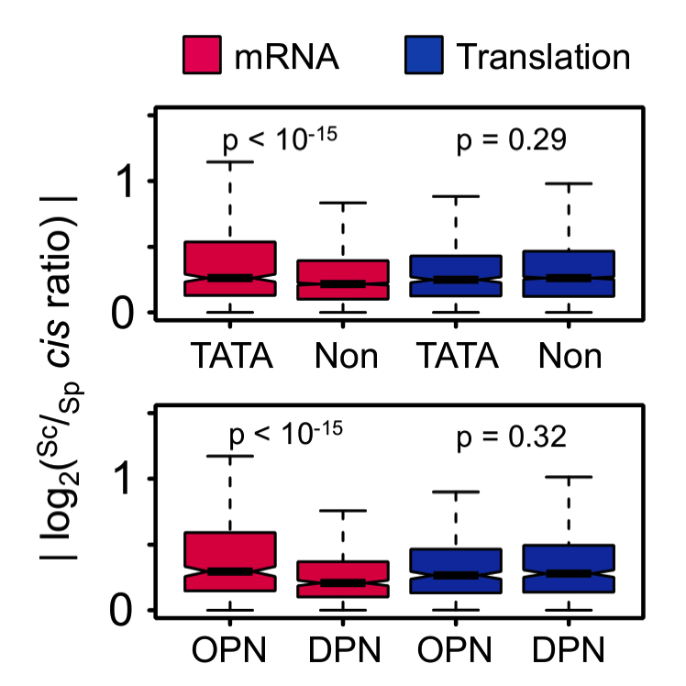

Supplemental Figure S9. Reproduction of Fig. 3C without controlling for the effect of the presence of OPNs in the TATA comparison, and vice versa. TATA and OPN containing genes are significantly more divergent in absolute cis ratio only at the mRNA level. Kruskal-Wallis rank sum test p-values are shown above each class. TATA, TATA-box containing promoter; Non, TATA-less promoter; OPN, occupied proximal-nucleosome; DPN, depleted proximal-nucleosome.

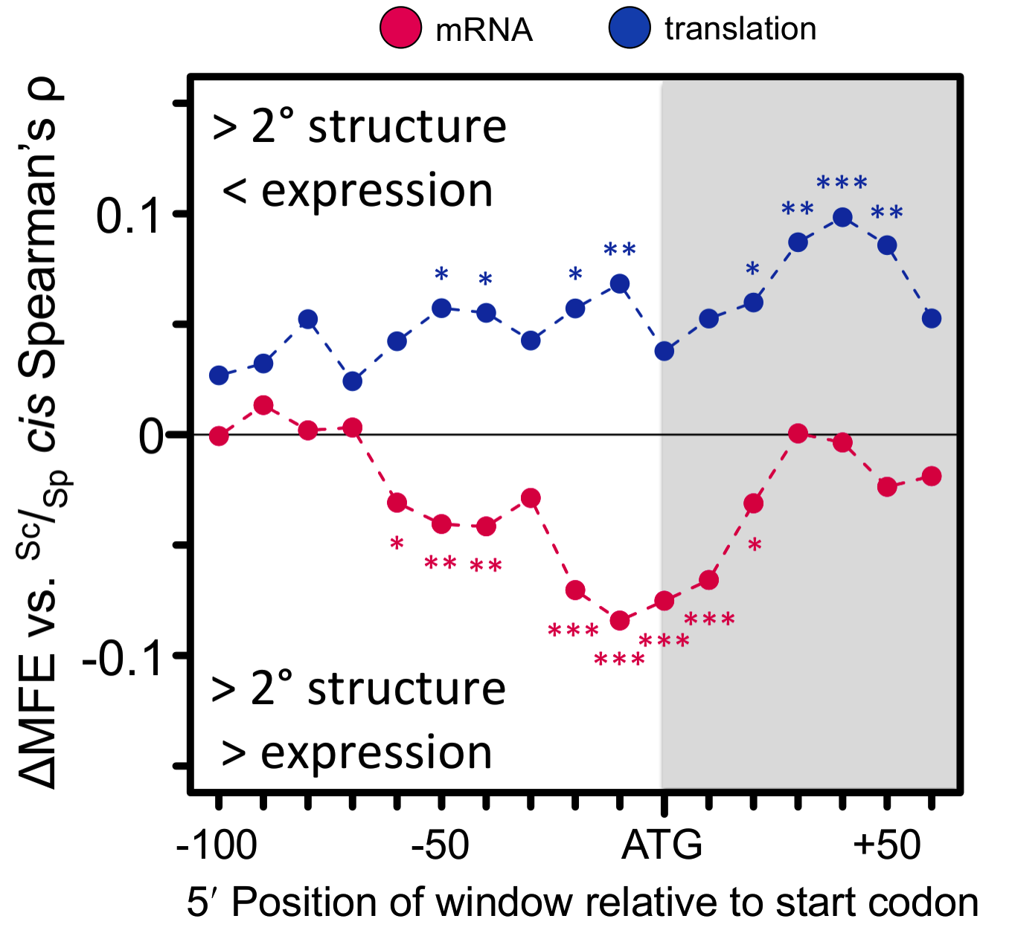

Supplemental Figure S10. Spearman’s correlation coefficient (ρ) between change in computed minimum free energy (ΔMFE) between orthologs and cis ratio for 41 nucleotide windows spanning the region -100 to +100 nucleotides upstream of the start codon for the 3,665 orthologs tested for significant divergence at both levels. ρ is polarized such that lower MFE (more secondary structure) is associated with lower expression. The relationship with ^{Sc}/_{Sp} mRNA cis is shown in red, and ^{Sc}/_{Sp} translational cis in blue. Windows showing significant correlations are indicated by asterisks where * indicates p < 0.05, ** indicates p < 0.01, and *** indicates p < 0.001. Windows beginning in the CDS are shaded to aid in visualization. All translational correlations are in the expected direction if secondary structure hampers ribosomal access to the start codon; however, the opposite relationship is seen at the mRNA level. The relationship observed in windows beginning at +30 are unique to the translational cis ratio, supporting an effect of secondary structure on translation in this region (e.g., Tuller et al. 2011).
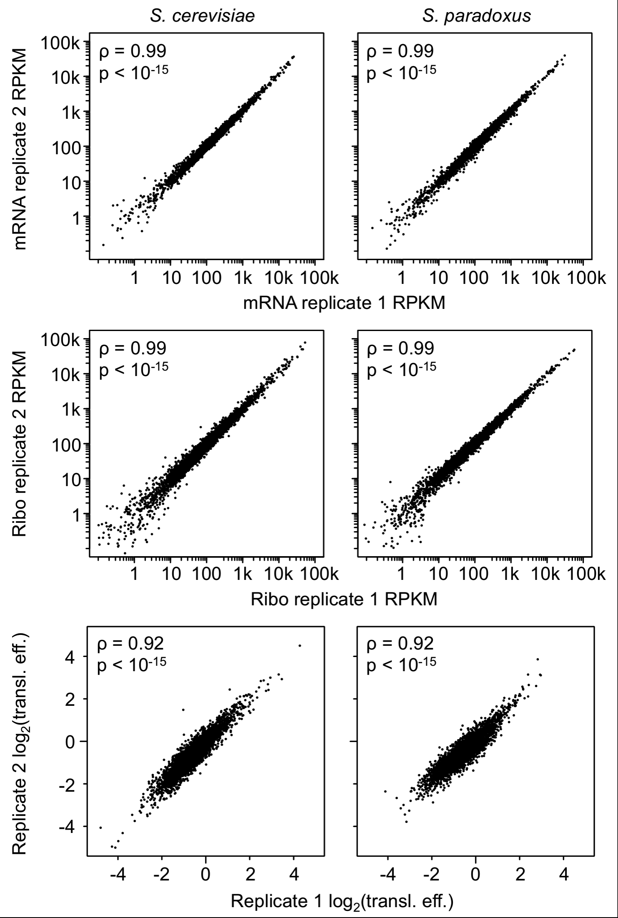

Supplemental Figure S11. Comparisons of parental biological replicate ortholog RPKM abundance estimates for all 4,640 orthologs. S. cerevisiae RPKMs are shown on the left while S. paradoxus estimates are on the right. The mRNA fraction (A) is shown above the Ribo fraction (B). C) Comparison between parental biological replicates of estimated translational efficiencies for the 3,634 orthologs with sufficient coverage to test for significant cis and trans regulatory divergence at both regulatory levels. Spearman’s correlation coefficients (ρ) indicate that all abundance measurements are highly reproducible. The higher correlations observed for the parental data may reflect the generally greater number of reads obtained from these libraries (Supplemental Table S2). Transl. eff: Translational efficiency.

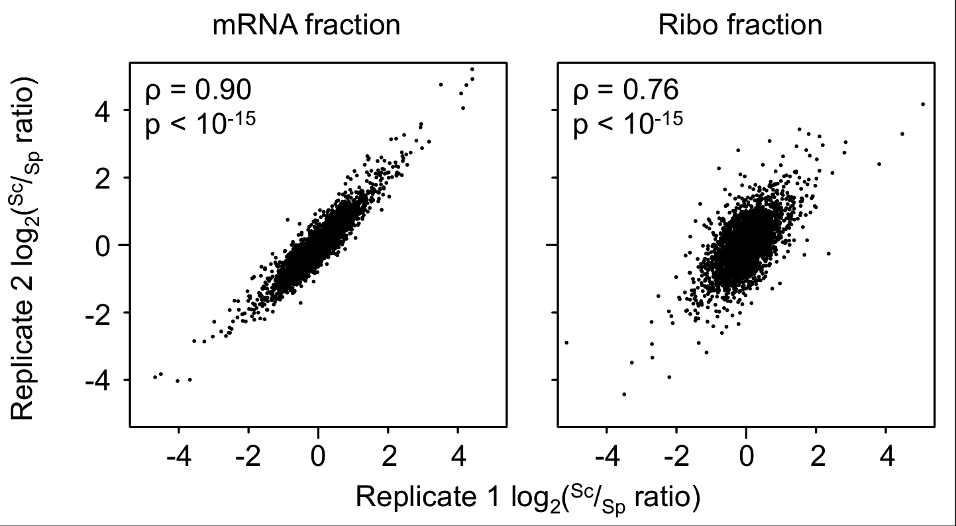

Supplemental Figure S12. Comparison of the estimated ^{Sc}/_{Sp} ortholog ratios for the parental mRNA and Ribo fractions. Spearman’s correlation coefficients (ρ) are shown in each panel. As was the case with the hybrid data, mRNA fraction ^{Sc}/_{Sp} ratios estimates are more reproducible, likely owing to both the greater number of mapping reads obtained from these fractions, and the more even distribution of coverage along the CDS of transcripts (Ingolia et al. 2009).

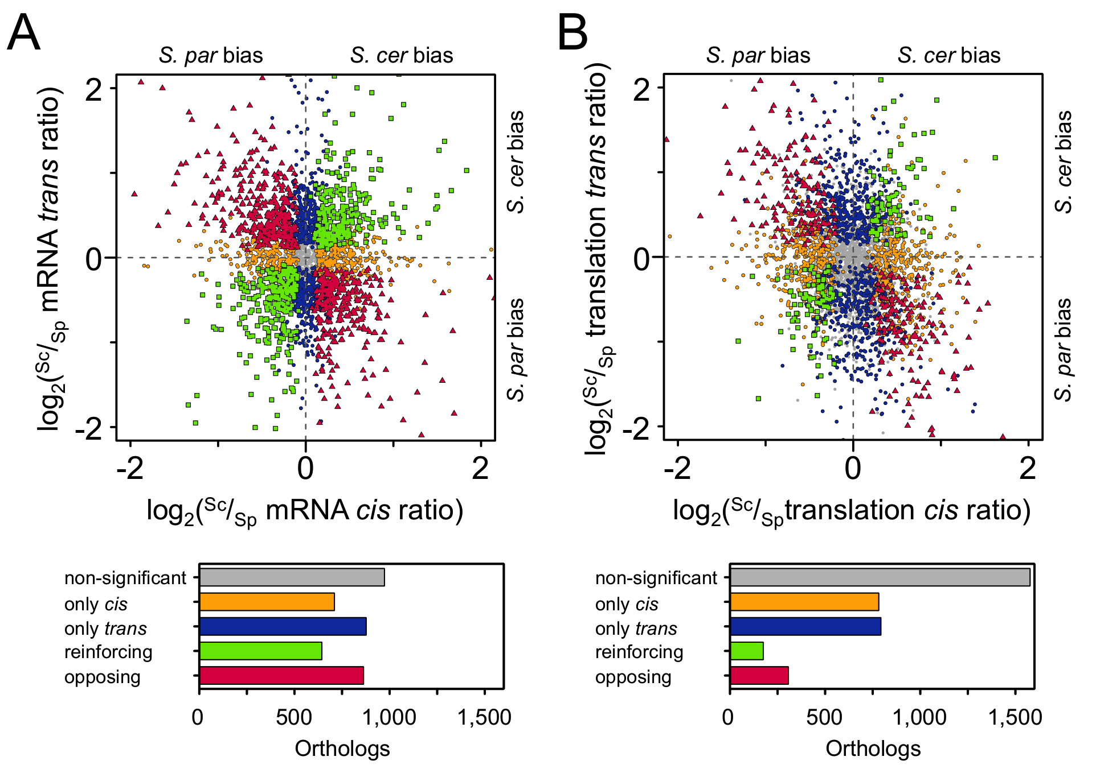

Supplemental Figure S13. (A) The relationship between cis-regulatory and trans-divergence at the mRNA level (all plotted ^{Sc}/_{Sp} ratios are the mean of the two biological replicates). While significantly more orthologs show divergence only in trans (blue circles) as compared to cis (orange circles; χ² = 14.3, p = 0.00016), overall there is no significant excess of either type of divergence (χ² = 3.7, p = 0.054). As was the case for cis divergence between regulatory levels, we observed an excess of opposing (red triangles) as compared to reinforcing (green boxes) divergence among the two regulatory mechanisms. (B) As above, but for the translational level. No significant differences are observed in the number of orthologs with significant cis vs. trans divergence, nor in those with reinforcing vs. opposing divergence (χ² = 0.030 and 0.049, p = 0.083 and 0.86, respectively; see Supplemental Fig. S15).

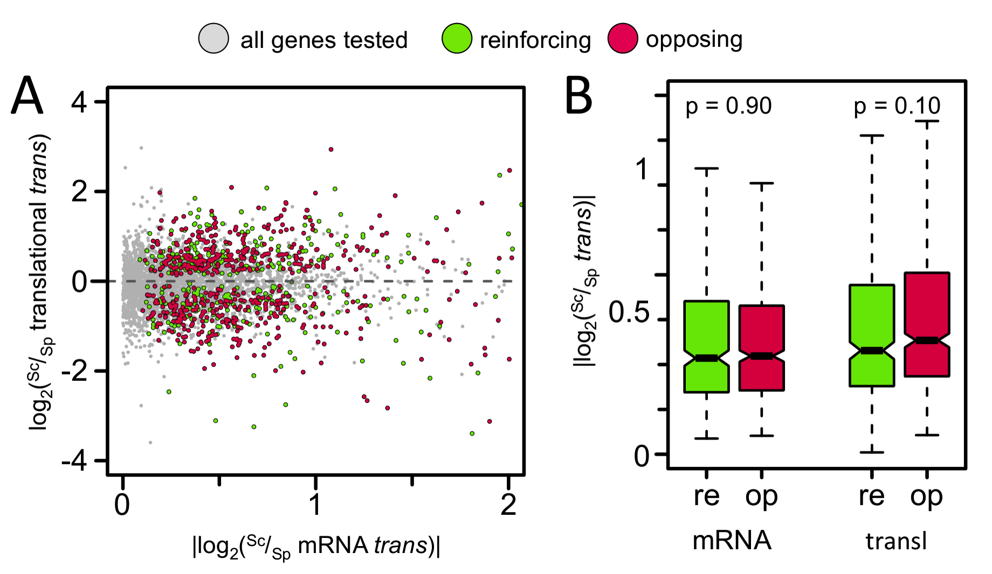

Supplemental Fig S14. (A) Scatterplot of |log₂(^{Sc}/_{Sp} mRNA trans)| vs. log₂(^{Sc}/_{Sp} translational trans) of orthologs with reinforcing or opposing trans divergence across regualtory levels. (B) Neither the distributions |log₂(^{Sc}/_{Sp} mRNA trans)| nor |log₂(^{Sc}/_{Sp} translational trans)| are significantly different among opposing vs. reinforcing orthologs (p = 0.90 and 0.10, for the mRNA and translational [transl] levels, respectively).

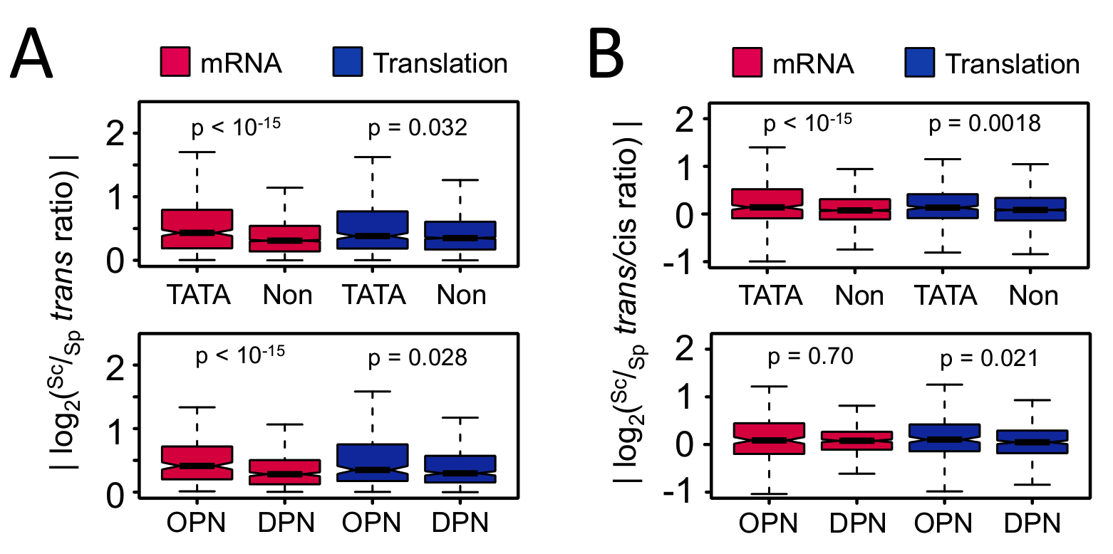

Supplemental Figure S15. (A) Orthologs whose promoters contain either TATA boxes (TATA) or occupied proximal nucleosome regions (OPN) show more trans-acting divergence only at the mRNA level when compared to non-TATA promoters (Non) or depleted proximal nucleosome regions (DPNs), respectively. p values of the Kruskal-Wallis rank sum test are indicated above each fraction. The marginal significance of the translational level comparisons are no longer significant after correction for multiple tests. (B) Comaparison of the relative trans/cis ratio shows a stronger effect of TATA boxes but not OPN on trans divergence at the mRNA level as has been previously observed in these hybrids (Tirosh et al. 2009). This pattern is also seen more weakly at the translational level, but could reflect the biases in absolute trans ratio due to the large number of measurements required (see Supplemental Fig. S15). Analysis was performed exactly as in Fig. 2C, with the exception that only orthologs analyzed in the parental comparisons were used (see Methods in the main text).

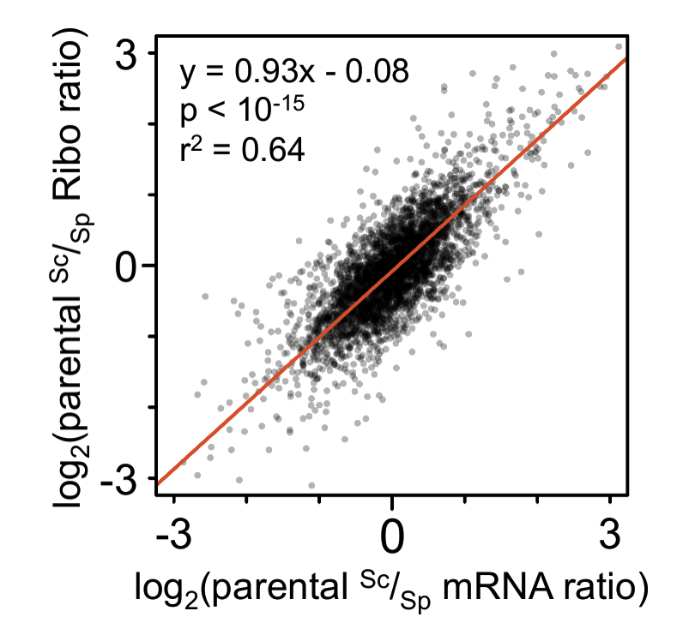

Supplemental Figure S16. Opposing divergence across regulatory levels is also observed in the parental samples. The red line indicates the best fit of a linear regression, with equation, p, and r² values indicated above. The slope is significantly lower than one (95% confidence interval ±0.016), indicating that interspecific ortholog ^{Sc}/_{Sp} mRNA ratios tend to overestimate the degree of difference by ~8% relative to that of the Ribo fraction. The higher degree of overestimation observed in the hybrids may reflect the buffering effect of opposing cis/trans divergence captured in the parental comparison.

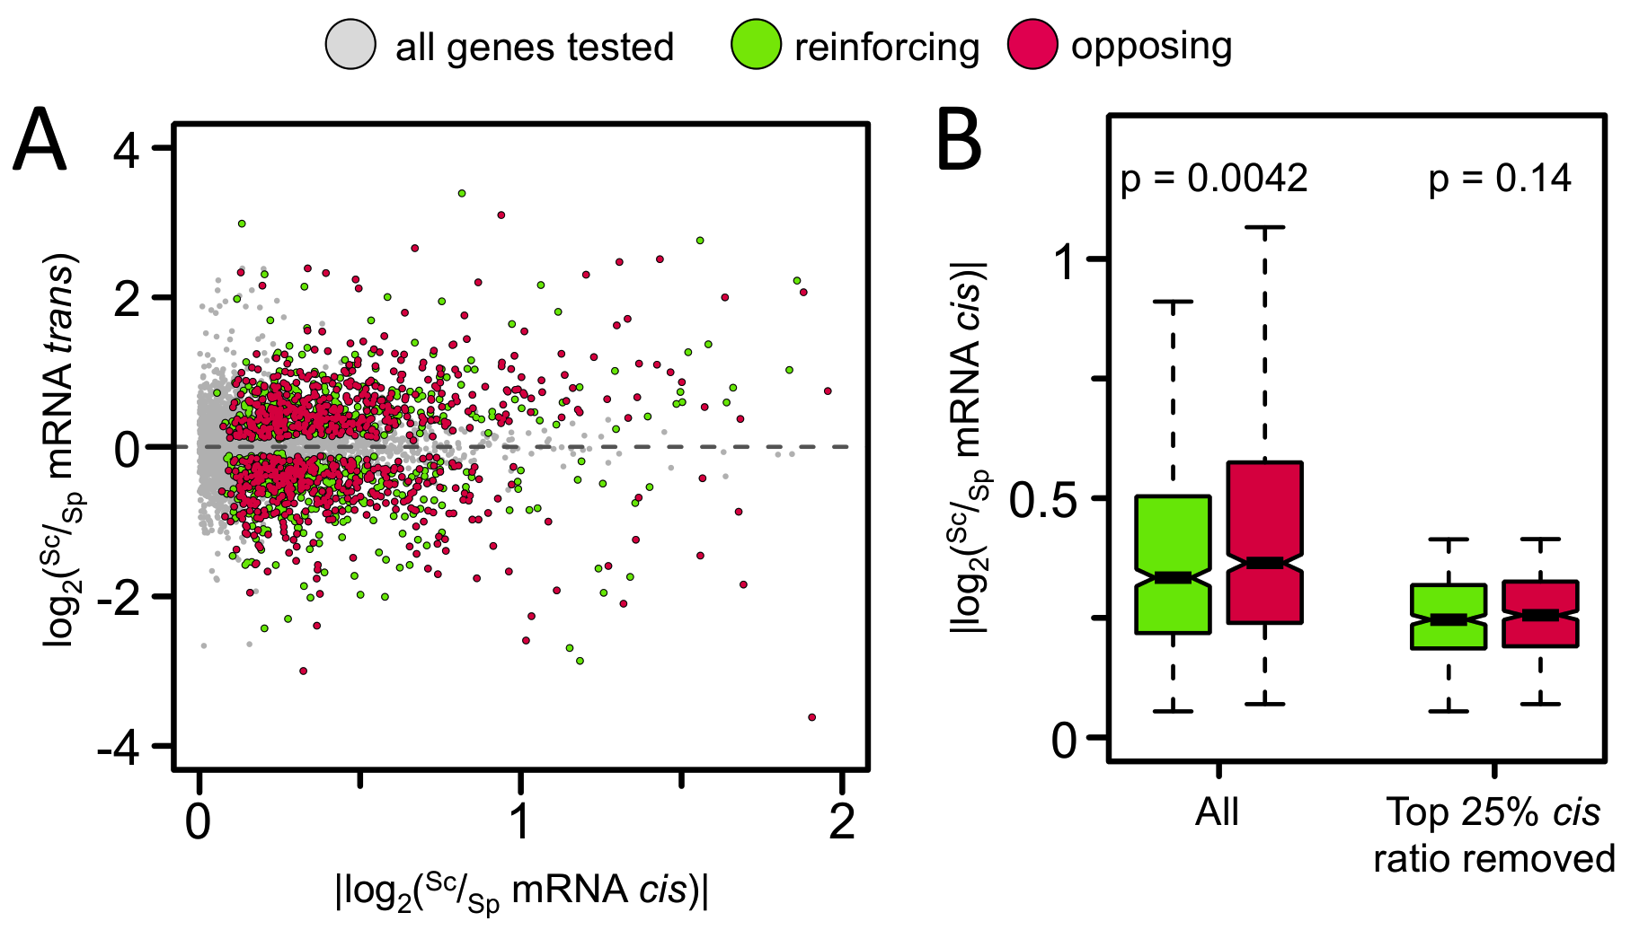

Supplemental Fig S17. (A) Scatterplot of |log₂(^{Sc}/_{Sp} mRNA cis)| vs. log₂(^{Sc}/_{Sp} mRNA trans) of orthologs with reinforcing or opposing cis/trans divergence at the mRNA level. (B) We observed a slight, but significantly higher absolute ^{Sc}/_{Sp} mRNA cis ratio among orthologs with opposing divergence (Kruskal-Wallis rank sum test, p = 0.0042), which may be biological, but is also consistent with a systematic overestimation of cis ratios or underestimation of trans ratios among orthologs with strong ASE. However, removal of the top 25% absolute ^{Sc}/_{Sp} mRNA cis ratio orthologs from the analysis removes this effect, and yet we still observed a significant excess of opposing divergence (406 reinforcing vs. 500 opposing, χ² = 9.8, p = 0.0018), which are the values presented in the main Results section. The reciprocal comparison of the distributions of |log₂(^{Sc}/_{Sp} mRNA trans)| in reinforcing vs. opposing orthologs indicates that they are not significantly different from one another when either comparing all ratios (p = 0.065) or with the top 25% of ratios removed (p = 0.61; not shown).

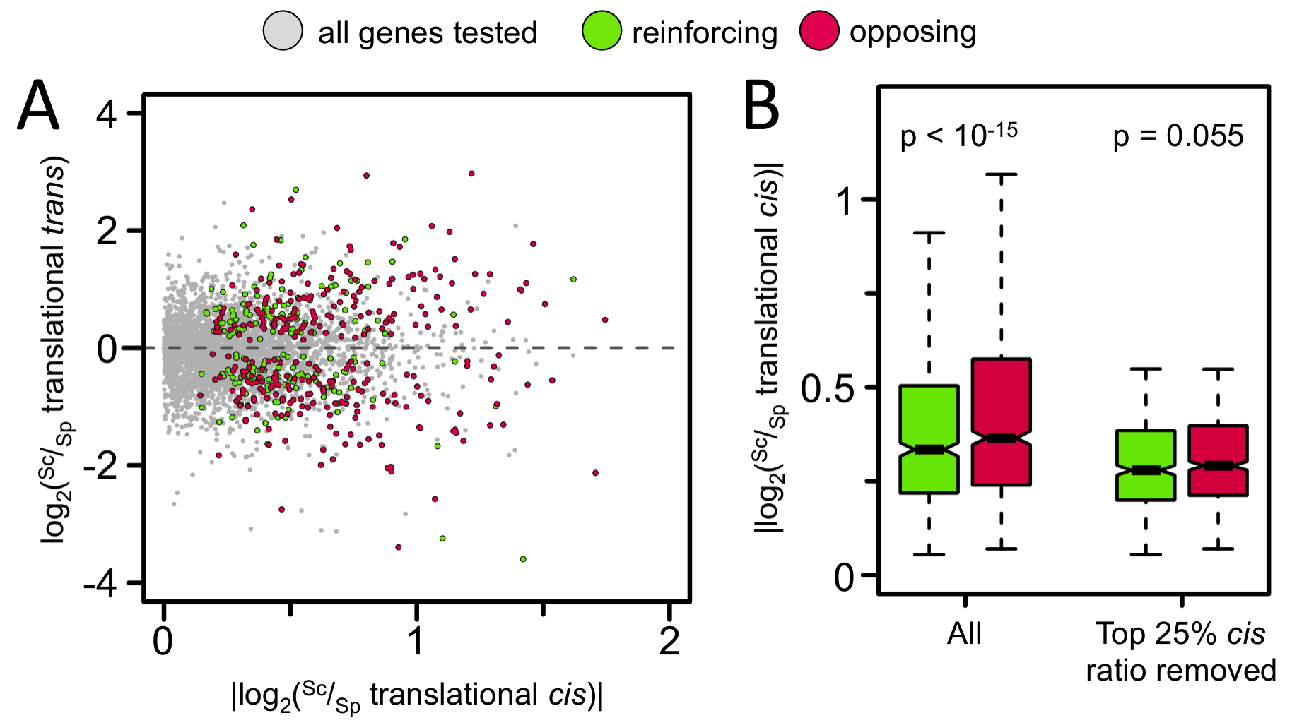

Supplemental Figure S18. (A) Scatterplot of |log₂(^{Sc}/_{Sp} translational cis)| vs. log₂(^{Sc}/_{Sp} translational trans) of orthologs with reinforcing or opposing cis/trans divergence at the translational level. (B) At this level, we observed a strong relationship of higher absolute ^{Sc}/_{Sp} translational cis ratio among orthologs with opposing divergence (Kruskal-Wallis rank sum test, p < 10⁻¹⁵), which could reflect the amount of variability that is included in the estimate of the translational ^{Sc}/_{Sp} trans ratio (i.e., parental ^{Sc}/_{Sp} Ribo - (hybrid ^{Sc}/_{Sp} Ribo + parental ^{Sc}/_{Sp} mRNA). Again, removal of the top 25% absolute ^{Sc}/_{Sp} translational cis ratio orthologs from the analysis removes this effect, and there is no evidence of an excess of either reinforcing or opposing divergence (94 reinforcing vs. 91 opposing, χ² = 0.049, p = 0.83), which are the values presented in the main Results section.

