Improved exome prioritization of disease genes through cross species phenotype comparison – Online Supplementary Material

Filtering | No. genes per exome(mean) | % recall | % top hit by CPVS | % top hit by variant score | % top hit by phenotypic relevance score | AUC
No ﬁltering | 5744-9530 (8388) | 100.0 | 6.4 | 0 .0 | 6.8 | 0.871
Off-target + Syn removed (default) | 3563-5883 (5109) | 99.0 | 60.9 | 29.4 | 10.2 | 0.993
MAF > 1%, Off-target + Syn removed | 162-704 (408) | 98.2 | 61.4 | 31.2 | 33.8 | 0.942
MAF > 1%, Off-target + Syn removed (AD model) | 142-684 (379) | 98.4 | 66.1 | 28.0 | 49.1 | 0.936
MAF > 1%, Off-target + Syn removed (AR model) | 17-84 (37) | 97.8 | 83.1 | 76.7 | 54.3 | 0.972

Supplementary Table 1: Performance of the PHIVE prioritization method. The Filtering column indicates the methods used to ﬁlter out variants or genes based on their minor allele frequency (MAF), status as synonymous (Syn) or noncoding, off-target variants (Off-target). The number of genes after each ﬁltering stage along with the total percentage recall of the correct disease gene are shown. The ﬁnal column shows the Area Under the Curve (AUC) from receiver operating characteristic analysis of the true positive rate vs. false positive rate.
Supplementary Figure 1. Precision Recall (P/R) plot showing the relative performance of the phenotypic relevance score, variant score and by the combined phenotype/variant score. Synonymous and non-coding variants, as well as all variants with an estimated population frequency of 1% or higher, were removed. In addition, only genes with variants fitting an Autosomal Recessive model of inheritance were considered. Precision (proportion of correct disease genes among all genes scoring above a given level) is plotted against recall (fraction of cases in which correct disease genes score at a given level or above). P/R plots for the other prioritization schemes consistently showed an advantage for combined phenotype/variant prioritization.

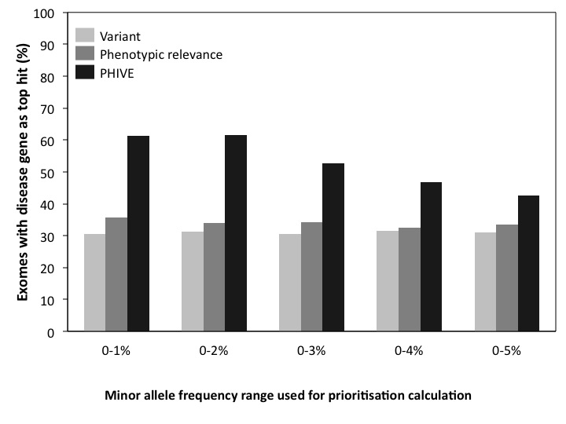
Supplementary Figure 2. Comparison of different methods for calculating the frequency scores used in the overall variant and PHIVE scores. The frequency score is calculated as $\max{(0, 1-xe^{100*f}})$, where x was adjusted to assign a score of 0 when the minor allele frequency (f) was either 0.01, 0.02, 0.03, 0.04 or 0.05 (1,23,4 or 5%). This gives us a range of 0 to 1 for the frequency score based on the MAF where the rarer the variant the higher the frequency score.
The individual groups show the results after ﬁltering to remove common, synonymous, and non-coding variants with one of the frequency score calculations. The bars show the percentage of times in which the true disease gene was assigned the top scoring match in 100,000 simulated WES datasets per analysis after prioritization based on PHIVE. The optimal strategy was found to be where a frequency score between 0 and 1 was assigned for MAFs in the range 0-2% with MAF > 2% assigned a score of 0.

